**Lec 7 Anti –hypertensive drugs**   **Dr. Ihab Alkhalifa**

**Overview**

**Hypertension** **(elevated blood pressure (BP)** : is a common, chronic disorder that affects 65 million Americans and over 1 billion people worldwide. Left untreated, hypertension can lead to heart disease, kidney disease, and stroke. Conversely, a treatment program of lifestyle modifications and drug therapy can reduce both BP and the risk of long-term complications.

However, it is important to appreciate that we cannot cure hypertension; we can only reduce symptoms

**Blood pressure categories**

Defines four BP categories:

A-- normal B- prehypertension

C- stage 1 hypertension, and D- stage 2 hypertension (Table 46-1).



Figure 16.2 Classification of blood pressure.

**A- Normal :** normal BP is defined as systolic BP below 120 mm Hg and diastolic BP below 80 mm Hg,

**B- Prehypertension or elevated B.P.** : Prehypertension is defined as systolic BP of 120 to 129 mm Hg or diastolic BP of 80 to 89 mm Hg.

BP in this range carries an increased risk of cardiovascular disease,, those with BP in the prehypertension range have a 2- to 3-fold increased risk of cardiovascular events. To reduce risk, these people should adopt certain health-promoting lifestyle changes

**C-Hypertension:** Hypertension is defined as systolic BP above 140 mm Hg or diastolic BP above 90 mm Hg. If systolic BP is above 140 mm Hg and diastolic BP is below 90 mm Hg,

**Hypertension categories**

There are two broad categories of hypertension: primary hypertension and secondary hypertension.

As indicated in Table 46-2, primary hypertension is by far the most common form of hypertensive disease. Less than 10% of people with hypertension have a secondary form.

**A- Primary (Essential) Hypertension**

Primary hypertension is defined as hypertension that has no identifiable cause Primary hypertension is also referred to as **essential hypertension.**

**B-Secondary Hypertension**

Secondary hypertension is defined as an elevation of BP brought on by an identifiable primary cause. Because secondary hypertension results from an identifiable cause, it may be possible to treat that cause directly, rather than relying on antihypertensive drugs for symptomatic relief.

As a result, some individuals can actually be cured. For example, if hypertension occurs secondary to pheochromocytoma (a catecholamine-secreting tumor), surgical removal of the tumor may produce permanent cure. When cure is not possible, secondary hypertension can be managed with the same drugs used for primary hypertension.

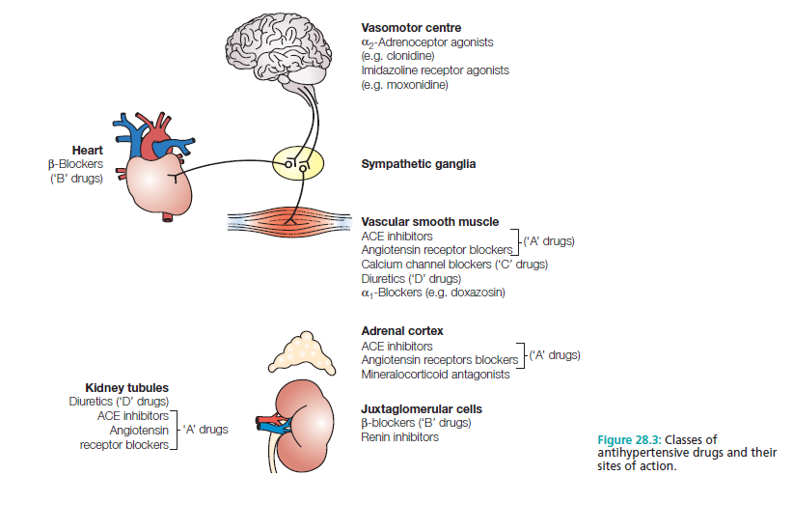

**MANAGEMENT OF CHRONIC HYPERTENSION**

**Treatment Goals**

1-For most patients with stage 1 or stage 2 hypertension, the goal is to maintain systolic BP below 140 mm Hg and diastolic BP below 90 mm Hg.

2- The ultimate goal in treating hypertension is to reduce cardiovascular and renal morbidity and mortality.

**LIFESTYLE MODIFICATIONS**

1-Lifestyle changes offer multiple cardiovascular benefits they do so with little cost and minimal risk.

2- they may actually prevent hypertension.

3- When implemented after hypertension has developed, they can lower BP, thereby decreasing or eliminating the need for drugs.

4- lifestyle modifications can decrease other cardiovascular risk factors. Accordingly, all patients should be strongly encouraged to adopt a healthy lifestyle.

**Strategies of Life style modification**

1- Weight Loss.

2- Sodium Restriction.

3- Alcohol Restriction.

4- Diet Restriction.

5- Aerobic Exercise.

6- Smoking Cessation.

7- Maintenance of Potassium and Calcium Intake.

**Principal Determinants of Blood Pressure**

The principal determinants of BP are summarized in Figure 46-1. As indicated, arterial pressure is the product of cardiac output and peripheral resistance.

An increase in either will increase BP. As shown in the figure, cardiac output is influenced by four factors: (1) heart rate, (2) myocardial contractility (force of contraction), (3) blood volume, and (4) venous return of blood to the heart. An increase in any of these will increase cardiac output, thereby causing BP to rise.

**Body Systems & Mechanisms for Controlling Blood Pressure.**

1- Renal Regulation of Blood Pressure

2- Renin-Angiotensin-Aldosterone System (RAAS)

3- Sympathetic Baroreceptor Reflex.

**Sites of Drug Action and Antihypertensive Effects**

* **Brainstem :** Antihypertensive drugs **acting in the brainstem suppress sympathetic** outflow to the heart and blood vessels,
* **Heart** : resulting in decreased heart rate, decreased myocardial contractility
* **Blood Vessel** :

1-Vasodilation contributes the most to reducing BP through Dilation of arterioles & decreasing vascular resistance reduces BP.

2- Dilation of veins reduces BP by decreasing venous return to the heart.

* **Sympathetic Ganglia :** Ganglionic blockade reduces sympathetic stimulation of the heart and blood vessels Ganglionic blocking agents (eg, mecamylamine) produce such a profound reduction in BP that they are used rarely, and then only for hypertensive emergencies.

**Terminals of Adrenergic Nerves :** Antihypertensive agents that act at adrenergic nerve terminals decrease the release of norepinephrine, resulting in decreased sympathetic stimulation of the heart and blood vessels.

**Blockade of cardiac beta1** receptors prevents sympathetic stimulation of the heart. As a result, heart rate and myocardial contractility decline.

**Alpha1-Adrenergic Receptors on Blood Vessels.**

Blockade of vascular alpha1 receptors promotes dilation of arterioles and veins. Arteriolar dilation reduces peripheral resistance. Venous dilation reduces venous return to the heart.

**Vascular Smooth Muscle:** Several antihypertensive drugs act directly on vascular smooth muscle to cause relaxation. Two of these agents—sodium nitroprusside and diazoxide— are used only for hypertensive emergencies. The rest are used for chronic hypertension.

**Renal Tubules**: Diuretics act on renal tubules to promote salt and water excretion. As a result, blood volume declines, causing BP to fall.

**Major Classes of Antihypertensive Drugs**

**1- Diuretics**

**2- Sympatholytic (Antiadrenergic Drugs)**

**3- Centrally acting antihypertensive**

**4- Adrenergic neuronal blockers**

**5- Direct vasodilators**

**6- Calcium channel blockers**

**REVIEW OF RENAL ANATOMY AND PHYSIOLOGY**

Understanding the diuretic drugs requires a basic knowledge of the anatomy and physiology of the kidney. Accordingly, we review these topics before discussing the diuretics themselves.

**Anatomy**

The basic functional unit of the kidney is the nephron.

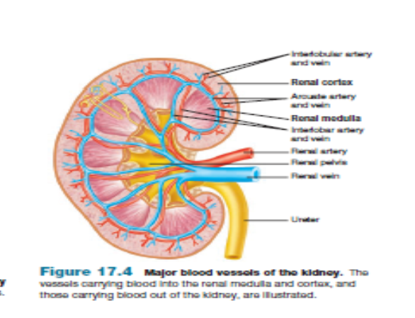

**الشكل للاطلاع**

indicated in Figure ( 38-1) the nephron has four functionally distinct regions:

(1) The glomerulus, (2) the proximal convoluted tubule, (3) the loop of Henle, and the distal convoluted tubule.

All nephrons are oriented within the kidney such that the upper portion of Henle's loop is located within the renal cortex and the lower end of the loop descends toward the renal medulla. In addition to the nephrons,the (4) collecting ducts (the tubules into which the nephrons pour their contents

**Renal Regulation of Blood Pressure**

When BP falls, glomerular filtration rate (GFR) falls as well, thereby promoting retention of sodium, chloride, and water. The resultant increase in blood volume increases venous return to the heart, causing an increase in cardiac output, which in turn increases arterial pressure.

**We can neutralize renal effects on BP with diuretics.**

**NORMAL REGULATION OF FLUID AND ELECTROLYTES BY THE KIDNEYS**

Approximately 16% to 20% of the blood plasma entering the kidneys is filtered from the glomerular capillaries into Bowman’s capsule. The filtrate, although normally free of proteins and blood cells, contains most of the low molecular weight plasma components in concentrations similar to that in the plasma. These include glucose, sodium bicarbonate, amino acids, and other organic solutes, as well as electrolytes, such as Na+, K+, and Cl−.

The kidney regulates the ionic composition and volume of urine by active reabsorption or secretion of ions and/or passive reabsorption of water at five functional zones along the nephron:

1) The proximal convoluted tubule

2) The descending loop of Henle

3) The ascending loop of Henle

4) The distal convoluted tubule,

5) The collecting tubule and duct

**Diuretics**

Diuretics are drugs that increase the volume of urine excreted.

Most diuretic agents are inhibitors of renal ion transporters that decrease the reabsorption of Na+ at different sites in the nephron. As a result, Na+ and other ions, such as Cl−, enter the urine in greater than normal amounts along with water, which is carried passively to maintain osmotic equilibrium.

Diuretics, thus, increase the volume of urine and often change its pH, as well as the ionic composition of the urine and blood.

**Diretics subclass :**

1. **Thiazide diuretics**

**B- High-ceiling diuretics (Loop diuretics)**

**C- Potassium-Sparing Diuretics**

**D- Drugs that Suppress the Renin-Angiotensin –Aldosterone system (RAAS)** 

Diuretics are a mainstay of antihypertensive therapy. These drugs reduce BP when used alone, and they can enhance the effects of other hypotensive drugs

Diuretics are drugs that increase the output of urine. These agents have two major applications:

(1) Treatment of hypertension

(2) Mobilization of edematous fluid (associated with heart failure, cirrhosis, and kidney disease).

**THIAZIDES AND RELATED DIURETICS**

The thiazides are the most widely used diuretics. They are sulfonamide derivatives.

All thiazides affect the distal convoluted tubule, thiazides increase renal excretion of sodium, chloride, potassium, and water

all have equal maximum diuretic effects, differing only in potency.

**Q/ Thiazides are sometimes called “low ceiling diuretics,”** ?

A/ Because increasing the dose above normal therapeutic doses does not promote further diuretic response.

**Q/ What are The principal difference between the thiazides and high-ceiling agents ?**

A/ 1- that the maximum diuresis produced by the thiazides is considerably lower than the maximum diuresis produced by the high-ceiling drugs.

2- Whereas loop diuretics can be effective even when urine flow is scant, thiazides cannot.

* **Chlorothiazide** & **Hydrochlorothiazide**

1. **CLASS : Chlorothiazide** [klor-oh-THYE-ah-zide] was the first orally active diuretic that was capable of affecting the severe edema with minimal side effects. Its properties are representative of the thiazide group.

**B-Mechanism of action**: The thiazide and thiazide-like diuretics act mainly in the cortical region of the ascending loop of Henle and the distal convoluted tubule to decrease the reabsorption of Na+, apparently by inhibition of a Na+/Cl− cotransporter on the luminal membrane of the tubules (Figure 18.2). promotes urine production by **blocking the reabsorption of sodium and chloride in the early segment of the distal convoluted tubule**

**Scheme diagram for thiazide action to decrease blood pressure الرسم مطلوب للحفظ**

**C-Pharmacokinetics :** Diuresis begins about 2 hours after oral administration. Effects peak within 4 to 6 hours, and may persist up to 12 hours. Most thiazides take 1 to 3 weeks to produce a stable reduction in blood pressure, and they exhibit a prolonged half-life

Although the thiazides differ from one another in milligram potency , at therapeutically equivalent doses, all elicit the same degree of diuresis.

**Although most have the same onset time (1 to 2 hours), these drugs differ significantly with respect to duration of action.**

**NOTE/ Most of the drug is excreted unchanged in the urine.**

**D-Therapeutic Uses & Adverse effects**

**1- Hypertension:** The primary indication for hydrochlorothiazide is hypertension, a condition for which thiazides are often drugs of first choice.

They are effective in reducing blood pressure in patients with mild to moderate essential hypertension.

2- **Edema in heart failure :** Thiazides are preferred drugs for mobilizing edema associated with mild to moderate heart failure. They are also given to mobilize edema associated with hepatic or renal disease.

**Adverse Effects**

The adverse effects of thiazide diuretics are similar to those of the high-ceiling agents. The adverse effects of the thiazides and loop diuretics are nearly identical Including:

* Hypokalemia
* Dehydration
* Hyperglycemia
* hyperuricemia
* disruption of lipid metabolism (ie, reduction of HDL cholesterol and elevation of LDL cholesterol and triglycerides).

**Q/ with decreased renal function, thiazide diuretics lose efficacy ?**

The efficacy of these agents may be diminished with concomitant use of NSAIDs, such as indomethacin ?

A/ Because the site of action of the thiazide derivatives is on the luminal membrane, these drugs must be excreted into the tubular lumen to be effective. Therefore, with reduced renal functions by disease or drugs affecting kidney functions , these drugs lose efficacy

**Q / Hypertension: Clinically, the thiazides are a mainstay of antihypertensive medication**?

A/ because they are inexpensive, convenient to administer, and well tolerated & They are effective in reducing blood pressure in patients with mild to moderate essential hypertension.

For many hypertensive patients, blood pressure can be controlled with a thiazide alone, although many other patients require multiple-drug therapy.

**Q/ Hydrochlorothiazide is the most widely used thiazide diuretic ?**

A/ Hydrochlorothiazide is more potent, so the required dose is considerably lower than that of chlorothiazide, but the efficacy is comparable to that of the parent drug. In all other aspects, hydrochlorothiazide resembles chlorothiazide.

**Q/ serum K+ should be measured periodically (more frequently at the beginning of therapy) ?**

A/ Because thiazides increase Na+ in the filtrate arriving at the distal tubule, more K+ is also exchanged for Na+, resulting in a continual loss of K+ from the body with prolonged use of these drugs. Thus, serum K+ should be measured periodically to monitor for the development of hypokalemia.

**Thiazide-like Diuretics**

These compounds lack the thiazide structure, but, like the thiazides, they have the unsubstituted sulfonamide group and, therefore, **share their mechanism of action**. The therapeutic uses and adverse effect profiles are similar to those of the thiazides.

* **Chlorthalidone**: Chlorthalidone [klor-THAL-i-done] is a **non-thiazide derivative** that behaves pharmacologically like hydrochlorothiazide. It has a long duration of action and, therefore, is often used once daily to treat hypertension.
* **Metolazone:** Metolazone[me-TOL-ah-zone] is more potent than the thiazides and, unlike the thiazides, causes Na+ excretion even in advanced renal failure.

**High-ceiling diuretics** **(Loop diuretics )**

The loop diuretics (furosemide, torsemide, bumetanide, and ethacrynic acid) act promptly by blocking sodium and chloride reabsorption in the kidneys, even in patients with poor renal function or those who have not responded to thiazide diuretics. Loop diuretics cause decreased renal vascular resistance and increased renal blood flow.

* **Furosemide & Torsemide**

Furosemide : is the most frequently prescribed loop diuretic

**A- class &subclass :** High-ceiling diuretics (loop diuretics)

**B- Mechanism of Action :** Furosemide acts in the thick segment of the ascending limb of **Henle's loop to block reabsorption of sodium and chloride** leading to prevent passive reabsorption of water produce profound diuresis.

**C-Pharmacokinetics :** Furosemide can be administered orally, IV, and IM. With oral administration, diuresis begins in 60 minutes Their duration of action is relatively brief (2 to 4 hours),

Furosemide undergo hepatic metabolism and renal excretion of metabolite

**D-Therapeutic Uses & Adverse effects**

Furosemide is a powerful drug that is generally reserved for situations that require rapid or massive mobilization of fluid Include :

(1) Pulmonary edema associated with congestive heart failure (CHF)

(2) Edema of hepatic, cardiac, or renal origin

(3) Hypertension that cannot be controlled with other diuretics.

Note/ Furosemide is especially useful in patients with severe renal impairment, since, unlike the thiazides (see below), the drug can promote diuresis even when renal blood flow and glomerular filtration rate (GFR) are low.

**Adverse Effects**

Most adverse effects are like those of the thiazides:

* Hypokalemia
* Dehydration
* Hyperglycemia
* hyperuricemia
* **disruption of lipid metabolism** (ie, reduction of HDL cholesterol and elevation of LDL cholesterol and triglycerides).
* **Ototoxicity:** Reversible or permanent hearing loss may occur with loop diuretics, particularly when used in conjunction with other ototoxic drugs (for example, aminoglycoside antibiotics).

**Q/ How loop diuretics cause Hyperurecemia** or why Plasma levels of uric acid should be measured periodically during therapy ?

A/ Hyperuricemia is the retention of uric acid, thereby **elevating plasma uric acid levels** ,loop diuretics compete with uric acid for the renal secretory systems, thus blocking its secretion and, in turn, causing or exacerbating gouty attacks.

Although hyperuricemia is usually asymptomatic, **it may precipitate gouty arthritis** in patients with a history of the disorder. **Plasma levels of uric acid should be measured periodically.**

**Other high-ceiling agents**

In addition to furosemide, three other high-ceiling agents are available:

* **Ethacrynic acid & Bumetanide**

**CLASS** : high-ceiling agents , loop diuretics

**Mechanism of action** : Much like furosemide. They all promote diuresis by inhibiting sodium and chloride reabsorption in the thick ascending limb of the loop of Henle.

**Therapeutic uses & adverse** **effects** : All are approved for edema caused by heart failure, chronic renal disease, and liver cirrhosis .

**Adverse effects** : All can cause ototoxicity, hypovolemia, hypotension, hypokalemia, hyperuricemia, hyperglycemia, and disruption of lipid metabolism (ie, reduction of HDL cholesterol and elevation of LDL cholesterol and triglycerides).

These agents are rarely used alone to treat hypertension but they are commonly used to manage symptoms of heart failure and edema.

**Q/ The high-ceiling agents are the most effective diuretics available**

**A/**  These drugs produce more loss of fluid and electrolytes than any other diuretics since their site of action is in the loop of Henle, the high-ceiling agents are also known as loop diuretics.

**Potassium-Sparing Diuretics**

The potassium-sparing agents, can be subdivided into:

**A-Aldosterone Antagonists (eg, Spironolactone)**

**B- Non-Aldosterone Antagonists (eg, Triamterene & Amiloride ).**

The degree of diuresis induced by the potassium-sparing agents (eg, spironolactone) is small.

Consequently, these drugs have only modest hypotensive effects. However, **because of their ability to conserve potassium,** these drugs can play an important role in an antihypertensive regimen.

Specifically, they can balance potassium loss caused by thiazides or loop diuretics.

The **most adverse effect of the potassium-sparing agents is hyperkalemia.**

However, because of their marked ability to decrease potassium excretion, these drugs are often used to counteract potassium loss caused by thiazide and loop diuretics.

* **Spironolactone**

**A-Class & subclass : potassium sparing, Aldosterone Antagonist**

**B-Mechanism of Action: Spironolactone blocks the actions of aldosterone in the distal nephron**. Since **Aldosterone is hormone secreted by adrenal cortex of the kidney** acts to control water & electrolyte balance through promoting sodium uptake from filtered fluid in exchange for potassium secretion , **Inhibition of aldosterone has the opposite effect: retention of potassium and increased excretion of sodium.**

**C-Pharmacokinetics** : The diuresis caused by spironolactone is scanty because most of the filtered sodium load has already been reabsorbed by the time the filtrate reaches the distal nephron., the effects of spironolactone are delayed, taking up to 48 hours to develop.

**D**- **Therapeutic Uses & Adverse effects**

**1- Hypertension and Edema**.: Spironolactone is used primarily for hypertension and edema. Although it can be employed alone, the drug is used most commonly in combination with a thiazide or loop diuretic.

**Q/ What is**  **The purpose of spironolactone in these combinations** with thiazide drugs ?

A/ to counteract the potassium-wasting effects of the more powerful thiazide diuretics, spironolactone also has a small contribution to diuresis.

**2-Heart Failure**: In patients with severe heart failure, spironolactone greatly reduces mortality and hospital admissions. Benefits derive from protective effects of aldosterone blockade in the heart and blood vessels .

3- Spironolactone can be used for primary **hyperaldosteronism symptoms**

4- Premenstrual syndrome, polycystic ovary syndrome and acne in young women , arise from its steroidal like sex hormones action like progesterone, estradiol, testosterone) **called (endocrine effects)**

**Adverse Effects**

* **Hyperkalemia**: The potassium-sparing effects of spironolactone can result in hyperkalemia, a condition that can produce fatal dysrhythmias. Therefore not used alone, it can be used in conjunction with potassium wasting agents (thiazides and high-ceiling diuretics).
* **Endocrine side effects** : As a result, spironolactone can cause a variety of side effects , including gynecomastia, menstrual irregularities, impotence, hirsutism, and deepening of the voice.
* **Triamterene**

**Class & subclass**  : **Non-Aldosterone antagonist** potassium sparing diuretics

**Mechanism of Action:** Amiloride and triamterene. Both drugs inhibit potassium loss by direct blockade of sodium-potassium exchange in the distal nephron.

Like spironolactone, triamterene disrupts sodium-potassium exchange in the distal nephron. However, in contrast to spironolactone, which reduces ion transport indirectly through blockade of aldosterone, triamterene is a direct inhibitor of the exchange mechanism itself.

The net effect of inhibition is a decrease in sodium reuptake and a reduction in potassium secretion.

**Therapeutic Uses & Adverse effects**

Triamterene can be used alone or in combination with other diuretics to treat hypertension and edema.

**Adverse Effects**

1- Hyperkalemia.

2-Relatively common side effects include nausea, vomiting, leg cramps, and dizziness. 3- Blood dyscrasias occur rarely.

**Renin-Angiotensin-Aldosterone System (RAAS)**

**Q/ How does the RAAS elevate BP ?**

1. The process begins with the **release of renin from juxtaglomerular cells of the kidney**. These cells release renin in response to reduced renal blood flow, reduced blood volume, reduced BP, and activation of beta1-adrenergic receptors on the cell surface.
2. Following its release, renin catalyzes the **conversion of angiotensinogen into angiotensin I**, a weak vasoconstrictor.
3. After this, **angiotensin-converting enzyme (ACE) acts on angiotensin I to form angiotensin II**, a compound that constricts systemic and renal blood vessels. Constriction of systemic blood vessels elevates BP by increasing peripheral resistance & retention of salt and water, which in turn increases blood volume and BP.

In addition to causing vasoconstriction, angiotensin II causes **release of aldosterone** from the adrenal cortex. Aldosterone acts on the kidney to further **increase retention of sodium and water.**

**Mode of action of Drugs affect RAA system**

We have five ways to cope with this problem.

1-Suppress renin release with beta blockers.

2- Prevent conversion of angiotensinogen to angiotensin I with a direct renin inhibitor.

3- Prevent the conversion of angiotensin I into angiotensin II with an ACE inhibitor.

4- Block receptors for angiotensin II with an angiotensin II receptor blocker.

5- Block receptors for aldosterone with an aldosterone antagonist.

**Drugs that Suppress the RAAS**

Because the RAAS plays an important role in controlling BP, drugs that suppress the system— especially the ACE inhibitors—have a significant role in controlling hypertension.

**ACE Inhibitors**

The ACE inhibitors, such as enalapril [e-NAL-ah-pril] and lisinopril [lye- SIN-oh-pril], are recommended as first-line treatment of hypertension in patients with a variety of compelling indications, including high coronary disease risk or history of diabetes, stroke, heart failure, myocardial infarction, or chronic kidney disease

* **Captopril, Enalapril , Lisinopril**

**A-Class & subclass : ACE Inhibitors , diuretics**

**B-Mechanism of action** : lower BP by preventing formation of angiotensin II, and thereby prevent angiotensin II–mediated vasoconstriction and aldosterone-mediated volume expansion. In hypertensive diabetic patients with renal damage, these actions slow progression of kidney injury.

1. **pharmacokinetics :** All of the ACE inhibitors are orally bioavailable as a drug or prodrug.

**Enalaprilat**  is the only drug in this class available intravenously.

**Captopril and lisinopril** are active as parent drugs not require hepatic activation so these agents may be preferred in patients with severe hepatic impairment.

**D-Therapeutic uses & Adverse effects**

1-ACE inhibitors are most effective in hypertensive patients who are white and young. However, when used in combination with a diuretic, the effectiveness of ACE inhibitors is similar in white and black patients with hypertension.

2- ACE inhibitors slow the progression of diabetic nephropathy and decrease albuminuria.

3- ACE inhibitors are also effective in the management of patients with chronic heart failure.

4-ACE inhibitors are a standard in the care of a patient following a myocardial infarction.

**Principal adverse effects** : are

* Persistent dry cough, which occurs in up to 10% of patients, is thought to be due to increased levels of bradykinin and substance P in the pulmonary tree and resolves within a few days of discontinuation
* First dose hypotension
* hyperkalemia (secondary to suppression of aldosterone release).

**NOTE /** Because of the risk of hyperkalemia, combined use with potassium supplements or potassium-sparing diuretics is generally avoided.

ACE inhibitors can cause serious fetal harm, especially during the second and third trimesters of pregnancy, and hence must not be given to pregnant women.

**Note/** ACE inhibitors—along with angiotensin receptor blockers (ARBs) and direct renin inhibitors (DRIs)—are the only antihypertensive drugs specifically contraindicated during pregnancy.

**Angiotensin II Receptors Blockers.( Sartans group)**

These drugs are alternatives to the ACE inhibitors. block the AT1 receptors, decreasing the activation of AT1 receptors by angiotensin II.

Their pharmacologic effects are similar to those of ACE inhibitors in that they produce arteriolar and venous dilation and block aldosterone secretion, thus lowering blood pressure and decreasing salt and water retention

* **Valsartan, Telmisartan, Losartan** **and irbesartan**

**A-Class & subclass :** Angiotensin II Receptors Blockers, diuretic

**B-Mechanism of action** : ARBs lower BP in much the same way as do ACE inhibitors. Like the ACE inhibitors, ARBs prevent angiotensin II–mediated vasoconstriction and release of aldosterone. These drugs block the (Angiotensin I) AT1 receptors. The only difference is that ARBs do so by blocking the actions of angiotensin II, whereas ACE inhibitors block the formation of angiotensin II.

**C- Theraputic uses & Adverse effects**

1- Hypertension

2- ARBs decrease the nephrotoxicity of diabetes, making them an attractive therapy in hypertensive diabetics.

Their adverse effects are similar to those of ACE inhibitors, although the risks of cough ( ARBs do not increase bradykinin levels ) and angioedema are significantly decreased.

ARBs are also fetotoxic can cause fetal harm and must not be used during pregnancy.

**Direct Renin Inhibitors (DRIs)**

* **Aliskiren**

**A-Class & Subclass :** Direct Renin Inhibitors , RASS diuretic

**B-Mechanism of action** : DRIs act directly on renin to inhibit conversion of angiotensinogen into angiotensin II. As a result, DRIs can suppress the entire RAAS. At this time, only one DRI—aliskiren is available.

**C- Theraputic uses & Adverse effects** : Antihypertensive effects equal those of ACE inhibitors, ARBs, and CCBs.

**Adverse effects** : Compared with ACE inhibitors, aliskiren causes less hyperkalemia, cough, or angioedema— but poses a similar risk of fetal harm.

In addition, aliskiren causes diarrhea in 2.3% of patients.

Accordingly, until experience with the drug is more extensive, other antihypertensives should be considered first.



**Scheme diagram for Effects of drugs on Renin-Angiotensin –Aldosteron system الشكل للحفظ**

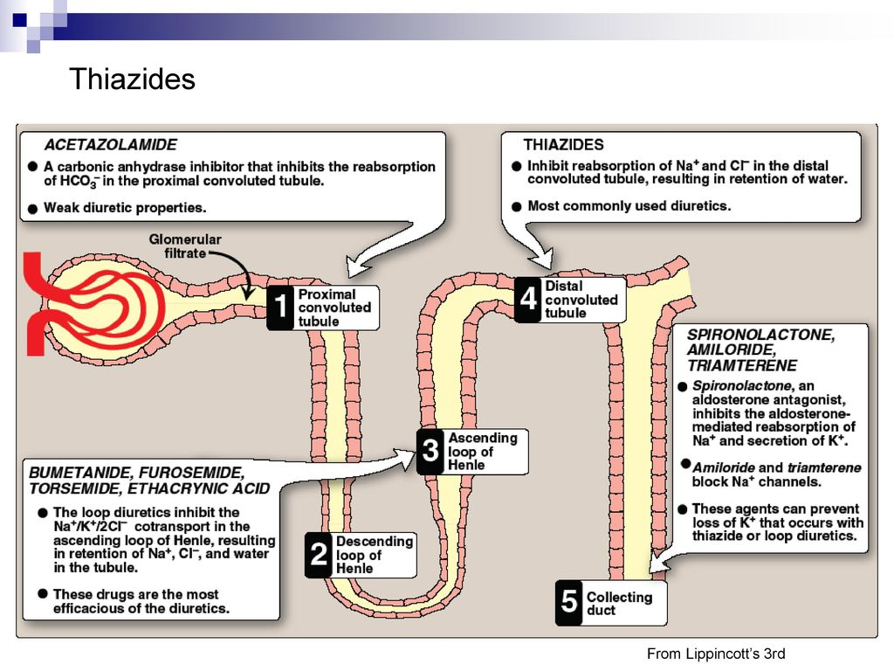

**Site of different diuretics action with examples drugs الشكل للحفظ مع اسماء الادوية**

**Normal Sympathetic control for blood pressure (Baroreceptor Reflex)**

(1) Baroreceptors in the aortic arch and carotid sinus sense BP and relay this information to the brainstem.

(2) When BP is perceived as too low, the brainstem sends impulses along sympathetic nerves to stimulate the heart and blood vessels.

(3) BP is then elevated by (a) activation of beta1 receptors in the heart, resulting in increased cardiac output; and (b) activation of vascular alpha1 receptors, resulting in vasoconstriction.

(4) When BP has been restored to an acceptable level, sympathetic stimulation of the heart and vascular smooth muscle subsides.

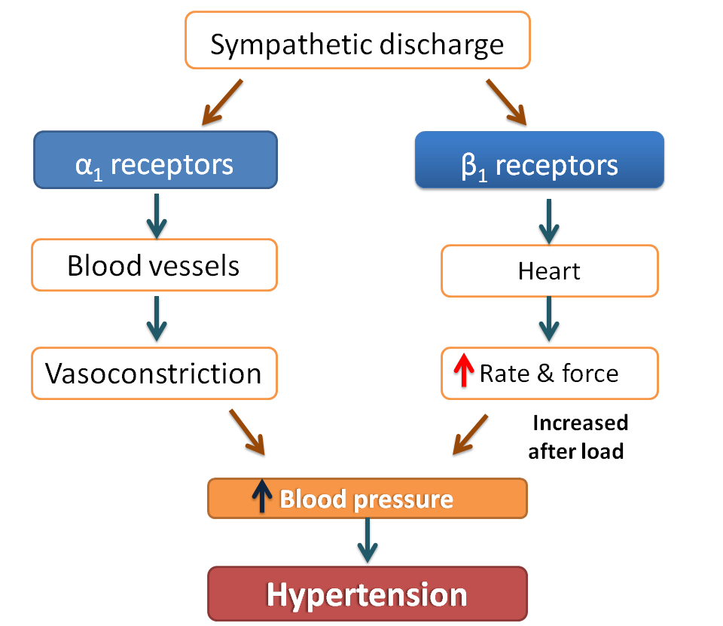

**Scheme diagram for The effects of sympathetic system activation on blood pressure control الشكل مطلوب للرسم**

**Sympatholytics (Antiadrenergic Drugs)**

Sympatholytic drugs suppress the influence of the sympathetic nervous system on the heart, blood vessels, and other structures. These drugs are used widely for hypertension.

As indicated in Table there are four subcategories of sympatholytic drugs:

(1) Beta blockers,

(2) Alpha1 blockers,

(3) alpha/beta blockers,

(4) Centrally acting alpha2 agonists,

**Beta-Adrenergic Blockers**

β-Blockers are a treatment option for hypertensive patients with concomitant heart disease or heart failure .

* **Non selective β-blocker** : propranolol [proe PRAN-oh-lol], which acts at both β1 and β2 receptors.
* **Selective blockers of β1 receptors**, such as **Metoprolol , Atenolol & Nebivolol** are among the most commonly prescribed β-blockers.
* **Propranolol & Metoprolol** are among the most widely used antihypertensive drugs **المعلومات التالية تخص اي من الدوائين اعلاه**
* **A-Class & subclass**: Beta-Adrenergic Blockers
* **Mechanism of Action :** The beta blockers have at least four useful actions in hypertension.

1- Blockade of cardiac beta1 receptors decreases heart rate and contractility, thereby causing cardiac output to decline.

2- Beta blockers can suppress reflex tachycardia caused by vasodilators.

3- Blockade of beta1 receptors on juxtaglomerular cells of the kidney reduces release of renin, thereby reducing angiotensin II–mediated vasoconstriction and aldosterone-mediated volume expansion.

4-Long-term use of beta blockers reduces peripheral vascular resistance—by a mechanism that is unknown. This action could readily account for most of their antihypertensive effects.

**Therapeutic uses & Adverse effects**

**Adverse effects**

Beta blockers can produce a variety of adverse effects as :

* **Cardiac effects** : bradycardia, decreased atrioventricular (AV) conduction, and reduced contractility.
* **CNS effects**  : In addition , beta blockers can cause depression, insomnia, bizarre dreams
* **Hyperglycemia :** Beta blockers can mask signs of hypoglycemia, and therefore must be used with caution in patients with diabetes.
* **The β-blockers may decrease libido and cause erectile dysfunction, which can severely reduce patient compliance.**

**Q/ The nonselective β-blockers are contraindicated in patients with asthma?**

Due to their blockade of β2-mediated bronchodilation so selective β-blockers may be administered to hypertensive patients who also have asthma.

**Used with caution** : must be used with care in patients with heart failure. Blockade of beta2 receptors in the lung can promote bronchoconstriction. Accordingly, beta blockers should be avoided by patients with asthma.

**Drug withdrawal** : Abrupt withdrawal may induce angina, myocardial infarction, and even sudden death in patients with ischemic heart disease. Therefore, these drugs must be tapered over a few weeks in patients with hypertension and ischemic heart disease.

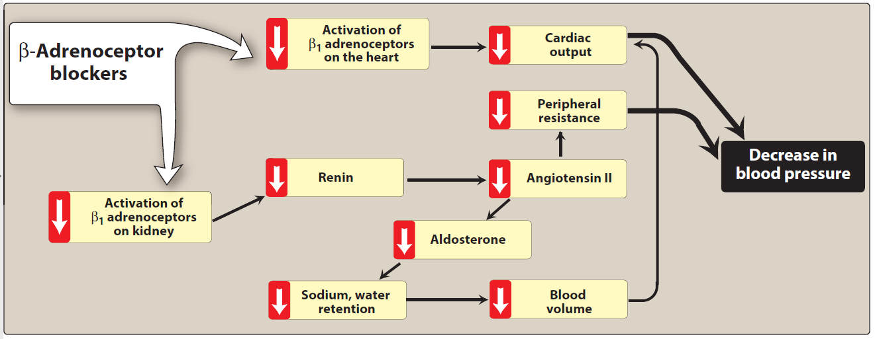

**Scheme diagram for Actions of B-receptor blockers in hypertension therapy الشكل مطلوب للرسم**

**Alpha/Beta Blockers:**

* **Carvedilol and Labetalol. المعلومات التالية تخص اي من الدوائين اعلاه**
* **Class & subclass** : Alpha/Beta Blockers , Sympatholytics Antihypertensive
* **mechanism of action** : Carvedilol and labetalol are unusual in that they can block alpha1 receptors as well as beta receptors. Blood pressure reduction results from a combination of actions:

(1) alpha1 blockade promotes dilation of arterioles and veins

(2) blockade of cardiac beta1 receptors reduces heart rate and contractility

(3) blockade of beta1 receptors on juxtaglomerular cells suppresses release of renin.

Presumably, these drugs also share the ability of other beta blockers to reduce peripheral vascular resistance.

* **Theraputic uses & adverse effects**

Therapeutic uses for hypertension and heart diseases ( Angina, Myocardial infarction )

**Adverse effects** : Like other nonselective beta blockers, labetalol and carvedilol can exacerbate bradycardia, AV heart block, and asthma. **Blockade of venous alpha1 receptors can produce postural hypotension.**

**Alpha1 Blockers**

* **Doxazosin & Terazosin المعلومات التالية تخص اي من الدوائين اعلاه**
* **Class & subclass :** direct Alpha1 Blockers , sympatholytic Antihypertensive
* **Mechanism of action :** The alpha1 blockers prevent stimulation of alpha1 receptors on arterioles and veins, thereby preventing sympathetically mediated vasoconstriction. The resultant vasodilation reduces both peripheral resistance and venous return to the heart.
* **Therapeutic uses & Adverse effects : Antihypertensive**

The most disturbing side effect of alpha blockers is orthostatic hypotension.( postural hypotension )

**Centrally Acting Alpha2 Agonists**

* **Clonidine & Methyldopa**
* **A-Class & subclass :** Centrally Acting Alpha2 Agonists
* **Mechanism of action** : These drugs act centrally as an α2 agonist to produce inhibition of sympathetic vasomotor centers within the brainstem suppress sympathetic outflow to the heart and blood vessels, leads to reduced total peripheral resistance and decreased blood pressure.

The result is vasodilation and reduced cardiac output, both of which help lower BP.

* **Therapeutic uses & Adverse effects** :

In early time Therapeutically used for hypertensive therapy but now is less commonly used , Clonidine is used primarily for the **treatment of hypertension that has not responded adequately** to treatment with other drugs.

Note/ Clonidine does not decrease renal blood flow or glomerular filtration and, therefore, is useful in the treatment of hypertension complicated by renal disease .

**Adverse effects** : All central alpha2 agonists can cause dry mouth and sedation. In addition, clonidine can cause severe rebound hypertension if treatment is abruptly discontinued.

**Q/ Clonidin should, therefore, be withdrawn slowly if discontinuation is required ?**

A/ To avoid the unwanted effect of rebound hypertension that may occur if the drug withdrawn suddenly .

**NOTE / Methyldopa** use is limited due to adverse effects and the need for multiple daily doses. It is mainly used for **management of hypertension in pregnancy**, where it has a record of safety

**Calcium Channel Blockers**

**The physiological role of calcium channels in heart & blood vessels**

Calcium enters muscle cells through special voltage-sensitive calcium channels. This triggers release of calcium from the sarcoplasmic reticulum and mitochondria, which further increases the cytosolic level of calcium, **The intracellular concentration of calcium plays an important role in maintaining the tone of smooth muscle of blood vessels and in the contraction of the myocardium.**

**Calcium-channel Antagonists block the inward movement of calcium** in the heart and in smooth muscle of the coronary and peripheral vasculature. This causes vascular smooth muscle to relax, dilating mainly arterioles & reducing heart contraction .

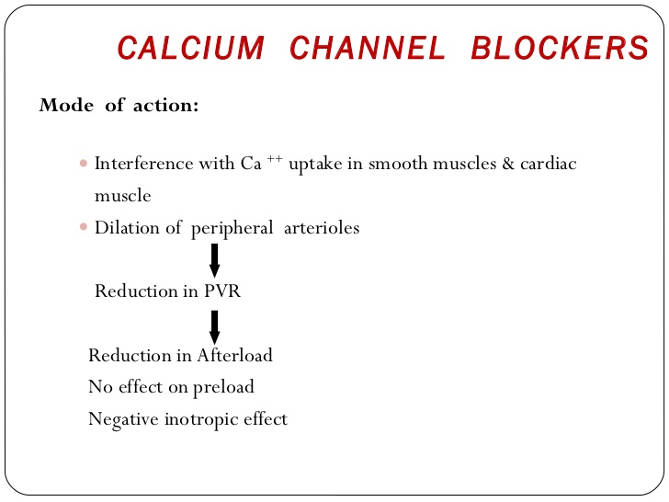

**Scheme diagram for action of Ca++ channel blockers in hypertension الرسم مطلوب للحفظ**

**The calcium channel blockers (CCBs) fall into two groups:**

**A- Dihydropyridines:**  This rapidly expanding class of calcium-channel blockers includes :

* **The first-generation agents : Nifedipine**
* **second-generation** **agents**: **Amlodipine, Felodipine**

**B- Non-dihydropyridines :**

* **Verapamil**
* **Diltiazem**
* **Dihydropyridines** : ( **Nifedipine , Amlodipine, Felodipine )**

**المعلومات التالية تخص اي من الادوية اعلاه**

* **CLASS :**  Dihydropyridines , calcium channel blockers
* **Mechanism of action**: Calcium-channel antagonists block the inward movement of calcium by **binding to L-type calcium channels** in the heart and in smooth muscle of the coronary and peripheral vasculature ( much greater affinity for vascular calcium channels than for calcium channels in the heart) . This causes vascular smooth muscle to relax, dilating mainly arterioles.
* **Therapeutic Drugs** in both groups promote **dilation of arterioles**.

These agents differ in pharmacokinetics, approved uses, and drug interactions.

All dihydropyridines have a much greater affinity for vascular calcium channels than for calcium channels in the heart. They are, therefore, particularly beneficial in treating hypertension.

**B- Non-dihydropyridines :**

* **Verapamil**
* **Diltiazem**

**المعلومات التالية تخص اي من الدوائين اعلاه**

* **Class :** Non-dihydropyridines, calcium channel blockers
* **Mechanism of action:** Calcium-channel antagonists block the inward movement of calcium by binding to L-type calcium channels in the heart and in smooth muscle of the coronary and peripheral vasculature ( much greater affinity for cardiac calcium channels than for vascular calcium channels) . so , **verapamil and diltiazem have direct suppressant effects on the heart.**
* **Therapeutic uses & Adverse effects**  : These agents are useful in the treatment of hypertensive patients who also have asthma, diabetes, angina, and/or peripheral vascular disease.

**Adverse effects** :

* Like other vasodilators, CCBs can cause **reflex tachycardia**. This reaction is greatest with the dihydropyridines and minimal with verapamil and diltiazem, Reflex tachycardia is low with verapamil and diltiazem because of cardio suppression . Since dihydropyridines do not block cardiac calcium channels, reflex tachycardia with these drugs can be substantial.
* Constipation occurs in 10 percent of patients treated with verapamil.
* Dizziness, headache, and a feeling of fatigue caused by a decrease in blood pressure are more frequent with dihydropyridines (Figure 19.13).

**Cautions & precautions**

* Verapamil should be avoided in patients with **congestive heart failure** or with **atrioventricular block** due to its negative inotropic (force of cardiac muscle contraction) and dromotropic (velocity of conduction) effects.
* Because of their ability to compromise cardiac performance, verapamil and diltiazem must be used cautiously in patients with **bradycardia, heart failure, or AV heart block**. These precautions do not apply to dihydropyridines ( nifidipines ) .
* The rapid-acting formulation of **nifedipine** has been associated with increased mortality in patients with **MI and unstable angina.**

Note: As a result, the National Heart, Lung, and Blood Institute has recommended that rapid-acting nifedipine be used with great caution.

High doses of short-acting calcium channel blockers should be avoided because of increased risk of myocardial infarction due to excessive vasodilation and marked reflex cardiac stimulation.

**Direct-Acting Vasodilators**

* **Hydralazine and Minoxidil**
* **Class & subclass** : Direct-Acting Vasodilators
* **Mechanism of action** : Hydralazine and minoxidil reduce BP by promoting dilation of arterioles. Neither drug causes significant dilation of veins. Because venous dilation is minimal, the risk of orthostatic hypotension is low. With both drugs,
* **Therapeutic uses & Adverse effects** : lowering of BP may be followed by reflex tachycardia, renin release, and fluid retention. Reflex tachycardia and release of renin can be prevented with a beta blocker. Fluid retention can be prevented with a diuretic.

The most disturbing adverse effect of **hydralazine is a syndrome resembling systemic lupus erythematosus (SLE).** Fortunately, this reaction is rare at recommended doses.

If an SLE–like reaction occurs, hydralazine should be withdrawn. Hydralazine is considered a third-choice drug for chronic hypertension.

**Minoxidil** is substantially more dangerous than hydralazine. By causing fluid retention, minoxidil can promote pericardial effusion (accumulation of fluid beneath the myocardium) that in some cases progresses to cardiac tamponade (compression of the heart).

A less serious effect is hypertrichosis (excessive hair growth). Because of its capacity for significant harm, minoxidil is not used routinely for chronic hypertension. Instead, the drug is reserved for patients with severe hypertension that has not responded to safer drugs.

**Anti-hypertensive drugs Combination therapy**

**Q/ Advantages of Combination therapy in hypertension ?**

A/ Initiating therapy with two antihypertensive drugs should be considered in patients with blood pressures that are more than 20/10 mm Hg above the goal.

fixed-dose combination pill may lower blood pressure more quickly with minimal adverse effects.

A variety of combination formulations of the various pharmacologic classes are available to increase ease of patient adherence to treatment regimens that require multiple medications to achieve the blood pressure goal.

**Individualized care**

Hypertension may coexist with other conditions that can be aggravated by some of the antihypertensive drugs or that may benefit from the use of some antihypertensive drugs independent of blood pressure control. In such cases, it is important to match antihypertensive drugs to the particular patient.

Figure 16.6 shows preferred therapies in hypertensive patients with concomitant diseases. In addition to the choice of therapy, blood pressure goals may also be individualized based on concurrent disease states and age

حفظ الجدول للربط بين الامراض المزمنة وافضل دواء لعلاج الضغط لدى المريض 