LEC. 1 Pharmacology Dr. Ihab Alkhalifa
Introduction to CNS Pharmacology

The CNS [brain and spinal cord (SC)] can be divided into its anatomical areas or its physiological functions, both of which our knowledge base of the entire system is not complete.
Definitions
• CNS Pharmacology : The study of the drugs that can affect the brain and their varied mechanisms of action (MOA) how drugs alter brain activity and offset pathology.
• Neuropharmacology: how drugs act on neurons at cellular/molecular level.
• Psychopharmacology : how drugs modify behavior, perception, affect and thought.

Cells forming CNS
• Neuron : functional unit of the nervous system , specialized cell responsible for nerve impulse production & transmission

الشكل للاطلاع
- Neuroglia : supporting cells for neuron , classified as :
– CNS cells : Astrocytes, Microglia , Oligodendrocytes & Ependymal cells
– PNS cells : satellite cells , Schwann cells

الشكل للاطلاع
Neurotransmission Systems
• Neurons function through communication networks that may be called neurotransmission systems,
• The major elements of neurotransmission systems;
- Neurotransmitters , synapses, and receptors.
their interaction promotes order or disorder in the body’s physical and mental processes.

Synapse: The effects of MOST therapeutically important CNS drugs are exerted mainly at synapse; possible mechanisms are:
A. Presynaptically : drugs act presynaptically to alter the
synthesis, storage, release, reuptake, or metabolism of transmitter chemicals.

B. Pre-post synaptic receptors: Other drugs activate or block of pre-post synaptic receptors

Neuronal action potential
In an unstimulated or Resting cell, a slight accumulation of negative charges (–) on the internal surface of the plasma membrane is attracted to an equal number of positive charges (+) that have accumulated on the external surface of the membrane.
Therefore, all cells at rest are electrically polarized ; that is, the inside of the cell is slightly negative relative to the outside.
This separation of charge across the plasma membrane is referred to as the membrane potential.
The membrane potential under resting conditions is negative.
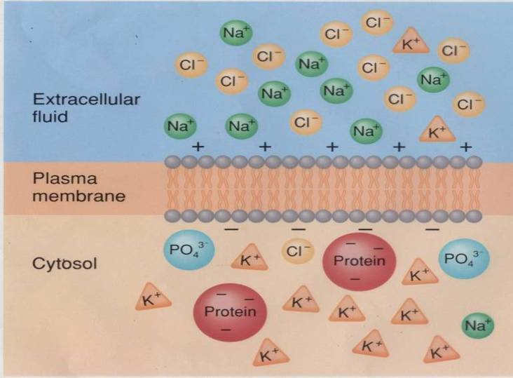
FIG . Resting membrane states الشكل للاطلاع

Neuronal Action potential phases
The changes in membrane conductance of Na⁺ and K⁺ that occur during the action potentials are shown in previous Figure .
A- Resting state: constant potential occur with the inside negative relative to the outside of the cell at rest. In neurons, the resting membrane potential is usually about –70 mV.
B- Depolarization phase : when Depolarizing stimulus lead to opening of some of the voltage-gated Na⁺ channels become active, and when the threshold potential is reached, the voltage-gated Na⁺ channels overwhelm the K⁺ and other channels , an action potential results (a positive feedback loop ). The membrane potential moves toward the equilibrium potential for Na ⁺ (+60 mV) .
C- Repolarization phase : involve the opening of voltage-gated K⁺ channels. increase in K⁺ conductance comes after the increase in Na⁺ conductance. The net movement of positive charge out of the cell due to K⁺ efflux at this time helps complete the process of repolarization.
D- After-hyper polarization (overshoot) : The slow return of the K⁺ channels to the closed state also explains the after-hyper polarization, followed by a return to the resting membrane potential,
Thus, voltage-gated K + channels bring the action potential to an end and cause closure of their gates through a negative feedback process.

FIG. Action potential phases الشكل للحفظ

What Happens to the Frequency of Action Potentials If the Membrane Gets Hyperpolarized?
Answer : Frequency of activation decreases
Remember that it is the rate of action potential propagation that determines neurologic function, – Determined by frequency of action potentials, Hyperpolarization decrease seizure (multiple action potential ) activity in the brain so drugs used for seizure & epilepsy act by this mechanism.

Ion channels and receptors types in the CNS
Ion channels are of two major types: Voltage & Ligand gated
1. Voltage gated : direct receptors regulated by changes in membrane potential activated by some transmitters as ACH effect on nicotinic receptors , GABA , Glutamate & Glycine .
Such receptors activated by 2 steps :
i) Axonal Na+ channels involved in propagation of action potentials
ii) Presynaptic Ca+2 channels that play a critical role in the
release of neurotransmitters from synaptic vesicles.
These receptors called ( ionic receptors )

الشكل للحفظ mechanism of ionic receptor activation steps

II. Ligand (transmitter) gated, Such receptors may be:
Indirectly activated by change ion channel function via second messenger system G- Protein cAMP, IP3, DAG, coupled receptors ( metabotropic receptors )
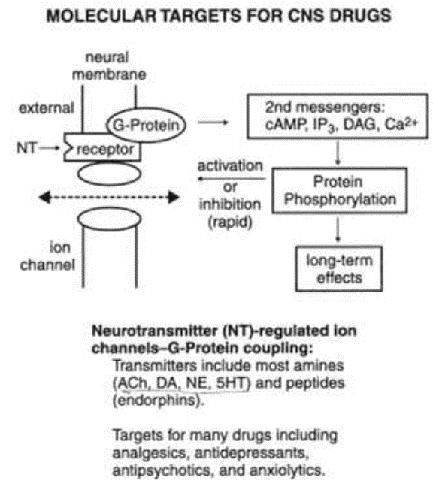

Mechanism of metabotropic or G-Protein coupled receptor activation steps الشكل للحفظ

Excitatory & Inhibitory Action potential
IPSP | EPSP
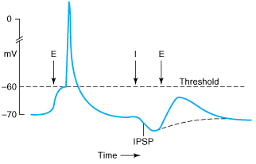 | 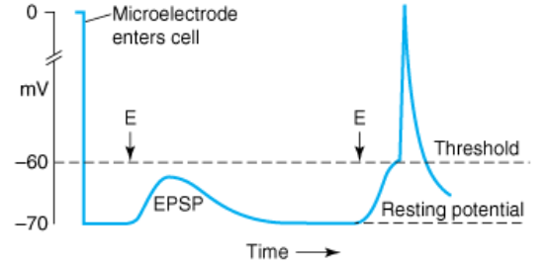
Inhibitory postsynaptic potential (IPSP): a hyperpolarizing potential change are usually generated by the opening of K+, or Cl- channels  ii) Presynaptic inhibition can occur via a ↓ Ca+2 influx or ↑Cl- or ↓ Ca+2 influx or ↑ K+ efflux → inhibition via membrane hyperpolarization (IPSP) | Excitatory post synaptic potential (EPSP) : a depolarizing potential change, are usually generated by the opening of Na+ or Ca+2 channels .
الجدول للحفظ
Neurotransmitters types, receptors & functions
Neurotransmitter : is a chemical released by one neuron that affects another neuron or an effector organ (e.g., muscle, gland, blood vessel).
Substance produced in the neuron (synthesized), contained and secreted by that neuron to transmit information to postsynaptic target.
Criteria Identifying Neurotransmitter
• Synthesis and storage in presynaptic neuron
• Released by presynaptic axon terminal upon stimulation
• binding to receptor : When experimentally applied, produces response in postsynaptic cell that mimics response produced by release of neurotransmitter from the presynaptic neuron
• Inactivation -a specific mechanism exists to remove the molecule from the synaptic cleft or to degrade it.
- undergo synaptic re-uptake from nerve ending
CENTRAL NEUROTRANSMITTERS
Neurotransmitters are chemical mediators which are released from nerve endings into the synaptic cleft once an action potential has been reached eliciting an influx of Ca++ ions (a voltage dependent action). The neurotransmitter then reaches it target postsynaptic receptor site with the result being either enhancing excitation or inhibition .
Neurotransmitters life cycle in nerve ending الشكل للحفظ
Neurotransmitters classification
- Biogenic amines:
- Norepinephrine (NE) : is chemical mediator which is released in relatively large amounts from nerve endings .
The Noradrenergic system: uses norepinephrine as its NT
• Location: located in hypothalamus and in certain zones of the limbic system (parts of amygdale & hippocampus)
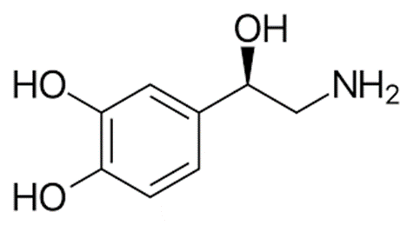
But is present in most brain regions (cerebral cortex, brain stem, cerebellum, and spinal cord) in lower amounts.
It is primarily an excitatory neurotransmitter but in selected areas in the CNS & PNS it has inhibitory effects.
• Function: Noradrenergic system is associated with – mood, wakefulness and alertness, reward, Arousal, Attention, Control mood
- Dysregulation : Functional deficiency contribute to psychological depression
- Adrenergic Receptors
Excitatory or inhibitory, depending on receptor subtype (second messenger coupling) :
1. Excitatory effects: α1 and β1 receptors : Activation of α1, β1, and β2 receptors: thought to stimulate activity of intracellular adenyl cyclase and the production of cAMP.

2. Inhibitory effects: α2 and β2 receptors
• Activation of α2 receptors on the presynaptic nerve ending : associated with inhibition of adenyl cyclase activity and decreased production of cAMP, regulate norepinephrine release.

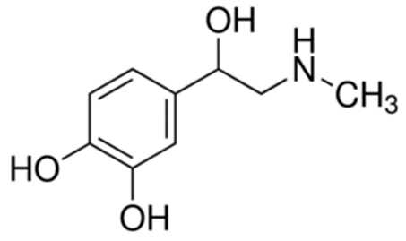
- Epinephrine (EP) : is chemical mediator which is released from neurons found in medullary reticular formation with some connections to the thalamus.
Also found in periaqueductal gray area and spinal cord.

- Dopamine : is precursor of norepinephrine. Approximately ½ of CNS content of catecholamines is dopamine with large amounts in the basal ganglia , amygdala, limbic system, and certain areas of the frontal cortex.
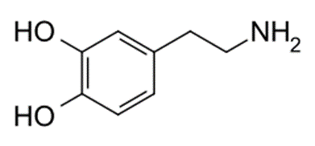
The dopaminergic system Uses dopamine as its NT.
• Function: Dopamine is important in;
− Motor control (Parkinsonism is due to dopamine deficiency),
− Behavioral effects (excessive dopamine activity is implicated in schizophrenia),
− Hormone release (inhibits prolactin secretion) and Chemoreceptor trigger zone causes nausea and vomiting.
- Dopamine receptors :
There are 5 dopamine receptor subtypes:
Two groups of dopamine receptors have been identified D1 and D5 receptors, activate adenyl cyclase to produce cAMP.

• The other group includes D2, D3, and D4 receptors , some of them inhibit activation of adenyl cyclase, other suppress calcium ion currents, and activate potassium ion currents.

Dopamine life cycle الشكل للحفظ

الشكل للاطلاع
- Serotonin (5-hydroxytryptamine or 5-HT)- : is primarily an inhibitory neurotransmitter. found in hypothalamus, limbic system, cerebellum, , cerebral cortex,
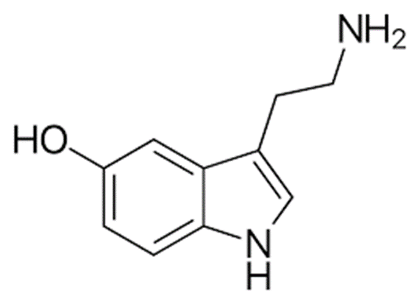
Location : Serotonin-synthesizing neurons widely distributed in the CNS, beginning in the midbrain (raphe nuclei) and projecting into the thalamus, hypothalamus, cerebral cortex, and spinal cord.
It is found in the highest concentration in platelets and the GI tract.
The serotonergic system:
• uses serotonin (5-hydroxytryptamine or 5-HT) as its NT.
•– synthesized from the amino acid tryptophan.
• function : Serotonin in CNS is associated with, Mood, Arousal (sleep–wake cycle), emotional behavior, temperature regulation, inhibition of pain pathways in the spinal cord.
Receptors : There are 14 receptor subtypes each of which is composed of a further set of subtypes.
Many types and sub types : 5-HT (1 – 7) , Mostly metabotropic
Except 5-HT3, ionotropic.

Serotonin life cycle (synthesis , release & binding ) الشكل للحفظ

- The cholinergic system & Cholinergic transmitters :
• Uses acetylcholine (Ach) as its NT .
– the first substance to be designated as a NT in the CNS.
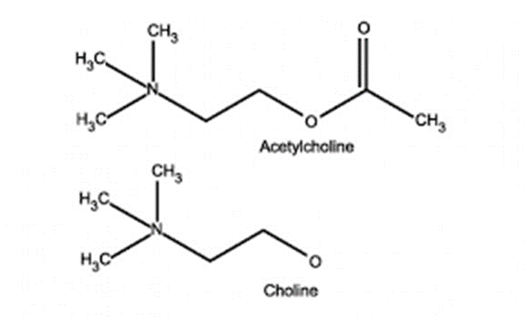
• Located in many areas of the brain, especially high concentrations in the motor cortex and basal ganglia.
In the CNS, acetylcholine is associated with, arousal, learning, memory, motor conditioning, and speech.
• Exerts excitatory effects at synapses and NMJs and inhibitory effects at some sites in the PNS
• Dementia and Parkinsonism is associated with abnormalities in cholinergic pathways.
- Amino acids Transmitters : Amino acids were recognized as NTs relatively recently, their roles and functions in this regard have not been completely elucidated.
Aspartate and glutamate are considered the major fast acting,
excitatory NTs in the brain.
- Aspartate: is an excitatory NT found in high concentrations in the brain mainly in the visual cortex.
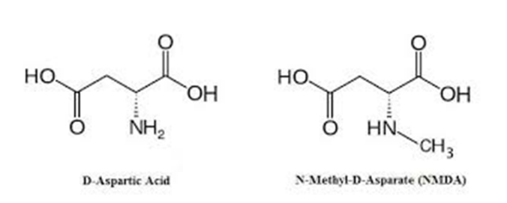
- Glutamate : is major excitatory neurotransmitter found in cerebral cortex and brain stem.

Function : plays a role in memory & learning
Overstimulation causes excitotoxicity that may result in cell death.
Receptors: Several subtypes of glutamate receptors have been identified, The functions of these receptor subtypes have not been fully established.
• NMDA glutamate receptor subtype ; The NMDA receptor is so named because the agonist molecule N-methyl-D-aspartate (NMDA) binds selectively to it, not to other glutamate receptors . Activation of NMDA receptors results in the opening of an ion channels (ionic receptor)

- Most common inhibitory and excitatory neurotransmitters in CNS are GABA & Glycine
1-Gamma-aminobutyric acid (GABA) : is major inhibitory mediator of the CNS
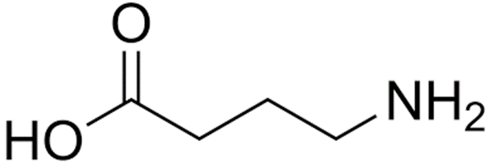
The GABA-ergic system
– uses GABA as its neurotransmitter
Location : Found in virtually every region of the brain in basal ganglia, cerebellar Purkinje, cerebral cortex, and certain interneurons in spinal cord.
• Receptors: GABA receptors- two main types, A and B.
• GABAA receptor: – a chloride ion channel that opens when GABA is released from presynaptic neurons –
• GABAB receptor: – GABA-B (a G-protein coupled receptor).
Function : Activation of theses receptors causes hyperpolarization & reduce CNS activity example drugs affecting this receptor are Benzodiazepines ( BZD) anxiolytic & hypnotics
2-Glycine: is an inhibitory NT found in the brain stem and spinal cord

GABA , life cycle (synthesis release & receptor binding) الشكل للحفظ
CNS amino acid transmitters balance for normal transmission

Other Non- neurotrasmiters mediaters

- Neuropeptides (polypeptides)
a. substance P
b. vasopressin
c. oxytocin
d. somatostatin
e. glucagons
f. angiotensin II
g. atrial natriuretic peptide
h. enkephalins
i. endorphins

- purine nucleotides
a. adenosine
b. ATP
ACTIONS OF DRUGS IN THE CNS
Drugs acting in the central nervous system (CNS) were among the first to be discovered by primitive humans and are still the most widely used group of pharmacologic agents.
These agents are invaluable therapeutically, e.g., without general anesthetics, modern surgery would be impossible.

The drugs that selectively modify CNS function specifically in which the drug binds to a target cell’s receptors and affects an identifiable intracellular mechanism and imparts a specific therapeutic action , theses Drugs that act with directly to give specific effect within the CNS include :
- Anticonvulsants
- Antiparkinsonian agents
- Opioid & nonopiod analgesics
- Antidepressants
- Anti- psychotic & Antimanic agents
- Sedatives & hypnotics.

Toxicity of drugs
In addition to their use in therapy, many drugs acting on the CNS are used without prescription to increase one's sense of well-being.
• However, the excessive use of such drugs can affect lives adversely?!
when their uncontrolled, compulsive use leads to:
1. Physical dependence on the drug
2. Toxic side effects, including lethal overdosage.

