**Cellular Metabolism**

**Cellular metabolism** is the set of chemical reactions that occur in living organisms in order to maintain life. Cellular metabolism involves complex sequences of controlled biochemical reaction. These processes allow organisms to grow and reproduce, maintain their structures, and respond to environmental changes.

Metabolic pathway is divided to:

**Catabolism**: chemical reaction that breaks down a large compound into smaller units.

**Anabolism**:chemical reaction in which build more complex molecules from smaller ones.

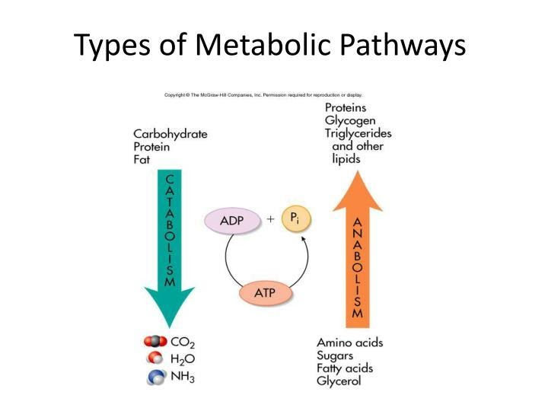

Organisms can be classified according to how they obtain energy:

**1.Autotrophs__ self-feeders:**  they get their energy from non-living sources such as the sun and carbon dioxide. Autotrophic are called producers because they provide energy and food sources for all heterotrophic organisms. Autotroph can be classified to:

_ **Photoautotrophs:** get their energy from sunlight and convert it into usable energy (sugar) by photosynthesis. During the process of photosynthesis, not only is sunlight turned into energy, but carbon dioxide is taken from the air and oxygen is released in its place. Because animals depend on this oxygen to breath.

_**Chemoautotrophs**: get their energy from oxidation inorganic materials,such as hydrogen sulfide and ammonia. For example , iron bacteria (*Thiobacillus ferooxidants)* and sulfur bacteria (*Thiobacillus thiooxidants*) and Nitrobacter.

2.**Heterotrophs_fedding on others:** Heterotrophs obtain energy by oxidation of organic compounds(carbohydrates.lipids,or protein).

Heterotrophs depends on autotrophs for these organic compounds.

**Oxygen**

Living organisms can obtain energy from the atmosphere or from water, according to this, organisms can be classified to:

* **Aerobes**: live in the presence of oxygen. They use oxygen to oxidize organic nutrients.
* **Anaerobes**:live in the absence of oxygen. Catabolize nutrients without molecular oxygen.
* **Obligate anaerobes**: are poisoned by oxygen, like bacteria (Clostridium) and fungus (piromonas).
* **Facultative**: Some organisms can live in either aerobic or anaerobic conditions. Like yeast and E.coli.

**Meaning of some abbreviation**

* **ATP** consists of adenosine (adenine+ ribose) and triphosphate group. The bonds between the phosphate groups are highly energy bonds.A-P~P~P, it is a highly energy compound that is the main direct fuel that cells use to molecule synthesis, muscule contract and transport substances and other tasks, ATP (A-P~P~P)                 ADP (A-P~P)

                 AMP (A-P).

* **GTP**: Guanosine tri phosphate, high energy compound, similar to ATP, but with three phosphate groups linked to guanosine.

* **NAD Nicotinamide adenine dinucleotide**: is a coenzyme found in all living cells and derived from B vitamin niacin, acts as an electron carrier in cell and undergo reversible oxidation and reduction.

* **NADP+ Nicotinamide adenine dinucleotide phosphate:** differs from NAD+ in the presence of an additional phosphate group on the 2 position of the ribose ring that carriers the adenine moietry

* **NADH: reduction form of NAD+**

* **NADPH: is the reduced form of NADP+**

* **CoA: cofactor derived from vit.B pantothenic**

* **Acetyl Co A:** reaction remove one carbon from three carbonate pyruvate adds CoA.

* **FDA: Flavin adenine dinucleotide**

* **FADH2:** the reduce form of **FAD** , this coenzyme derived from B vitamin riboflavin, acts as an electron carrier in cell and undergo reversible oxidation and reduction

**Photosynthesis**

Photosynthesis is take place in two stages:

**A-Light reaction (light dependent reaction)**

* Capturing energy from sunlight
* Using the energy to make ATP and reducing power in the form of a compound called NADPH
* The reactions of light take place within thylakoid membranes within chloroplast in leaf cell.
* Light +H2O               ATP+NADPH+O2

**B –Dark reaction (light independent reaction or Calvin cycle)**

Using the ATP and NADPH to power the synthesis of organic molecules (chemical energy stored briefly in ATP and NADPH eventually stored in glucose). It takes place in the stroma of chloroplasts.

ATP+ NADPH+CO2              sugars

The following simple equation summarizes the overall process of photosynthesis

**6CO2+12 H2O +light                    C6H12O6+ 6H2O+6O2**

**Carbon dioxide                                  glucose    water    oxygen**

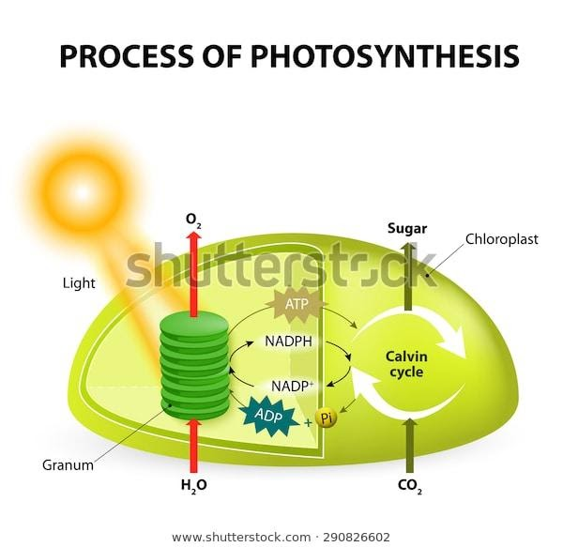

**Extracting Energy from Glucose**

For obtaining energy from glucose by aerobic pathway , four major metabolic pathways must be occurring**: Glycolysis , conversion pyruvic acid to Acetyl CoA,citric acid cycle and the electron transport chain**.

**1. Glycolysis**

**It first stage in cellular respiration.**

* A series of enzyme catalyzed reactions.
* Glucose converted to pyruvic acid.
* 2 ATPs made per one glucose molecule plus 2 NADH molecules which carry high energy electron to the electron transport chain for production ATP
* All living organisms use glycolysis, aerobic and anaerobic respiration.
* Glycolysis takes place in the cytosol.
* Summary of the enzymatically catalyzed reactions in glycolysis

**Glucose +2ADP+2P+2 NAD˖              2 Pyruvic acid +2 NADH+ 2ATP**

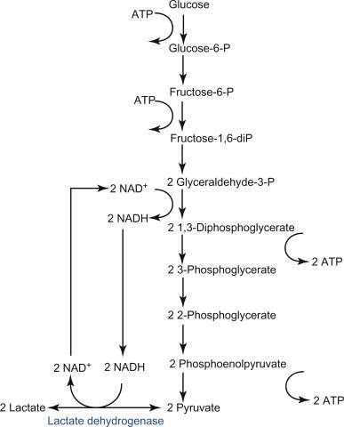

**2.Conversion pyruvic acid to Acteyl CoA**

**It occurring in the mitochondria**

1. **When oxygen is available (Aerobic pathway)**

Each pyruvate molecules formed from glucose yield one molecule of Acetyl Co A, one CO2 and NADH (which used in ATP production)

**2.When oxygen is not available (Anaerobic pathway)**

* Pyruvate is formed lactate
* Lactate is alternative fuel that muscle cells can use or the liver can converted it to glucose
* When oxygen is become available, lactate is converted back to pyruvate, then ,to Acetyl Co A.

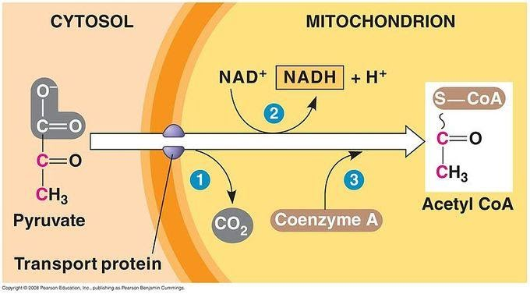

In aerobic respiration , approximately 2900 KJ of energy is released when one mole of glucose is broken down.

Glucose +6O2                                     CO2+H2O+energy (2900KJ)

In glycolysis , glucose is broken down to pyruvic acid, and two ATP molecules are generated even through oxygen is not present, During anaerobic respiration, pyruvic acid is converted to lactic acid.

Or, in the liver, gluconeogenesis occur (gluconeogenesis reverses glucolysis) by converting lactate first into pyruvate, and finally back to glucose. The glycose is then supplied to the muscles through the bloodstream; it is ready to fed into further glycolysis reactions. If muscle activity has stopped, the glucose is used to replenish the supplies of glycogen through glycogenesis.

Creatine phosphate, a highly-energy molecules stored in muscle cells, transfers its high-energy phosphate group to ADP to form ATP. The creatine phosphate in muscle cells is able to generate enough ATP to maintain contraction for about 15 seconds.

Phosphocreatine +ADP                       ATP +creatine +energy

Phosphocreatine (Pce): molecule that serves as a rapidly mobilizable reserve of high energy phosphates in skeletal muscle and the brain, it synthesize from amino acids in the liver and transported to the muscle cells, via the bloodstream, for storage. Phosphocreatine can anaerobically donate a phosphate group to ADP to form ATP during the first 2 to 7 seconds following an intense muscular or neuronal effort.

With the presence of oxygen ,pyruvic acid can enter the mitochondria, if muscle contraction continuous, aerobic respiration (slower but high ATP-producing pathway) begins and produces large amountd of ATP as long as is available. Eventually, oxygen is depleted, and aerobic respiration stops. ATP production by anaerobic respiration may still support some further muscle contraction and can supply ATP for about 30 seconds, some of the lactic acid stays in the muscle, and some goes back out into the blood or to liver, but the accumulation of lactic acid from anaerobic respiration and the depletion of resources (ATP,oxygen and glycogen) lead to muscle fatigue , and muscle contraction stops.

RBCs contain no mitochondria, so there is. The RBC is highly dependent upon glucose as its energy source. ATP is obtained only from breakdown of glucose with the production of lactate (anaerobic glycolysis). Glucose is transported through RBC membrane by facilitated diffusion. One molecule of glucose yields 2 molecules of ATP by on anaerobic glycolytic pathway. In addition, 2 molecules of lactate are produced and transported to blood and in the liver it is converted to glucose.

Glucose                      2 Lactic acid +energy (120KJ/mol)

|  |  |
| --- | --- |
| **Aerobic** | **Anaerobic** |
| 1. **Oxygen present**   **2.Release more energy**  **3.produce Co2, water and energy**    **4.Glucose completely broken down**  **5.occur in mitochondria**  **6.it relatively slow** | 1. **Oxygen not present**      1. **Release less energy**      1. **Produce lactic acid and energy (muscle cell) or ethanol,CO2 and energy(yeast).**      1. **Glucose not completely broken down**      1. **Occur in cytoplasm**      1. **It relatively speeds** |

Anaerobic respiration also used by yeast cells which is referred to as fermentation as the following

Glucose                                2 Ethanol + 2 Carbon dioxide +Energy

**3. Citric acid cycle**

* Citric acid cycle tricarboxylic acid **(TCA)** cycle or the Krebs cycle is a series of chemical reactions used by all aerobic organisms to release stored energy through the oxidation of acetyl CoA.
* It occurring in mitochondria
* Final step of this cycle is oxaloacetate with 2 CO2, 3 NADH , 1 FADH2 and 1 GTP (converted to ATP in electron transport chain).

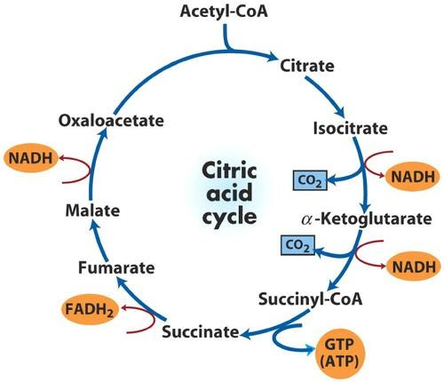

**4. Electron transport chain (or oxidation phosphorylation):**

* It need to Co enzyme and cytochrome which located in inner membrane of mitochondria.
* NADH molecules deliver pair of high electron energy electrons to beginning the chain, FADH2 also enter this pathway but it produce fewer ATP than electron pairs carried by NADH
* The final production are oxygen which react with hydrogen to form water and ADP to form ATP, it called oxidation phosphorylation
* Most ATP is produced here
* Scientists has estimated that electron pair from NADH produce 3ATP and those from FADH2 produce 2 ATP

The finally energy yielded from aerobic respiration about 36-38 ATP per glucose molecule.

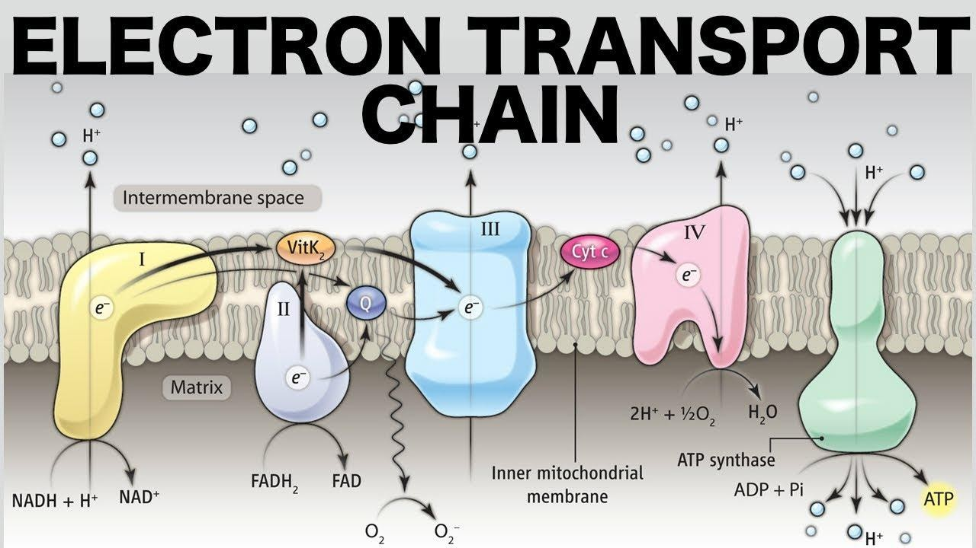

**Fat metabolism**

Whereas carbohydrates provide a readily available source of energy, lipids function primarily as an energy reserve. Lipids yield 9 Kcal of energy per gram while carbohydrates and proteins yield only 4 Kcal per gram. Lipid metabolism are involved with fatty acid oxidation to produce energy or the synthesis of lipids which is called **lipogenesis.**

**Protein metabolism**

it is the breakdown of proteins into amino acids and simple derivative compounds. The primary reason  for protein catabolism is so organisms can convert proteins into a form of energy that they can use or store. The first step of protein catabolism is breaking the protein down into amino acids by cleaving their peptide bonds, also known as proteolysis to convert it to other compounds via the krebs cycle.