Semiconductor
76 ■■■■■ Principles of Electronics
6
Diode

6.1 Semiconductor Diode
6.3 Resistance of Crystal Diode
6.5 Crystal Diode Equivalent Circuits
6.7 Crystal Diode Rectifiers
6.9 Output Frequency of Half-Wave Rectifier
6.11 Full-Wave Rectifier
6.13 Full-Wave Bridge Rectifier
6.15 Efficiency of Full-Wave Rectifier
6.17 Nature of Rectifier Output
6.19 Comparison of Rectifiers
6.21 Types of Filter Circuits
6.23 Half-Wave Voltage Doubler
6.25 Zener Diode
6.27 Zener Diode as Voltage Stabiliser
6.29 Crystal Diodes versus Vacuum Diodes

INTRODUCTION
I
t has already been discussed in the previous chapter that a pn junction conducts current easily when forward biased and practically no current flows when it is reverse biased. This unilateral conduction characteristic of pn junction (i.e. semiconductor diode) is similar to that of a vacuum diode. Therefore, like a vacuum diode, a semiconductor diode can also accomplish the job of rectification i.e. change alternating current to direct current. However, semiconductor diodes have become more *popular as they are smaller in size, cheaper and robust and usually operate with greater efficiency. In this chapter, we shall focus our attention on the circuit perfor-
mance and applications of semiconductor diodes.
* On the other hand, vacuum diodes can withstand high reverse voltages and can operate at fairly high temperatures.

Semiconductor Diode  77
  - Semiconductor Diode
A pn junction is known as a semi-conductor or *crystal diode.
The outstanding property of a crystal diode to conduct current in one direction only permits it to be used as a rectifier. A crystal diode is usually represented by the schematic symbol shown in Fig. 6.1. The arrow in the symbol indicates the direction of easier conventional current flow.
A crystal diode has two ter- minals. When it is connected
Fig. 6.1

– N P +
in a circuit, one thing to decide is whether the diode is forward or reverse biased. There is an easy rule to ascer- tain it. If the external circuit is trying to push the con-

ventional current in the direction of arrow, the diode is forward biased. On the other hand, if the conventional current is trying to flow opposite to arrowhead, the diode is reverse biased. Putting in simple words :
    - If arrowhead of diode symbol is positive w.r.t. bar of the symbol, the diode is forward biased.
    - If the arrowhead of diode symbol is negative w.r.t. bar, the diode is reverse biased.
Identification of crystal diode terminals. While using a crystal diode, it is often necessary to know which end is arrowhead and which end is bar. For this purpose, the following methods are available :
- Some manufacturers actually paint the symbol on the body of the diode e.g. BY127, BY114 crystal diodes manufactured by BEL [See Fig. 6.2 (i)].

Fig. 6.2
- Sometimes, red and blue marks are used on the body of the crystal diode. Red mark denotes arrow whereas blue mark indicates bar e.g. OA80 crystal diode [See Fig. 6.2 (ii)].

Crystal Diode as a Rectifier
Fig. 6.3 illustrates the rectifying action of a crystal diode. The a.c. input voltage to be rectified, the
diode and load RL are connected in series. The d.c. output is obtained across the load as explained in the following discussion. During the positive half-cycle of a.c. input voltage, the arrowhead becomes positive w.r.t. bar. Therefore, diode is forward biased and conducts current in the circuit. The result
is that positive half-cycle of input voltage appears across RL as shown. However, during the negative half-cycle of input a.c. voltage, the diode becomes reverse biased because now the arrowhead is negative w.r.t. bar. Therefore, diode does not conduct and no voltage appears across load RL. The
result is that output consists of positive half-cycles of input a.c. voltage while the negative half-cycles are suppressed. In this way, crystal diode has been able to do rectification i.e. change a.c. into d.c. It may be seen that output across RL is pulsating d.c.

* So called because pn junction is grown out of a crystal.

It is interesting to see that behaviour of diode is like a switch. When the diode is forward biased,
it behaves like a closed switch and connects the a.c. supply to the load RL. However, when the diode is reverse biased, it behaves like an open switch and disconnects the a.c. supply from the load RL. This switching action of diode permits only the positive half-cycles of input a.c. voltage to appear
across RL.
Fig. 6.3

Example 6.1. In each diode circuit of Fig. 6.4, find whether the diodes are forward or reverse biased.
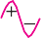

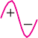

Fig. 6.4

Solution.
    - Refer to Fig. 6.4 (i). The conventional current coming out of battery flows in the branch circuits. In diode D1, the conventional current flows in the direction of arrowhead and hence this diode is forward biased. However, in diode D2,the conventional current flows opposite to arrowhead and hence this diode is reverse biased.
    - Refer to Fig. 6.4 (ii). During the positive half-cycle of input a.c. voltage, the conventional current flows in the direction of arrowhead and hence diode is forward biased. However, during the negative half-cycle of input a.c. voltage, the diode is reverse biased.
    - Refer to Fig. 6.4 (iii). During the positive half-cycle of input a.c. voltage, conventional current flows in the direction of arrowhead in D1 but it flows opposite to arrowhead in D2. Therefore, during positive half-cycle, diode D1 is forward biased and diode D2 reverse biased. However, during the negative half-cycle of input a.c. voltage, diode D2 is forward biased and D1 is reverse biased.

Semiconductor Diode  79
    - Refer to Fig. 6.4 (iv). During the positive half-cycle of input a.c. voltage, both the diodes are reverse biased. However, during the negative half-cycle of input a.c. voltage, both the diodes are forward biased.

Resistance of Crystal Diode
It has already been discussed that a forward biased diode conducts easily whereas a reverse biased diode practically conducts no current. It means that forward resistance of a diode is quite small as compared with its reverse resistance.
- Forward resistance. The resistance offered by the diode to forward bias is known as forward resistance. This resistance is not the same for the flow of direct current as for the changing current. Accordingly; this resistance is of two types, namely; d.c. forward resistance and a.c. forward resistance.
- d.c. forward resistance. It is the opposition offered by the diode to the direct current. It is measured by the ratio of d.c. voltage across the diode to the resulting d.c. current through it. Thus, referring to the forward characteristic in Fig. 6.5, it is clear that when forward voltage is OA, the forward current is OB.
OA
=
∴
d.c. forward resistance, Rf OB
- a.c. forward resistance. It is the opposition offered by the diode to the changing forward current. It is measured by the ratio of change in voltage across diode to the resulting change in current through it i.e.

a.c. forward resistance, rf
= Change in voltage across diode Corresponding change in current through diode

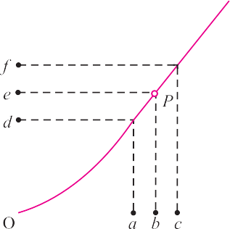
Fig. 6.5
Fig. 6.6
The a.c. forward resistance is more significant as the diodes are generally used with alternating
voltages. The a.c. forward resistance can be determined from the forward characteristic as shown in Fig. 6.6. If P is the operating point at any instant, then forward voltage is ob and forward current is oe. To find the a.c. forward resistance, vary the forward voltage on both sides of the operating point equally as shown in Fig. 6.6 where ab = bc. It is clear from this figure that :
For forward voltage oa, circuit current is od. For forward voltage oc, circuit current is of.

∴ a.c. forward resistance, r
= Change in forward voltage
= oc − oa
= ac

f Change in forward current of − od df
It may be mentioned here that forward resistance of a crystal diode is very small, ranging from 1 to 25 Ω.

- Reverse resistance. The resistance offered by the diode to the reverse bias is known as reverse resistance. It can be d.c. reverse resistance or a.c. reverse resistance depending upon whether the reverse bias is direct or changing voltage. Ideally, the reverse resistance of a diode is infinite. However, in practice, the reverse resistance is not infinite because for any value of reverse bias, there does exist a small leakage current. It may be emphasised here that reverse resistance is very large compared to the forward resistance. In germanium diodes, the ratio of reverse to forward resistance is 40000 : 1 while for silicon this ratio is 1000000 : 1.

Equivalent Circuit of Crystal Diode
It is generally profitable to replace a device or system by its equivalent circuit. An equivalent circuit of a device (e.g. crystal diode, transistor etc.) is a combination of electric elements, which when connected in a circuit, acts exactly as does the device when connected in the same circuit. Once the device is replaced by its equivalent circuit, the resulting network can be solved by traditional circuit analysis techniques. We shall now find the equivalent circuit of a crystal diode.
    - *Approximate Equivalent circuit. When the forward voltage VF is applied across a diode, it will not conduct till the potential barrier V0 at the junction is overcome. When the forward voltage exceeds the potential barrier voltage, the diode starts conducting as shown in Fig. 6.7 (i). The for- ward current If flowing through the diode causes a voltage drop in its internal resistance rf . There- fore, the forward voltage VF applied across the actual diode has to overcome :
- potential barrier V0
- internal drop If rf
∴ VF = V0 + If rf
For a silicon diode, V0 = 0.7 V whereas for a germanium diode, V0 = 0.3 V.
Therefore, approximate equivalent circuit for a crystal diode is a switch in series with a battery V0 and internal resistance rf as shown in Fig. 6.7 (ii). This approximate equivalent circuit of a diode is very helpful in studying the performance of the diode in a circuit.
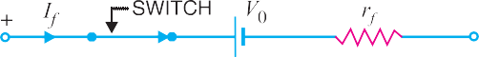

    - Simplified Equivalent circuit. For most applications, the internal resistance rf of the crystal diode can be ignored in comparison to other elements in the equivalent circuit. The equivalent circuit then reduces to the one shown in Fig. 6.8 (ii). This simplified equivalent circuit of the crystal diode is frequently used in diode-circuit analysis.
Fig. 6.7

Fig. 6.8

* We assume here that V/I characteristic of crystal diode is linear.

Semiconductor Diode  81
    - Ideal diode model. An ideal diode is one which behaves as a perfect conductor when forward biased and as a perfect insulator when reverse biased. Obviously, in such a hypothetical situation, forward resistance rf = 0 and potential barrier V0 is considered negligible. It may be men- tioned here that although ideal diode is never found in practice, yet diode circuit analysis is made on this basis. Therefore, while discussing diode circuits, the diode will be assumed ideal unless and until stated otherwise.

Crystal Diode Equivalent Circuits
It is desirable to sum up the various models of crystal diode equivalent circuit in the tabular form given below:

S.No. | Type | Model | Characteristic
1. | Approximate model
2. | Simplified model
3. | Ideal Model

Example 6.2. An a.c. voltage of peak value 20 V is connected in series with a silicon diode and load resistance of 500 Ω. If the forward resistance of diode is 10 Ω, find :
(i) peak current through diode (ii) peak output voltage What will be these values if the diode is assumed to be ideal ?

Solution.
Peak input voltage = 20 V
Forward resistance, rf = 10 Ω
Load resistance, RL = 500 Ω
Potential barrier voltage, V0 = 0.7 V
The diode will conduct during the positive half-cycles of a.c. input voltage only. The equivalent circuit is shown in Fig. 6.9 (ii).
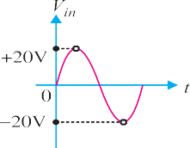
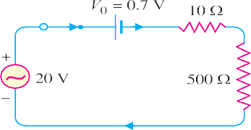
Fig. 6.9

    - The peak current through the diode will occur at the instant when the input voltage reaches positive peak i.e. Vin = VF = 20 V.
∴ VF = V0 + (If)peak [rf + RL] ...(i)

or (I )
= VF − V0

= 20 − 0.7 = 19.3 A
= 37.8 mA

f peak
rf + RL
10 + 500 510

    - Peak output voltage = (If)peak × RL = 37.8 mA × 500 Ω = 18.9 V Ideal diode. For an ideal diode, put V0 = 0 and rf = 0 in equation (i).
∴ VF = (If)peak × RL

V
or (If)peak = F
RL
= 20 V
500 Ω
= 40 mA

Peak output voltage = (If)peak × RL = 40 mA × 500 Ω = 20 V
Comments. It is clear from the above example that output voltage is nearly the same whether the actual diode is used or the diode is considered ideal. This is due to the fact that input voltage is quite large as compared with V0 and voltage drop in rf . Therefore, nearly the whole input forward voltage appears
across the load. For this reason, diode circuit analysis is generally made on the ideal diode basis.
Example 6.3. Find the current through the diode in the circuit shown in Fig. 6.10 (i). Assume the diode to be ideal.

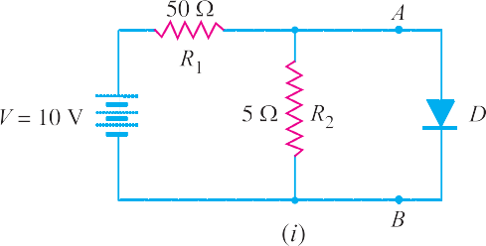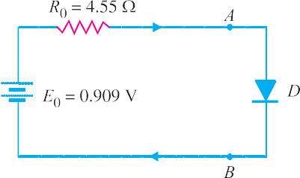
Fig. 6.10
Solution. We shall use Thevenin's theorem to find current in the diode. Referring to Fig. 6.10(i),
E0 = Thevenin’s voltage
= Open circuited voltage across AB with diode removed

= R2 × V R1 + R2
= 5 × 10
50 + 5
= 0.909 V

R0 = Thevenin’s resistance
= Resistance at terminals AB with diode removed and battery replaced by a short circuit

= R1 R2 R1 + R2
= 50 × 5
50 + 5
= 4.55 Ω

Fig. 6.10 (ii) shows Thevenin’s equivalent circuit. Since the diode is ideal, it has zero resistance.

∴ Current through diode =
E0 =
R0
0.909
4.55
= 0.2 A = 200 mA

Example 6.4. Calculate the current through 48 Ω resistor in the circuit shown in Fig. 6.11 (i).
Assume the diodes to be of silicon and forward resistance of each diode is 1 Ω.
Solution. Diodes D1 and D3 are forward biased while diodes D2 and D4 are reverse biased. We
can, therefore, consider the branches containing diodes D2 and D4 as “open”. Replacing diodes D1 and D3 by their equivalent circuits and making the branches containing diodes D2 and D4 open, we get the circuit shown in Fig. 6.11 (ii). Note that for a silicon diode, the barrier voltage is 0.7 V.

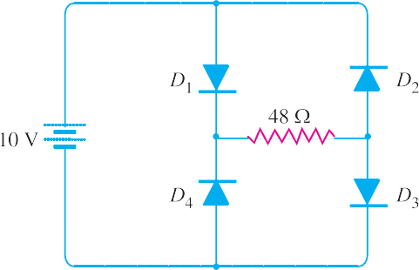
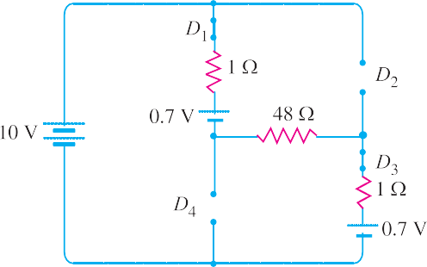
Semiconductor Diode  83

Fig. 6.11
Net circuit voltage = 10 − 0.7 − 0.7 = 8.6 V
Total circuit resistance = 1 + 48 + 1 = 50 Ω
∴ Circuit current = 8.6÷50 = 0.172 A = 172 mA
Example 6.5. Determine the current I in the circuit shown in Fig. 6.12 (i). Assume the diodes to be of silicon and forward resistance of diodes to be zero.

Fig. 6.12
Solution. The conditions of the problem suggest that diode D1 is forward biased and diode D2 is reverse biased. We can, therefore, consider the branch containing diode D2 as open as shown in Fig. 6.12 (ii). Further, diode D1 can be replaced by its simplified equivalent circuit.

∴ I =
E1 − E2 − V0
R
= 24 − 4 − 0.7
2 kΩ
= 19.3 V
2 kΩ
= 9.65 mA

Example 6.6. Find the voltage VA in the circuit shown in Fig. 6.13 (i). Use simplified model.
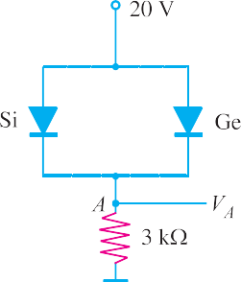
Fig. 6.13

Solution. It appears that when the applied voltage is switched on, both the diodes will turn “on”. But that is not so. When voltage is applied, germanium diode (V0 = 0.3 V) will turn on first and a level of 0.3 V is maintained across the parallel circuit. The silicon diode never gets the opportunity to have 0.7 V across it and, therefore, remains in open-circuit state as shown in Fig. 6.13 (ii).
∴ VA = 20 − 0.3 = 19.7 V
Example 6.7. Find VQ and ID in the network shown in Fig. 6.14 (i). Use simplified model.
Solution. Replace the diodes by their simplified models. The resulting circuit will be as shown in
Fig. 6.14 (ii). By symmetry, current in each branch is ID so that current in branch CD is 2ID. Applying Kirchhoff’s voltage law to the closed circuit ABCDA, we have,
− 0.7 − ID × 2 − 2 ID × 2 + 10 = 0 (ID in mA)
or 6 ID = 9.3

∴ ID
9.3
6
=
= 1.55 mA

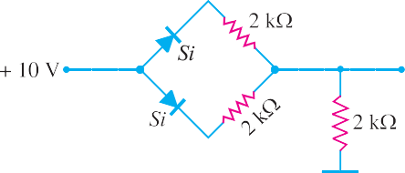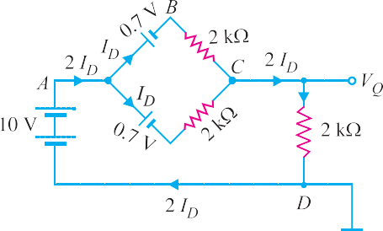Also VQ = (2 ID) × 2 kΩ = (2 × 1.55 mA) × 2 kΩ = 6.2 V
Fig. 6.14

Example 6.8. Determine current through each diode in the circuit shown in Fig. 6.15 (i). Use
simplified model. Assume diodes to be similar.

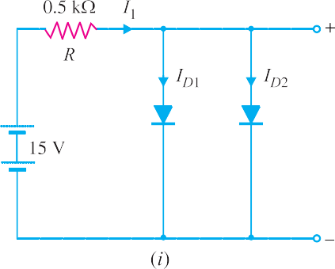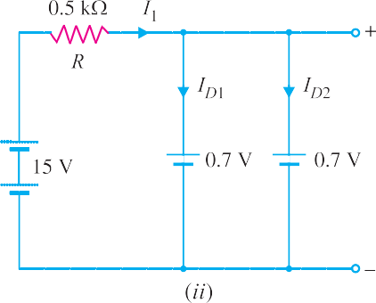
Fig. 6.15
Solution. The applied voltage forward biases each diode so that they conduct current in the same
direction. Fig. 6.15 (ii) shows the equivalent circuit using simplified model. Referring to Fig. 6.15 (ii),

I1 =
Voltage across R R
= 15 − 0.7
0.5 kΩ
= 28.6 mA

Since the diodes are similar, I = I
= I1

= 28.6
= 14.3 mA

D1 D2 2 2
Comments. Note the use of placing the diodes in parallel. If the current rating of each diode is 20

20 mA and a single diode is used in this circuit, a current of 28.6 mA would flow through the diode, thus damaging the device. By placing them in parallel, the current is limited to a safe value of 14.3 mA for the same terminal voltage.
Example 6.9. Determine the currents I1, I2 and I3 for the network shown in Fig. 6.16(i). Use simplified model for the diodes.

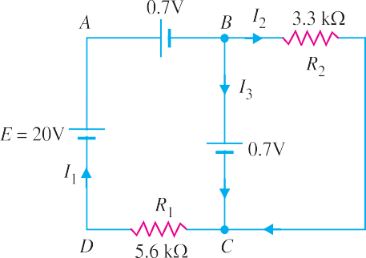
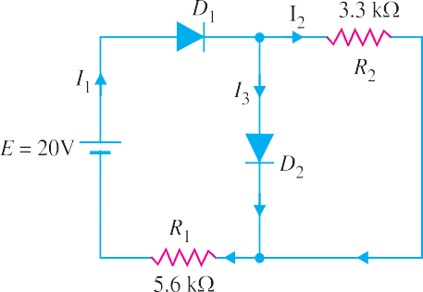Solution. An inspection of the circuit shown in Fig. 6.16 (i) shows that both diodes D1 and D2 are forward biased. Using simplified model for the diodes, the circuit shown in Fig. 6.16 (i) becomes the one shown in Fig. 6.16 (ii). The voltage across R2 (= 3.3 k Ω) is 0.7V.
Fig. 6.16

∴ I2
= 0.7 V = 0.212 mA
3.3 kΩ

Applying Kirchhoff’s voltage law to loop ABCDA in Fig. 6.16 (ii), we have,
– 0.7 – 0.7 – I1 R1 + 20 = 0

∴ I = 20 − 0.7 − 0.7 = 18.6 V
= 3.32 mA

1 R1
Now I1 = I2 + I3
5.6 kΩ

∴ I3 = I1 – I2 = 3.32 – 0. 212 = 3.108 mA
Fig. 6.17
Example 6.10. Determine if the diode (ideal) in Fig. 6.17 (i) is forward biased or reverse biased.
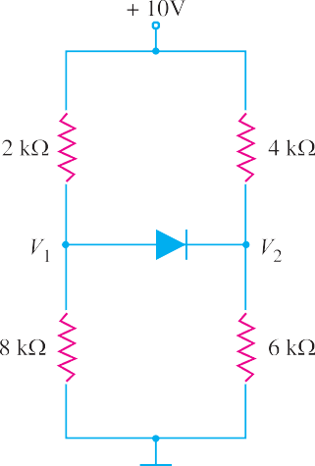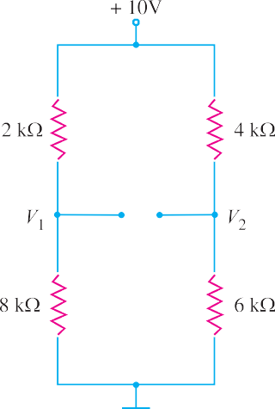

Solution. Let us assume that diode in Fig. 6.17 (i) is OFF i.e. it is reverse biased. The circuit then becomes as shown in Fig. 6.17 (ii). Referring to Fig. 6.17 (ii), we have,

V = 10 V × 8 kΩ = 8V
1 2 kΩ + 8 kΩ
V = 10 V × 6 kΩ = 6V
2 4 kΩ + 6 kΩ
∴ Voltage across diode = V1 – V2 = 8 – 6 = 2V
Now V1 – V2 = 2V is enough voltage to make the diode forward biased. Therefore, our initial assumption was wrong.
Example 6.11. Determine the state of diode for the circuit shown in Fig. 6.18 (i) and find ID and VD. Assume simplified model for the diode.

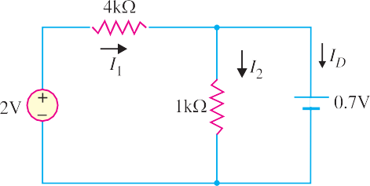

Solution. Let us assume that the diode is ON. Therefore, we can replace the diode with a 0.7V battery as shown in Fig. 6.18 (ii). Referring to Fig. 6.18 (ii), we have,
Fig. 6.18

I = (2 − 0.7) V = 1.3 V
1 4 kΩ 4 kΩ
= 0.325 mA

I = 0.7 V
2 1 kΩ
= 0.7 mA

Now ID = I1 – I2 = 0. 325 – 0.7 = – 0.375 mA
Since the diode current is negative, the diode must be OFF and the true value of diode current is ID = 0 mA. Our initial assumption was wrong. In order to
analyse the circuit properly, we should replace the diode in Fig. 6.18 (i) with an open circuit as shown in Fig.
6.19. The voltage VD across the diode is
V = 2 V × 1 kΩ = 0.4V
D 1 kΩ + 4 kΩ
Fig. 6.19
We know that 0.7V is required to turn ON the diode. Since VD is only 0.4V, the answer confirms that the diode is OFF.

Important Terms
While discussing the diode circuits, the reader will generally come across the following terms :
    - Forward current. It is the current flowing through a forward biased diode. Every diode has a maximum value of forward current which it can safely carry. If this value is exceeded, the diode may be destroyed due to excessive heat. For this reason, the manufacturers’ data sheet specifies the maximum forward current that a diode can handle safely.

    - Peak inverse voltage. It is the maximum reverse voltage that a diode can withstand with- out destroying the junction.
If the reverse voltage across a diode exceeds this value, the reverse current increases sharply and breaks down the junction due to excessive heat. Peak inverse voltage is extremely important when diode is used as a rectifier. In rectifier service, it has to be ensured that reverse voltage across the diode does not exceed its PIV during the negative half-cycle of input a.c. voltage. As a matter of fact, PIV consideration is generally the deciding factor in diode rectifier circuits. The peak inverse volt- age may be between 10V and 10 kV depending upon the type of diode.
    - Reverse current or leakage current. It is the current that flows through a reverse biased diode. This current is due to the minority carriers. Under normal operating voltages, the reverse current is quite small. Its value is extremely small (< 1μ A) for silicon diodes but it is appreciable (j 100 μA) for germanium diodes.
It may be noted that the reverse current is usually very small as compared with forward current. For example, the forward current for a typical diode might range upto 100 mA while the reverse current might be only a few μA—a ratio of many thousands between forward and reverse currents.

Crystal Diode Rectifiers
For reasons associated with economics of generation and transmission, the electric power available is usually an a.c. supply. The supply voltage varies sinusoidally and has a frequency of 50 Hz. It is used for lighting, heating and electric motors. But there are many applications (e.g. electronic circuits) where d.c. supply is needed. When such a d.c. supply is required, the mains a.c. supply is rectified by using crystal diodes. The following two rectifier circuits can be used :
    - Half-wave rectifier (ii) Full-wave rectifier

Half-Wave Rectifier
In half-wave rectification, the rectifier conducts current only during the positive half-cycles of input
  - 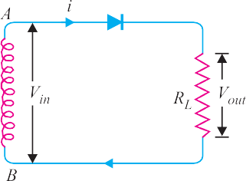supply. The negative half-cycles of a.c. supply are suppressed i.e. during negative half-cycles, no current is conducted and hence no voltage appears across the load. Therefore, current always flows in one direction (i.e. d.c.) through the load though after every half-cycle.

Circuit details. Fig. 6.20 shows the circuit where a single crystal diode acts as a half-wave rectifier. The a.c. supply to be rectified is applied in series with the diode and load resistance RL. Generally, a.c. supply is given through a transformer. The use of transformer permits two advantages. Firstly, it allows us to step up or step down the a.c. input voltage as the situation demands. Secondly, the transformer isolates the rectifier circuit from power line and thus reduces the risk of electric shock.
Fig. 6.20

Operation. The a.c. voltage across the secondary winding AB changes polarities after every half-cycle. During the positive half-cycle of input a.c. voltage, end A becomes positive w.r.t. end B. This makes the diode forward biased and hence it conducts current. During the negative half-cycle, end A is negative w.r.t. end B. Under this condition, the diode is reverse biased and it conducts no current. Therefore, current flows through the diode during positive half-cycles of input a.c. voltage only ; it is blocked during the negative half-cycles [See Fig. 6.20 (ii)]. In this way, current flows through load RL always in the same direction. Hence d.c. output is obtained across RL. It may be noted that output across the load is pulsating d.c. These pulsations in the output are further smooth- ened with the help of filter circuits discussed later.
Disadvantages : The main disadvantages of a half-wave rectifier are :
    - The pulsating current in the load contains alternating component whose basic frequency is equal to the supply frequency. Therefore, an elaborate filtering is required to produce steady direct current.
    - The a.c. supply delivers power only half the time. Therefore, the output is low.

Output Frequency of Half-Wave Rectifier
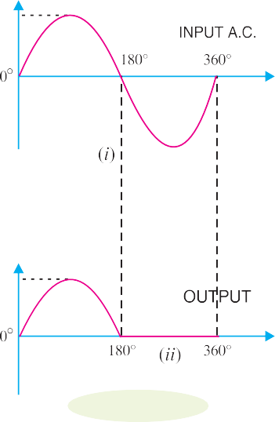The output frequency of a half-wave rectifier is equal to the input frequency (50 Hz). Recall how a complete cycle is defined. A waveform has a complete cycle when it repeats the same wave pattern over a given time. Thus in Fig. 6.21 (i), the a.c. input voltage repeats the same wave pattern over 0° – 360°, 360° – 720° and so on. In Fig. 6.21 (ii), the output waveform also repeats the same wave pattern over 0° – 360°, 360° – 720° and so on. This means that when input a.c. completes one cycle, the output half- wave rectified wave also completes one cycle. In other words, the output frequency is equal to the input frequency i.e.
Fig. 6.21
fout = fin
For example, if the input frequency of sine wave applied to a half-wave rectifier is 100 Hz, then frequency of the output wave will also be 100 Hz.
  - Efficiency of Half-Wave Rectifier The ratio of d.c. power output to the applied input a.c. power is known as rectifier efficiency i.e.
Rectifier efficiency, = d.c. power output
η
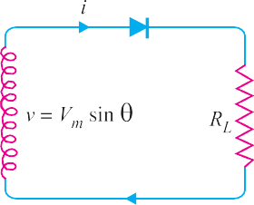Input a.c. power
Fig. 6.22
Consider a half-wave rectifier shown in Fig. 6.22. Let v = Vm sin θ be the alternating voltage that appears across the secondary winding. Let rf and RL be the diode resistance and load resistance respectively. The diode conducts during positive half-cycles of a.c. supply while no current conduc-
tion takes place during negative half-cycles.

d.c. power. The output current is pulsating direct current. Therefore, in order to find d.c. power, average current has to be found out.

*Iav = Idc
π
2π ∫ i d θ =
= 1
1 π Vm sin θ θ
2π r + R
∫ d

0 0 f L
= Vm π Vm π

2π (r
- R ) ∫ sin θ d θ =
2π (r
+ R ) [− cos θ]0

f L
= Vm
0

× 2 =
f L
Vm × 1

2π(rf + RL)
**Im

(rf
- RL) π
⎡

Vm ⎤

= π ⎢∵ Im = (r
+ R ) ⎥

2 ⎛ I ⎞²
⎣ f L ⎦

∴ d.c. power, Pdc = Idc × RL =
⎜ m ⎟
⎝ π ⎠
× RL ...(i)

a.c. power input : The a.c. power input is given by :
P = I² (r + R )
ac rms f L
For a half-wave rectified wave, Irms = Im/2
⎛ I ⎞²

∴ Pac =
⎜ m ⎟
× (rf + RL) ...(ii)

⎝ 2 ⎠

d.c. output power
(I / π)² × R

∴ Rectifier efficiency =
= m 2 L

a.c. input power (Im / 2) (rf
- RL)

= 0.406 RL

= 0.406

rf + RL
1 + rf
RL

The efficiency will be maximum if rf is negligible as compared to RL.
∴ Max. rectifier efficiency = 40.6%
This shows that in half-wave rectification, a maximum of 40.6% of a.c. power is converted into d.c. power.

Example 6.12. The applied input a.c. power to a half-wave rectifier is 100 watts. The d.c. output power obtained is 40 watts.
- What is the rectification efficiency ?
- What happens to remaining 60 watts ?

Solution.
- Rectification efficiency = d.c. output power
= 40

= 0.4 = 40%

a.c. input power 100
- 40% efficiency of rectification does not mean that 60% of power is lost in the rectifier circuit. In fact, a crystal diode consumes little power due to its small internal resistance. The 100 W
=
2 π π
av dc
2 Im Im
I = I =
∴
** It may be remembered that the area of one-half cycle of a sinusoidal wave is twice the peak value. Thus in this case, peak value is Im and, therefore, area of one-half cycle is 2 Im.
2π
Base
π
∫0 idθ
Area under the curve over a cycle =
* Average value =

90  Principles of Electronics
a.c. power is contained as 50 watts in positive half-cycles and 50 watts in negative half-cycles. The 50 watts in the negative half-cycles are not supplied at all. Only 50 watts in the positive half-cycles are converted into 40 watts.

Power efficiency = 40 × 100
∴
50
= 80%

Although 100 watts of a.c. power was supplied, the half-wave rectifier accepted only 50 watts and converted it into 40 watts d.c. power. Therefore, it is appropriate to say that efficiency of rectification is 40% and not 80% which is power efficiency.
Example 6.13. An a.c. supply of 230 V is applied to a half-wave rectifier circuit through a transformer of turn ratio 10 : 1. Find (i) the output d.c. voltage and (ii) the peak inverse voltage. Assume the diode to be ideal.

Solution.
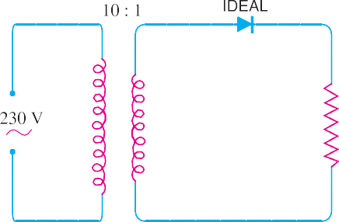Primary to secondary turns is
N1
N2 = 10
R.M.S. primary voltage
= 230 V
∴ Max. primary voltage is

Vpm = (
= (
2 ) × r.m.s. primary voltage
2 ) × 230 = 325.3 V
Fig. 6.23

Max. secondary voltage is
Vsm

= Vpm
- N2
N1

= 325.3 × 1
10

= 32.53 V

- Id.c. =

∴ V =
Im

π
Im × R

= Vsm

= 32.53

= 10.36 V

dc π L π π
- During the negative half-cycle of a.c. supply, the diode is reverse biased and hence conducts no current. Therefore, the maximum secondary voltage appears across the diode.
∴ Peak inverse voltage = 32.53 V
Example 6.14. A crystal diode having internal resistance rf = 20Ω is used for half-wave rectifi- cation. If the applied voltage v = 50 sin ω t and load resistance RL = 800 Ω, find :
(i) Im, Idc, Irms (ii) a.c. power input and d.c. power output
(iii) d.c. output voltage (iv) efficiency of rectification.

Solution.

v = 50 sin ω t

∴ Maximum voltage, Vm = 50 V

- Im =
Vm
rf + RL
50
20 + 800
=
= 0.061 A = 61 mA

Idc = Im/π = 61/π = 19.4 mA
Irms = Im/2 = 61/2 = 30.5 mA
- a.c. power input = (Irms)² × (rf + RL) = ( 30.5 )
1000
2

× (20 + 800) = 0.763 watt

d.c. power output = I²
dc
  - RL
= 19.4 2 × 800 = 0.301 watt
1000
( )

- d.c. output voltage = Idc RL = 19.4 mA × 800 Ω = 15.52 volts
- Efficiency of rectification = 0.301 100 = 39.5%
×
0.763
Example 6.15. A half-wave rectifier is used to supply 50V d.c. to a resistive load of 800 Ω. The diode has a resistance of 25 Ω. Calculate a.c. voltage required.

Solution.
Output d.c. voltage, Vdc = 50 V Diode resistance, rf = 25 Ω Load resistance, RL = 800 Ω
Let Vm be the maximum value of a.c. voltage required.
∴ Vdc = Idc × RL

I
m
= π × RL = π (r
Vm × R
- R ) L
V
⎢∵ Im = r + R ⎥
⎡
m
⎤

or 50 =

Vm

π (25 + 800)
f L

× 800
⎣ f L ⎦

∴ Vm
= π × 825 × 50
800

= 162 V

Hence a.c. voltage of maximum value 162 V is required.

Full-Wave Rectifier
In full-wave rectification, current flows through the load in the same direction for both half-cycles of input a.c. voltage. This can be achieved with two diodes working alternately. For the positive half- cycle of input voltage, one diode supplies current to the load and for the negative half-cycle, the other diode does so ; current being always in the same direction through the load. Therefore, a full-wave rectifier utilises both half-cycles of input a.c. voltage to produce the d.c. output. The following two circuits are commonly used for full-wave rectification :
(i) Centre-tap full-wave rectifier (ii) Full-wave bridge rectifier

Centre-Tap Full-Wave Rectifier
The circuit employs two diodes D1 and D2 as shown in Fig. 6.24. A centre tapped secondary winding
AB is used with two diodes connected so that each uses one half-cycle of input a.c. voltage. In other
words, diode D1 utilises the a.c. voltage appearing across the upper half (OA) of secondary winding for rectification while diode D2 uses the lower half winding OB.
Operation. During the positive half-cycle of secondary voltage, the end A of the secondary winding
becomes positive and end B negative. This makes the diode D1 forward biased and diode D2 reverse biased. Therefore, diode D1 conducts while diode D2 does not. The conventional current flow is through diode D1, load resistor RL and the upper half of secondary winding as shown by the dotted arrows. During the negative half-cycle, end A of the secondary winding becomes negative and end B positive. Therefore,
diode D2 conducts while diode D1 does not. The conventional current flow is through diode D2, load RL
and lower half winding as shown by solid arrows. Referring to Fig. 6.24, it may be seen that current in the
load RL is in the same direction for both half-cycles of input a.c. voltage. Therefore, d.c. is obtained across the load RL. Also, the polarities of the d.c. output across the load should be noted.

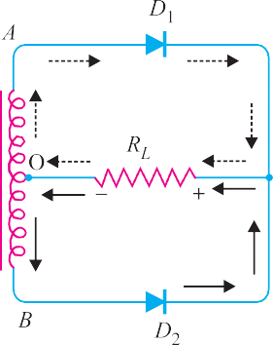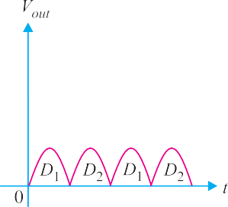
Fig. 6.24
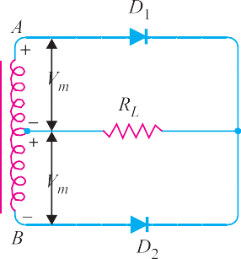Peak inverse voltage. Suppose Vm is the maxi- mum voltage across the half secondary winding. Fig.
  - shows the circuit at the instant secondary voltage reaches its maximum value in the positive direction. At this instant, diode D1 is conducting while diode D2 is non-conducting. Therefore, whole of the secondary voltage appears across the non-conducting diode. Con- sequently, the peak inverse voltage is twice the maxi- mum voltage across the half-secondary winding i.e.
PIV = 2 Vm

Disadvantages
    - It is difficult to locate the centre tap on the secondary winding.
Fig. 6.25
    - The d.c. output is small as each diode utilises only one-half of the transformer secondary voltage.
    - The diodes used must have high peak inverse voltage.

Full-Wave Bridge Rectifier
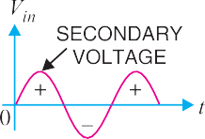
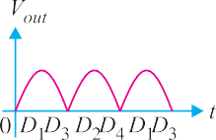
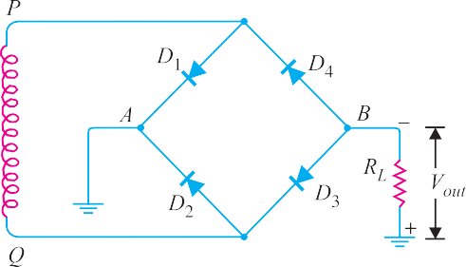The need for a centre tapped power transformer is eliminated in the bridge rectifier. It contains four diodes D1, D2, D3 and D4 connected to form bridge as shown in Fig. 6.26. The a.c. supply to be rectified is applied to the diagonally opposite ends of the bridge through the transformer. Between other two ends of the bridge, the load resistance RL is connected.

Fig. 6.26

Semiconductor Diode  93 Operation. During the positive half-cycle of secondary voltage, the end P of the secondary winding becomes positive and end Q negative. This makes diodes D1 and D3 forward biased while
diodes D2 and D4 are reverse biased. Therefore, only diodes D1 and D3 conduct. These two diodes
will be in series through the load RL as shown in Fig. 6.27 (i). The conventional current flow is shown by dotted arrows. It may be seen that current flows from A to B through the load RL .
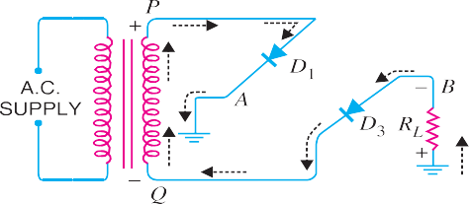During the negative half-cycle of secondary voltage, end P becomes negative and end Q posi- tive. This makes diodes D2 and D4 forward biased whereas diodes D1 and D3 are reverse biased. Therefore, only diodes D2 and D4 conduct. These two diodes will be in series through the load RL as shown in Fig. 6.27 (ii). The current flow is shown by the solid arrows. It may be seen that again current flows from A to B through the load i.e. in the same direction as for the positive half-cycle. Therefore, d.c. output is obtained across load RL.
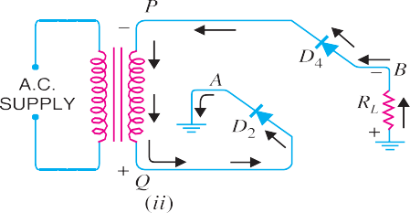
Fig. 6.27
Peak inverse voltage. The peak inverse voltage (PIV) of each diode is equal to the maximum
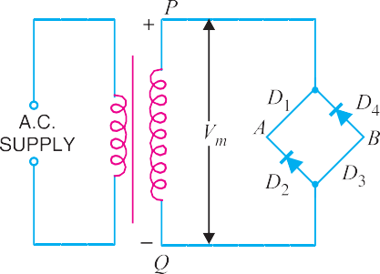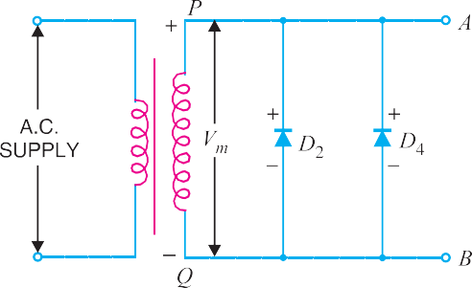secondary voltage of transformer. Suppose during positive half cycle of input a.c., end P of second- ary is positive and end Q negative. Under such conditions, diodes D1 and D3 are forward biased while diodes D2 and D4 are reverse biased. Since the diodes are considered ideal, diodes D1 and D3 can be replaced by wires as shown in Fig. 6.28 (i). This circuit is the same as shown in Fig. 6.28 (ii).

Fig. 6.28
Referring to Fig. 6.28 (ii), it is clear that two reverse biased diodes (i.e., D2 and D4) and the
secondary of transformer are in parallel. Hence PIV of each diode (D2 and D4) is equal to the maxi- mum voltage (Vm) across the secondary. Similarly, during the next half cycle, D2 and D4 are forward biased while D1 and D3 will be reverse biased. It is easy to see that reverse voltage across D1 and D3 is equal to Vm.

Advantages
- The need for centre-tapped transformer is eliminated.
- The output is twice that of the centre-tap circuit for the same secondary voltage.
- The PIV is one-half that of the centre-tap circuit (for same d.c. output).

Disadvantages
- It requires four diodes.

- As during each half-cycle of a.c. input two diodes that conduct are in series, therefore, voltage drop in the internal resistance of the rectifying unit will be twice as great as in the centre tap circuit. This is objectionable when secondary voltage is small.

Output Frequency of Full-Wave Rectifier
The output frequency of a full-wave rectifier is double the input frequency. Remember that a wave has a complete cycle when it repeats the same pattern. In Fig. 6.29 (i), the input a.c. completes one cycle from 0° – 360°. However, the full-wave rectified wave completes 2 cycles in this period [See Fig. 6.29 (ii)]. Therefore, output frequency is twice the input frequency i.e.
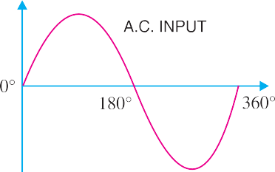
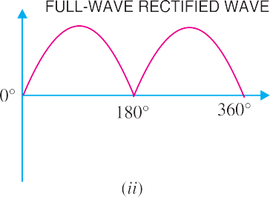
fout = 2 fin

Fig. 6.29
For example, if the input frequency to a full-wave rectifier is 100 Hz, then the output frequency will be 200 Hz.

Efficiency of Full-Wave Rectifier
Fig. 6.30 shows the process of full-wave rectification. Let v = Vm sin θ be the a.c. voltage to be rectified. Let rf and RL be the diode resistance and load resistance respectively. Obviously, the rectifier will conduct current through the load in the same direction for both half-cycles of input a.c. voltage. The instantaneous current i is given by :

i = v =
Vm sin θ

rf + RL rf + RL
Fig. 6.30
d.c. output power. The output current is pulsating direct current. Therefore, in order to find the
d.c. power, average current has to be found out. From the elementary knowledge of electrical engi- neering,

Idc

= 2 Im
π
2

⎛ 2 I

Semiconductor Diode  95

⎞2

∴ d.c. power output, Pdc = I dc × RL =
⎜ m ⎟
  - RL
...(i)

⎝ π ⎠
a.c. input power. The a.c. input power is given by :
P = I² (r + R )
ac rms f L
For a full-wave rectified wave, we have,
Irms = Im/
2
⎛ I ⎞²
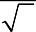
∴ P = ⎜ ^{m} ⎟ (r + R ) ... (ii)
ac ⎝ 2 ⎠ f L

∴ Full-wave rectification efficiency is
P

(2 I

/ π)²R

η = dc = m L

Pac
⎛ I ⎞²
⎜ ^{m} ⎟
⎝ 2 ⎠
(rf
- RL)

= 8 × RL
= 0.812 RL
= 0.812

π2 (rf + RL )
rf + RL
1 + rf
RL

The efficiency will be maximum if rf is negligible as compared to RL.
∴ Maximum efficiency = 81.2%
This is double the efficiency due to half-wave rectifier. Therefore, a full-wave rectifier is twice as effective as a half-wave rectifier.
Example 6.16. A full-wave rectifier uses two diodes, the internal resistance of each diode may be assumed constant at 20 Ω. The transformer r.m.s. secondary voltage from centre tap to each end of secondary is 50 V and load resistance is 980 Ω. Find :
(i) the mean load current (ii) the r.m.s. value of load current

Solution.

rf = 20 Ω, RL = 980 Ω
2

Max. a.c. voltage, Vm = 50 ×
= 70.7 V

Max. load current, Im =
Vm
rf + RL
= 70.7 V (20 + 980) Ω

= 70.7 mA

- Mean load current, Idc
= 2 Im
π
= 2 × 70.7
π

= 45 mA

- 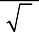R.M.S. value of load current is
2
AB

Irms =
2
Im = 70.7 . .
= 50 mA

Example 6.17. In the centre-tap circuit shown in Fig. 6.31, the diodes are assumed to be ideal
  - having zero internal resistance. Find :
    - d.c. output voltage(ii) peak inverse voltage (iii) rectification efficiency.

Solution.
Primary to secondary turns, N1/N2 = 5

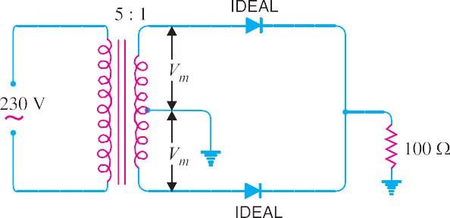
R.M.S. primary voltage = 230 V
∴ R.M.S. secondary voltage
= 230 × (1/5) = 46 V
Maximum voltage across secondary

= 46 ×
2
= 65V

Maximum voltage across half secondary winding is
Vm = 65/2 = 32.5 V
Fig. 6.31
- Average current, Idc =

2Vm
π RL
= 2 × 32.5
π × 100
= 0.207 A

∴ d.c. output voltage, Vdc = Idc × RL = 0.207 × 100 = 20.7 V
- The peak inverse voltage is equal to the maximum secondary voltage, i.e.
PIV = 65 V
- Rectification efficiency = 0.812
r
1 + ^{f}
RL
Since rf = 0
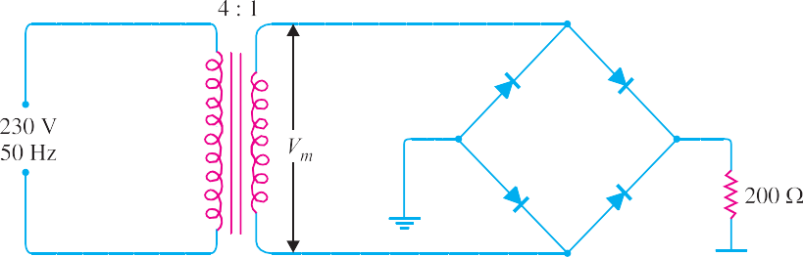∴ Rectification efficiency = 81.2 %
Example 6.18. In the bridge type circuit shown in Fig. 6.32, the diodes are assumed to be ideal. Find :
(i) d.c. output voltage (ii) peak inverse voltage (iii) output frequency. Assume primary to secondary turns to be 4.
Fig. 6.32

Solution.
Primary/secondary turns, N1/N2 = 4
R.M.S. primary voltage = 230 V
∴ R.M.S. secondary voltage = 230 (N2/N1) = 230 × (1/4) = 57.5 V Maximum voltage across secondary is
2

Vm = 57.5 ×
= 81.3 V

  - Average current, Idc
= 2Vm
π RL
= 2 × 81.3
π × 200
= 0.26 A

∴ d.c. output voltage, Vdc = Idc × RL = 0.26 × 200 = 52 V

  - The peak inverse voltage is equal to the maximum secondary voltage i.e.
PIV = 81.3 V
  - In full-wave rectification, there are two output pulses for each complete cycle of the input
  - voltage. Therefore, the output frequency is twice that of the a.c. supply frequency i.e.
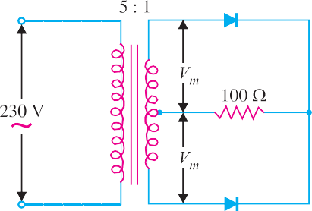
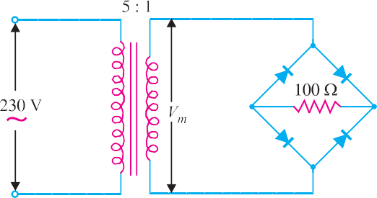
fout = 2 × fin = 2 × 50 = 100 Hz
Example 6.19. Fig. 6.33 (i) and Fig. 6.33 (ii) show the centre-tap and bridge type circuits having the same load resistance and transformer turn ratio. The primary of each is connected to 230V, 50 Hz supply.
- Find the d.c. voltage in each case.
- PIV for each case for the same d.c. output. Assume the diodes to be ideal.
Fig. 6.33

Solution.
    - D.C. output voltage

Centre-tap circuit
R.M.S. secondary voltage = 230 × 1/5 = 46 V
Max. voltage across secondary = 46 × 2 = 65 V Max. voltage appearing across half secondary winding is
Vm = 65/2 = 32.5 V

Average current, Idc
= 2Vm
π RL

D.C. output voltage, Vdc
= Idc
- RL
= 2Vm
π RL
  - RL

= 2V_{m} = 2 × 32.5

= 20.7 V

π π

Bridge Circuit

Max. voltage across secondary, Vm = 65 V
D.C. output voltage, V = I R
= 2Vm × R

= 2 Vm

= 2 × 65

= 41.4 V

dc dc L
π RL L π π

This shows that for the same secondary voltage, the d.c. output voltage of bridge circuit is twice that of the centre-tap circuit.

PIV for same d.c. output voltage
The d.c. output voltage of the two circuits will be the same if Vm (i.e. max. voltage utilised by each circuit for conversion into d.c.) is the same. For this to happen, the turn ratio of the transformers should be as shown in Fig. 6.34.

Centre-tap circuit
R.M.S. secondary voltage = 230 × 1/5 = 46 V
2

Max. voltage across secondary = 46 ×
Max. voltage across half secondary winding is
= 65 V

Vm = 65/2 = 32.5 V
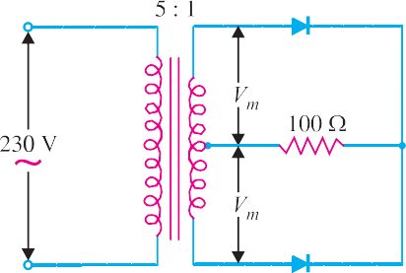
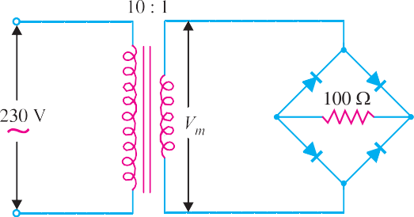
Fig. 6.34

∴ PIV = 2 Vm = 2 × 32.5 = 65 V

Bridge type circuit
R.M.S. secondary voltage = 230 × 1/10 = 23 V
2

Max. voltage across secondary, Vm = 23 ×
= 32.5 V

∴ PIV = Vm = 32.5 V
This shows that for the same d.c. output voltage, PIV of bridge circuit is half that of centre-tap circuit. This is a distinct advantage of bridge circuit.
Example 6.20. The four diodes used in a bridge rectifier circuit have forward resistances which may be considered constant at 1Ω and infinite reverse resistance. The alternating supply voltage is 240 V r.m.s. and load resistance is 480 Ω. Calculate (i) mean load current and (ii) power dissipated in each diode.

Solution.

Max. a.c. voltage, Vm = 240 × V
2

- At any instant in the bridge rectifier, two diodes in series are conducting. Therefore, total circuit resistance = 2 rf + RL.

Max. load current, Im =

2 rf
Vm
- RL
= 240 × 2
2 × 1 + 480
= 0.7 A

∴ Mean load current, Idc
= 2 Im = 2 × 0.7
π π

= 0.45 A

- Since each diode conducts only half a cycle, diode r.m.s. current is :
Ir.m.s. = Im/2 = 0.7/2 = 0.35 A

Power dissipated in each diode = I²
r.m.s.
  - rf
= (0.35)² × 1 = 0.123 W

Example 6.21. The bridge rectifier shown in Fig. 6.35 uses silicon diodes. Find (i) d.c. output

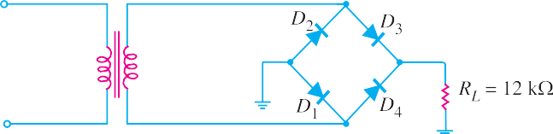voltage (ii) d.c. output current. Use simplified model for the diodes.

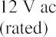

Fig. 6.35
Solution. The conditions of the problem suggest that the a.c voltage across transformer second- ary is 12V r.m.s.
∴ Peak secondary voltage is
Vs (pk) = 12 × 2 = 16.97 V
- At any instant in the bridge rectifier, two diodes in series are conducting.
∴ Peak output voltage is
Vout (pk) = 16.97 – 2 (0.7) = 15.57 V
∴ Average (or d.c.) output voltage is

V = V
= 2 Vout ( pk )

= 2 × 15.57
= 9.91V

av dc π π
- Average (or d.c.) output current is

I = Vav = 9.91V

= 825.8 μA

av RL
12 kΩ

Faults in Centre-Tap Full-Wave Rectifier
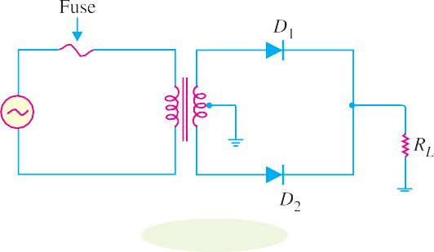The faults in a centre-tap full-wave rectifier may occur in the transformer or rectifier diodes. Fig. 6.36 shows the circuit of a centre-tap full-wave rectifier. A fuse is connected in the primary of the trans- former for protection purposes.
Fig. 6.36
We can divide the rectifier faults into two classes viz.
    - Faults in transformer 2. Faults in rectifier diodes
- Faults in Transformer. The transformer in a rectifier circuit can develop the following faults :
- A shorted primary or secondary winding.
- An open primary or secondary winding.
- A short between the primary or secondary winding and the transformer frame.
- In most cases, a shorted primary or shorted secondary will cause the fuse in the primary

100  Principles of Electronics
to blow. If the fuse does not blow, the d.c. output from the rectifier will be extremely low and the transformer itself will be very hot.
- When the primary or secondary winding of the transformer opens, the output from the rectifier will drop to zero. In this case, the primary fuse will not blow. If you believe that either transformer winding is open, a simple resistance check will verify your doubt. If either winding reads a very high resistance, the winding is open.
- If either winding shorts to the transformer casing, the primary fuse will blow. This fault can be checked by measuring the resistances from the winding leads to the transformer casing. A low resistance measurement indicates that a winding-to-case short exists.
- Faults in Rectifier Diodes. If a fault occurs in a rectifier diode, the circuit conditions will indicate the type of fault.
- If one diode in the centre-tap full-wave rectifier is shorted, the primary fuse will blow. The reason is simple. Suppose diode D2 in Fig. 6.36 is shorted. Then diode D2 will behave as a wire. When diode D1 is forward biased, the transformer secondary will be shorted through D1. This will cause excessive current to flow in the secondary (and hence in the primary), causing the primary fuse to blow.
- If one diode in the centre-tap full-wave rectifier opens, the output from the rectifier will resemble the output from a half-wave rectifier. The remedy is to replace the diode.
Bridge Rectifier Faults. The transformer faults and their remedies for bridge rectifier circuits are the same as for centre-tap full-wave rectifier. Again symptoms for shorted and open diodes in the bridge rectifier are the same as those for the centre-tap circuit. In the case of bridge circuit, you simply have more diodes that need to be tested.

Nature of Rectifier Output
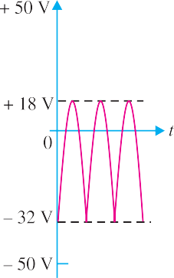
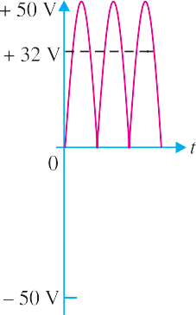
It has already been discussed that the output of a rectifier is pul- sating d.c. as shown in Fig. 6.37. In fact, if such a waveform is carefully analysed, it will be found that it contains a d.c. compo- nent and an a.c. component. The a.c. component is responsible for the *pulsations in the wave. The reader may wonder how a pulsating d.c. voltage can have an a.c. component when the volt- age never becomes negative. The answer is that any wave which varies in a regular manner has an a.c. component.
Fig. 6.37
(i) (ii) (iii)
Fig. 6.38

* Means changing output voltage.

The fact that a pulsating d.c. contains both d.c. and a.c. compo- nents can be beautifully illustrated by referring to Fig. 6.38. Fig. 6.38
(i) shows a pure d.c. component, whereas Fig. 6.38 (ii) shows the *a.c. component. If these two waves are added together, the resulting wave will be as shown in Fig. 6.38 (iii). It is clear that the wave shown in Fig. 6.38 (iii) never becomes negative, although it contains both a.c. and d.c. components. The striking resemblance between the rectifier output wave shown in Fig. 6.37 and the wave shown in Fig. 6.38 (iii) may be noted.

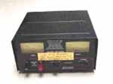
Rectifier

It follows, therefore, that a pulsating output of a rectifier contains a d.c. component and an a.c. component.

Ripple Factor
The output of a rectifier consists of a d.c. component and an a.c. component (also known as ripple). The a.c. component is undesirable and accounts for the pulsations in the rectifier output. The effec- tiveness of a rectifier depends upon the magnitude of a.c. component in the output ; the smaller this component, the more effective is the rectifier.
The ratio of r.m.s. value of a.c. component to the d.c. component in the rectifier output is known as ripple factor i.e.

r.m.s. value of a.c component
Ripple factor = value of d.c. component
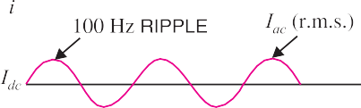Therefore, ripple factor is very important in decid- ing the effectiveness of a rectifier. The smaller the ripple factor, the lesser the effective a.c. component and hence more effective is the rectifier.
Mathematical analysis. The output current of a rectifier contains d.c. as well as a.c. component. The undesired a.c. component has a frequency of 100 Hz (i.e. double the supply frequency 50 Hz) and is called the ripple (See Fig. 6.39). It is a fluctuation su- perimposed on the d.c. component.
Fig. 6.39
= Iac
Idc

By definition, the effective (i.e. r.m.s.) value of total load current is given by :
I ² + I ²
dc ac
I 2
rms dc
- I ²
Irms =
or Iac =
Dividing throughout by Idc, we get,

Iac
Idc
But Iac/Idc is the ripple factor.
= 1
Idc
I 2
rms
- I ²
dc

I 2
rms dc
- I ²
⎛ I ⎞²
⎜ rms ⎟
⎝ Idc ⎠
− 1

∴ Ripple factor =
1 =
Idc

- For half-wave rectification. In half-wave rectification,
Irms = Im/2 ; Idc = Im/π

* Although the a.c. component is not a sine-wave, yet it is alternating one.

102  Principles of Electronics
⎛ I /2 ⎞²
⎜ m ⎟
⎝ Im / π ⎠
− 1

∴ Ripple factor =
= 1.21

It is clear that a.c. component exceeds the d.c. component in the output of a half-wave rectifier. This results in greater pulsations in the output. Therefore, half-wave rectifier is ineffective for con- version of a.c. into d.c.
- For full-wave rectification. In full-wave rectification,

I
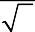Irms = m
2
⎛ I /
⎜ 2 I /π ⎟
m
2 ⎞2
− 1
⎝
m
⎠

; Idc
= 2 Im
π

∴ Ripple factor =
= 0.48

i.e. effective a.c. component
d.c. component

= 0.48

This shows that in the output of a full-wave rectifier, the d.c. component is more than the a.c. component. Consequently, the pulsations in the output will be less than in half-wave rectifier. For this reason, full-wave rectification is invariably used for conversion of a.c. into d.c.
Example 6.22. A power supply A delivers 10 V dc with a ripple of 0.5 V r.m.s. while the power supply B delivers 25 V dc with a ripple of 1 mV r.m.s. Which is better power supply ?
Solution. The lower the ripple factor of a power supply, the better it is.
For power supply A

For power supply B
Ripple factor =
Vac(r.m.s.)

Vdc
= 0.5 × 100
10
= 5%

Ripple factor = Clearly, power supply B is better.
Vac(r.m.s.)

Vdc
= 0.001 × 100
25
= 0.004%

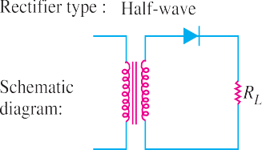
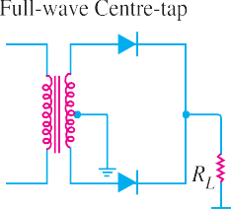Comparison of Rectifiers

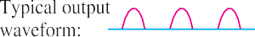

S. No. | Particulars | Half-wave | Centre-tap | Bridge type
1 | No. of diodes | 1 | 2 | 4
2 | Transformer necessary | no | yes | no
3 | Max. efficiency | 40.6% | 81.2% | 81.2%
4 | Ripple factor | 1.21 | 0.48 | 0.48
5  6 | Output frequency Peak inverse voltage | fin Vm | 2 fin  2 Vm | 2 fin Vm

A comparison among the three rectifier circuits must be made very judiciously. Although bridge circuit has some disadvantages, it is the best circuit from the viewpoint of overall performance. When cost of the transformer is the main consideration in a rectifier assembly, we invariably use the bridge circuit. This is particularly true for large rectifiers which have a low-voltage and a high-current rating.

Filter Circuits
Generally, a rectifier is required to produce pure d.c. supply for using at various places in the elec- tronic circuits. However, the output of a rectifier has pulsating *character i.e. it contains a.c. and d.c. components. The a.c. component is undesirable and must be kept away from the load. To do so, a filter circuit is used which removes (or filters out) the a.c. component and allows only the d.c. compo- nent to reach the load.
A filter circuit is a device which removes the a.c. component of rectifier output but allows the
d.c. component to reach the load.
Obviously, a filter circuit should be installed between the rectifier and the load as shown in Fig. 6.40. A filter circuit is generally a combination of inductors (L) and capacitors (C). The filtering action of L and C depends upon the basic electrical principles. A capacitor passes a.c. readily but does not **pass d.c. at all. On the other hand, an inductor †opposes a.c. but allows d.c. to pass through it. It then becomes clear that suitable network of L and C can effectively remove the a.c. component, allowing the d.c. component to reach the load.
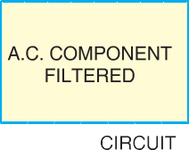
Fig. 6.40

Types of Filter Circuits
The most commonly used filter circuits are capacitor filter, choke input filter and capacitor input filter or π-filter. We shall discuss these filters in turn.
- Capacitor filter. Fig. 6.41 (ii) shows a typical capacitor filter circuit. It consists of a capacitor C placed across the rectifier output in parallel with load RL. The pulsating direct voltage of the rectifier is applied across the capacitor. As the rectifier voltage increases, it charges the capacitor and also supplies current to the load. At the end of quarter cycle [Point A in Fig. 6.41 (iii)], the
Hence, a capacitor does not allow d.c. to pass through it.
† We know XL = 2π fL. For d.c., f = 0 and, therefore, XL = 0. Hence inductor passes d.c. quite readily. For a.c., it offers opposition and drops a part of it.
2 π fC 2 π × 0 × C
1 = 1 = ∞
∴ XC =
* If such a d.c. is applied in an electronic circuit, it will produce a hum.
** A capacitor offers infinite reactance to d.c. For d.c., f = 0.

104  Principles of Electronics
capacitor is charged to the peak value Vm of the rectifier voltage. Now, the rectifier voltage starts to decrease. As this occurs, the capacitor discharges through the load and voltage across it (i.e. across parallel combination of R-C) decreases as shown by the line AB in Fig. 6.41 (iii). The voltage across load will decrease only slightly because immediately the next voltage peak comes and recharges the capacitor. This process is repeated again and again and the output voltage waveform becomes ABCDEFG. It may be seen that very little ripple is left in the output. Moreover, output voltage is higher as it remains substantially near the peak value of rectifier output voltage.
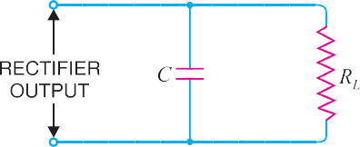
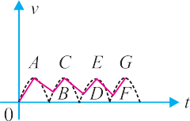
Fig. 6.41

The capacitor filter circuit is extremely popular because of its low cost, small size, little weight and good characteristics. For small load currents (say upto 50 mA), this type of filter is preferred. It is commonly used in transistor radio battery eliminators.
- Choke input filter. Fig. 6.42 shows a typical choke input filter circuit. It consists of a
*choke L connected in series with the rectifier output and a filter capacitor C across the load. Only a single filter section is shown, but several identical sections are often used to reduce the pulsations as effectively as possible.
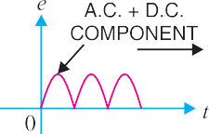
The pulsating output of the rectifier is applied across terminals 1 and 2 of the filter circuit. As discussed before, the pulsating output of rectifier contains a.c. and d.c. components. The choke offers high opposition to the passage of a.c. component but negligible opposition to the d.c. compo- nent. The result is that most of the a.c. component appears across the choke while whole of d.c. component passes through the choke on its way to load. This results in the reduced pulsations at terminal 3.
Fig. 6.42
At terminal 3, the rectifier output contains d.c. component and the remaining part of a.c. compo- nent which has managed to pass through the choke. Now, the low reactance of filter capacitor by- passes the a.c. component but prevents the d.c. component to flow through it. Therefore, only d.c. component reaches the load. In this way, the filter circuit has filtered out the a.c. component from the rectifier output, allowing d.c. component to reach the load.
- Capacitor input filter or π-filter. Fig. 6.43 shows a typical capacitor input filter or **π- filter. It consists of a filter capacitor C1 connected across the rectifier output, a choke L in series and
* The shorthand name of inductor coil is choke.
** The shape of the circuit diagram of this filter circuit appears like Greek letter π (pi) and hence the name
π-filter.

another filter capacitor C2 connected across the load. Only one filter section is shown but several identical sections are often used to improve the smooth- ing action.
The pulsating output from the rectifier is applied across the input terminals (i.e. terminals 1 and 2) of the filter. The filtering action of the three components viz C1, L and C2 of this filter is described below :
Fig. 6.43
- The filter capacitor C1 offers low reactance to a.c. component of rectifier output while it offers infinite reactance to the d.c. component. Therefore, capacitor C1 bypasses an appreciable amount of a.c. component while the d.c. component continues its journey to the choke L.
- The choke L offers high reactance to the a.c. component but it offers almost zero reactance to the d.c. component. Therefore, it allows the d.c. component to flow through it, while the *unbypassed
a.c. component is blocked.
- The filter capacitor C2 bypasses the a.c. component which the choke has failed to block. Therefore, only d.c. component appears across the load and that is what we desire.
Example 6.23. For the circuit shown in Fig. 6.44, find the output d.c. voltage.
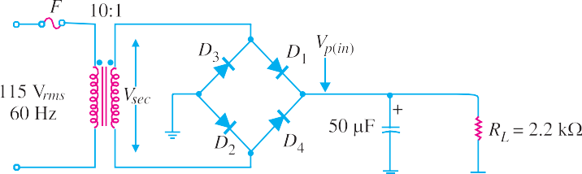
Fig. 6.44

Solution. It can be proved that output d.c. voltage is given by :

V = V
⎛1 − 1 ⎞

dc p(in) ⎜
2 f R C ⎟

⎝ L ⎠
Here Vp(in) = Peak rectified full-wave voltage applied to the filter
f = Output frequency
Peak primary voltage, Vp(prim) = 2 × 115 = 163V Peak secondary voltage, Vp(sec) = ( 1 ) × 163 = 16.3V
10
Peak full-wave rectified voltage at the filter input is
Vp (in) = Vp (sec) – 2×0.7 = 16.3 – 1.4 = 14.9V
For full-wave rectification, f = 2 fin = 2×60 = 120 Hz
1 = 1

Now
2 f RLC
2 × 120 × (2.2 ×10³) × (50 × 10⁻ ⁶)
= 0.038

* That part of a.c. component which could not be bypassed by capacitor C1.

106  Principles of Electronics
∴ V = V ⎛1 − 1 ⎞ = 14.9 (1 – 0.038) = 14.3V

dc p(in) ⎜
2 f R C ⎟

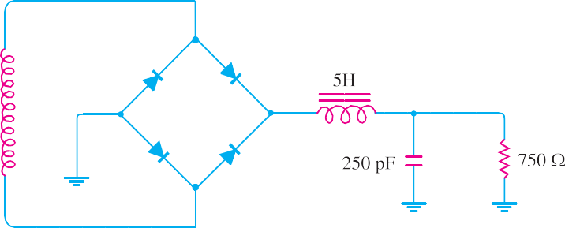⎝ L ⎠
Example 6.24. The choke of Fig. 6.45 has a d.c. resistance of 25 Ω. What is the d.c. voltage if the full-wave signal into the choke has a peak value of 25.7 V ?
Fig. 6.45

Solution. The output of a full-wave rectifier has a d.c. component and an a.c. component. Due to the presence of a.c. component, the rectifier output has a pulsating character as shown in Fig. 6.46. The maximum value of the pulsating output is Vm and d.c. component is Vd′c = 2 Vm/π.
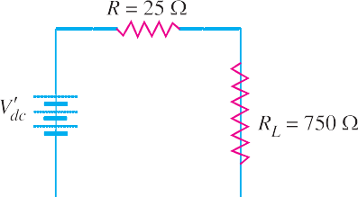
Fig. 6.46
Fig. 6.47
For d.c. component V′dc, the choke resistance is in series with the load as shown in Fig. 6.47.

∴ Voltage across load, Vdc =
Vd′c
R + RL
  - RL

In our example, V′
= 2Vm

= 2 × 25.7
= 16.4 V

dc π π

∴ Voltage across load, Vdc =
Vd′c

R + RL
  - RL
= 16.4 × 750
25 + 750
= 15.9 V

The voltage across the load is 15.9 V dc plus a small ripple.

Voltage Multipliers
With a diode, we can build a rectifier to produce a d.c. voltage that is nearly equal to the peak value of input a.c. voltage. We can also use diodes and capacitors to build a circuit that will provide a d.c output that is multiple of the peak input a.c. voltage. Such a circuit is called a voltage multiplier. For example, a voltage doubler will provide a d.c. output that is twice the peak input a.c. voltage, a voltage tripler will provide a d.c. output that is three times the peak input a.c. voltage and so on.
While voltage multipliers provide d.c. output that is much greater than the peak input a.c. volt- age, there is no power amplification and law of conservation of energy holds good. When a voltage multiplier increases the peak input voltage by a factor n, the peak input current is decreased by approximately the same factor. Thus the actual power output from a voltage multiplier will never be

greater than the input power. In fact, there are losses in the circuit (e.g. in diodes, capacitors etc.) so that the output power will actually be less than the input power.

Half-Wave Voltage Doubler
A half-wave voltage doubler consists of two diodes and two capacitors connected in a manner as shown in Fig. 6.48. It will be shown that if the peak input a.c. voltage is VS(pk), the d.c. output voltage will be 2 VS (pk) provided the diodes are ideal (this assumption is fairly reasonable). The basic idea in a voltage multiplier is to charge each capacitor to the peak input a.c. voltage and to arrange the capacitors so that their stored voltages will add.

Fig. 6.48
Circuit action. We now discuss the working of a half-wave voltage doubler.
- 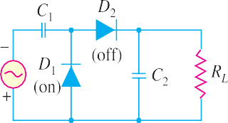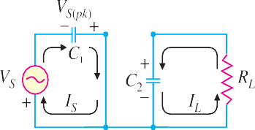During the negative half-cycle of a.c. input voltage [See Fig. 6.49 (i)], diode D1 is forward biased and diode D2 is reverse biased [See Fig. 6.49 (i)]. Therefore, diode D1 can be represented by a short and diode D2 as an open. The equivalent circuit then becomes as shown in Fig. 6.49 (ii).

Fig. 6.49
As you can see [See Fig.6.49 (ii)], C1 will charge until voltage across it becomes equal to peak value of source voltage [VS (pk)]. At the same time, C2 will be in the process of discharging through the load RL (The source of this charge on C2 will be explained in a moment). Note that in all figures electron flow is shown.
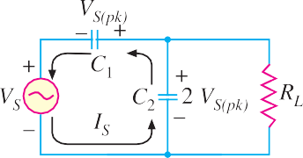
- 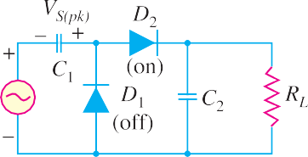When the polarity of the input a.c. voltage reverses (i.e. during positive half-cycle), the circuit conditions become as shown in Fig. 6.50 (i). Now D1 is reverse biased and D2 is forward biased and the equivalent circuit becomes as shown in Fig. 6.50 (ii).

Fig. 6.50

Referring to Fig. 6.50 (ii), it is easy to see that C1 (charged to VS (pk) )and the source voltage (VS) now act as series-aiding voltage sources. Thus C2 will be charged to the sum of the series peak voltages i.e. 2 VS(pk).
- When VS returns to its original polarity (i.e. negative half-cycle), D2 is again turned off (i.e. reverse biased). With D2 turned off, the only discharge path for C2 is through the load resistance RL. The time constant (= RL C2) of this circuit is so adjusted that C2 has little time to lose any of its charge before the input polarity reverses again. During the positive half-cycle, D2 is turned on and C2 recharges until voltage across it is again equal to 2 VS (pk).
∴ D.C. output voltage, Vdc = 2 VS (pk)
Since C2 barely discharges between input cycles, the output waveform of the half-wave voltage doubler closely resembles that of a filtered half-wave rectifier. Fig. 6.51 shows the input and output waveforms for a half-wave voltage doubler.

Fig. 6.51
The voltage multipliers have the disadvantage of poor voltage regulation. This means that d.c. output voltage drops considerably as the load current increases. Large filter capacitors are needed to help maintain the output voltage.

Voltage Stabilisation
A rectifier with an appropriate filter serves as a good source of d.c. output. However, the major disadvantage of such a power supply is that the output voltage changes with the variations in the input voltage or load. Thus, if the input voltage increases, the d.c. output voltage of the rectifier also increases. Similarly, if the load current increases, the output voltage falls due to the voltage drop in the rectifying element, filter chokes, transformer winding etc. In many electronic applications, it is desired that the output voltage should remain constant regardless of the variations in the input voltage or load. In order to ensure this, a voltage stabilising device, called voltage stabiliser is used. Several stabilising circuits have been designed but only zener diode as a voltage stabiliser will be discussed.

Zener Diode
It has already been discussed that when the reverse bias on a crystal diode is increased, a critical voltage, called breakdown voltage is reached where the reverse current increases sharply to a high value. The breakdown region is the knee of the reverse characteristic as shown in Fig. 6.52. The satisfactory explanation of this breakdown of the junction was first given by the American scientist C. Zener. Therefore, the breakdown voltage is sometimes called zener voltage and the sudden increase in current is known as zener current.
The breakdown or zener voltage depends upon the amount of doping. If the diode is heavily doped, depletion layer will be thin and consequently the breakdown of the junction will occur at a lower reverse voltage. On the other hand, a lightly doped diode has a higher breakdown voltage. When an ordinary crystal diode is properly doped so that it has a sharp breakdown voltage, it is called

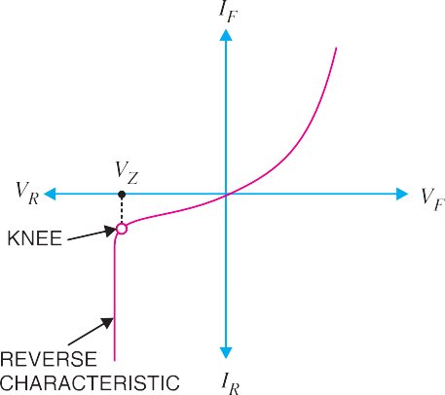
a zener diode.
A properly doped crystal diode which has a sharp breakdown voltage is known as a zener diode.
Fig. 6.53 shows the symbol of a zener diode. It may be seen that it is just like an ordinary diode except that the bar is turned into z-shape. The following points may be noted about the zener diode:
- A zener diode is like an ordinary diode ex- cept that it is properly doped so as to have a sharp breakdown voltage.
- A zener diode is always reverse connected
i.e. it is always reverse biased.
Fig. 6.52
- A zener diode has sharp breakdown volt- age, called zener voltage VZ.
- When forward biased, its characteristics are just those of ordinary diode.
- The zener diode is not immediately burnt just because it has entered the *breakdown region. As long as the external circuit connected to the diode
limits the diode current to less than burn out value, the diode will not burn out.

Equivalent Circuit of Zener Diode
Fig. 6.53
The analysis of circuits using zener diodes can be made quite easily by replac- ing the zener diode by its equivalent circuit.
- “On” state. When reverse voltage across a zener diode is equal to or more than break down voltage VZ, the current increases very sharply. In this region, the curve is almost vertical. It means that voltage across zener diode is constant at VZ even though the current through it changes. Therefore, in the breakdown region, an **ideal zener diode can be represented by a battery of voltage VZ as shown in Fig. 6.54 (ii). Under such conditions, the zener diode is said to be in the “ON” state.

- “OFF” state. When the reverse voltage across the zener diode is less than VZ but greater than 0 V, the zener diode is in the “OFF” state. Under such conditions, the zener diode can be represented by an open-circuit as shown in Fig. 6.55 (ii).

Fig. 6.54
* The current is limited only by both external resistance and the power dissipation of zener diode.
** This assumption is fairly reasonable as the impedance of zener diode is quite small in the breakdown region.

Fig. 6.55

Zener Diode as Voltage Stabiliser
A zener diode can be used as a voltage regulator to provide a constant voltage from a source whose voltage may vary over sufficient range. The circuit arrangement is shown in Fig. 6.56 (i). The zener diode of zener voltage VZ is reverse connected across the load RL across which constant output is desired. The series resistance R absorbs the output voltage fluctuations so as to maintain constant voltage across the load. It may be noted that the zener will maintain a constant voltage VZ (= E0) across the load so long as the input voltage does not fall below VZ.
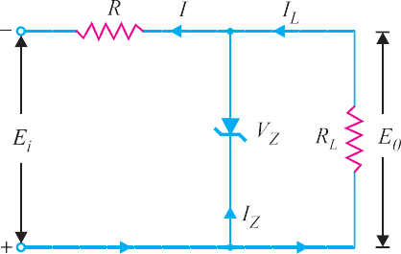
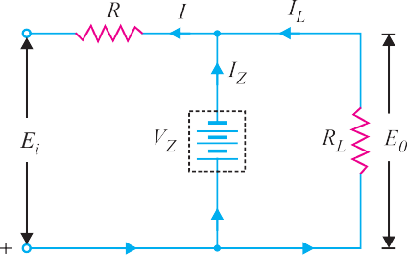
Fig. 6.56

When the circuit is properly designed, the load voltage E0 remains essentially constant (equal to
VZ) even though the input voltage Ei and load resistance RL may vary over a wide range.
- Suppose the input voltage increases. Since the zener is in the breakdown region, the zener diode is equivalent to a battery VZ as shown in Fig. 6.56 (ii). It is clear that output voltage remains constant at VZ (= E0). The excess voltage is dropped across the series resistance R. This will cause an increase in the value of total current I. The zener will conduct the increase of current in I while the load current remains constant. Hence, output voltage E0 remains constant irrespective of the changes in the input voltage Ei.
- Now suppose that input voltage is constant but the load resistance RL decreases. This will cause an increase in load current. The extra current cannot come from the source because drop in R (and hence source current I) will not change as the zener is within its regulating range. The additional load current will come from a decrease in zener current IZ. Consequently, the output voltage stays at constant value.
Voltage drop across R = Ei − E0
Current through R, I = IZ + IL

Applying Ohm’s law, we have,
R =

Ei − E0 IZ + IL

Solving Zener Diode Circuits
The analysis of zener diode circuits is quite similar to that applied to the analysis of semiconductor diodes. The first step is to determine the state of zener diode i.e., whether the zener is in the “on” state or “off” state. Next, the zener is replaced by its appropriate model. Finally, the unknown quantities are determined from the resulting circuit.
- Ei and RL fixed. This is the simplest case and is shown in Fig. 6.57 (i). Here the applied voltage Ei as well as load RL is fixed. The first step is to find the state of zener diode. This can be determined by removing the zener from the circuit and calculating the voltage V across the resulting open-circuit as shown in Fig. 6.57 (ii).

V = E0 =
RLEi R + RL

Fig. 6.57
If V ≥ VZ, the zener diode is in the “on” state and its equivalent model can be substituted as shown in Fig. 6.58 (i). If V < VZ, the diode is in the “off” state as shown in Fig. 6.58 (ii).
- On state. Referring to circuit shown in Fig. 6.58 (i),
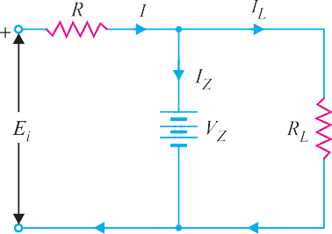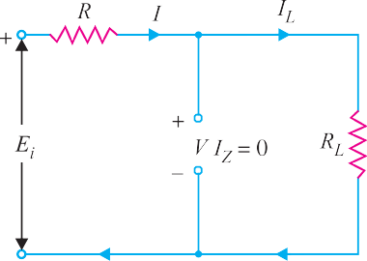E0 = VZ

Fig. 6.58

IZ = I − IL

where IL =
E0 and I =
RL
Ei − E0 R

Power dissipated in zener, PZ = VZ IZ
- Off state. Referring to the circuit shown in Fig. 6.58 (ii),
I = IL and IZ = 0
VR = Ei − E0 and V = E0 (V < VZ)
∴ PZ = V IZ = V(0) = 0
- 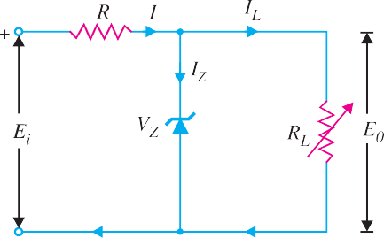Fixed Ei and Variable RL. This case is shown in Fig. 6.59. Here the applied voltage (Ei) is fixed while load resistance RL (and hence load current IL) changes. Note that there is a definite range of RL values (and hence IL values) which will ensure the zener diode to be in “on” state. Let us calculate that range of values.

- RLmin and ILmax. Once the zener is in the “on” state, load voltage E0 (= VZ) is constant. As a result, when load resistance is minimum (i.e., RLmin), load cur- rent will be maximum (IL = E0/RL). In order to find the minimum load resistance that will turn the
Fig. 6.59
zener on, we simply calculate the value of RL that will result in E0 = VZ i.e.,
* RL Ei

E0 = VZ =
R + RL

∴ RLmin =
R VZ

Ei − VZ
...(i)

This is the minimum value of load resistance that will ensure that zener is in the “on” state. Any value of load resistance less than this value will result in a voltage E0 across the load less than VZ and the zener will be in the “off” state.

Clearly ; I

Lmax =
E0 =
RLmin
VZ
RLmin

- ILmin and RLmax. It is easy to see that when load resistance is maximum, load current is minimum.
Now, Zener current, IZ = I − IL
When the zener is in the “on” state, I remains **fixed. This means that when IL is maximum, IZ will be minimum. On the other hand, when IL is minimum, IZ is maximum. If the maximum current that a zener can carry safely is †IZM, then,
** Voltage across R, VR = Ei − E0 and I = VR/R. As Ei and E0 are fixed, I remains the same.
† Max. power dissipation in zener, PZM = VZ IZM
R + RL
The zener will be turned on when V = VZ.
V =
* If you remove the zener in the circuit shown in Fig. 6.59, then voltage V across the open-circuit is
RL Ei

ILmin = I − IZM

and R
Lmax =
E0 =
ILmin
VZ

ILmin

If the load resistance exceeds this limiting value, the current through zener will exceed IZM and the device may burn out.
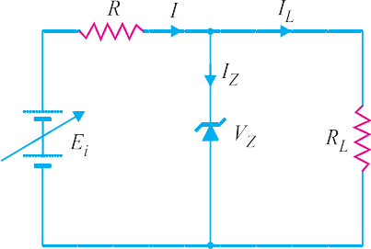
- Fixed RL and Variable Ei. This case is shown in Fig. 6.60. Here the load resistance RL is fixed while the applied voltage (Ei) changes. Note that there is a definite range of Ei values that will en- sure that zener diode is in the “on” state. Let us cal-
culate that range of values.
- Ei (min). To determine the minimum ap- plied voltage that will turn the zener on, simply cal- culate the value of Ei that will result in load voltage
Fig. 6.60
E0 = VZ i.e.,

E0 = VZ =
RL Ei R + RL

∴ E
- Ei (max)

i (min)
= (R + RL) VZ
RL

Now, current through R, I = IZ + IL
Since IL (= E0/RL = VZ/RL) is fixed, the value of I will be maximum when zener current is maxi- mum i.e.,
Imax = IZM + IL
Now Ei = I R + E0
Since E0 (= VZ) is constant, the input voltage will be maximum when I is maximum.
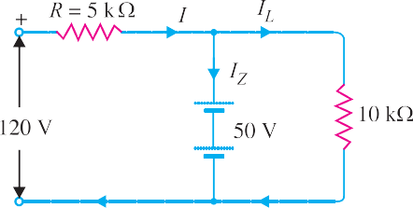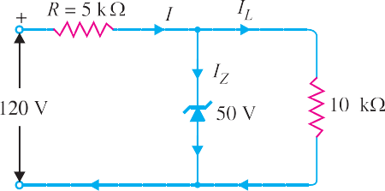∴ Ei (max) = Imax R + VZ
Example 6.25. For the circuit shown in Fig. 6.61 (i), find :
(i) the output voltage (ii) the voltage drop across series resistance
(iii) the current through zener diode.
Fig. 6.61

Solution. If you remove the zener diode in Fig. 6.61 (i), the voltage V across the open-circuit is given by :

V = RL Ei R + RL
= 10 × 120
5 + 10

= 80 V

Since voltage across zener diode is greater than VZ (= 50 V), the zener is in the “on” state. It can, therefore, be represented by a battery of 50 V as shown in Fig. 6.61 (ii).
- Referring to Fig. 6.61 (ii),
Output voltage = VZ = 50 V
- Voltage drop across R = Input voltage − VZ = 120 − 50 = 70 V
- Load current, IL = VZ/RL = 50 V/10 kΩ = 5 mA

Current through R, I = 70 V
5 kΩ
Applying Kirchhoff’s first law, I = IL + IZ

= 14 mA

∴ Zener current, IZ = I − IL = 14 − 5 = 9 mA
Example 6.26. For the circuit shown in Fig. 6.62 (i), find the maximum and minimum values of zener diode current.
Solution. The first step is to determine the state of the zener diode. It is easy to see that for the given range of voltages (80 − 120 V), the voltage across the zener is greater than VZ (= 50 V). Hence the zener diode will be in the “on” state for this range of applied voltages. Consequently, it can be replaced by a battery of 50 V as shown in Fig. 6.62 (ii).
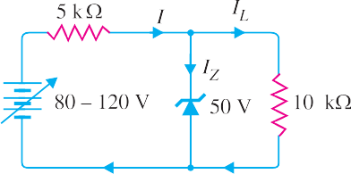
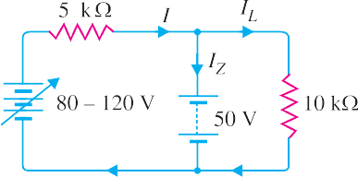

Fig. 6.62
Maximum zener current. The zener will conduct *maximum current when the input voltage is maximum i.e. 120 V. Under such conditions :
Voltage across 5 kΩ = 120 − 50 = 70 V

Current through 5 kΩ, I = 70 V
Ω
5 k
= 14 mA

Load current, IL
= 50 V
10 kΩ
= 5 mA

Applying Kirchhoff's first law, I = IL + IZ
∴ Zener current, IZ = I − IL = 14 − 5 = 9 mA
i
Z 0
R
Ei − VZ . Since V (= E ) and R are fixed, I will be maximum when E is
=
R
maximum and vice-versa.
Now, I =
* IZ = I − IL. Since IL (= VZ/RL) is fixed, IZ will be maximum when I is maximum.
Ei − E0

Minimum Zener current. The zener will conduct minimum current when the input voltage is minimum i.e. 80 V. Under such conditions, we have,
Voltage across 5 kΩ = 80 − 50 = 30 V

Current through 5 kΩ, I = 30 V
Ω
5 k
Load current, IL = 5 mA
= 6 mA

∴ Zener current, IZ = I − IL = 6 − 5 = 1 mA
Example 6.27. A 7.2 V zener is used in the circuit shown in Fig. 6.63 and the load current is to vary from 12 to 100 mA. Find the value of series resistance R to maintain a voltage of 7.2 V across the load. The input voltage is constant at 12V and the minimum zener current is 10 mA.
Fig. 6.63

Solution. Ei = 12 V ; VZ = 7.2 V
R = Ei − E0
IZ + IL
The voltage across R is to remain constant at 12 − 7.2 = 4.8 V as the load current changes from 12 to 100 mA. The minimum zener current will occur when the load current is maximum.

∴ R =
Ei − E0
= 12 V − 7.2 V = 4.8 V
= 43.5 Ω

(IZ )min + (IL )max
(10 + 100) mA 110 mA

If R = 43.5 Ω is inserted in the circuit, the output voltage will remain constant over the regulating range. As the load current IL decreases, the zener current IZ will increase to such a value that IZ + IL = 110 mA. Note that if load resistance is open-circuited, then IL = 0 and zener current becomes 110 mA.
Example 6.28. The zener diode shown in Fig. 6.64 has VZ = 18 V. The voltage across the load stays at 18 V as long as IZ is maintained between 200 mA and 2 A. Find the value of series resistance R so that E0 remains 18 V while input voltage Ei is free to vary between 22 V to 28V.
Fig. 6.64

Solution. The zener current will be minimum (i.e. 200 mA) when the input voltage is minimum (i.e. 22 V). The load current stays at constant value IL = VZ / RL = 18 V/18 Ω = 1 A = 1000 mA.

∴ R =
Ei − E0
= (22 − 18) V = 4 V
= 3.33 Ω

(IZ )min + (IL )max
(200 + 1000) mA 1200 mA

Example 6.29. A 10-V zener diode is used to regulate the voltage across a variable load resistor
[See fig. 6.65]. The input voltage varies between 13 V and 16 V and the load current varies between 10 mA and 85 mA. The minimum zener current is 15 mA. Calculate the value of series resistance R.

Fig. 6.65
Solution. The zener will conduct minimum current (i.e. 15 mA) when input voltage is minimum
(i.e. 13 V).

∴ R =
Ei − E0
= (13 − 10) V = 3 V
= 30 Ω

(IZ )min + (IL )max
(15 + 85) mA 100 mA

Example 6.30. The circuit of Fig. 6.66 uses two zener diodes, each rated at 15 V, 200 mA. If the circuit is connected to a 45-volt unregulated supply, determine :
(i) The regulated output voltage (ii) The value of series resistance R

Solution. When the desired regulated output voltage is higher than the rated voltage of the zener, two or more zeners are connected in series as shown in Fig. 6.66. However, in such circuits, care must be taken to select those zeners that have the same current rating.
Fig. 6.66
.
Current rating of each zener, IZ = 200 mA Voltage rating of each zener, VZ = 15 V
Input voltage, Ei = 45 V
- Regulated output voltage, E0 = 15 + 15 = 30 V

- Series resistance, R =
E_{i} − E₀ = 45 − 30 = 15 V

= 75 Ω

IZ 200 mA 200 mA
Example 6.31. What value of series resistance is required when three 10-watt, 10-volt, 1000 mA zener diodes are connected in series to obtain a 30-volt regulated output from a 45 volt d.c. power source ?
Solution. Fig. 6.67 shows the desired circuit. The worst case is at no load because then zeners carry the maximum current.
Fig. 6.67

Voltage rating of each zener, VZ = 10V Current rating of each zener, IZ = 1000 mA Input unregulated voltage, Ei = 45V
Regulated output voltage, E0 = 10 + 10 + 10 = 30 V Let R ohms be the required series resistance.
Voltage across R = Ei − E0 = 45 − 30 = 15 V

∴ R =
Ei − E0 IZ
= 15 V 1000 mA
= 15 Ω

Example 6.32. Over what range of input voltage will the zener circuit shown in Fig. 6.68 maintain 30 V across 2000 Ω load, assuming that series resistance R = 200 Ω and zener current rating is 25 mA ?

Fig. 6.68
Solution. The minimum input voltage required will be when IZ = 0. Under this condition,

I = I = 30 V
L 2000 Ω
= 15 mA

∴ Minimum input voltage = 30 + I R = 30 + 15 mA × 200 Ω
= 30 + 3 = 33 V
The maximum input voltage required will be when IZ = 25 mA. Under this condition,
I = IL + IZ = 15 + 25 = 40 mA
∴ Max. input voltage = 30 + I R
= 30 + 40 mA × 200 Ω
= 30 + 8 = 38 V
Therefore, the input voltage range over which the circuit will maintain 30 V across the load is

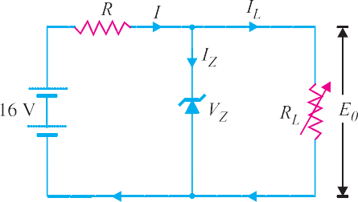
33 V to 38 V.
Example 6.33. In the circuit shown in Fig. 6.69,
the voltage across the load is to be maintained at 12 V as load current varies from 0 to 200 mA. Design the regulator. Also find the maximum wattage rating of zener diode.
Solution. By designing the regulator here means to find the values of VZ and R. Since the load voltage is to be maintained at 12 V, we will use a zener diode of zener voltage 12 V i.e.,
VZ = 12 V
Fig. 6.69
The voltage across R is to remain constant at 16 − 12 = 4 V as the load current changes from 0 to 200 mA. The minimum zener current will occur when the load current is maximum.

∴ R =
Ei − E0
= 16 − 12 = 4 V
= 20 Ω

(IZ )min + (IL)max
(0 + 200) mA 200 mA

Maximum power rating of zener is
PZM = VZ IZM = (12 V) (200 mA) = 2.4 W
Example. 6.34. Fig. 6.70 shows the basic zener diode circuits. What will be the circuit behaviour if the zener is (i) working properly (ii) shorted (iii) open-circuited?

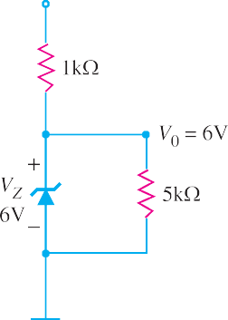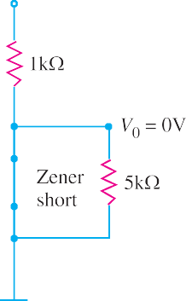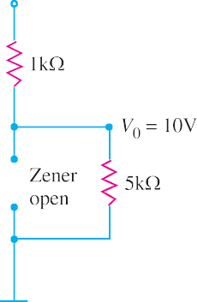

Fig. 6.70
Solution. Zener diodes cannot be tested individually with a multimeter. It is because multimeters usually do not have enough input voltage to put the zener into breakdown region.
- If the zener diode is working properly, the voltage V0 across the load (= 5 kΩ) will be nearly 6V [See Fig. 6.70 (i)].
- If the zener diode is short [See Fig. 6.70 (ii)], you will measure V0 as 0V. The same problem could also be caused by a shorted load resistor (= 5kΩ) or an opened source resistor (= 1 kΩ). The only way to tell which device has failed is to remove the resistors and check them with an ohmmeter. If the resistors are good, then zener diode is bad.
- If the zener diode is open-circuited, the voltage V0 across the load (= 5 kΩ) will be 10V.
Example 6.35. Fig. 6.71 shows regulated power supply using a zener diode. What will be the circuit behaviour if (i) filter capacitor shorts (ii) filter capacitor opens?
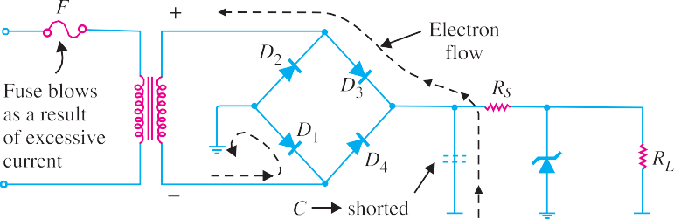
Fig. 6.71

Solution. The common faults in a zener voltage regulator are shorted filter capacitor or opened
filter capacitor.
- When filter capacitor shorts. When the filter capacitor shorts, the primary fuse will blow. The reason for this is illustrated in Fig. 6.71. When the filter capacitor shorts, it shorts out the load resistance RL. This has the same effect as wiring the two sides of the bridge together (See Fig. 6.71).

If you trace from the high side of the bridge to the low side, you will see that the only resistance across the secondary of the transformer is the forward resistance of the two ON diodes. This effectively shorts out the transformer secondary. The result is that excessive current flows in the secondary and hence in the primary. Consequently, the primary fuse will blow.
- When filter capacitor opens. When the filter capacitor opens, it will cause the ripple in the power supply output to increase drastically. At the same time, the d.c. output voltage will show a significant drop. Since an open filter capacitor is the only fault that will cause both of these symp- toms, no further testing is necessary. If both symptoms appear, replace the filter capacitor.

Crystal Diodes versus Vacuum Diodes
Semiconductor diodes (or crystal diodes) have a number of advantages and disadvantages as com- pared to their electron-tube counterparts (i.e., vacuum diodes).

Advantages :
- They are smaller, more rugged and have a longer life.
- They are simpler and inherently cheaper.
- They require no filament power. As a result, they produce less heat than the equivalent vacuum diodes.

Disadvantages :
  - They are extremely heat sensitive. Even a slight rise in temperature increases the current appreciably. Should the temperature *exceed the rated value of the diode, the increased flow of current may produce enough heat to ruin the pn junction. On the other hand, vacuum diodes function normally over a wide range of temperature changes.
It may be noted that silicon is better than germanium as a semiconductor material. Whereas a germanium diode should not be operated at temperatures higher than 80ºC, silicon diodes may oper- ate safely at temperatures upto about 200ºC.
  - They can handle small currents and low inverse voltages as compared to vacuum diodes.
  - They cannot stand an overload even for a short period. Any slight overload, even a transient pulse, may permanently damage the crystal diode. On the other hand, vacuum diodes can stand an overload for a short period and when the overload is removed, the tube will generally recover.
MULTIPLE-CHOICE QUESTIONS

- A crystal diode has ........
  - one pn junction
  - two pn junctions
  - three pn junctions
  - none of the above
- A crystal diode has forward resistance of the order of ........
  - kΩ (ii) Ω
(iii) MΩ (iv) none of the above
- If the arrow of crystal diode symbol is posi- tive w.r.t. bar, then diode is ........ biased.
- forward
- reverse
- either forward or reverse
- none of the above
- The reverse current in a diode is of the order of ........
  - kA (ii) mA
(iii) μA (iv) A
- The forward voltage drop across a silicon diode is about ........

* Even when soldering the leads of a crystal diode, care must be taken not to permit heat from the soldering device to reach the crystal diode.

  - 2.5 V (ii) 3 V
(iii) 10 V (iv) 0.7 V
- A crystal diode is used as ........
  - an amplifier (ii) a rectifier
(iii) an oscillator (iv) a voltage regulator
- The d.c. resistance of a crystal diode is ........ its a.c. resistance.
  - the same as (ii) more than
(iii) less than (iv) none of the above
- An ideal crystal diode is one which behaves as a perfect ........ when forward biased.
  - conductor
  - insulator
  - resistance material
  - none of the above
- The ratio of reverse resistance and forward resistance of a germanium crystal diode is about ........
(i) 1 : 1 (ii) 100 : 1
(iii) 1000 : 1 (iv) 40000 : 1
- The leakage current in a crystal diode is due to ........
  - minority carriers
  - majority carriers
  - junction capacitance
  - none of the above
- If the temperature of a crystal diode in- creases, then leakage current ........
  - remains the same
  - decreases
  - increases
  - becomes zero
- The PIV rating of a crystal diode is ........ that of equivalent vacuum diode.
  - the same as (ii) lower than
(iii) more than (iv) none of the above
- If the doping level of a crystal diode is in- creased, the breakdown voltage .........
  - remains the same
  - is increased
  - is decreased
  - none of the above
- The knee voltage of a crystal diode is ap- proximately equal to ........
  - applied voltage
  - breakdown voltage
  - forward voltage
  - barrier potential
- When the graph between current through and voltage across a device is a straight line, the device is referred to as ........
  - linear (ii) active
(iii) nonlinear (iv) passive
- When the crystal diode current is large, the bias is ........
  - forward (ii) inverse
(iii) poor (iv) reverse
- A crystal diode is a ........ device.
  - non-linear (ii) bilateral
(iii) linear (iv) none of the above
- A crystal diode utilises ........ characteristic for rectification.
  - reverse (ii) forward
- forward or reverse
- none of the above
- When a crystal diode is used as a rectifier, the most important consideration is ........
  - forward characteristic
  - doping level
  - reverse characteristic
  - PIV rating
- If the doping level in a crystal diode is in- creased, the width of depletion layer ........
  - remains the same
  - is decreased
  - is increased
  - none of the above
- A zener diode has ........
  - one pn junction
  - two pn junctions
  - three pn junctions
  - none of the above
- A zener diode is used as ........
  - an amplifier (ii) a voltage regulator
(iii) a rectifier (iv) a multivibrator
- The doping level in a zener diode is ........ that of a crystal diode.

  - the same as (ii) less than
(iii) more than (iv) none of the above
- A zener diode is always .......... connected.
  - reverse
  - forward
  - either reverse or forward
  - none of the above
- A zener diode utilises ........ characteristic for its operation.
  - forward
  - reverse
  - both forward and reverse
  - none of the above
- In the breakdown region, a zener diode be- haves like a ......... source.
  - constant voltage
  - constant current
  - constant resistance
  - none of the above
- A zener diode is destroyed if it ........
  - is forward biased
  - is reverse biased
  - carries more than rated current
  - none of the above
- A series resistance is connected in the zener circuit to ........
  - properly reverse bias the zener
  - protect the zener
  - properly forward bias the zener
  - none of the above
- A zener diode is ........ device.
  - a non-linear (ii) a linear
(iii) an amplifying (iv) none of the above
- A zener diode has ........ breakdown voltage.
  - undefined (ii) sharp
(iii) zero (iv) none of the above
- ........ rectifier has the lowest forward resis- tance.
  - solid state (ii) vacuum tube
(iii) gas tube (iv) none of the above
- Mains a.c. power is converted into d.c. power for ........
  - lighting purposes
  - heaters
  - using in electronic equipment
  - none of the above
- The disadvantage of a half-wave rectifier is that the ........
  - components are expensive
  - diodes must have a higher power rating
  - output is difficult to filter
  - none of the above
- If the a.c. input to a half-wave rectifier has an r.m.s. value of 400/ 2 volts, then diode PIV rating is ........
(i) 400/ 2 V (ii) 400 V
(iii) 400 × 2 V (iv) none of the above
- The ripple factor of a half-wave rectifier is
........
(i) 2 (ii) 1.21
(iii) 2.5 (iv) 0.48
- There is a need of transformer for ........
  - half-wave rectifier
  - centre-tap full-wave rectifier
  - bridge full-wave rectifier
  - none of the above
- The PIV rating of each diode in a bridge rec- tifier is ........ that of the equivalent centre- tap rectifier.
  - one-half (ii) the same as
(iii) twice (iv) four times
- For the same secondary voltage, the output voltage from a centre-tap rectifier is ........ than that of bridge rectifier.
  - twice (ii) thrice
(iii) four times (iv) one-half
- If the PIV rating of a diode is exceeded, ........
  - the diode conducts poorly
  - the diode is destroyed
  - the diode behaves as zener diode
  - none of the above
- A 10 V power supply would use ........ as filter capacitor.
  - paper capacitor (ii) mica capacitor
- electrolytic capacitor
- air capacitor

- A 1000 V power supply would use ........ as a filter capacitor.
  - paper capacitor
  - air capacitor
  - mica capacitor
  - electrolytic capacitor
- The ...... filter circuit results in the best volt- age regulation.
  - choke input
  - capacitor input
  - resistance input
  - none of the above
- A half-wave rectifier has an input voltage of 240 V r.m.s. If the step-down transformer
Answers to Multiple-Choice Questions
has a turns ratio of 8 : 1, what is the peak load voltage ? Ignore diode drop.
(i) 27.5 V (ii) 86.5 V
(iii) 30 V (iv) 42.5 V
- The maximum efficiency of a half-wave rec- tifier is ...........
(i) 40.6% (ii) 81.2%
(iii) 50% (iv) 25%
- The most widely used rectifier is ...........
  - half-wave rectifier
  - centre-tap full-wave rectifier
  - bridge full-wave rectifier
  - none of the above

1. | (i) | 2. | (ii) | 3. | (i) | 4. | (iii) | 5. | (iv)
6. | (ii) | 7. | (iii) | 8. | (i) | 9. | (iv) | 10. | (i)
11. | (iii) | 12. | (ii) | 13. | (iii) | 14. | (iv) | 15. | (i)
16. | (i) | 17. | (i) | 18. | (ii) | 19. | (iv) | 20. | (iii)
21. | (i) | 22. | (ii) | 23. | (iii) | 24. | (i) | 25. | (ii)
26. | (i) | 27. | (iii) | 28. | (ii) | 29. | (i) | 30. | (ii)
31. | (i) | 32. | (iii) | 33. | (iii) | 34. | (ii) | 35. | (iv)
36. | (ii) | 37. | (i) | 38. | (iv) | 39. | (ii) | 40. | (iii)
41. | (i) | 42. | (i) | 43. | (iv) | 44. | (i) | 45. | (iii)

Chapter Review Topics
    - What is a crystal diode ? Explain its rectifying action.
    - Draw the graphic symbol of crystal diode and explain its significance. How the polarities of crystal diode are identified ?
    - What do you understand by the d.c. and a.c. resistance of a crystal diode ? How will you determine them from the V-I characteristic of a crystal diode ?
    - Draw the equivalent circuit of a crystal diode.
    - Discuss the importance of peak inverse voltage in rectifier service.
    - Describe a half-wave rectifier using a crystal diode.
    - Derive an expression for the efficiency of a half-wave rectifier.
    - With a neat sketch, explain the working of (i) Centre-tap full-wave rectifier (ii) Full-wave bridge rectifier.
    - Derive an expression for the efficiency for a full-wave rectifier.
    - Write a short note about the nature of rectifier output.
    - What is a ripple factor ? What is its value for a half-wave and full-wave rectifier ?
    - Describe the action of the following filter circuits : (i) capacitor filter (ii) choke input filter (iii) capacitor input filter.
    - What is a zener diode ? Draw the equivalent circuit of an ideal zener in the breakdown region.
    - Explain how zener diode maintains constant voltage across the load.

Problems
- What is the current in the circuit in Fig. 6.72 ? Assume the diode to be ideal. [10 mA]

Fig. 6.72
Fig. 6.73
- Using equivalent circuit, determine the current in the circuit shown in Fig. 6.73. Assume the forward resistance of the diode to be 2 Ω. [358 mA]
- Find the voltage VA and current I in the circuit shown in Fig. 6.74. Use simplified model. [14 V; 2 mA]
- Determine the magnitude of VA in the circuit shown in Fig. 6.75. [9.5 V]
- A half-wave rectifier uses a transformer of turn ratio 4 : 1. If the primary voltage is 240 V (r.m.s.), find
  - d.c. output voltage (ii) peak inverse voltage. Assume the diode to be ideal. [(i) 27 V (ii) 85 V]
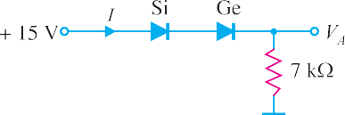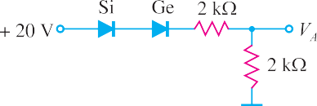

Fig. 6.74
Fig. 6.75
- A half-wave rectifier uses a transformer of turn ratio 2 : 1. The load resistance is 500 Ω. If the primary voltage (r.m.s.) is 240 V, find (i) d.c. output voltage (ii) peak inverse voltage. [(i) 54 V (ii) 170 V]
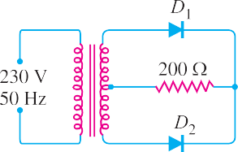
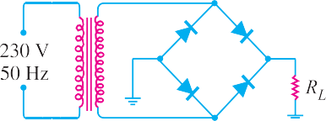

Fig. 6.76
Fig. 6.77
- In Fig. 6.76, the maximum voltage across half of secondary winding is 50 V. Find (i) the average load voltage (ii) peak inverse voltage (iii) output frequency. Assume the diodes to be ideal.
[(i) 31.8 V (ii) 100 V (iii) 100 Hz]
- In Fig. 6.77, the maximum secondary voltage is 136 V. Find (i) the d.c. load voltage (ii) peak inverse voltage (iii) output frequency. [(i) 86.6 V (ii) 136 V (iii) 100 Hz]
- A semiconductor diode having ideal forward and reverse characteristics is used in a half-wave recti- fier circuit supplying a resistive load of 1000 Ω. If the r.m.s. value of the sinusoidal supply voltage is 250 V, determine (i) the r.m.s. diode current and (ii) power dissipated in the load.
[(i) 177 mA (ii) 31.3W]
- The four semiconductor diodes used in a bridge rectifier circuit have forward resistance which can be considered constant at 0.1Ω and infinite reverse resistance. They supply a mean current of 10 A to a resistive load from a sinusoidally varying alternating supply of 20V r.m.s. Determine the resistance of the load and the efficiency of the circuit. [1.6Ω ; 72%]
- Find the average value of each voltage in Fig. 6.78.
[(i) 1.59 V (ii) 63.7 V (iii) 16.4 V (iv) 10.5 V]

Discussion Questions
- Why are diodes not operated in the breakdown region in rectifier service ?
- Why do we use transformers in rectifier service ?
- Why is PIV important in rectifier service ?
- Why is zener diode used as a voltage regulator ?
- Why is capacitor input filter preferred to choke input filter ?

Fig. 6.78
- Calculate the peak voltage across each half of a centre-tapped transformer used in a full-wave rectifier that has an average output voltage of 110V. [173V]
- What PIV rating is required for the diodes in a bridge rectifier that produces an average output voltage of 50V? [78.5 V]
- In the circuit shown in Fig. 6.79, is zener diode in the on or off state ? [Off]
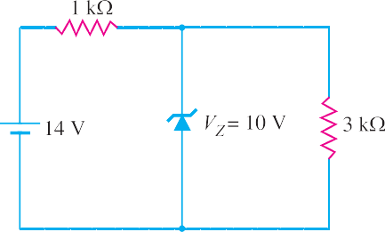
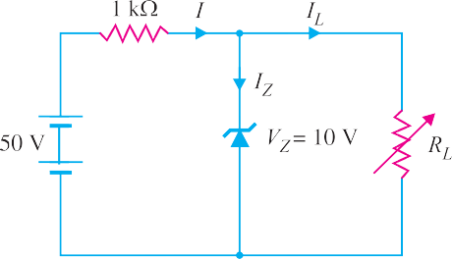
Fig. 6.79
Fig. 6.80

- In the circuit shown in Fig. 6.80, determine the range of RL that will result in a constant voltage of 10 V across RL. [250 Ω to 1.25 kΩ]

