8

Transistors

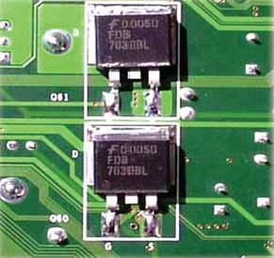
8.1 Transistor
8.3 Some Facts about the Transistor
8.5 Transistor Symbols
8.7 Transistor Connections
8.9 Characteristics of Common Base Connection
8.11 Measurement of Leakage Current
8.13 Common Collector Connection
8.15 Commonly Used Transistor Connection
8.17 Transistor Load Line Analysis
8.19 Practical Way of Drawing CE Circuit
8.21 Performance of Transistor Amplifier
8.23 Power Rating of Transistor
8.25 Semiconductor Devices Numbering System
8.27 Transistor Testing
8.29 Transistors Versus Vacuum Tubes

INTRODUCTION
W
hen a third doped element is added to a crystal diode in such a way that two pn junctions are formed, the resulting device is known as a transistor. The transistor—an entirely new type of electronic device—is capable of achieving amplification of weak signals in a
fashion comparable and often superior to that realised by vacuum tubes. Transistors are far smaller than vacuum tubes, have no filament and hence need no heating power and may be operated in any position. They are mechanically strong, have practically unlimited life and can do some jobs better than vacuum tubes.

Invented in 1948 by J. Bardeen and W.H. Brattain of Bell Telephone Laboratories, U.S.A.; tran- sistor has now become the heart of most electronic applications. Though transistor is only slightly more than 58 years old, yet it is fast replacing vacuum tubes in almost all applications. In this chapter, we shall focus our attention on the various aspects of transistors and their increasing applications in the fast developing electronics industry.

Transistor
A transistor consists of two pn junctions formed by *sandwiching either p-type or n-type semicon- ductor between a pair of opposite types. Accordingly ; there are two types of transistors, namely;
    - n-p-n transistor (ii) p-n-p transistor
An n-p-n transistor is composed of two n-type semiconductors separated by a thin section of p- type as shown in Fig. 8.1 (i). However, a p-n-p transistor is formed by two p-sections separated by a thin section of n-type as shown in Fig. 8.1 (ii).

Fig. 8.1
In each type of transistor, the following points may be noted :
- These are two pn junctions. Therefore, a transistor may be regarded as a combination of two diodes connected back to back.
- There are three terminals, one taken from each type of semiconductor.
- 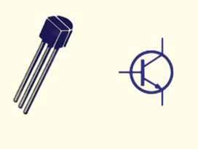The middle section is a very thin layer. This is the most important factor in the function of a transistor.
3 Collector
2
Base
1
2
1 Emitter
3
Origin of the name “Transistor”. When new devices are invented, scientists often try to de- vise a name that will appropriately describe the device. A transistor has two pn junctions. As discussed later, one junction is forward biased and the other is reverse biased. The forward biased junction has a low resistance path whereas a reverse biased junction has a high resistance path. The weak signal is introduced in the low resistance circuit and output is taken from the high resistance circuit. Therefore, a transistor transfers a signal from a low resistance to high resistance. The prefix ‘trans’ means the signal
transfer property of the device while ‘istor’ classifies it as a solid element in the same general family with resistors.
* In practice, these three blocks p, n, p are grown out of the same crystal by adding corresponding impurities in turn.

Naming the Transistor Terminals
A transistor (pnp or npn) has three sections of doped semiconductors. The section on one side is the emitter and the section on the opposite side is the collector. The middle section is called the base and forms two junctions between the emitter and collector.
    - Emitter. The section on one side that supplies charge carriers (electrons or holes) is called the emitter. The emitter is always forward biased w.r.t. base so that it can supply a large number of *majority carriers. In Fig. 8.2 (i), the emitter (p-type) of pnp transistor is forward biased and supplies hole charges to its junction with the base. Similarly, in Fig. 8.2 (ii), the emitter (n-type) of npn transistor has a forward bias and supplies free electrons to its junction with the base.
    - Collector. The section on the other side that collects the charges is called the collector. The collector is always reverse biased. Its function is to remove charges from its junction with the base. In Fig. 8.2 (i), the collector (p-type) of pnp transistor has a reverse bias and receives hole charges that flow in the output circuit. Similarly, in Fig. 8.2 (ii), the collector (n-type) of npn transistor has reverse bias and receives electrons.
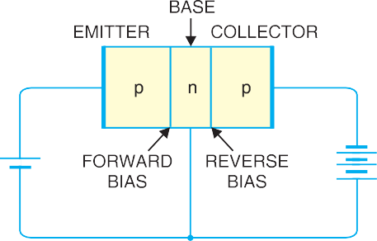
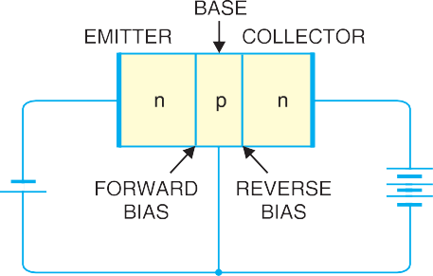
Fig. 8.2

    - Base. The middle section which forms two pn-junctions between the emitter and collector is called the base. The base-emitter junction is forward biased, allowing low resistance for the emit- ter circuit. The base-collector junction is reverse biased and provides high resistance in the collector circuit.

Some Facts about the Transistor
Before discussing transistor action, it is important that the reader may keep in mind the following facts about the transistor :
    - The transistor has three regions, namely ; emitter, base and collector. The base is much thinner than the emitter while **collector is wider than both as shown in Fig. 8.3. However, for the sake of convenience, it is customary to show emitter and collector to be of equal size.
    - The emitter is heavily doped so that it can inject a large number of charge carriers (electrons or holes) into the base. The base is lightly doped and very thin ; it passes most of the emitter injected charge carriers to the collector. The collector is moderately doped.
* Holes if emitter is p-type and electrons if the emitter is n-type.
** During transistor operation, much heat is produced at the collector junction. The collector is made larger to dissipate the heat.

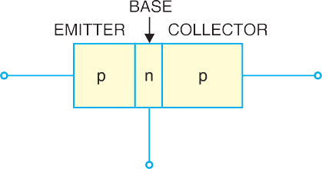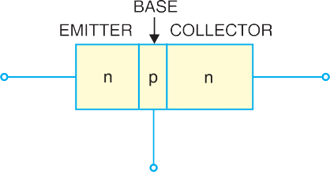
Fig. 8.3

    - The transistor has two pn junctions i.e. it is like two diodes. The junction between emitter
and base may be called emitter-base diode or simply the emitter diode. The junction between the base and collector may be called collector-base diode or simply collector diode.
    - The emitter diode is always forward biased whereas collector diode is always reverse bi- ased.
    - The resistance of emitter diode (forward biased) is very small as compared to collector diode (reverse biased). Therefore, forward bias applied to the emitter diode is generally very small whereas reverse bias on the collector diode is much higher.

Transistor Action
The emitter-base junction of a transistor is forward biased whereas collector-base junction is reverse biased. If for a moment, we ignore the presence of emitter-base junction, then practically* no current would flow in the collector circuit because of the reverse bias. However, if the emitter-base junction is also present, then forward bias on it causes the emitter current to flow. It is seen that this emitter current almost entirely flows in the collector circuit. Therefore, the current in the collector circuit depends upon the emitter current. If the emitter current is zero, then collector current is nearly zero. However, if the emitter current is 1mA, then collector current is also about 1mA. This is precisely what happens in a transistor. We shall now discuss this transistor action for npn and pnp transistors.
    - Working of npn transistor. Fig. 8.4 shows the npn transistor with forward bias to emitter- base junction and reverse bias to collector-base junction. The forward bias causes the electrons in the
n-type emitter to flow towards the base. This constitutes the emitter current IE. As these electrons flow through the p-type base, they tend to combine with holes. As the base is lightly doped and very
thin, therefore, only a few electrons (less than 5%) combine with holes to constitute base** current IB. The remainder (***more than 95%) cross over into the collector region to constitute collector current IC. In this way, almost the entire emitter current flows in the collector circuit. It is clear that emitter
current is the sum of collector and base currents i.e.
IE = IB + IC
* In actual practice, a very little current (a few µA) would flow in the collector circuit. This is called collector cut off current and is due to minority carriers.
** The electrons which combine with holes become valence electrons. Then as valence electrons, they flow down through holes and into the external base lead. This constitutes base current IB.
*** The reasons that most of the electrons from emitter continue their journey through the base to collector to form collector current are : (i) The base is lightly doped and very thin. Therefore, there are a few holes which find enough time to combine with electrons. (ii) The reverse bias on collector is quite high and exerts attractive forces on these electrons.

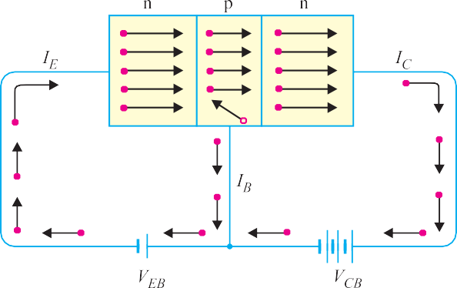

Fig. 8.4
    - Working of pnp transistor. Fig. 8.5 shows the basic connection of a pnp transistor. The forward bias causes the holes in the p-type emitter to flow towards the base. This constitutes the emitter current IE. As these holes cross into n-type base, they tend to combine with the electrons. As
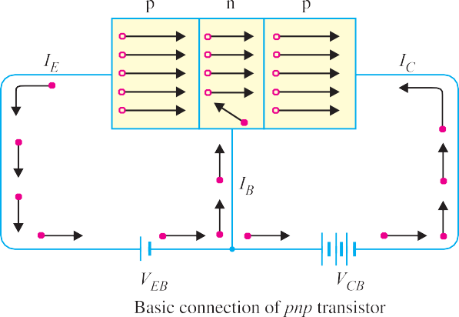the base is lightly doped and very thin, therefore, only a few holes (less than 5%) combine with the
Fig. 8.5
electrons. The remainder (more than 95%) cross into the collector region to constitute collector current IC. In this way, almost the
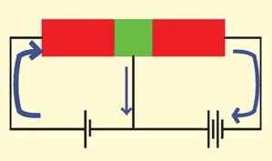entire emitter current flows in the collector
VCB
VEB
Conventional currents
IC
IB
IE
n-type p-type
p-type
base collector
emitter
circuit. It may be noted that current con- duction within pnp transistor is by holes. However, in the external connecting wires, the current is still by electrons.
Importance of transistor action. The input circuit (i.e. emitter-base junction) has low resistance because of forward bias whereas output circuit (i.e. collector-base junction) has high resistance due to reverse bias. As we have seen, the input emitter
current almost entirely flows in the collector circuit. Therefore, a transistor transfers the input signal current from a low-resistance circuit to a high-resistance circuit. This is the key factor responsible for

the amplifying capability of the transistor. We shall discuss the amplifying property of transistor later in this chapter.
Note. There are two basic transistor types : the bipolar junction transistor (BJT) and field- effect transistor (FET). As we shall see, these two transistor types differ in both their operating characteristics and their internal construction. Note that when we use the term transistor, it means bipolar junction transistor (BJT). The term comes from the fact that in a bipolar transistor, there are two types of charge carriers (viz. electrons and holes) that play part in conductions. Note that bi means two and polar refers to polarities. The field-effect transistor is simply referred to as FET.

Transistor Symbols
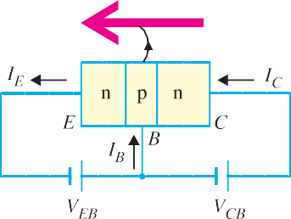
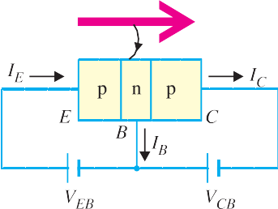
In the earlier diagrams, the transistors have been shown in diagrammatic form. However, for the sake of convenience, the transistors are represented by schematic diagrams. The symbols used for npn and pnp transistors are shown in Fig. 8.6.

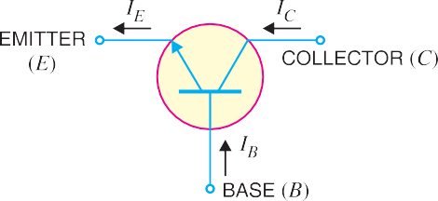
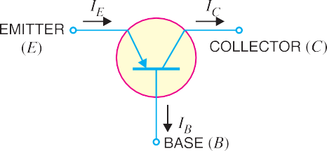
Fig. 8.6

Note that emitter is shown by an arrow which indicates the direction of conventional current flow with forward bias. For npn connection, it is clear that conventional current flows out of the emitter as indicated by the outgoing arrow in Fig. 8.6 (i). Similarly, for pnp connection, the conventional current flows into the emitter as indicated by inward arrow in Fig. 8.6 (ii).

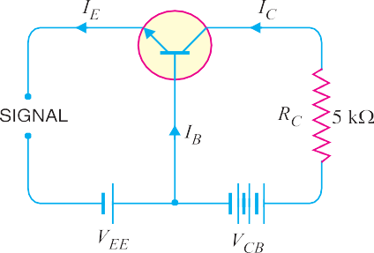
Transistor Circuit as an Amplifier
A transistor raises the strength of a weak signal and thus acts as an amplifier. Fig. 8.7 shows the basic circuit of a transistor amplifier. The weak signal is applied between emitter-base junction and output is taken across the load RC connected in the collector circuit. In order to achieve faithful amplification, the input circuit should always remain forward biased. To do so, a d.c. voltage VEE is applied in the input circuit in addition to the signal as
Fig. 8.7

shown. This d.c. voltage is known as bias voltage and its magnitude is such that it always keeps the input circuit forward biased regardless of the polarity of the signal.
As the input circuit has low resistance, therefore, a small change in signal voltage causes an appreciable change in emitter current. This causes almost the *same change in collector current due to transistor action. The collector current flowing through a high load resistance RC produces a large voltage across it. Thus, a weak signal applied in the input circuit appears in the amplified form in the collector circuit. It is in this way that a transistor acts as an amplifier.
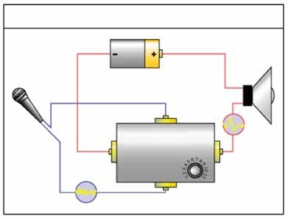Illustration. The action of a transistor as an amplifier can be made more illustrative if we consider typical circuit values. Suppose collector load resistance RC = 5 k∧. Let us further assume that a change of 0.1V in signal volt- age produces a change of 1 mA in emitter current. Obviously, the change in col- lector current would also be approximately 1 mA. This collector current flowing through collector load RC would produce a voltage = 5 k∧ × 1 mA = 5 V. Thus, a change of 0.1 V in the signal has caused a change of 5 V
How Amplifiers Work

circuit carrying large electrical current
Amplifier
circuit carrying small electrical current
amplifier modifies larger current based on smaller current
in the output circuit. In other words, the transistor has been able to raise the voltage level of the signal from 0.1 V to 5 V i.e. voltage amplification is 50.
Example 8.1. A common base transistor amplifier has an input resistance of 20 ∧ and output resistance of 100 k∧. The collector load is 1 k∧. If a signal of 500 mV is applied between emitter and base, find the voltage amplification. Assume αac to be nearly one.
Solution. **Fig. 8.8 shows the conditions of the problem. Note that output resistance is very high as compared to input resistance. This is not surprising because input junction (base to emitter) of the transistor is forward biased while the output junction (base to collector) is reverse biased.
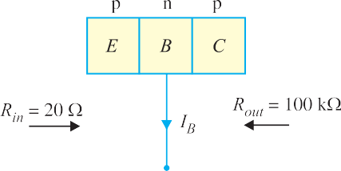
* The reason is as follows. The collector-base junction is reverse biased and has a very high resistance of the order of mega ohms. Thus collector-base voltage has little effect on the collector current. This means that a large resistance RC can be inserted in series with collector without disturbing the collector current relation to the emitter current viz. IC = αIE + ICBO. Therefore, collector current variations caused by a small base- emitter voltage fluctuations result in voltage changes in RC that are quite high—often hundreds of times larger than the emitter-base voltage.
** The d.c. biasing is omitted in the figure because our interest is limited to amplification.
Fig. 8.8

Input current, I
= Signal
= 500 mV
= 25 mA. Since α

is nearly 1, output current, I

= I =

25 mA.
E Rin
20 ∧ ac C E

Output voltage, Vout = IC RC = 25 mA × 1 k∧ = 25 V

∴ Voltage amplification, A =
Vout
= 25 V
= 50

v signal 500 mV
Comments. The reader may note that basic amplifying action is produced by transferring a current from a low-resistance to a high-resistance circuit. Consequently, the name transistor is given to the device by combining the two terms given in magenta letters below :
Transfer + Resistor ⎯→ Transistor

Transistor Connections
There are three leads in a transistor viz., emitter, base and collector terminals. However, when a transistor is to be connected in a circuit, we require four terminals; two for the input and two for the output. This difficulty is overcome by making one terminal of the transistor common to both input and output terminals. The input is fed between this common terminal and one of the other two terminals. The output is obtained between the common terminal and the remaining terminal. Accord- ingly; a transistor can be connected in a circuit in the following three ways :
    - common base connection (ii) common emitter connection
(iii) common collector connection
Each circuit connection has specific advantages and disadvantages. It may be noted here that regardless of circuit connection, the emitter is always biased in the forward direction, while the col- lector always has a reverse bias.

Common Base Connection
In this circuit arrangement, input is applied between emitter and base and output is taken from collec- tor and base. Here, base of the transistor is common to both input and output circuits and hence the name common base connection. In Fig. 8.9 (i), a common base npn transistor circuit is shown whereas Fig. 8.9 (ii) shows the common base pnp transistor circuit.
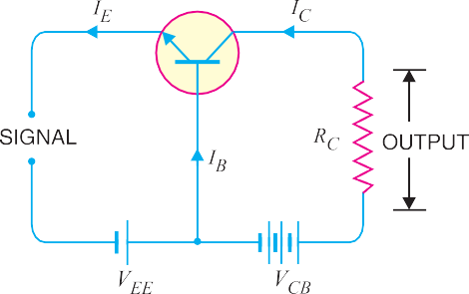
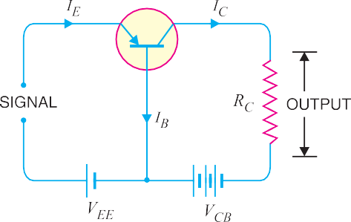

Fig. 8.9
- Current amplification factor (α). It is the ratio of output current to input current. In a common base connection, the input current is the emitter current IE and output current is the collector current IC.
The ratio of change in collector current to the change in emitter current at constant collector- base voltage VCB is known as current amplification factor i.e.

*α =
⊗IC ⊗IE
at constant VCB

It is clear that current amplification factor is less than **unity. This value can be increased (but not more than unity) by decreasing the base current. This is achieved by making the base thin and doping it lightly. Practical values of α in commercial transistors range from 0.9 to 0.99.
- Expression for collector current. The whole of emitter current does not reach the collector. It is because a small percent-
Fig. 8.10
age of it, as a result of electron-hole combinations occurring in base area, gives rise to base current. Moreover, as the collector-base junction is reverse biased, therefore, some leakage current flows due to minority carriers. It follows, therefore, that total collector current consists of :
- That part of emitter current which reaches the collector terminal i.e. ***α IE.
- The leakage current Ileakage. This current is due to the movement of minority carriers across base-collector junction on account of it being reverse biased. This is generally much smaller than
α IE.
∴ Total collector current, IC = α IE + Ileakage
It is clear that if IE = 0 (i.e., emitter circuit is open), a small leakage current still flows in the collector circuit. This Ileakage is abbreviated as ICBO, meaning collector-base current with emitter open. The ICBO is indicated in Fig. 8.10.
∴ IC = α IE + ICBO ...(i)
Now IE = IC + IB
∴ IC = α (IC + IB) + ICBO
or IC (1 − α) = α IB + ICBO

or IC =
α I +
1 −α B
ICBO
1 −α
...(ii)

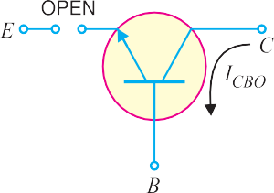
Relation (i) or (ii) can be used to find IC. It is further clear from these relations that the collector current of a transistor can be controlled by either the emitter or base current.
Fig. 8.11 shows the concept of ICBO. In CB configuration, a small collector current flows even when the emitter current is zero. This is the leakage collector current (i.e. the collector current when
emitter is open) and is denoted by ICBO. When the emitter voltage VEE is also applied, the various currents are as shown in Fig. 8.11 (ii).
Note. Owing to improved construction techniques, the magnitude of ICBO for general-purpose and low-powered transistors (especially silicon transistors) is usually very small and may be neglected in calculations. However, for high power applications, it will appear in microampere range. Further, ICBO is very much temperature dependent; it increases rapidly with the increase in temperature. Therefore, at higher temperatures, ICBO plays
an important role and must be taken care of in calculations.
E
In other words, α IE part of emitter current reaches the collector terminal.
E
C
∴ I = α I
I
IC
α =
***
* If only d.c. values are considered, then α = IC/IE.
** At first sight, it might seem that since there is no current gain, no voltage or power amplification could be possible with this arrangement. However, it may be recalled that output circuit resistance is much higher than the input circuit resistance. Therefore, it does give rise to voltage and power gain.

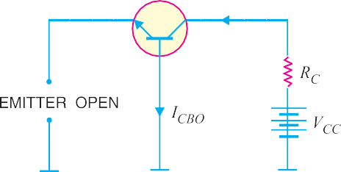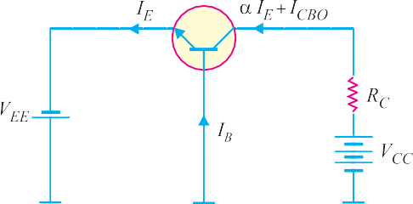

Fig. 8.11

Example 8.2. In a common base connection, IE = 1mA, IC = 0.95mA. Calculate the value of IB.
Solution. Using the relation, | IE | = | IB + IC
or | 1 | = | IB + 0.95
∴ | IB | = | 1 − 0.95 = 0.05 mA
Example 8.3. In a common base connection, current amplification factor is 0.9. If the emitter current is 1mA, determine the value of base current.
Solution. Here, α = 0.9, IE = 1 mA
IC
I
Now α =
E

or  Also | IC  IE | =  = | α IE = 0.9 × 1 = 0.9 mA  IB + IC
∴ | Base current, IB | = | IE − IC = 1 − 0.9 = 0.1 mA
Example 8.4. In a common base connection, IC = 0.95 mA and IB = 0.05 mA. Find the value of α.
Solution. We know IE = IB + IC = 0.05 + 0.95 = 1 mA

∴ Current amplification factor, α =
IC =
IE
0.95
1

= 0.95

Example 8.5. In a common base connection, the emitter current is 1mA. If the emitter circuit is open, the collector current is 50 µA. Find the total collector current. Given that α = 0.92.
Solution. Here, IE = 1 mA, α = 0.92, ICBO = 50 µA
∴ Total collector current, I = α I + I = 0.92 × 1 + 50 × 10⁻³
C E CBO
= 0.92 + 0.05 = 0.97 mA
Example 8.6. In a common base connection, α = 0.95. The voltage drop across 2 k∧ resistance which is connected in the collector is 2V. Find the base current.
Solution. Fig. 8.12 shows the required common base connection. The voltage drop across RC (= 2 k∧) is 2V.
∴ IC = 2 V/2 k∧ = 1 mA
Now α = IC/IE

∴ IE =
IC =
α
1
0.95
= 1.05 mA

Using the relation, IE = IB + IC
∴ IB = IE − IC = 1.05 − 1
= 0.05 mA
Example 8.7. For the common base circuit shown in Fig. 8.13, determine IC and VCB. Assume the transistor to be of silicon.
Solution. Since the transistor is of silicon, VBE = 0.7V. Applying Kirchhoff’s voltage law to the emitter-side loop, we get,
VEE = IE RE + VBE
Fig. 8.12
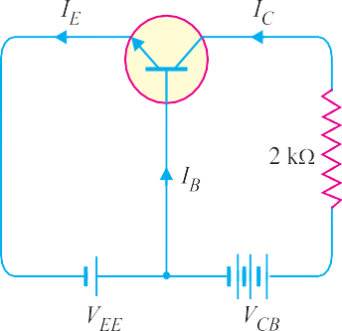
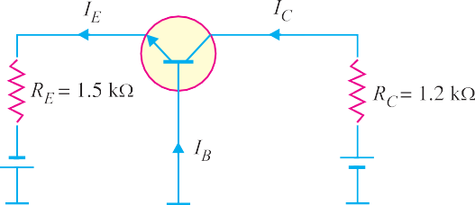VEE − VBE
or IE = RE

= 8V − 0.7V
1.5 k∧
= 4.87 mA

∴ IC j IE = 4.87 mA
Applying Kirchhoff’s voltage law to the collector-side loop, we have,
VCC = IC RC + VCB
Fig. 8.13
∴ VCB = VCC − IC RC
= 18 V − 4.87 mA × 1.2 k∧ = 12.16 V

Characteristics of Common Base Connection
The complete electrical behaviour of a transistor can be described by stating the interrelation of the various currents and voltages. These relationships can be conveniently displayed graphically and the curves thus obtained are known as the characteristics of transistor. The most important characteristics of common base connection are input characteristics and output characteristics.
- Input characteristic. It is the curve between emitter current IE and emitter-base voltage
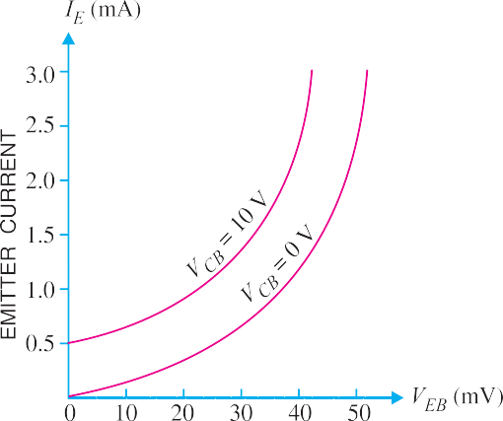
VEB at constant collector-base voltage VCB. The emitter current is generally taken along y-axis and emitter-base voltage along x-axis. Fig. 8.14
shows the input characteristics of a typical tran- sistor in CB arrangement . The following points may be noted from these characteristics :
- The emitter current IE increases rapidly with small increase in emitter-base voltage VEB. It means that input resistance is very small.
- The emitter current is almost independent of collector-base voltage VCB. This leads to the conclusion that emitter current (and hence collector current) is almost independent of collector voltage.
Input resistance. It is the ratio of change in emitter-base voltage (⊗VEB) to the resulting
Fig. 8.14

change in emitter current (⊗IE) at constant collector-base voltage (VCB) i.e.

Input resistance, ri =
⊗VBE ⊗IE
at constant VCB

In fact, input resistance is the opposition offered to the signal current. As a very small VEB is sufficient to produce a large flow of emitter current IE, therefore, input resistance is quite small, of the order of a few ohms.
- Output characteristic. It is the curve between collector current IC and collector-base volt- age VCB at *constant emitter current IE. Generally, collector current is taken along y-axis and collec- tor-base voltage along x-axis. Fig. 8.15 shows the output characteristics of a typical transistor in CB arrangement.
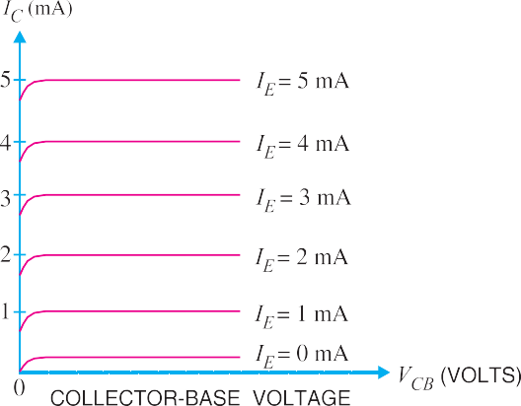
The following points may be noted from the characteristics :
- The collector current IC varies with VCB only at very low voltages ( < 1V). The transistor is never operated in this re-
gion.
- When the value of VCB is raised above 1 − 2 V, the collector current be-
comes constant as indicated by straight horizontal curves. It means that now IC is independent of VCB and depends upon IE
only. This is consistent with the theory that
the emitter current flows almost entirely to the collector terminal. The transistor is always operated in this region.
Fig. 8.15
- A very large change in collector-base voltage produces only a tiny change in collector cur- rent. This means that output resistance is very high.
Output resistance. It is the ratio of change in collector-base voltage (⊗VCB) to the resulting change in collector current (⊗IC) at constant emitter current i.e.

Output resistance, ro =
⊗VCB ⊗IC
at constant IE

The output resistance of CB circuit is very high, of the order of several tens of kilo-ohms. This is not surprising because the collector current changes very slightly with the change in VCB.

Common Emitter Connection
In this circuit arrangement, input is applied between base and emitter and output is taken from the collector and emitter. Here, emitter of the transistor is common to both input and output circuits and hence the name common emitter connection. Fig. 8.16 (i) shows common emitter npn transistor circuit whereas Fig. 8.16 (ii) shows common emitter pnp transistor circuit.
* IE has to be kept constant because any change in IE will produce corresponding change in IC. Here, we are interested to see how VCB influences IC.

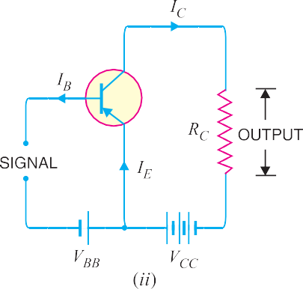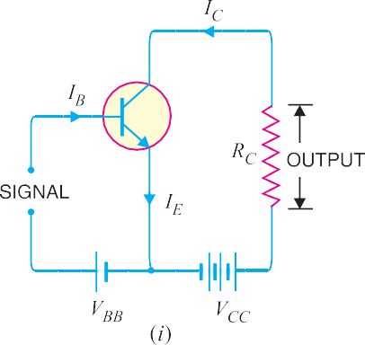
Fig. 8.16
- Base current amplification factor ( β). In common emitter connection, input current is IB
and output current is IC.
The ratio of change in collector current (⊗IC) to the change in base current (⊗IB) is known as

base current amplification factor i.e.

β* =
⊗IC ⊗IB

In almost any transistor, less than 5% of emitter current flows as the base current. Therefore, the value of β is generally greater than 20. Usually, its value ranges from 20 to 500. This type of connection is frequently used as it gives appreciable current gain as well as voltage gain.
Relation between β and α. A simple relation exists between β and α. This can be derived as follows :

β = ⊗IC ⊗IB

...(i)

α = ⊗IC ⊗IE
Now IE = IB + IC
or ⊗IE = ⊗IB + ⊗IC
or ⊗IB = ⊗IE − ⊗IC
Substituting the value of ⊗ IB in exp. (i), we get,

...(ii)

β = ⊗IC
⊗IE − ⊗IC
...(iii)

Dividing the numerator and denominator of R.H.S. of exp. (iii) by ⊗IE, we get,
⊗I

⊗IC / ⊗IE α

⎡ ⊗IC ⎤

β =
⊗IE −
⊗IE
⊗IC ⊗IE
= 1 −α
⎢Q α= ⎥
E ⎦
⎣

∴ β = 1 α
−α
It is clear that as α approaches unity, β approaches infinity. In other words, the current gain in common emitter connection is very high. It is due to this reason that this circuit arrangement is used in about 90 to 95 percent of all transistor applications.
* If d.c. values are considered, β = IC /IB.

- Expression for collector current. In common emitter circuit, IB is the input current and IC
is the output current.
We know IE = IB + IC ...(i)
and IC = α IE + ICBO ...(ii)
From exp. (ii), we get, IC = α IE + ICBO = α (IB + IC) + ICBO
or IC (1 − α) = α IB + ICBO

or IC =

α I
1 −α B
+ 1 I
1 −α
CBO
...(iii)

From exp. (iii), it is apparent that if IB = 0 (i.e. base circuit is open), the collector current will be the current to the emitter. This is abbreviated as ICEO, meaning collector-emitter current with base open.

∴ ICEO
= 1 ICBO

Substituting the value of 1 I
1 −α
CBO
1 −α
= ICEO in exp. (iii), we get,

I = α I
C 1 −α B
- ICEO

⎛ α ⎞

or IC = β IB + ICEO
⎜Q β = ⎟

⎝ 1 −α ⎠
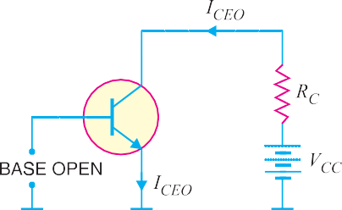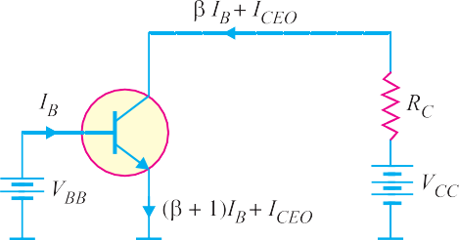Concept of ICEO. In CE configuration, a small collector current flows even when the base current is zero [See Fig. 8.17 (i)]. This is the collector cut off current (i.e. the collector current that flows when base is open) and is denoted by ICEO. The value of ICEO is much larger than ICBO.

Fig. 8.17
When the base voltage is applied as shown in Fig. 8.17 (ii), then the various currents are :
Base current = IB
Collector current = β IB + ICEO
Emitter current = Collector current + Base current
= (β IB + ICEO) + IB = (β + 1) IB + ICEO

It may be noted here that :

1

⎡ 1 ⎤
⎣ ⎦

ICEO =
1 −α ICBO = (β + 1) ICBO
⎢Q 1 −α = β + 1⎥

Measurement of Leakage Current
A very small leakage current flows in all transistor circuits. However, in most cases, it is quite small and can be neglected.
    - Circuit for ICEO test. Fig. 8.18 shows the circuit for measuring ICEO. Since base is open

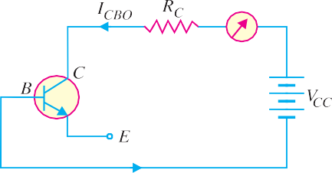
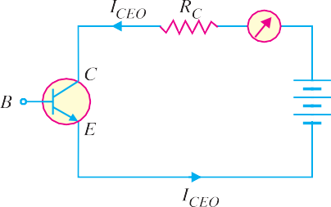
(IB = 0), the transistor is in cut off. Ideally, IC = 0 but actually there is a small current from collector to emitter due to minority carriers. It is called ICEO (collector-to-emitter current with base open). This current is usually in the nA range for silicon. A faulty transistor will often have excessive leakage current.

Fig. 8.18
Fig. 8.19
    - Circuit for ICBO test. Fig. 8.19 shows the circuit for measuring ICBO. Since the emitter is open (IE = 0), there is a small current from collector to base. This is called ICBO (collector-to-base current with emitter open). This current is due to the movement of minority carriers across base- collector junction. The value of ICBO is also small. If in measurement, ICBO is excessive, then there is a possibility that collector-base is shorted.
Example 8.8. Find the value of β if (i) α = 0.9 (ii) α = 0.98 (iii) α = 0.99.

Solution. (i) β =

      - β =

      - β =

α =
1 −α

α =
1 −α

α =
1 −α
Example 8.9. Calculate IE in a transistor for which β = 50 and IB = 20 µA.
0.9
1 − 0.9
0.98
1 − 0.98
0.99
1 − 0.99
= 9

= 49

= 99

Solution. Here β = 50, IB = 20µA = 0.02 mA

Now β = IC
IB
∴ IC = β IB = 50 × 0.02 = 1 mA
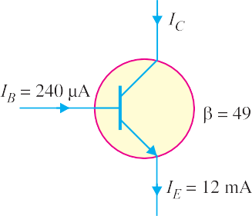
Using the relation, IE = IB + IC = 0.02 + 1 = 1.02 mA
Example 8.10. Find the α rating of the transistor shown in Fig. 8.20. Hence determine the value of IC using both α and β rating of the transistor.
Solution. Fig. 8.20 shows the conditions of the problem.

α = β =
1 +β
49
1 + 49

= 0.98

The value of IC can be found by using either α or β rating as under :
IC = α IE = 0.98 (12 mA) = 11.76 mA
Also IC = β IB = 49 (240 µA) = 11.76 mA
Fig. 8.20

Example 8.11. For a transistor, β = 45 and voltage drop across 1k∧ which is connected in the collector circuit is 1 volt. Find the base current for common emitter connec- tion.
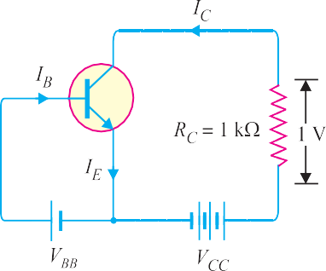
Solution. Fig. 8.21 shows the required common emit- ter connection. The voltage drop across RC (= 1 k∧) is 1volt.

∴ IC

= 1 V
1 k ∧
= 1 mA

Now β =

∴ IB =

IC IB

IC = 1
β 45

Fig. 8.21

= 0.022 mA

Example 8.12. A transistor is connected in com- mon emitter (CE) configuration in which collector sup- ply is 8V and the voltage drop across resistance RC connected in the collector circuit is 0.5V. The value of RC = 800 ∧. If α = 0.96, determine :
- collector-emitter voltage
- base current
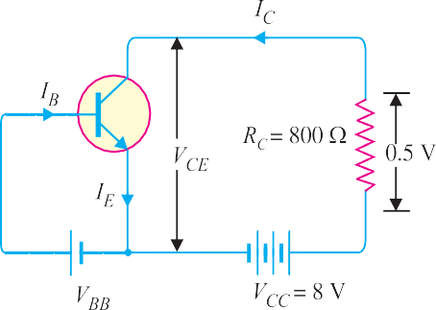
Solution. Fig. 8.22 shows the required common
emitter connection with various values.
- Collector-emitter voltage,
VCE = VCC − 0.5 = 8 − 0.5 = 7.5 V
Fig. 8.22
- The voltage drop across RC (= 800 ∧ ) is 0.5 V.

∴ IC
= 0.5 V 800 ∧
= 5 mA = 0.625 mA
8

Now β =

α =
1 −α
0.96
1 − 0.96
= 24

∴ Base current, IB =

IC =
β
0.625
24
= 0.026 mA

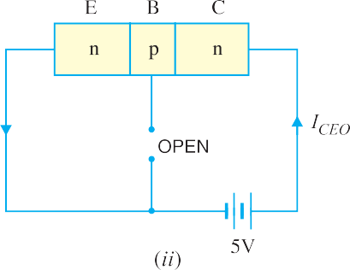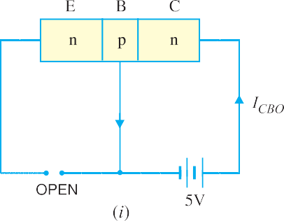
Fig. 8.23
Example 8.13. An n-p-n transistor at room temperature has its emitter disconnected. A voltage of 5V is applied between collector and base. With collector positive, a current of 0.2 µA flows. When the base is disconnected and the same voltage is applied between collector and emitter, the current is found to be 20 µA. Find α, IE and IB when collector current is 1mA.

Solution. When the emitter circuit is open [See Fig. 8.23 (i)], the collector-base junction is reverse biased. A small leakage current ICBO flows due to minority carriers.
∴ ICBO = 0.2 µA ...given
When base is open [See Fig. 8.23 (ii)], a small leakage current ICEO flows due to minority carriers.
∴ ICEO = 20 µA . . . given

We know I
CEO =
ICBO
1 −α

or 20 = 0.2
 |  |  | 1 −α
∴ | α | = | 0.99
Now | IC | = | α IE + ICBO
Here | IC | = | 1mA = 1000 µA ; α = 0.99 ; ICBO = 0.2 µA
∴ | 1000 | = | 0.99 × IE + 0.2

or IE
= 1000 − 0.2
0.99
= 1010 µA

and IB = IE − IC = 1010 − 1000 = 10 µA
Example 8.14. The collector leakage current in a transistor is 300 μA in CE arrangement. If now
the transistor is connected in CB arrangement, what will be the leakage current? Given that β = 120.
Solution. ICEO = 300 μA

β = 120 ; α = β = 120 = 0.992
β + +
1 120 1
ICBO
Now, ICEO = 1– α
∴ ICBO = (1 – α) ICEO = (1 – 0.992) × 300 = 2.4 μA
Note that leakage current in CE arrangement (i.e. ICEO) is much more than in CB arrangement (i.e. ICBO).
Example 8.15. For a certain transistor, IB = 20 μA; IC = 2 mA and β = 80. Calculate ICBO.

Solution.
IC = βIB + ICEO
or 2 = 80 × 0.02 + ICEO
∴ ICEO = 2 – 80 × 0.02 = 0.4 mA

Now α =

β = 80
β + 1 80 + 1

= 0.988

∴ ICBO = (1 – α) ICEO = (1 – 0.988) × 0.4 = 0.0048 mA
Example 8.16. Using diagrams, explain the correctness of the relation ICEO = (β + 1) ICBO.
Solution. The leakage current ICBO is the current that flows through the base-collector junction when emitter is open as shown is Fig. 8.24. When the transistor is in CE arrangement, the *base current (i.e. ICBO) is multiplied by β in the collector as shown in Fig. 8.25.
∴ ICEO = ICBO + βICBO = (β + 1) ICBO
* The current ICBO is amplified because it is forced to flow across the base-emitter junction.

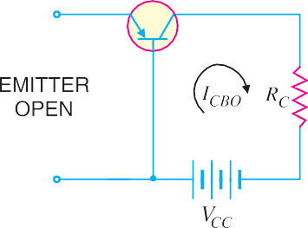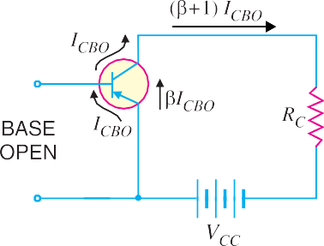
Fig. 8.24
Fig. 8.25

Example 8.17 Determine VCB in the transistor * circuit shown in Fig. 8.26 (i). The transistor is of silicon and has β = 150.
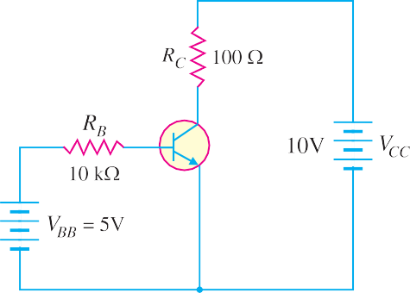
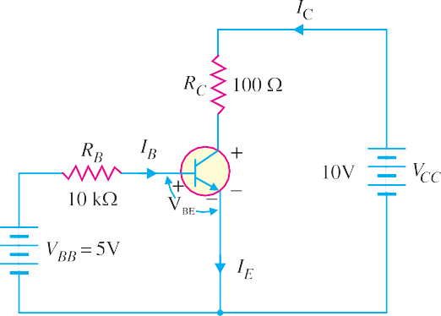

Fig. 8.26
Solution. Fig. 8.26 (i) shows the transistor circuit while Fig. 8.26 (ii) shows the various currents and voltages along with polarities.
Applying Kirchhoff’s voltage law to base-emitter loop, we have,
VBB – IB RB – VBE = 0

or I
= VBB – VBE = 5V – 0.7V

= 430 μA

B RB
10 k∧

∴ IC = βIB = (150)(430 μA) = 64.5 mA
Now VCE = VCC – IC RC
= 10V – (64.5 mA) (100∧) = 10V – 6.45V = 3.55V
We know that : VCE = VCB + VBE
∴ VCB = VCE – VBE = 3.55 – 0.7 = 2.85V
Example 8.18. In a transistor, IB = 68 μA, IE = 30 mA and β = 440. Determine the α rating of the transistor. Then determine the value of IC using both the α rating and β rating of the transistor.

Solution.

α = β = 440 = 0.9977
β + +
1 440 1

* The resistor RB controls the base current IB and hence collector current IC ( = βIB). If RB is increased, the base current (IB) decreases and hence collector current (IC) will decrease and vice-versa.

IC = α IE = (0.9977) (30 mA) = 29.93 mA
Also IC = β IB = (440) (68 μA) = 29.93 mA
Example 8.19. A transistor has the following ratings : IC (max) = 500 mA and βmax = 300.
Determine the maximum allowable value of IB for the device.

Solution.

IB (max) =

IC (max)

βmax
= 500 mA
300

= 1.67 mA

For this transistor, if the base current is allowed to exceed 1.67 mA, the collector current will exceed its maximum rating of 500 mA and the transistor will probably be destroyed.
Example 8.20. Fig. 8.27 shows the open circuit failures in a transistor. What will be the circuit behaviour in each case ?

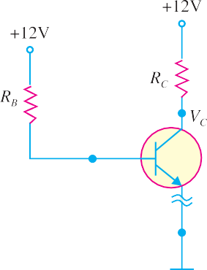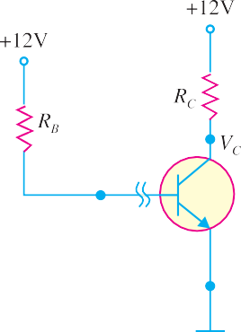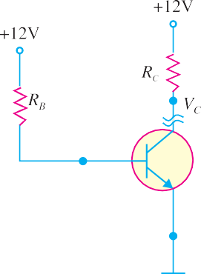

Fig. 8.27
Solution. *Fig 8.27 shows the open circuit failures in a transistor. We shall discuss the circuit behaviour in each case.
- Open emitter. Fig. 8.27 (i) shows an open emitter failure in a transistor. Since the collector diode is not forward biased, it is OFF and there can be neither collector current nor base current. Therefore, there will be no voltage drops across either resistor and the voltage at the base and at the collector leads of the transistor will be 12V.
- Open-base. Fig. 8.27 (ii) shows an open base failure in a transistor. Since the base is open, there can be no base current so that the transistor is in cut-off. Therefore, all the transistor currents are 0A. In this case, the base and collector voltages will both be at 12V.
Note. It may be noted that an open failure at either the base or emitter will produce similar results.
- Open collector. Fig. 8.27 (iii) shows an open collector failure in a transistor. In this case, the emitter diode is still ON, so we expect to see 0.7V at the base. However, we will see 12V at the collector because there is no collector current.
Example 8.21. Fig. 8.28 shows the short circuit failures in a transistor. What will be the circuit behaviour in each case ?
* The collector resistor RC controls the collector voltage VC (= VCC – ICRC). When RC increases, VC decreases and vice-versa.

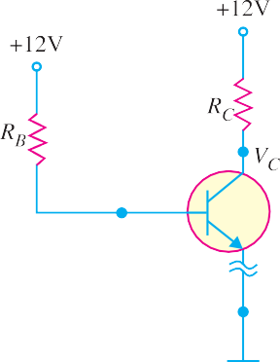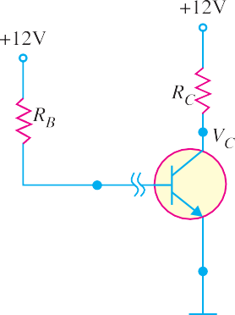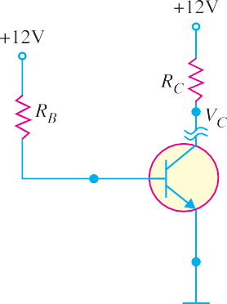

Fig. 8.28
Solution. Fig. 8.28 shows the short circuit failures in a transistor. We shall discuss the circuit behaviour in each case.
- Collector-emitter short. Fig. 8.28 (i) shows a short between collector and emitter. The emitter diode is still forward biased, so we expect to see 0.7V at the base. Since the collector is shorted to the emitter, VC = VE = 0V.
- Base -emitter short. Fig 8.28 (ii) shows a short between base and emitter. Since the base is now directly connected to ground, VB = 0. Therefore, the current through RB will be diverted to ground and there is no current to forward bias the emitter diode. As a result, the transistor will be cut-
off and there is no collector current. So we will expect the collector voltage to be 12V.
- Collector-base short. Fig. 8.28 (iii) shows a short between the collector and the base. In this case, the emitter diode is still forward biased so VB = 0.7V. Now, however, because the collector is shorted to the base, VC = VB = 0.7V.
Note. The collector-emitter short is probably the most common type of fault in a transistor. It is because the collector current (IC) and collector-emitter voltage (VCE) are responsible for the major part of the power dissipation in the transistor. As we shall see (See Art. 8.23), the power dissipation in
a transistor is mainly due to IC and VCE (i.e. PD = VCE IC). Therefore, the transistor chip between the collector and the emitter is most likely to melt first.

Characteristics of Common Emitter Connection
The important characteristics of this circuit arrangement are the input characteristics and output characteristics.
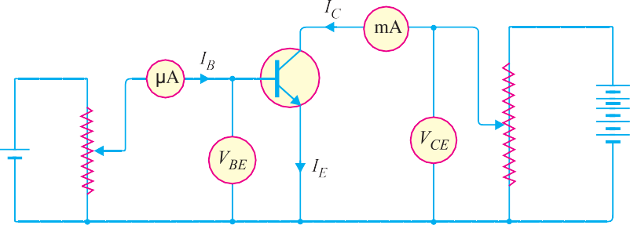
Fig. 8.29

- Input characteristic. It is the curve between base current IB and base-emitter voltage VBE at constant collector-emitter voltage VCE.
The input characteristics of a CE connection can be determined by the circuit shown in Fig. 8.29. Keeping VCE constant (say at 10 V), note the base current IB for various values of VBE. Then plot the readings obtained on the graph, taking IB along y-
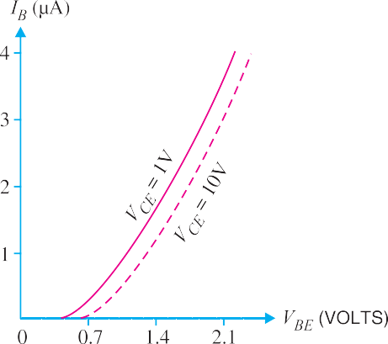
axis and VBE along x-axis. This gives the input char-
acteristic at VCE = 10V as shown in Fig. 8.30. Fol- lowing a similar procedure, a family of input charac- teristics can be drawn. The following points may be
noted from the characteristics :
- The characteristic resembles that of a for- ward biased diode curve. This is expected since the base-emitter section of transistor is a diode and it is forward biased.
- As compared to CB arrangement, IB increases less rapidly with VBE. Therefore, input resistance of a CE circuit is higher than that of CB circuit.
Input resistance. It is the ratio of change in base-emitter voltage (⊗VBE) to the change in base current (⊗IB) at constant VCE i.e.
Fig. 8.30

Input resistance, ri =
⊗VBE ⊗IB
at constant VCE

The value of input resistance for a CE circuit is of the order of a few hundred ohms.
- Output characteristic. It is the curve between collector current IC and collector-emitter voltage VCE at constant base current IB.
The output characteristics of a CE circuit can be drawn with the help of the circuit shown in Fig.
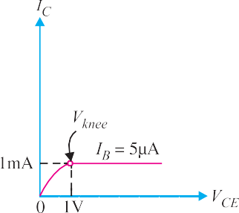
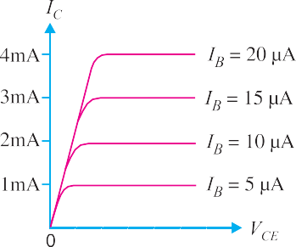
  - 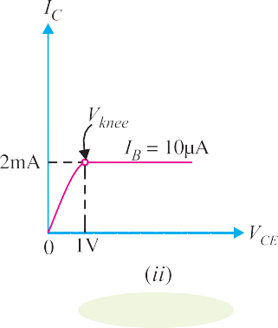Keeping the base current IB fixed at some value say, 5 µA, note the collector current IC for various values of VCE. Then plot the readings on a graph, taking IC along y-axis and VCE along x-axis. This gives the output characteristic at IB = 5 µA as shown in Fig. 8.31 (i). The test can be repeated for IB = 10 µA to obtain the new output characteristic as shown in Fig. 8.31 (ii). Following similar procedure, a family of output characteristics can be drawn as shown in Fig. 8.31 (iii).
Fig. 8.31

The following points may be noted from the characteristics:
    - The collector current IC varies with VCE for VCE between 0 and 1V only. After this, collector current becomes almost constant and independent of VCE. This value of VCE upto which collector

current IC changes with VCE is called the knee voltage (Vknee). The transistors are always operated in the region above knee voltage.
    - Above knee voltage, IC is almost constant. However, a small increase in IC with increasing VCE is caused by the collector depletion layer getting wider and capturing a few more majority carri- ers before electron-hole combinations occur in the base area.
    - For any value of VCE above knee voltage, the collector current IC is approximately equal to
β × IB.
Output resistance. It is the ratio of change in collector-emitter voltage (⊗VCE) to the change in collector current (⊗IC) at constant IB i.e.

Output resistance, ro =
⊗VCE ⊗IC
at constant IB

It may be noted that whereas the output characteristics of CB circuit are horizontal, they have noticeable slope for the CE circuit. Therefore, the output resistance of a CE circuit is less than that of CB circuit. Its value is of the order of 50 k∧.

Common Collector Connection
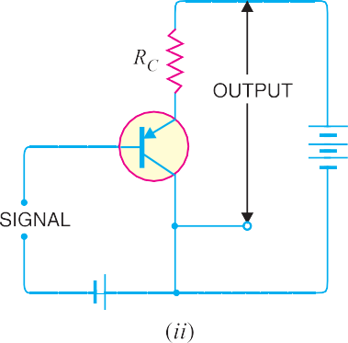
In this circuit arrangement, input is applied between base and collector while output is taken between the emitter and collector. Here, collector of the transistor is common to both input and output circuits and hence the name common collector connection. Fig. 8.32 (i) shows common collector npn transis- tor circuit whereas Fig. 8.32 (ii) shows common collector pnp circuit.

Fig. 8.32
- Current amplification factor γ. In common collector circuit, input current is the base current IB and output current is the emitter current IE. Therefore, current amplification in this circuit arrangement can be defined as under :
The ratio of change in emitter current (⊗IE) to the change in base current (⊗IB) is known as
current amplification factor in common collector (CC) arrangement i.e.

= ⊗IE
γ
⊗IB
This circuit provides about the same current gain as the common emitter circuit as ⊗IE j ⊗IC. However, its voltage gain is always less than 1.

Relation between γ and α

γ = ⊗IE
⊗IB

⊗IC
α = ⊗IE
...(i)

...(ii)

Now | IE | = | IB + IC
or | ⊗IE | = | ⊗IB + ⊗IC
or | ⊗IB | = | ⊗IE – ⊗IC
Substituting the value of ⊗IB in exp. (i), we get,
γ = ⊗IE
⊗IE − ⊗IC
Dividing the numerator and denominator of R.H.S. by ⊗IE, we get,

⊗IE
⊗I

⊗IE 1

⎛ ⊗IC ⎞

γ =
⊗IE −
⊗IE
⊗IC ⊗IE
= 1 −α
⎜Q α = ⎟
⎝ E ⎠

1
∴ γ =
1 −α

Expression for collector current
We know | IC | = | α IE + ICBO | (See Art. 8.8)
Also | IE | = | IB + IC = IB + (α IE + ICBO)
∴ IE (1 – α) = IB + ICBO

or IE =

IB +
1 −α
ICBO
1 −α

or IC ; IE = *(β + 1) IB + (β + 1) ICBO
- Applications. The common collector circuit has very high input resistance (about 750 k∧) and very low output resistance (about 25 ∧). Due to this reason, the voltage gain provided by this circuit is always less than 1. Therefore, this circuit arrangement is seldom used for amplification. However, due to relatively high input resistance and low output resistance, this circuit is primarily used for impedance matching i.e. for driving a low impedance load from a high impedance source.

Comparison of Transistor Connections
The comparison of various characteristics of the three connections is given below in the tabular form.

S. No. | Characteristic | Common base | Common emitter | Common collector
1. | Input resistance | Low (about 100 ∧) | Low (about 750 ∧) | Very high (about 750 k∧)
2. | Output resistance | Very high (about | High (about 45 k∧) | Low (about 50 ∧)
 |  | 450 k∧)
3.  4. | Voltage gain Applications | about 150  For high frequency | about 500  For audio frequency | less than 1  For impedance
 |  | applications | applications | Matching
5. | Current gain | No (less than 1) | High (β) | Appreciable
The following points are worth noting about transistor arrangements :
*
β = α
1 −α
∴ β + 1 = α + 1 = 1
1 −α
1 −α

- CB Circuit. The input resistance (ri) of CB circuit is low because IE is high. The output resistance (ro) is high because of reverse voltage at the collector. It has no current gain (α < 1) but voltage gain can be high. The CB circuit is seldom used. The only advantage of CB circuit is that it provides good stability against increase in temperature.
- CE Circuit. The input resistance (ri) of a CE circuit is high because of small IB. Therefore, ri for a CE circuit is much higher than that of CB circuit. The output resistance (ro) of CE circuit is smaller than that of CB circuit. The current gain of CE circuit is large because IC is much larger than IB. The voltage gain of CE circuit is larger than that of CB circuit. The CE circuit is generally used because it has the best combination of voltage gain and current gain. The disadvantage of CE circuit is that the leakage current is amplified in the circuit, but bias stabilisation methods can be used.
- CC Circuit. The input resistance (ri) and output resistance (ro) of CC circuit are respec- tively high and low as compared to other circuits. There is no voltage gain (Av < 1) in a CC circuit. This circuit is often used for impedance matching.

Commonly Used Transistor Connection
Out of the three transistor connections, the common emitter circuit is the most efficient. It is used in about 90 to 95 per cent of all transistor applications. The main reasons for the widespread use of this circuit arrangement are :
- High current gain. In a common emitter connection, IC is the output current and IB is the input current. In this circuit arrangement, collector current is given by :
IC = β IB + ICEO
As the value of β is very large, therefore, the output current IC is much more than the input current IB. Hence, the current gain in CE arrangement is very high. It may range from 20 to 500.
- High voltage and power gain. Due to high current gain, the common emitter circuit has the highest voltage and power gain of three transistor connections. This is the major reason for using the transistor in this circuit arrangement.
- Moderate output to input impedance ratio. In a common emitter circuit, the ratio of output impedance to input impedance is small (about 50). This makes this circuit arrangement an ideal one for coupling between various transistor stages. However, in other connections, the ratio of output impedance to input impedance is very large and hence coupling becomes highly inefficient due to gross mismatching.

Transistor as an Amplifier in CE Arrangement
Fig. 8.33 shows the common emitter npn amplifier circuit. Note that a battery VBB is connected in the input circuit in addition to the signal voltage. This d.c. voltage is known as bias voltage and its magnitude is such that it always keeps the emitter-base junction forward *biased regardless of the polarity of the signal source.
Operation. During the positive half-cycle of the **signal, the forward bias across the emitter-base junction is increased. Therefore, more electrons flow from the emitter to the collector via the base. This causes an increase in collector current. The increased collector current produces a greater voltage drop across the collector load resistance RC. However, during the negative half-cycle of the

* If d.c. bias voltage is not provided, then during negative half-cycle of the signal, the emitter-base junction will be reverse biased. This will upset the transistor action.
** Throughout the book, we shall use sine wave signals because these are convenient for testing amplifiers. But it must be realised that signals (e.g. speech, music etc.) with which we work are generally complex having little resemblance to a sine wave. However, fourier series analysis tells us that such complex signals may be expressed as a sum of sine waves of various frequencies.

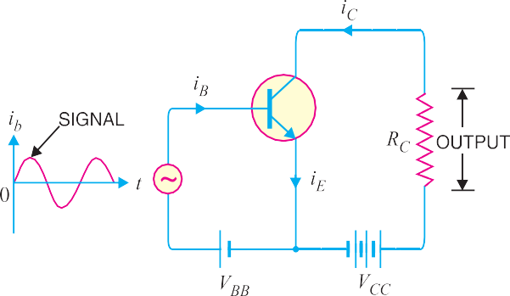
signal, the forward bias across emitter-base junction is decreased. Therefore, collector current de- creases. This results in the decreased output voltage (in the opposite direction). Hence, an amplified output is obtained across the load.
Fig. 8.33
Fig. 8.34

Analysis of collector currents. When no signal is applied, the input circuit is forward biased by the battery VBB. Therefore, a d.c. collector current IC flows in the collector circuit. This is called zero signal collector current. When the signal voltage is applied, the forward bias on the emitter- base junction increases or decreases depending upon whether the signal is positive or negative. During the positive half-cycle of the signal, the forward bias on emitter-base junction is increased, causing total collector current iC to increase. Reverse will happen for the negative half-cycle of the signal.
Fig. 8.34 shows the graph of total collector current iC versus time. From the graph, it is clear that total collector current consists of two components, namely ;
- The d.c. collector current IC (zero signal collector current) due to bias battery VBB. This is the current that flows in the collector in the absence of signal.
- The a.c. collector current ic due to signal.
∴ Total collector current, iC = ic + IC
The useful output is the voltage drop across collector load RC due to the a.c. component ic. The purpose of zero signal collector current is to ensure that the emitter-base junction is forward biased at all times. The table below gives the symbols usually employed for currents and voltages in transistor
applications.

S. No. | Particular | Instantaneous a.c. | d.c. | Total
1. | Emitter current | ie | IE | iE
2. | Collector current | ic | IC | iC
3. | Base current | ib | IB | iB
4.  5. | Collector-emitter voltage Emitter-base voltage | vce veb | VCE VEB | vCE vEB

Transistor Load Line Analysis
In the transistor circuit analysis, it is generally required to determine the collector current for various collector-emitter voltages. One of the methods can be used to plot the output characteristics and determine the collector current at any desired collector-emitter voltage. However, a more convenient method, known as load line method can be used to solve such problems. As explained later in this section, this method is quite easy and is frequently used in the analysis of transistor applications.

d.c. load line. Consider a common emitter npn transistor circuit shown in Fig. 8.35 (i) where no signal is applied. Therefore, d.c. conditions prevail in the circuit. The output characteristics of this circuit are shown in Fig. 8.35 (ii).
The value of collector-emitter voltage VCE at any time is given by ;
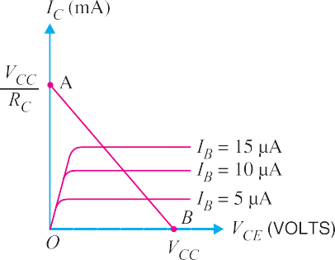
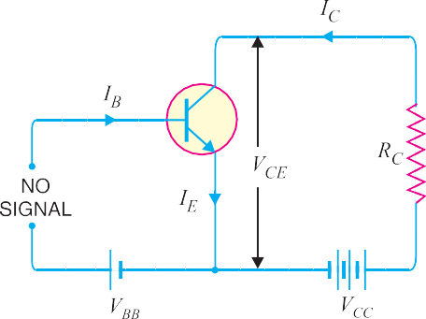VCE = VCC – IC RC ...(i)

Fig. 8.35
As VCC and RC are fixed values, therefore, it is a first degree equation and can be represented by a straight line on the output characteristics. This is known as d.c. load line and determines the locus of VCE − IC points for any given value of RC. To add load line, we need two end points of the straight line. These two points can be located as under :
- When the collector current IC = 0, then collector-emitter voltage is maximum and is equal to
VCC i.e.
Max. VCE = VCC – IC RC
= VCC (ä IC = 0)
This gives the first point B (OB = VCC) on the collector-emitter voltage axis as shown in Fig. 8.35 (ii).
- When collector-emitter voltage VCE = 0, the collector current is maximum and is equal to
VCC /RC i.e.
VCE = VCC − IC RC
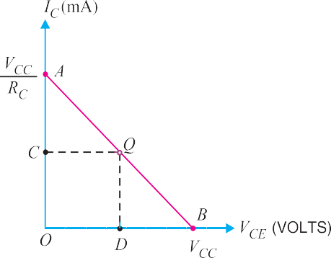
or 0 = VCC − IC RC
∴ Max. IC = VCC /RC
This gives the second point A (OA = VCC /RC) on the collector current axis as shown in Fig. 8.35 (ii). By joining these two points, d.c. *load line AB is constructed.
Importance. The current (IC) and voltage (VCE) conditions in the transistor circuit are represented by some point on the output characteristics. The same information can be obtained from the load line. Thus when IC is maximum (= VCC /RC), then VCE = 0 as shown in Fig. 8.36. If IC = 0, then VCE is maximum
Fig. 8.36
* Why load line ? The resistance RC connected to the device is called load or load resistance for the circuit and, therefore, the line we have just constructed is called the load line.

and is equal to VCC. For any other value of collector current say OC, the collector-emitter voltage VCE
= OD. It follows, therefore, that load line gives a far more convenient and direct solution to the
problem.
Note. If we plot the load line on the output characteristic of the transistor, we can investigate the behaviour of the transistor amplifier. It is because we have the transistor output current and voltage specified in the form of load line equation and the transistor behaviour itself specified implicitly by the output characteristics.

Operating Point
The zero signal values of IC and VCE are known as the operating point.
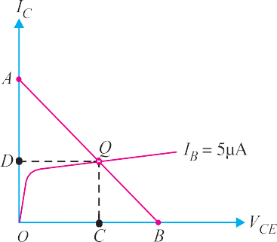
It is called operating point because the variations of IC and VCE take place about this point when signal is applied. It is also called quiescent (silent) point or Q-point because it is the point on IC − VCE characteristic when the transistor is silent i.e. in the absence of the signal.
Suppose in the absence of signal, the base current is 5 µA. Then IC and VCE conditions in the circuit must be repre- sented by some point on IB = 5 µA characteristic. But IC and
VCE conditions in the circuit should also be represented by
some point on the d.c. load line AB. The point Q where the
load line and the characteristic intersect is the only point which satisfies both these conditions. Therefore, the point Q de- scribes the actual state of affairs in the circuit in the zero signal conditions and is called the operating point. Referring to Fig. 8.37, for IB = 5 µA, the zero signal values are :
Fig. 8.37
VCE = OC volts
IC = OD mA
It follows, therefore, that the zero signal values of IC and VCE (i.e. operating point) are deter- mined by the point where d.c. load line intersects the proper base current curve.
Example 8.22. For the circuit shown in Fig. 8.38 (i), draw the d.c. load line.
Solution. The collector-emitter voltage VCE is given by ;
VCE = VCC − IC RC ...(i)
When IC = 0, then,
VCE = VCC = 12.5 V
This locates the point B of the load line on the collector-emitter voltage axis.
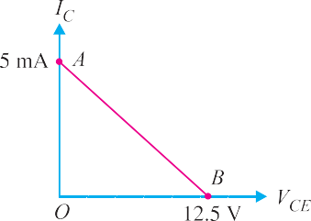
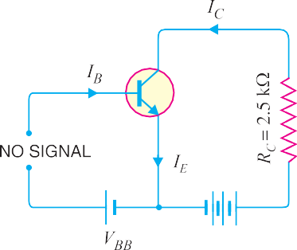

Fig. 8.38

When VCE = 0, then,
IC = VCC/RC = 12.5 V/2.5 k∧ = 5 mA
This locates the point A of the load line on the collector current axis. By joining these two points, we get the d.c. load line AB as shown in Fig. 8.38 (ii).
Example 8.23. In the circuit diagram shown in Fig. 8.39 (i), if VCC = 12V and RC = 6 k∧, draw the d.c. load line. What will be the Q point if zero signal base current is 20µA and β = 50 ?
Solution. The collector-emitter voltage VCE is given by :
VCE = VCC – IC RC
When IC = 0, VCE = VCC = 12 V. This locates the point B of the load line. When VCE = 0, IC = VCC /RC = 12 V/6 k∧ = 2 mA. This locates the point A of the load line. By joining these two points, load line AB is constructed as shown in Fig. 8.39 (ii).
Zero signal base current, IB = 20 µA = 0.02 mA Current amplification factor, β = 50
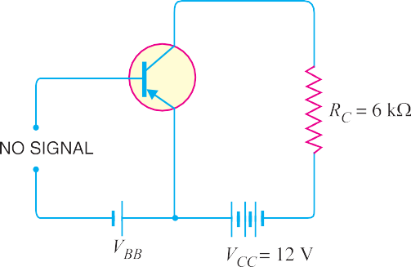
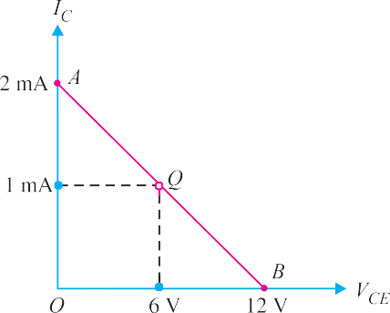
∴ Zero signal collector current, IC = β IB = 50 × 0.02 = 1 mA

Fig. 8.39
Zero signal collector-emitter voltage is
VCE = VCC – IC RC = 12 – 1 mA × 6 k ∧ = 6 V
∴ Operating point is 6 V, 1 mA.
Fig. 8.39 (ii) shows the Q point. Its co-ordinates are IC = 1 mA and VCE = 6 V.
Example 8.24. In a transistor circuit, collector load is 4 k∧ whereas quiescent current (zero
signal collector current) is 1mA.
- What is the operating point if VCC = 10 V ?
- What will be the operating point if RC = 5 k∧ ?
Solution. VCC = 10 V, IC = 1 mA
    - When collector load RC = 4 k ∧ , then,
VCE = VCC – IC RC = 10 – 1 mA × 4 k ∧ = 10 – 4 = 6 V
∴ Operating point is 6 V, 1 mA.
    - When collector load RC = 5 k ∧ , then,
VCE = VCC – IC RC = 10 – 1 mA × 5 k ∧ = 10 – 5 = 5 V
∴ Operating point is 5 V, 1 mA.
Example 8.25. Determine the Q point of the transistor circuit shown in Fig. 8.40. Also draw the
d.c. load line. Given β = 200 and VBE = 0.7V.

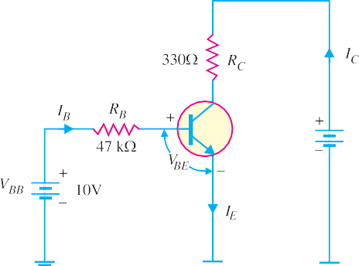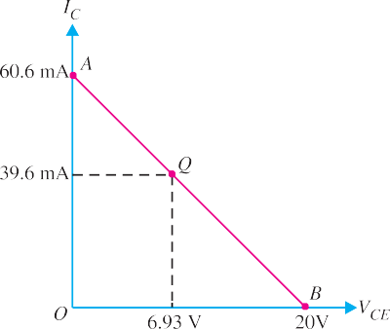
Fig 8.40
Fig. 8.41
Solution. The presence of resistor RB in the base circuit should not disturb you because we can apply Kirchhoff’s voltage law to find the value of IB and hence IC (= βIB). Referring to Fig. 8.40 and applying Kirchhoff’s voltage law to base-emitter loop, we have,
VBB – IB RB – VBE = 0

∴ I =
VBB − VBE = 10V − 0.7V

= 198 μA

B RB
47 k∧

Now IC = βIB = (200)(198 μA) = 39.6 mA
Fig. 8.43
Also VCE = VCC – IC RC = 20V – (39.6mA) (330 ∧) = 20V – 13.07V = 6.93V
Therefore, the Q-point is IC = 39.6 mA and VCE = 6.93V.
D.C. load line. In order to draw the d.c. load line, we need two end points.
VCE = VCC – IC RC
When IC = 0, VCE = VCC = 20V. This locates the point B of the load line on the collector-emitter voltage axis as shown in Fig. 8.41. When VCE = 0, IC = VCC/RC = 20V/330∧ = 60.6 mA. This locates the point A of the load line on the collector current axis. By joining these two points, d.c. load line AB
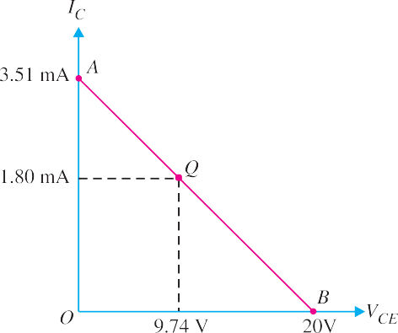
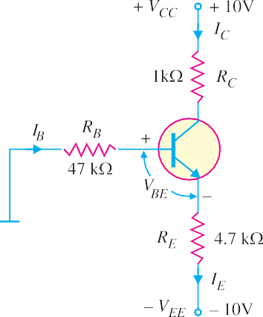is constructed as shown in Fig. 8.41.
Example 8.26. Determine the Q point of the transistor circuit shown in *Fig. 8.42. Also draw the d.c. load line. Given β = 100 and VBE = 0.7V.
Fig. 8.42

* The presence of two power supplies has an effect on the baisc equations for IC and VCE used for single power supply (i.e. VCC). Normally, the two supply voltages will be equal. For example, if VCC = + 10V (d.c.), then VEE = – 10 V (d.c.).

Solution. The transistor circuit shown in Fig. 8.42 may look complex but we can easily apply Kirchhoff’s voltage law to find the various voltages and currents in the * circuit.
Applying Kirchhoff’s voltage law to the base-emitter loop, we have,
– IB RB – VBE – IE RE + VEE = 0 or VEE = IB RB + IE RE + VBE
Now IC = βIB and IC j IE . ∴ IB = IE/β. Putting IB = IE/β in the above equation, we have,

VEE =

⎛ I_{E} ⎞
⎜⎝ β ⎟⎠
RB + IE
RE + VBE

⎛ R_{B} ⎞
or I + R = V – V

or I
VEE − VBE
=

E ⎝⎜ β
E ⎠⎟
EE BE
E RE + RB / β

Since I
j I , I
VEE − VBE
=

10V – 0.7V
=
= 9.3 V
= 1.8 mA

C E C
RE + RB / β
4.7 kΩ + 47 kΩ/100 5.17 k∧

Applying Kirchhoff’s voltage law to the collector side, we have,
VCC – IC RC – VCE – IE RE + VEE = 0
or V_{CE} = V_{CC} + V_{EE} – I_{C} (R_{C} + R_{E}) (Q I_{E} j I_{C})
= 10V + 10V – 1.8 mA (1 k∧ + 4.7 k∧) = 9.74V
Therefore, the operating point of the circuit is IC = 1.8 mA and VCE = 9.74V.
D.C. load line. The d.c. load line can be constructed as under :
VCE = VCC + VEE – IC (RC + RE)
When IC = 0 ; VCE = VCC + VEE = 10V + 10V = 20V. This locates the first point B (OΒ = 20V) of the load line on the collector-emitter voltage axis. When VCE = 0,
I = VCC + VEE = 10V + 10V = 20V = 3.51 mA

C RC + RE 1 k∧ + 4.7 k∧ 5.7 k∧
This locates the second point A (OA = 3.51 mA) of the load line on the collector current axis. By joining points A and B, d.c. load line AB is constructed as shown in Fig. 8.43.
Example 8.27. In the above example, find (i) emitter voltage w.r.t. ground (ii) base voltage w.r.t. ground (iii) collector voltage w.r.t. ground.

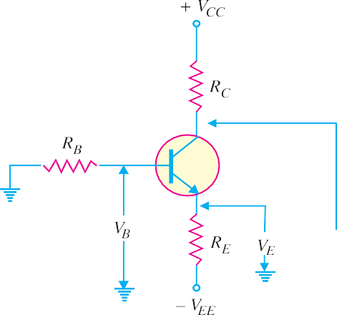
Fig. 8.44
* The emitter resistor RE provides stabilisation of Q-point (See Art. 9.12).

Solution. Refer to Fig. 8.44.
- The emitter voltage w.r.t. ground is
VE = – VEE + IE RE = – 10V + 1.8 mA × 4.7 k∧ = – 1.54V
- The base voltage w.r.t. ground is
VB = VE + VBE = 10V + 0.7V = 10.7V
- The collector voltage w.r.t. ground is
VC = VCC – IC RC = 10V – 1.8 mA × 1 k∧ = 8.2V

Practical Way of Drawing CE Circuit
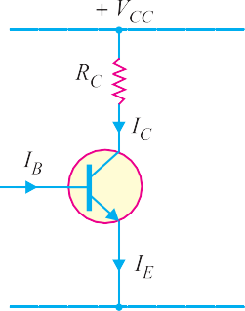
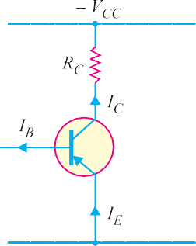
The common emitter circuits drawn so far can be shown in another convenient way. Fig. 8.45 shows the practical way of drawing CE circuit. In Fig. 8.45 (i), the practical way of drawing common emitter npn circuit is shown. Similarly, Fig. 8.45 (ii) shows the practical way of drawing common emitter pnp circuit. In our further discussion, we shall often use this scheme of presentation.
Fig. 8.45

  - Output from Transistor Amplifier A transistor raises the strength of a weak signal and thus acts as an amplifier. Fig. 8.46 shows the common emitter amplifier.
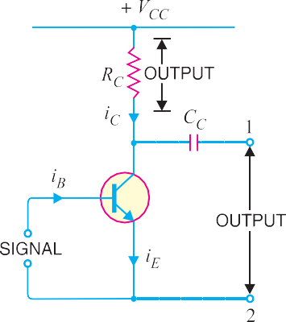There are two ways of taking output from this transistor con-
Fig. 8.46
nection. The output can be taken either across RC or across terminals 1 and 2. In either case, the magnitude of output is the same. This is clear from the following discussion :
- First method. We can take the output directly by putting a load resistance RC in the collector circuit i.e.
Output = voltage across RC = ic RC ...(i)
This method of taking output from collector load is used only in single stage of amplification.
- Second method. The output can also be taken across terminals 1 and 2 i.e. from collector and emitter end of supply.
Output = Voltage across terminals 1 and 2
= VCC − ic RC
As VCC is a direct voltage and cannot pass through capacitor CC, therefore, only varying voltage
ic RC will appear across terminals 1 and 2.
∴ Output = − ic RC ...(ii)

From exps. (i) and (ii), it is clear that magnitude of output is the same whether we take output across collector load or terminals 1 and 2. The minus sign in exp. (ii) simply indicates the phase reversal. The second method of taking output is used in multistages of amplification.

Performance of Transistor Amplifier
The performance of a transistor amplifier depends upon input resistance, output resistance, effective collector load, current gain, voltage gain and power gain. As common emitter connection is univer- sally adopted, therefore, we shall explain these terms with reference to this mode of connection.
- Input resistance. It is the ratio of small change in base-emitter voltage (⊗VBE) to the resulting change in base current (⊗IB) at constant collector-emitter voltage i.e.

Input resistance, Ri =
⊗VBE ⊗IB

The value of input resistance is quite small because the input circuit is always forward biased. It ranges from 500 ∧ for small low powered transistors to as low as 5 ∧ for high powered transistors. In fact, input resistance is the opposition offered by the base-emitter junction to the signal flow. Fig.
8.47 shows the general form of an amplifier. The input voltage VBE causes an input current IB.

∴ Input resistance, Ri =
⊗VBE ⊗IB
= VBE IB

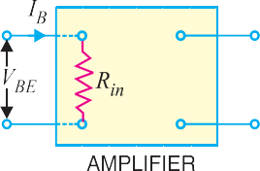
Thus if the input resistance of an amplifier is 500 ∧ and the sig- nal voltage at any instant is 1 V, then,

Base current, ib
= 1V
500 ∧
= 2 mA

- Output resistance. It is the ratio of change in collector- emitter voltage (⊗VCE) to the resulting change in collector current (⊗IC) at constant base current i.e.

Output resistance, RO =
⊗VCE
⊗IC
Fig. 8.47

The output characteristics reveal that collector current changes very slightly with the change in collector-emitter voltage. Therefore,
output resistance of a transistor amplifier is very high– of the order of several hundred kilo-ohms. The physical explanation of high output resistance is that collector-base junction is reverse biased.
- Effective collector load. It is the total load as seen by the a.c. collector current.
In case of single stage amplifiers, the effective collector load is a parallel combination of RC and
RO as shown in Fig. 8.48 (i).
Effective collector load, RAC = RC || RO

= RC × RO RC + RO
= *RC

It follows, therefore, that for a single stage amplifier, effective load is equal to collector load RC. However, in a multistage amplifier (i.e. having more than one amplification stage), the input resistance Ri of the next stage also comes into picture as shown in Fig. 8.48 (ii). Therefore, effective
collector load becomes parallel combination of RC, RO and Ri i.e.
Effective collector load, RAC = RC || RO || Ri
O
= RC
R
RAC =
* As output resistance RO is several times RC, therefore, RC can be neglected as compared to RO.
RC × RO

= *RC

|| Ri =

RC Ri
RC + Ri

As input resistance Ri is quite small (25 ∧ to 500 ∧), therefore, effective load is reduced.
- Current gain. It is the ratio of change in collector current (⊗IC) to the change in base current (⊗IB) i.e.

Current gain, β =
⊗IC ⊗IB

The value of β ranges from 20 to 500. The current gain indicates that input current becomes β
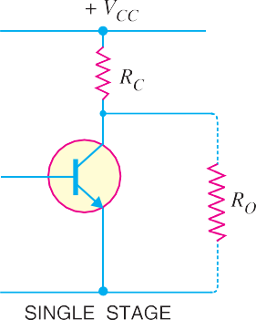
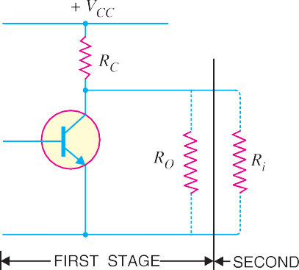
times in the collector circuit.

Fig. 8.48
- Voltage gain. It is the ratio of change in output voltage (⊗VCE) to the change in input voltage (⊗VBE) i.e.

Voltage gain, Av =
⊗VCE ⊗VBE

= Change in output current × effective load Change in input current × input resistance

= ⊗IC × RAC
= ⊗IC × RAC

= β × RAC

⊗IB × Ri ⊗IB Ri Ri

For single stage, RAC
= RC. However, for multistage, RAC =
RC × Ri RC + Ri
where Ri
is the input

resistance of the next stage.
- Power gain. It is the ratio of output signal power to the input signal power i.e.

(⊗I
)² × R
⎛ ⊗I ⎞ ⊗I × R

Power gain, Ap =
C AC
2
= ⎜ ⊗ C ⎟ × C AC

(⊗IB)
- Ri
⎝ IB ⎠
⊗IB × Ri

= Current gain × Voltage gain
Example 8.28. A change of 200 mV in base-emitter voltage causes a change of 100 µA in the base current. Find the input resistance of the transistor.
Solution. Change in base-emitter voltage is
* RC || RO = RC as already explained.

⊗VBE = 200 mV
Change in base current, ⊗IB = 100 µA

∴ Input resistance, Ri
= ⊗VBE ⊗IB
= 200 mV
100 µ A

= 2 k∧

Example 8.29. If the collector current changes from 2 mA to 3mA in a transistor when collec- tor-emitter voltage is increased from 2V to 10V, what is the output resistance ?
Solution. Change in collector-emitter voltage is
⊗VCE = 10 – 2 = 8 V
Change in collector current is ⊗IC = 3 – 2 = 1 mA

∴ Output resistance, RO =
⊗VCE ⊗IC
= 8V
1 mA
= 8 k∧

Example 8.30. For a single stage transistor amplifier, the collector load is RC = 2k∧ and the input resistance Ri = 1k∧. If the current gain is 50, calculate the voltage gain of the amplifier.
Solution. Collector load, RC = 2 k∧
Input resistance, Ri = 1 k∧ Current gain, β = 50

∴ Voltage gain, Av =
β× RAC
Ri
= β × RC
Ri
[ä For single stage, RAC
= RC]

= 50 × (2/1) = 100

Cut off and Saturation Points
Fig. 8.49 (i) shows CE transistor circuit while Fig. 8.49 (ii) shows the output characteristcs along with the d.c. load line.
- Cut off. The point where the load line intersects the IB = 0 curve is known as cut off. At this point, IB = 0 and only small collector current (i.e. collector leakage current ICEO) exists. At cut off, the base-emitter junction no longer remains forward biased and normal transistor action is lost. The collector-emitter voltage is nearly equal to VCC i.e.
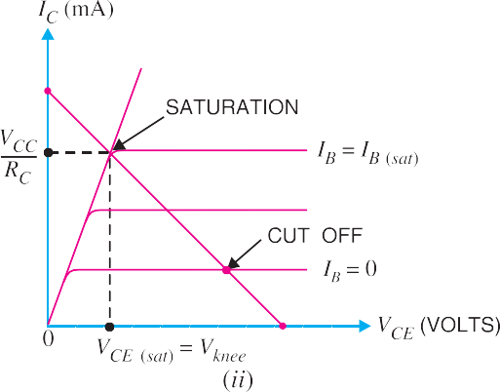VCE (cut off) = VCC
Fig. 8.49

- Saturation. The point where the load line intersects the IB = IB(sat) curve is called saturation. At this point, the base current is maximum and so is the collector current. At saturation, collector- base junction no longer remains reverse biased and normal transistor action is lost.

I j VCC ; V = V = V

C (sat) RC
CE CE(sat)
knee

If base current is greater than IB(sat), then collector current cannot increase because collector-base junction is no longer reverse-biased.
- Active region. The region between cut off and saturation is known as active region. In the active region, collector-base junction remains reverse biased while base-emitter junction remains forward biased. Consequently, the transistor will function normally in this region.
Note. We provide biasing to the transistor to ensure that it operates in the active region. The reader may find the detailed discussion on transistor biasing in the next chapter.
Summary. A transistor has two pn junctions i.e., it is like two diodes. The junction between base and emitter may be called emitter diode. The junction between base and collector may be called collector diode. We have seen above that transistor can act in one of the three states : cut-off, saturated and active. The state of a transistor is entirely determined by the states of the emitter diode and collector diode [See Fig. 8.50]. The relations between the diode states and the

Fig. 8.50
transistor states are :
CUT-OFF : Emitter diode and collector diode are OFF. ACTIVE : Emitter diode is ON and collector diode is OFF. SATURATED : Emitter diode and collector diode are ON.
In the active state, collector current [See Fig 8.51 (i)] is β times the base cur- rent (i.e. IC = βIB). If the transistor is cut-off, there is no base current, so there is no collector or emitter current. That is collector emitter pathway is open [See Fig. 8.51
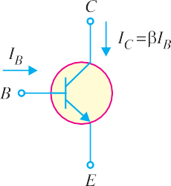
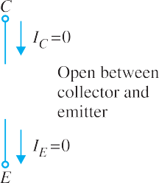
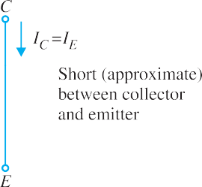
(ii)]. In saturation, the collector and emitter are, in effect, shorted together. That is the transistor behaves as though a switch has been closed between the collector and emitter [See Fig. 8.51 (iii)].

Fig. 8.51
Note. When the transistor is in the active state, IC = βIB. Therefore, a transistor acts as an amplifier when operating in the active state. Amplification means linear amplification. In fact, small signal amplifiers are the most common linear devices.
Example 8.31. Find IC(sat) and VCE(cut off) for the circuit shown in Fig. 8.52 (i).
Solution. As we decrease RB, base current and hence collector current increases. The increased collector current causes a greater voltage drop across RC ; this decreases the collector-emitter voltage. Eventually at some value of RB, VCE decreases to Vknee. At this point, collector-base junction is no longer reverse biased and transistor action is lost. Consequently, further increase in collector current is
not possible. The transistor conducts maximum collector current ; we say the transistor is saturated.

IC(sat) =
VCC − *Vknee

RC
= VCC
RC
= 20 V
1 k∧
= 20mA

* Vknee is about 0.5 V for Ge transistor and about 1V for Si transistor. Consequently, Vknee can be neglected as compared to VCC (= 20 V in this case).

As we increase RB, base current and hence collector current decreases. This decreases the volt- age drop across RC. This increases the collector-emitter voltage. Eventually, when IB = 0, the emitter- base junction is no longer forward biased and transistor action is lost. Consequently, further increase in VCE is not possible. In fact, VCE now equals to VCC.
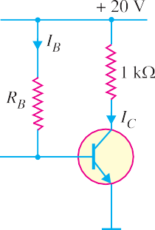VCE(cut-off) = VCC = 20 V

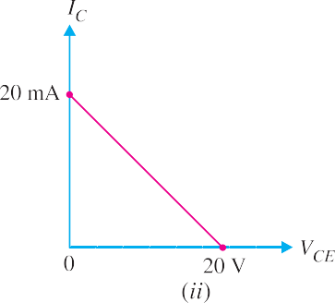Figure 8.52 (ii) shows the saturation and cut off points. Incidentally, they are end points of the
Fig. 8.52
d.c. load line.
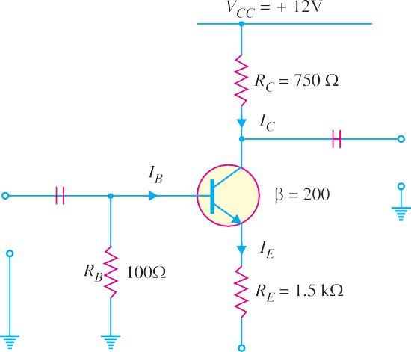
Note. The exact value of VCE(cut-off) = VCC − ICEO RC. Since the collector leakage current ICEO is very small, we can neglect ICEO RC as compared to VCC.
Example 8.32. Determine the values of VCE (off) and IC (sat) for the circuit shown in Fig. 8.53.

Fig. 8.53
Solution. Applying Kirchhoff’s voltage law to the collector side of the circuit in Fig. 8.53, we
have,
VCC – IC RC – VCE – *IC RE + VEE = 0
or VCE = VCC + VEE – IC (RC + RE) ... (i)
* Voltage across RE = IE RE. Since IE j IC, voltage across RE = IC RE.

We have VCE (off ) when IC = 0. Therefore, putting IC = 0 in eq. (i), we have,
VCE (off) = VCC + VEE = 12 + 12 = 24V
We have IC (sat) when VCE = 0.

∴ I =
VCC + VEE = (12 + 12) V = 10.67 mA

C ( sat )
RC + RE (750 + 1500) ∧

Example 8.33. Determine whether or not the transistor in Fig. 8.54 is in stauration. Assume Vknee = 0.2V.

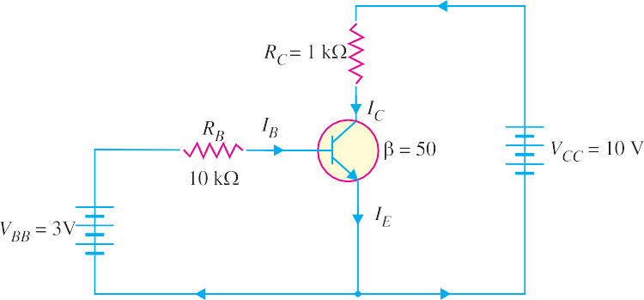
Fig. 8.54

Solution.

IC (sat) =
VCC − Vknee RC
= 10 V − 0.2 V
1 k∧
= 9.8 V
1 k∧

= 9.8 mA

Now we shall see if IB is large enough to produce IC (sat).

Now IB =
VBB − VBE RB
= 3V − 0.7V
10 k∧
= 2.3 V
10 k∧

= 0.23 mA

∴ IC = βIB = 50 × 0.23 = 11.5 mA
This shows that with specified β, this base current (= 0.23 mA) is capable of producing IC greater than IC (sat). Therefore, the transistor is saturated. In fact, the collector current value of 11. 5 mA is never reached. If the base current value corresponding to IC (sat) is increased, the collector current remains at the saturated value (= 9.8 mA).
Example 8.34. Is the transistor in Fig. 8.55 operating in saturated state ?
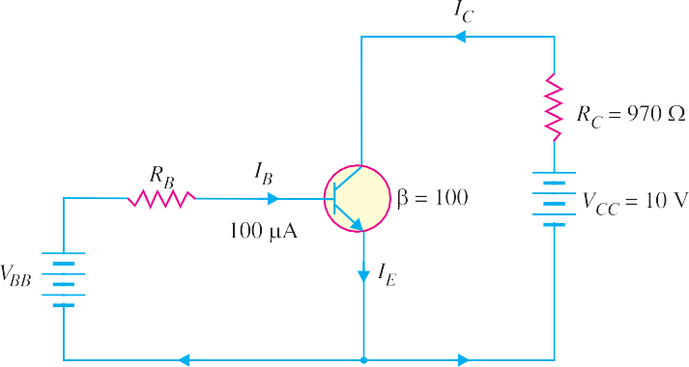
Fig. 8.55

Solution.

IC = βIB = (100)(100 μA) = 10 mA
VCE = VCC – IC RC
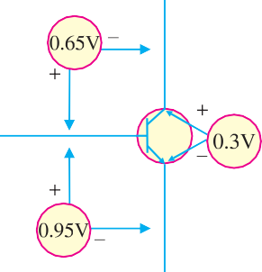
= 10V – (10 mA)(970∧) = 0.3V

Let us relate the values found to the transistor shown in Fig. 8.56. As you can see, the value of VBE is 0.95V and the value of VCE = 0.3V. This leaves VCB of 0.65V (Note that VCE = VCB + VBE). In this case, collector – base junction (i.e., collector diode) is forward biased as is the emitter-base junction (i.e., emitter diode). Therefore, the transistor is operating in the saturation region.
Note. When the transistor is in the saturated state, the base cur- rent and collector current are independent of each other. The base cur- rent is still (and always is) found only from the base circuit. The col- lector current is found apporximately by closing the imaginary switch between the collector and the emitter in the collector circuit.
Example 8.35. For the circuit in Fig. 8.57, find the base supply voltage (VBB) that just puts the transistor into saturation. Assume β = 200.
Fig. 8.56
Solution. When transistor first goes into saturation, we
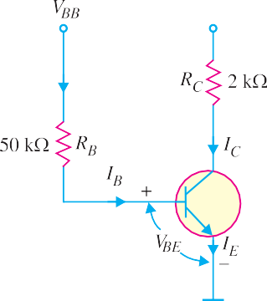can assume that the collector shorts to the emitter (i.e. VCE = 0) but the collector current is still β times the base current.

IC(sat) =
VCC − VCE RC
10 V − 0
= VCC − 0
RC

= 2 k∧ = 5 mA
The base current IB corresponding to IC (sat) (=5 mA) is

I = IC (sat) = 5 mA

= 0.025 mA

B β 200
Applying Kirchhoff’s voltage law to the base circuit, we have,
Fig. 8.57
VBB – IB RB – VBE = 0
or VBB = VBE + IB RB
= 0.7V + 0.025 mA × 50 k∧ = 0.7 + 1.25 = 1.95V
Therefore, for VBB ≥ 1.95, the transistor will be in saturation.

Solution. Since IE does not depend on the value of the collector resistor RC, the emitter current (IE) is the same for all three parts.
Example. 8.36. Determine the state of the transistor in Fig. 8.58 for the following values of collector resistor :
(i) RC = 2 k∧ (ii) RC = 4 k∧ (iii) RC = 8 k∧
Emitter voltage,VE = VB – VBE = VBB – VBE
= 2.7V – 0.7 V = 2V
VE 2V
Also I = = = 2 mA

E RE
1 k∧

- When RC = 2 k∧. Suppose the transistor is active.
∴ IC = IE = 2 mA
∴ IB = IC/β = 2 mA/100 = 0.02 mA

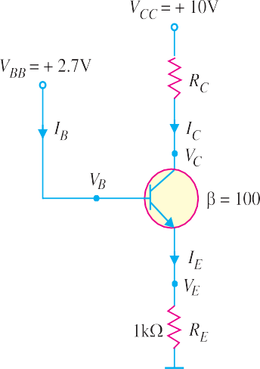Collector voltage, VC = VCC – IC RC
Fig. 8.58
= 10V – 2 mA×2 k∧ = 10V – 4V = 6V
Since VC (= 6V) is greater than VE (= 2V), the transistor is active. Therefore, our assumption that transistor is active is cor- rect.
- When RC = 4 k∧. Suppose the transistor is active.
∴ IC = 2mA and IB = 0.02 mA ... as found above Collector voltage,VC = VCC – IC RC
= 10V – 2 mA × 4 k∧ = 10V – 8V = 2V
Since VC = VE, the transistor is just at the edge of saturation. We know that at the edge of saturation, the relation between the transistor currents is the same as in the active state. Both answers are correct.
- When RC = 8 k∧. Suppose the transistor is active.
∴ IC = 2mA ; IB = 0.02 mA ... as found earlier. Collector voltage, VC = VCC – IC RC
= 10V – 2 mA × 8 k∧ = 10V – 16V = – 6V
Since VC < VE, the transistor is saturated and our assumption is not correct.
Example 8.37. In the circuit shown in Fig. 8.59, VBB is set equal to the following values :
(i) VBB = 0.5V (ii) VBB = 1.5V (iii) VBB = 3V
Determine the state of the transistor for each value of the base supply voltage VBB.
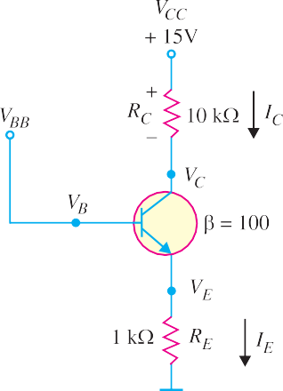Solution. The state of the transistor also depends on the base supply voltage VBB.
Fig. 8.59
- For VBB = 0.5V
Because the base voltage VB (= VBB = 0.5V) is less than 0.7V, the transistor is cut-off.
- For VBB = 1.5V
The base voltage VB controls the emitter voltage VE which controls the emitter current IE.
Now VE = VB – 0.7V = 1.5V – 0.7V = 0.8V

∴ I =
VE = 0.8 V

= 0.8 mA

E RE
1 k∧

If the transistor is active, we have,
IC = IE = 0.8 mA and IB = IC/β = 0.8/100 = 0.008 mA
∴ Collector voltage, VC = VCC – IC RC
= 15V – 0.8 mA × 10 k∧ = 15V – 8V = 7V
Since VC > VE, the transistor is active and our assumption is correct.
- For VBB = 3V
VE = VB – 0.7V = 3V – 0.7V = 2.3V

∴ I =
VE = 2.3V

= 2.3 mA

E RE
1 k∧

Assuming the transistor is active, we have,
IC = IE = 2.3 mA ; IB = IC/β = 2.3/100 = 0.023 mA
Collector voltage, VC = VCC – IC RC
= 15V – 2.3 mA × 10 k∧ = 15V – 23V = – 8V
Since VC < VE, the transistor is saturated and our assumption is not correct.

Power Rating of Transistor
The maximum power that a transistor can handle without destruction is known as power rating of the transistor.
When a transistor is in operation, almost all the power is dissipated at the reverse biased
*collector-base junction. The power rating (or maximum power dissipation) is given by :
PD (max) = Collector current × Collector-base voltage
= IC × VCB
∴ PD (max) = IC × VCE
[ä VCE = VCB + VBE. Since VBE is very small, VCB j VCE]
While connecting transistor in a circuit, it should be ensured that its power rating is not exceeded otherwise the transistor may be destroyed due to excessive heat. For example, suppose the power rating (or maximum power dissipation) of a transistor is 300 mW. If the collector current is 30 mA, then maximum VCE allowed is given by ;
PD (max) = IC × VCE (max)
or 300 mW = 30 mA × VCE (max)
300 mW

or VCE (max) =
30 mA = 10V

This means that for IC = 30 mA, the maximum VCE allowed is 10V. If VCE exceeds this value, the transistor will be destroyed due to excessive heat.
Maximum power dissipation curve. For **power transistors, it is sometimes necessary to draw maximum power dissipation curve on the output characteristics. To draw this curve, we should know the power rating (i.e. maximum power dissipation) of the transistor. Suppose the power rating of a transistor is 30 mW.
PD (max) = VCE × IC
or 30 mW = VCE × IC
Using convenient VCE values, the corresponding collector currents are calculated for the maxi- mum power dissipation. For example, for VCE = 10V,

I (max) =
PD (max) = 30 mW

= 3mA

C VCE
10 V

This locates the point A (10V, 3 mA) on the output characteristics. Similarly, many points such as B, C, D etc. can be located on the output characteristics. Now draw a curve through the above points to obtain the maximum power dissipation curve as shown in Fig. 8.60.
In order that transistor may not be destroyed, the transistor voltage and current (i.e. VCE and IC) conditions must at all times be maintained in the portion of the characteristics below the maximum power dissipation curve.
* The base-emitter junction conducts about the same current as the collector-base junction (i.e. IE j IC ). However, VBE is very small (0.3 V for Ge transistor and 0.7 V for Si transistor). For this reason, power dissipated at the base-emitter junction is negligible.
** A transistor that is suitable for large power amplification is called a power transistor. It differs from other transistors mostly in size ; it is considerably larger to provide for handling the great amount of power.

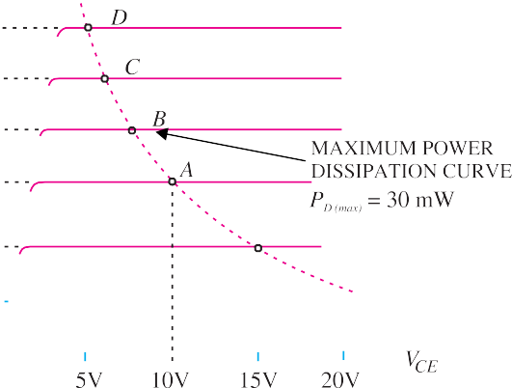
Fig. 8.60

Example 8.38. The maximum power dissipation of a transistor is 100mW. If VCE = 20V, what is the maximum collector current that can be allowed without destruction of the transistor?
Solution. PD (max) = VCE × IC (max)
or 100 mW = 20 V × IC (max)

∴ IC (max) = 100 mW 20 V
= 5 mA

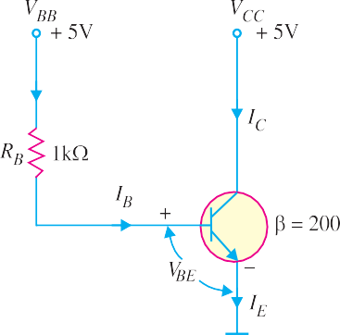Thus for VCE = 20V, the maximum collector current allowed is 5 mA. If collector current exceeds this value, the transistor may be burnt due to excessive heat.
Note. Suppose the collector current becomes 7mA. The power produced will be 20 V × 7 mA = 140 mW. The transistor can only dissipate 100 mW. The remaining 40 mW will raise the temperature of the transistor and eventually it will be burnt due to excessive heat.
Example 8.39. For the circuit shown in Fig. 8.61, find the transistor power dissipation. Assume that β = 200.

Solution.
Fig. 8.61
I = VBB – VBE = (5 − 0.7) V

= 4.3 mA

B RB
1 k∧

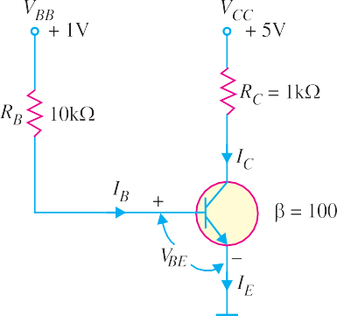∴ IC = βIB = 200 × 4.3 = 860 mA Now VCE = VCC – IC RC = 5 – IC × 0 = 5V
∴ Power dissipation, PD = VCE × IC
= 5V × 860 mA = 4300 mW = 4.3W
Example 8.40. For the circuit shown in Fig. 8.62, find the power dissipated in the transistor. Assume β = 100.
Solution. The transistor is usually used with a resistor RC connected between the collector and its power supply VCC as shown is Fig. 8.62. The collector resistor RC serves two purposes. Firstly, it allows us to control the voltage VC at the collector. Secondly, it protects the transistor from excessive collector
current IC and, therefore, from excessive power dissipation.
Fig. 8.62

Referring to Fig. 8.62 and applying Kirchhoff’s voltage law to the base side, we have,
VBB – IB RB – VBE = 0

∴ I =
VBB − VBE = 1V − 0.7 V = 0.3V

= 0.03 mA

B RB
10 k∧
10 k∧

Now IC = βIB = 100 × 0.03 = 3 mA
∴ VCE = VCC – IC RC = 5V – 3 mA × 1 k∧ = 5V – 3V = 2V
∴ Power dissipated in the transistor is
PD = VCE × IC = 2V × 3 mA = 6 mW
Example 8.41. The transistor in Fig. 8.63 has the following maximum ratings : PD (max) = 800 mW ; VCE (max) = 15V ; IC (max) = 100 mA
Determine the maximum value to which VCC can be adjusted without exceeding any rating.
Which rating would be exceeded first ?

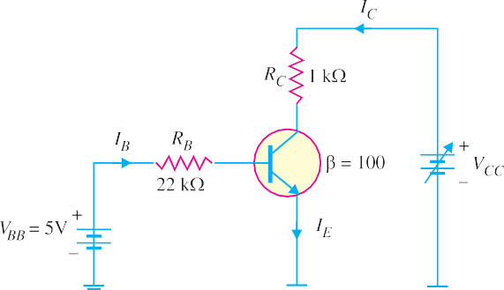
Fig. 8.63

Solution.

IB =

VBB − VBE RB

= 5V − 0.7V
22 k∧

4.3 V
22 k∧ = 195 μA
=

∴ IC = βIB = 100 × 195 μA = 19.5 mA
Note that IC is much less than IC(max) and will not change with VCC. It is determined only by IB and
β. Therefore, current rating is not exceeded.
Now VCC = VCE + IC RC
We can find the value of VCC when VCE (max) = 15V.
∴ VCC (max) = VCE (max) + IC RC
= 15V + 19.5 mA × 1 k∧ = 15V + 19.5 V = 34.5V
Therefore, we can increase VCC to 34.5V before VCE (max) is reached.
PD = VCE (max) IC = (15V) (19.5 mA) = 293 mW
Since PD (max) = 800 mW, it is not exceeded when VCC = 34.5V.
If base current is removed causing the transistor to turn off, VCE (max) will be exceeded because the entire supply voltage VCC will be dropped across the transistor.

MULTIPLE-CHOICE QUESTIONS

- A transistor has ........
  - one pn junction
  - two pn junctions
  - three pn junctions
  - four pn junctions
- The number of depletion layers in a transis- tor is ........
  - four (ii) three
(iii) one (iv) two
- The base of a transistor is ....... doped.
  - heavily (ii) moderately
(iii) lightly (iv) none of the above
- The element that has the biggest size in a transistor is ........
  - collector (ii) base
- emitter
- collector-base junction
- In a pnp transistor, the current carriers are
........
  - acceptor ions (ii) donor ions
(iii) free electrons (iv) holes
- The collector of a transistor is ........ doped.
  - heavily (ii) moderately
(iii) lightly (iv) none of the above
- A transistor is a ......... operated device.
  - current (ii) voltage
- both voltage and current
- none of the above
- In an npn transistor, ....... are the minority carriers.
  - free electrons (ii) holes
(iii) donor ions (iv) acceptor ions
- The emitter of a transistor is ........ doped.
  - lightly (ii) heavily
(iii) moderately (iv) none of the above
- In a transistor, the base current is about ........ of emitter current.
  - reverse bias
  - a wide depletion layer
  - low resistance
  - none of the above
- The input impedance of a transistor is ......
  - high (ii) low
(iii) very high (iv) almost zero
- Most of the majority carriers from the emit- ter .........
  - recombine in the base
  - recombine in the emitter
  - pass through the base region to the col- lector
  - none of the above
- The current IB is ........
  - electron current
  - hole current
  - donor ion current
  - acceptor ion current
- In a transistor, ........
  - IC = IE + IB (ii) IB = IC + IE
(iii) IE = IC − IB (iv) IE = IC + IB
- The value of α of a transistor is ........
  - more than 1 (ii) less than 1
(iii) 1 (iv) none of the above
17. IC = α IE + .........
(i) IB (ii) ICEO
(iii) ICBO (iv) β IB
- The output impedance of a transistor is ........
  - high (ii) zero
(iii) low (iv) very low
- In a transistor, IC = 100 mA and IE =
100.5 mA. The value of β is ........
(i) 100 (ii) 50
(iii) about 1 (iv) 200
- In a transistor if β = 100 and collector cur- rent is 10 mA, then IE is ........
(i) 100 mA (ii) 100.1 mA
(iii) 110 mA (iv) none of the above
- The relation between β and α is ........

(i) 25% (ii) 20%
(iii) 35% (iv) 5%
11. At the base-emitter junction of a transistor, one finds ........
(i) β = 1
1 − α
- β = α
1 −α
(ii) β = 1 − α
α
- β = α
1 +α

- The value of β for a transistor is generally
........
  - 1 (ii) less than 1
- between 20 and 500
- above 500
- The most commonly used transistor arrange- ment is ........ arrangement.
  - common emitter
  - common base
  - common collector
  - none of the above
- The input impedance of a transistor con-
- The voltage gain of a transistor connected in common collector arrangement is .......
  - equal to 1 (ii) more than 10
(iii) more than 100 (iv) less than 1
- The phase difference between the input and output voltages of a transistor connected in common collector arrangement is ........
(i) 180º (ii) 0º
(iii) 90º (iv) 270º
33. IC = β IB + ........
  - ICBO (ii) IC
- ICEO (iv) α IE

nected in .......... arrangement is the highest.
  - common emitter
- IC
= α
1 −α
IB + ........

  - common collector
  - common base
(i) ICEO (ii) ICBO
- IC (iv) (1 − α) IB

- none of the above
25. The output impedance of a transistor con-
- IC
= α
1 −α
I + .......
B 1 −α

nected in ......... arrangement is the highest.
  - common emitter
  - common collector
  - common base
  - none of the above
- The phase difference between the input and output voltages in a common base arrange- ment is .........
(i) 180º (ii) 90º
(iii) 270º (iv) 0º
- The power gain of a transistor connected in
........ arrangement is the highest.
  - common emitter
  - common base
  - common collector
  - none of the above
- The phase difference between the input and output voltages of a transistor connected in common emitter arrangement is ........
(i) 0º (ii) 180º
(iii) 90º (iv) 270º
- The voltage gain of a transistor connected in ........ arrangement is the highest.
  - common base (ii) common collector
- common emitter
- none of the above
- As the temperature of a transistor goes up, the base-emitter resistance ........
  - decreases (ii) increases
- remains the same
- none of the above
(i) ICBO (ii) ICEO
(iii) IC (iv) IE
- BC 147 transistor indicates that it is made
of ........
  - germanium (ii) silicon
(iii) carbon (iv) none of the above
37. ICEO = (........) ICBO
(i) β (ii) 1 + α
(iii) 1 + β (iv) none of the above
- A transistor is connected in CB mode. If it is now connected in CE mode with same bias voltages, the values of IE, IB and IC will ....
  - remain the same
  - increase
  - decrease (iv) none of the above
- If the value of α is 0.9, then value of β is ........ (i) 9 (ii) 0.9
(iii) 900 (iv) 90
- In a transistor, signal is transferred from a
........ circuit.
  - high resistance to low resistance
  - low resistance to high resistance
  - high resistance to high resistance
  - low resistance to low resistance
- The arrow in the symbol of a transistor indi- cates the direction of .........
  - electron current in the emitter
  - electron current in the collector
  - hole current in the emitter
  - donor ion current
- The leakage current in CE arrangement is

....... that in CB arrangement.
  - more than (ii) less than
(iii) the same as (iv) none of the above
- A heat sink is generally used with a transis- tor to ........
  - increase the forward current
  - decrease the forward current
  - compensate for excessive doping
  - prevent excessive temperature rise
- The most commonly used semiconductor in
the manufacture of a transistor is ........
  - germanium (ii) silicon
(iii) carbon (iv) none of the above
- The collector-base junction in a transistor has ........
  - forward bias at all times
  - reverse bias at all times
  - low resistance
  - none of the above

1. | (ii) | 2. | (iv) | 3. | (iii) | 4. | (i) | 5. | (iv)
6. | (ii) | 7. | (i) | 8. | (ii) | 9. | (ii) | 10. | (iv)
11. | (iii) | 12. | (ii) | 13. | (iii) | 14. | (i) | 15. | (iv)
16. | (ii) | 17. | (iii) | 18. | (i) | 19. | (iv) | 20. | (ii)
21. | (iii) | 22. | (iii) | 23. | (i) | 24. | (ii) | 25. | (iii)
26. | (iv) | 27. | (i) | 28. | (ii) | 29. | (iii) | 30. | (i)
31. | (iv) | 32. | (ii) | 33. | (iii) | 34. | (i) | 35. | (i)
36. | (ii) | 37. | (iii) | 38. | (i) | 39. | (iv) | 40. | (ii)
41. | (iii) | 42. | (i) | 43. | (iv) | 44. | (ii) | 45. | (ii)

Chapter Review Topics
Answers to Multiple-Choice Questions
    - What is a transistor ? Why is it so called ?
    - Draw the symbol of npn and pnp transistor and specify the leads.
    - Show by means of a diagram how you normally connect external batteries in (i) pnp transistor (ii) npn
transistor.
    - Describe the transistor action in detail.
    - Explain the operation of transistor as an amplifier.
    - Name the three possible transistor connections.
    - Define α. Show that it is always less than unity.
    - Draw the input and output characteristics of CB connection. What do you infer from these character- istics ?
    - Define β. Show that : β = α .
1 −α
    - How will you determine the input and output characteristics of CE connection experimentally ?
    - Establish the following relations :

      - IC = α IE + ICBO (ii) IC =
α IB + 1 ICBO

(iii) IC = β IB + ICEO (iv) γ = (v) IE = (β + 1) IB + (β + 1) ICBO
1 −α
1
1 −α
1 −α

    - How will you draw d.c. load line on the output characteristics of a transistor ? What is its importance?
    - Explain the following terms : (i) voltage gain (ii) power gain (iii) effective collector load.
    - Write short notes on the following : (i) advantages of transistors (ii) operating point (iii) d.c. load line.

Problems
- In a transistor if IC = 4.9mA and IE = 5mA, what is the value of α ? [0.98]
- In a transistor circuit, IE = 1mA and IC = 0.9mA. What is the value of IB ? [0.1 mA]
- Find the value of β if α = 0.99. [100]
- In a transistor, β = 45, the voltage across 5k∧ resistance which is connected in the collector circuit is 5 volts. Find the base current. [0.022 mA]
- In a transistor, IB = 68 µA, IE = 30 mA and β = 440. Find the value of α. Hence determine the value of IC. [0.99 ; 29.92 mA]
- The maximum collector current that a transistor can carry is 500 mA. If β = 300, what is the maxi- mum allowable base current for the device ? [1.67 mA]
- For the circuit shown in Fig. 8.69, draw the d.c. load line.
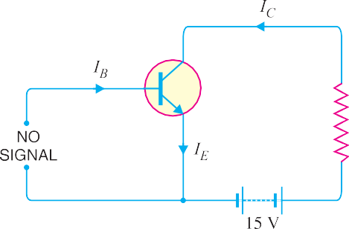
Fig. 8.69

- Draw the d.c. load line for Fig. 8.70.
[The end points of load line are 6.06 mA and 20 V]
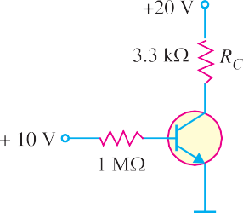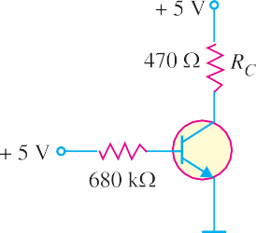
Fig. 8.70
Fig. 8.71

- If the collector resistance RC in Fig. 8.70 is reduced to 1 k∧, what happens to the d.c. load line ?
[The end points of d.c. load line are now 20 mA and 20 V]
- Draw the d.c. load line for Fig. 8.71.
[The end points of d.c. load line are 10.6 mA and 5V]
- If the collector resistance RC in Fig. 8.71 is increased to 1 k∧, what happens to the d.c. load line ?
[The end points of d.c. load line are now 5 mA and 5 V]

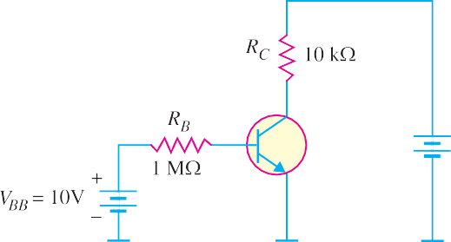

Fig. 8.72
- Determine the intercept points of the d.c. load line on the vertical and horizontal axes of the collector curves in Fig. 8.72. [2 mA ; 20 V]
- For the circuit shown in Fig. 8.73, find (i) the state of the transistor and (ii) transistor power.

[(i) active (ii) 4.52 mW]
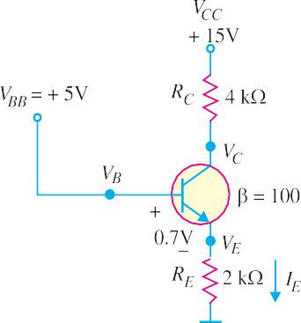
Fig. 8.73
Fig. 8.74

- A base current of 50 μA is applied to the transistor in Fig. 8.74 and a voltage of 5V is dropped across RC . Calculate α for the transistor. [0.99]
- A certain transistor is to be operated at a collector current of 50 mA. How high can VCE go without exceeding PD (max) of 1.2 W ? [24 V]
Discussion Questions
- Why is a transistor low powered device ?
- What is the significance of arrow in the transistor symbol ?
- Why is collector wider than emitter and base ?
- Why is collector current slightly less than emitter current ?
- Why is base made thin ?

