CHAPTER FOUR
TYPES OF TRANSISTER OSCILLATORS
CLASS TWO, COMPUTER ENGINEERING TECHNIQE

A TRANSISTOR CAN WORK AS AN OSCILLATOR TO PRODUCE CONTINUOUS UNDAMPED OSCILLATOR OF ANY DESIRED FREQUENCY (ALL OSCILLATORS DO SAME FUNCTIONS.
THE DIFFERENCE BETWEEN DIFFERENT TYPES OF OSCILLATORS LIES IN THE METHOD BY WHICH ENERGY IS SUPPLIED TO THE CIRCUIT
TYPES:

1-TUNED COLLECTOR OSCILLATOR
2-COLPITT”S OSCILLATOR
3-HARTLEY OSCILLATOR
4-PHASE SHIFT OSCILLATOR
5-WIEN BRIDGE OSCILLATOR
6-CRYSTAL OSCILLATOR

1-TUNED COLLECTOR OSCILLATOR
THS OSCILLATOR IS SHOWN IN THE FIGURE: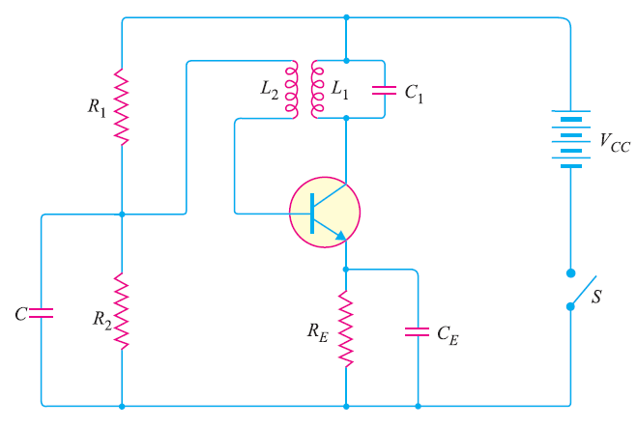
THE FREQUENCY OF OSCILLATOR (f ) DEPENDS ON L1&L2 :
f=$\frac{1}{\begin{aligned}2π\sqrt{L1C1} \\ \end{aligned}}$
L1 &L2 ARE FOR THE PRIMARY AND SECONDARY OF TRANSFORMER
THE BIASING IS PROVIDED BY POTENTIAL DEVIDER CONNECTED IN THE BIASE CIRCUIT PROVIDES LOW REACTANCE PATH TO THE OSCILLATIONS
Ex:THE TUNED COLLECTOR OSCILLATOR CIRCUIT USED IN THE LOCAL OSCILLATOR OF A RADIO RECEIVER MAKE UES OF AN LC TUNED CIRCUIT WITH L1=58.6 µH C1=300 pf ,CALCULATE FREQUENCY OF OSCILLATION : $f=\frac{1}{\begin{aligned}2π\sqrt{L1C1} \\ \end{aligned}}=\frac{1}{\begin{aligned}2π\sqrt{58.6*{10}^{-6}*300*{10}^{-12}} \\ \end{aligned}}=1199 KHz$
EX: FIND THE CAPACITANCE OF C REQUIRED TO BUILD AN LC OSCILLATOR THAT USED AN L1=1 mH TO PRODUCE A SINE WAVE OF FREQUENCY =1GHz.
SOLUTION :$f=\frac{1}{\begin{aligned}2π\sqrt{L1C1} \\ \end{aligned}} C1=\frac{1}{\begin{aligned} \\ \end{aligned}{L1(2πf)}^{2}}$
C1=$\frac{1}{(1*{10}^{-3}){(2π*1*{10}^{12})}^{2}}=2.53*{10}^{-11}pF$
2-Colpittis Oscillator
$f=\frac{1}{2π\sqrt{lC_{t}}}$
$$C_{T}=\frac{c_{1}c_{2}}{c_{1}+c_{2}}$$
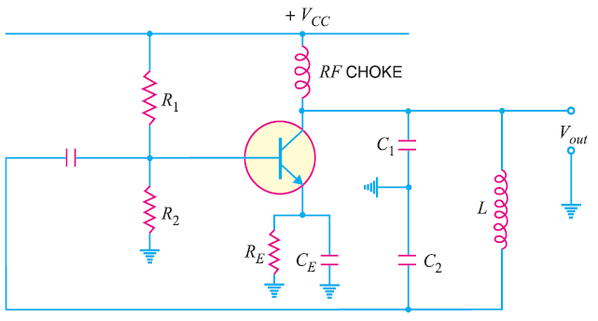
EX: Determine
(a)operating freq (b) feedback fraction for colpitt’s oscillator
C₁=0.001µF , c₂=0.01µF , L=15µH
Solution
C_{t}=$\frac{c_{1}c_{2}}{c_{1}+c_{2}}=\frac{0.001*0.01}{0.001+0.01}=9.09*{10}^{-4}μF$
=909*10⁻¹²F
(b)feedback fraction:
m_{v}=$\frac{c_{1}}{c_{2}}=\frac{0.001}{0.01}=0.1$
3-HARTLEY OSCILLATOR $f=\frac{1}{2π\sqrt{CL_{T}}} L_{T}=L_{1}+L_{2}+2M$ M IS THE MUTUAL INDUSTANCE BETWEEN L₁ AND L₂
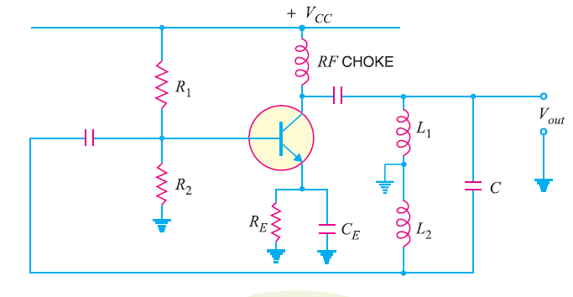
EX:CALCULATE (i)OPERATING FREQUENCY
(ii)FEEDBACK FACTION FOR HARTLEY
L₁=1000µH , L₂=100µH, M=20µH
L_{T}=1000+100+2*20=1140*10⁻⁶H
C=20PF=20*10⁻¹²F
SOLUTION
$$f=\frac{1}{2π\sqrt{L_{T}C}}=\frac{1}{2π\sqrt{1140*{10}^{-6}*20*{10}^{-12}}}=1052 KHz$$
$$m_{v}=\frac{L_{2}}{L_{1}}=\frac{100μH}{1000μH}=0.1$$
EX: 1PF CAPACITOR IS AVAILABLE .CHOOSE THE INDUCTANCE VALUES IN A HARTLEY OCSILLATOR . SO THAT f =1 MHz AND m_{v}=0.2
$$m_{v}=\frac{L_{2}}{L_{1}} 0.2=\frac{L_{2}}{L_{1}} L_{1}=5L_{2}$$
$$f=\frac{1}{2π\sqrt{L_{T}C}}$$
$$L_{T}=\frac{1}{C{\left(2πf\right)}^{2}}=\frac{1}{\left(1*{10}^{-12}\right){\left(2π*1*{10}^{6}\right)}^{2}}$$
=25.3mH=L₁+L₂
5L₂+L₂=25.3 L₂=4.22 mH
L₁=5L₂=5*4.22=21.1mH
4-PHASE SHIFT OSCILLATOR 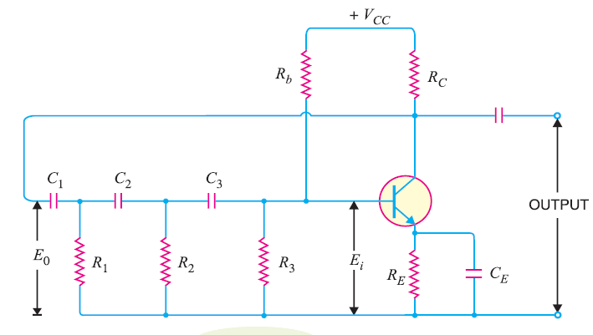$f_{0}=\frac{1}{2πRC\sqrt{6}}$
R1=R2=R3=R C1=C2=C3=C
EX: IN THE PHAS SHIFT OSCILLATOR R1=R2=R3=1MΩ C1=C2=C3= 68 PF
WHAT IS f₀ :
$$f_{0}=\frac{1}{2πRC\sqrt{6}}=\frac{1}{2π*{10}^{6}*68*{10}^{-12}\sqrt{6}}=954Hz$$
EX:FIND R TO PRODUCE f₀=800KHz, C=5PF
$$f_{0}=\frac{1}{2πRC\sqrt{6}} →R=\frac{1}{2πf_{0}C\sqrt{6}}$$
$$R=\frac{1}{2π*800*{10}^{3}*5*{10}^{-12}*\sqrt{6}}=16.2 KΩ$$

5-WIEN BRIDGE OSCILLATOR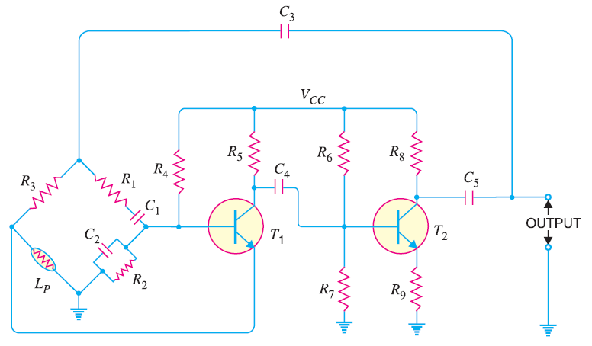
$$f=\frac{1}{2π\sqrt{R_{1}C_{1}R_{2}C_{2}}}$$
IF R₁=R₂=R , C₁=C₂=C

EX: IN THE WIEN BRIDGE OSCILLATOR :
R1=R2=220 KΩ C1=C2=250 PF DETERMINE f:
$$f=\frac{1}{2πRC}=\frac{1}{2π*220*{10}^{3}*250*{10}^{-12}}Hz$$
=2892Hz
6-TRANSISTOR CRYSTAL OSCILLATOR 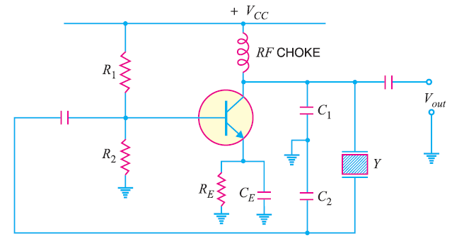
NOTE THAT IT IS A COLLPIT’S OSCILLATOR MODIFIED TO ACT AS A CRYSTAL OSCILLATOR $f_{S}=\frac{1}{2π\sqrt{LC}} f_{P}=\frac{1}{2π\sqrt{LC_{T}}} C_{T}=\frac{C*C_{m}}{C+C_{m}}$
EX: A CRYSTAL HAS THICKNESS OF 1mm.
IF THE THICKNESS IS REDUCED BY 1% WHAT HAPPENS TO FREQUENCY OF OSCILLATION $f=\frac{K}{t} f α\frac{1}{t}$ NOTE: K IS CONSTANT
IF THE THICKNESS OF THE CRYSTAL IS REDUCED BY 1% THE FREQUENCY OF OSCILLATIONS WILL INCREASE BY 1%
EX:L= 1H , C=0.01PF , R=1000Ω , C_{m}=20PF NOTE: C_{m} IS A MOUNTING CAPACITANCE
CALCULATE f_{S} , f_{P} OF THE CRYSTAL
$$f_{S}=\frac{1}{2π\sqrt{LC}}=\frac{1}{2π\sqrt{1*0.01*{10}^{-12}}}=1589KHz.$$
$$C_{T}=\frac{C*C_{m}}{C+C_{m}}=\frac{0.01*20}{0.01+20}=9.99*{10}^{-3}PF$$
$$f_{P}=\frac{1}{2π\sqrt{LC_{T}}}=\frac{1}{2π\sqrt{1*9.99*{10}^{-15}}}=1590KHz$$
f_{S}=SERIES-RESONANT FREQUENCY
f_{P}=PARALLEL-RESONANT FREQUENCY
SINCE C_{T} < C THERFORE f_{P} ALWAYS > f_{S}
f_{S} & f_{P} ARE VERY CLOSE

