Chapter five.
Power Amplifiers (P A)

Classification of PA :
- Class A PA 2) Cass B PA
- CLASS A PA
IF THE COLLECTOR CURRENT FLOWS AT ALL TIME DURING THE FULL CYCLE OF THE SIGNAL, THE POWER AMPLIFIER IS KNOWN AS CLASS A POWER AMPLIFIER
THE DISADVANTAGEES OF CLASS A PA ARE:
-LOW POWER OUTPUT
-LOW COLLECTOR EFFICIENCY

THE ADVANTAGES :
- THE OUTPUT WAVE SHAPE IS SIMILAR TO THE INPUT WAVE SHAPE
- THEY HAVE THE LEAST DISTORTION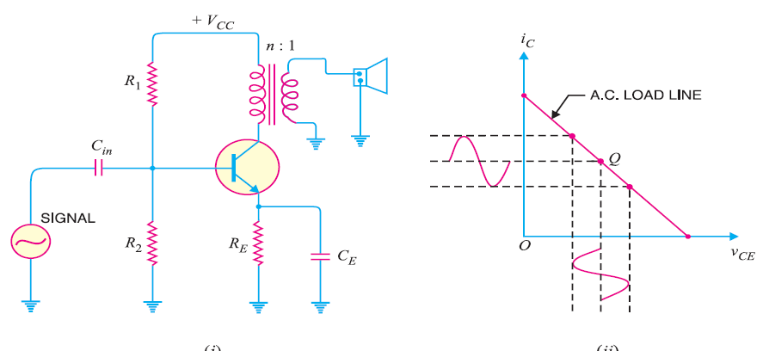

2)CLASS B (PA )
IN THESE PA THE COLLECTOR CURRENT FLOWS ONLY DURING THE POSITIVE HALF CYCLE OF THE INPUT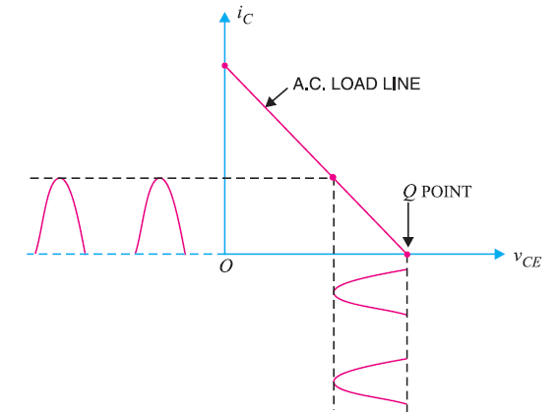
-IN THIS PA ,THE TRANSISTER BIASE IS SO ADJUSTED THAT ZERO SIGNAL, COLLECTOR OCURRENT IS ZERO (NO BIASING SIGNAL IS NEEDED -DURING THE POSITIVE HALF CYCLE OF THE SIGNAL , THE INPUT CIRCUIT IS FORWARD BIASED AND HENCE COLLECTOR CURRENT FLOWS DURING THE NEGETIVE HALF CYCLE OF THE SIGNAL, THE INPUT CIRCUIT IS REVERSED BIASED AND NO COLLECTOR CURRENT FLOWS.
ADVANTAGES
-PROVIDE HIIGHER POWER OUTPUT AND COLLECTER EFFICIENCY (50%-60%)
-TWO TRANSISTORS ARE USED , ONE AMPLIFIES THE POSITIVE HALF CYCLE OF THE SIGNAL WHILE THE OTHER TRANSISTOR AMPLIFIES THE NEGETIVE HALF

3)CLASS C (PA )
IN THIS AMPLIFIER THE COLLECTOR CURRENT FLOWS FOR LESS THAN HALF CYCLE OF THE INPUT SIGNAL
SUCH AMPLIFIERS ARE NOT USED FOR POWER AMPLIFICATION.

THE COLLECTOR EFFICIENCY
FOR COMPARING PA , COLLECTOR EFFICIENCY IS THE MAIN CRITERION
$$£=\frac{a.c.power output }{d.c.power input}=\frac{Po}{Pdc}$$
Pdc = Vcc Ic Po=Vce Ic
(Vcc is rms value of signal output voltage)
(Ic is rms value of signal output current)
Po=[(0.5*0.707)*Vce_{pp}](0.5*0.707)ic_{pp}
$=\frac{Vcepp*Icpp}{8Vcc*Ic}$
EX: calculate: the output power and collector efficiency for the following power amplifier in this figure below if it is given that input voltage results in a base current of 10 m A PEAK
SOLUTION :
Ic=$\frac{Vcc}{Rc}$=$\frac{20V}{20Ω}$=1 A
Vcc=20V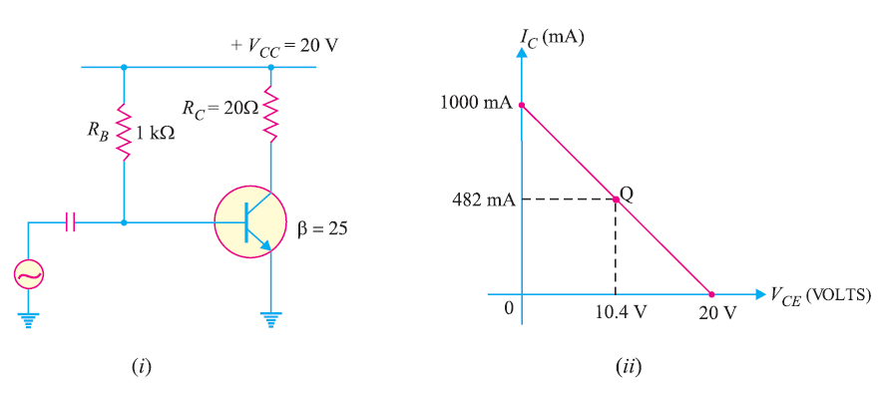
Q point is 10.4 , 482 m A for the Load line :
IB=$\frac{Vcc-VBE}{RB}$=$\frac{20-0.7}{1kΩ}$=482 mA Vce=Vcc-IcRc =20-((482*0.001)*20)- 10.4 V
Ic(peak)= βIb(peak)=25*10=250mA
Po(ac)=$\frac{(ic\left(p\right)){}^{2}}{2}$Rc=$\frac{(250*{10}^{-3}){}^{2}}{2}$*20=0.625w
(ii)Pdc=Vcc Ic =(20v)(482*10⁻³)=9.6w
(iii)$£$=$\frac{Po(ac)}{pdc}*100=\frac{0.625}{9.6}*100=6.5\%$
IMPORTANT POINTS ABOUT CLASS A ( PA )
-THE POWER DISSIPATION BY TRANSISTER IS :
Pdis=Pdc- Pac
-IN THIS TYPE THE TRANSISTER MUST DISSIPATE LESS HEAT WHEN SIGNAL IS APPLIED AND THEN RUNS COOLER.
-WHEN NO SIGNAL IS APPLIED TO THIS CLASS Pac=0 and then Pdis= Pdc so max power dissipation is when no signal
-IF 1W IS THE ZERO SIGNAL POWER DISSIPATION ,THEN TRANSISTER NEEDS AT LEAST 1W
-IF THE POWER RATING IS LESS THAN 1W , IT IS LIKELY TO BE DAMEGED

EX: A CLASS (A) (P A ) TRANSISTOR HAS ZERO SIGNAL POWER DISSIPATION OF 10 W . IF THE AC OUTPUT POWER IS 4W ,FIND : 1):COLLECTOR EFFICIENCY 2)POWER RATING OF TRANSISTER
SOLUTION :Pdc=10W (ZERO SIGNAL POWER DISSIPATION)
Po=4W (AC POWER OUTPUT)
1)COLLECTOR EFF.=( $\frac{Po}{Pdc}$ )*(100)=($\frac{4}{10}$)*(100)=40%
2)the zero signalPOWER DISSIPATION IN A TRANSISTER OCCURES UNDER ZERO CONDITION POWER RATING OF TRANSISTOR WHICH=10W
IT MEANS, TO AVOIDE DAMAGE, THE TRANSISTOR MUST HAVE A POWER RATING OF AT LEAST 10 W :
EX: IN A PA : IC(max)=160 m A , IC(min) = 10 mA , Vc(max)= 12V , Vc(min)= 2 v
CALCULATE THE AC POWER OUTPUT Po
Po=$\frac{[[VCe(pp)]*ICpp ]}{8}$
Vce(pp)=12-2=10 v IC(PP)=160 m A-10Ma=150 Ma Po=$\frac{(10v) *(150mv)}{8}$=187.5 mw

