Isolation of bacteria
Bacteria are the simplest of microorganisms, known as prokaryotes. Within this prokaryotic group, there are the filamentous microbes known as actinomycetes. Actinomycetes are actually bacteria, but they are frequently considered to be a unique group within the classification of bacteria because of their filamentous structure, which consists of multiple cells strung together to form hyphae. This experiment uses glycerol case media that select for actinomycete colonies, during dilution and plating. Typically, actinomycetes are approximately 10% of the total bacterial population. Bacteria and actinomycetes are found in every environment on Earth. These microbes are also essential for human life and affect what people eat, drink, breathe, or touch. In addition, there are bacterial species that can infect people and cause disease, and there are bacteria that can produce natural products capable of healing people.
Bacteria are critical for nutrient cycling, plant growth, and degradation of organic contaminants.
Bacteria are highly diverse in terms of the number of species that can be found in soil, in part because they are physiologically and metabolically diverse. Bacteria can be heterotrophic, meaning they utilize organic compounds, such as glucose, for food and energy, or autotrophic, meaning they utilize inorganic compounds, such as elemental sulfur, for food and energy. They can also be aerobic, utilizing oxygen for respiration, or anaerobic, utilizing combined forms of oxygen, such as nitrate or sulfate, to respire. Some bacteria can use oxygen or combined forms of oxygen and are known as facultative anaerobes.

PRINCIPLES
a small sample of soil is serially diluted in water, prior to being plated on agar within a Petri plate. Typically, a small amount of soil contained within 0.1 to 1 mL of the diluted soil suspension is “spread” over the surface of the agar plate. The plates contain agar
During serial dilution of the soil, soil particles can settle out (fall to the bottom), so the true aliquot of soil is not passed on into the next dilution
dilution and plating of soil bacteria only accounts for culturable bacteria and underestimates the true viable soil population by one to two orders of magnitude.
two media are used: one designed for all bacteria, and the other that selects for actinomycetes. Once the bacterial colonies have grown on the agar plates, isolate the pure cultures of selected colonies. Such pure cultures can then be further analyzed and characterized for specific traits and functions.

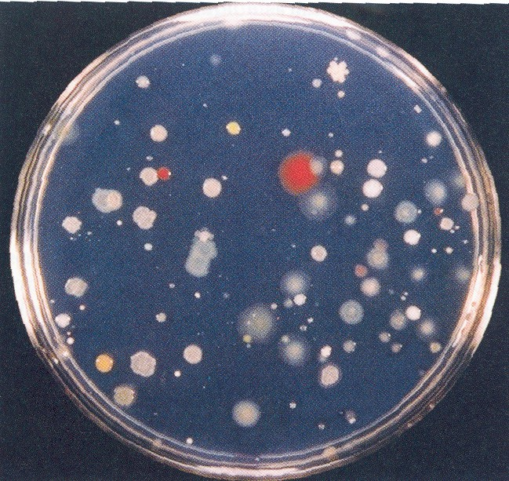

PROCEDURE
1. Preparation of Soil Dilutions
- To begin the procedure, weigh out 10 g of soil sample and add to 95 mL of deionized water. Shake the suspension well, and label as “A”.
- Before the soil settles, remove 1 mL of the suspension with a sterile pipette and transfer it to a 9-mL deionized water blank. Vortex thoroughly, and label as “B”.
- Repeat this dilution step three times, each time with 1 mL of the previous suspension and a 9-mL deionized water blank. Label these sequentially as tubes C, D, and E. This results in serial dilutions of 10⁻¹ through 10⁻⁵ grams of soil per mL
2. Making Spread Plates for Bacterial Culture
- To grow bacterial colonies, take three pre-prepared peptone-yeast agar plates and label them as C, D, and E. Vortex samples C, D, and E, and pipette 0.1 mL onto each plate. This increases the dilution value further, by a factor of ten (C = 10⁻³, D = 10⁻⁴, E = 10⁻⁵)..
- Hold the spreader above the first plate until the flame is extinguished. Open the plate quickly, and then spread the drop of inoculum around the surface of the agar until traces of free liquid disappear.
- Re-flame the spreader and repeat the process with the next plate, working quickly so as not to contaminate the agar with airborne organisms
- Incubate the bacteria plates at room temperature for 1 week. Make sure the plates are inverted during the incubation to prevent drops of moisture from condensation from falling onto the agar surface.
3. Making Spread Plates for Actinomycetes
- To grow actinomycetes, take three pre-prepared glycerol-casein plates and label them as B, C, and D. Using the techniques shown previously, spread plate 0.1 mL from the suspensions B, C, and D. The lower dilutions are used because actinomycetes are typically present as 1/10th of the bacterial population (B = 10⁻², C = 10⁻³, D = 10⁻⁴).
- Incubate the actinomycete plates (inverted) at room temperature for 2 weeks.
4. Bacterial and Actinomycete Counts
- After incubation, examine all of the bacteria plates carefully, and note differences in colony size and shape. When grown on agar, bacteria produce slimy colonies ranging from colorless to bright orange, yellow, or pink. In contrast, actinomycete colonies are chalky, firm, leathery, and will break under pressure, where other bacterial colonies will smear. This allows colonies to be distinguished by touch with a sterile loop.
- Count and record the number of bacterial colonies, including any actinomycetes. Only count plates with 30-200 colonies per plate.

RESULTS

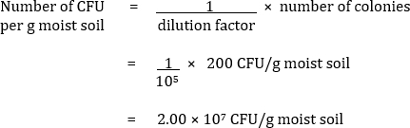

Step |  | Dilution
10 g soil (weight/volume) | 95 mL saline (solution A) | 10⁻¹
1 mL solution A (volume/volume) | 9 mL saline (solution B) | 10⁻²
1 mL solution B (volume/volume) | 9 mL saline (solution C) | 10⁻³
1 mL solution C (volume/volume) | 9 mL saline (solution D) | 10⁻⁴
1 mL solution D (volume/volume) | 9 mL saline (solution E) | 10⁻⁵

