**Phaeophyta (Brown algae) Lecture 4**

**General features**

-The brown algae are distinguish by their colour, which varies from olive green through light golden to a rather deep shade of brown. This is due to the presence of a golden brown xanthophyll pigment **fucoxanthin.**

-This is in addition to **chlorophyll a**, **chlorophyll c** and **carotens.**

-Usually the thalli of brown algae **secrete abundant mucilage which readily absorbs moisture and retain it tenaciously.** This keeps the plants moist at low tide when they are exposed.

**Mannitol** and **laminarin** are the reserve photosynthetic products. Mannitol it is a kind of complex alcohol widely distributed in the cells of almost all the brown algae.

The simple sugars are converted into **mannitol** type alcohol, therefore the sugars are rare in Phaeophyceae.

**Motile reproductive cells are commonly found in the brown algae,** generally these are pyriform or spinle-shaped and biflagellate.

The two flagella are of **unequal lengths and inserted laterally**, one of these is **whiplash type** and the other **tinsel.**

Sexual reproduction ,**Oogamy** is the general rule.

**Distribution**

Unlike theCyanophyceae and the Chlorophyceae, which are mainly fresh water forms, **the brown algae are almost exclusively marine**. There are only few rare ones, which are fresh water and usually grow in the streams that drain directly into the ocean. The marine forms are found in the shallow waters along the coasts of all seas but they attain their greatest development both in number and large size in the cold waters of oceans and seas of northern latitudes.

They are **benthonic** and grow as lithophytes attached by holdfasts to the rocks, stones or timbers beneath the surface. They usually develop air bladders to buoy up the free portions of their thalli.

**Range of thallus organization**

They display the highest degree of body differentiation.The simplest type of the plant body in the brown algae is represented by a **heterotrichous** **filament which is the highest stage of development in the green algae**. **Morphologically therefore the brown algae begin where the green algae finish**.

**Visible structures**

Brown algae exhibit marked morphological and anatomical complexity. The plant body consist of a forked, flattened, band-shaped upper part known as the **blade (photosynthetic and reproductive structures),** a more or less cylindrical lower part called the **stipe** and[**holdfast**](https://en.wikipedia.org/wiki/Holdfast) is a rootlike structure present at the base of the alga (Fig.1).

A [**holdfast**](https://en.wikipedia.org/wiki/Holdfast) Like a root system in plants, a holdfast serves to **anchor the alga in place on the substrate where it grows**, and thus prevents the alga from being carried away by the current.

A [**stipe**](https://en.wikipedia.org/wiki/Stipe_(botany)) is a stalk or stemlike structure present in an alga. It may grow as a short structure near the base of the alga (as in [***Laminaria***](https://en.wikipedia.org/wiki/Laminaria)), or it may develop into a large, complex structure running throughout the algal body (as in [***Macrocystis***](https://en.wikipedia.org/wiki/Macrocystis)).

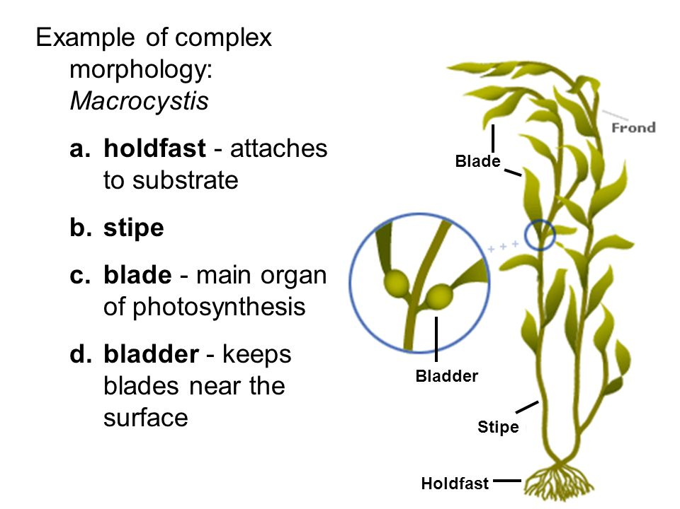

Fig.1: morphology of Phaeophyta (*Macrocystis*)

**Reproduction**

**-**asexual reproduction: takes place both by vegetative methods and spore formation.

* **Vegetative reproduction**

**i-fragmentation**

**ii-propagula**: some genera of brown algae produce special, adventitious branches called the **propagula (**include smaller or larger thallus fragments detached from the plant body of the alga).

* **Spore formation**

**Economic importance**

**1-** Brown algae include a number of [edible seaweeds](https://en.wikipedia.org/wiki/Edible_seaweed)

**2-** Certain brown algae (***Laminaria***, ***Fucus*)** are a **source of commercial iodine**. High concentrations of iodine, potassium, magnesium and other solutes from seawater accumulate in the cells of brown algae.

**3-** Brown algae including [kelp](https://en.wikipedia.org/wiki/Kelp) also fix a significant portion of the earth's carbon dioxide yearly through photosynthesis.

**4-** [**Sargachromanol G**](https://en.wikipedia.org/wiki/Sargachromanol), an extract of [***Sargassum***](https://en.wikipedia.org/wiki/Sargassum_siliquastrum), has been shown to **have anti-inflammatory effects.**