**Lecture -6**

**Bryophyta**

Plants grow in two well-defined habitats. These are the water and the land. The plants which grow in water are called the **aquatics** and the others **terrestrial.** The best examples of aquatic plants are the **algae** and the land dwellers are the **seed plants**.

Between these two extremes of habitats is a transitional zone, it is represented by the swamps and the areas where water and land meet. It may well be called the **amphibious zone** which inhabited by the **mosses**, **liverworts** and **hornworts** which collectively constitute a group of non-vascular land plants called the **bryophytes.**

The latter are simple, thallus-like plants. Which suggest the stages through wich the green algae may have evolved to become terrestrial. Most of the bryophytes are land dwellers which inhabit damp, shaded and humid localities. A few of them, however, live in or float on water.

Evidence supports the view that these early land plants descended from algae-like ancestors which were probably green. Adaptation to land environment or sub-aerial life involved the development of certain features that were not possessed by their aquatic ancestors. These are:

1. **Development of organs for attachment and absorption of water.**
2. **Protection against desiccation.**
3. **Absorption of carbon dioxide from the atmosphere for photosynthesis.**
4. **Protection of reproductive cells from drying and mechanical injury.**
5. **The fertilized egg is retained with archegonium.**

**Life cycle**

The bryophytes have evolved a life cycle which comprises two phases: **gametophyte** and **sporophyte**. The former is the most conspicuous of the two. It is green, long-lived, freely branching and independent.

1. **Gametophyte:**
2. **Plant body**

The bryophyte is a small group of most primitive land dwellers. A few of them, however, are strictly aquatic. Example of aquatic genera is *Ricciocarpus*. The bryophytes number about 24000 species which are grouped under nearly 960 genera. All of them are small and inconspicuous plants ranging in size from about a millimeter in length to 30 centimeter or more.

The majority of the bryophytes, however, have the plant body differentiated into stem and leaves. The leafy gametophyte of the liverworts is dorsiventral but in the mosses it is erect. The erect, leafy moss gametophyte has a stem-like central axis which bears leaf-like appendages. It is fixed to the substratum by means of branched multicellular **rhizoids** apparently resembling the **roots.** The thallus-like plant body of bryophytes bears the gametes. For this reason it is called the **gametophyte** plant.

**b) Reproduction**

The bryophytes, have multicellular, jacketed sex organs. Each of these sex organs consist of an outer, protective wall of groups of cells which produce the gametes. The male sex organ is called the **antheridium**. The female, however, is known as the **archegonium**.Both kinds of sex organs may be developed on the same individual and called **monoecious** or on distinct plants and called **dioecious.**

1. **Antheridium**

The antheridium(Fig.1 A) is a multicellular club-shaped sometimes spherical in form. It is borne on a short stalk which attaches it to the gametophyte tissue.

The body of a **ntheridium** has a wall of a single layer of sterile cells. It surrounds a mass of small squarish or cubical cells called the **androcytes**. The latter produce the biflagellate male gametes called the **sperms**. Several sperms are produced in each antheridium. They are motile structure. Each sperm usually consists of a minute, slender, spirally curved body furnished with two long, terminal, whiplash type flagella (Fig.1 B).

**Antheridial wall or jacket**

**Stalk**

**Androcytes**

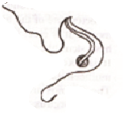 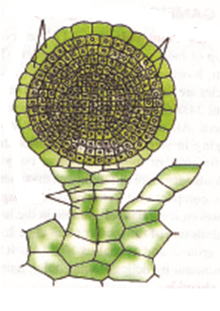

**Fig.1B**

**Fig.1A**

1. **Archegonium**

Archegonium (Fig.1 C). Is a flask-shaped organ. The slender, elongated upper portion is called the **neck** and the lower sac-like, swollen portion called the **venter**.

The venter is attached to and often deeply embedded in the parent plant tissue. The neck has a wall of a single layer of sterile cells which surrounds a central row of elongated, necked cells called the **neck canal cells**.

The neck is usually projecting or freely exposed so as to be accessible to sperms .The venter wall encloses two cells, the larger called **egg** cell or the **ovum** and the smaller **ventral canal cell**.

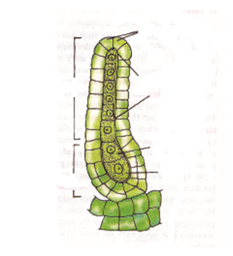

**Neck**

**Lid or cover cells**

**Neck canal cells**

**Venter**

**Egg**

**Ventral canal cell**

**Fig.1C.**

1. **Fertlization:**

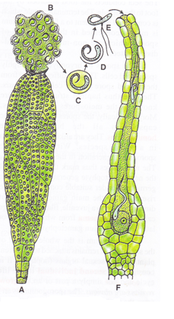

Fig.2 (A-F). **Bryophytes**. Dehiscence of sex organs and fertilization in a Moss plant.

**A:** dehisced antheridium;

**B:** androcyte mass;

**C:** sperm within the androcyte membrane; **D:** androcyte wall dissolving;

**E:** liberated sperm;

**F:** dehisced archegonium showing fertilization.

**2) Sporophyte:**

With the fertilization starts the second phase in the life cycle of the bryophytes. It is called the sporophyte. The pioneer structure of this phase is the **zygote**. The spherical mass of diploid tissue within the enlarged archegonial venter is called the **sporophyte.**

**a) Zygote**

**b) Embryo**

**c) Sporogonium**