Lab 3

Phaeophyta (Brown algae)

General Characteristics of phaeophyta
  - Unlike the chlorophyta and cyanophyta which are mainly freshwater forms, the brown algae are almost exclusively marine.
  - Presence of a golden brown xanthophylls pigments (fucoxanthin).
  - Mannitol and laminarin are the reserve photosynthetic products.

  - Motile reproductive cells are pyriform or spindle-shaped and biflagellate (heterokont).

- Division: Phaeophyta
    - Class : Isogenerateae Order :Ectocarpales Family: Ectocarpaceae Genus: Ectocarpus

    - Class: Heterogenerateae Order : Laminariales Family: Laminariaceae Genus: Laminaria

    - Class: Cyclosporae Order: Fucales
Family: Fucaceae Genus: Fucus

Microscopic identification

Order :Ectocarpales
Genus: Ectocarpus:
      - Branched filamentous thalli, forming generally bushy plants reach to 15 cm. in length.
      - Cells have band- shaped chloroplast.

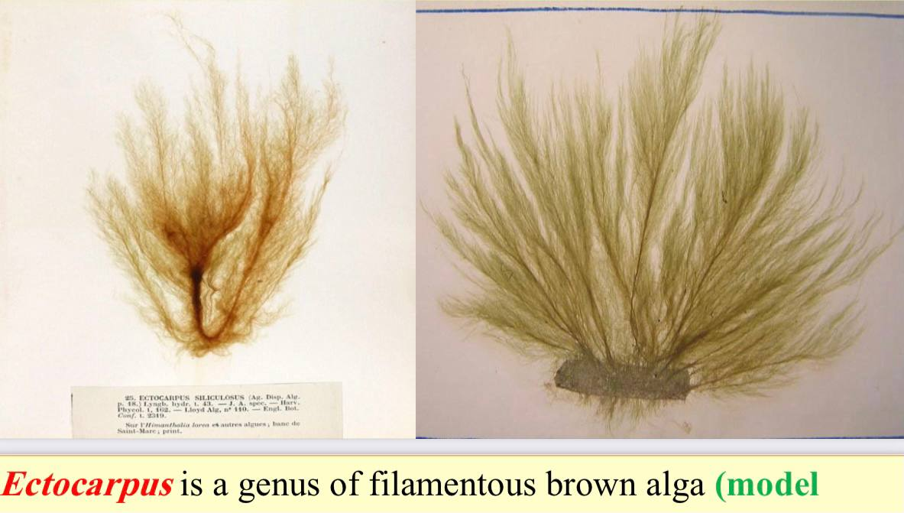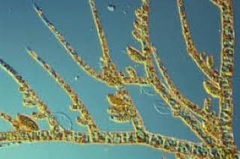

Genus: Laminaria :

- The common name of these algae is the kelps.

- Cross section through the blade of sporophyte appears three different regions: epidermis, cortex and central medulla.

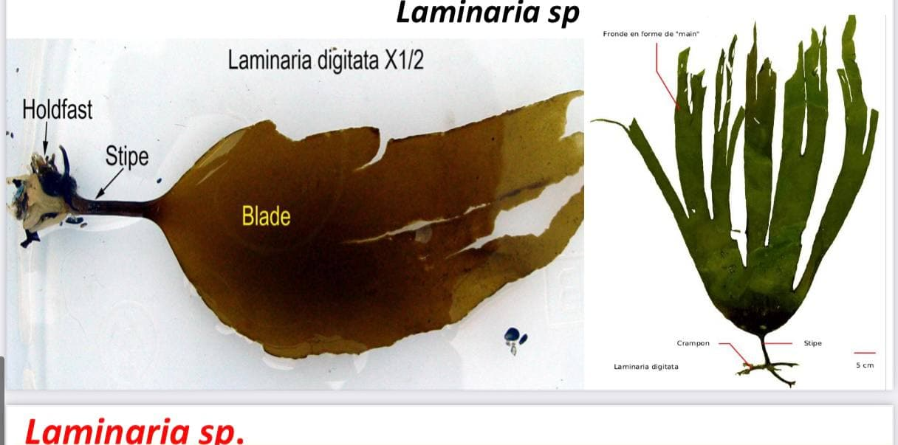

Genus: Fucus:
- The thallus of these algae is leathery, flattened and dichotomously branched, supported by a short narrow stalk that is attached to a discoid hold fast.
- The common name is rock weed.

- The life cycle is cyclosporae, because the gametophyte reduced into only male and female gametes (antheridia and oogonia) within sporophyte itself.

