Biosystematics
Lab- 2
The Root: It is the plant part that grows under the ground and work to anchor the plant in the soil and absorb water and minerals.
Root system:
- Tap root (in dicot plants).
- Adventitious root (in monocot plants).

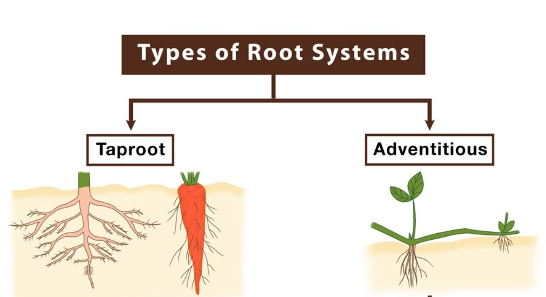

Types of tap root:
1-normal ex: Vicia
2-fleshy:
A/ Conical ex: Daucus
B/fusiform ex: Raphanus
C/ globoid ex: Beta

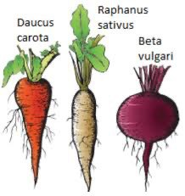

Types of adventitious roots:
1-fibrous root ex: Triticum
2-tuberous root ex: Dhalia
3-Prop root ex: Zea mays
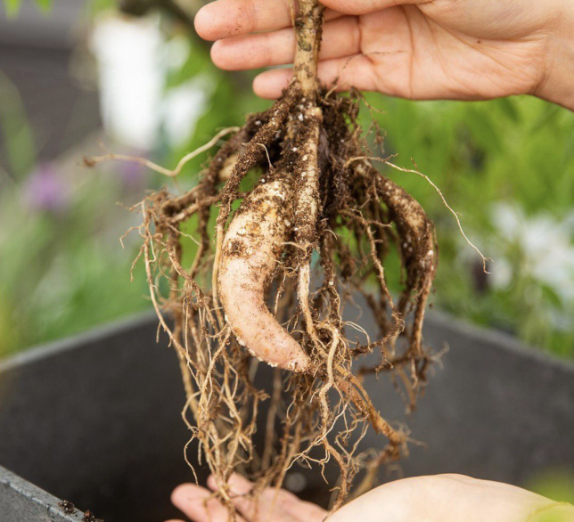
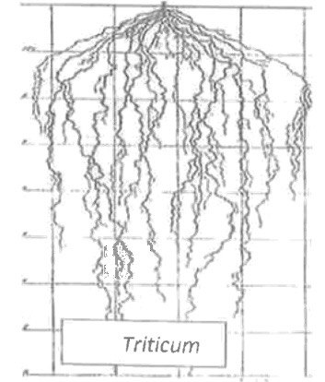
Dhalia

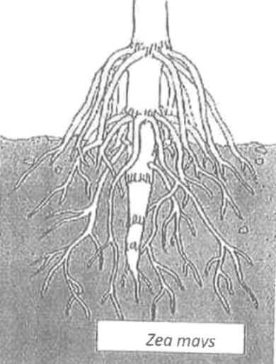

The Stems
The stems: It is the main axis of plant bearing nodes, leaves, buds and flowers.
Types of stems:
1-Aerial stems: : stem occurring above ground or water:
A/ Erect ex: Phoenix
B/ Ascending ex: Nerium
C/ Weak ex: Convolvulus

2-Subterranean stem: stem occurring below the surface of the ground:
A/ Rhizome ex: Cana cepa
B/ Bulbs ex: Allium cepa
C/ Tuber ex: Solanum
D/ Corms ex: Cyperus

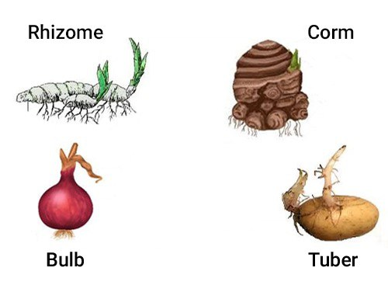

3-Aquatic stem: stem with characteristics ofherbs, not woody.
Modified stem:
- spines ex: Bougainvillea
- tendrils ex: Vitis
- cladophylla ex: Ruscus

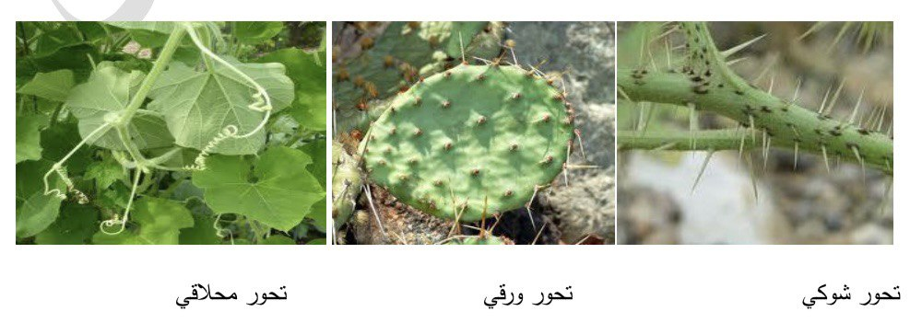
Tendrils stem Cladophylla stem Spines stem

