Lecture: 6
****Corolla : It’s the second part of perianth composed of petals and usually colored, the main function of corolla is to assist pollination and therefore increase the chance of successful reproduction of the flower.

*** Types of Corolla :-
- Polypetalous : Corolla composed of separate petals. This type could be in different shapes:-
A/ Cruciform : four free petals arranged in the form of cross as in Brassicaceae.
B/ Caryophyllaceous : Five free clawed petals with limb at right angles to the claw.
**Claw: Its narrowed stalk of petals.
**Limb : The junction of corolla tubes and lobes.
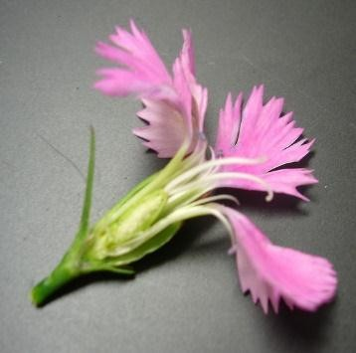
C/ Rosaceous : Five sessile petals with limbs spreading out as in Rosaceae .

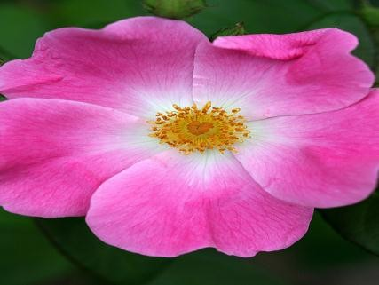

D/ Papillionaceous : Its five petals with single posterior petals (standard), two lateral petals (wings) and two anterior petals slightly united to form keel, as in Fabaceae.
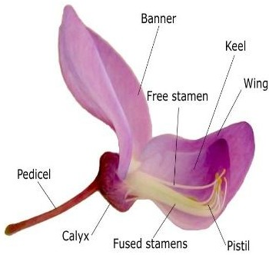

- Gamopetalous :- Corolla composed of united petals. It may be in variety shapes:
A/ Bilabiate: two- lipped, with two, generally upper and lower segments as in Lamiaceae.
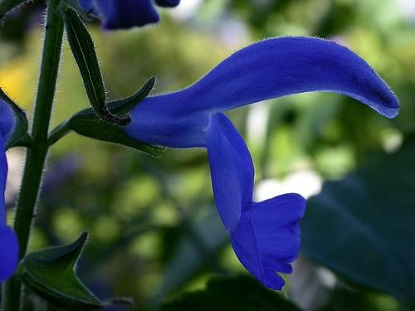
B/ Campanulate : bell-shaped, with a basally round flaring tube about as broad as long plus flaring lobes as in Campanula.

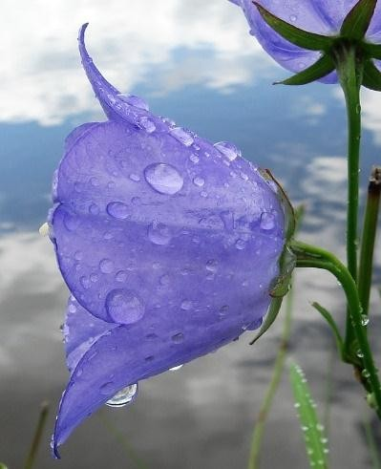

C/ Ligulate: having a short, tubular corolla with a single, elongate, strap-like a pical extension as in some Asteraceae.
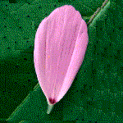
D/ Salverform : Petals united to form salver-like shape as in Vinca.
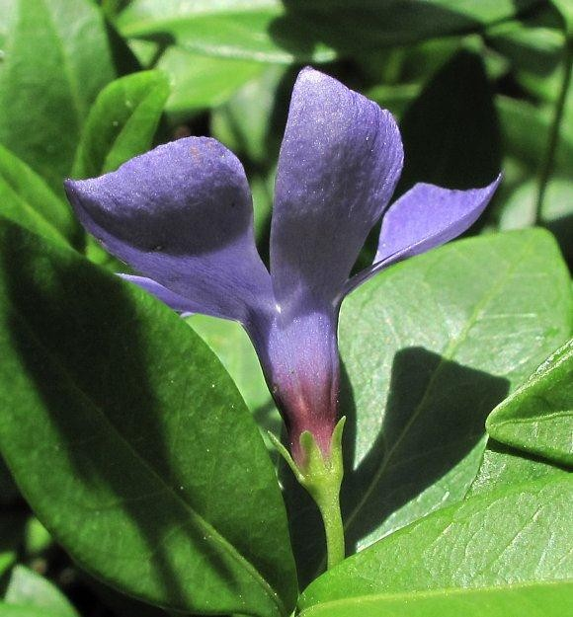
E/ Tubular : Petals united to form tube like shape as in discoid flower of
Helianthus.

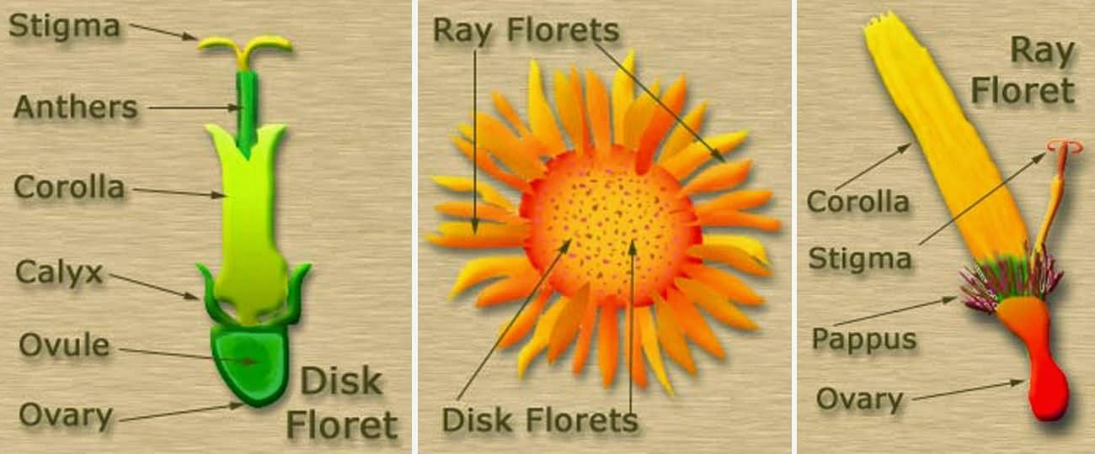

***Androecium :
It consists of all floral male (pollen- producing), the units of which are stamens. Stamens are defined as modified sporangia bearing leaves or microsporophylls.
Stamen type: There are two types of stamens:
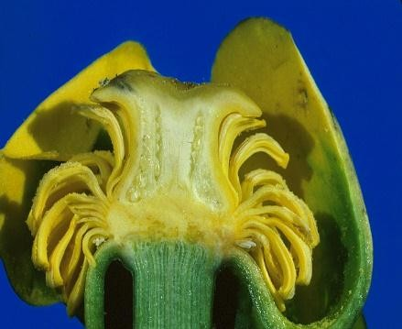
- Laminar S. : It possess a leaf like, dorsiventrally flattened structure bearing two theca.
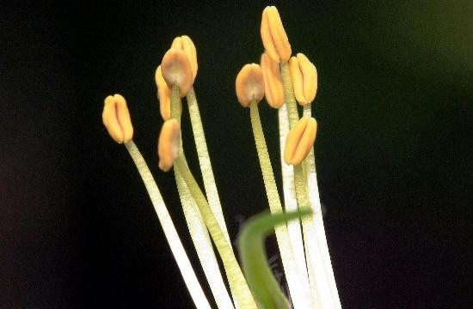
- Filamentous S. : It has a stalk like, terete filament with a discrete pollen – bearing part, the anther.

**Stamen structure : each stamen has an:
- Anther : Its tetra sporangiate with two anther sacs (microsporangia) in each of the two anther lobes.
- Filament : filiform structure, hollow or solid, helps in settle down of anther; filament might be long as in Lilium, or short in Phoenix dactylifera or absent as in aquatic plants.
**Anther: They are discete pollen containing units, found in the stamens of the great majority of angiosperms.
The typical anther is dithecal, in few taxa such Malvaceae and Cannaceae, anthers are monothecal.

