Lab 6
*** Inflorescence
Is the arrangement of flowers on the stem of a plant. All flowers arising from the main stem axis or peduncle.
**Inflorescence parts:
- Peduncle: the stem holding the whole inflorescence, and the major axis
- Rachis: holding the flowers or more branches within the inflorescence.
- Pedicle: the stalk of each single flower.
- Floret: any flower in an inflorescence.

*** Types of inflorescence:
A: Determinate inflorescence (Cymose). the terminal bud forms terminal flower and then dies out. Other flowers then grow from lateral buds.
1-Monochasium: is cyme that develops along one axis only:
A/Simple monochasium: have one terminal flower with one
flower below ex: Convolvulus
B-Compound monochasium
1/Helicoid: the one flower below repeat many times to give a long coiled inflorescence
2/ Scorpoid cyme: have one sided branching, forming a coiled inflorescence zigzag like)

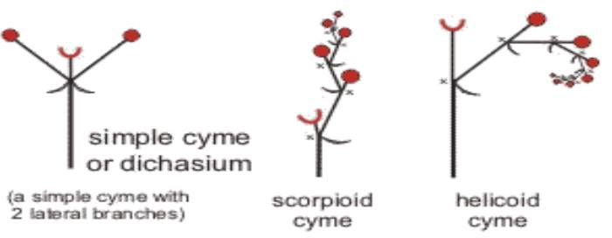
2-Dichasium: one that develops along two axes, forming one or more pairs of opposite, lateral axes:
A/ simple dichasium
B/ Compound dichasium

B: indeterminate inflorescence:
1-Spike
2-Raceme
3-Corymb
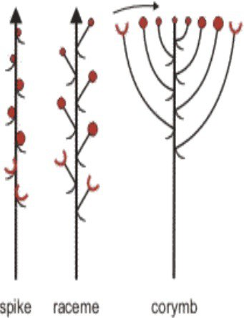

C: Specialized inflorescence
- Cyathium
- Verticillate
- Syconium (Hypanthodium)

