Lab 7
The Fruit :Mature ovary with is contains, fruits often have pericarp differentiated to 3 zones:
- Epicarp
- Mesocarp
- Endocarp

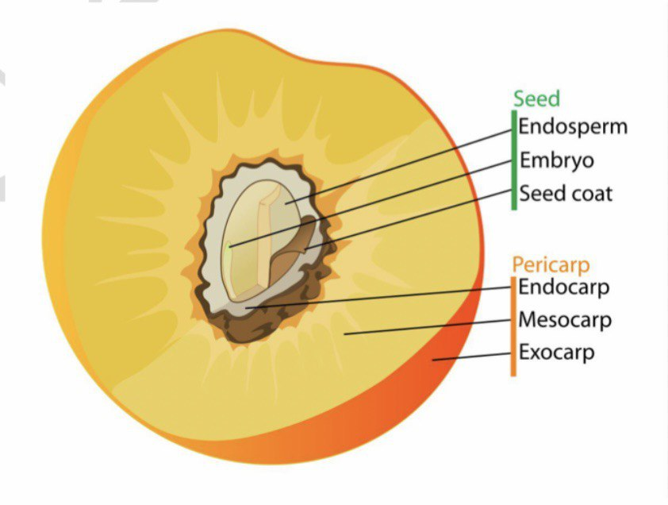

Capsular fruit: dry fruits resulting from maturity of compound ovary (superior or inferior) usually opening at maturity by one or more line of dehiscence.
1-Follicale: dry, capsular and dehiscent fruit resulting from maturing of simple and superior ovary, opening only on dorsal suture.
2-Legume: dry, capsular fruit resulting from maturing of simple and superior ovary, opening on both suture
3-Silique : dry, capsular and dehiscent fruit resulting from maturing of compound (2carpels) and superior ovary which is separated to tow chambers by false septum, this fruit opening by two valves from down to up.

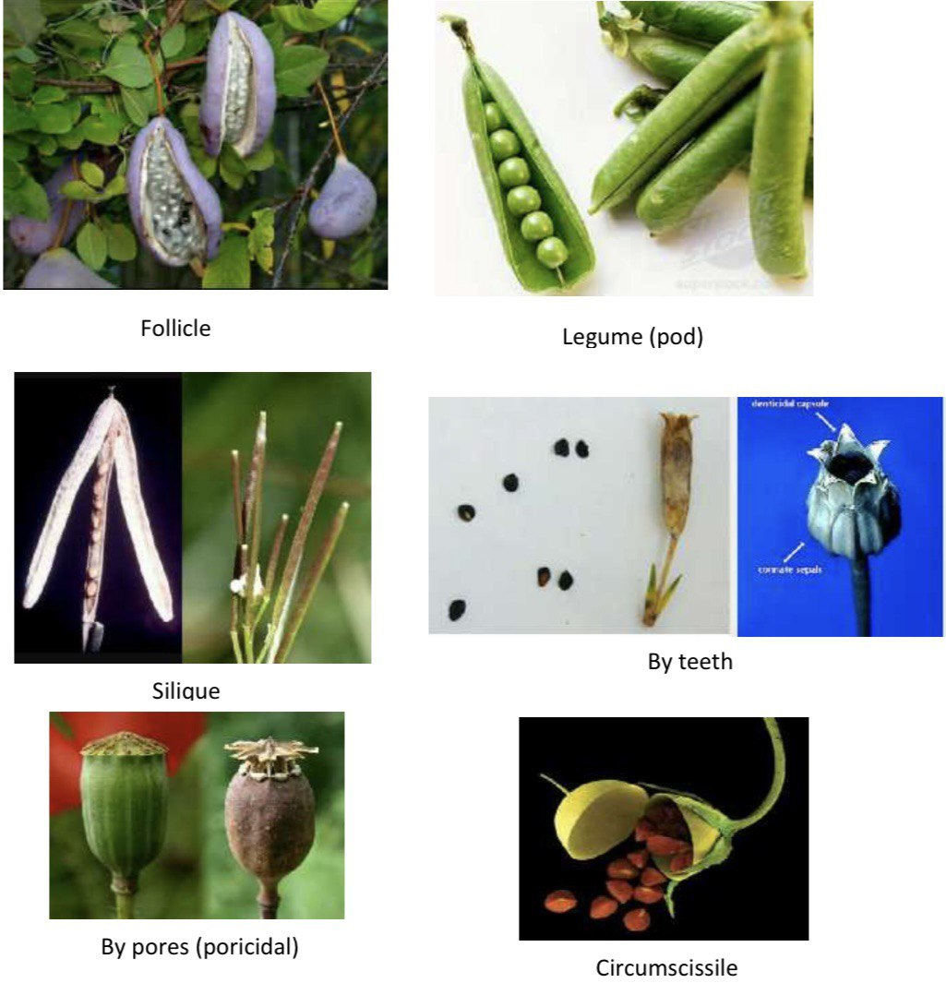

Achenial fruit: small dry indehiscent fruit with one seed with thin pericarp
1-Caryopsis: its achenial fruit resulting from superior ovary, with seed coat fused to the pericarp.
2-Samara: achenial winged fruit.
3- Nut: achenial fruit resulting from superior or inferior ovary with one chamber or more this fruit having strong woody pericarp separated from seed coat.

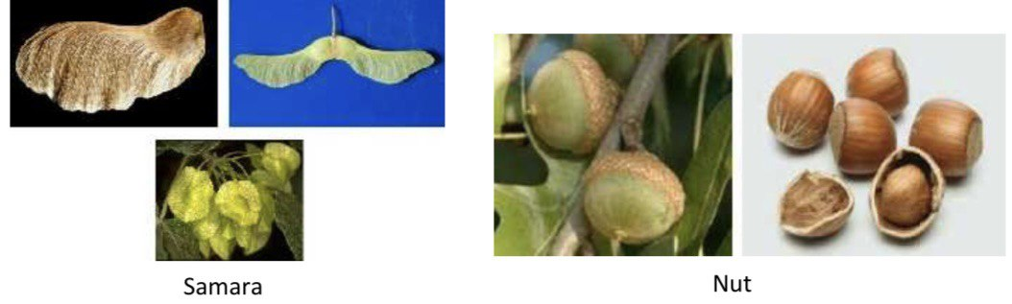

Schizocarpic fruit: dry multiple seeds fruit splits in to 2-many parts each one named mericarp.
Cremocarp: This fruit resulting from inferior ovary with 2 carples.
Carcerulus: schizocarpic dry fruit split by many splitting longitudinal line, equal to chamber number of the ovary

