Lecture 1 ( An Introduction to Cell Biology)
The Cell
The cell (from Latin cell meaning small room) is the basic structural, functional and biological unit of all known organisms. A cell is the smallest unit of life. Cells are often called the building blocks of life. The study of cell is called Cell Biology, Cellular Biology or Cytology.
In 1665, the cell was discovered by Robert Hook. It is a small united area where all kinds of actions and reactions collectively take place. Some cells have membrane- bound organelles and some do not have. Depending upon the internal structure of the cell, two types of cells are found in an organism namely Eukaryotic and Prokaryotic. Organisms that are made up of single cells are known as single-celled unicellular organisms and from many cells are known as multi-cellular organisms.

The Cell Theory:
The cell theory includes four principles in modern biology:
- All organisms are composed of one or more cells. While many organisms, such as the bacteria, are single-celled unicellular, other organisms, including humans and plants, are multicellular within the life processes of metabolism and heredity occur.
- Cells are the smallest living things.

- Addition cells are not originating at present, rather, life on earth represent a continuous line of descent from those early cells.
- Cells arise only by the division of previously existing cell.

The functions of cells:
  - The capacity to extract energy from the environment and change it from one form to another.
  - The capacity to use this energy to build more organic molecules to maintain themselves and grow.
  - The capacity to deal with the environment selectively.
4- The capacity to reproduce.
In general, the smallest living microorganism on the earth is the viruses while the smallest unicellular microorganisms are the mycoplasma. But the biggest living organism is the Sequoia plant (red wood tree).

Prokaryotes and Eukaryotes
Biologists classify cells into two broad categories the Prokaryotes and Eukaryotes. The primary difference between a prokaryotic cell and a eukaryotic cell is the presence or absence of a nucleus, a membrane-bound structure that houses the DNA. Prokaryotic cells lack a nucleus, whereas eukaryotic cells possess a nucleus. Despite their differences, both types of cells have a plasma membrane, a membrane that regulates what enters and exists a cell.

Table 1: A comparison between Prokaryotic cell as in bacteria and Eukaryotic cell as a plant (Figure 1)

Prokaryotic Cell | Eukaryotic Cell
Nucleus is absent | Nucleus is present
Membrane-bound nucleus absent. | Membrane-bound Nucleus is present.
Cell wall chemically complex | Cell wall is present in plants and fungi and  chemically simpler
Mitochondria absent | Mitochondria present
One chromosome is present, but not  true chromosome plastids | More than one number of chromosomes is  present.
Chloroplasts absent; chlorophyll  scattered in the cytoplasm | Chloroplasts present in plants
Vacuoles absent | Vacuoles present
Sexual reproduction is absent  divided by binary fission | Sexual reproduction is present divided by  mitosis meiosis
Golgi apparatus absent | Golgi apparatus present

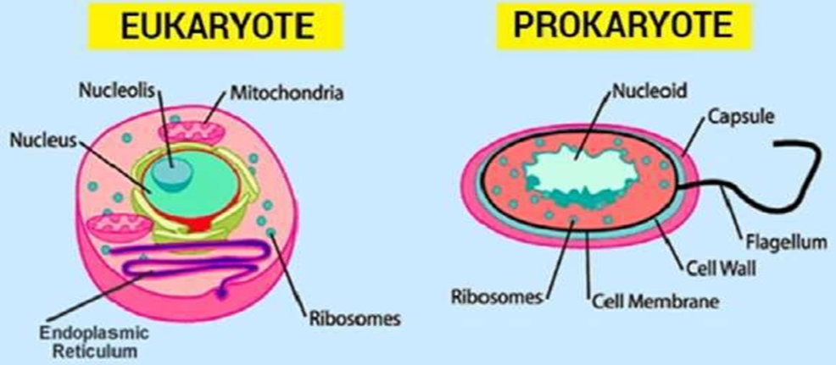
Figure1: comparison between Prokaryotic cell as in bacteria and Eukaryotic cell

