Lecture2
Animal Cell and Plant Cell
- All living things are made up of cells. Animal cells and plant cells share the common components of a nucleus, cytoplasm, mitochondria and a cell membrane.
- Plant cells have three extra components,a vacuole,chloroplast and a cell wall.

Animal cells
Animals are made up of millions of cells. Animal cells have an irregular shapes and are made up of four key parts (Figure 2):

- Nucleus – This contains genetic material (DNA), and controls the cell's activity.
- Cell membrane – A flexible layer that surrounds the cell and controls the substances that enter and exit.
- Cytoplasm – A jelly-like substance where the chemical reactions happen.
- Mitochondria – This is where energy is released from the food molecules.

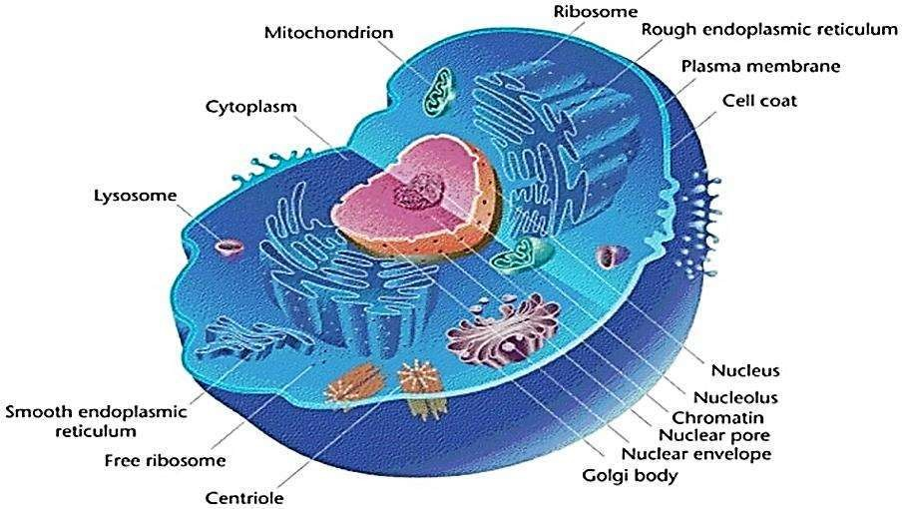
Figure 2: The animal cell

Plant cells
Plants are also made up of millions of cells. Plant cells have a nucleus, cell membrane, cytoplasm and mitochondria too, but they also contain the following structures (Figure 3):

- Cell wall – A hard layer outside the cell membrane, containing cellulose to provide strength to the plant.
- Vacuole – A space inside the cell that is used to store substances and help the cell keep its shape.
- Chloroplasts – Structures that contain the green pigment chlorophyll, which are a key part of photosynthesis.

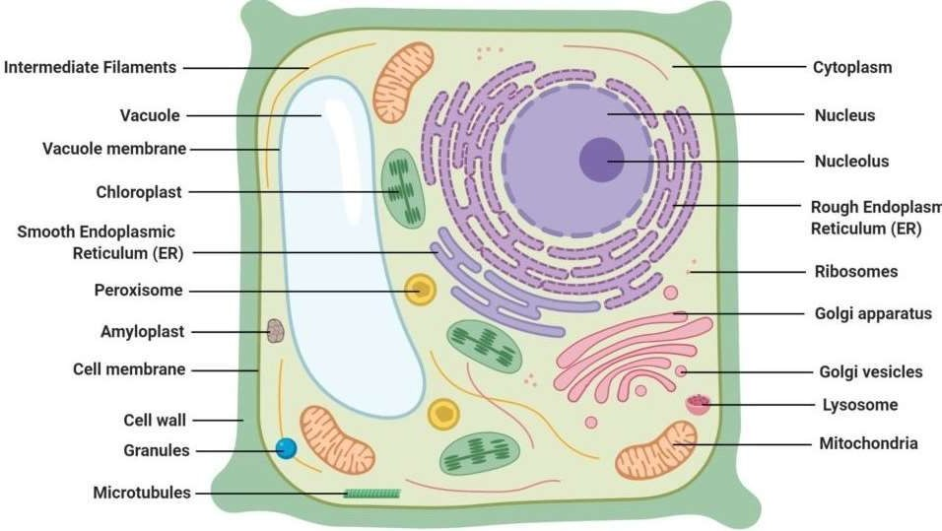
Figure )3(: The plant cell

Table 2 Comparsion between Animal cell and Plant cell

Characteristic | Animal cells | Plant cells
Size and Shape | Generally smaller than plant cells with their cells ranging from 10-30um in length.  Shapes vary greatly from irregular shapes to round  shapes. | Larger than animal cells with the cell size ranging from 10um-100um in length.  Plant cells similar in shape with most cells being rectangular or cube-shaped.
Cell Wall | They lack the cell wall but  possess a plasma (cell) membrane, | They have both a cell wall that is  made up of cell membrane and cellulose.
Plasma membrane | Present | Present
Ribosomes | They are present and they are used for protein synthesis and  genetic coding of the protein, amino acid sequences. | They are present and they are used for protein synthesis and cellular repair mechanisms.
Endoplasmic reticulu | Present | Present
Lysosomes | lysosomes, contain digestive enzymes to break down cellular macromolecules. | rarely contain lysosomes as the plant vacuole and the Golgi bodies handle  molecule degradation of waste cellular products.
Vacuoles | Present | Present
Nucleus | Present and it lies at the  center of the cell | Present and it lies on the side of the  Cell
Centrioles | They are present with their major function involving the assistance of the cell division  process. | They are absent in plant cells
Microfilaments and Microtubules | Present | Present.
Cilia and Filaments | Present; they allow movement of cells or part of the cell, for example,  swimming of the sperm to the ova. | Absent in plants
Plastides | Absent | Present; they give pigmentation color to the plants and also facilitate trapping of light energy used for  photosynthesis.
Golgi bodies | They have larger and fewer Golgi bodies with their major function being to process and package protein and lipid macromolecules as they are  being synthesized. | They have smaller but more Golgi bodies with their major role being modification, processing, sorting and packaging proteins for cellular secretion.

Table(3) Comparison between Bacterial, Animal and Plant Cells as shown figure 4 (For information only).
 | Bacterium | Animal | Plant
Type of Cell | Prokaryotic cells | Eukaryotic cells | Eukaryotic cells
Cell Wall | Present (protein-  polysaccharide) | Absent | Present (cellulose)
Cell membrane | Present | Present | Present
Nucleus | Absent | Present | Present
Plasmids | Present | Absent | Absent
Plastids | Absent | Absent | Present
Mitochondria | Absent | Present | Present
Ribosomes | Present | Present | Present
Lysosomes | Absent | Present | Present but are few in  numbers
Chromosomes | A single circle of  naked DNA | Multiple units DNA  associated with protein | Multiple units DNA  associated with protein
ER | Absent | Present | Present
Centrioles | Absent | Present | Absent
Vacuoles | Absent | Absent or small | Usually a large single  Vacuole in mature cell
Golgi Apparatus | Absent | Present | Present
Mode of Nutrition | Both heterotrophs  and autotrophs | Heterotrophs | Autotrophs
Mode of Respiration | Both aerobic and  Anaerobic | Aerobic respiration | Aerobic respiration
Mode of Reproduction | Both sexual and asexual mode of reproduction. | Sexual reproduction in higher animals and asexual in lower  animals. | Both sexual and asexual mode of reproduction.

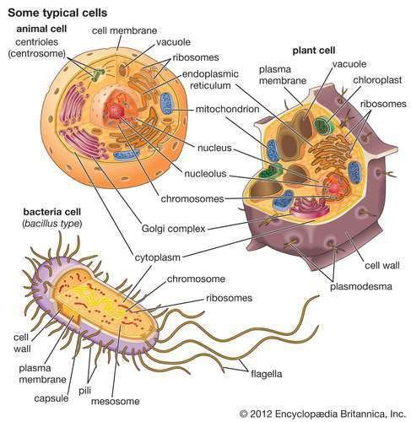

Figure (4): Comparison between Bacterial Animal and Plant Cells

