(Lecture 3) Cell Content

The Plasma Membrane

Despite differences in structure and function, all living cells in multicellular organisms have a surrounding plasma membrane (also known as the cell membrane). As the outer layer of your skin separates your body from its environment, the plasma membrane separates the inner contents of a cell from its exterior environment. The plasma membrane can be described as a phospholipid bilayer with embedded proteins that controls the passage of organic molecules, ions, water, and oxygen into and out of the cell.
Wastes (such as carbon dioxide and ammonia) also leave the cell by passing through the membrane.
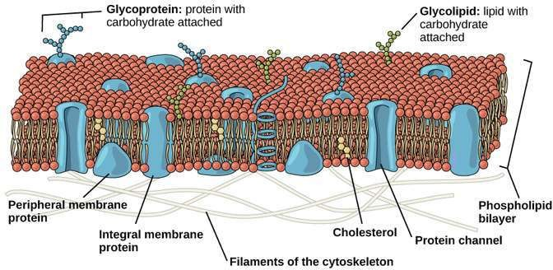
Figure1: Eukaryotic Plasma Membrane: The eukaryotic plasma membrane is a phospholipid bilayer with proteins and cholesterol embedded in it.

The cell membrane is an extremely pliable structure composed primarily of two adjacent sheets of phospholipids. Cholesterol, also present, contributes to the fluidity of the membrane. A single phospholipid molecule consists of a polar phosphate ―head,‖ which is hydrophilic, and a non-polar lipid ―tail,‖ which is hydrophobic. Unsaturated fatty acids result in kinks in the hydrophobic tails. The phospholipid bilayer consists of two phospholipids arranged tail to tail. The hydrophobic tails associate with one another, forming the interior of the membrane. The polar heads contact the fluid inside and outside of the cell (Figure1).

Cell wall

A cell wall is a structural layer surrounding some types of cells, just outside the cell membrane. It can be tough, flexible, and sometimes rigid. It provides the cell with both structural support and protection, and also acts as a filtering mechanism. Cell walls are present in most prokaryotes (except mollicute bacteria), in algae, fungi and eukaryotes including plants but are absent in animals. A major function is to act as pressure vessels, preventing over-expansion of the cell when water enters. The composition of cell walls varies between species and may depend on cell type and developmental stage. The primary cell wall of land plants is composed of the : polysaccharides cellulose, hemicelluloses and pectin. Often, other polymers such as lignin, suberin or cutin are anchored to or embedded in plant cell walls. Algae possess cell walls made of glycoproteins and polysaccharides such as carrageenan and agar that are absent from land plants. In bacteria, the cell wall is composed of peptidoglycan.

Cytoplasm
All types of cells contain cytoplasm, which is a semi-fluid medium that contains water and various types of molecules suspended or dissolved in the medium. The presence of proteins accounts for the semi-fluid nature of the cytoplasm. The cytoplasm of a eukaryotic cell contains organelles, internal compartments that have specialized functions. Eukaryotic cells have many types of organelles. Organelles allow for the compartmentalization of the cell. This keeps the various cellular activities separated from one another.

The Nucleus
The nucleus, a prominent structure in cells, stores genetic information. Every cell in the body contains the same genes. Genes are segments of DNA that contain information for the production of specific proteins. Each type of cell has certain genes turned on and others turned off. DNA, with RNA acting as an intermediary, specifies the proteins in a cell. Proteins have many functions in cells, and they help determine a cell‘s specificity (Figure 2).
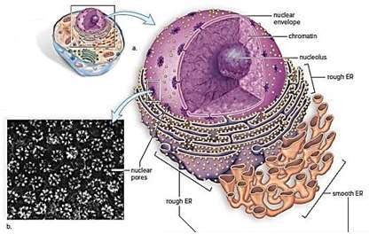
Figure 2: The nucleus and endoplasmic reticulum
A: Nuleolus, b. nuclear envelope
Chromatin is the combination of DNA molecules and proteins that make up the chromosomes. Chromatin can coil tightly to form visible chromosomes during meiosis (cell division that forms reproductive cells in humans) and mitosis
(cell division that duplicates cells). Chromatin is immersed in a semifluid medium called the nucleoplasm. There were one or more dark regions of the chromatin, these are nucleoli (sing., nucleolus), where ribosomal RNA (rRNA) is produced. This is also where RNA joins with proteins to form the subunits of ribosomes. The nucleus is separated from the cytoplasm by a double membrane known as the nuclear envelope. This is continuous with the endoplasmic reticulum. The nuclear envelope has nuclear pores of sufficient size to permit the passage of ribosomal subunits out of the nucleus and proteins into the nucleus

Ribosomes
Ribosomes are organelles composed of proteins and rRNA. Protein synthesis occurs at the ribosomes. Ribosomes are often attached to the endoplasmic reticulum; but they also may occur are digested by lysosomal enzymes into simpler subunits that then enter the cytoplasm. In a process called autodigestion, parts of a cell may be broken down by the lysosomes

Mitochondria
Mitochondria (sing., mitochondrion) are often called the powerhouses of the cell. Just as a powerhouse burns fuel to produce electricity, the mitochondria convert the chemical energy of glucose products into the chemical energy of ATP molecules. In the process, mitochondria use up oxygen and give off carbon dioxide. Therefore, the process of producing ATP is called cellular respiration.
The inner membrane is folded to form little shelves called cristae. This project into the matrix, an inner space filled with a gel-like fluid (Figure 3). The matrix of a mitochondrion contains enzymes for breaking down glucose products. ATP production then occurs at the cristae. Protein complexes that aid in the conversion of energy are located in an assembly-line fashion on these membranous shelves.
The structure of a mitochondrion supports the hypothesis that mitochondria were originally prokaryotes that became engulfed by a cell. Mitochondria are bound by a double membrane. Mitochondria have their own genes—and they reproduce themselves ATP-ADP Cycle. The ATP resembles that of a rechargeable battery.
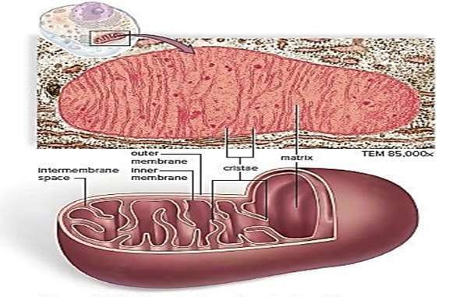

Figure 3: The structure of mitochondria
Lecture 4

The Endoplasmic Reticulum
The endoplasmic reticulum (ER) has two portions. Rough ER is studded with ribosomes on the side of the membrane that ribosomes enter the interior of the ER for additional processing and modification. Some of these proteins are incorporated into the plasma membrane (for example, channel proteins), whereas others are packed into vesicles and sent to the Golgi apparatus. The smooth ER is continuous with the rough ER, but it does not have attached ribosomes (Figure 4). Smooth ER synthesizes the phospholipids and other lipids that occur in membranes. It also has various other functions, depending on the particular cell.

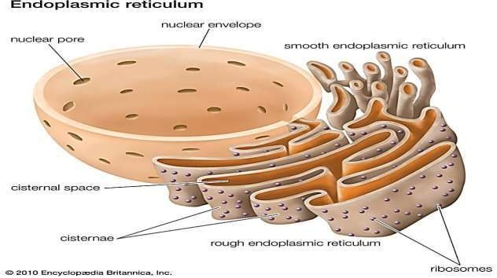

Figure 4: Endoplasmic reticulum

The Golgi apparatus
The Golgi apparatus is named for Camillo Golgi, who discovered its presence in cells in 1898. The Golgi apparatus consists of a stack of slightly curved saccules, whose appearance can be compared to a stack of pancakes. Here proteins and lipids received from the ER are modified. The vesicles that leave the Golgi apparatus move to other parts of the cell. Some vesicles proceed to the plasma membrane, where they discharge their contents. In all, the Golgi apparatus is involved in processing, packaging, and secretion.

Lysosomes
Lysosomes, membranous sacs produced by the Golgi apparatus, contain hydrolytic enzymes that can break down many kinds of biomolecules. A lysosome has a specific composition, of both its membrane proteins, and its luminal proteins. The lumen's pH
(~4.5–5.0) is optimal for the enzymes involved in hydrolysis. Lysosomes are found in all cells of the body but are particularly numerous in white blood cells that engulf disease-causing microbes.

Cilia and Flagella
Cilia (sing., cilium) and flagella (sing., flagellum) are involved in movement. The ciliated cells that line our respiratory tract sweep back up the throat the debris trapped within mucus. Similarly, ciliated cells move an egg along the uterine tube, where it may be fertilized by a flagellated sperm cell (Figure 5). Motor molecules, powered by ATP, allow the microtubules in cilia and flagella to interact and bend and, thereby, move.

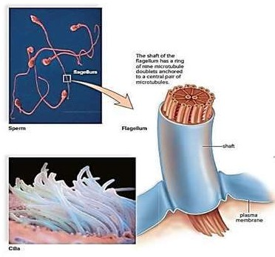
Figure 5: Structure of cilia and flagella

In cell biology a centriole is a cylindrical organelle composed mainly of a protein called tubulin. Centrioles are found in most eukaryotic cells. A bound pair of centrioles, surrounded by a shapeless mass of dense material, called the pericentriolar material (PCM), makes up a structure called a centrosome. Centrioles are typically
made up of nine sets of short microtubule triplets, arranged in a cylinder (figure 4). The main function of centrioles is to produce cilia during interphase and the aster and the spindle during cell division. Centrioles are involved in the organization of the mitotic spindle and in the completion of cytokinesis. The centrioles can self- replicate during cell division. Centrioles are a very important part of centrosomes, which are involved in organizing microtubules in the cytoplasm. The position of the centriole determines the position of the nucleus and plays a crucial role in the spatial arrangement of the cell.

The Cytoskeleton

Movement and Cell Junctions
It took a high-powered electron microscope to discover that the cytoplasm of the cell is containing by several types of protein fibers, called the cytoskeleton. The cytoskeleton helps maintain a cell‘s shape and either anchors the organelles or assists in their movement, as appropriate. In the cytoskeleton, microtubules are much larger than actin filaments. Each is a cylinder that contains rows of a protein called tubulin. Microtubules help maintain the shape of the cell and act as tracks along which organelles move. During cell division, microtubules form spindle fibers, which assist in the movement of chromosomes.
Actin filaments, made of a protein called actin, are long; extremely thin fibers that usually occur in bundles or other groupings. Actin filaments are involved in movement. Microvilli, which project from certain cells, contain actin filaments.
Intermediate filaments, as their name implies, are intermediate in size between microtubules and actin filaments.

Vacuole
A vacuole is a membrane-bound organelle which is present in all plant and fungal cells and some protist, animal, and bacterial cells. Vacuoles are essentially enclosed compartments which are filled with water containing inorganic and organic molecules including enzymes in solution, though in certain cases they may contain solids which have been engulfed. Vacuoles are formed by the fusion of multiple membrane vesicles and are effectively just larger forms of these. The organelle has no basic shape or size.

Vacuole Functions
The function of vacuoles varies according to the type of cell in which they are present. In general, the functions of the vacuole include:
- Isolating materials that might be harmful or a threat to the cell.
- Containing waste products.
- Containing water in plant cells.
- Maintaining internal hydrostatic pressure within the cell.
- Maintaining an acidic internal pH.

made up of nine sets of short microtubule triplets, arranged in a cylinder (figure 4). The main function of centrioles is to produce cilia during interphase and the aster and the spindle during cell division. Centrioles are involved in the organization of the mitotic spindle and in the completion of cytokinesis. The centrioles can self- replicate during cell division. Centrioles are a very important part of centrosomes, which are involved in organizing microtubules in the cytoplasm. The position of the centriole determines the position of the nucleus and plays a crucial role in the spatial arrangement of the cell.

The Cytoskeleton

Movement and Cell Junctions
It took a high-powered electron microscope to discover that the cytoplasm of the cell is containing by several types of protein fibers, called the cytoskeleton. The cytoskeleton helps maintain a cell‘s shape and either anchors the organelles or assists in their movement, as appropriate. In the cytoskeleton, microtubules are much larger than actin filaments. Each is a cylinder that contains rows of a protein called tubulin. Microtubules help maintain the shape of the cell and act as tracks along which organelles move. During cell division, microtubules form spindle fibers, which assist in the movement of chromosomes.
Actin filaments, made of a protein called actin, are long; extremely thin fibers that usually occur in bundles or other groupings. Actin filaments are involved in movement. Microvilli, which project from certain cells, contain actin filaments.
Intermediate filaments, as their name implies, are intermediate in size between microtubules and actin filaments.

Vacuole
A vacuole is a membrane-bound organelle which is present in all plant and fungal cells and some protist, animal, and bacterial cells. Vacuoles are essentially enclosed compartments which are filled with water containing inorganic and organic molecules including enzymes in solution, though in certain cases they may contain solids which have been engulfed. Vacuoles are formed by the fusion of multiple membrane vesicles and are effectively just larger forms of these. The organelle has no basic shape or size.

Vacuole Functions
The function of vacuoles varies according to the type of cell in which they are present. In general, the functions of the vacuole include:
- Isolating materials that might be harmful or a threat to the cell.
- Containing waste products.
- Containing water in plant cells.
- Maintaining internal hydrostatic pressure within the cell.
- Maintaining an acidic internal pH.

