  - Nucleic Acids
Nucleic acids (DNA &RNA), which are polymers of nucleotides, storage and processing of the genetic information, include instructions for life, and conduct chemical reactions. The general structure of a nucleotide is shown in the figure below:

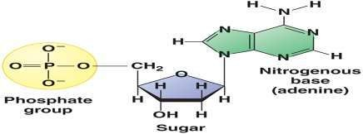
Each nucleotide is a molecular complex of three types of subunit molecules phosphate, a pentose (5-carbon) sugar, and a nitrogen-containing base. The nucleotides in DNA contain the sugar deoxyribose, and the nucleotides in RNA contain the sugar ribose; this
difference accounts for their respective names.

Nucleotide’s structure

Nitrogen bases are grouped into two categories; adenine (A) and guanine (G) constitute the purine category, whereas cytosine (C), thymine (T), and uracil (U) form the pyrimidine class.
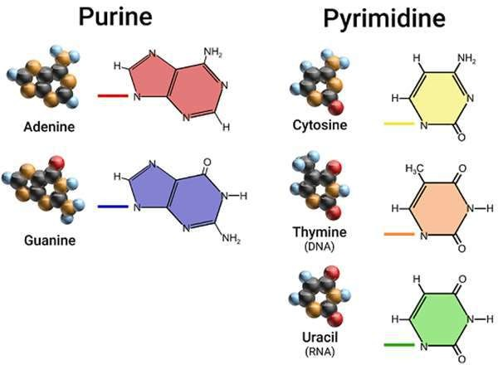
In RNA, the base uracil (U) replaces the base thymine. The nucleotides link to make a polynucleotide called a strand, which has a backbone made up of phosphate- sugar-phosphate-sugar. The bases project to one side of the backbone.
The different types of Nitrogen bases

DNA (deoxyribonucleic acid)
DNA is double-stranded, with the two strands twisted about each other in the form of a double helix (see figure 2). In DNA the two strands are held together by hydrogen bonds between the bases. When coiled, DNA resembles a spiral staircase. When unwound, it resembles a stepladder. The uprights (sides) of the ladder are made entirely of phosphate and sugar molecules, and the rungs of the ladder exhibit complementary base pairing. Thymine (T) always pairs with adenine (A), and guanine

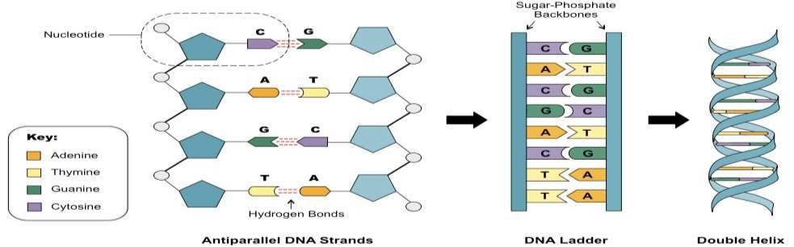
(G) always pairs with cytosine (C). Complementary bases have shapes that fit together.

Figure 2: DNA structure

Ribonucleic acid (RNA)
RNA is single-stranded. When RNA forms, complementary base pairing with one DNA strand passes the correct sequence of bases to RNA. RNA is the nucleic acid directly involved in protein synthesis. RNA is a diverse type of nucleic acid that has multiple uses, RNA main types contains:
- Messenger RNA (mRNA) is a temporary copy of a gene in the DNA that specifies what the amino acid sequence will be during the process of protein synthesis.

- Transfer RNA (tRNA) is also necessary in synthesizing proteins and helps translate the sequence of nucleic acids in a gene into the correct sequence of amino acid during protein synthesis.
- Ribosomal RNA (rRNA) is the RNA component of the ribosome, it works as an enzyme to form the peptide bonds between amino acids in a polypeptide.

Not all nucleotides are made into DNA or RNA polymers. Some nucleotides are directly involved in metabolic functions in cells. For example, ATP (adenosine triphosphate) is a nucleotide that stores large amounts of energy needed for synthetic reactions and for various other energy-requiring processes in cells.

Differences in the Structures of DNA and RNA
There are some small differences in the types of subunits each contains and in their final structure. These differences give DNA and RNA their unique functions in the body.

Features | DNA | RNA
Sugar | Deoxyribose Ribose | Ribose
Bases | Adenine, guanine, thymine,  Cytosine | Adenine, guanine, uracil, cytosine
Strands | Double-stranded with base pairing | Single-stranded
Helix | Yes | No

