Cytology

المرحلة الاولى

أعداد: أ.د. سعد محمود شكر المشهداني

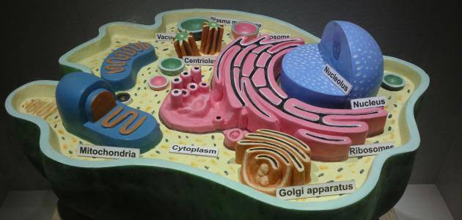

Cell cycle

Cellular division through repeated cell cycles ensures the development of a single fertilized egg into the more than 1013 cells of the human body and the multiplication of a single bacterium into a colony consisting of millions of daughter cells during an overnight incubation. The cellular events that occur in sequence from one cell division to another are referred to as cell cycle (Figure1). Many variations exist in the overall duration of cell cycles depending on the cell type and the requirement of the organism.
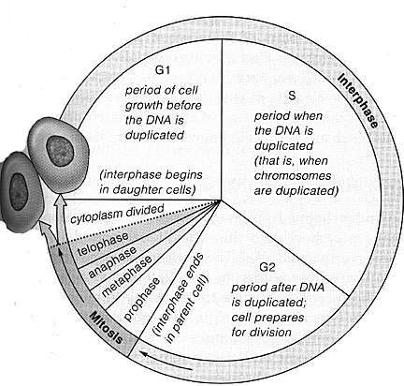
Figure 1: Phases of a Cell Cycle

A typical Eukaryotic cell cycle comprises of the following phases:

G0 Phase
This phase is also known as the ‗resting phase‘. In this phase the cell is described
as being quiescent, as it is neither growing nor dividing but metabolically active.

G1 (gap 1) Phase
This is also known as the growth phase. It is the most variable phase of the cell cycle in terms of length. In the G1 phase, the cell rapidly grows in size and is metabolically active with profound protein synthesis occurring. Duplication of organelles occurs, proteins (enzymes) required for DNA replication is synthesized and sufficient mitochondria are produced for the energy requirement of the next phase.

S Phase
The S phase is also known as the synthesis phase. The cell in this phase is in a low metabolic state and the major activity of the cell centers around the DNA/Genome duplication. The duplication of the DNA is necessary for the distribution of the complete of the DNA to the daughter cells ensuring that the daughter cells have genes exactly similar to the parent cells.

G2 (Gap 2) Phase
In this phase, cellular growth continues as in G1. The proteins required for the next phase (M phase) are synthesized.

M Phase
This is also called Mitosis phase. Cell division through the distribution and transfer of the earlier duplicated chromosomes into daughter cells occurs in this phase. It is usually the shortest and last for about an hour for a typical 24 hours‘ cycle. M phase is usually followed by cytokinesis usually after the movement of the divided chromosomes to the opposite poles by the spindle fiber.

Cytokinesis
Cytokinesis results in the cell undergoing cell cycle to be divided into two daughter cells; it involves the division of the cytoplasm. In some cycles the M phase is not followed by cytokinesis resulting in the attachment of the repeatedly formed daughter cells.

Mitotic Cell Division
The mitotic cell division is critical to some single-cell organisms such as protozoan, some fungi and algae as it is the basis for their reproduction (asexual), an in all eukaryotic organisms as it is the basis for their growth. In eukaryotic organisms, it typically occurs in the somatic cells (non-sex cells).

There are five stages in mitosis (Figure 2) which are as follows:

Interphase
Interphase divide three stages; G1, S and G2. Chromosome replication takes place in interphase. During interphase the individual chromosomes are elongated and are difficult to see under the light microscope. The DNA of each chromosome is replicated in the S phase, giving two exact copies called sister chromatids, which are held together by the replicated but unseparated centromeres.

- Prophase
During this stage the chromosomes become visible as threads because they condense more. This is followed by progressing coiling and folding. Each prophase chromosome now consists of two adjacent chromosome threads called chromatids. The nucleolus breaks down and disappears. Electron microscopic studies have shown that the component parts of the nucleolus disperse throughout the nucleus during this stage. At the end of prophase, the nuclear envelope breaks down into fragments. This allows the chromosomes to spread over the greater part of the cell and gives them a better chance to separate as chromatids during pole ward movement.

- Metaphase
At metaphase the chromosomes are at their highest level of coiling and therefore appear to be shorter and thicker than in any other stage. The chromosomes move to the equator of the cell. With the attachment of the spindle fibers and the completion of the spindle itself, the chromosomes move into position in the equatorial plane of the spindle called Metaphase Plate. Alignment of the chromosomes on this plate marks the end of metaphase.

- Anaphase
This is a stage of active and rapid movement and is the shortest of all mitotic stages. During this stage, the sister chromatid separate and move towards the opposite poles on the spindle. The physical separation of the sister chromatids and their movement to opposite poles are two separate activities.

- Telophase
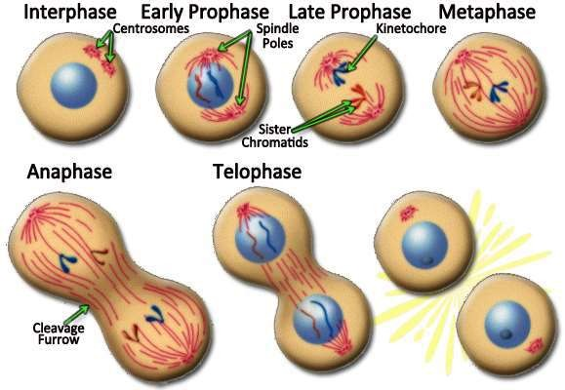
At the end of anaphase, the separated sister chromatids have been pulled to opposite poles of the cell. At that time the nuclear envelope reforms around the two daughter nuclei, the nucleoli form at the distinct site of the nuclear organizer chromosomes, and the chromosomes fuse into an indistinguishable mass of chromatin. The uncoiling of the chromatin threads aid in this process of reforming ainterphase nucleus where the chromosomes lose their density and stain ability.

Figure 2: Mitotic cell division

