Lecture 7
Energy-releasing pathways (cellular respiration)
Cells manage a wide range of functions in their tiny package — growing, moving, housekeeping, and so on — and most of those functions require energy. Energy-releasing pathways are set of metabolic reactions and processes in which the energy in glucose is transferred to ATP( Adenosine Triphosphate). These processes are summarized in the by the below equation:

C₆H₁₂O₆ + 6O₂ → 6CO₂ + 6H₂O+ Energy (36ATP)

Energy-releasing pathway (also call cellular respiration) is a collection of three unique metabolic pathways: glycolysis, the citric acid cycle, and the electron transport chain. Glycolysis is an anaerobic process, while the other two pathways are aerobic. In order to move from glycolysis to the citric acid cycle, pyruvate molecules (the output of glycolysis) must be oxidized in a process called pyruvate oxidation.

Glycolysis
Glycolysis is the first pathway in cellular respiration. This pathway is anaerobic and takes place in the cytoplasm of the cell. This pathway breaks down ¹ glucose molecule and produces ² pyruvate molecules. Glycolysis has a net gain of 2 ATP molecules and 2 NADH. If O2 is available, pyruvate inters the mitochondria, where it is metabolized. If O2 is not available, fermentation occurs.

Pyruvate Oxidation
In eukaryotes, pyruvate oxidation takes place in the mitochondria. Pyruvate oxidation can only happen if oxygen is available. In this process, the pyruvate created by glycolysis is oxidized. In this oxidation process, a carboxyl group is removed from pyruvate, creating acetyl groups, which compound with coenzyme A (CoA) to form acetyl CoA. This process also releases CO₂.

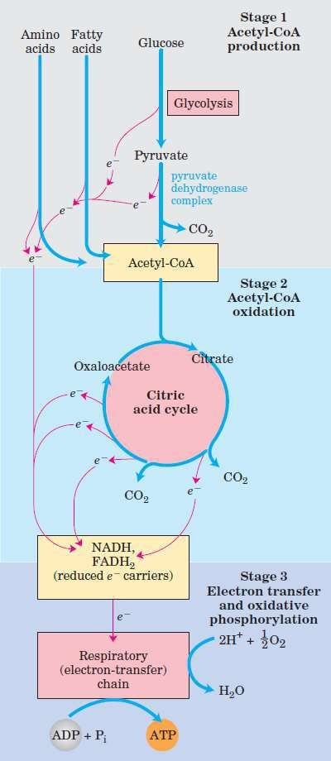
Citric Acid Cycle (Krebs cycle)
The citric acid cycle is the second pathway in cellular respiration, and it also takes place in the mitochondria. The citric acid cycle is considered an aerobic pathway because the NADH and FADH₂ it produces act as temporary electron storage compounds, transferring their electrons to the next pathway (electron transport chain), which uses atmospheric oxygen. Each turn of the citric acid cycle provides a net gain of CO₂, 1 GTP or ATP, and 3 NADH and 1 FADH₂.

Electron Transport Chain
Most ATP from glucose is generated in the electron transport chain. It is the only part of cellular respiration that directly consumes oxygen. In eukaryotes, this pathway takes place in the inner mitochondrial membrane. In prokaryotes it occurs in the plasma membrane (Figure 7).

The electrons received from NADH and FADH2 are passed down through a chain of carriers until they finally received O₂, which combined with H⁺ to produce water. As the electrons pass down the chain, energy is captured and stored for the ATP production.

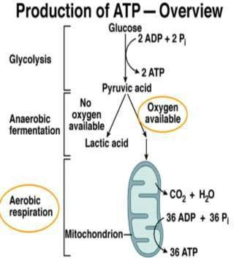
Figure 7: Cellular respiration

