Lecture 9 Meiosis
Meiosis is reduction division that takes place in the germ cells to generate male and female gametes, sperm and egg cells, respectively. Meiosis requires two cell division, meiosis I and meiosis II, to reduce the number of chromosomes from diploid (2n) to haploid number (1n). The end products of meiosis are 4 haploid (1n) cells.
Meiosis in males is called (Spermatogenesis) and produce sperm,

Meiosis in females is called (Oogenesis) and produce ova (egg),

- Diploid cells (2n) have double structured chromosomes (46 chromosomes).

- Haploid cells (1n) have single stranded chromosomes (23 chromosomes).

- Fertilization is the fusion of a sperm (1n) and egg cell (1n) to produce a zygote,

- Zygote has a diploid chromosome (2n) number, one set from each parent.

Meiosis has two distinct stages:
1- Meiosis I 2- Meiosis II

- Meiosis I consist of 4 phases
1- Prophase I 2-Metaphase I 3-Anaphase I 4-Telophase I (Figure1).
Male germ cells (spermatocytes) and female germ cells (primary oocyte) at the beginning of meiosis I (interphase I):

- Replicate their DNA so that each chromosome consists of two sister chromatids held together at a centromere.
- Centriole pairs also replicate.
- Interphase I similar to mitosis interphase.

Prophase I
- Homologous chromosomes (each consisting of two sister chromatids) are paired, a process called synapsis.
- The structure formed is called a tetrad (tetrad: is 2 chromosomes or 4 chromatids).
- crossovers, are the interchange of non-sister chromatid segments between paired homologous chromosomes at cross-over point called chiasmata, produces genetic recombination in the offspring, (Figure 2).
Prophase I is divided into 5 subphases: Leptotene, Zygotene, Pachytene, Diplotene, and Diakinesis. Throughout these stages, the disappearance of the nucleolus, the formation of meiotic spindle between the two centrosomes in the opposite poles of the cytoplasm and the disappearance of the nuclear envelope take place sequentially.

Metaphase I
- The homologous pairs (four chromatids) align at the equator (metaphase plate) for separation.
- The centrioles are at opposite poles of the cell. The spindle fibres attach to kinetochore of the centromeres of each chromosome.

Anaphase I
- Homologous chromosomes separate and move to opposite poles.
- Sister chromatids remain attached at their centromeres.

Telophase I
The separated Chromosomes are pulled to the opposite pole
- The separated chromosomes are pulled to the opposite poles; each pole has haploid set of chromosomes.
- Nuclear envelopes reappear and Spindle fibres disappear.
- Cytokinesis (cytoplasm division) occurs and two haploid daughter cells (1n) are formed

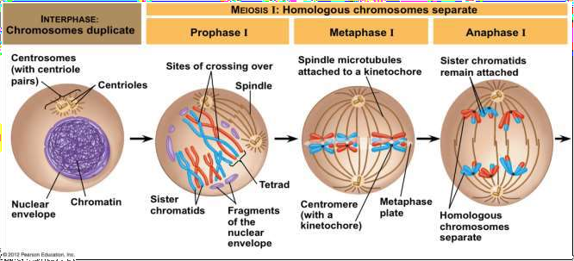

Figure 1: Meiosis I

- Meiosis II
- No interphase II (no more DNA replication)
- Meiosis II is similar to mitosis

Meiosis II consist of 4 phases
1- Prophase II 2- Metaphase II 3- Anaphase II 4- Telophase II (figure 2).

Prophase II
- Chromosomes coil and become compact
- Nuclear envelope breaks down, and the spindle apparatus forms
- Centrioles duplicated and move to opposite poles.

Metaphase II
- Duplicated chromosomes align on the equator (each duplicated chromosome: consist of two sister chromatids remain held together at centromere).

Anaphase II
- Centromeres are cleaved and Sister chromatids separate and move to opposite poles.

Telophase II
- Decondense chromosomes and Spindle fibres disappear
- Nuclear envelopes and nucleoli are formed
- Cytokinesis occurs and produces four haploid daughter cells (1n).

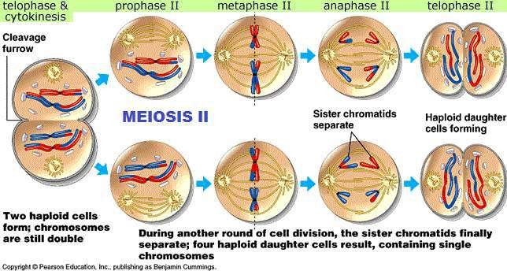
Figure 2: Meiosis II

Comparison of meiosis I with meiosis II

 | meiosis I | meiosis II
1- | Interphase I  DNA replication | No interphase II
2- | Prophase I  Pairing of homologous chromosomes | Prophase II  No pairing of chromosomes
3- | Metaphase I  Homologous duplicated chromosomes at equator | Metaphase II  Haploid number of duplicated chromosomes at equator
4- | Anaphase I  Homologous chromosomes separate | Anaphase II  Sister chromatids separate, becoming daughter chromosomes that move to the poles
5- | Telophase I  Two haploid daughter cells | Telophase II  Four haploid daughter cells

