Diagnostic bacteria
Staining and Fixation
Prepared by
Msc. Hawraa D. salman

Staining
- Used to identify the shape of bacteria.
- Used to increase visibility of microorganisms being studied
- Used to determine the morphological features of microorganisms (Simple stain).
- Used to detect contamination.
- Used to differentiate and classify microorganisms (differential stains).
- Used to detect bacterial parts such as capsule, spores, flagella or inclusion bodies (special stains).
Fixation
- The process by which the internal and external structures of microorganisms are preserved and fixed in place by to method:
- Heat fixation – fixation by means of application of heat (The prepared smear of microorganisms is gently heated and air-dried).
- Chemical fixation – involves the use of chemicals such as ethanol and formaldehyde.
The stains divide into 3 groups
- Simple stain: Acidic (Safranine), Basic (Methylene blue, Crystal violet)
- Differential stain: Gram stain, Acid fast stain(Ziehl Neelson stain)
- Special stain: Spore stain , Capsule stain , Flagella stain , Cell wall stain , Nucleic acid stain

Simple Stain (using one dye –one step for staining)
It used to reveal the morphological features of most bacterial cell including relative size, shape and arrangement of group of cells.
Crystal Violet, Carbol Fuchsin, and Methylene Blue are examples of basic dyes used in simple staining technique.
Steps of work in general:
1-Smear preparation
2-Fixation
3-Staining with stain
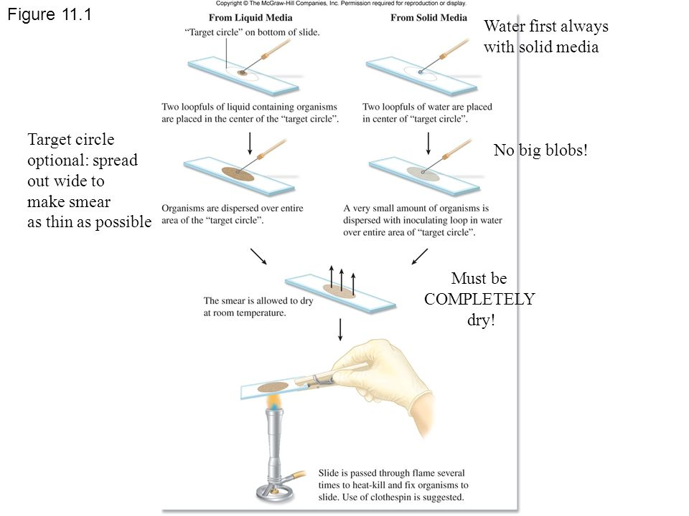

Differential Stain

Gram stain

Gram staining is a common technique used to differentiate two large groups of bacteria based on their different cell wall constituents. The Gram stain procedure distinguishes between Gram positive and Gram negative groups
by coloring these cells red or violet. Gram positive
bacteria stain violet due to the presence of a thick
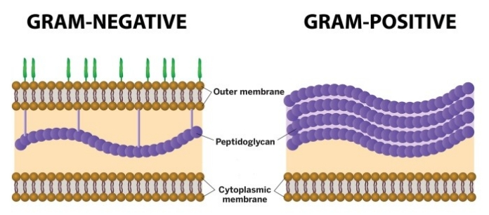
layer of peptidoglycan in their cell walls, which
retains the crystal violet these cells are stained with. Alternatively, Gram negative bacteria stain red, which is attributed to a thinner peptidoglycan wall, which does not retain the crystal violet during the discoloring process.
Principle of Gram Staining
When the bacteria is stained with primary stain Crystal Violet and fixed by the mordant, some of the bacteria are able to retain the primary stain and some are decolorized by alcohol. The cell walls of gram positive bacteria have a thick layer of protein-sugar complexes called peptidoglycan and lipid content is low. Decolorizing the cell causes this thick cell wall to dehydrate and shrink, which closes the pores in the cell wall and prevents the stain from exiting the cell. So the ethanol cannot remove the Crystal Violet-Iodine complex that is bound to the thick layer of peptidoglycan of gram positive bacteria and appears blue or purple in color.
In case of gram negative bacteria, cell wall also takes up the CV-Iodine complex but due to the thin layer of peptidoglycan and thick outer layer which is formed of lipids, CV-Iodine complex gets washed off. When they are exposed to alcohol, decolorizer dissolves the lipids in the cell walls, which allows the crystal violet-iodine complex to leach out of the cells. Then when again stained with safranin, they take the stain and appears red in color.

Reagents Used in Gram Staining
- Crystal Violet, the primary stain
- Iodine, the mordant
- A decolorizer made of acetone and alcohol (95%)
- Safranin, the counterstain

Procedure of Gram Staining
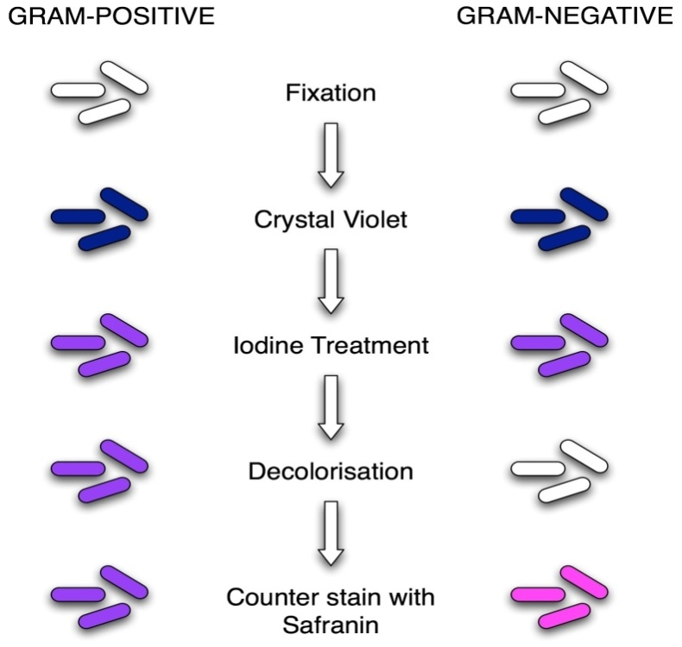

Examples gram positive bacteria

Staphylococcus aureus
Streptococcus pyogenes

Clostridium perfringens

Listeria monocytogenes
Examples gram Negative bacteria

Escherichia coli

Haemophilus influenza

Vibrio cholera
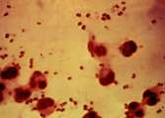

Neisseria meningitidis

