Al-Rasheed University College
Second year
Medical Lab Technology
Microbiology (Practical)
Assist. Prof. Hawraa Dawood
14\3\2022

Microbiology
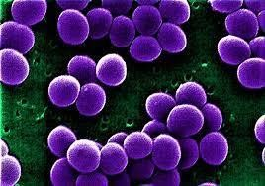
Staphylococcus species
Staphylococcus aureus General characteristic:
1)Gram positive cocci
- facultatively anaerobic.
- S. aureus produces the yellow pigment (staphyloxanthine) and characteristic gold colored colonies are formed on all rich media.
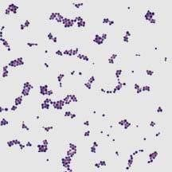
- Violet color under the microscope
5)Non motile& non spore forming
6)Grape like clusters and appear in spherical shape.
 Habitat:
1)As normal micro biota on (skin & mucous membrane and upper respiratory tract).
2)When the skin is exposed to:
- change of Humaditiy
- Change of pH
- & scratch and injury
- sweating
transformed the staphylocoocus aureus from normal flora to opportunistic pathogen.
Staphylococcus aureus infections:
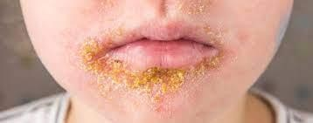

- It cause infections on skin and mucus membrane such as Impetigo in children & abscess on skin surface.
- In deep lesions< it may cause osteomyelitis.
- It may cause sinusitis
- When it reaches the blood cause:
1) bacteremia in bloodstream
2)Meningitis in brain
3) Endocarditis ,an infection of the inner lining the heart chambers and pneumonia in Lung.

Virulent factors of staphylococcus aureus
 It secretes some enzymes such as:
A) coagulase B) Hyalurinidase :
This enzyme works to degrade the connective tissue on the surface of the skin to move to wider areas
C)Lipase:
This enzyme works to break down the fat secreted from the glands on the skin and convert it into fatty acids and glycerol as a source of carbon from which bacteria benefit for nourishment. It is secreted by bacteria when it grows on Baired paker agar medium.
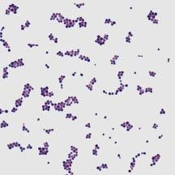
D)Staphykinase ,, E)Dnase

Also secretes some Toxins: such as TSST(Toxic shock syndrome) Identification of staphylococcus aureus
1)Gram stain morphology (appear as grape & spherical hape and violet colour under microscop).
2)catalase test :Differentiate between staphylococcus bacteria and streptococcus bacteria principle this test:The breakdown of hydrogen peroxide into oxygen and water is mediated by the
enzyme catalase. If the bacteria are able to produce catalase, bubbles will result.
Reagent used in this test: Hydrogen peroxide(H2O2 )
Which preform by add 3 drops from H2O2 on slide and put loopful from growth.
Positive result of the test: bubbles appear .
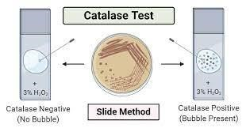
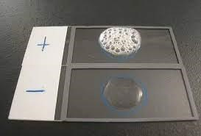
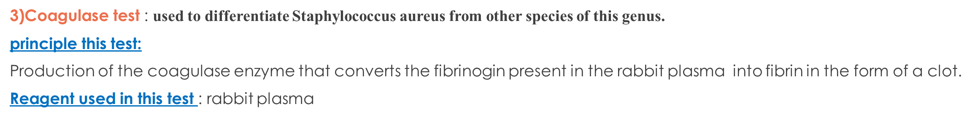
Two test perform for coagulase test:
1)Slide Coagulase Test:
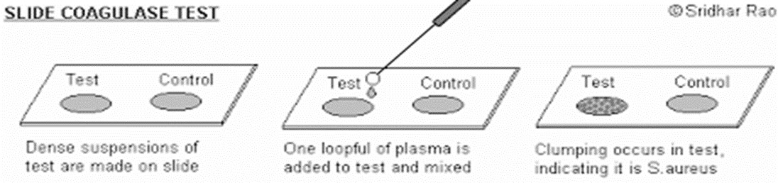
Detects bound coagulase only. Bound coagulase is an enzyme in the cell wall of Staphylococcus aureus
Positive result: If fine grains of sand or small clumps are seen.
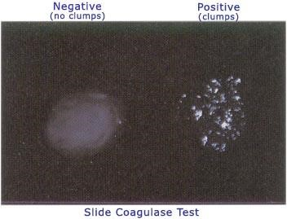
2) Tube Coagulase Test:
- Detects free coagulase which is an enzyme excreted outside the cell wall by the bacteria.
- Positive result : If the tube has a thick, solid clot within 24 hours, it is Staphylococcus aureus
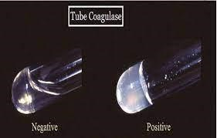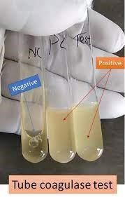
On the nutrient medium and the trypton soya agar(TSA) medium: golden colonies are formed, Why?
On Mannitol salt agar(MSA):
1)Selective and differenation media for staphylococcus 2)This medium contains a source of carbon, and this medium is special for Staphylococcus aureus.
3)It contains 7.5% salts, and this is a special feature of the
Staphylococcus aureus, It contains high salts as it loves high salinity, why? because it is Halophilic bacteria.
3)Yellow colonies,why?
4)Contain phenol red as indicator.
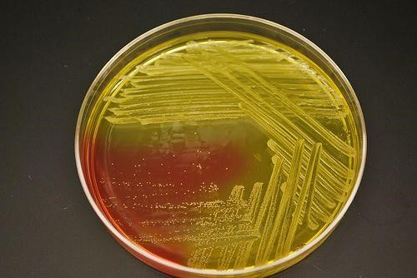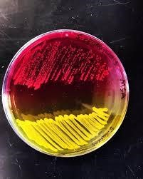
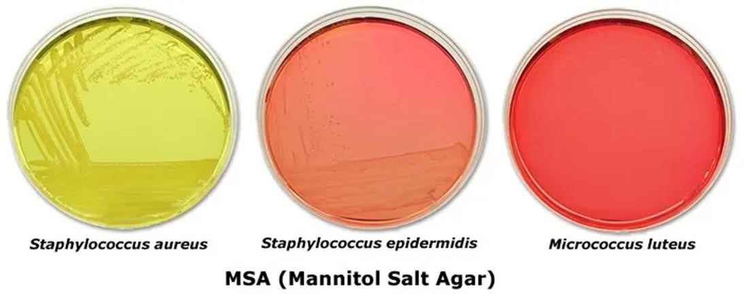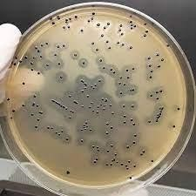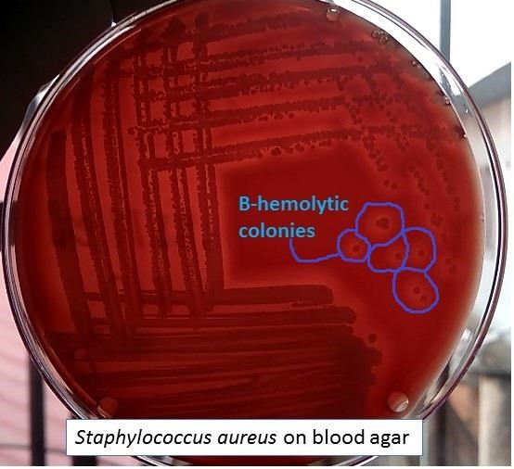
On
Baired
parker agar:
1)

Selective media for staphylococcus
aureus
.
2)
Contain two component
(
potassium
tollurite
+
Egg yolk
)
3
)
Black colonies surrounding by clear
zone,Why
?
On Blood agar:
Beta
Heamolysis
(
clear zone),why?

