**Lecture -3- Virology**

**Viral Replication**

Viruses are intracellular obligate organism which mean can not replicate or express their genes without the help of a living cell. In general steps of viral replication show in (figure- 1-)

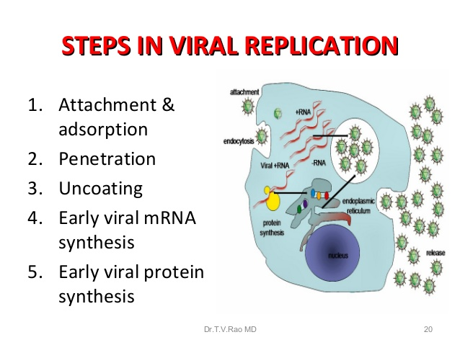

**Steps in Viral Replication:**

**A. Attachment & adsorption** : This is the first step in viral replication. Surface proteins of the virus interact with specific receptors on the target cell surface.

**B. Penetration (Uptake)**

After binding of virus, virus is taken up inside the cell which is referred as penetration or engulfment. Some enveloped viruses penetrate cells by **direct fusion** of the viral envelope with host plasma membrane release nuclocapsid directly into the cytoplasma for example:-paramyxoviruses (measles) , retroviruses (HIV) .figure (2) .The other enveloped and naked viruses (**unenveloped**) viruses penetrate cells by translocation of the virion across the host cell membrane or receptor mediated **endocytosis** **(viropexis or pinocytosis)** in which The cell engulfs virus by invagination of the cell membrane then vesicles formation in the cell cytoplasm. Low PH made the virus fuse with the vesicles membrane, followed by release of the virus.

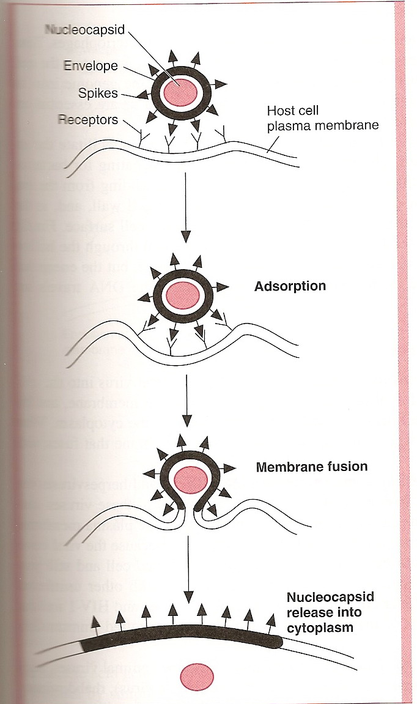

**Figure (2) Entry of some enveloped viruses by fusion of the viral envelope.**

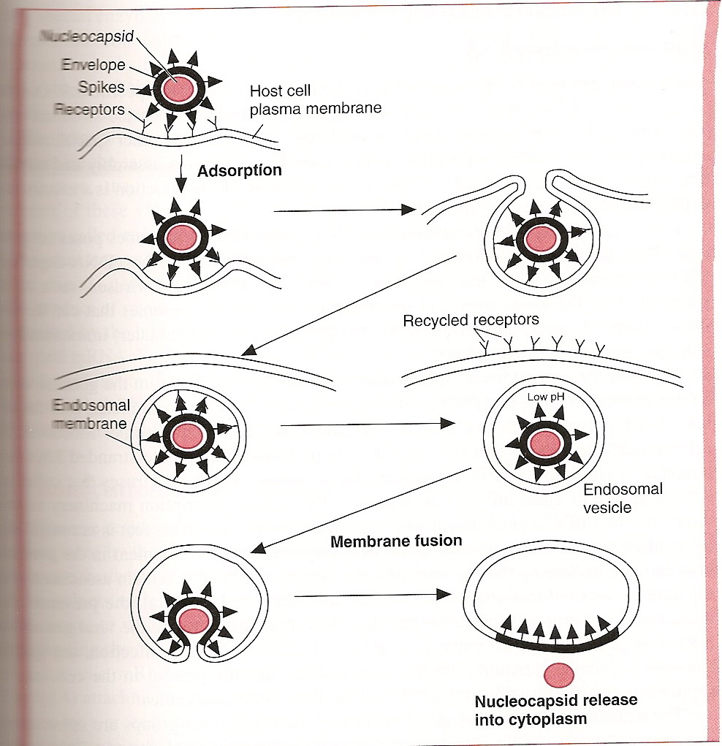

**Figure (3) Unenveloped and some enveloped viruses enter the cell by endocytosis ( viropexis).**

**C. Uncoating:**

This process release of the viral genome from its protective capsid to enable the viral nucleic acid to replicate.The period of the replication cycle between the end of the uncoating stage and maturation of new viral particales is termed the **Eclipse period .**

**D. Transcription and Translation**

In **transcription** synthesis of m-RNA and The viral genome is **translated** using cell ribosomes into structural and non-structural proteins.

**E. Assembly(Maturation )**

* New virus genomes and proteins are assembled to form new virus particles. The assembly occurs in nucleus or cytoplasm of host cell depending upon types of virus.
* DNA virus assembled in nucleus **except Poxvirus** and RNA viruses assembled in cytoplasm **except Influenza virus and Reo virus.**

**F- Release**

Release of mature virus from host cell is the final event in virus replication. **enveloped viruses** are released by **budding** from the infected cells. **Unenveloped viruses** are released by **rupture or lysis** of the infected cells.

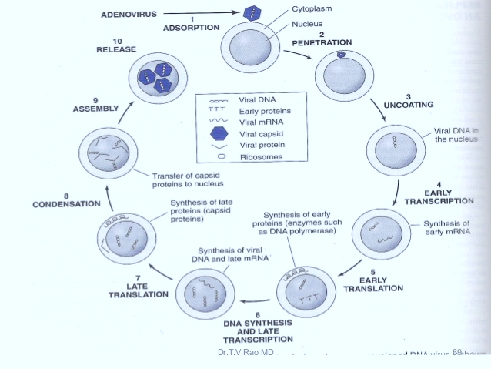

**Figure( 4) Steps in replication of adenoviruses which contain DNA in its genome.**

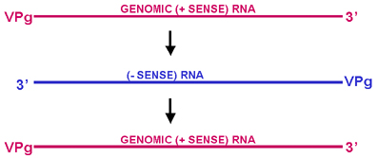

**Figure (5) Single stranded RNA families with positive sense**



**Figure (6) single strand RNA families with negative sense**



**Figure (7) Retroviral genome strategy**

**Viral genetics**

Viruses grow rapidly, there are usually a large number of progeny virions per cell. There is, therefore, more chance of mutations occurring over a short time period.

The nature of the viral genome (RNA or DNA; segmented or non-segmented) plays an important role in the genetics of the virus.

Viruses may change genetically due to mutation or [recombination](http://www.mondofacto.com/facts/dictionary?query=recombination).

**Mutantion**

**a- Spontaneous mutations**

These arise naturally during viral replication: e.g. due to errors by the genome-replicating polymerase or a result of the incorporation of  [tautomeric](http://www.mondofacto.com/facts/dictionary?query=tautomerism) forms of the bases. Figure (8)

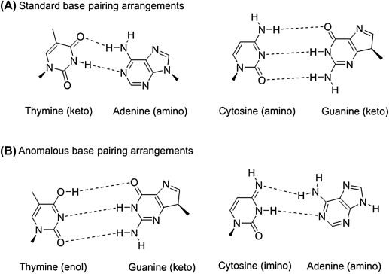

**Figure (8)Tautomerization changes the base pairing abilities of the base**

DNA viruses tend to more genetically stable than RNA viruses. There are error correction mechanisms in the host cell for DNA repair, but probably not for RNA.

**b- Mutations that are induced by physical or chemical means**

**Chemical:**

Agents acting directly on bases, e.g. nitrous acid  
Agents acting indirectly, e.g. base analogs which mispair more frequently than normal bases thus generating mutations.

**Physical:**

Agents such as UV light or X-rays

**Types of mutation**

* Pointmutation
* Insertion mutation
* Deletion mutation

**Exchange Of Genetic Material**

**Recombination:** Exchange of genetic information between two related viruses genomes during coinfection of a host cell..

**"Classic" recombination**: This involves breaking of covalent bonds within the nucleic acid, exchange of genetic information, and reforming of covalent bonds.

This kind of break/join recombination is common in **DNA viruses** or those **RNA viruses which have a DNA phase (retroviruses)**. The host cell has recombination systems for DNA. Recombination of this type is very rare in RNA viruses (there are probably no host enzymes for RNA recombination). 

**Reassortments**

* Form of recombination (non classical)
* Very efficient
* Segmented viruses only
  + Can occur naturally
  + Used in some new vaccines : e.g for influenza and rotaviruses.

If a virus has a segmented genome and if two variants of that virus infect a single cell, progeny virions can result with some segments from one parent, some from the other.

This is an efficient process - but is limited to viruses with segmented genomes - so far the only human viruses characterized with segmented genomes are RNA viruses e.g. orthomyxoviruses, reoviruses, arenaviruses, bunya viruses.

Reassortment may play an important role in nature in generating novel reassortants and has also been useful in laboratory experiments.

(figure 3,4). For example, in a reassorted virus  if one segment comes from virus A and the rest from virus B, we can see which properties resemble virus A and which virus B.

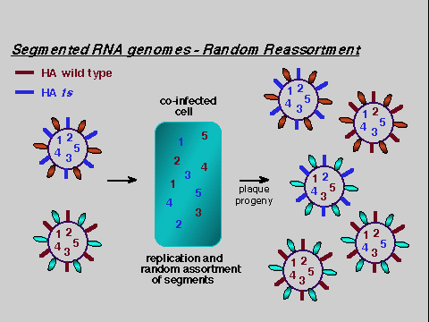

**Figure 3: Reassortment of viral genome in segmented virus**

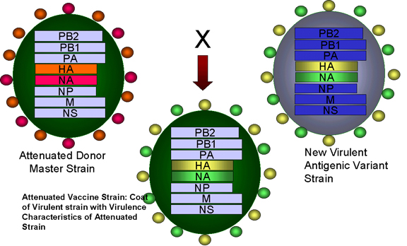

**Figure 4: Reassortment of genes between the attenuated strain of influenza virus and a new virulent strain in the formation of an attenuated influenza vaccine**