Hepatitis Viruses lecture-8
Hepatitis C Virus
Properties of the Virus
1- Is member of the genus Hepacivirus , family Flaviviridae.
2- Genome contain single-stranded RNA , positive-sense.
3- HCV consists of a lipid membrane enveloped . enveloped contain two viral glycoproteins ( E1 & E2).
3- Most new infection with HCV are subclinical but the majority of HCV infection (70%- 90%) develop chronic hepatitis and many at risk of progressing to chronic active hepatitis , cirrhosis which may lead to hepatocellular carcinoma.
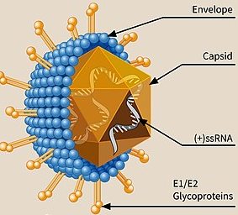
Structure of HCV
Clinical feature
It is similar to other Hepatitis Viruses clinical features but characterized by the followings:-
1) Incubation period 15-160 days.
2) It is most commonly occurred in adults.
3) The root of infection parenteral (blood borne virus).
4) The virus present in the blood and saliva but absent in stool and urine.
5) It can pass to chronicity.
6) It is oncogenic virus.
Diagnosis of HCV
1) Serological assay by antibodies testing by ELISA to detected the presence of antibodies to HCV.
2) PCR to detect the presence of Viral RNA which are useful for monitoring patient on antiviral therapy.
Treatment
- α –interferon , Lamivudine antiviral drugs.
- No vaccine is available.
Hepatitis D Virus
HDV is a defective virus that is required the HBs Ag coat for transmission and it is only present with HBV infection .Transmission of HDV by parenteral route. The genome of the virus is ss RNA with a negative sense , HD virus antigen is the only protein coded by the HDV RNA and it is antigentically distinct from HBV antigens. HDV is the smallest human pathogens and it is associated with most sever forms of hepatitis in the HBs Ag positive patients.
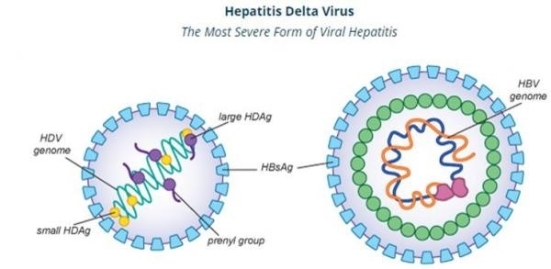

Clinical features
The incubation period of HDV infection is 14-60 days.clinical feature for HDV is similar to that of HBV, but because HDV is dependent on a coexistent of HBV infection ,the acute HDV infection occurs in two clinical forms :-
a) Co infection
When the two viruses HBV& HDV infect the body at the same time.
b) Super infection:-
When hepatitis D virus infect a patient who is infect with HBV with chronic infection.
Diagnosis of HDV
1) Coinfection
We can find the following antibodies and antigens
a) Ab to HD Ag develops late in the acute phase of infection and may be of low titer.
B) Assay for the presence of HD Ag , HD RNA, IgM to HDV.
2) Super infection
Detect the presence of IgM and IgG Abs to HDV Ag and HDV RNA , to gather with HBs Ag and anti HBc IgG.
Treatment
Similar to HBV treatment and vaccine.
Hepatitis E
HEV is a member of the Hepeviridae family, genus Hepevirus which causes acute hepatitis in the normal host and chronic hepatitis in immunosuppressed patients. it has ssRNA with a positive sense , non envelope virus . HEV is transmitted enterically and occur in epidemic form in developing countries.
Clinical features
Similar to HAV. But if the infection occur pregnancy it may has a high mortality rate reach to 20-30%.
Diagnosis
Detection the presence of antibodies to HEV antigen IgM & IgG.
Treatment
No drug but supportive treatment .
No vaccine present .

