Orthomyxoviruses lecture 9
The Orthomyxoviridae (influenza viruses) ,
Ortho =True or real , Myxo = Affinity to mucins.
Introduction
True influenza is an acute infectious disease caused by a member of the orthomyxovirus family: influenza virus A, B or, to a much lesser extent, influenza virus C. However, the term (flu) is often used for any febrile respiratory illness with systemic symptoms which may be caused by many of bacterial or viral agents as well as influenza. Influenza outbreaks usually occur in the winter in temperate climates.
ORTHOMXYOVIRUSES: Influenza viruses
Orthomyxoviruses are divided into four types: influenza A, B , C and D but only A, B, and C infect humans. Human influenza A and B are the virus types responsible for the seasonal flu epidemics, whereas influenza type C infections generally cause mild illness. Influenza A viruses are the only influenza viruses known to cause flu pandemics and are divided into subtypes . The single stranded, negative sense RNA genomes of influenza A and B viruses occur as eight separate segments; influenza C viruses contain seven segments of RNA, lacking a neuraminidase gene .
Structure & Composition
Virion :- Spherical, pleomorphic, 80–120 nm in diameter. (helical nucleocapsid ).
Composition: RNA (1%), protein (73%), lipid (20%), carbohydrate (6%) .
Genome: Single - stranded RNA, segmented (eight molecules), negative-sense, 13.6 kb overall size.
Proteins: eight structural proteins, two nonstructural protein .
Envelope: Contains viral hemagglutinin (HA) and neuraminidase (NA) proteins.
Replication: Nuclear transcription , particles mature by budding from plasma membrane .
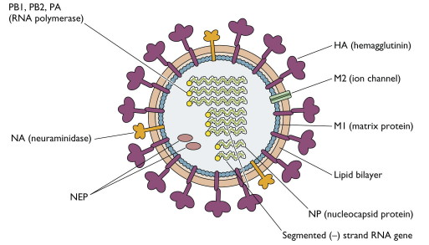
Structure of influenza virus
Influenza virus life cycle
Replication of influenza A virus. After binding to sialic acid-containing receptors, influenza is endocytosed and fuses with the vesicle membrane . Unlike for most other RNA viruses, transcription and replication of the genome occur in the nucleus were Viral proteins synthesized . Helical nucleocapsid segments form and associated with the M1 protein-lined membranes containing M2 and the HA and NA glycoprotein’s . The virus buds from the plasma membrane .
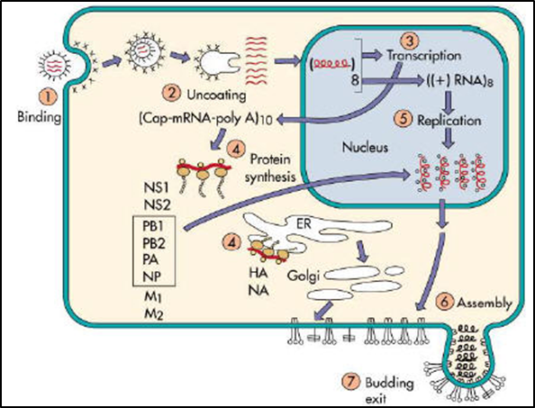
Influenza virus life cycle

Structure and Function of Hemagglutinin
The HA protein of influenza virus binds virus particles to susceptible cells. Variability in HA is primarily responsible for the continual evolution of new strains and subsequent influenza epidemics. Hemagglutinin derives its name from its ability to agglutinate erythrocytes under certain conditions.
The primary sequence of HA contains 566 amino acids. The HA protein is cleaved into two subunits, HA1 and HA2, that remain tightly associated by a disulfide bridge. The HA spike on the virus particle is a trimer. The trimerization imparts greater stability to the spike than could be achieved by a monomer.
Structure and Function of Neuraminidase (NA)
The antigenicity of NA, the other glycoprotein on the surface of influenza virus particles, is also important in determining the subtype of influenza virus isolates. The spike on the virus particle is a tetramer, composed of four identical monomers. The NA functions at the end of the viral replication cycle include :-
a) It is a sialidase enzyme that removes sialic acid from glycoconjugates.
b) It facilitates release of virus particles from infected cell surfaces during the budding process
c) helps prevent self-aggregation of virions.
Antigenic Drift and Antigenic Shift
Influenza viruses are remarkable because of the frequent antigenic changes that occur in HA and NA. This phenomenon is responsible for the unique epidemiologic features of influenza. The two surface antigens of influenza undergo antigenic variation independent of each other. Minor antigenic changes(accumulate point mutations during virus replication) are termed antigenic drift; major antigenic changes in HA or NA, called antigenic shift, result in the appearance of a new subtype.
Antigenic shifts can result from mechanisms Genetic reassortment between subtypes. Reassortment is possible whenever two different influenza viruses infect a cell simultaneously; when the new viruses (the progeny) are assembled, they may contain some genes from one parent virus and some genes from the other .
Types of influenza viruses
There are four types of influenza viruses: A, B, C and D
- Influenza A viruses
Influenza A viruses include the avian, swine, equine and canine influenza viruses, as well as the human influenza A viruses. Influenza A viruses are classified into subtypes based on two surface antigens, the hemagglutinin (H) and neuraminidase (N) protein. There are 18 different known H antigens (H1 to H18) and 11 different known N antigens (N1 to N11). H1N1, H1N2, and H3N2 are the only known influenza A virus subtypes currently circulating among humans.
2. Influenza B viruses
Influenza B viruses are mainly found in humans. These viruses can cause epidemics in human population, but have not, to date, been responsible for pandemics.
3- Influenza C viruses
Influenza type C infections generally cause mild illness and are not thought to cause human flu epidemics.
4- Influenza D viruses primarily affect cattle and are not known to infect or cause illness in people.
Viral Transmission
Influenza viruses are transmitted in aerosols created by coughing and sneezing, and by contact with nasal discharges, either directly or on fomites. Close contact and closed environments favor transmission . Person-to-person transmission occurs with the H1N1 virus that is currently circulating in humans.
Clinical findings
Incubation Period :

The incubation period for human influenza is usually short; most infections appear after one to four days . The incubation period for the novel H1N1 virus circulating in humans appears to be 2 to 7 days .

Clinical Signs &Pathogenicity
Uncomplicated infections with human influenza A or B viruses are usually characterized by upper respiratory symptoms, which may include fever, chills, anorexia, headache, myalgia, weakness, sneezing, rhinitis, sore throat and a nonproductive cough . Nausea, vomiting and otitis media are common in children, and febrile seizures have been reported in severe cases. Most people recover in one to seven days, but in some cases, the symptoms may last up to two weeks or longer.
More severe symptoms, including pneumonia, can be seen in individuals with chronic respiratory or heart disease. Secondary bacterial or viral infections may also occur.
Laboratory Diagnosis of Human Influenza
Specimen collection
Respiratory specimens: Respiratory specimens obtained within four days of onset of symptoms and different types of respiratory specimens can be used such as nasal washes and nasopharyngeal aspirates tend to be more sensitive than pharyngeal swabs.
Blood specimens : Acute and convalescent serum samples 14 − 21 days should be collected to demonstrate a significant (at least fourfold) rise in strain-specific antibody titer.
Laboratory Tests
1- Isolation methods (Viral Culture)
- Embryonated egg culture
- Cell culture :- Various cell-lines are utilized to isolate influenza viruses, most commonly primary monkey kidney cells. infection of cells gives a visible cytopathic effect (CPE).
2- Direct methods
- Immunofluorescence
- Enzyme immuno assays
- Reverse transcription polymerase chain reaction (RT-PCR).

3- Serology
Different serological techniques are available for influenza diagnosis include haemagglutination inhibition (HI), complement fixation (CF), enzyme immunoassays (EIA) and indirect immunofluorescence.

