**حقيبة تعليمية**

**بعنوان:**

**الفيروسات و الفطريات الطبية**

**إعداد**

**أ.م.د. سعد محي عارف**

**دكتوراه في العلوم الطبية**

**2022 - 2023**

# المقدمة

يتسم البرنامج التعليمي لمقرر الفيروسات والفطريات الطبية بالتدريس باللغة الانكليزية لمدة ثلاثون اسبوعا بواقع ساعتين اسبوعيا حيث يتم تدريس الطلبة بأساسيات ومختلف التقنيات المتعلقة بتشخيص الفيروسات والفطريات الطبية ضمن منهج متكامل ويتدرب الطالب خلال هذه الفترة على إكتساب المعلومات والمهارات اليدوية المهمة وعلى فهم دورتشخيص الأحياء في الحالة الصحية والمرضية في أجهزة الجسم المختلفة وكذلك تفسير نتائج تحاليل الاصابات الميكروبية ودمجها مع الممارسة السريرية للطب.

# فهرس المحتويات

|  |  |  |
| --- | --- | --- |
| **م** | **الموضوع** | **الصفحة** |
|  | مقدمة | **2** |
|  | الفهر س | **3** |
|  | وصف المقرر | **4** |
|  | إرشادات للطلبة | **5** |
| **1** | الوحدة الأولى + المحاضرة الأولى | **6** |
| **2** | المحاضرة الثانية | **6** |
|  |  | **6** |
|  |  | **6** |

# وصف المقرر الدراسي

|  |  |  |
| --- | --- | --- |
| **1** | **اسم البرنامج التعليمي** | الفيروسات والفطريات الطبية |
| **2** | **رمز البرنامج التعليمي** | ViMy330 |
| **3** | **اسم التدريسي** | أ.م.د. سعد محي عارف |
| **4** | **مدة البرنامج** | (30) اسبوعا بواقع (2) ساعة اسبوعيا |
| **5** | **عدد الساعات الكلية** | (60) ساعة |
| **6** | **الفئة المستهدفة من البرنامج** | طلبة المرحلة الثالثة/ قسم تقنيات المختبرات الطبية |
| **7** | **اسم الجهة المشرفة على التنفيذ** | كلية الرشيد الجامعة |
| **8** | **تاريخ اعداد البرنامج** | 22 /9/ 2022 |

# إرشادات للطلبة

* **الرغبة والحماس للتعليم**
* **كن مشاركاً في جميع الأنشطة**
* **احترم أفكار المدرس والزملاء**
* **أنقد أفكار المدرس والزملاء بأدب إن كانت هناك حاجة.**
* **احرص على استثمار الوقت**
* **تقبل الدور الذي يسند إليك في المجموعة**
* **حفز أفراد مجموعتك في المشاركة في النشاطات**
* **احرص على بناء علاقات طيبة مع المدرس والزملاء أثناء المحاضرة**
* **احرص على ما تعلمته في المحاضرة وطبقه في الميدان .**
* **ركز ذهنك بالتعليم واحرص على التطبيق المباشر**
* **تغلق الموبايل قبل الشروع بالمحاضرة**

**الوحدة الأولى - المحاضرة الأولى - الزمن: 90 دقيقة**

### **أهداف المحاضرة الاولى:**

**يتوقع في نهاية الجلسة أن يكون الطالب قادراً على:**

1.Explain the safety regulation & good microbiological practice.

2. Enumerate the biohazardous materials.

### **موضوعات المحاضرة الاولى:**

1. Safety regulation & good microbiological practice.

2. Biohazardous materials.

### **الأساليب والأنشطة والوسائل التعليمية**

|  |  |  |  |
| --- | --- | --- | --- |
| **الوحدة** | **المحاضرة** | **الإجراءات** | **الزمن بالدقيقة** |
| الاولى | الاولى | القاء المحاضرة مستخدما جهاز العرض والسبورة  طرح الأسئلة الشفوية لبعض الطلبة خلال القاء المحاضرة  نشاط (1/1/1) تمرين متعدد الخيارات  نشاط (1/1/2) تمرين التطابق | 90 دقيقة |

### **خطة إجراءات تنفيذ المحاضرة الاولى**

|  |  |  |  |
| --- | --- | --- | --- |
| **الوحدة** | **المحاضرة** | **الإجراءات** | **الزمن بالدقيقة** |
| الأولى | الاولى | القاء المحاضرة مستخدما جهاز العرض والسبورة  طرح الأسئلة الشفوية لبعض الطلبة خلال القاء المحاضرة  نشاط (1-1-1) تمرين متعدد الخيارات  نشاط (2-1-1) تمرين التطابق | 90 دقيقة |

**المادة العلمية:**

**Clinical Samples collection & Preservation for viral infection**

❖In general, specimens for virus isolation should be collected within 4 days after onset of illness as virus shedding decreases rapidly after that time. With only a rare exception, virus cultures are not

worthwhile for specimens collected more than 7 days after the onset of illness.

❖ Most viruses remain stable at 4oC for 2-3 days and almost indefinitely at –70oC. Do not freeze at –20oC.

❖ To ensure proper evaluation, the following information should accompany the specimen:

(1) date of illness onset.

(2) date and time specimen was collected.

(3) source of specimen. ❖ Collection of acute and convalescent phase sera should always be considered

(4) source of specimen.

**Instructions for Specimen Collection by type**

▪ Collect in sterile screw-cap tube, 1.0 ml. (VTM not required).

􀀀 **Cervical or vaginal swab**

If lesions are present, swab vigorously. Place swab in VIM.

􀀀 **Conjunctiva swab**

1. Collect material from the lower conjunctiva with a flexible, fine-shafted swab moistened with sterile saline.

2. Place swab in VTM.

**Nasopharynx swab.**

1- Pass a flexible, fine shafted swab into the nasopharynx.

2. Allow secretions to absorb for 5 seconds; then carefully remove

swab and place it in VTM.

3. Repeat for other nostril using a fresh swab. Place both swabs in thesame transport tube. Submit at 4oC.

􀀀 **Oral swab**

1-Firmly sample base of lesion with a swab.

2. Place swab in VTM.

Specimens should be stored in sterile containers and refrigerated immediately upon collection.

Ship with enough ice packs sufficient to maintain an approximate 4ºC environment.

**الوحدة الثانية - المحاضرة الثانية - الزمن: 90 دقيقة**

### **أهداف المحاضرة الثانية:**

**يتوقع في نهاية الجلسة أن يكون الطالب قادراً على:**

1.Identify the medical virology, virus & virion.

2.Enumerate the general properties of viruses.

3.Comper between virus & bacteria

### **موضوعات المحاضرة الثانية:**

1. Medical virology, virus & virion.

2. General properties of viruses.

3.Comper between virus & bacteria.

### **الأساليب والأنشطة والوسائل التعليمية:**

|  |  |  |  |
| --- | --- | --- | --- |
| **الوحدة** | **المحاضرة** | **الإجراءات** | **الزمن بالدقيقة** |
| الثانية | الثانية | القاء المحاضرة مستخدما جهاز العرض والسبورة  طرح الأسئلة الشفوية لبعض الطلبة خلال القاء المحاضرة  نشاط (2- 1-2) تمرين متعدد الخيارات | 90 دقيقة |

### **خطة إجراءات تنفيذ المحاضرة الثانية:**

|  |  |  |  |
| --- | --- | --- | --- |
| **الوحدة** | **المحاضرة** | **الإجراءات** | **الزمن بالدقيقة** |
| الثانية | الثانية | القاء المحاضرة مستخدما جهاز العرض والسبورة  طرح الأسئلة الشفوية لبعض الطلبة خلال القاء المحاضرة  نشاط (1-2-2) تمرين متعدد الخيارات  نشاط (2- 2-2) تمرين التطابق | 90 دقيقة |

**المادة العلمية:**

**Medical virology :-** The science that deal with the study of the medically viruses which infect human**.**

**Virus** is a broad general term for any aspect of the infectious agent and includes**:-**

* The infectious or inactivated virus particle.
* Viral nucleic acid and protein in the infected cell.

**Virion:-** is the physical particle in the extra-cellular phase which is able to spread to new host cells; complete intact virus particle. The whole virus particle is called (Virion).

**General Properties of Viruses**

1. Viruses are smaller than bacteria, they range in size between 20-300 nanometer(nm). (Table- 1-).

2. Viruses contain only one type of nucleic acid, either DNA or RNA, but never both.

3. Viruses consist of nucleic acid surrounded by a protein coat. Some viruses have additional lipoprotein envelope.

4. Viruses lack cellular organelles, such as mitochondria and ribosomes.

5. Viruses are obligate cellular parasites. They replicate only inside living cells.

**The structure of viruses:**

**1-Viral nucleic acid:**

The viral nucleic acid is located internally and can be either single or double- stranded RNA or DNA. The nucleic acid can be either linear or circular. The DNA is always a single molecule, the RNA can exist either as a single molecule or in several pieces (segmented).

• Some RNA viruses are positive polarity and others are negative polarity.

• Positive polarity is defined as an RNA with same base sequence as the mRNA. (positive strand RNA)

• Negative polarity has a base sequence that is complementary to the mRNA. (Negative strand RNA).

**2- Capsid**

The protein shell, or coat, that encloses the nucleic acid genome and mediates the attachment of the virus to specific receptors on the host cell surface.

**3- Capsomeres**

Morphologic units seen in electron microscope. Each capsomere, consisting of one or several proteins. Naked viruses are composed of nucleic acid + capsid (nucleocapsid). (Figure -1-)

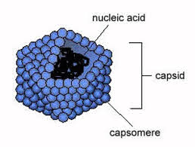

**Figure (1) virus composition**

**4- Viral Envelope**

The envelope is a lipoprotein membrane composed of lipid derived from the host cell membrane and protein that is virus- specific. Furthermore, there are frequently glycoproteins in form of spike-like projections on the surface, which attach to host cell receptors.

**Matrix protein** mediates the interaction between the capsid proteins and enveloped.

The presence of an envelope confers instability on the virus.

**Nucleic acid +capsid + envelope =** **enveloped** **Viruses** (Figure (2).

**Table (1) : Comparison between viruses and bacteria**

|  |  |  |  |
| --- | --- | --- | --- |
| **Bacteria** | **Viruses** | **property** | **No** |
| **1000nm** | **20-300 nm** | **Size** | **1** |
| **DNA and RNA** | **DNA or RNA but not both** | **Genome**  **(type of nucleic acid)** | **2** |
| **Cell wall** | **Envelope present in some viruses** | **Cell wall** | **3** |
| **Ribosomes** | **No Ribosomes** | **Ribosomes** | **4** |
| **+** | - | **Multiplication by binary fission** | **5** |
| **+** | **-** | **Sensitivity to antibiotics** | **6** |
| **Grow in culture media** | **Growth only in the living host cell** | **Crowth in culture media** | **7** |

[**Atypical Virus-like Agents**](https://image2.slideserve.com/4400272/atypical-viruslike-agents-l.jpg)

**(1) Defective Viruses** are composed of viral nucleic acid and proteins but cannot replicate without a "helper" virus, which provides the missing function. Defective viruses usually have a mutation or a deletion of part of their genetic material. During the growth of most human viruses, many more defective than infectious virus particles are produced. [The ratio of defective to infectious particles can be as](https://image2.slideserve.com/4400272/slide19-l.jpg) high as 100:1 .

For example certain **Adenovirses** and **Hepatitis -D virus** are defective viruses.

**(2)**  [**Pseudovirions** contain host cell DNA instead of viral DNA](https://image2.slideserve.com/4400272/slide20-l.jpg) within the capsid. They are formed during infection with certain viruses when the host cell DNA is fragmented and pieces of it are incorporated within the capsid protein. Pseudovirions can infect cells, but they do not replicate.

**(3) Viroids**: Consist of a single molecule of circular RNA without a protein coat or envelope. There is extensive homology between bases in the viroid RNA leading to large double-stranded regions. viroids replicate but the mechanism is unclear. They cause several plant diseases but are not implicated in any human disease.

**( 4) Prions** are infectious particles that are composed of only protiens i.e, they contain no detectable nucliec acid.

Is a type of protein that can trigger normal proteins in the brain to fold abnormally. Prions are composed of a single glycoprotein with a molecular weight of 27,000-30,000. prion diseases are called spongiform encephalopathies (slowly progressive diseases) which include Creutzfldt-**Jakob disease or Kuru** in humans and **scrapie** in sheep and **Mad cow** in cattle.

Because neither DNA nor RNA has been detected in prions, they are clearly different from viruses . Furthermore, electron microscopy reveals filament rather than virus particles. Prions are much more resistant to inactivation by ultraviolet light and heat than are viruses. They are remarkably resistant to formaldehyde and nucleases. However, they are inactivated by hypochlorite, NaOH, and autoclaving.

**Comparsion between prions and conventional viruses**

|  |  |  |
| --- | --- | --- |
| Feature | Prions | Conventional viruses |
| Nucleic acid | No | Yes |
| Protein | Yes , encoded by cellular genes | Yes ,encoded by viral genes |
| Heat inactivation | No | Yes |
| Appearance | Amyloid- like | Icosahedral |
| Antibody response | No | Yes |
| Inflammatory responses | No | Yes |

**Causes of prion disease**

Prion diseases occur when normal prion protein, found on the surface of many cells, becomes abnormal and clump in the brain, causing brain damage. This abnormal accumulation of protein in the brain can cause memory impairment, personality changes, and difficulties with movement. Experts still don't know a lot about prion diseases, but unfortunately, these disorders are generally fatal.

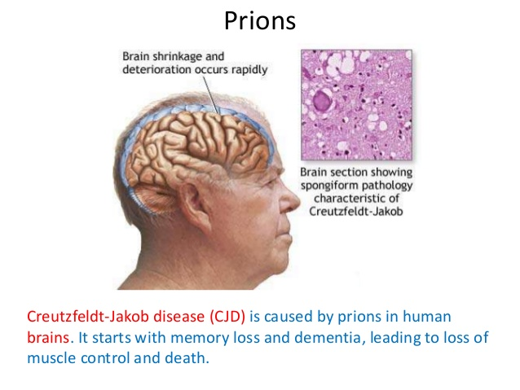

**الوحدة الثالثة - المحاضرة الثالثة - الزمن: 90 دقيقة**

### **أهداف المحاضرة الثالثة:**

**يتوقع في نهاية الجلسة أن يكون الطالب قادراً على:**

1- Identify the types of symmetry of virus particles

2- To know the reaction of viruses to physical and chemical agents**.**

3- To know the classification of viruses.

### **موضوعات المحاضرة الثالثة:**

* Symmetry of virus particle.
* Reaction of viruses to physical and chemical agents.
* Classification of viruses.

### **الأساليب والأنشطة والوسائل التعليمية**

|  |  |  |
| --- | --- | --- |
| **م** | **الأساليب والأنشطة التدريبية** | **الوسائل التدراثيبية** |
| **الثالثة** | * نشاط التعارف ( 3- 3-1) * محاضرة * مناقشة * سؤال وجواب | * جهاز حاسوب * جهاز عرض * سبورة * اوراق واقلام |

t

### **خطة إجراءات تنفيذ المحاضرة الثالثة**

|  |  |  |  |
| --- | --- | --- | --- |
| **الوحدة** | **المحاضرة** | **الإجراءات** | **الزمن بالدقيقة** |
| **الثالثة** | **الثالثة** | القاء المحاضرة مستخدما جهاز العرض والسبورة  طرح الأسئلة الشفوية لبعض الطلبة خلال القاء المحاضرة  نشاط (1-3-3) تمرين متعدد الخيارات  نشاط (2-3-3) تمرين التطابق | 90 دقيقة |

**المادة العلمية:**

**Types of symmetry of virus particles**

Viruses are divided into three groups, based on the morphology of the nucleocapsid and the arrangement of capsomeres.

**1- Icosahedral (Cubic) symmetry**

Composed of 12 vertices, has 20 faces (each an equilateral triangle) with the approximate outline of a sphere. e.g. Virus that cause yellow fever and Poliovirus.

**2. Helical symmetry**

The virus particle is elongated or pleomorphic (not spherical), and the nucleic acid is spiral. Caposomeres are arranged round the nucleic acid. e.g. Rabies virus.

**3. Complex structures**

The virus particle does not confirm either cubic or helical symmetry e.g. Poxviruses.



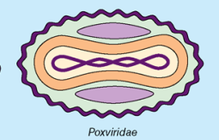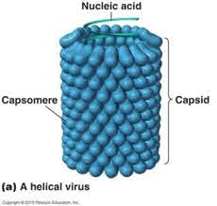

**Icosahedral Complex Helical**

**Figure (3) Types of symmetry of virus particles**.

**Reaction to physical and chemical agents:**

1. **Heat and cold**

Viral infectivity is generally destroyed by heating at 50-60oC for 30 mint., Viruses can be preserved at -90 oC or -196oC (liquid nitrogens).

1. **PH** Viruses can be preserved at physiological PH (7.3).
2. **Ether susceptibility**

Ether susceptibility can be used to distinguish viruses that possess an envelope from those that do not.

4. **Detergents:**

Nonionic detergents solubilize lipid constituents of viral membranes. The viral proteins in the envelope are released. Anionic detergents also solubilize viral envelopes; in addition, they disrupt capsids into separated polypeptides.

**5. Salts**

Many viruses can be stabilized by salt in concentrations of 1 mol/L. e.g. MgCl2, MgSO4, Na2SO4.

**6. Radiation**

Ultraviolet, X-ray, and high-energy particles inactivate viruses

**7. Formaldehyde**

Destroys viral infectivity by reacting with nucleic acid.

**8. Antibiotics**

Antibacterial antibiotics have no effect on viruses.

**Classification of viruses:**

1- Virion morphology, including size, shape, type of symmetry, presence or absence of enveloped.

2. Virus genome properties, including type of nucleic acid (DNA or RNA), size of genome, strandedness (single or double), whether linear or circular, positive or negative sense (polarity), segments (number, size).

3.Physicochemical properties of the virion, including PH stability,thermal stability, and susceptibility to physical and chemical agents especially ether and detergents.

4. Virus protein properties, including number, size and functional activities of structural and non-structural proteins, amino acid sequences, and special functional activities (transcriptase, reverse

5. Genome organization and replication, including gene order, strategy of replication (patterns of transcription, translation), and cellular sites (accumulation of proteins, virion assembly, virion release).

6. Antigenic properties

7. Biological properties, including natural host range, mode of transmission, vector relationships, pathogenicity, tissue tropisms, and pathology.

**الوحدة الرابعة - المحاضرة الرابعة - الزمن: 90 دقيقة**

### **أهداف المحاضرة الرابعة:**

**يتوقع في نهاية الجلسة أن يكون الطالب قادراً على:**

1- Identify the structure of viruses**.**

2- To know the viral of pathogenicity of viruses.

3- To know the mechanism of pathogenicity.

### **موضوعات المحاضرة الرابعة:**

* Structure of Viruses.
* Viral pathogenicity of viruses.
* The mechanism of viral pathogenicity.

### **الأساليب والأنشطة والوسائل التعليمية**

|  |  |  |
| --- | --- | --- |
| **م** | **الأساليب والأنشطة التدريبية** | **الوسائل التدريبية** |
| **الرابعة** | * نشاط التعارف ( 4- 4-1) * محاضرة * مناقشة * سؤال وجواب | * جهاز حاسوب * جهاز عرض * سبورة * اوراق واقلام |

### **خطة إجراءات تنفيذ المحاضرة الرابعة**

|  |  |  |  |
| --- | --- | --- | --- |
| **الوحدة** | **المحاضرة** | **الإجراءات** | **الزمن بالدقيقة** |
| **الرابعة** | **الرابعة** | القاء المحاضرة مستخدما جهاز العرض والسبورة  طرح الأسئلة الشفوية لبعض الطلبة خلال القاء المحاضرة  نشاط (1-4-4) تمرين متعدد الخيارات  نشاط (2-4-4) تمرين التطابق | 90 دقيقة |

**المادة العلمية:**

**The structure of viruses:**

**1-Viral nucleic acid:**

The viral nucleic acid is located internally and can be either single or double- stranded RNA or DNA. The nucleic acid can be either linear or circular. The DNA is always a single molecule, the RNA can exist either as a single molecule or in several pieces (segmented).

• Some RNA viruses are positive polarity and others are negative polarity.

• Positive polarity is defined as an RNA with same base sequence as the mRNA. (positive strand RNA)

• Negative polarity has a base sequence that is complementary to the mRNA. (Negative strand RNA) .

**2- Capsid**

The protein shell, or coat, that encloses the nucleic acid genome and mediates the attachment of the virus to specific receptors on the host cell surface.

**3- Capsomeres**

Morphologic units seen in electron microscope. Each capsomere, consisting of one or several proteins. Naked viruses are composed of nucleic acid + capsid (nucleocapsid). ( Figure -1-



**Figure (1) Naked virus composition**

**4- Viral Envelope**

The envelope is a lipoprotein membrane composed of lipid derived from the host cell membrane and protein that is virus- specific. Furthermore, there are frequently glycoproteins in form of spike-like projections on the surface, which attach to host cell receptors.

**Matrix protein** mediates the interaction between the capsid proteins and enveloped.

The presence of an envelope confers instability on the virus.

**Nucleic acid +capsid + envelope =** **enveloped** **Viruses** (Figure (2).

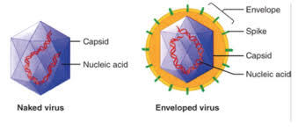

**Figure (2) illustrate the difference between Enveloped virus and Naked virus.**

**4- Viral Envelope**

The envelope is a lipoprotein membrane composed of lipid derived from the host cell membrane and protein that is virus- specific. Furthermore, there are frequently glycoproteins in form of spike-like projections on the surface, which attach to host cell receptors.

**Matrix protein** mediates the interaction between the capsid proteins and enveloped .

The presence of an envelope confers instability on the virus.

[**Viral** **pathogenesis**](http://en.wikipedia.org/wiki/Viral_pathogenesis) : The study of the Capability & manner of viruses to infect and cause disease.

[**Virulence**](http://en.wikipedia.org/wiki/Virulence) **:** The degree to which a virus causes disease. Strains of virus differ greatly in their ability to cause disease

**How do Viruses cause a diseas**

Viruses are capable of infecting all types of living organism from bacteria to humans.

**Factors in viral pathogenesis**

**1- Cell tropism** a major factor that controls which cells a virus can infect is the presence on the cell surface of the appropriate receptor, to which the virus must attach in order to gain entry into the cell.

**2- Viruses enter the body (Routs of infection)**

Inhalation, ingestion, sexual intercourse or inoculation through the skin or mucous membranes. Infection may also sometimes be passed from a mother to her fetus transplacentally (Vertical transmission).

**3- Type of infection**

Once a virus has gained entry into the body, it may either remain localized and replicate only in the tissues adjacent to the site of entry (an example of this is influenza where the virus remains confined to the respiratory tract) or it may cause a disseminated infection. Here, the virus replicates initially at the site of entry, but then enters the blood (viraemia) or lymphatic system and spreads throughout the body (e.g. Measles). Other viruses such as Rabies and Herpes Simplex may replicate locally initially, then enter nerve endings and travel up the axon to infect the central nervous system.

**4- Incubation period**

defines the time from exposure to an organism to the onset of clinical disease. In general, virus causes localized infections have short incubation periods (<7 days), while in disseminated infections, the incubation period tends to be longer.

**5- Immune respons**

Viruses replicate intra-cellular, recovery from a viral infection requires the action of specific **cytotoxic T lymphocytes** which recognize and lyses the infected cells. Antibody plays only a limited role in recovery from an established infection, but is very important in preventing infection.

**Mechanisms of Viral Pathogenicity**

Generally, the virulence of pathogenic bacteria is directly related to the ability of the organism to produce one or more toxins. However, the virulence of viruses is not well defined.

**A number of factors contribute to the virulence (pathogenicity) of a particular strain of virus.**

* 1. Ability to enter the cell
  2. Ability to grow within the cell
  3. Ability to combat host defense mechanisms
  4. Ability to produce temporary or permanent damage in the host via:

1. Cell lyses
2. Production of toxic substances
3. Cell transformation
4. Induction of formation of substances which apparently are cellular products normally not produced by the cell.

**الوحدة الخامسة - المحاضرة الخامسة - الزمن: 90 دقيقة**

### **أهداف المحاضرة الخامسة:**

**يتوقع في نهاية الجلسة أن يكون الطالب قادراً على:**

1-Discribe brieflythe replication of viruses.

2.Comper between conventional virus & prion.

**موضوعات المحاضرة الخامسة:**

1. Replication of viruses.

2. Conventional virus & prion.

### **الأساليب والأنشطة والوسائل التعليمية**

|  |  |  |
| --- | --- | --- |
| **م** | **الأساليب والأنشطة التدريبية** | **الوسائل التدريبية** |
| الخامسة | * نشاط التعارف ( 5- 5-1) * محاضرة * مناقشة * سؤال وجواب | * جهاز حاسوب * جهاز عرض * سبورة * اوراق واقلام |

### **خطة إجراءات تنفيذ المحاضرة الخامسة**

|  |  |  |  |
| --- | --- | --- | --- |
| **الوحدة** | **المحاضرة** | **الإجراءات** | **الزمن بالدقيقة** |
| الخامسة | الخامسة | القاء المحاضرة مستخدما جهاز العرض والسبورة  طرح الأسئلة الشفوية لبعض الطلبة خلال القاء المحاضرة  نشاط (1-5-5) تمرين متعدد الخيارات  نشاط (2-5-5) تمرين التطابق | 90 دقيقة |

**المادة العلمية:**

**Viral Replication**

Viruses are intracellular obligate organism which mean can not replicate or express their genes without the help of a living cell. In general steps of viral replication show in (figure- 1-)

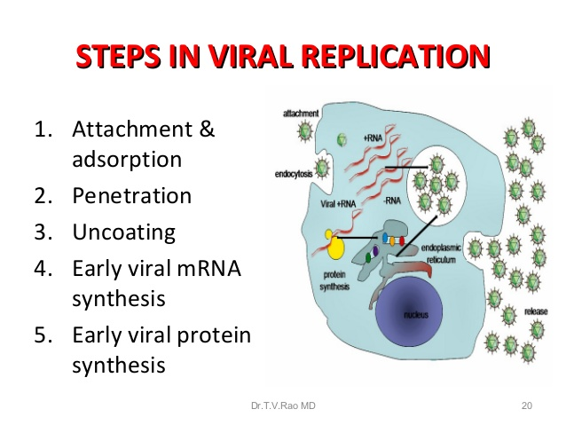

**Steps in Viral Replication:**

**A. Attachment & adsorption**: This is the first step in viral replication. Surface proteins of the virus interact with specific receptors on the target cell surface.

**B. Penetration (Uptake)**

After binding of virus, virus is taken up inside the cell which is referred as penetration or engulfment. Some enveloped viruses penetrate cells by **direct**

**fusion** of the viral envelope with host plasma membrane release nuclocapsid directly into the cytoplasma for example: paramyxoviruses (measles),

retroviruses (HIV) .figure (2) .The other enveloped and naked viruses (**unenveloped**) viruses penetrate cells by translocation of the virion across the host cell membrane or receptor mediated **endocytosis** **(viropexis or pinocytosis)** in which The cell engulfs virus by invagination of the cell membrane then vesicles formation in the cell cytoplasm. Low PH made the virus fuse with the vesicles membrane, followed by release of the virus.

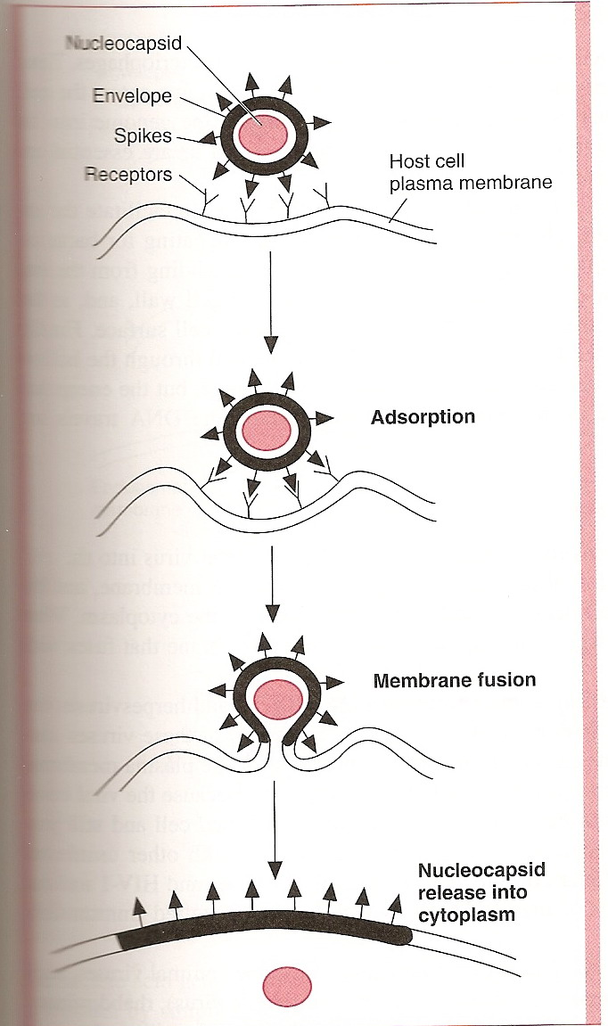 **Figure (2) Entry of some enveloped viruses by fusion of the viral envelope.**

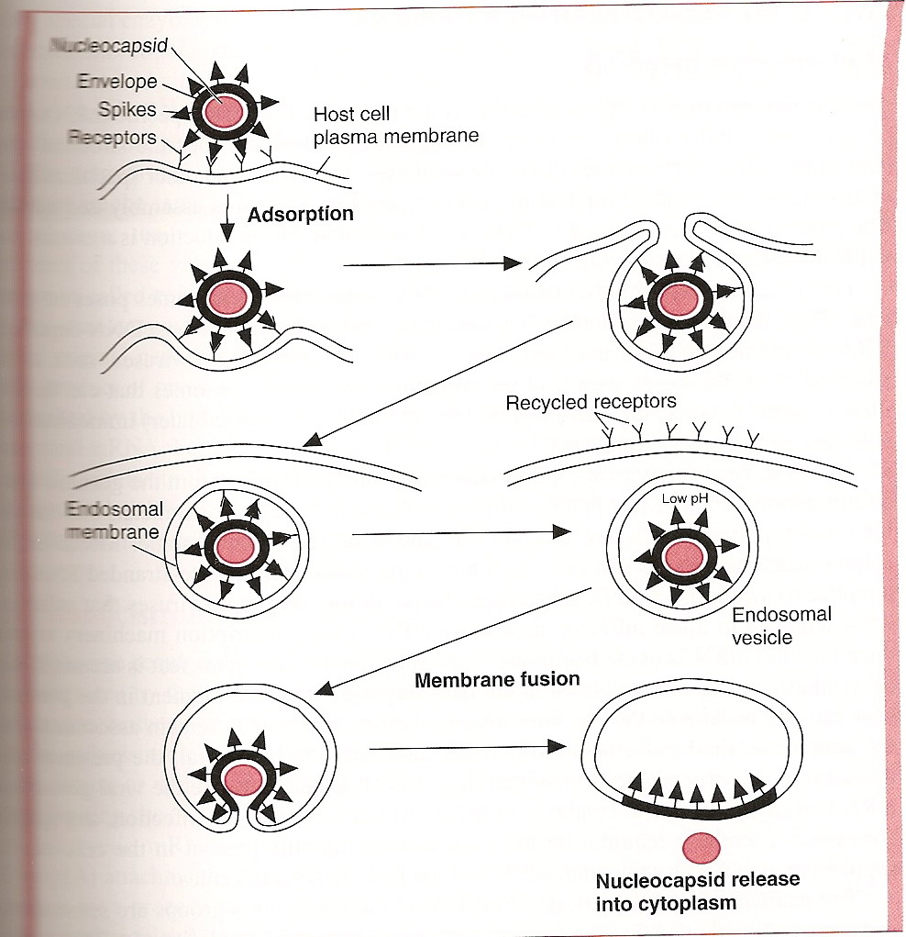

**Figure (3) Unenveloped and some enveloped viruses enter the cell by endocytosis ( viropexis).**

**C. Uncoating:**

This process release of the viral genome from its protective capsid to enable the viral nucleic acid to replicate. The period of the replication cycle between the end of the uncoating stage and maturation of new viral particales is termed the **Eclipse period .**

**D. Transcription and Translation**

In **transcription** synthesis of m-RNA and the viral genome is **translated** using cell ribosomes into structural and non-structural proteins.

**E. Assembly(Maturation )**

* New virus genomes and proteins are assembled to form new virus particles. The assembly occurs in nucleus or cytoplasm of host cell depending upon types of virus.
* DNA virus assembled in nucleus **except Poxvirus** and RNA viruses assembled in cytoplasm **except Influenza virus and Reo virus.**

**F- Release**

Release of mature virus from host cell is the final event in virus replication. **enveloped viruses** are released by **budding** from the infected cells. **Unenveloped viruses** are released by **rupture or lysis** of the infected cells.

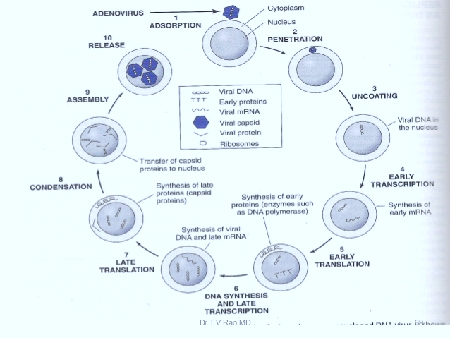

**Figure( 4) Steps in replication of adenoviruses which contain DNA in its genome.**

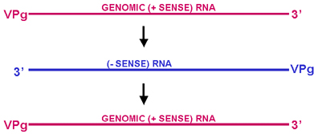

**Figure (5) Single stranded RNA families with positive sense**



**Figure (6) single strand RNA families with negative sense**



**Figure (7) Retroviral genome strategy**

**الوحدة السادسة - المحاضرة السادسة - الزمن: 90 دقيقة**

### **أهداف المحاضرة السادسة:**

**يتوقع في نهاية الجلسة أن يكون الطالب قادراً على:**

1-Enumerate the propertiesof herpes viruses.

2-Discus the transmission of herpes virus.

3-Identify the pathogenesis of herpes virus

**موضوعات المحاضرة السادسة:**

### 1-Properties of herpes viruses.

2-Mode transmission of herpes viruses.

3-Pathogenesis of herpes virus.

### **الأساليب والأنشطة والوسائل التعليمية:**

|  |  |  |
| --- | --- | --- |
| **م** | **الأساليب والأنشطة التدريبية** | **الوسائل التدريبية** |
| السادسة | * نشاط التعارف ( 6- 6-1) * محاضرة * مناقشة * سؤال وجواب | * جهاز حاسوب * جهاز عرض * سبورة * اوراق واقلام |

### **خطة إجراءات تنفيذ المحاضرة السادسة:**

|  |  |  |  |
| --- | --- | --- | --- |
| **الوحدة** | **المحاضرة** | **الإجراءات** | **الزمن بالدقيقة** |
| السادسة | السادسة | القاء المحاضرة مستخدما جهاز العرض والسبورة  طرح الأسئلة الشفوية لبعض الطلبة خلال القاء المحاضرة  نشاط (1-6-6) تمرين متعدد الخيارات  نشاط (2-6-6) تمرين التطابق | 90 دقيقة |

**المادة العلمية:**

**Herpesviruses**

* The herpes virus family contains several of the most important human pathogens. clinically the virus exhibit human pathogens with spectrum of diseases. Some have a wide host range, where are others have a narrow host range
* The outstanding property of herpes viruses is their ability to establish lifelong persistent infections in their hosts and to undergo periodic reactivation.
* Herpes viruses that are commonly infect humans include:

1. Herpes simplex viruses type 1&2.
2. Varicella- Zoster virus.
3. Cytomegalovirus(CMV).
4. Human herpes viruses 6,7
5. Epstein- Barr viruses.
6. Kaposis sarcoma associated herpes virus.
7. Herpes B virus of monkey can also infect human.

**Properties of Herpes viruses:**

1. Virion: Spherical,
2. Genome: dsDNA, Linear.
3. Protein: more than 35proteins in virion.
4. Envelope: contain viral glycoprotein and Fc receptor.
5. Replication: in the nucleus and bud from the nuclear membrane.

**Classification:**

Classified into three sub families – based on physical & genitical properties: 1. **Alpha Herpes:** They have rapid replicate cycle (12-18 hrs). It is variable host range. The alpha virus tendency to form latency in sensory ganglia. Produced rapid CPE & release virus from the infected cells Ex: HSV-1, HSV-2, VZV (**Varicella-Zoster Virus**).

2. **Beta Herpes:** They have narrow host range. Has slow replication cycle (more than 24 hrs). **Ex: Cytomegalovirus**Virus (CMV), HHV-6, HHV-7.

3. **Gama herpes:** They infected lymphoid tissue & causes latency in lymphocyte. Ex: Epstein-Barr Virus (EBV), HHV-8

**Morphology**

All Herpes viruses virions have four structural: Core, Capsid, Tegument, Envelope.

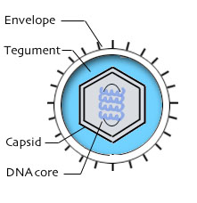

**Figure (1): show the morphology of HSV**

**Herpes virus infection in human**

**1) Herpes simplex viruses (HSV)**

* **Properties of the viruses**

a) HSV is a wide spread in human, it has a wide host range and can infect many different animals in addition to human.

b) It has two types 1&2, there genome is similar in organization and share 50 - 70% homology, but they can distinguishesd by restriction enzyme analysis of viral DNA.

c) It is able to replicate in many types of cells and they grow rapidly, also it is highly cytolytic.

d) Double stranded DNA enveloped virus with a genome of around 150 kp.

**Mode of Transmission:**

**HSV-1** transmitted by direct contact with infected saliva, skin lesions or respiratory secretions.

**HSV-2** is transmitted sexually (Venereal disease) and also from maternal genital to newborn (Perinatal**).**

* **Pathology**

The virus is cytolytic and lead for the formation of ballooning of infected cells and the formation of intracellular inclusion bodies.

* **Pathogenesis**

**a) primary infection**

Herpes simplex is one of the most common viral infections in humans. Primary infection is usually acquired in early childhood, between two and five years of age. Humans are the only natural hosts. Asymptomatic carriers form the more important source of infection.

The virus enters through defects or broken in the skin or mucous membranes and multiplies locally with cell-to cell spread. The virus enters cutaneous nerve fibres and is transported intra-axonally to the dorsal root ganglia where it replicates. migration of the virus can take place from the ganglia to the skin and mucosa to cause cutaneous and mucosal lesions. The virus remains latent in the ganglia to be reactivated periodically in some individuals causing recurrent oral and genital lesions. **HSV-1** it is limited to the oropharynx but **HSV-2** occurs in the genital tract.

**b) latent infection**

HSV have ability to stay as latent virus in infected cells for life time. The stimuli or trigger which is lead for the reactivation of the latent virus are:

1. Axonal injury
2. Fever
3. Physical or emotion al stress.
4. Exposure to ultraviolet, sunlight
5. Infection especially pneumococcal and meningococcal.

* **Laboratory diagnosis:**

**1- Direct Detection**

- Take a scraping from the base of the vesicles and stain it with Giemsa stain and examine under light microscope or Electron microscope to see the multinucleated giant.

- Electron microscopy of vesicle fluid - rapid result but cannot distinguish between HSV and VZV, Immunofluorescence of skin scrapping - can distinguish between HSV and VZV.

**2- PCR** - Now used routinely for the diagnosis of herpes simplex encephalitis

**3- Virus Isolation**

HSV-1 and HSV-2 are among the easiest viruses to cultivate. It usually takes only 1 - 5 days

**3- Serology** use to detect (IgM&IgG) after 4-7 days by ELISA test.

**2- Varicella-Zoster Virus (VZV)/ Human Herpes virus 3**

**Transmission**: Direct contact, Respiratory droplet.

**Diseas**: Two disease caused by **Varicella-Zoster Virus:**

**1-Varicella ( Chicken pox)**: It is the acute disease that occurred by the primary contact with the virus which include Erythematous ulcerating encrusting vesicles beginning on the face and trunk and then progressing towards the extremities, as well as mucous membranes and

Presents fever, lymphadenopathy. Spontaneously resolves in < 1 week.

2- **Zoster** **(shingles)** it is disease occur in response to the reactivation of latent VZV in neurons in sensory ganglia.

**Pathogenesis and clinical features:-**

**a)Varicella**

The infection is occur through the mucosa of the conjunctiva and upper respiratory tract followed by initial replication in the regional lymph node then after primary and secondary viremia the virus transported by the mononuclear cells to the skin this associated with typical vesicles of chicken pox.

**b) Zoster**

The lesions of Zoster are histopathologically identical to those of varicella. the lesion is closely to the areas of innervation of dorsal root ganglia. the reactivation is occurred as a result of lowering of immunity which allows for replication of the virus and then it travel down with the nerve to the skin and induce vesicle formation.

**Laboratory diagnosis:**

**1-Direct detection**

staining of the smear which has been taken from the base of the vesicle and examine under the microscope to see a multinucleate giant cell**.**

**2- Virus Isolation:**

culture of the vesicle fluid in human cell.

**3- serology**

**Elisa or IF test by detect antibodies.** the presence of VZV IgG is indicative of past infection and immunity. The presence of IgM is indicative of recent primary infection.

**3-Epstein-Barr Virus (EBV) /Human Herpes virus 4**

**Properties of the virus:** there are two types of EBV (EBV1&2) based on the differences in the latency nuclear antigen genes (EBNAs, EBERs).

* + - 1. **Biology of EBV:**

The major target cell for EBV is the B lymphocytes. The infection occurs by binding of the virus with the CD21 receptor of the B lymphocyte. Then the virus will enter directly a latent state in the lymphocyte without undergoing a period of complete viral replication.

EBV –immortalized B lymphocytes express differentiated functions such as:

1- Secretion of I.g (Immunoglobulin)

2- B cell activation products (e.g CD23) are also expressed.

3- Ten viral gene products are expressed including six different EBV nuclear antigens (EBNA-1, 2, -3A, 3B, 3C, and leader protein (EBNA-LP), two later membrane proteins (LMP-1, LMP-2) and two small untranslated RNAs (EBER 1& 2) EBV encoded RNA.The latency will stop and the virus start to replicate in the cell by a variety of stimuli.

**B) Viral Antigen:**

EBV antigens are divided into 3 classes:

1) **Latent phase antigens:** EBNAs & LMPs.

2) **Early antigens:** are nonstructural proteins who synthesis is not dependent on viral DNA replication. the expression of these antigens indicates the onset od productive viral replication.

**3) Late antigens:** are the structural component of the viral capsid**.**

**Pathogenesis and pathology:**

**A) Primary infection**

EBV is transmitted by infected saliva (the kissing disease). Infection starts in the oropharynx by replication the virus in epithelial cell then spreads to the blood. In blood, the virus infects B lymphocytes. • In B lymphocytes, viral DNA integrates in cell genome. After primary infection, EBV maintains a steady low grade latent infection in the body. Primary infection in children are usually subclinical but if they occur in young adults develop Infectious Mononucleosis (I.M) the typical antibody produce with disease is the heterophile antibody that react with antigen on sheep RBC **(Monospot test)**.

B) Reactivation from Latency.

C) Tumors

EBV is the tumor virus number one as has been reported by the WHO.

**Clinical findings:**

**1-** Infectious Mononucleosis

self-limited disease which consists of Fever, headache, severe pharyngitis, splenomegaly and generalized Lymphadenomegaly.

**2-** Oral hairyleukoplakia

**3-** Nasopharyngeal Carcinoma.

4- Burkitt Lymphoma.

5-Lymphoproliferative disease and lymphoma in the immunodeficiency host.

6- Gastric carcinoma

7- prostate carcinoma

8- Breast carcinoma

9- Hodgkin lymphoma

**Laboratory diagnosis:**

A) Isolation and identification

1-Nucleic acid hybridization is the most sensitive methods for detecting EBV by targeting EBERs.

2-EBV can be isolated from saliva, peripheral blood by immortalization of normal human lymphocytes, this assay is time consuming (6-8) weeks.

3- PCR

B) Serology: by ELISA, IIFT

1) In acute disease: a transient rise in IgM to VCA (viral capsid antigen)

2- within weeks replaced by IgG to VCA which persist for life.

3) Slightly later AB to several EA (early antigen) develop that persist for several months.

4- Several weeks after acute infection AB to EBNA and membrane Ag rise and persist throughout life.

**Prevention & treatment:**

No vaccine to EBV available. Acyclovir reduce EBV shedding but has no effect on symptoms.

**4- Cytomegalovirus (CMV)** / **Human Herpes virus 5**

CMV are ubiquitous herpes viruses that are common causes of human disease. The name for classic cytomegalic inclusion disease, derive from the massive enlargement of CMV infected cells.

**Properties of the virus:**

1- It has the largest genetic content of the human herpesviruses.

2- CMV are very species specific and cell type specific.

3- Human CMV replicates in vitro only in human fibroblast.

4- CMV produces characteristic cytopathic effect perinuclear cytoplasmic inclusion form in addition to the intranuclear inclusion typical of herpes viruses.

5- It is the only virus have ability to infect the kidney.

**Pathogenesis, Pathology, clinical findings**

**1) Normal host**

CMV may be transmitted from infected person to person by close contact with virus bearing material **(**saliva, blood, urine, semen, cervical/vaginal secretions or breast milk and Perinatal. After 4-8 weeks the virus produce systemic infection. primary CMV infection of older children and adults usually asymptomatic but occasionally causes spontaneous I.M syndrome.

**B) Immunocompromised host**

The primary infection is more severe than in normal. pneumonia is the most common complication. virus associated leukopenia is common in solid organ transplant recipients also CMV related rejection of renal transplants.

**C) Congenital and Perinatal infection**

Fetal and newborn infections with CMV may be sever. A high percentage of babies with this disease will exhibit developmental defects and mental retardation. The virus can be transmitted in utro with both primary and reactivated maternal infection. Generalized cytomegalic inclusion disease results most often from primary maternal infection fetal damage seldom results from reactivated maternal infections. The infection of the infant remains subclinical though chronic.

Mortality rates can reach up to 30%, Majority of the survivor with develop significant CNS defects within 2years. About 10% will develop deafness.

**NOTE:** the virus usually shed in saliva and urine for weeks or months after infection.

**Laboratory Diagnosis:**

**A - PCR and antigen detection**

PCR assay have replaced virus isolation and culture (too slow). the PCR assays are design to detect replicating virus, not latent viral genomes. blood and urine are most commonly tested.

**B- Isolation of the virus**

Human fibroblast are used for virus isolation.

**C- Serology**: detection of IgG indicated past infection potential for undergo reactivation. Detection of IgM AB suggest current infection.

**Treatment**

Ganciclovir used specifically in immunocomprimised patients.

Acyclovir

**الوحدة السابعة - المحاضرة السابعة - الزمن: 90 دقيقة**

### **أهداف المحاضرة السابعة:**

**يتوقع في نهاية الجلسة أن يكون الطالب قادراً على:**

1-Enumerate the propertiesof hepatitis C virus.

2-Discus the transmission of hepatitis C virus.

3-Identify the pathogenesis of hepatitis C virus

**موضوعات المحاضرة السابعة:**

### 1-Properties of hepatitis C virus.

2-Mode transmission of hepatitis C virus.

3-Pathogenesis of hepatitis C virus.

### **الأساليب والأنشطة والوسائل التعليمية:**

|  |  |  |
| --- | --- | --- |
| **م** | **الأساليب والأنشطة التدريبية** | **الوسائل التدريبية** |
| السابعة | * نشاط التعارف ( 7- 7-1) * محاضرة * مناقشة * سؤال وجواب | * جهاز حاسوب * جهاز عرض * سبورة * اوراق واقلام |

### **خطة إجراءات تنفيذ المحاضرة السابعة:**

|  |  |  |  |
| --- | --- | --- | --- |
| **الوحدة** | **المحاضرة** | **الإجراءات** | **الزمن بالدقيقة** |
| السابعة | السابعة | القاء المحاضرة مستخدما جهاز العرض والسبورة  طرح الأسئلة الشفوية لبعض الطلبة خلال القاء المحاضرة  نشاط (1-7-7) تمرين متعدد الخيارات  نشاط (2-7-7) تمرين التطابق | 90 دقيقة |

**المادة العلمية:**

**Hepatitis C Virus**

**Properties of the Virus**

1- Is member of the genus Hepacivirs, family Flaviviridae**.**

2- Genome contain**single-stranded RNA ,** [**positive-sense**](https://en.wikipedia.org/wiki/Sense_(molecular_biology)#Positive-sense)**.**

3- HCV consists of a [lipid membrane](https://en.wikipedia.org/wiki/Lipid_membrane) [envelope](https://en.wikipedia.org/wiki/Viral_envelope)d. enveloped contain two viral glycoproteins (E1 & E2).

3- Most new infection with HCV are subclinical but the majority of HCV infection (70%- 90%) develop chronic hepatitis and many at risk of progressing to chronic active hepatitis, cirrhosis which may lead to hepatocellular carcinoma.

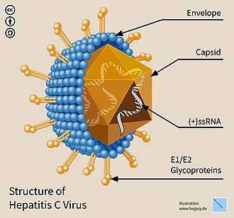

**Structure of HCV**

**Clinical feature**

It is similar to other Hepatitis Viruses clinical features but characterized by the followings:

1) Incubation period 15-160 days.

2) It is most commonly occurred in adults.

3) The root of infection parenteral (blood borne virus).

4) The virus present in the blood and saliva but absent in stool and urine.

5) It can pass to chronicity.

6) It is oncogenic virus.

**Diagnosis of HCV**

**1) Serological assay** by antibodies testing by ELISA to detected the presence of antibodies to HCV.

**2) PCR** to detect the presence of Viral RNA which are useful for monitoring patient on antiviral therapy.

**Treatment**

**-** α –interferon, Lamivudine antiviral drugs.

- No vaccine is available.

**Hepatitis D Virus**

HDV is a defective virus that is required the HBs Ag coat for transmission and it is only present with HBV infection. Transmission of HDV by parenteral route. The genome of the virus is ssRNA with a negative sense, HD virus antigen is the only protein coded by the HDV RNA and it is antigentically distinct from HBV antigens. HDV is the smallest human pathogens and it is associated with most sever forms of hepatitis in the HBs Ag positive patients.

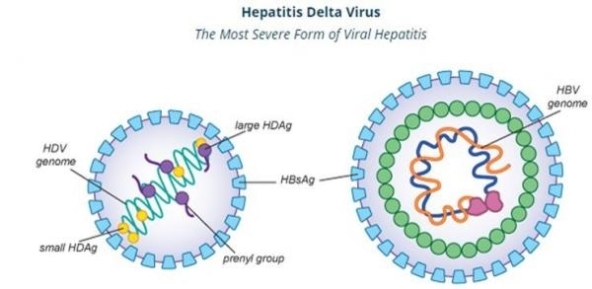

**Clinical features**

The incubation period of HDV infection is 14-60 days. Clinical feature for HDV is similar to that of HBV, but because HDV is dependent on a coexistent of HBV infection, **Virus**

1- Is member of the genus Hepacivirs, family Flaviviridae**.**

2- Genome contain**single-stranded**[**RNA**](https://en.wikipedia.org/wiki/RNA_virus) **,** [**positive-sense**](https://en.wikipedia.org/wiki/Sense_(molecular_biology)#Positive-sense)**.**

3- HCV consists of a [lipid membrane](https://en.wikipedia.org/wiki/Lipid_membrane) [envelope](https://en.wikipedia.org/wiki/Viral_envelope)d . enveloped contain two viral glycoproteins (E1 & E2).

3- Most new infection with HCV are subclinical but the majority of HCV infection (70%- 90%) develop chronic hepatitis and many at risk of progressing to chronic active hepatitis, cirrhosis which may lead to hepatocellular carcinoma.

the acute HDV infection occurs in two clinical forms:

a) Co infection

When the two viruses HBV& HDV infect the body at the same time.

b) Super infection:

When hepatitis D virus infect a patient who is infect with HBV with chronic infection.

**Diagnosis of HDV**

1) Coinfection

We can find the following antibodies and antigens

a) Ab to HD Ag develops late in the acute phase of infection and may be of low titer.

B) Assay for the presence of HD Ag, HD RNA, IgM to HDV.

2) Super infection

Detect the presence of IgM and IgG Abs to HDV Ag and HDV RNA, to gather with HBs Ag and anti HBc IgG.

**Treatment**

Similar to HBV treatment and vaccine.

**Hepatitis E**

HEV is a member of the Hepeviridae family, genus Hepevirus which causes acute hepatitis in the normal host and chronic hepatitis in immunosuppressed patients. it has ssRNA with a positive sense, non envelope virus. HEV is transmitted enterically and occur in epidemic form in developing countries.

**Clinical features**

Similar to HAV. But if the infection occur pregnancy it may has a high mortality rate reach to 20-30%.

**Diagnosis**

Detection the presence of antibodies to HEV antigen IgM & IgG.

**Treatment**

No drug but supportive treatment.

No vaccine present.

**الوحدة الثامنة - المحاضرة الثامنة - الزمن: 90 دقيقة**

### **أهداف المحاضرة الثامنة:**

**يتوقع في نهاية الجلسة أن يكون الطالب قادراً على:**

1-Enumerate the types of influenza virus.

2-Discus the transmission of influenza virus.

3-Identify the life cycle of influenza virus

**موضوعات المحاضرة الثامنة:**

### 1-Properties of influenza virus.

2-Mode transmission of influenza virus.

3-Life cycle of influenza virus.

### **الأساليب والأنشطة والوسائل التعليمية:**

|  |  |  |
| --- | --- | --- |
| **م** | **الأساليب والأنشطة التدريبية** | **الوسائل التدريبية** |
| **الثامنة** | * نشاط التعارف ( 8- 8-1) * محاضرة * مناقشة * سؤال وجواب | * جهاز حاسوب * جهاز عرض * سبورة * اوراق واقلام |

**خطة إجراءات تنفيذ المحاضرة الثامنة:**

|  |  |  |  |
| --- | --- | --- | --- |
| **الوحدة** | **المحاضرة** | **الإجراءات** | **الزمن بالدقيقة** |
| **الثامنة** | **الثامنة** | القاء المحاضرة مستخدما جهاز العرض والسبورة  طرح الأسئلة الشفوية لبعض الطلبة خلال القاء المحاضرة  نشاط (1-8-8) تمرين متعدد الخيارات  نشاط (2-8-8) تمرين التطابق | 90 دقيقة |

**المادة العلمية:**

The Orthomyxoviridae (influenza viruses) ,

**Ortho =True or real, Myxo =Affinity to mucins.**

**Introduction**

True influenza is an acute infectious disease caused by a member of the orthomyxovirus family: influenza virus **A, B** or, to a much lesser extent, influenza virus **C**. However, the term (**flu)** is often used for any febrile respiratory illness with systemic symptoms which may be caused by many of bacterial or viral agents as well as influenza. Influenza outbreaks usually occur in the winter in temperate climates.

**ORTHOMXYOVIRUSES:Influenza viruses**

Orthomyxoviruses are divided into four types: influenza A, B, C and D but only A, B, and C infect humans. Human influenza A and B are the virus types responsible for the seasonal flu epidemics, whereas influenza type C infections generally cause mild illness. Influenza A viruses are the only influenza viruses known to cause flu pandemics and are divided into subtypes. The single stranded, negative sense RNA genomes of influenza A and B viruses occur as eight separate segments; influenza C viruses contain seven segments of RNA, lacking a neuraminidase gene.

**Structure & Composition**

**Virion:** Spherical, pleomorphic, 80–120 nm in diameter. (helical nucleocapsid ).

**Composition:** RNA (1%), protein (73%), lipid (20%), carbohydrate (6%).

**Genome:** Single - stranded RNA, segmented (eight molecules), negative-sense, 13.6 kb overall size.

**Proteins:** eight structural proteins, two nonstructural protein.

**Envelope:** Contains viral hemagglutinin (HA) and neuraminidase (NA) proteins.

**Replication:** Nuclear transcription, particles mature by budding from plasma membrane.

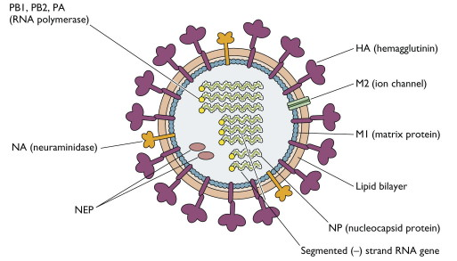

**Structure of influenza virus**

**Influenza virus life cycle**

Replication of influenza A virus. After binding to sialic acid-containing receptors, influenza is endocytosed and fuses with the vesicle membrane. Unlike for most other RNA viruses, transcription and replication of the genome occur in the nucleus were Viral proteins synthesized. Helical nucleocapsid segments form and associated with the M1 protein-lined membranes containing M2 and the HA and NA glycoprotein’s. The virus buds from the plasma membrane.

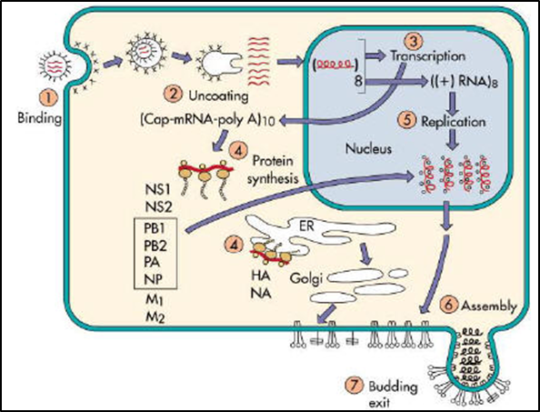

**Influenza virus life cycle**

**Structure and Function of Hemagglutinin**

The HA protein of influenza virus binds virus particles to susceptible cells. Variability in HA is primarily responsible for the continual evolution of new strains and subsequent influenza epidemics. Hemagglutinin derives its name from its ability to agglutinate erythrocytes under certain conditions.

The primary sequence of HA contains 566 amino acids. The HA protein is cleaved into two subunits, HA1 and HA2, that remain tightly associated by a disulfide bridge. The HA spike on the virus particle is a **trimer**. The trimerization imparts greater stability to the spike than could be achieved by a monomer.

**Structure and Function of Neuraminidase** **(NA)**

The antigenicity of NA, the other glycoprotein on the surface of influenza virus particles, is also important in determining the subtype of influenza virus isolates. The spike on the virus particle is a tetramer, composed of four identical monomers. The NA functions at the end of the viral replication cycle include:

**a)** It is a sialidase enzyme that removes sialic acid from glycoconjugates.

**b)** It facilitates release of virus particles from infected cell surfaces during the budding process

**c)** helps prevent self-aggregation of virions.

**Antigenic Drift and Antigenic Shift**

Influenza viruses are remarkable because of the frequent antigenic changes that occur in HA and NA. This phenomenon is responsible for the unique epidemiologic features of influenza. The two surface antigens of influenza undergo antigenic variation independent of each other. Minor antigenic changes (accumulate point mutations during virus replication) are termed **antigenic drift;** major antigenic changes in HA or NA, called **antigenic shift,** result in the appearance of a new subtype.

Antigenic shifts can result from mechanisms Genetic reassortment between subtypes. Reassortment is possible whenever two different influenza viruses infect a cell simultaneously; when the new viruses (the progeny) are assembled, they may contain some genes from one parent virus and some genes from the other.

**Types of influenza viruses**

There are four types of influenza viruses: **A, B, C and D**

1. **Influenza A viruses**

Influenza A viruses include the avian, swine, equine and canine influenza viruses, as well as the human influenza Avirus. Influenza A viruses are classified into subtypes based on two surface antigens, the hemagglutinin (H) and neuraminidase (N) protein. There are 18 different known H [antigens](https://en.wikipedia.org/wiki/Antigen) (H1 to H18) and 11 different known N antigens (N1 to N11).  H1N1, H1N2, and H3N2 are the only known influenza A virus subtypes currently circulating among humans.

**2. Influenza B viruses**

Influenza B viruses are mainly found in humans. These viruses can cause epidemics in human population, but have not, to date, been responsible for pandemics**.**

**3- Influenza C viruses**

Influenza type C infections generally cause mild illness and are not thought to cause human flu epidemics.

**4- Influenza D** **viruses** primarily affect cattle and are not known to infect or cause illness in people.

**Viral Transmission**

Influenza viruses are transmitted in aerosols created by coughing and sneezing, and by contact with nasal discharges, either directly or on fomites. Close contact and closed environments favor transmission. Person-to-person transmission occurs with the H1N1 virus that is currently circulating in humans.

**Clinical findings**

**Incubation Period :**

The incubation period for human influenza is usually short; most infections appear after one to four days. The incubation period for the novel H1N1 virus circulating in humans appears to be 2 to 7 days.

**Clinical Signs &Pathogenicity**

Uncomplicated infections with human influenza A or B viruses are usually characterized by upper respiratory symptoms, which may include fever, chills, anorexia, headache, myalgia, weakness, sneezing, rhinitis, sore throat and a

nonproductive cough. Nausea, vomiting and otitis media are common in children, and febrile seizures have been reported in severe cases. Most people recover in one to seven days, but in some cases, the symptoms may last up to two weeks or longer.

More severe symptoms, including pneumonia, can be seen in individuals with chronic respiratory or heart disease. Secondary bacterial or viral infections may also occur.

**Laboratory Diagnosis of Human Influenza**

**Specimen collection**

**Respiratory specimens:** Respiratory specimens obtained within four days of onset of symptoms and different types of respiratory specimens can be used such as nasal washes and nasopharyngeal aspirates tend to be more sensitive than pharyngeal swabs.

**Blood specimens:** Acute and convalescent serum samples 14 − 21 days should be collected to demonstrate a significant (at least fourfold) rise in strain-specific antibody titer.

**Laboratory Tests**

**1- Isolation methods (Viral Culture)**

**- Embryonated egg culture**

**- Cell culture**: Various cell-lines are utilized to isolate influenza viruses, most commonly primary monkey kidney cells. infection of cells gives a visible cytopathic effect (CPE).

**2- Direct methods**

* Immunofluorescence
* Enzyme immuno assays
* Reverse transcription polymerase chain reaction (RT-PCR).

**3- Serology**

Different serological techniques are available for influenza diagnosis include haemagglutination inhibition (HI), complement fixation (CF), enzyme immunoassays (EIA) and indirect immunofluorescence**.**

**الوحدة التاسعة - المحاضرة التاسعة - الزمن: 90 دقيقة**

### **أهداف المحاضرة التاسعة:**

**يتوقع في نهاية الجلسة أن يكون الطالب قادراً على:**

1-Enumerate the members of paramyxoviruses.

2-Discus the transmission of measles virus.

3-To know the lab diagnosis of Respiratory syncytial virus (RSV).

**موضوعات المحاضرة التاسعة:**

### 1-Properties of paramyxoviruses.

2-Mode transmission of mumps virus.

3- Laboratory diagnosis of Respiratory syncytial virus (RSV).

### **الأساليب والأنشطة والوسائل التعليمية:**

|  |  |  |
| --- | --- | --- |
| **م** | **الأساليب والأنشطة التدريبية** | **الوسائل التدريبية** |
| **التاسعة** | * نشاط التعارف (9- 1-9) * محاضرة * مناقشة * سؤال وجواب | * جهاز حاسوب * جهاز عرض * سبورة * اوراق واقلام |

**خطة إجراءات تنفيذ المحاضرة التاسعة:**

|  |  |  |  |
| --- | --- | --- | --- |
| **الوحدة** | **المحاضرة** | **الإجراءات** | **الزمن بالدقيقة** |
| **التاسعة** | **التاسعة** | القاء المحاضرة مستخدما جهاز العرض والسبورة  طرح الأسئلة الشفوية لبعض الطلبة خلال القاء المحاضرة  نشاط (1-9-9) تمرين متعدد الخيارات  نشاط (2-9-9) تمرين التطابق | 90 دقيقة |

**المادة العلمية:**

**Paramyxoviruses**

The paramyxoviruses include the most important agents of respiratory infections of infants and young children as well as the causative agents of two of the most common contagious diseases of childhood (mumps and measles).

**PARAMYXOVIRUS FAMILY**

|  |  |  |
| --- | --- | --- |
| **GLYCOPROTEINS** | **MEMBERS** | **GENUS** |
| HN, F | mumps  human parainfluenza viruses (HPIV 1-4) | Paramyxovirus |
| H, F | Measles | Morbillivirus |
| G, F | Respiratory syncytial virus | Pneumovirus |

**Properties of paramyxoviruses**

**Virion:** enveloped and can be spherical sometimes filamentous, larger than influenza Virus (100-300) nm in diameter Composed of inner **Helical nucleocapsid** containing Genome.

**Genome**: linear, non segmented, **ssRNA,** negative-sense **(-ve).** There is **no reassortment.**

**Proteins:**

**1- N**P – The nucleocapsid protein associates with genomic RNA.

**2- L** and **P** - polymerase activity.

**3- HN** - The cell attachment proteins span the viral envelope and project from the surface as spikes. haemagglutinin + neuraminidase activities.

**4**- **F:** the fusion protein projects from the envelope surface.

**5-** **M:** The matrix protein lines the inner surface of the envelope.



**Structure of paramyxovirus**

**Replication**: replication of the viruses occurred in the cytoplasm and bud from plasma membrane. A large excess of nucleocapsids are produced in infected cells, which form characteristic cytoplasmic inclusion bodies.

**Transmission**: spread by droplets from the nose and mouth to close contacts. Many of them are highly infectious and go around the community in epidemics- often seasonal, eg. Winter coughs and colds. Fomites might also assist spread.

**Parainfluenza viruses infections:**

These viruses are the common cause of respiratory illness in all ages but specially in infant and young children. The reinfection of these viruses are common.

**Pathogensis and pathology:**

The replication of this viruses are limited to the respiratory epithelial cells, the infection is limited to the nose and throat resulting to common cold syndrome, but it may involve the larynx and upper trachea and resulting to **croup**. the duration of the shedding of the virus about 1 week after onset of the illness. the severity of the disease related to the production of specific IgE antibodies.

**Clinical findings:**

Rhinitis, phyarngitis, fever, bronchitis and may be pass to croup. The severity of the disease occurred in infant less than 6 months.

**Laboratory diagnosis**

1. **Clinical feature**
2. **Antigen detection**

Direct detection of viral antigens in respiratory secretions (collected within 1 week of symptom onset) using **immunofluorescence or enzyme immunoassay.**

1. **Isolation and identification**

Nasal wash are good specimens, culture in monkey kidney cell line , the diagnosis depending on hemadsorption.

**4) Nucleic acid detection:** by polymerase chain reaction assays **(PCR)**.

**5) Serology**: detection of specific IgM antibodies by **ELISA test**.

**Treatment:**

No specific treatment but ribavirin has been used with some benefit in immunocompromised patients. no vaccine is available.

**Respiratory syncytial virus(RSV)**

It is the most common cause of lower respiratory tract illness in infant and young children.

**Pathogenesis and pathology**

Replication of the virus occurred initially in the nasopharynx, then the virus may spread to the lower respiratory tract and produce bronchiolitis and pneumonia. The incubation period 3-5 days and virus shedding for 1-3 weeks.

**Clinical findings:**

Common cold, pneumonia in infant and may bronchrolitis and Bronchitis. Reinfection is common in both children and adult with less severity. This virus is a common cause of otitis media about 30% of otitis media cause in infant.

**Laboratory diagnosis of Respiratory syncytial virus(RSV)**

**1) Clinical feature**

**2) Antigen detection**

Nasal wash or aspirate are good sample. Virus antigens detection by immunofluorescence test.

**3) Isolation and identification of the virus**

By culturing the specimen into human heteroploid cell line ( Hela) and Hep-2, the diagnosis is depend on the cytopathic effect and appearance of giant cells.

**4) Nucleic acid detection**

Diagnosis by detection of the RNA of the virus by PCR.

**5) Serology**

Detection of serum antibodies which include IgM and IgG Abs by using immunofluorescence test.

**Treatment**

Supportive care, Ribavirin may be used in the treatment of severe cases by aerosol for 3-6 days. No vaccine is available today.

**Mumps virus infections**

Mumps is acute disease characterized by non suppurative enlargement of one or both saliva glands. It is a mild disease in children but in adult it may produce orchitis (infection of the testis).

**Pathogenesis and pathology**

Human are the only natural host of mumps virus. primary replication is occurred in the epithelial cells of the upper respiratory tract The virus spreads to lymphoid tissue which, in turn, leads to viremia. The virus thus spreads to a variety of sites, including salivary glands specially the parotid salivary glands, other glands and other body sites. The incubation period 2-4 weeks, shedding of the virus 3 before infection and 9 days after the appearance of salivary gland infection.

**Clinical findings**

Fever, malaise followed by rapid enlargement of the parotid gland and it is painful . mumps may be associated with aseptic meningitis. testes and ovaries may be infected especially after puberty and it may pass to sterility in man but it is rare (not more than 1%).

**Laboratory diagnosis of Mumps virus**

**1) Clinical feature**

**2) Isolation and identification**

Sample s (Saliva, CSF and Urine).

Culture in monkey kidney cells and diagnosis by using mumps specific antiserum by immunofluorescence method, hemadsorption test can also be used.

**3) Nucleic acid detection**

By PCR test.

**4) Serology**

IgM and IgG Abs detection by ELISA and Heamagglutin inhibition test.

**Treatment**

No specific treatment but there is vaccination for mumps, measles, rubella vaccine **(MMR).**

**Measles virus infection**

Measles is an acute, highly infectious disease characterized by fever, respiratory symptoms and maculopapular rash.

**Pathogensis and pathology**

Human are the only natural host for measles virus. the site of replication is the respiratory tract, the infection then spread to the regional lymph node followed by primary viremia then replicate in the reticuloendothelial system followed by secondary viremia then seeds to the skin, respiratory tract and conjunctiva.

**Clinical findings**

Fever, sneezing, coughing, runny nose, redness of the eye, the appearance of maculopapular rash.

**Laboratory diagnosis of Measles**

**1)** **Clinical feature**

**2)** **Antigen detection**

Measles antigen can be directly detected from specimen includes respiratory secretion, nasopharynx and conjunctiva by Immunofluorescence test.

**3)** **Isolation and identification**

Specimen, Nasopharyngeal and conjunctiva swabs, respiratory secretion culture in monkey and human kidney cells, diagnosis by cytopathic effect, multinucleated and intranuclear and intracytoplasmic inclusion bodies.

**4) Serology**

IgM and IgG antibodies by ELISA and Heamagglution inhibition test (HI) test.

5) **Nucleic acid detection**

By PCR for RNA of the viruses.

**Treatment:** No treatment. Vaccination with MMR.