Republic of Iraq Assist. Prof. Dr.: Abbas Atiya Hammoudi
Ministry of Higher Education & Scientific Research fourth class (Lecture 1)
Al-Rasheed university College Clinical immunology
Department of medical laboratory Techniques 2022/2023

Rheumatic diseases:
affect the joints tendons, ligaments, bones, and muscles. Among them are many types of arthritis, a term used for conditions that affect the joints. Sometimes they’re called musculoskeletal diseases. Common symptoms include:
- Joint pain
- Loss of motion in a joint or joints
- Inflammation -- swelling, redness, and warmth in a joint or affected area
Rheumatology: is the medical field that studies these types of conditions.
Rheumatologist : is a doctor who’s specially trained to treat rheumatic diseases.
• Rheumatoid Arthritis (RA)
Rheumatoid Arthritis is a systemic chronic inflammatory autoimmune disease. It happens when the immune system attacks the tissues. It is characterized by chronic and erosive polyarthritis, synovial hyperplasia and progressive joint destruction, leads to abnormal growth of synovial tissue and causes joint pain (irreversible joint disability), swelling, and stiffness (joint damage). Therefor the early diagnosis and treatment of the disease is very useful to avoid the occurrence of joint damage.
Symptoms (Rheumatoid arthritis criteria):
- Pain and swelling {proximal interphalangeal (PIP), metacarpo-phalangeal(MCP)}, in multiple joints (usually the same joints(Symmetric) on both sides of the body, like both wrists or
1
both ankles) (observed by physician).
- Problems in other organs such as the eyes and lungs
- Joint stiffness, especially in the morning lasting at least one hour before maximal improvement.
- joint tenderness, redness and warmth around the joint,
- Fatigue.
- Fever.
- Weight loss.
- Lumps called rheumatoid nodules
- Radiographic changes (erosions and/ or peri-articular osteopeniain hand/ wrist joints).
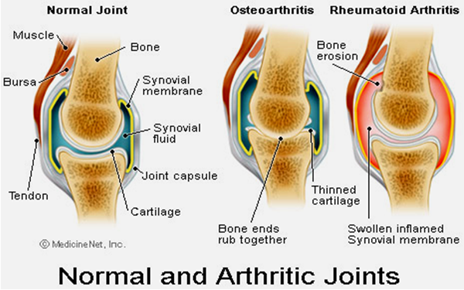
Figure 1: A comparison between normal and Rheumatoid Arthritis joints.
Etiology
The exact cause of rheumatoid arthritis is unknown. However, it is believed to be caused by a combination the following factors:
- Genetics (heredity)
2
- Abnormal immunity
- The environmental exposures: Although uncertain and poorly understood, some exposures such as asbestos or silica may increase the risk for developing rheumatoid arthritis.
- Hormones.
Risk factors of developing rheumatoid arthritis:
Normally, the immune system protects the body from disease. In people who have rheumatoid arthritis, the followings criteria trigger the immune system to attack the joints:
1.Infections.
2. cigarette smoking.
3. physical or emotional stress.
4. Gender, heredity (genes largely determine a person's risk of developing rheumatoid arthritis. For example, women are about three times more likely than men to develop rheumatoid arthritis).
5. Obesity: People who are overweight or obese appear to be at somewhat higher risk of developing rheumatoid arthritis, especially in women diagnosed with the disease when they were 55 or younger.
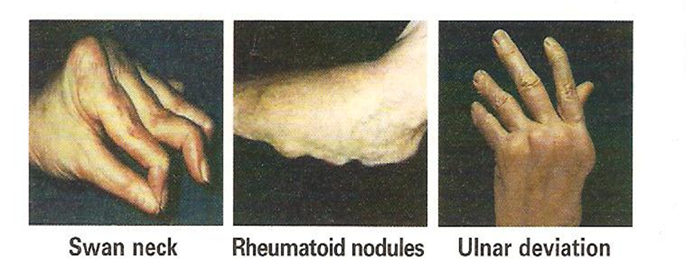
Figure 2.: Some of RA Classification Criteria (Fox, 2007A)
3
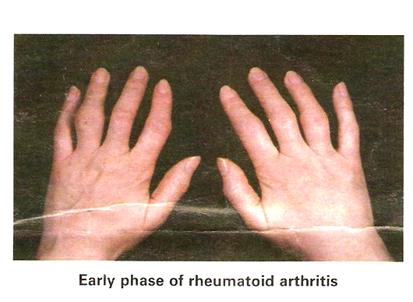
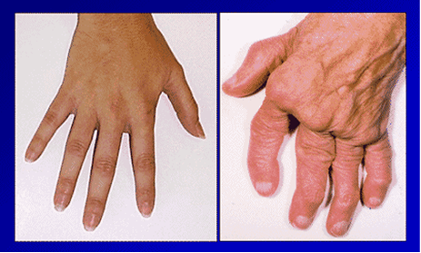
Hand at Late Stage of RA in comparison with healthy hand
Figure 3 : The appearance of RA Hand's patients in comparison with control at early and late stage of the RA
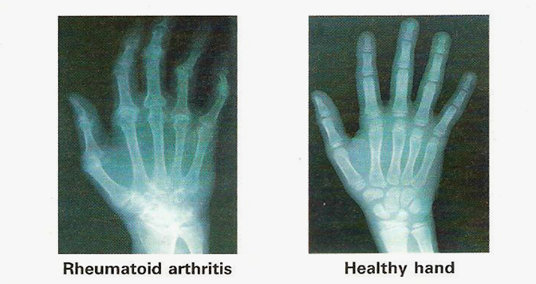
Figure4: Swelling of figure joints and Ulnar deviation of the fingers as shown under X-ray image in comparison with healthy hand bones

4
Rheumatoid nodules
*Seen in 20-30% of patients with RA and associated with aggressive diseases.
*An extra-articular process found most commonly on extensor surfaces at sites of frequent mechanical irritation over IP joints, and over ulnar border of the forearm.
* Patient complain of pain and cosmetic concerns.
*Treatment-non operative –steroid injection, operative surgical excision
Reference: Rheumatoid nodules: differential diagnosis and immunological findings, journal of the rheumatic diseases,1993,52625-626.
Pathophysiology (Immune mechanism) :
How does the immune system work with rheumatoid arthritis?
The immune system normally makes antibodies that attack bacteria and viruses, helping to fight infection. If subject have rheumatoid arthritis, the immune system mistakenly sends antibodies to the lining of the joints, where they attack the tissue surrounding the joint.
Rheumatoid arthritis (RA) is a chronic inflammatory autoimmune disease that is characterized by synovial hyperplasia and progressive joint destruction. The pathogenesis of RA is not completely understood.
Synovial cell hyperplasia and endothelial cell activation are early events in the pathologic process that progresses to uncontrolled inflammation and consequent cartilage and bone destruction. Genetic factors and immune system abnormalities contribute to disease propagation.
CD4 T cells, mononuclear phagocytes, fibroblasts, osteoclasts, and neutrophils play major cellular roles in the pathophysiology of RA, whereas B cells produce autoantibodies (ie, rheumatoid factors). Abnormal production of numerous cytokines, chemokines, and other inflammatory mediators has been demonstrated in patients with RA, including the following:
5
- Tumor necrosis factor alpha (TNF-α)
- Interleukin (IL)-1
- IL-6
- IL-8
- Transforming growth factor beta (TGF-ß)
- Fibroblast growth factor (FGF)
- Platelet-derived growth factor (PDGF)
Ultimately, inflammation and exuberant proliferation of the synovium (ie, pannus) leads to destruction of various tissues, including cartilage (see the image below), bone, tendons, ligaments, and blood vessels. Although the articular structures are the primary sites involved by RA, other tissues are also affected.

6
Diagnosis: The diagnosis of the disease depends on:
1. the patient's history and
2.look for different signs of inflammation.
so the following investigations are necessary:
* X-ray-joint narrowing, erosions at the joint margins.
*Samples of joint fluid- high neutrophil count in uncomplicated disease.
*Blood tests include:
- Antinuclear antibody (ANA)
- Serum Autoantibodies-Anti-citrullinated peptide (Anti-CCP) has high specificity (90%)
- Complete blood count- usually a normochromic, normocytic anemia
- C-reactive protein (CRP) is high.
- Erythrocyte sedimentation rate (ESR) are raised.
- Rheumatoid factor (RF) is positive in 70% of cases sensitivity (80%) for RA.
Test that support the diagnosis of RA if +/ elevated:
*Rheumatoid factor.
* Anti-citrullinated peptide (Anti-CCP) antibodies.
* Erythrocyte sedimentation rate (ESR).
* C-reactive protein (CRP).
Test that aid in differential diagnosis:
* Antinuclear antibody (ANA)
* Complete blood count with differential.
*platelet count.
7
*serum uric acid.
*HLA tissue testing.
Additional testing for select patients:
*serological studies for infections.
*Synovial fluid analysis;
-Cell count.
- Crystal search.
- Gram stain.
- Culture.
Treatment of rheumatoid arthritis
The goals of rheumatoid arthritis treatment are to:
1. Control a patient's signs and symptoms.
2. Prevent joint damage.
3. Maintain the patient's quality of life and ability to function.
Treatments for rheumatoid arthritis include;
medications, rest, exercise, physical therapy/occupational therapy, and surgery to correct damage to the joint.
The type of treatment will depend on several factors including:
the person's age, overall health, medical history, and the severity of the arthritis.
Non-pharmacologic therapies
Non-pharmacologic therapy is the first step in treatment for all people who have rheumatoid arthritis. Non-pharmacologic therapies include the following:
- Rest: When joints are inflamed, the risk of injury to the joint and to nearby soft tissue structures (such as tendons and ligaments) is high. This is why inflamed joints should be rested.

8
2. Exercise:
Pain and stiffness often prompt people with rheumatoid arthritis to become inactive. However, inactivity can lead to a loss of joint motion, contractions, and a loss of muscle strength. These, in turn, decrease joint stability and increase fatigue (walking, swimming, and cycling)
3. Physical and occupational therapy
Physical and occupational therapy can relieve pain, reduce inflammation, and help preserve joint structure and function for patients with rheumatoid arthritis.
Specific types of therapy are used to address specific problems of
rheumatoid arthritis:
a. The application of heat or cold can relive pain or stiffness.
b. Ultrasound can help reduce inflammation of the sheaths
Surrounding tendons (tenosynovitis).
c. Exercises can improve and maintain range of motion of the joints.
d. Rest and splinting can help reduce joint pain and improve joint function.
e. Finger-splinting and other assistive devices can prevent deformities and improve hand function.
f. Relaxation techniques can relieve secondary muscle spasm.
g. Occupational therapists also focus on helping people with rheumatoid arthritis continue to actively participate in work and recreational activity.
4. Nutrition and dietary therapy
Weight loss may be recommended for overweight and obese people to
9
reduce stress on inflamed joints. People with rheumatoid arthritis have a higher risk of developing coronary artery disease. High blood cholesterol (a risk factor for coronary artery disease) can respond to changes in diet.
Medications
There are many medications to decrease joint pain, swelling, and inflammation, and prevent or slow down the disease. The type of drugs is recommended by doctor that depends on how severe the arthritis is and how well the subject responds to the medications. These medications include:
Non -steroidal anti-inflammatory drugs (NSAIDs), such as 1. aspirin, ibuprofen, or naproxen
2.Corticosteroids (oral and injectable forms)
3. COX-2 inhibitor (celecoxib [Celebrex®])
(COX-2 inhibitors are a type of nonsteroidal anti-inflammatory drug (NSAID) that directly targets cyclooxygenase-2, COX-2, an enzyme responsible for inflammation and pain.)
4. Disease-modifying anti-rheumatic drugs (DMARDs)
such as hydroxychloroquine (Plaquenil), methotrexate (Rheumatrex®,
5.Biologic agents, such as infliximab (Remicade®), etanercept (Enbrel®). Biologics tend to work rapidly; they may be used alone or in combination with other DMARDs. Usually they are reserved for patients who do not adequately respond to DMARDs, or if the prognosis (outlook) for the patient is problematic.
- 6. Anti-TNF agents such as infliximab, etanercept, are not recommended for people who have lymphoma or who have been treated for lymphoma. Anti-TNF agents have been associated with a further increase in the risk of lymphoma in some studies but not others. 10
- (TNF-alfa (alpha) inhibitors (TNF-alpha) are a group of medicines that suppress the body's natural response to tumor necrosis factor
(TNF), a protein produced by white blood cells that is involved in early inflammatory events)
- Testing for tuberculosis (TB) is needed before starting anti-TNF therapy. People who have evidence of earlier TB infection should be treated for TB, because there is an increased risk of developing active
- TB while receiving anti-TNF therapy.
Surgery
When bone damage from the arthritis has become severe or pain is not controlled with medications, surgery is an option to restore function to a damaged joint.
Reference:1987 revision, American Rheumatism Association
RA vs (versus) OA
 | Rheumatoid Arthritis | Osteoarthritis
Pain | Eases with use | Increase with use
Stiffness | Significant(>60mins) | Not prolonged(>30 mins)
 | Early morning | Morning/ Evening
 | After rest
Swelling | Synovial+/- bony | Bony/None
Inflammation | Hot, red joints | No inflammation
Demographics | Young ,FH | Older, occupation
joint distribution | Small joints / Hands & feet | 1stCMCJ,DIPJ / Knees
NSAIDs | Good response | Less convincing response

CMCJ= Carpometacarpal Joint
DIPJ= Distal phalanx Joint

11

