Subject : Medical Physics (Lecture Notes) 1/16
Instructor: Dr. Mohamed Saleh Ahmed
CH. 2

Forces on and in the Body
Physicists like to consider the very fundamental origins of forces:
- Gravitational force (Medical effects; varicose veins, ‘’healthy bones’’….).
- Electrical force (note that electrical forces in H atom is about 10³⁹ times greater than G between e and p). (our body is basically an electrical machine; control of the muscles)
- Nuclear force (involve the nucleus of the atom).
(strong NF and a weaker NF; electron ((beta)) decay from the nucleus)

There are two types of problems involving forces on the body:
- Static (stationary); the body is in equilibrium.
- Dynamic (= = = accelerated).
Note: (Friction is involved in both statics and dynamics).

2-1 STATIC (forces involved with muscles, bones, and tendons)
- State of equilibrium: The sum of the forces in any direction is equal to zero, and the sum of the torques about any axis also equals zero.
- Many of the muscle and bone systems of the body act as levers.

2/16

Levers are classified as:
1-First class system (least common), 2-Second class, and 3- Third class (most common)

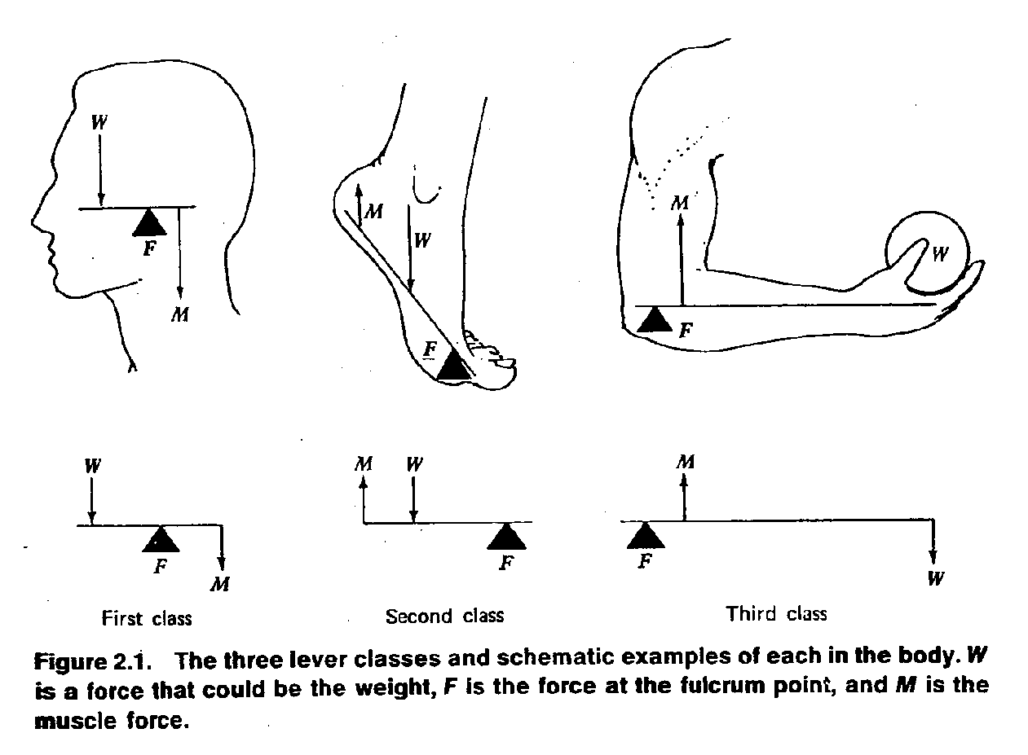

Example, (p.18), Find the force supplied by the biceps : 3/16
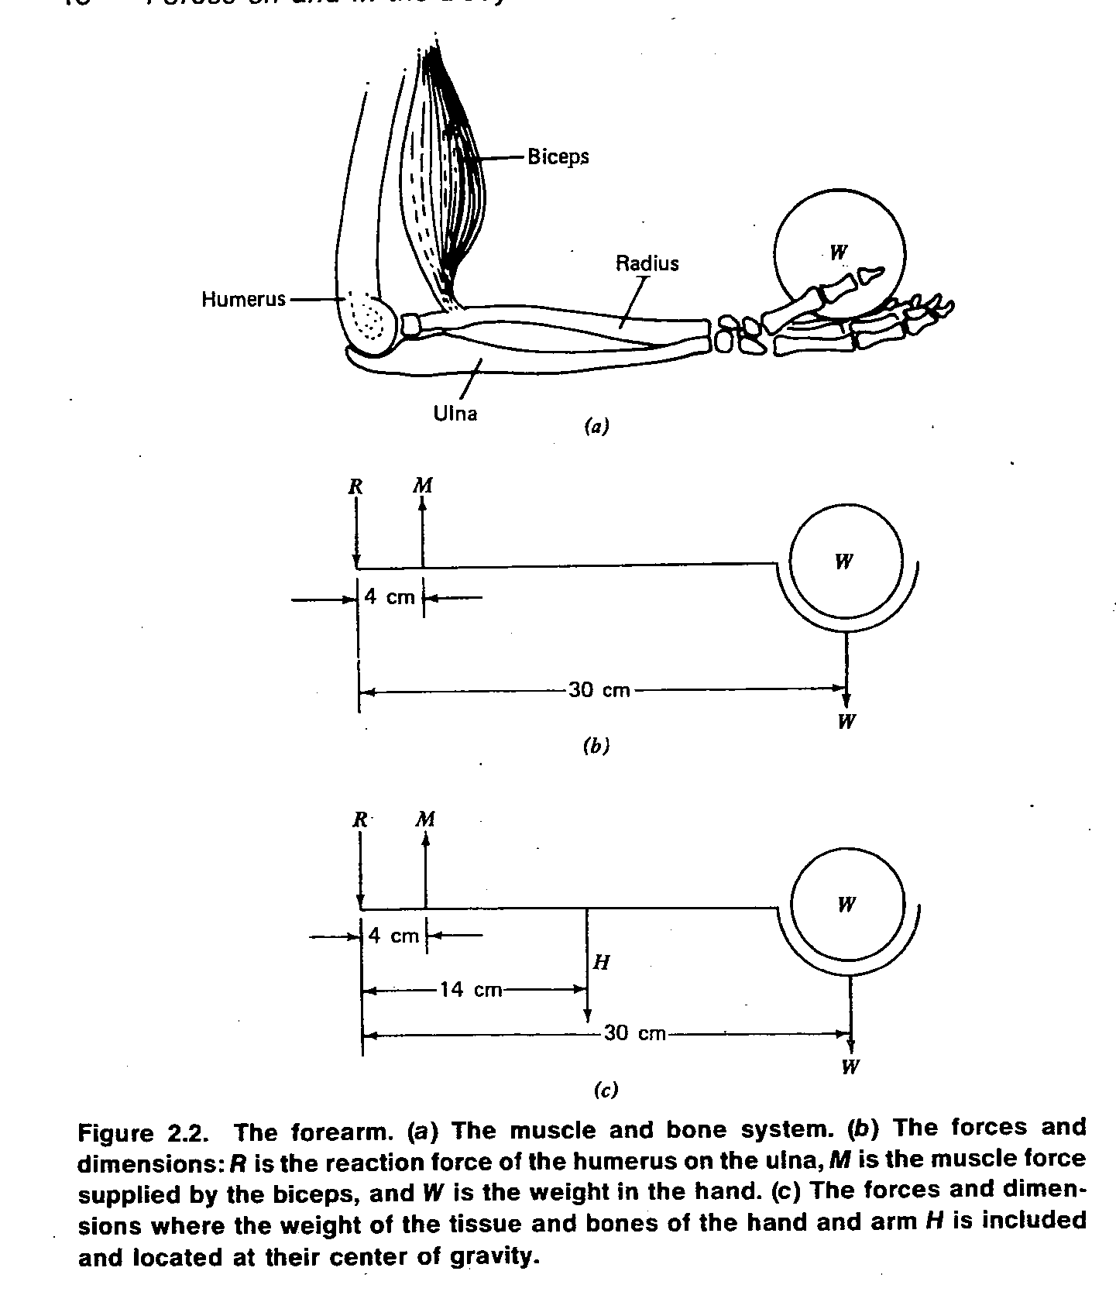
Sol: there are two torques, (H is excluded):
30 *W = 4*M , 4M – 30W = 0
M=7.5W (muscle force 7.5 times the weight is needed) 4/16
For W =100N (~ 22lb) the force needed is 750 N (~ 165 lb) .
(H is involved):
30W + 14H =4M , 7.5W+ 3.5H =M
For H = 15N (3.3 lb) , 3.5H = 52.5N (~ 11.8 lb).
* Consider: The Forearm at an angle α to the horizontal,

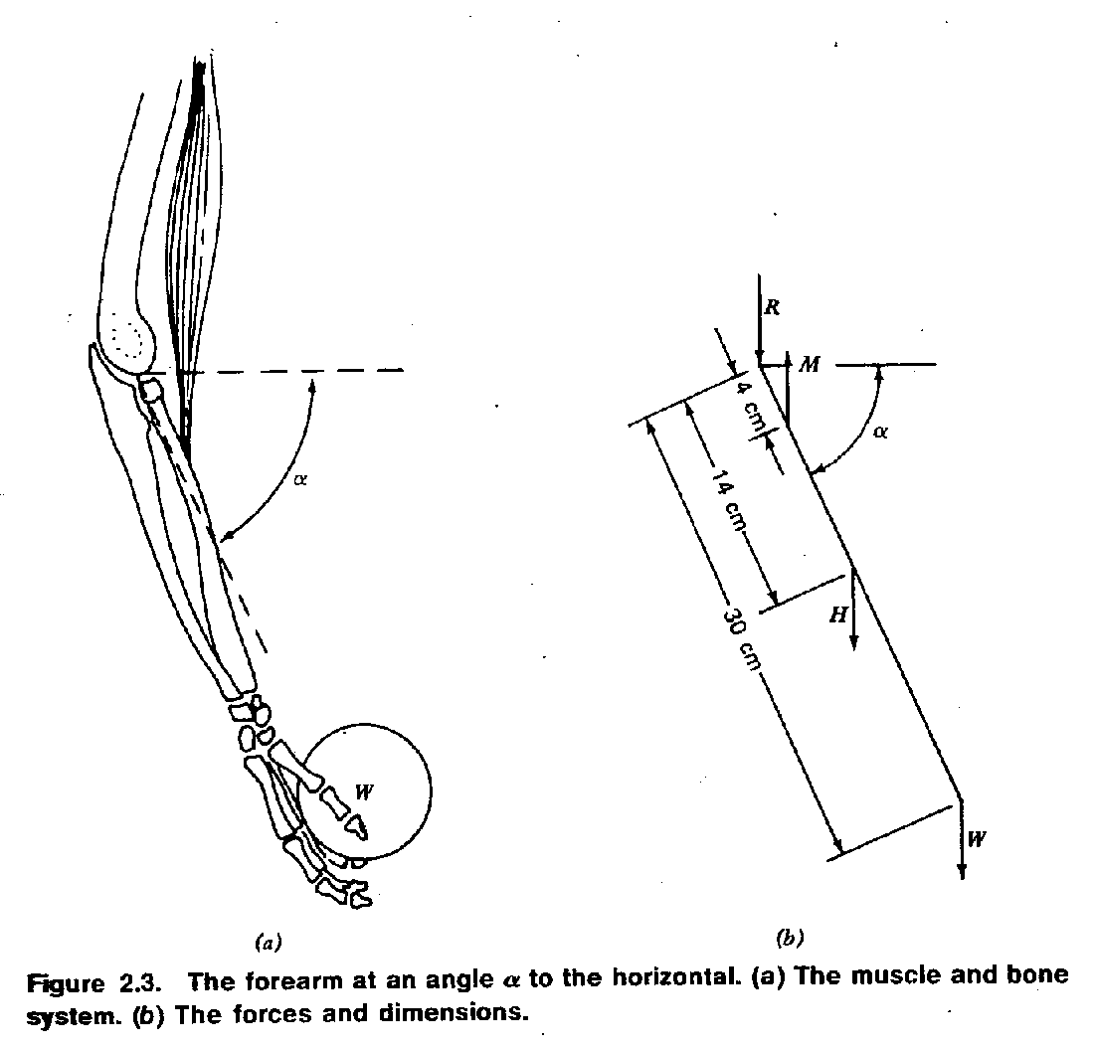
Take the torques about the joint: 5/16
30W cos α + 14H cos α = 4M cos α
30W + 14H = 4M
M remains constant as α changes, however, the biceps changes with α.
(M ~0 , minimum length, M~0 maximum length), See Fig. 2.4
Case of raising the arm: the arm can be raised and held out horizontally from the shoulder by the deltoid muscle.
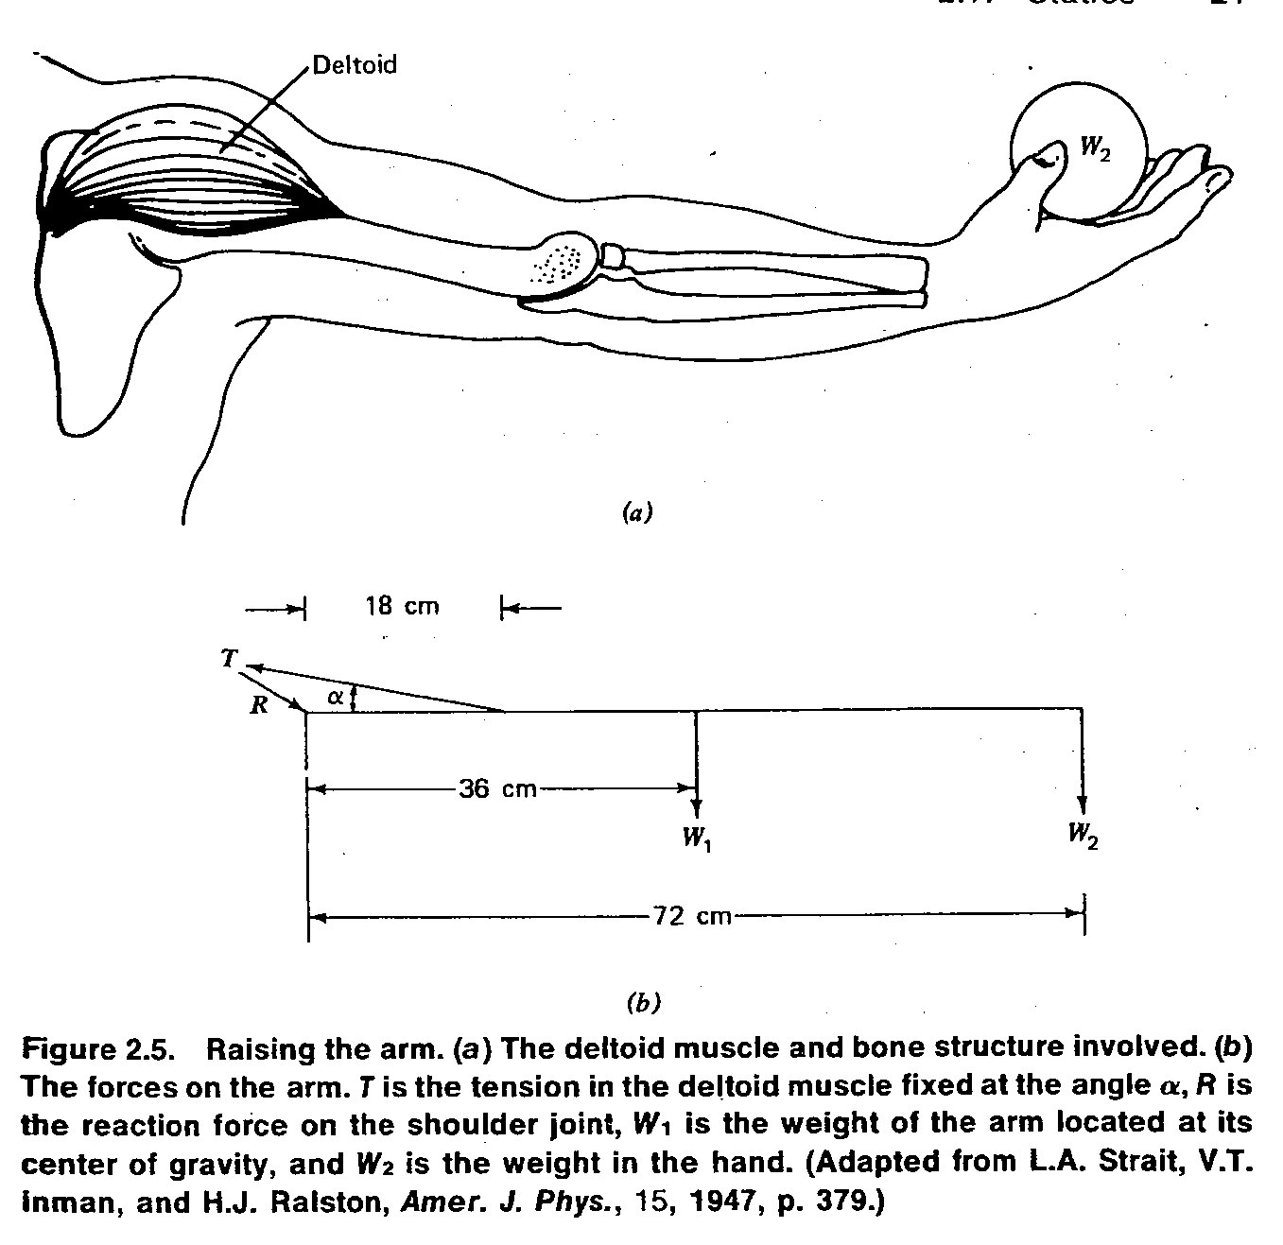
6/16

72W₂ +36W₁ =18T sin α
4W₂ +2W₁ =T sin α, T (tension) = (2W₁ + 4W₂)/sinα
If α =16º, W₁=68N (~15lb), and W₂= 45N (~10lb) then T=1145N (250 lb) (surprisingly large)

- An often abused part of the body is the lumbar (lower back) region, (fifth lumbar vertebra).

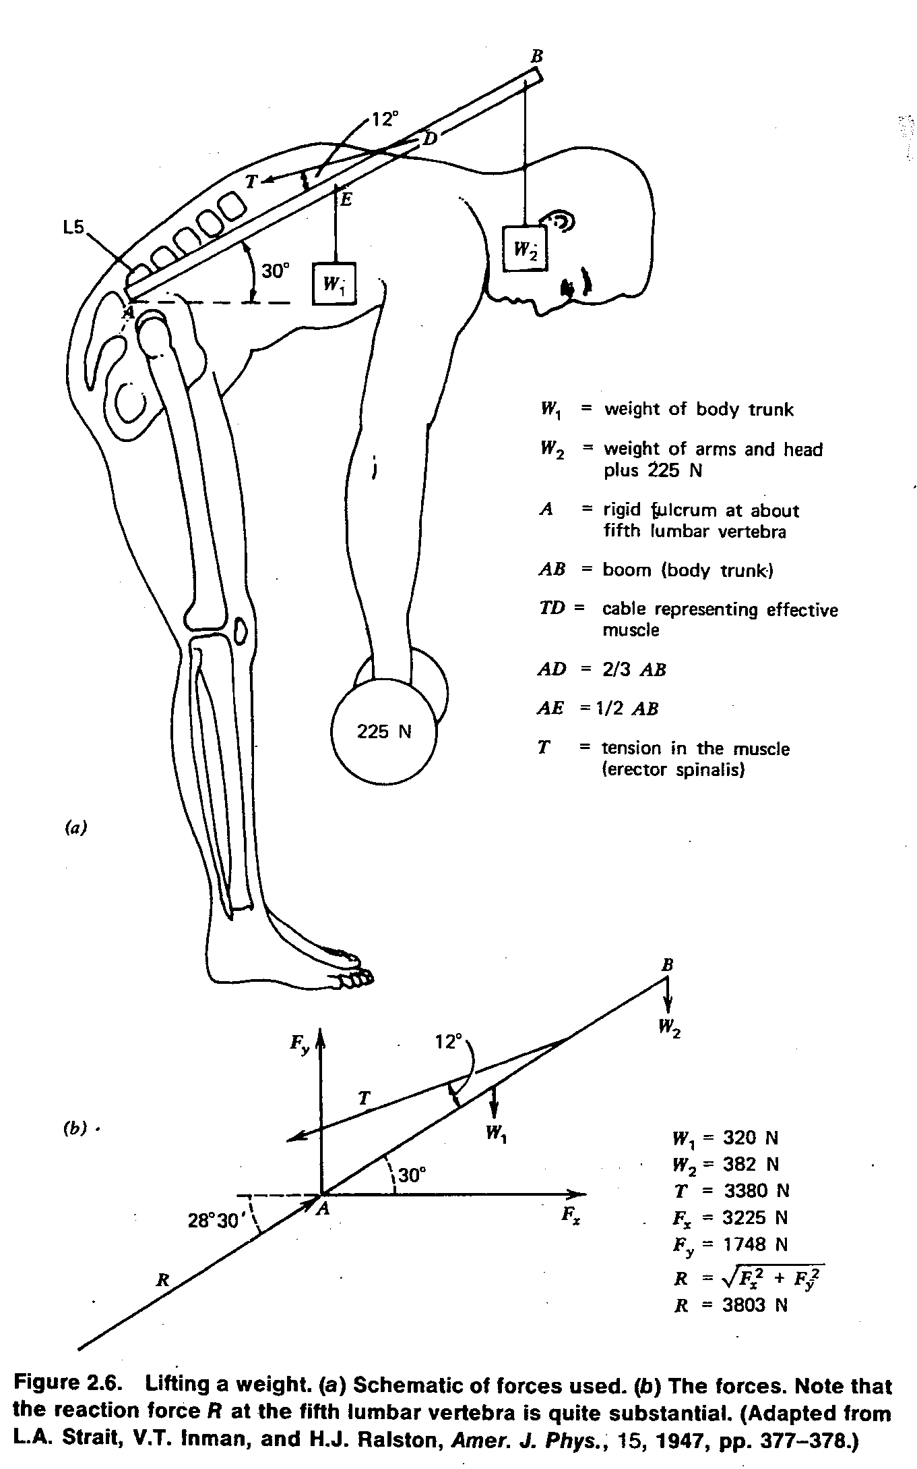 7/16
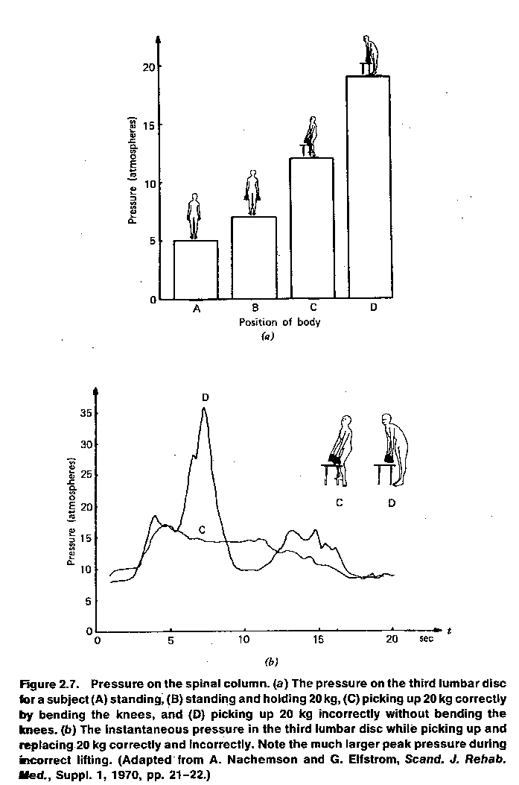 8/16
9/16
- Forces of muscles in the body are transmitted by tendons. Tendons minimize the bulk at a join.
- Example, in the leg, tendons pass over grooves in the knee cap (patella, also serves as a pulley) and connect to the shin bone (tibia). Some of the greatest forces in the body occur at the patella.

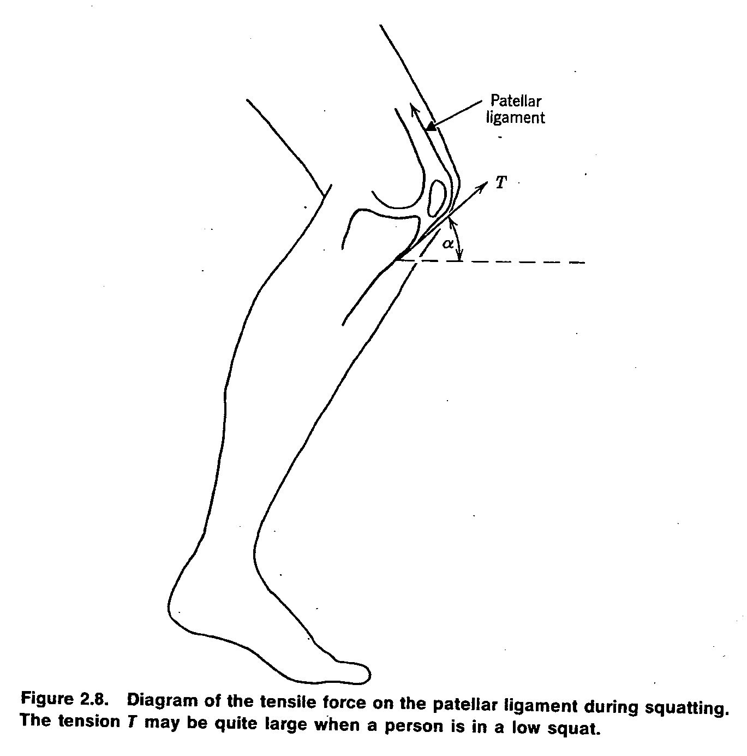
2.2 Frictional Forces: Friction and energy loss due to friction appear everywhere in our life. It limits the efficiency, however, we can make use of it in many devices. Example, normal walking.
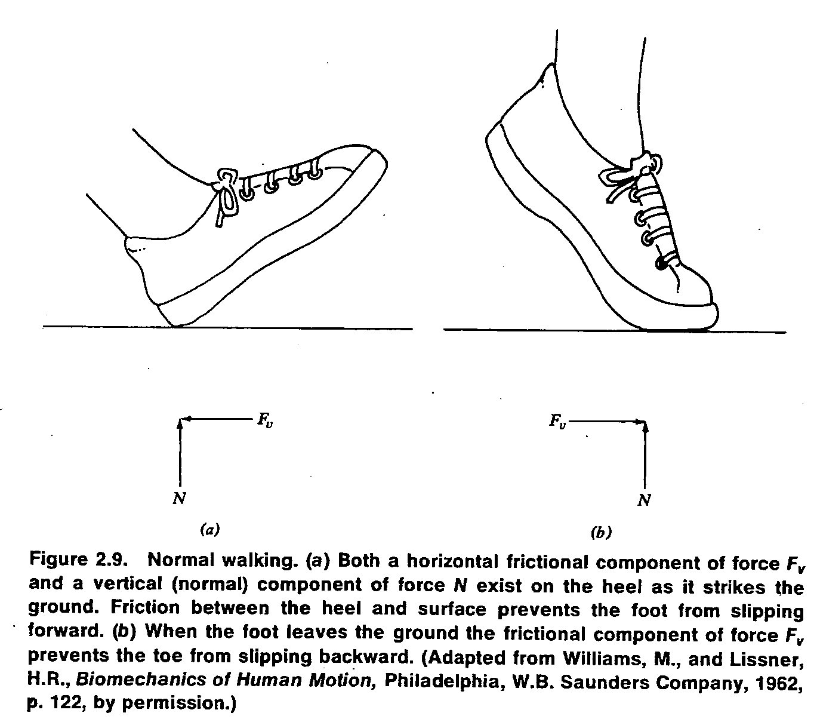
Maximum force of friction f = µ N, where µ is the coefficient of friction between two surfaces, and N is the normal force.
When N=W, then f=0.15W and for µ=1, f=W which is larger than needed.
- The synovial fluid in the joint is involved in the lubrication.
- The saliva add when chew food acts as a lubricant.
- Organs (heart, lungs, intestines) are lubricated by slippery mucus
covering to minimize friction . 10/16
2.3 Dynamics, 11/16
Examine forces on the body where acceleration or deceleration is involved.
Newton’s Second Law (F = ma). In fact Newton said force equals the change of momentum Δ (mv) over a short interval of time Δt, F=Δ(mv)/Δt. See, Examples 2.1and2.2.
Example 2.1
A 60 kg (~ 135 lb) person walking at 1 m/sec (~ 2 mph) bumps into a wall and stops in a distance of 2.5 cm in about 0.05 sec. What is the force developed on impact?
Δ(mv) = (60 kg)(1 m/sec) – (60 kg)(0 m/sec) = 60 kg m/sec.
F = Δ(mv)/Δt = 60 kg m/sec/0.05 sec =1200 kg m/sec²
or 1200 N (~ 270 lb, or ~ 2 times her weight)
Example 2.2
a. A person walking at 1 m/sec hits his head on a steel beam. Assume his head stops in 0.5 cm in about 0.01 sec. If the mass of his head is 4 kg, what is the force developed?
Δ(mv) = (4 kg)(1 m/sec) – (4 kg)(0 m/sec) = 4 kg m/sec
F = Δ(mv)/Δt = 4 kg m/sec /0.01 sec = 400 N (~ 90 lb)
b. If the steel beam has 2 cm of padding and Δt is increased to 0.04 sec, what is the force developed?
F = Δ(mv)/Δt = 4 kg m/sec / 0.04 sec =100 N (~ 22.5 lb)

12/16

An example of a dynamic force in the body is the apparent increase of weight when the heart beats (systole).
Example: About 60g of blood is given a velocity of about 1m/s upward in about 0.1sec. Then;
(the upward momentum) Δ (mv) = 0.06 kg * 1m/s =0.06 kg.m/s.
(the downward reaction force) (Newton’s Third Law) F=0.06/0.1=0.6kg.m/sec².
Or F=0.6N (~2oz).
Example on deceleration, consider the landing force.
- Headrests (whiplash injury), seat belts, shoulder belts, air bags, absorbing steering columns, penetration resistance windshields, and side door beams have helped to reduce injuries.
Effects of accelerations:
- An apparent increase or decrease in body weight.
- Changes in internal hydrostatic pressure.
- Distortion of the elastic tissues of the body.
- The tendency of solids with different densities suspended in a liquid to separate.
Resonance behavior: Each of our major organs has its own resonant frequency depending on its mass and the elastic forces that act on it.

13/16

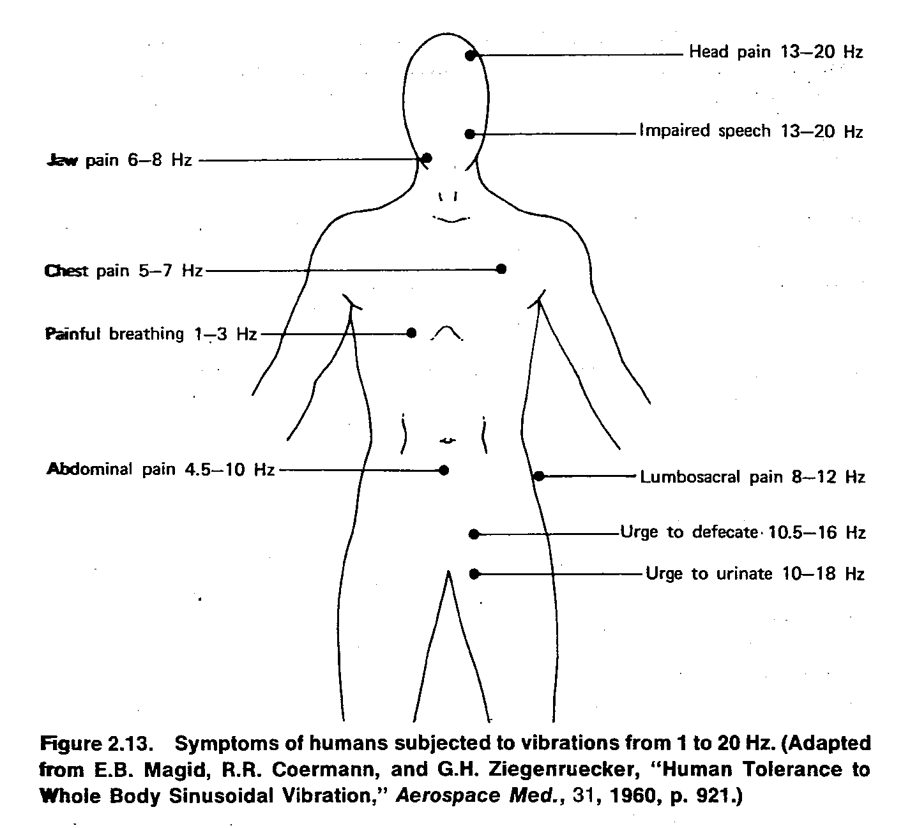

14/16
The centrifuge is a way to increase apparent weight. It speeds up the sedimentation rate. We can artificially increase the gravity (g) by spinning the fluid in a centrifuge.
Consider sedimentation of small spherical (radius a) objects of density ρ in a solution of density ρ_{o} in a gravitational field g.
Stokes has shown that the retarding force F_{d} =6πaην, where η is the viscosity(in Pas or poise) and ν is the terminal velocity.
When the particle is moving at a constant speed, F_{d} is in equilibrium with F_{g} –F_{B}, that is to say F_{g} - F_{B} =F_{d} . We have:
- The force of gravity F_{g} =$\frac{4}{3}πa^{3}$ρg (downward)
- The buoyant force F_{B} =$\frac{4}{3}$ π$a^{3 }ρ_{0}$g (upward)
- The retarding force F_{d} =6πaην
$\frac{4}{3}$ πa³ρg - $\frac{4}{3}$ πa³$ρ_{0}$g = 6πaην
$\frac{4}{3}$ ga² (ρ – ρ_{o}) = 6ην
ν = $\frac{2}{9}\frac{a^{2}}{η}$ g (ρ – ρ_{o}) is the terminal velocity (sedimentation velocity),
ν is proportional with a² g.

This equation can be used to determine the hematocrit (the percent of red blood cells in the blood). (g) can be increased by means of a centrifuge, thus provides:
g_{eff}(effective acceleration) = 4π²f²r,where f is the rotation rate and r is the position on the radius of the centrifuge.
- Standard method
time =30 min
f =3000 rpm
r=22 cm
normal hematocrit is 40 to 60
anemia ˂ normal
polycythemia vera ˃ normal
15/ 16
REVIEW QUESTIONS (CH. 2)
R.Q.6. The action of chewing involves a third-class lever system. Fig. A shows the jaw and chewing (Masseter) muscle; Fig. B is the lever diagram. M is the force supplied by the chewing muscles that close the jaw about the fulcrum F. W is the force exerted by the front teeth.

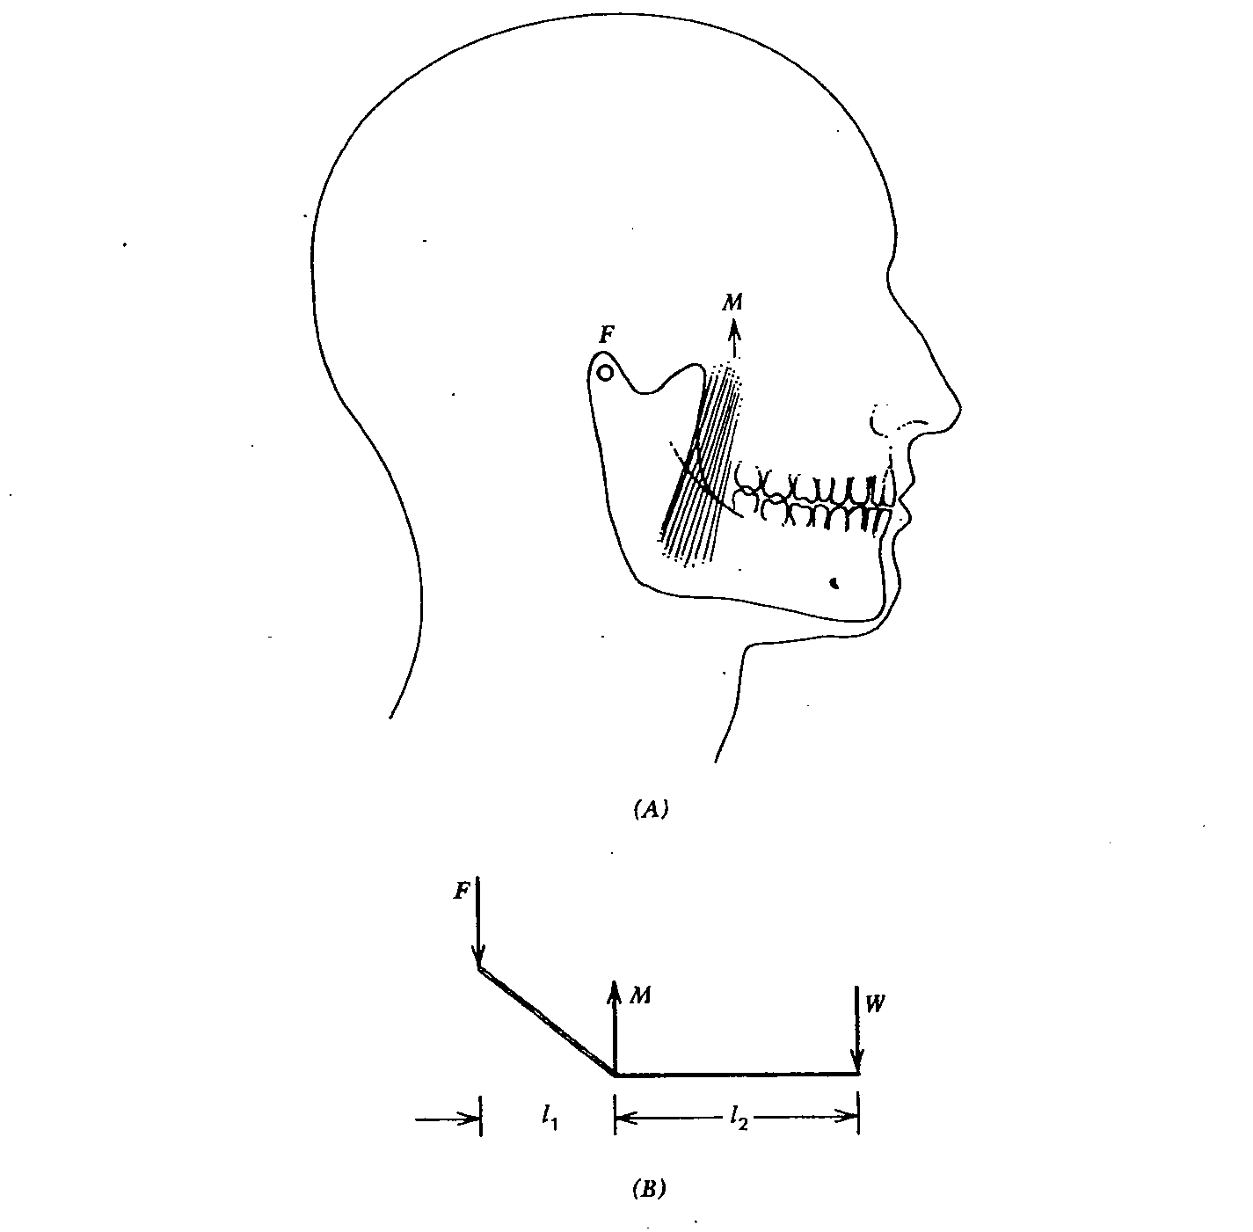

16/16
(a) If l₂ =3l₁ and W= 100N, find M.

(b) If the front teeth have a surface area of 0.5 cm²in contact with an apple, find the force per unit area (N/m²) for part (a).

- The sum of the torques about F = 0.
W (l₁ + l₂) = Ml₁
W (l₁ + 3l₁) =Ml₁
M = 4W = 400 N

- $\frac{100 N}{0.5* {10}^{-4} m^{2}}$ = 2* 10⁶ N/m²

R.Q.10. Find the effective acceleration (in terms of g) at a radius r=22 cm for a centrifuge rotating at 3000 rpm ( g = 9.8 m/sec²).

g _{eff} = 4 π²f²r = 4π²(3000/60)²(0.22) ≈ 21,700 m/sec² ≈ 2200 g where g , the acceleration of gravity, is 9.8 m/sec².

.

