Subject: Medical Physics (Lecture Notes) 1/8
Instructor: Dr. Mohamed Saleh Ahmed
CH. 3 Physics of the Skeleton
Dentistry and orthopedic surgery, are mainly devoted to this area. Rheumatologists, M.D, .s who specialize in problems of rheumatism and arthritis, radiologists, and others are interested in bones (about 200 bones).
Functions of bones:
- Support, 2- Locomotion, 3- Protection of various organs,4- Storage of chemicals, 5- Nourishment, and Sound transmission.
* Teeth (incisors, canines, and molars) serve in providing nourishment for the body. In man, they come in two sets- deciduous and permanent.
* The smallest (three) bones of the body are the ossicles in the middle ear. They are the only bones that attain full adult size before birth.
* Osteocytes (2% of the volume of bone) are cells (distributed through bones) that maintain the bone in a healthy condition.
* A serious hip problem is caused by a condition called Aseptic Necrosis in which the bone cells in the hip die due to lack of blood.
* A continuous process of destroying old bone and building new bone, called bone remodeling, (slow work), is performed by specialized bone cells. Osteoclasts destroy the bone (about 0.5g of Ca) and Osteoblasts build it (0.5g of Ca) each day. ( the bones have about 1000g of Ca ).
Osteoblasts do more than the osteoclasts, but after the body is 35 to 40 years old the activity of the osteoclasts is greater than that of osteoblasts.
The condition osteoporosis (especially in women), results in spontaneous fractures (especially in spine and hips).
3.1 What is bone made of?
X-rays show bones so well because of the large percentage of calcium Ca (atomic number 20) in bone.
Composition of compact bone, Femur (table 3.1) 2/8

H, C (15.5 %), N, O (44.0%), Mg, P (10.2%), S, Ca (22.2%), and Miscellaneous.
Bone consists of two quite different materials plus water:
- Collagen (organic) (produced by osteoblastic cells), 40% of the weight and 60% of its volume.
- Bone mineral (inorganic) (crystals of rod shaped with diameters of 20 to70Å and lengths of from 50 to 100Å) , made up of calcium hydroxyapatite Ca₁₀(PO₄)₆(OH)₂,60% of the weight and 40% of its volume. Because of the small size of the crystals, bone mineral has a very large surface area.
Note: Fluorine in drinking water may prevent caries, or cavities in the teeth, by turning microscopic areas of the teeth into the rock fluorapatite, which is more stable than bone mineral.
Note: A small quantity of radioactive fluorine (¹⁸ F) can be injected into a patient to identify bone tumors as they are not yet visible on an x-ray.
3.2 How strong are your bones
Shapes of bones:
- Small flat plate-like bones (shoulder blade (scapula), some of the bones of the skull).
- Long hollow bones (arms, legs, fingers).
- More or less cylindrical bones (vertebrae).
- Irregular (wrist, ankle).
- Do not belong to any of the above shapes (ribs).
Composition of bones: bones are composed of one or a combination of two quite different types of bones:
- Solid, or compact (in the central shaft).
- Spongy, cancellous, bone made up of thin thread like trabeculae-trabecular
bone (found in vertebra, ends of the bones). Notice the compression and tension lines appear in Fig. 3.6.

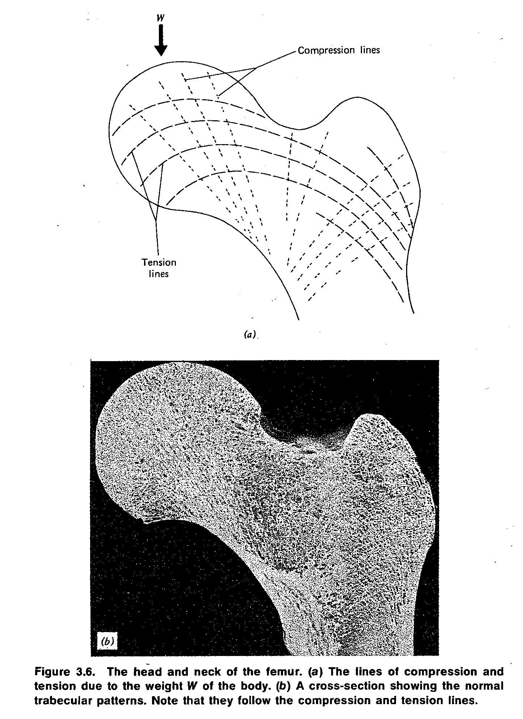

4/8

* Stress (force per unit area) in a bone can be analyzed the same way as stress in a beam in a building.

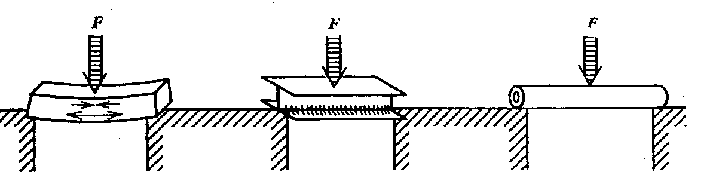

Rectangular beam T beam Hollow cylinder
Note: The hollow cylinder structure (thickest in the center and thinnest at the ends) of the femur (shaft) indicates the high quality of the design.
* Density of compact bone is constant throughout life at about 1.9 g/cm³.
What are the advantages of trabecular bone over compact bone?
1- Gives the strength necessary with less material than compact bone.
2- Can absorb some energy when large forces are involved (walking, running, and jumping). However, it cannot withstand very well the bending stresses that occur mostly in the central portions of long bones.
Stress – strain curve (see Fig. 3.7)

5/8

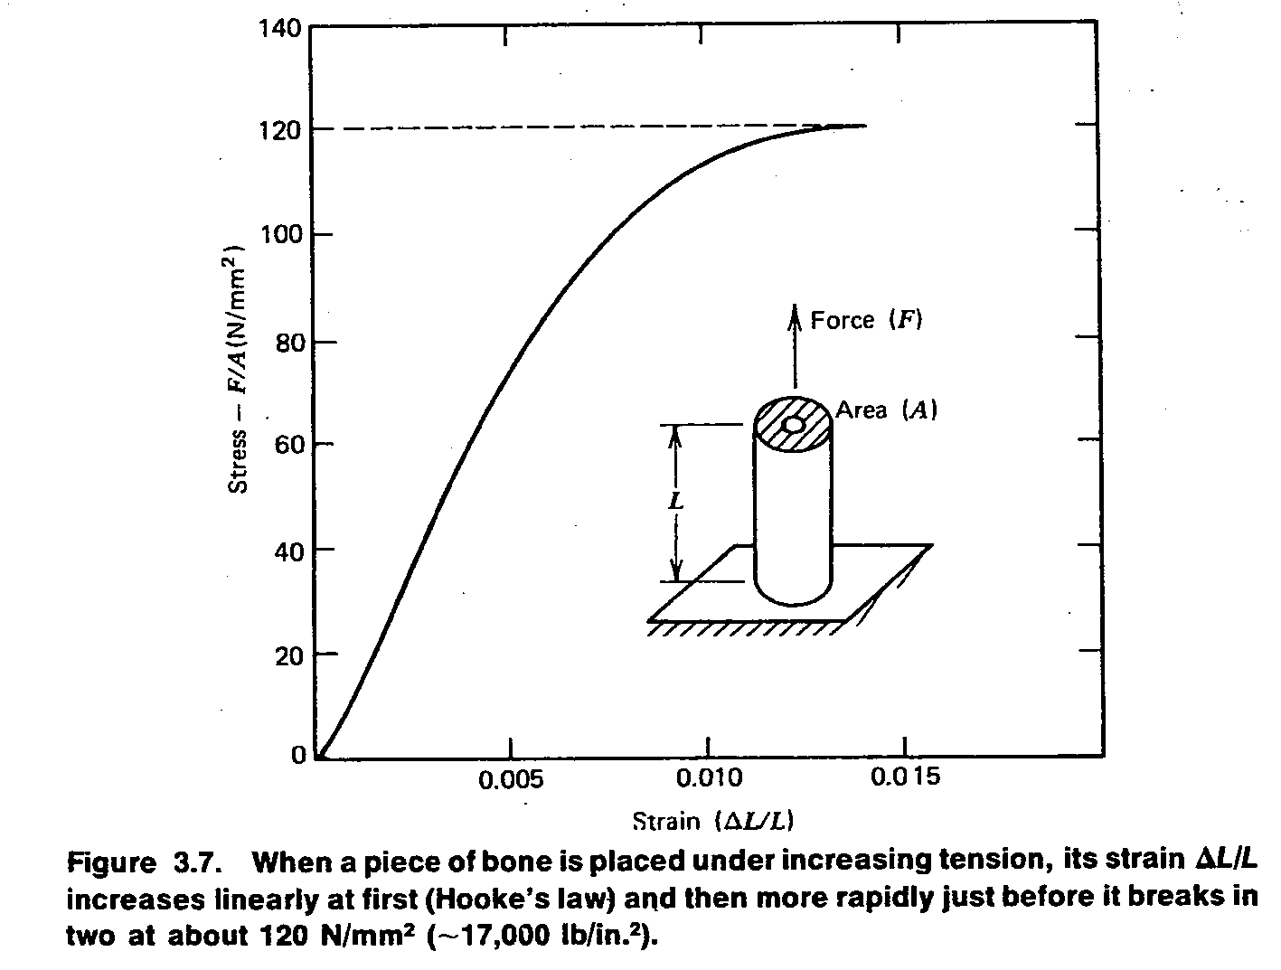

Hooke,s law: The strain ΔL/L is proportional to stress F/A .
Young s modulus (Y) = $\frac{stress}{strain}$ = $\frac{F/A}{∆L/L}$ =$\frac{LF}{A∆L}$ , ΔL= $\frac{LF}{AY}$ (for tension and compression)
6/8
Example 3.1: A leg of 1.2m in length and an average cross-sectional area of 3 cm².

Determine the amount of shortening when all of the body weight of 700N is supported on this leg.
ΔL =$\frac{LF}{AY}$ = $\frac{\left(1.2m\right)\left(7*{10}^{2 }\right)N}{\left(3*{10}^{-4 }m^{2 }\right)\left(1.8*{10}^{10 }\right)N/m^{2 } }$ =1.5 * 10⁻⁴ m = 0.15 mm.
* Healthy compact bone is able to withstand a compression stress about 170 N/mm² (~ 25,000 lb/in²).
* The bones are not as strong under tension as they are in compression; a tension stress of about 120N/mm² (~ 17,000 lb/in²) will cause a bone to break.
* To reduce the force and thereby reduce the likelihood of fracture, it is necessary to increase the impact time. (rolling with the impact)
* Viscoelasticity: the property that causes a bone breaking of applying a force over a longer period of time, while it can withstand the same force for a short period without breaking.
* When bone is bent it generates an electrical charge on its surface (piezoelectricity)-- may be the stimulus for bone growth and repair--.
3.3 Lubrication of bone joints
There are two major diseases that affect the joints:
- Rheumatoid arthritis (over production of synovial fluid).
- Osteoarthrosis (a disease of the joint itself).
* The lubricating properties of a fluid depend on its viscosity; thin oil is less viscous and a better lubricant than thick oil. The good lubricating properties of synovial fluid are thought to be due to the presence of hyaluronic acid and mucopolysaccharides (molecular weight, ~500,000) that deform under load.
The components of a joint are:
1- The synovial membrane (encases the joint and retains the lubricating synovial fluid).
7/8
2-Articular cartilage.
3-Synovial fluid.

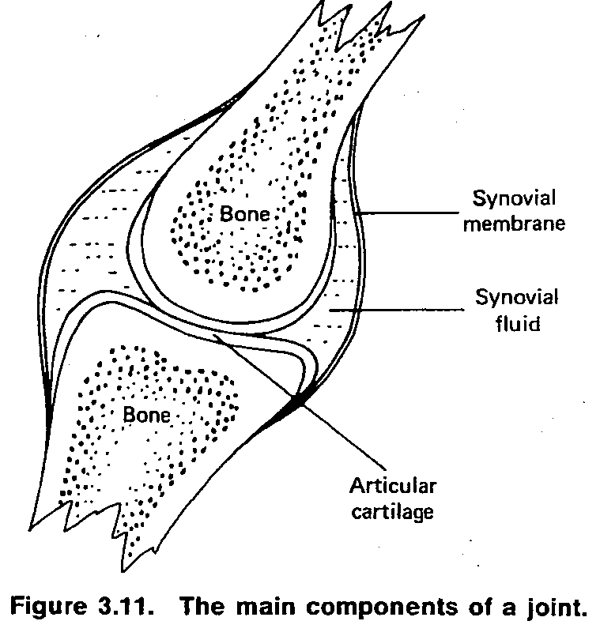

8/8

Determining the coefficient of friction of a joint
Experimental arrangement

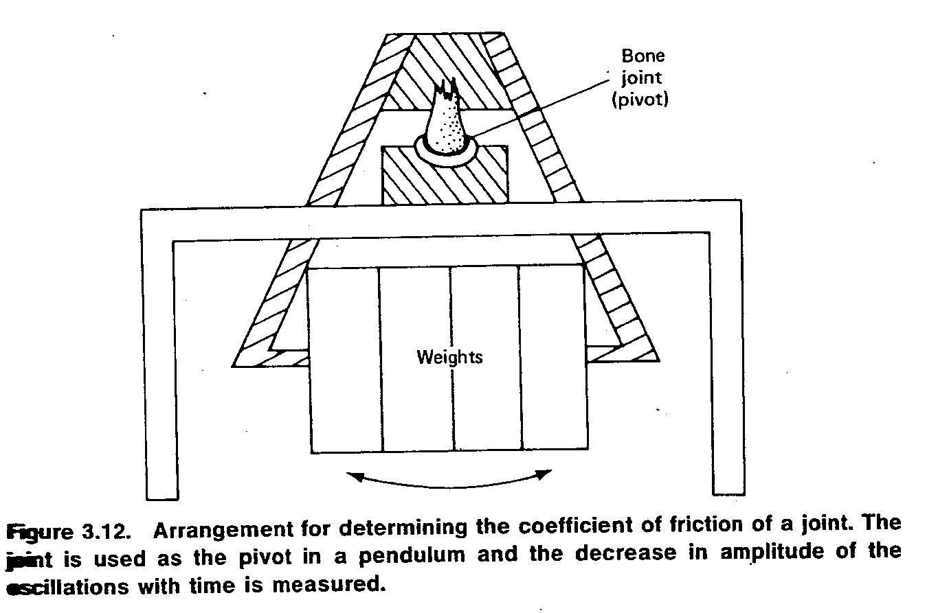

From the rate of decrease of the amplitude with time, the coefficient of friction is calculated. For healthy joints it was found to be less than 0.01, much less than that of a steel blade on ice---0.03.

