Subject: Medical Physics (Lecture Notes)1/5
Instructor: Dr. Mohamed Saleh Ahmed
CH.4
HEAT AND COLD IN MEDICINE
This chapter deals with elevated and reduced temperatures in medicine.
- Molecules moving means that they have kinetic energy, and this kinetic energy is related to the temperature.
- The energy transferred from flame to the gas causing the temperature rise is called heat.
- Heat can be removed from a substance to lower temperature. Low temperature are referred to as cryogenic region.
- The ultimate in cold is “absolute zero”. (-273.15ºC).
4.2. Thermometry and Temperature Scales.
Temperature is indirectly measured by relating a physical property to temperature by a suitable calibration.
- Fahrenheit ( ºF ) scale: water freezes at 32ºF and boils at 212ºF, and the normal body temperature (rectal) is about 98.6ºF(~100ºF).
- Celsius(ºC) scale (centigrade scale): water freezes at 0ºC and boils at 100ºC, and the normal body temperature (rectal) is about 37ºC.
- Kelvin(ºK ) scale (or absolute scale ): 0ºK (absolute zero) is -273.15 ºC. Water freezes at 273.15 ºK and boils at 373.15ºK, and the normal body temperature (rectal) is about 310ºK.(not used in medicine).
* ºFtoºC :ºC = (ºF – 32 )* 5/9 .
* ºC to ºF : ºF = ( ºC * 9/5) + 32 .
In glass fever thermometer (logarithmic scale), a temperature increase causes the alcohol or mercury to expand (1 cm³ Hg increases in volume by only 1.8% in going from 0 to 100ºC) more than the glass and thus produces an increase in the level of the liquid.

Two other devices are used in medicine: 2/5
- A thermistorwhich is a special resistor that changes its resistance rapidly with temperature (~ 5%/ºC).(can measure temperature changes of 0.01ºC).

A bridge circuit with a thermistor in one of the legs
- Initially the bridge is balanced when T =R₁=R₂=R₃. A temperature change causes the thermistor resistance to change. This unbalances the bridge.
- Pneumograph is (an instrument) a thermistor placed in the nose to monitor the breathing rate of patients by showing the temperature change between inspired cold air and expired warm air.
- A thermocouple: consists of two junctions of two different metals. If the two junctions are at different temperatures, a voltage is produced that depends on the temperature difference.

4-3 Thermography- mapping the body’s temperature.
Measurements of body surface temperature indicate the variation of temperature from point to point (due to external and internal factors). Asurface temperature map (thermogram) is obtained by measuring the radiation emitted from the body; the emitted radiation is in the far infrared (IR) invisible region; mainly at 12 µm.
Stefan-Boltzmann Law: (total radiative power per surface area W). 3/5
W = e σ T⁴
T is the absolute temperature,e is the emissivity (=1 for a human body),
σ is the Stefan-Boltzmann constant =5.7* 10⁻¹²W/cm^{2o}K⁴.
Example: Determine W radiated from skin at 306ºK. What is the power radiated from a nude body 1.75 m²( 1.75*10⁴cm²) in area.
- W =(5.7*10⁻¹²)(306)⁴ = 0.05 W/cm².
- W= (0.05)(1.75*10⁴cm²)= 875 W.
Note: (For the clothed body, the loss in W is considerably smaller than 140W).

A basic thermographic unit
Note: CRT displays the different body temperatures (for different positions) as different shades of gray; hot areas can be shown as either black or white. (0.2ºC difference and record a thermogram in 2 sec.).
- Thermography (screening technique) is used as an aid in detecting breast cancer. However, X-ray studies are much more reliable than other detection means for breast cancer. (detect over 80% of known cancers).
- It is used to study the circulation of blood in the head.
- Can help in reducing leg amputations in diabetics. (the presence of a hot spot on the foot can be determined before an ulcer forms).
4.5 Use of cold in medicine 4/5
Cryogenics is the science and technology of producing and using very low temperatures. The study of low- temperature effects in biology and medicine is called cryobiology. Examples of cryogenic fluids are liquid air (-196 ºC) and liquid helium(-269ºC). Dewar vessel(or Dewar flask) (a liquid-storage insulated container) is made of glass or thin stainless steel(minimize conduction losses) and has vacuum space(eliminating convective losses). The sides are silvered or polished to prevent heat absorption. A transfer line is constructed similar to the Dewar structure.
In medicine low temperatures have been used for long-term preservation of blood, sperm, bone marrow and tissues.
Cryonics is a science that aims to preserve at low temperature people with fatal diseases with the hope that in the future they could be revived and their diseases cured.
- Preservation is much better at(-196ºC liquid nitrogen) than at (-79ºC solid carbon dioxide).
- Freeze- thaw cycle; there is no unique cooling rate that will ensure survival for al materials (limitation on preserving biomaterials composed of many different cell types (e.g. marrow and red blood cells).
- The optimum cooling rate for preserving red blood cells is 2*10^{3o}C/min (Fig.4.12).
- Two techniques are used for storing blood much longer time.
- Using thin –walled container (after the container is filled with blood it is quickly inserted into liquid N₂ (-196 ºC).
- “blood-sand” method; blood is sprayed onto a liquid N₂ surface and freezes into small droplets.
4-4 .Cryosurgery
Cryogenic methods are used to destroy cells; this application is called cryosurgery.
Advantages of cryosurgery:
- Little bleeding.
- Controlling the volume of tissue destroyed.
- Little pain sensation. 5/5
Cooper cryosurgery system (see Fig. 4-14)
Cooper treats Parkinson,s disease (“shaking palsy”) (a disease associated with basal ganglion of the brain by destructively freezing the appropriate region in the thalamus using “ cryoknife”. (tip of the probe is cooled to (-10ºC) for temporary freezing of the regions (recovered less than 30 sec). The region is then destroyed by freezing for several minutes at ~ - 85ºC. After that the tip is warmed and removed.
Eye Surgery
- The repair of a detached retina (detached from the wall of the eyeball) using a cold tip to “weld” the retina to the wall.
- Cryosurgical extraction (cataract surgery) of a darkened lens.

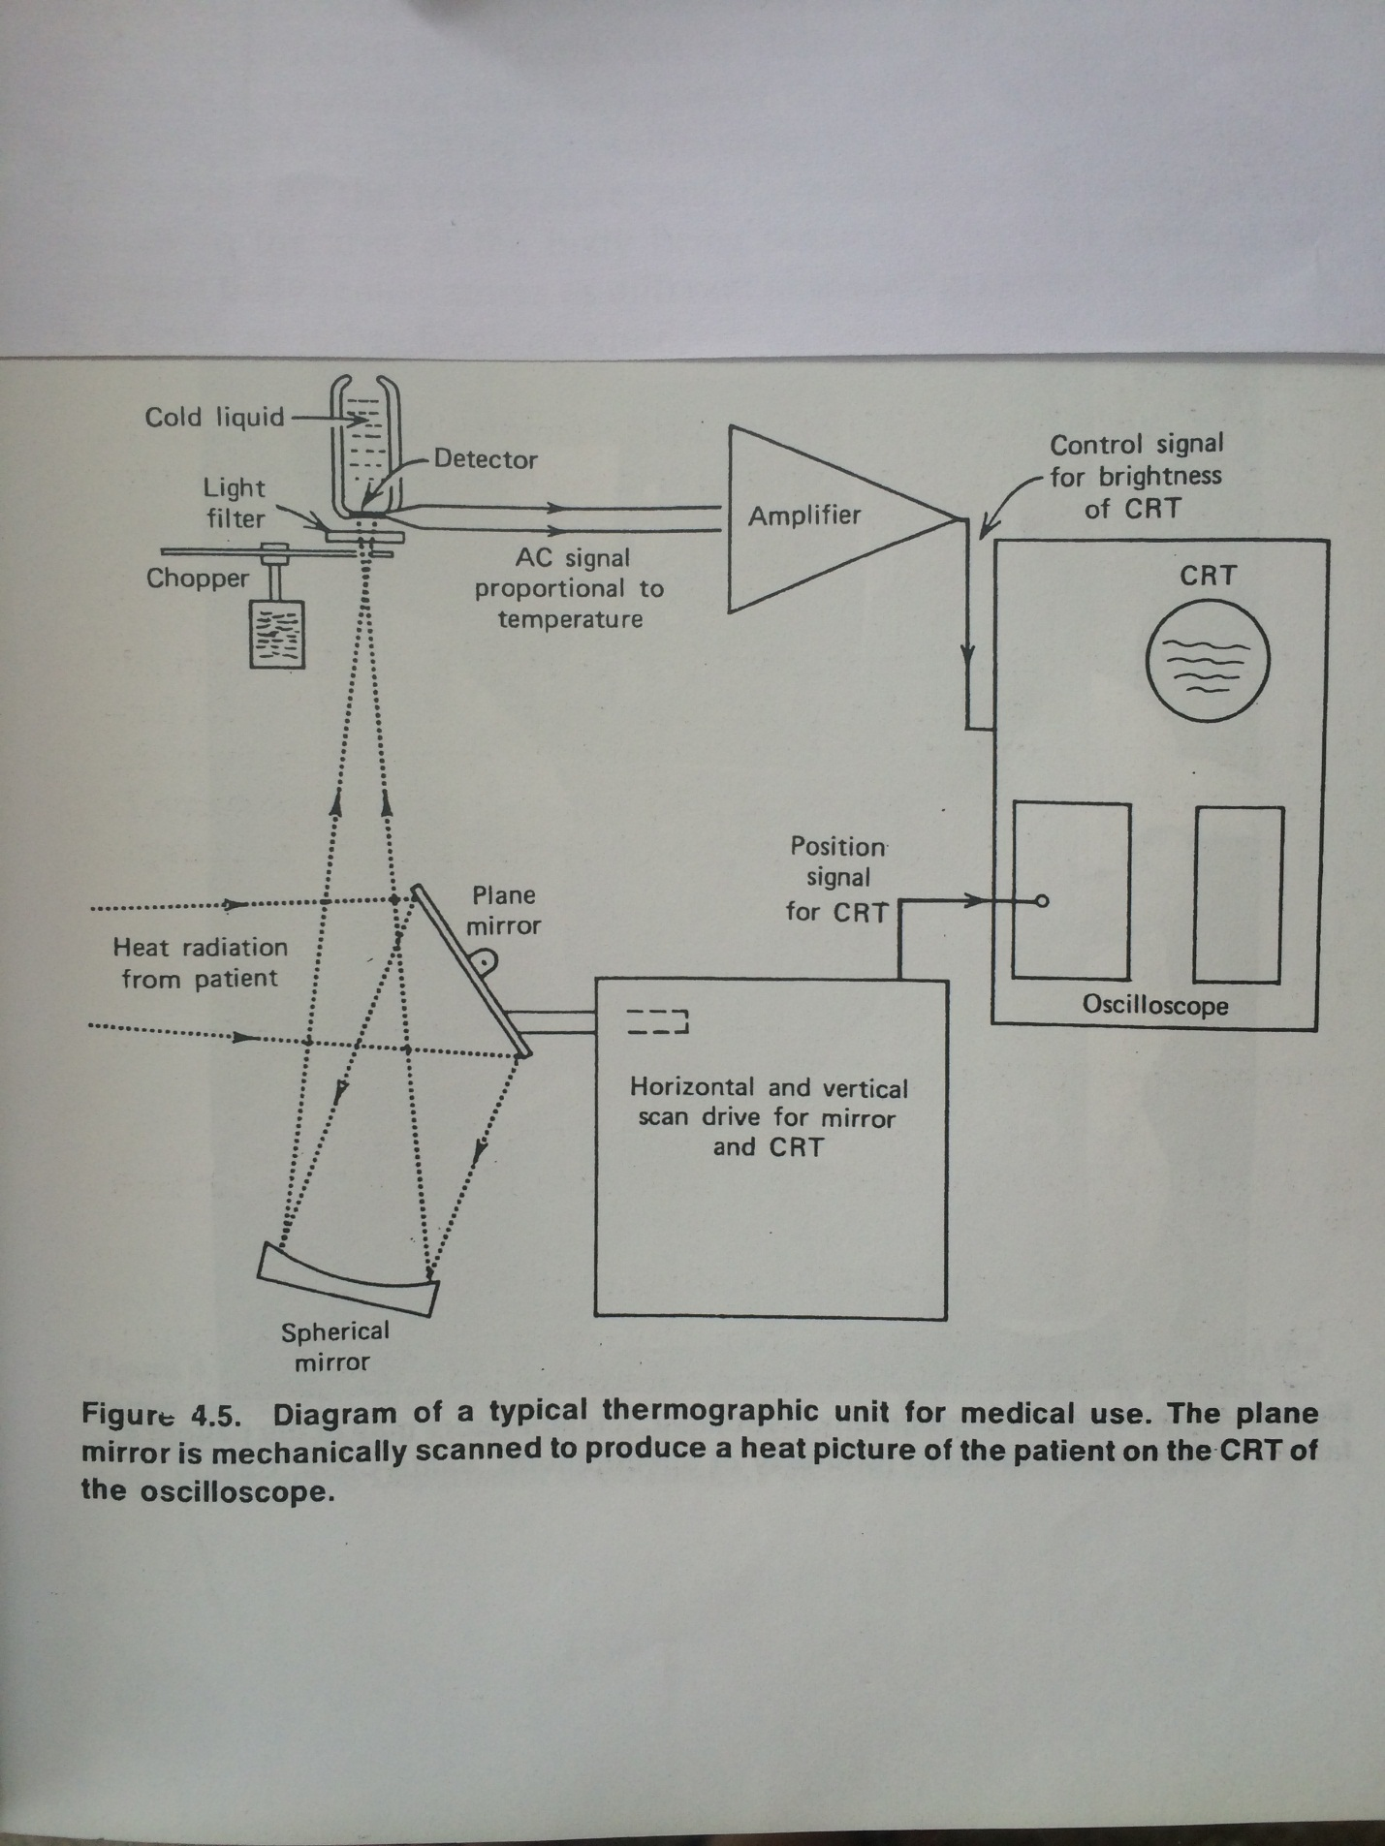
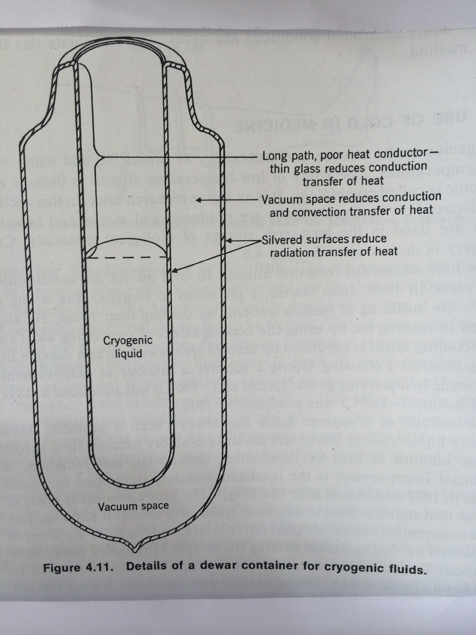
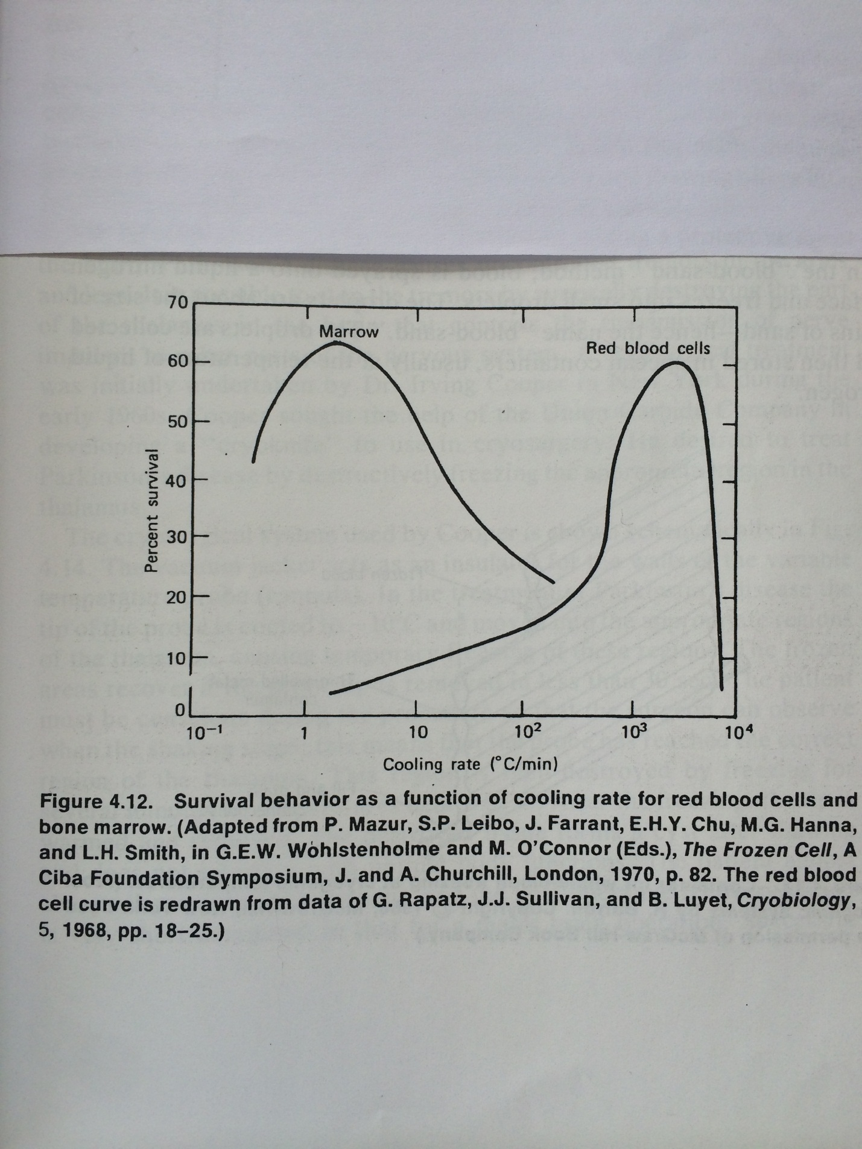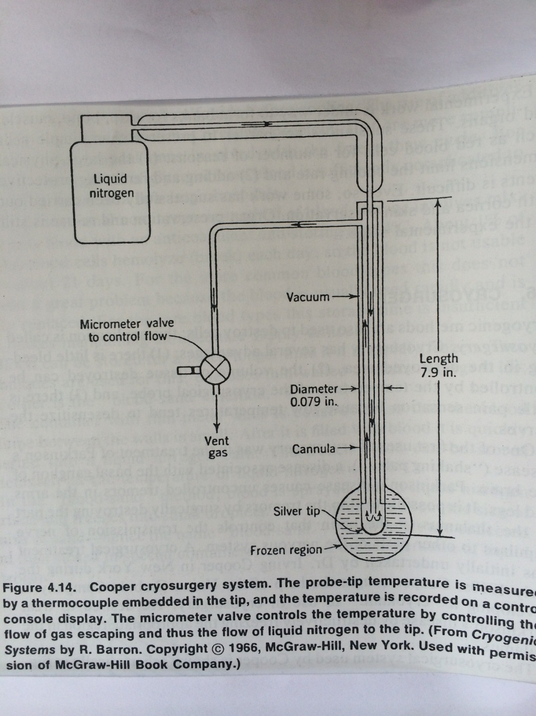

Review Questions

4-3 Consider a fever thermometer that contains 0.01 cm³of mercury. Find the diameter of the capillary if a 1ºC change corresponds to a level change of 0.5 cm. Assume the glass does not expand.
Sol: A 100ºC change gives a 1.8% in volume. A 1ºC change gives a 1.8*10⁻⁴ fractional change in volume or a change of mercury volume of (1.8*10⁻⁴)(10⁻²)= 1.8*10⁻⁶cm³.
Thus,
(πd²/4)(0.5) = 1.8*10⁻⁶cm³
d² = (14.4/π)*10⁻⁶
d =2.14*10⁻³cm = 2.14*10⁻²mm

4-10 (a) What is the optimum cooling rate for preserving red blood cells?
(b) At the optimum rate, how long would it take to cool red blood cells
from37 to – 196ºC?

Sol: (a) 2*10^{3 o}C/min
(b) (2*10^{3 o}C/min)(t) = (196 + 37) = 233ºC
t = (2.33*10²)/(2*10³) = 0.116 min $≅$ 7 sec

