College of Pharmacy
Fourth year. Clinical Pharmacy
Cardiovascular disorders
Hypertension

Introduction
1-Hypertension is defined as persistently elevated arterial blood pressure (BP). (See Table -1 for the classification of BP in adults).

Table-1: Classification of Blood Pressure in Adults

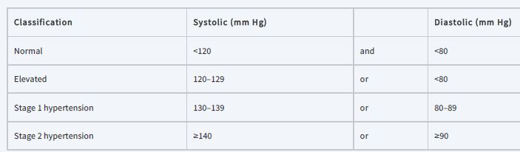

2-Isolated systolic hypertension is diastolic blood pressure (DBP) <80 mm Hg and systolic blood pressure (SBP) ≥130 mm Hg.

3-Hypertensive crisis (BP >180/120 mm Hg) is categorized as hypertensive emergency (extreme BP elevation with acute or progressing end-organ damage) or hypertensive urgency (extreme BP elevation without acute or progressing end-organ injury).

Pathophysiology
1-Hypertension may result from an unknown etiology (primary or essential hypertension) or from a specific cause (secondary hypertension).

2-Secondary hypertension (<10% of cases) is usually caused by chronic kidney disease (CKD) or renovascular disease.

3-Examples of drugs that may increase BP include corticosteroids, estrogens, NSAIDs, cyclosporine, erythropoietin, and venlafaxine.

4-Major causes of death include cerebrovascular events, cardiovascular (CV) events, and renal failure.

Clinical presentation
1-Patients with uncomplicated primary hypertension are usually asymptomatic initially.

2-Patients with secondary hypertension may have symptoms of the underlying disorder.

Diagnosis
1-Elevated BP may be the only sign of primary hypertension on physical examination.

2-Diagnosis should be based on the average of two or more readings taken at each of two or more clinical encounters.

3-Signs of end-organ damage occur primarily in the eyes, brain, heart, kidneys, and peripheral vasculature.

Treatment
1-Goals of Treatment: The overall goal is to reduce morbidity and mortality from CV events. The 2017 ACC/AHA guideline recommends a goal BP of <130/80 mm Hg for most patients.

2-For institutionalized older patients and those with a high disease burden or limited life expectancy, consider a relaxed SBP goal of <150 mm Hg (or <140 mm Hg if tolerated).

Nonpharmacologic Therapy
A-Implement lifestyle modifications in all patients with elevated BP or stage 1 or 2 hypertension.

B-Lifestyle modifications shown to lower BP include:
(1) weight loss if overweight or obese, (2) the Dietary Approaches to Stop Hypertension (DASH) eating plan, (3) reduced salt intake, ideally to 1.5 g/day sodium (3.8 g/day sodium chloride), (4) physical activity (90–150 min/week of aerobic or dynamic resistance training), and (5) moderation of alcohol intake. Although smoking cessation does not control BP, it reduces CV disease risk and should be encouraged.

Pharmacologic Therapy

General Approach to Treatment
1-Initial drug selection depends on the degree of BP elevation and presence of compelling indications for certain drugs.

2-Use a single first-line drug as initial therapy in most patients with newly diagnosed stage 1 hypertension.

3-Start combination drug therapy (preferably with two first-line drugs) as the initial regimen in patients with newly diagnosed stage 2 hypertension.

4-The four first-line options are angiotensin-converting enzyme (ACE) inhibitors, angiotensin II receptor blockers (ARBs), calcium channel blockers (CCBs), and thiazide diuretics.

5-β-Blockers should be reserved to treat a specific compelling indication or in combination with a first-line antihypertensive agent for patients without a compelling indication.

6-Other antihypertensive drug classes (α1-blockers, direct renin inhibitors, central α2-agonists, and direct arterial vasodilators) may be used for select patients after implementing first-line agents.

Compelling Indications
Compelling indications are specific comorbid conditions for which clinical trial data support using specific antihypertensive drug classes to treat both hypertension and the compelling indication.

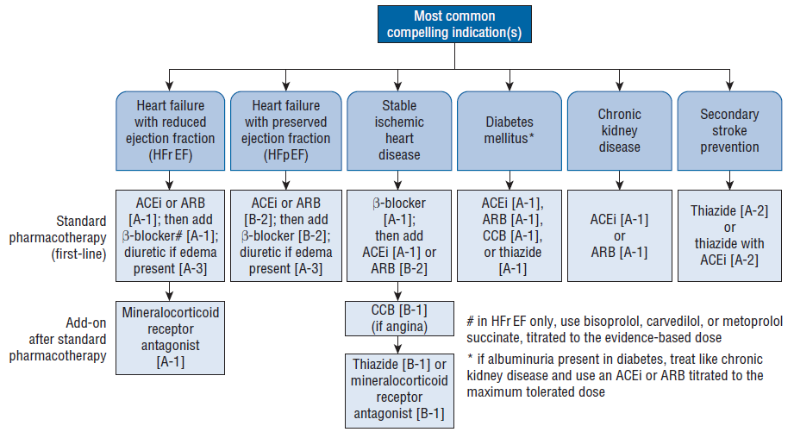

Notes:

1-β-Blockers (without ISA) are first-line therapy in Stable Ischemic Heart Disease (SIHD).

2-For acute coronary syndromes, first-line therapy includes a β-blocker and ACE inhibitor (or ARB).

3-Any first-line agent can be used to control hypertension in patients with diabetes in the absence of albuminuria.

4-In addition to lowering BP, ACE inhibitors and ARBs reduce intraglomerular pressure, which may further slow chronic kidney disease progression.

5-The threshold for starting antihypertensive drug therapy in patients with a history of stroke is when BP is >140/90 mm Hg (goal of <130/80 mm Hg).

Angiotensin-Converting Enzyme Inhibitors (captopril, enalapril, fosinopril, imidapril, lisinopril, perindopril, quinapril, ramipril, and trandolapril)

1-ACE inhibitors block conversion of angiotensin I to angiotensin II, a potent vasoconstrictor and stimulator of aldosterone secretion.

2-Starting doses should be low with slow dose titration. Acute hypotension may occur at the onset of therapy.

3-ACE inhibitors decrease aldosterone and can increase serum potassium concentrations. Hyperkalemia occurs primarily in patients with CKD or those also taking potassium supplements, potassium-sparing diuretics, mineralocorticoid receptor antagonists, ARBs, or direct renin inhibitors.

4-AKI is an uncommon but serious side effect; preexisting kidney disease increases risk. Bilateral renal artery stenosis or unilateral stenosis are particularly susceptible to AKI.

5-Serum creatinine concentrations often increase, but modest elevations (eg, absolute increases <1 mg/dL) do not warrant treatment changes. Discontinue therapy or reduce dose if larger increases occur.

6-Angioedema occurs in <1% of patients. Drug withdrawal is necessary, and some patients may require drug treatment and/or emergent intubation to support respiration.

7-An ARB can generally be used in patients with a history of ACE inhibitor-induced angioedema, with careful monitoring.

8-A persistent dry cough occurs in up to 20% of patients and is thought to be due to inhibition of bradykinin breakdown.

9-ACE inhibitors (as well as ARBs and direct renin inhibitors) are contraindicated in pregnancy.

Angiotensin II Receptor Blockers (candesartan, eprosartan, irbesartan, losartan, olmesartan, telmisartan, and valsartan)

1-The ARBs directly block the angiotensin II type 1 receptor that mediates the effects of angiotensin II.

2-Unlike ACE inhibitors, ARBs do not block bradykinin breakdown and this accounts for the lack of cough as a side effect.

3-ARBs have a low incidence of side effects. Like ACE inhibitors, they may cause renal insufficiency, hyperkalemia, and orthostatic hypotension.

Calcium Channel Blockers
1-Dihydropyridine and nondihydropyridine CCBs are first-line antihypertensive therapies and are also used in addition to or instead of other first-line agents for the compelling indication of ischemic heart disease.

2-Dihydropyridine CCBs may cause reflex sympathetic activation, and all agents (except amlodipine and felodipine) may have negative inotropic effects.

3-Verapamil produces a negative inotropic effect that may precipitate HF in patients with borderline cardiac reserve. Diltiazem decreases heart rate to a lesser extent than verapamil.

4-Both diltiazem and verapamil can cause peripheral edema and hypotension. Verapamil causes constipation in about 7% of patients.

5-Dihydropyridines cause a baroreceptor-mediated reflex increase in heart rate because of potent peripheral vasodilating effects. Other side effects of dihydropyridines are dizziness, flushing, headache, gingival hyperplasia, and peripheral edema.

Diuretics
1-Thiazides are the preferred type of diuretic and are a first-line option for most patients with hypertension. Chlorthalidone (thiazide-like) is preferred over hydrochlorothiazide, especially in resistant hypertension, because it is more potent on a milligram-per-milligram basis.

2-Loop diuretics (Furosemide, Bumetanide and Torasemide) are more potent for inducing diuresis but are not ideal antihypertensives unless edema treatment is also needed. Loop diuretics are sometimes required over thiazides in patients with severe CKD when eGFR is <30 mL/min/1.73 m², especially when edema is present.

3-Potassium-sparing diuretics are weak antihypertensives when used alone. Their primary use is in combination with another diuretic to counteract potassium-wasting properties.

4-Mineralocorticoid receptor antagonists (spironolactone and eplerenone) are also potassium-sparing diuretics that are usually used to treat resistant hypertension because elevated aldosterone concentrations are prevalent in this setting. They are also used as add-on agents in patients with HFrEF with or without concomitant hypertension.

5-Acutely, diuretics lower BP by causing diuresis. With chronic therapy, reduced peripheral vascular resistance is responsible for persistent hypotensive effects.

6-Side effects of thiazides include hypokalemia, hypomagnesemia, hypercalcemia, hyperuricemia, hyperglycemia, dyslipidemia, and sexual dysfunction.

7-Loop diuretics have less effect on serum lipids and glucose, but hypokalemia is more pronounced, and hypocalcemia may occur.

8-Hypokalemia and hypomagnesemia may cause muscle fatigue or cramps, and severe electrolyte abnormalities may result in serious cardiac arrhythmias.

9-Potassium-sparing diuretics may cause hyperkalemia, especially in patients with CKD or diabetes and in patients receiving concurrent treatment with a mineralocorticoid receptor antagonist, ACE inhibitor, ARB, direct renin inhibitor, or potassium supplement.

10-Spironolactone may cause gynecomastia in up to 10% of patients; this effect occurs rarely with eplerenone.

β-Blockers
1-Evidence suggests that β-blockers may not reduce CV events as well as ACE inhibitors, ARBs, CCBs, or thiazides when used as the initial drug in patients who do not have a compelling indication for a β-blocker.

2-β-Blockers are appropriate first-line agents when used to treat specific compelling indications or when an ACE inhibitor, ARB, CCB, or thiazide cannot be used.

3-Atenolol, betaxolol, bisoprolol, metoprolol, and nebivolol are β1-cardioselective at low dose. As a result, they are less likely to provoke bronchospasm and vasoconstriction and are safer than nonselective β-blockers in patients with asthma or diabetes. Cardioselectivity is a dose-dependent phenomenon, and the effect is lost at higher doses.

4-Acebutolol, carteolol, and pindolol possess intrinsic sympathomimetic activity (ISA) or partial β-receptor agonist activity. Theoretically, these drugs may have advantages in select patients with HF or sinus bradycardia. Unfortunately, they do not reduce CV events as well as other β-blockers and may increase CV risk in patients with SIHD. Thus, agents with ISA are rarely needed and have no role in hypertension management.

5-Atenolol and nadolol have relatively long half-lives and are excreted renally; the dosage may need to be reduced in patients with renal insufficiency.

6-Even though the half-lives of other β-blockers are shorter, once-daily administration still may be effective.

7-Cardiac side effects include bradycardia, AV conduction abnormalities, and acute HF. Blocking β2-receptors in arteriolar smooth muscle may cause cold extremities and aggravate intermittent claudication or Raynaud phenomenon because of decreased peripheral blood flow.

8-Increases in serum lipids and glucose appear to be transient and of little clinical significance.

9-Abrupt cessation of β-blockers should be avoided. The dose should always be tapered gradually over 1–2 weeks before discontinuation.

α1-Receptor Blockers
1-Prazosin, terazosin, and doxazosin are selective α1-receptor blockers that inhibit catecholamine uptake in smooth muscle cells of peripheral vasculature, resulting in vasodilation and BP lowering.

2-Although they can provide symptomatic benefit in men with benign prostatic hyperplasia, they should be used to lower BP only in combination with first-line antihypertensive agents.

Direct Renin Inhibitor
Aliskiren blocks the RAAS at its point of activation, resulting in reduced plasma renin activity and BP. It is approved for monotherapy or in combination therapy. Its role in the management of hypertension is limited.

Central α2-Agonists
1-Clonidine, guanfacine, and methyldopa lower BP primarily by stimulating α2-adrenergic receptors in the brain, which reduces sympathetic outflow from the vasomotor center.

2-Clonidine is often used in resistant hypertension, and methyldopa is frequently used for pregnancy-induced hypertension.

Direct Arterial Vasodilators
Hydralazine and minoxidil directly relax arteriolar smooth muscle, resulting in vasodilation and BP lowering.

Special Populations

Older Persons
1-Older patients may present with either isolated systolic hypertension or elevation in both SBP and DBP. CV morbidity and mortality are more directly correlated to SBP than to DBP in patients aged 50 and older.

2-First-line antihypertensives provide significant benefits and can be used safely in older patients, but smaller-than-usual initial doses must be used for initial therapy.

Children and Adolescents
1-Because secondary hypertension is more common in children and adolescents than in adults, an appropriate workup is required if elevated BP is identified.

2-Nonpharmacologic treatment is the cornerstone of therapy for primary hypertension.

3-ACE inhibitors, ARBs, β-blockers, CCBs, and thiazide diuretics are all acceptable drug therapy choices.

Pregnancy
1-Preeclampsia (Further reading 1) can lead to life-threatening complications for both mother and fetus.

2-Eclampsia is the onset of convulsions in preeclampsia and is a medical emergency.

3-Definitive treatment of preeclampsia is delivery, and labor induction is indicated if eclampsia is imminent or present. Otherwise, management consists of restricting activity, bed rest, and close monitoring. Salt restriction or other measures that contract blood volume should be avoided.

4-Antihypertensives are used before induction of labor if DBP is >105 mm Hg, with a target DBP of 95–105 mm Hg. Intravenous (IV) hydralazine is most commonly used; IV labetalol is also effective.

5-Chronic hypertension is hypertension that predates pregnancy. Labetalol, long-acting nifedipine, or methyldopa is recommended as first-line therapy due to favorable safety profiles. β-Blockers (except atenolol) and CCBs are also reasonable alternatives.

Black Patients
CCBs and thiazides are most effective in African Americans and should be first-line in the absence of a compelling indication.

Pulmonary Disease and Peripheral Arterial Disease (PAD)
1-Although β-blockers (especially nonselective agents) have generally been avoided in hypertensive patients with asthma and COPD because of fear of inducing bronchospasm, cardioselective β-blockers can be used safely.

2-β-Blockers can theoretically be problematic in patients with PAD because of possible decreased peripheral blood flow secondary to unopposed stimulation of α1-receptors that results in vasoconstriction. However, available data indicate that β-blockers do not worsen claudication symptoms or cause functional impairment. Therefore, antihypertensive treatment for patients with PAD should follow the same general principles as patients without PAD.

Hypertensive Urgencies and Emergencies
1-Acute administration of a short-acting oral drug (captopril, clonidine, or labetalol) is an option.

2-Hypertensive emergencies require immediate BP reduction with a parenteral agent to limit new or progressing end-organ damage.

Evaluation of therapeutic outcomes
1-Evaluate BP response in the clinic 4 weeks after initiating or making changes in therapy and compare the results to home BP readings.

2-Once goal BP is obtained, monitor BP every 3–6 months, assuming no signs or symptoms of acute end-organ damage.

3-Assess patient adherence with the regimen regularly.

Reference
Joseph T. DiPiro, Robert L. Pharmacotherapy: A Pathophysiologic Approach, 12th Edition. 2023.

Further reading

1-Preeclampsia is defined as hypertension (elevated BP ≥140/90 mm Hg on more than two occasions at least 4 hours apart after 20 weeks’ gestation or ≥160/110 mm Hg confirmed within a short interval) and either proteinuria or new onset hypertension with the onset of thrombocytopenia, impaired liver function, new onset renal insufficiency, pulmonary edema, or new onset cerebral or visual disturbances.

