Subject: Medical Physics (Lecture Notes)1/9
Instructor: Dr. Mohamed Saleh Ahmed
CH. 6 Pressure
Pressure (P) is defined as the force per unit area in a gasor liquid. For example, the atmospheric pressure (1 atm) is about 10⁵ N/m² (14.7lb/in.²). For a solidthe quantity force per unit area is referred to as stress.
# Inphysics and engineering the pressure is measured in dynes per square centimeter (dyne/cm²) or newton per square meter (N/m²); the SI unit for the latter is the pascal (Pa).
# In medicine the pressure is indicating by the height of a column of a mercury (Hg). For example, a peak (systolic) blood pressure reading 120 mm Hg. Atmospheric pressure is about 30 in. Hg or 760mm Hg.
Table 6.1. shows some of the common units used to measure pressure
Atmospheres N/m² cm H₂O mm Hg lb/in.²(psi)
1 atmosphere 1 1.01*10⁵ 1033 760 14.7
1 N/m² 0.987*10⁻⁵ 1 0.0102 0.0075 0.145*10⁻³
1 cm H₂O 9.68*10⁻⁴ 98.1 1 0.735 0.014
1 mm Hg 0.00132 133 1.36 1 0.0193
1 lb/in.²(psi) 0.0680 6895 70.3 51.7 1
The pressure P under a column of liquid can be calculated from
P= ρgh
Where ρ is the density, (for Hg ρ=13.6 g/cm³), (for H₂O ρ=1 g/cm³), h_{water}=13.6 h_{Hg}
g is the acceleration due to gravity, and
h isthe height of the column.

2/9
Example:What height of water will produce the same pressure as 120 mm Hg?
For mercury P(120 mm Hg) = ρgh = (13.6 g/cm³)(980 cm/sec²)(12cm)
= 1.6*10⁵ dynes/cm²
For water1.6*10⁵=(1 g/cm³)(980 cm/sec²)(h cm H₂O)
h = 163 cm H₂O
Orh_{(water)} = 13.6 h_{(mercury)}
=13.6*12cm = 163 cm H₂O
# True or absolute pressure equals the gauge pressure plus the atmospheric pressure.
Ex. If the pressure in a bicycle tire is 60lb/in.² the absolute pressure equals 60+14.7 $≅$ 75 lb/in.², where 60ib/in.² is the gauge pressure.
# Negative pressure is a pressure which is lower than atmospheric.
There are a number of places in the body where the pressures are negative.
Examples: 1- The lung pressure during breathing (inspiration) is typically a few centimeters of water negative. 2- When drinking through a straw the pressure in the mouth must be negative by an amount equal to the height of the mouth above the level of the liquid we are drinking.
# Pressure in the circulatory system; The heart acts as a pump, producing quite high pressure (~ 100 to 140 mm Hg) to force the blood through the arteries. The returning venous blood is at quite low pressure and, in fact, needs help to get from the legs to the heart. The failure of this return system in the legs often results in varicose veins.

3/9
Table 6.2. shows typical pressures in the body
Typical Pressure
(mm Hg)
Arterial blood pressure
Maximum(systole) 100-140
Minimum (diastole) 60-90
Venous blood pressure 3-7
Great veins $<1$
Capillary blood pressure
Arterial end 30
Venous end 10
Middle ear pressure $<1$
Eye pressure-aqueous humor 20
Cerebrospinal fluid pressure in brain (lying down) 5-12
Gastrointestinal pressure 10-20
Intrathoracic pressure (between lung and chest wall) - 10

6.1. Measurement of Pressure in the Body
# Theclassical method of measuring pressure is to determine the height of a column of liquid that produces a pressure equal to the pressure being measured. An instrument that measures pressure by this method is called a manometer.
# A common type of manometer is U-shaped tube containing a fluid (could be a mercury or water) that is connected to the pressure to be measured. This type can measure both positive and negative pressures. See the figure below.

4/9
# Themost common clinical instrument used in measuring blood pressure is the sphygmomanometer.
Two types of pressure gauges are used in sphygmomanometers.
- A mercury type, in which the pressure is indicated by the height of a column of mercury inside a glass tube.
- An aneroid type, in which the pressure changes the shape of a sealed flexible container, which causes a needle to move on a dial.
# Note that some parts of the body can act like crude pressure indicators.
Examples are:
a- A person going up or down in an elevator or an airplane is often aware of the change in atmospheric pressure on the ears.
b- As a hand is raised slightly above the level of the heart the veins on the back of the hand become smaller in the size due to the lower venous blood pressure.
6.2. Pressure inside the Skull
The brain contains approximately 150 cm³ of cerebrospinal fluid (CSF) in a series of interconnected openings called ventricles. Cerebrospinal fluid is generated inside the brain and flows through the ventricles into the spinal column and eventually into circulatory system. One of the ventricles, the aqueduct, is especially narrow. If at birth this opening is blocked for any reason, the CSF is trapped inside the skull and increases the internal pressure. The increased pressure causes the skull to enlarge. This serious condition, called hydrocephalus
(literally, water- head), is a moderately common problem in infants. However, if the condition is detected soon enough, it can often be corrected by surgically installing a by-pass drainage system for the CSF.
- Two qualitative (crude) methods of detecting hydrocephalus are:
- By measuring the circumference of the skull just above the ear; normal values from 32 to 37 cm, larger may indicate hydrocephalus.
- -By transillumination (is the transmission of light through the tissues of the body). It is used clinically (using Chun gun transilluminator) in the

5/9
detection of hydrocephalus in infants. Since the skull of young infants is not fully calcified, light is able to penetrate to the inside of the skull; if there is an excess of relatively clear cerebrospinal fluid (CSF) in the skull, light is scattered to different parts of the skull producing patterns characteristic of hydrocephalus.
6.3. Eye pressure
The aqueous and vitreous humors (the clear fluids in the eyeball that transmit light to the retina; the light- sensitive part of the eye), are under pressure and maintain the eyeball in a fixed size and shape.
# Theaqueous humor(maintains the internal pressure of the eye at about 20 mmHg) fills the space between the lens and the cornea. This fluid, mostly water, is continuously being produced, and the surplus escapes through a drain tube, the canal of Schlemm. Blockage of the drain tube results in increased pressure in the eye; this condition is called glaucoma. It affects the vision; produces tunnel vision in moderate cases and blindness in severe cases.
# Thevitreous humor is a clear jelly-like substance that fills the large space between the lens and the retina. It helps keep the shape of the eye fixed and is essentially permanent. It sometimes called the vitreous body.
# The dimensions of the eye are critical to good vision; a change of only 0.1 mm in its diameter has a significant effect on the clarity of vision.
# Pressure in the eye is measured with several different instruments, called tonometers, that measure the amount of indentation produced by a known force. The pressure in normal eyes ranges from 12 to 23 mm Hg.
6.5. Pressure in the skeleton
# The highest pressures in the body are found in the weight-bearing bone joints. When all the weight is on one leg, such as when walking, the pressure in the knee joint may be more than 10 atm! If it were not for the relatively large area of the joints, the pressure would be even higher. The surface area of a bone at the joint is greater than its area either above or below the joint. The larger area at the jointdistributes the force, thus reducing the pressure, since the pressure (P) =F/A.
6/9
When the system of healthy bone joints is under high pressure, better joint lubrication can be found.
# The finger bone has adapted in another way to reduce pressure. The finger bones are flat rather than cylindrical on the gripping side, and the force is spread over a large surface; this reduces the pressure on the tissues over the bones when we carry something heavy like a suitcase.
6.6. Pressure in the urinary bladder
One of the most noticeable internal pressures is the pressure in the bladder due to accumulation of urine. The figure below shows the typical pressure-volume curve (cystometrogram) for the bladder, which stretches as the volume increases.

Notice that:
1-for a given increase in radius R the volume increases as R³while the pressure only increases as about R².
2-for adults, the typical maximum volume before voiding is 500 ml. At some pressure (~ 30 cm H₂O) micturition (“gotta go”) reflex occurs. The resulting sizable muscular contraction in the bladder wall produces a momentary pressure of up to 150 cm H₂O.
3-normal voiding pressure is fairly low(20 to 40 cm H₂O), but for men who suffer from prostatic obstruction of the urinary passage it may be over 100 cm H₂O.
7/9
#The pressure in the bladder can be measured by:
1-passing a catheter with a pressure sensor into the bladder through the urinary passage (urethra).
2-direct cystometry in whicha needle is inserted through the wall of the abdomen directly into the bladder. This technique gives information on the function of the exist valves (sphincters).
#The bladder pressure increases during, coughing, straining, sitting up, pregnancy, and stressful situation (like studying for exams).
6.6. Pressure effects while diving
Most solids and liquids in the body do not be greatly affected by pressure changes. However, gas cavities in the body will be profoundly affected by sudden pressure changes. To understand why, we must recall Boyle’s law, which states that:
For a fixed quantity of gas at a fixed temperature the product of the absolutepressure and volume is constant (PV = constant).
Example:
(a). What volume of air at an atmospheric pressure of 1.01*10⁵ N/m² is needed to fill a 14.2 liter (0.5ft³) scuba tank to a pressure of 1.45*10⁷ N/m² (2100 lb/in.²)?
P₁V₁ = P₂V₂
(1.01*10⁵) (V₁) = (1.45*10⁷) (14.2)
V₁ = 2*10³ liters (72 ft³)
Note that, during moderate activity, at sea level a diver uses about 14.2 liters (0.5ft³) of air per minute, therefore the tank in (a) would last 144 min.
(b). Considering the results of (a), how long would the tank last at a depth of 10m (33 ft) where the pressure is increased by 1 atmosphere, assuming the same volume use rate?
Since the absolute pressure is twice as great (2 atm),and according to Boyle’s law, if the absolute pressure is doubled, the volume is halved,the tank will last 72 min.
8/9
Effects of pressure on scuba divers (during descent and ascent)
1- Difficulty of obtaining pressure equalization and feel pressure on ears; for comfort the pressure in the middle ear should equal the pressure on the outside of the eardrum. The equalization is produced by air flowing through the Eustachian tube, which is usually closed except during swelling, chewing, and yawning. A pressure differential of 120 mmHg across the eardrum, which can occur in about 1.7m (5.5 ft) can cause the eardrum to rapture.
2- Sinus squeeze; pressure in the sinus cavities in the skull usually equalizes with surrounding pressure. Situations cause pain, (a)- if a diver has a cold, the sinus cavities may become closed off and not equalize. (b)- pain during and after dives from small volumes of air trapped beneath fillings in the teeth.
3- Eye squeeze can occur if goggles are used instead of a facemask.
4- Lung damage; this occurs during ascent as the air volume in the lung expands. At a depth of 10m, the air volume will expand by a factor of two and thus cause a serious pressure rise in the lungs. If the lungs are filled to capacity, an ascent of only 1.2m (4 ft) can cause serious lung damage. All scuba divers learn during training to avoid breath-holding during ascent and exhale continuously if a rapid ascent is necessary.
5- Oxygen poisoning; the pressure in the lungs at any depth is greater than the pressure in the lungs at sea level. This means that the air in the lungs is more dense underwater and that the partial pressures of all the air components are proportionately higher. The higher partial pressure of oxygen causes more oxygen molecules to be transferred into the blood, and oxygen poisoning results if the partial pressure of oxygen gets too high. Usually oxygen poisoning occurs when the partial pressure of oxygen is about 0.8 atm (when the absolute air pressure is about 4 atm), or at a depth of about 30m (100 ft).
6- Nitrogen narcosis, which is an intoxication effect, and the bends, or decompression sickness, which is an ascent problem. Breathing air at a depth of 30m is also dangerous because it may result in excess nitrogen in the blood. While oxygen is transported primarily by chemical attachment to the red blood cells, nitrogen is dissolved in the blood and from there into the tissues. According to Henry,s law, the amount of gas that will dissolve in a liquid is proportional to the partial pressure of the gas in contact with liquid. Thus more nitrogen is dissolved in the blood and from there to the tissues as a diver goes deeper since the pressure of the air and thus the partial pressure of nitrogen are increasing. When the diver ascends, the extra nitrogen in the tissues must be removed via the blood and the lungs. The removal is a slow process, and if the diver ascends too fast bubbles form in the tissues and joints. The bends are quite painful. Stricken divers are usually recompressed in a chamber; the pressure in the chamber is slowly decreased so that the nitrogen can be removed from the tissues via the blood and the chest.
7- Other problems can occur during ascent:
(a)- One of the membranes that separate air and blood in the lung can burst, allowing air to go directly into the bloodstream (air embolism).
(b)- Air can also become trapped under the skin around the base of the neck or in the middle of the chest.
(c)- Pneumothorax (lung collapse) can result if air gets between the lungs and the chestwall.
6.8. Hyperbaric oxygen therapy (HOT)
A therapy in which special high pressure (hyperbaric) oxygen chambers are used in some medical situations to increase the proportion of oxygen in order to provide more oxygen to the tissues; The body normally lives in at atmosphere that is about 1/5 O₂ and 4/5 N₂.
HOT is used to treat:
# Gas gangrene; bacillus that causes gas gangrene cannot survive in the presence of oxygen.
# Carbon monoxide poisoning; red blood cells cannot carry oxygen to the tissues because CO fastens to the hemoglobin at places normally used by oxygen.
# Cancer; experimentally, HOT has been used in conjunction with radiation therapy. The theory is that more oxygen would make the poorly oxygenated radiation-resistant cells in the center of the tumor more susceptible to the radiation damage.
9/9
Review Questions (CH. 6)
6- Positive pressure is used in blood transfusions. Suppose a container is placed 1m above a vein with a venous pressure of 2mm Hg; if the density of the blood is 1.04 g/cm³, what is the net pressure acting to transfer the blood into the vein?
Sol: Pressure of 1m of blood =( ρ_{blood/}ρ_{Hg} ) х 10³
= (1.04/13.6) х 10³ =76.5 mm Hg
Net pressure = 76.5 – 2 = 74.5 mm Hg
7- Negative pressure or suction is often used to drain body cavities. If the negative pressure supplied to the collection bottle is 100 mm Hg and the top end of the tube is 370 mm above the tube in the body, find the net negative pressure at the lower end of the tube.
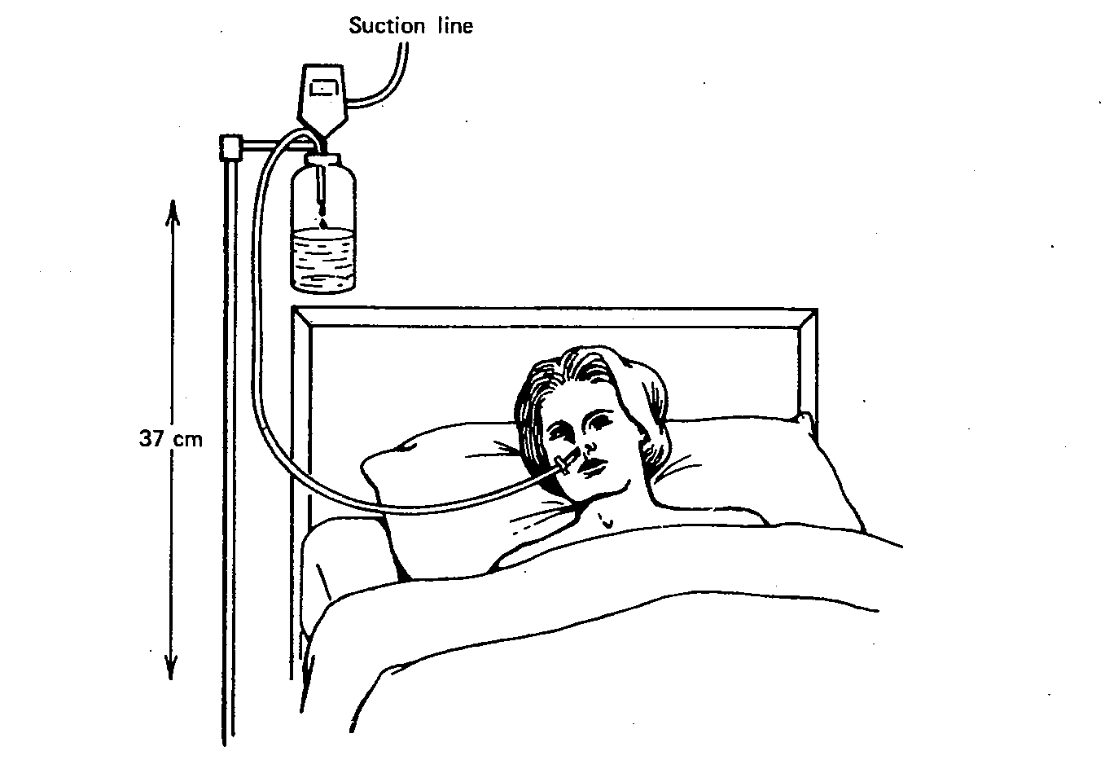
Sol: Net negative pressure = 100 mm Hg – 370 (1.0 /13.6) = 73 mm Hg
Drainage could be accomplished by gravity (siphoning).

