College of Pharmacy
Fourth year. Clinical Pharmacy
Rheumatologic Disorders
Osteoarthritis

Introduction
Osteoarthritis (OA) is a common, progressive disorder affecting primarily weight-bearing diarthrodial joints, characterized by progressive destruction of articular cartilage, osteophyte formation, pain, limitation of motion, deformity, and disability.

Pathophysiology
1-Primary (idiopathic) OA, the more common type, has no known cause. Secondary OA is associated with a known cause such as trauma.

2-OA usually begins with damage to articular cartilage through injury, excessive joint loading from obesity or other reasons, or joint instability.

3-Cartilage loss causes joint space narrowing and painful, deformed joints. New bone formations (osteophytes) at joint margins are thought to help stabilize affected joints.

4-Inflammatory changes can occur in the joint capsule and synovium. Inflammatory changes result in synovial effusions and thickening.

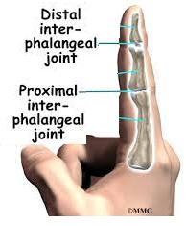
Clinical presentation
1-Risk factors include increasing age, obesity, sex, certain occupations and sports activities, history of joint injury or surgery, and genetic predisposition.

2-The predominant symptom is pain in affected joints. Pain accompanies joint activity and decreases with rest.

3-Joints most commonly affected are the distal interphalangeal (DIP) and proximal interphalangeal (PIP) joints of the hand, first carpometacarpal joint, knees, hips, cervical and lumbar spine, and first metatarsophalangeal (MTP) joint of the toe.

4-Limitation of motion, stiffness, crepitus, and deformities may occur.

5-Upon arising, joint stiffness typically lasts less than 30 minutes and resolves with motion. Presence of warm, red, and tender joints suggests inflammatory synovitis.

6-Physical examination of affected joints reveals tenderness, crepitus, and possibly enlargement. Heberden and Bouchard nodes are bony enlargements (osteophytes) of the DIP and PIP joints, respectively.

Diagnosis
1-Diagnosis is made through patient history, physician examination, radiologic findings, and laboratory testing.

2-American College of Rheumatology criteria for classification of OA of the hips, knees, and hands include presence of pain, bony changes on examination, normal erythrocyte sedimentation rate (ESR), and radiographs showing osteophytes or joint space narrowing.

Treatment
Goals of Treatment: (1) Educate the patient, family members, and caregivers; (2) relieve pain and stiffness; (3) maintain or improve joint mobility; (4) limit functional impairment; and (5) maintain or improve quality of life.

Nonpharmacologic Therapy
1-Educate the patient about the disease process and extent, prognosis, and treatment options. Promote dietary counseling, exercise, and a weight loss program for overweight patients.

2-Physical therapy—with heat or cold treatments and an exercise program—helps maintain range of motion and reduce pain and need for analgesics.

3-Assistive and orthotic devices (canes, walkers, braces, heel cups, and insoles) can be used during exercise or daily activities.

4-Surgical procedures (e.g., osteotomy, arthroplasty, joint fusion) are indicated for functional disability and/or severe pain unresponsive to conservative therapy

Pharmacologic Therapy

General Approach
Drug therapy is targeted at relief of pain. Apply an individualized approach (Figs. 1 and 2). Continue appropriate nondrug therapies when initiating drug therapy.

Knee and Hip OA
1-Acetaminophen is a preferred first-line treatment; it may be less effective than oral NSAIDs but has a lower risk of serious gastrointestinal (GI) and cardiovascular (CV) events.

2-Acetaminophen is usually well tolerated, but potentially fatal hepatotoxicity with overdose is well documented. It should be avoided in chronic alcohol users or patients with liver disease.

3-Nonselective NSAIDs or cyclooxygenase-2 (COX-2) selective inhibitors (eg, celecoxib) are recommended if a patient fails acetaminophen.

4-Nonselective NSAIDs may cause minor GI complaints such as nausea, dyspepsia, anorexia, abdominal pain, and diarrhea. They may cause gastric and duodenal ulcers and bleeding through direct (topical) or indirect (systemic) mechanisms.

5-Risk factors for NSAID-associated ulcers and ulcer complications (perforation, gastric outlet obstruction, and GI bleeding) include longer duration of NSAID use, higher dosage, age older than 60 years, past history of peptic ulcer disease of any cause, history of alcohol use, and concomitant use of glucocorticoids or anticoagulants.

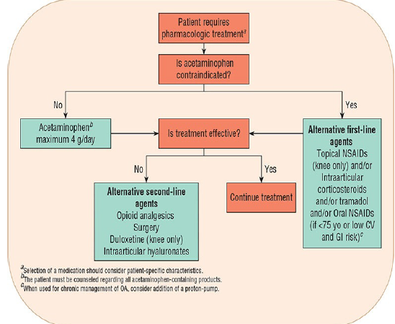
Figure 1: Treatment recommendations for knee and hip osteoarthritis.

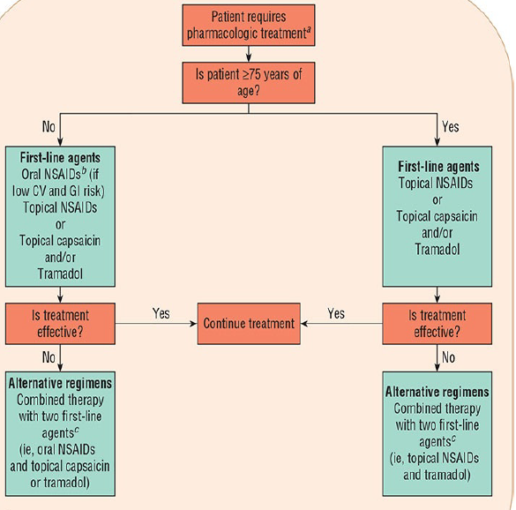
Figure 2: Treatment recommendations for hand osteoarthritis.

6-Options for reducing the GI risk of nonselective NSAIDs include using (1) the lowest dose possible and only when needed, (2) misoprostol with the NSAID, and (3) a PPI or H2-receptor antagonist daily with the NSAID.

7-COX-2 inhibitors pose less risk for adverse GI events than nonselective NSAIDs, but this advantage is substantially reduced for patients taking aspirin. Both nonselective and selective NSAIDs are associated with an increased risk for CV events (hypertension, stroke, myocardial infarction, and death).

8-Unlike aspirin, celecoxib and nonspecific NSAIDs inhibit thromboxane formation reversibly, with normalization of platelet function 1–3 days after drug discontinuation. Avoid NSAIDs in late pregnancy because of risk of premature closure of the ductus arteriosus.

9-Topical NSAIDs are recommended for knee OA if acetaminophen fails, and they are preferred over oral NSAIDs in patients older than 75 years.

10-Topical NSAIDs provide similar pain relief with fewer adverse GI events than oral NSAIDs but may be associated with adverse events at the application site (e.g., dry skin, pruritus, and rash).

11-Patients using topical products should avoid oral NSAIDs to minimize the potential for additive side effects. Use of topical NSAIDs has not been linked with increased risk of CV events.

12-Intra-articular (IA) corticosteroid injections are recommended for both hip and knee OA when analgesia with acetaminophen or NSAIDs is suboptimal. They can provide excellent pain relief, particularly when joint effusion is present.

13-Local anesthetics such as lidocaine or bupivacaine are commonly combined with corticosteroids to provide rapid pain relief. Injections may also be given with concomitant oral analgesics for additional pain control. Local adverse effects can include infection, osteonecrosis, tendon rupture, and skin atrophy at the injection site.

14-Do not administer injections more frequently than once every 3 months to minimize systemic adverse effects. Systemic corticosteroid therapy is not recommended in OA, given lack of proven benefit and well-known adverse effects with long-term use.

15-Tramadol is recommended for hip and knee OA in patients who have failed acetaminophen and topical NSAIDs, who are not appropriate candidates for oral NSAIDs, and who are not able to receive IA corticosteroids.

16-Tramadol can be added to partially effective acetaminophen or oral NSAID therapy. Tramadol is associated with opioid-like adverse effects such as nausea, vomiting, dizziness, constipation, headache, and somnolence.

17-The most serious adverse event is seizures. Tramadol is classified as a Schedule IV controlled substance due to its potential for dependence, addiction, and diversion.

18-Duloxetine can be used as adjunctive treatment of knee (not hip) OA in patients with partial response to first-line analgesics (acetaminophen, oral NSAIDs). It may be a preferred second-line medication in patients with both neuropathic and musculoskeletal OA pain.

19-IA hyaluronic acid (sodium hyaluronate) is not routinely recommended because injections have shown limited benefit for knee OA and have not been shown to benefit hip OA.

20-Glucosamine and/or chondroitin and topical rubefacients (e.g, methyl salicylate, trolamine salicylate) lack uniform improvement in pain control or functional status for hip and knee pain and are not preferred treatment options.

Hand OA
1-Topical NSAIDs are a first-line option for hand OA. Efficacy with topical NSAIDs typically occurs with 1–2 weeks.

2-Oral NSAIDs are an alternative first-line treatment for patients who cannot tolerate the local skin reactions or who received inadequate relief from topical NSAIDs.

3-Capsaicin cream is an alternative first-line treatment. It is a reasonable option for patients unable to take oral NSAIDs. Capsaicin must be used regularly to be effective, and it may require up to 2 weeks to take effect. Adverse effects are primarily local.

4-Tramadol is an alternative first-line treatment and is a reasonable option for patients who do not respond to topical therapy and are not candidates for oral NSAIDs because of high GI, CV, or renal risks.

5-Tramadol may also be used in combination with partially effective acetaminophen, topical therapy, or oral NSAIDs.

Evaluation of therapeutic outcomes
1-To monitor efficacy, assess baseline pain with a visual analog scale, and assess range of motion for affected joints with flexion, or extension.

2-Depending on the joint(s) affected, measurement of grip strength and 50-ft walking time can help assess hand and hip/knee OA, respectively.

Reference
Joseph T. DiPiro, Robert L. Pharmacotherapy: A Pathophysiologic Approach, 12th Edition. 2023.

