College of Pharmacy
Fourth year. Clinical Pharmacy
Respiratory disorders
Chronic Obstructive Pulmonary Disease

Introduction

Chronic Obstructive Pulmonary Disease (COPD) is a heterogeneous lung condition characterized by chronic respiratory symptoms (dyspnea, cough, sputum production and/or exacerbations) due to abnormalities of the airways (bronchitis, bronchiolitis) and/or alveoli (emphysema) that cause persistent, often progressive, airflow obstruction ⁽³⁾.
It includes two principal conditions:

A-Chronic bronchitis: Chronic or recurrent excess mucus secretion with cough that occurs on most days for at least 3 months of the year for at least 2 consecutive years.

B-Emphysema: Abnormal, permanent enlargement of the airspaces distal to the terminal bronchioles, accompanied by destruction of their walls, without fibrosis.

Pathophysiology
1-The most common cause of COPD is exposure to tobacco smoke.

2-Inhalation of noxious particles and gases activates inflammatory cells to release inflammatory mediators. Inflammatory cells and mediators lead to widespread destructive changes in airways resulting in chronic airflow limitation.

3-Chronic hypoxemia and changes in pulmonary vasculature lead to increases in pulmonary pressures. Sustained elevated pulmonary pressures can lead to right-sided heart failure (cor pulmonale) characterized by right ventricle hypertrophy in response to increased pulmonary vascular resistance.

Clinical presentation
1-Initial symptoms include chronic cough and sputum production; patients may experience cough for several years before dyspnea develops.

2-Dyspnea (described by patients as “increased effort to breathe” or “air hunger”) ⁽²⁾ is worse with exercise and progressive over time, with decreased exercise tolerance or decline in physical activity. Chest tightness or wheezing may be present.

3-When airflow limitation progresses, patients may have shallow breathing, increased resting respiratory rate, “barrel chest” due to lung hyperinflation, pursed lips during expiration, use of accessory respiratory muscles, and cyanosis of mucosal membranes.

Diagnosis
1-Diagnosis is based on patient symptoms, history of exposure to risk factors such as tobacco smoke and occupational substances, and confirmation by pulmonary function testing, such as spirometry (Spirometry assesses lung volumes and capacities. Forced vital capacity (FVC) is the total volume of air exhaled after maximal inhalation, and FEV1 is the total volume of air exhaled in 1 second).
2-The Global Initiative for Chronic Obstructive Lung Disease (GOLD) guidelines suggest a four-grade classification of airflow limitation: mild (GOLD 1), moderate (GOLD 2), severe (GOLD 3), or very severe (GOLD 4).

Treatment

Goals of Treatment: Prevent or slow disease progression, relieve symptoms, improve exercise tolerance, improve overall health status, prevent and treat exacerbations, prevent and treat complications, and reduce morbidity and mortality (Further reading 1).

Nonpharmacologic Therapy
1-Smoking cessation is the most important intervention to prevent development and progression of COPD.

2-Reducing exposure to occupational dust and fumes as well as other environmental toxins is also important.

3-Pulmonary rehabilitation programs include exercise training, breathing exercises, and psychosocial support.

4-Administer the influenza vaccine annually during each influenza season. Vaccination against pneumococcal infection is recommended for all adults with COPD.

5-Some patients with severe COPD required long-term O2 therapy (by nasal cannula).

Pharmacologic Therapy
1-Bronchodilators are the mainstay of drug therapy; classes include short- and long-acting β2-agonists, short- and long-acting muscarinic antagonists (anticholinergics), and methylxanthines.

2-Short-acting inhaled bronchodilators relieve symptoms (e.g., dyspnea). Long acting inhaled bronchodilators relieve symptoms and reduce exacerbation frequency.

Patient assessment and selection of therapy
GOLD guidelines combine symptoms (by questionnaires) and frequency of exacerbations in the previous 12 months to determine patient risk group and recommend initial treatment (Figure 1 and 2) ⁽²⁾.
Note
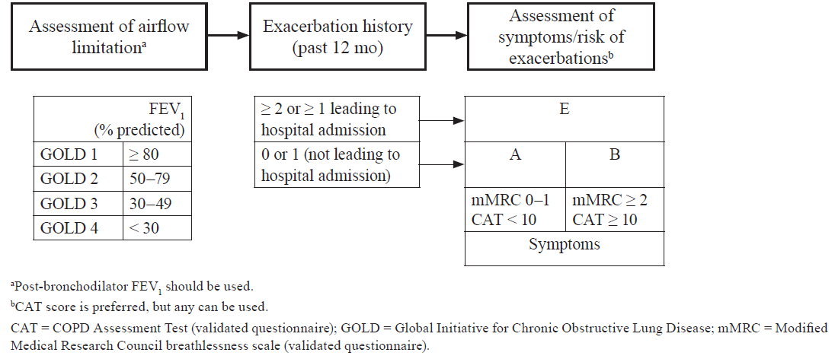
Figure 1. GOLD guidelines: refined assessment of COPD severity and risk ⁽²⁾.
Initial pharmacological management
1-Rescue short-acting bronchodilators should be prescribed to all patients for immediate symptom relief ⁽³⁾.
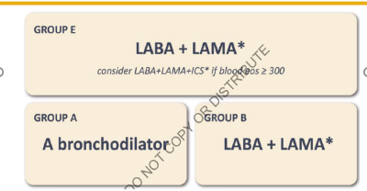
Figure 2: Initial pharmacological management ⁽³⁾.

2-Group A: All Group A patients should be offered bronchodilator treatment based on its effect on breathlessness. This can be either a short- or a long-acting bronchodilator ⁽³⁾.

3-Group B: Treatment should be initiated with a LABA+LAMA combination.

4-Group E (“E” for “Exacerbations”):
A-LABA+LAMA is the preferred choice for initial therapy in group E patients.
B-Consider LABA+LAMA+ICS in group E if eosinophil count ≥ 300 cells/μL.

Maintenance therapy
Maintenance therapy adjustments are recommended according to the predominant treatable trait of dyspnea (Figure 3 left column); or exacerbations (Figure 3 right column). If both exacerbations and dyspnea need to be targeted, the exacerbation pathway should be followed ^{(2, 3)}.

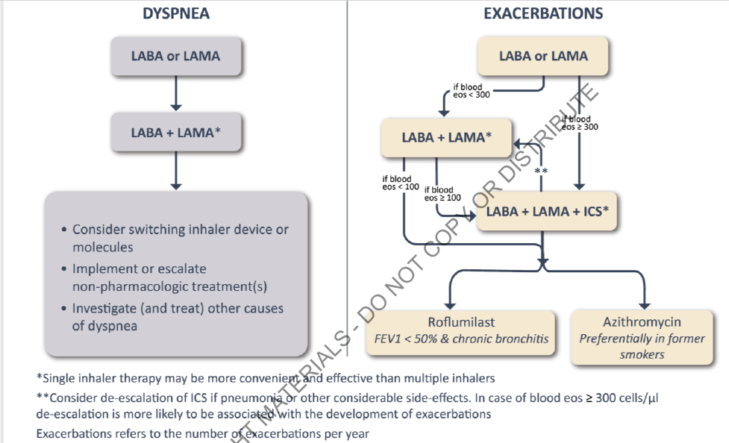

Figure 3: Maintenance therapy of COPD ⁽³⁾.

Dyspnea (patients with persistent dyspnea)

For patients with persistent breathlessness or exercise limitation on bronchodilator monotherapy, the use of two long acting bronchodilators is recommended ⁽³⁾.

Exacerbations [patients continuing to have exacerbations (with or without persistent dyspnea)]

1-For patients with persistent exacerbations on bronchodilator monotherapy:

A-Escalation to LABA+LAMA+ICS may be considered if blood eosinophil count ≥ 300 cells/μL⁽³⁾.

B-If blood eosinophil count < 300 cells/μL escalation to LABA+LAMA is recommended ⁽³⁾.

2-In patients on LABA+LAMA and still have exacerbations, Escalation to LABA+LAMA+ICS if eosinophil counts ≥ 100 cells/ml may be considered ⁽³⁾.

3-In patients on LABA+LAMA and eosinophil counts < 100 cells/ μL who still have exacerbations, or patient treated with LABA+LAMA+ICS and still have exacerbations, the following options may be considered ⁽³⁾:

A-Add roflumilast. This may be considered in patients with an FEV1 < 50% predicted and chronic bronchitis ⁽³⁾.

B-Add azithromycin (especially in those who are not current smokers) ⁽³⁾.

Short-Acting Bronchodilators
1-Either a short- or long-acting bronchodilator is recommended initially for patients with occasional symptoms (category A).

2-Short acting bronchodilators are also recommended for all patients (categories A–E) as rescue or as-needed therapy to manage symptoms.

3-Choices among short-acting bronchodilators include short-acting β2-agonists (SABAs) or short-acting muscarinic antagonists (SAMAs). Both drug classes have a relatively rapid onset of action, relieve symptoms to a similar degree, and improve exercise tolerance and lung function.

4-Short-acting bronchodilators do not reduce the frequency or severity of COPD exacerbations.

5-If a patient does not achieve adequate symptom control with one agent, combining a SABA with a SAMA is reasonable.

6-The SABA choices include albuterol and levalbuterol. Inhalation is the preferred route for SABAs, and administration via metered-dose or dry powder inhalers (MDIs, DPIs) is at least as effective as nebulization therapy and is more convenient and less costly.

7-Inhaled SABAs are generally well tolerated; they can cause sinus tachycardia and rhythm disturbances rarely in predisposed patients. Skeletal muscle tremors can occur initially but generally subside as tolerance develops. Older patients may be more sensitive and experience palpitations, tremors, and “jittery” feelings.

8-Ipratropium bromide is the most commonly prescribed SAMA. Improvements in pulmonary function are similar to inhaled SABAs, although ipratropium has a slower onset of action (15–20 minutes vs. 5 minutes for albuterol) and more prolonged effect.

9-Because of its slower onset, ipratropium may be less suitable for as needed use but is often prescribed in this manner.

10-The most frequent patient complaints are dry mouth, nausea, and occasionally metallic taste.

Long-Acting Bronchodilators
1-Therapy can be administered as an inhaled long-acting β2-agonist (LABA) or muscarinic antagonist (LAMA). There is no dose titration for any of these agents; the starting dose is the effective and recommended dose for all patients.

2-The available LABA formoterol, has an onset of action similar to albuterol (<5 minutes), whereas salmeterol has a slower onset (15–20 minutes); however, none of these agents are recommended for acute relief of COPD symptoms.

5-The available LAMA: tiotropium has an onset of action (80 minutes) and is not recommended for acute relief of symptoms.

Methylxanthines (Theophylline and aminophylline)
1-Methylxanthines have a limited role in COPD therapy because of the availability of LABAs and LAMAs as well as significant methylxanthine drug interactions and interpatient variability in dosage requirements.

2-Theophylline may be considered in patients intolerant of or unable to use inhaled bronchodilators.

3-Sustained-release theophylline preparations are most appropriate for long-term COPD management. Caution should be used in switching from one sustained-release preparation to another because of variability in sustained-release characteristics.

4-Common theophylline side effects include dyspepsia, nausea, vomiting, diarrhea, headache, dizziness, and tachycardia. Arrhythmias and seizures may occur, especially at toxic concentrations.

Corticosteroids
1-The clinical benefits of ICS therapy have been observed with combination therapy. ICS monotherapy is not recommended for patients with COPD.

2-Short-term systemic corticosteroids may also be considered for acute exacerbations. Chronic systemic corticosteroids should be avoided in COPD because of questionable benefits and high risk of toxicity.

Roflumilast
1-Roflumilast is a phosphodiesterase 4 (PDE4) inhibitor that relaxes airway smooth muscle.

2-Roflumilast is recommended for patients with recurrent exacerbations despite treatment with triple inhalation therapy (LAMA/LABA/ICS) or [dual therapy (LAMA/LABA) who are not candidates for ICS (eosinophil count <100 cells/ μL)].

3-Because theophylline and roflumilast have similar mechanisms of action, they should
not be used together.

Azithromycin
1-Chronic azithromycin was associated with a lower rate of COPD exacerbation but also with colonization with macrolide resistant bacteria and hearing deficits.

2-In addition, the azithromycin product labeling includes a precaution about QT prolongation.

3-Current guidelines recommend to consider adding chronic azithromycin only for patients with recurrent exacerbations despite optimal therapy (especially in those who
are not current smokers) ⁽³⁾.

COPD exacerbations
1-A COPD exacerbation is defined as a change in the patient’s baseline symptoms (dyspnea, cough, or sputum production) (worsening dyspnea, increased sputum volume, or increased sputum purulence) sufficient to warrant a change in management.

2- Classification ⁽²⁾:
A. Mild: SA bronchodilators only
B. Moderate: SA bronchodilators plus antibiotics and/or oral corticosteroids
C. Severe: hospitalization or emergency department (ED) visits

3-Goals of Treatment: (1) Minimize the negative consequences of the acute exacerbation (i.e., reduce symptoms, prevent hospitalization, shorten hospital stay, prevent acute respiratory failure or death) and (2) prevent future exacerbations.

Nonpharmacologic therapy
1-Provide oxygen therapy for patients with significant hypoxemia.

2-Noninvasive positive-pressure ventilation (NPPV) provides ventilatory support with oxygen using a face or nasal mask without endotracheal intubation.

3-Intubation and mechanical ventilation may be needed in patients failing NPPV or who are poor candidates for NPPV.

Pharmacologic Therapy
The three classes of medications most commonly used for COPD exacerbations are bronchodilators, corticosteroids, and antibiotics ⁽³⁾.

A-Bronchodilators
1-It is recommended that inhaled SABAs are the initial bronchodilators for acute treatment of a COPD exacerbation ⁽³⁾. SABAs are preferred because of rapid onset of action. Muscarinic antagonists may be added if symptoms persist despite increased doses of β2-agonists.

2-Bronchodilators may be administered via MDI, DPI, or nebulization with equal efficacy. Nebulization may be considered for patients with severe dyspnea who are unable to hold their breath after actuation of an MDI.

3-Methylxanthines are not recommended due to increased side effect profiles. [I.V methylxanthines (theophylline or aminophylline) are not recommended due to significant side effects] ⁽³⁾.

B-Corticosteroids
Although the optimal corticosteroid dose and duration are unknown, prednisone 40 mg orally daily (or equivalent) for 5 days is effective for many patients.

C-Antimicrobial Therapy
1-In order to limit unnecessary use, antibiotics should be initiated in any of these clinical situations:
(1) patients presenting with three cardinal symptoms of acute exacerbation (worsening dyspnea, increased sputum volume, or increased sputum purulence).
(2) patients presenting with two cardinal symptoms as long as one is increased sputum purulence.
(3) patients requiring mechanical ventilation regardless of symptoms.

2-The most common pathogens in COPD exacerbations are Streptococcus pneumoniae, Haemophilus influenzae, and Moraxella catarrhalis ⁽²⁾.

3-The choice of the antibiotic should be based on the local bacterial resistance pattern. Usually, initial empirical treatment is an aminopenicillin with clavulanic acid, macrolide, tetracycline or, in selected patients, quinolone ⁽³⁾.

3-Continue antimicrobial therapy for at least 5–7 days. If the patient deteriorates or does not improve as anticipated, hospitalization may be necessary, and more aggressive attempts should be made to identify potential pathogens responsible for the exacerbation.

Evaluation of therapeutic outcomes
1-In chronic stable COPD, assess pulmonary function tests annually and with any treatment additions or discontinuations.

2-In acute exacerbations of COPD, assess white blood cell count, vital signs, chest x-ray, and changes in frequency of dyspnea, sputum volume, and sputum purulence at the onset and throughout treatment of the exacerbation.

3-In more severe exacerbations, ABG and SaO2 should also be monitored.

Reference
1-Joseph T. DiPiro, Robert L. Pharmacotherapy: A Pathophysiologic Approach,
12th Edition. 2023.
2-ACCP 2023
3-Global Initiative for Chronic Obstructive Lung Disease. GLOBAL STRATEGY FOR PREVENTION, DIAGNOSIS AND MANAGEMENT OF COPD: 2023 Report. Global Initiative for Chronic Obstructive Lung Disease - GOLD. 2023.

Further reading

Pharmacological and non-pharmacological therapies with evidence of efficacy in reducing the mortality of COPD patients include [Triple combinations (LABA+LAMA+ICS), Smoking cessation, Pulmonary rehabilitation, Long term oxygen therapy, Non-invasive positive pressure ventilation, Lung transplantation and lung volume reduction surgery] ⁽³⁾.

