Subject: Medical Physics (Lecture Notes) 1/12
Instructor: Dr. Mohamed Saleh Ahmed
CH.14
Light in Medicine
Light has some interesting properties, many of which are used in medicine:
1- The speed of light changes when it goes from one material (medium) into another. The ratio of the speed of light in a vacuum to its speed in a given material is called the index of refraction (or refractive index n);
n = $\frac{c}{v}$
If a light beam meets a new material at an angle other than perpendicular, it bends, or is refracted, in conformity to Snell’s Law. This property permits light to be focused. n’ sin α’ =n sin α ( Snell’s Law)
2- Light behaves both as a wave (produces interference and diffraction) and as particle (it can absorbed by a single molecule).
*When a light photon is absorbed in one of the sensitive cells (consider the cones and the rods) of the retina it causes a chemical change. The chemical change in a particular point of the retina triggers an electrical signal to the brain to inform it that a light photon has been absorbed at that point.
Note: The cones (≈6.5 million in each eye) are primarily used for day light, or photopic, vision. The rods (≈120 million in each eye) are used in night, or scotopic, vision and peripheral vision.
3- When light is absorbed, its energy generally appears as heat. This property is the basis for the use in medicine of IR light to heat tissues. Also, the heat produced by laser beams is used to “weld” a detached retina to the back of the eyeball and to coagulate small blood vessels in the retina.
4- Sometimes when a light photon is absorbed, a lower energy light photon is emitted. This property is known as fluorescence. One way fluorescence is used in medicine is in the detection of porphyria, a condition in which the teeth fluoresce red when irradiated with UV light. Another important application is in fluorescent
microscopes. 2/12
5- Light is reflected to some extent from all surfaces. There are two types of reflection. Diffuse reflection occurs when rough surfaces scatter the light in many directions. Specular reflection; it is obtained from very smooth shiny surfaces such as mirrors where the light is reflected at an angle that is equal to the angle of incidence. Mirrors are used in many medical instruments such as the one that is held at the back of the patient’s throat to look at his vocal folds.
14-1. Measurement of light and its units
UV (100 to 400 nm), visible (400 to 700 nm), and IR (extends from about700 to 10000 nm) are defined in terms of their wavelengths. Each of these categories is further subdivided according to wavelength (λ). For example, UV-C (100 to 290 nm), UV-B (290 to 320 nm), and UV-A (320 to 400 nm).
Note: (1 µ = 10⁻⁶ m), (1 Å = 10⁻¹⁰ m), and (1 nm = 10⁻⁹ m)
Visible light is measured in photometric units that relate to how light is seen by the average human eye. All light radiation, including UV and IR radiation can be measured in radiometric units, see Table 14-1.
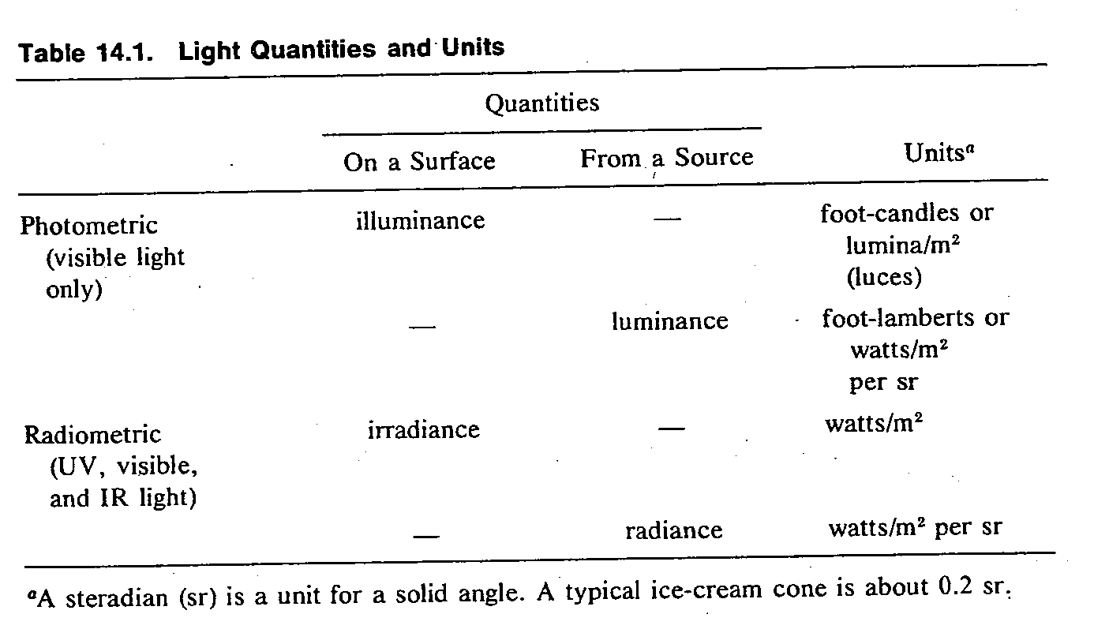

3/12
Since light is a form of energy, it is sometimes useful to talk about the energy of individual light photons. (See Figure 14.3)

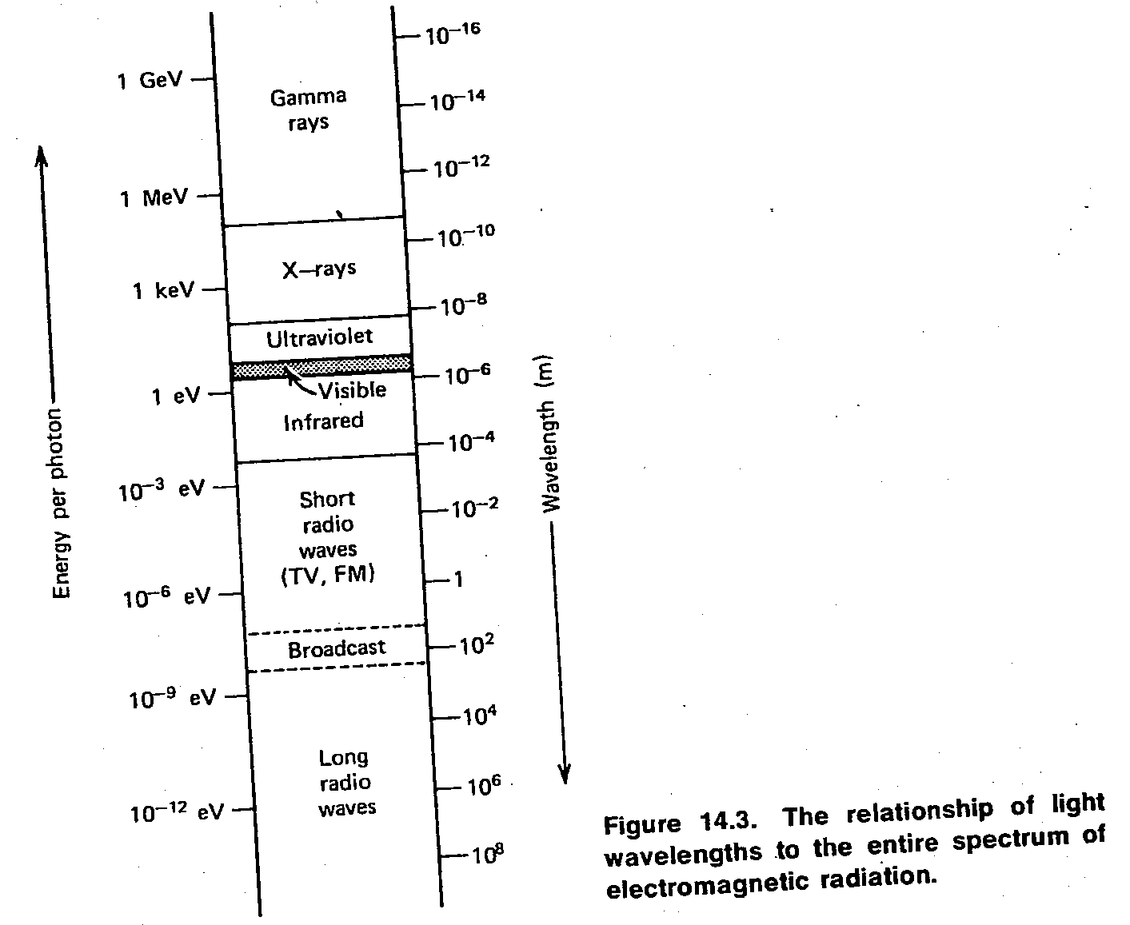

Visible light has energies from about 2 eV up to about 4 eV. The energy of a typical x-ray photon used in medicine is about 50,000 eV, or 50 keV.

14-2. Applications of visible light in medicine
# Physician uses mirrors to look into a body opening (see Figure 14.4). More sophisticated instruments, such as the ophthalmoscope (Figure 15.31) for looking
4/12
into eyes and the otoscope for looking into the ears, use basically the same principle.

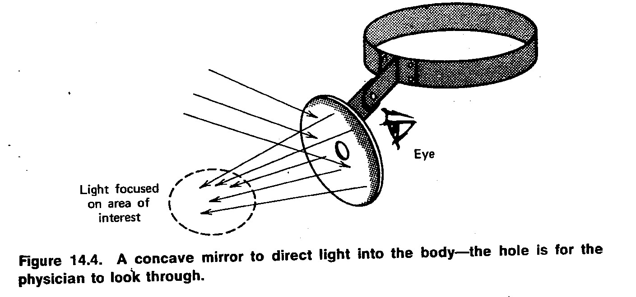

5/12
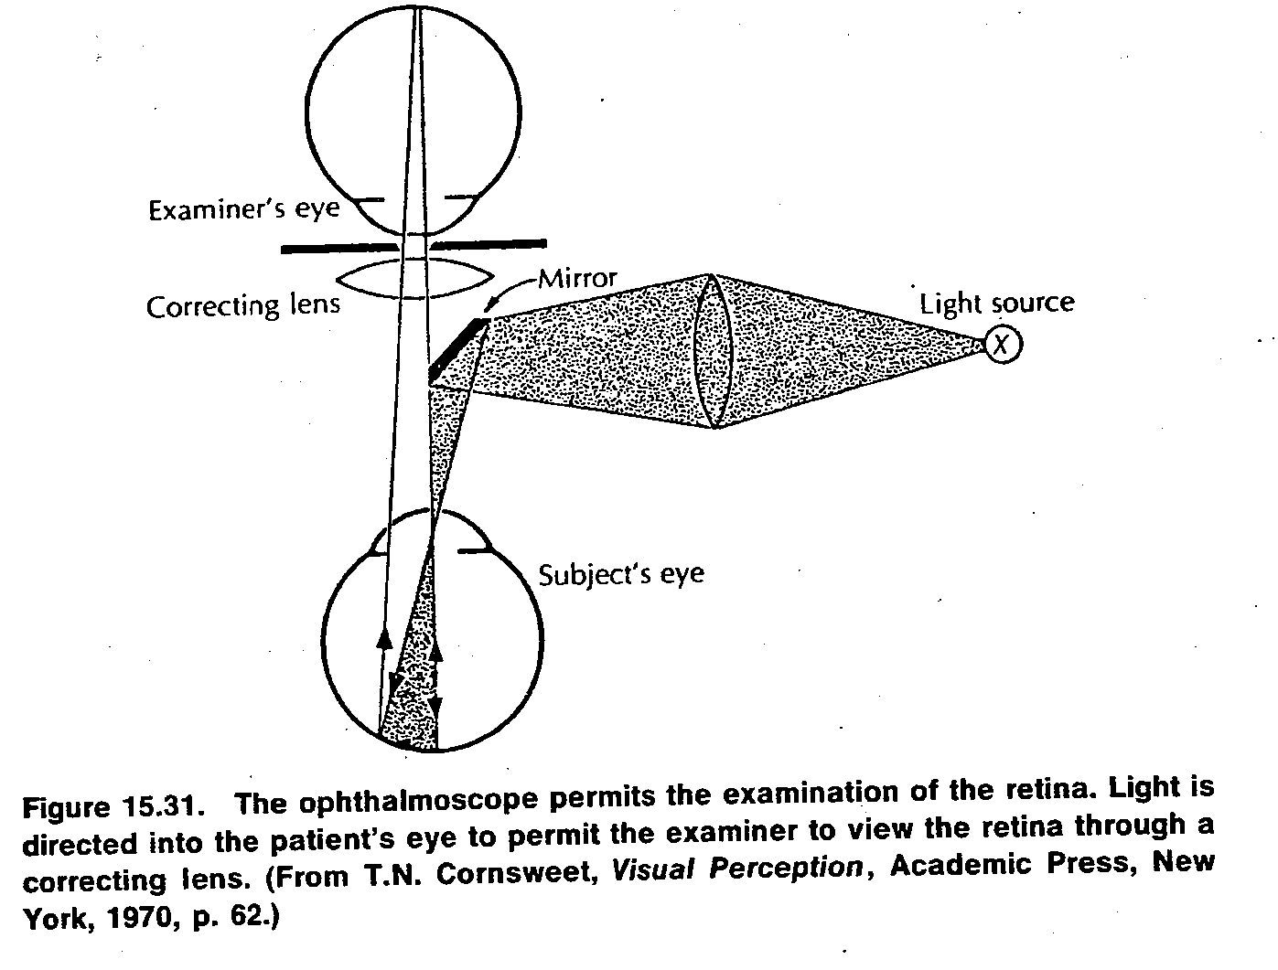

# Pediatricians shine light (using Chun Gun) into the bodies of infants and observe the amount of scattered light (transillumination) produced in order to detect
hydrocephalus (water-head) or pneumothorax (collapsed lung). They also use visible light (~ 450 nm) for treating jaundice in premature infants (phototherapy).
# Internists often use tubes with built in light sources (endoscopes; Figures 14.5 and 14.6) to see inside the body. Cystoscopies (used to examine the bladder, proctoscopes (used for examining the rectum), and bronchoscopes (used for examining the air passages into the lungs are special purpose endoscopes.

6/12

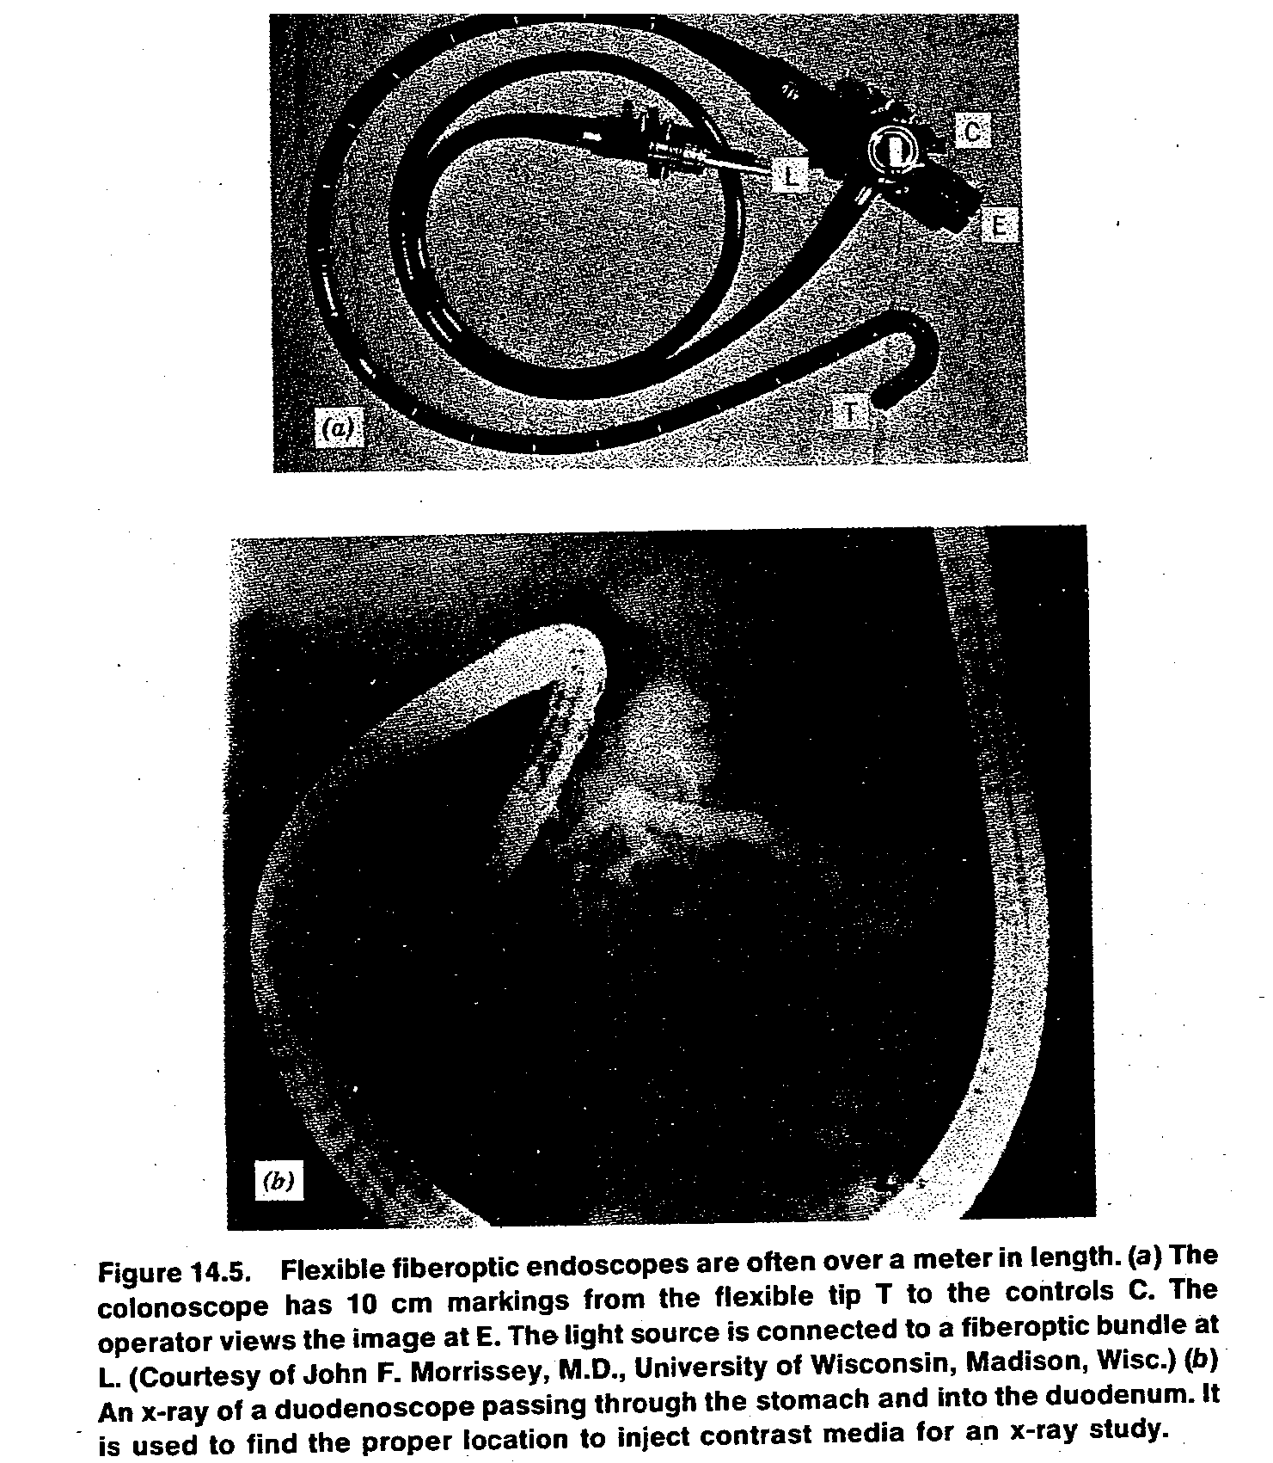

7/12
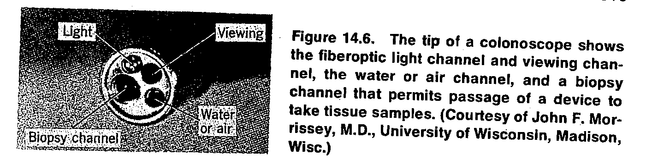

14-3. Applications of ultraviolet and infrared light in medicine
* Physiatrists (M.D.s in physical medicine) use IR and UV light for therapeutic purposes. However, because of their higher energies, UV photons are more useful than IR photons.
Harming and beneficial UV light reactions in the skin
# UV light with wavelengths below 290 nm is germicidal and it is sometimes used to sterilize medical instruments.
# One of the major beneficial effects of UV light from the sun is the conversion of molecular products in the skin into vitamin D. Dermatologists have also found that UV light improves certain skin conditions.
# Ultraviolet light from the sun affects the melanin in the skin to cause tanning. However, it can produce sunburn (around λ= 300 nm) as well as tan in the skin. Ordinary window glass permits some near UV to be transmitted but absorbs the sunburn component.
# Solar UV is also the major cause of skin cancer in humans (usually appears on the tip of the nose, the tops of the ears, and the back of the neck); may be related to the fact that the UV wavelengths that produce sunburn are also very well absorbed by the DNA in the cells.
8/12
# In a summer day, one can get a sunburn even when sitting in the shade, due to the fact that about half of the UV light hitting the skin comes directly from the sun and the other half is scattered from the air in other parts of the sky.
* UV light cannot be seen by the eye because it is absorbed before it reaches the retina (Figure 14.13). The large percentage of near-UV light absorbed by the lens may be the cause of some cataracts (opacities of the lens).
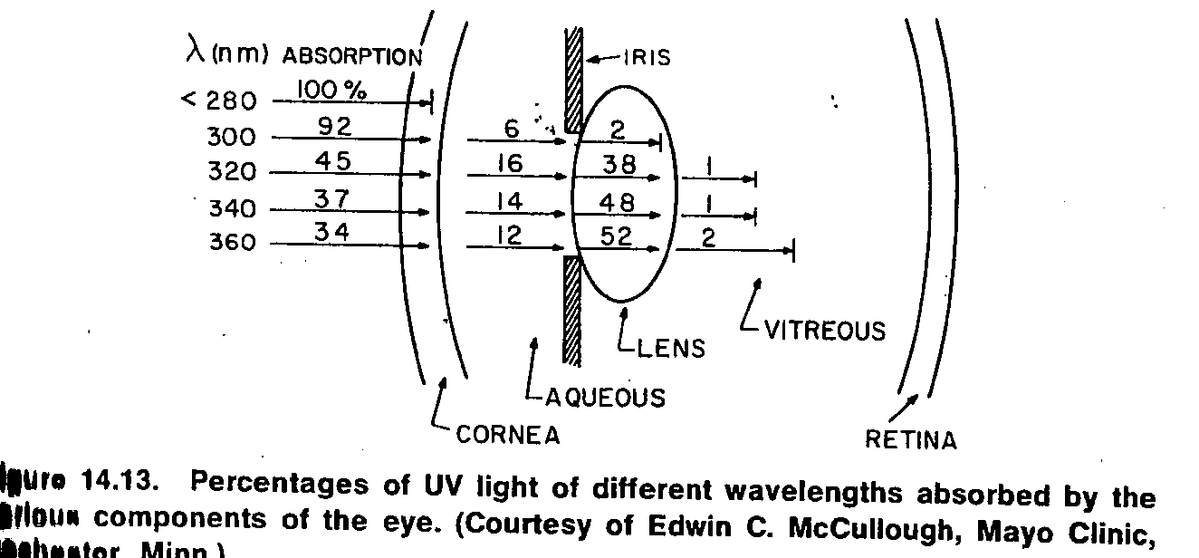

IR in medicine
# About half of the energy from the sun is in the IR region. Looking at the sun through a filter (e.g., plastic sunglasses) that removes most of the visible light and allows most the IR wavelengths can cause a burn on the retina.
# Heat lamps (produce ~ 1000 nm to 2000 nm) are often used for physical therapy purposes, as IR light penetrates further into the tissues than visible light and thus is better able to heat deep tissues.
# Two types of photography are used in medicine: reflective IR photography and emissive IR (thermography). The former uses wavelengths of 700 to 900 nm to show the patterns of veins (venous pattern) just below the skin. Near IR penetrates about 3mm below the skin regardless of the color of the skin. IR photographs of

9/12
biological specimens illuminated with blue-green light sometimes show IR luminescence (fluorescence or phosphorescence).
14-4. Lasers in medicine
# Laser is an acronym for Light Amplification by Stimulated Emission of Radiation. It is a unique light source that emits a narrow beam of light of a single wavelength (monochromatic light) in which each wave is in phase with the others near it (coherent light).
# In a laser, energy that has been stored in the laser material (gases, liquids, as well as solids like ruby) is released as narrow beam of light – either as a steady beam continuous wave (CW) or as an intense pulse (pulsed).
# A laser can be focused to a spot only few microns in diameter. When all of the energy of the laser is concentrated in such a small area, the power density (power per unit area) becomes very large. The total energy of a typical laser pulse used in medicine, which is measured in millijoules (mJ), can be delivered in less than a microsecond, and the resultant instantaneous power may be in megawatts.
# In medicine short wavelengths lasers (400 to 600 nm) are always absorbed by tissue better than the long wavelengths (≈700nm). See Figure 14.16.

10/12

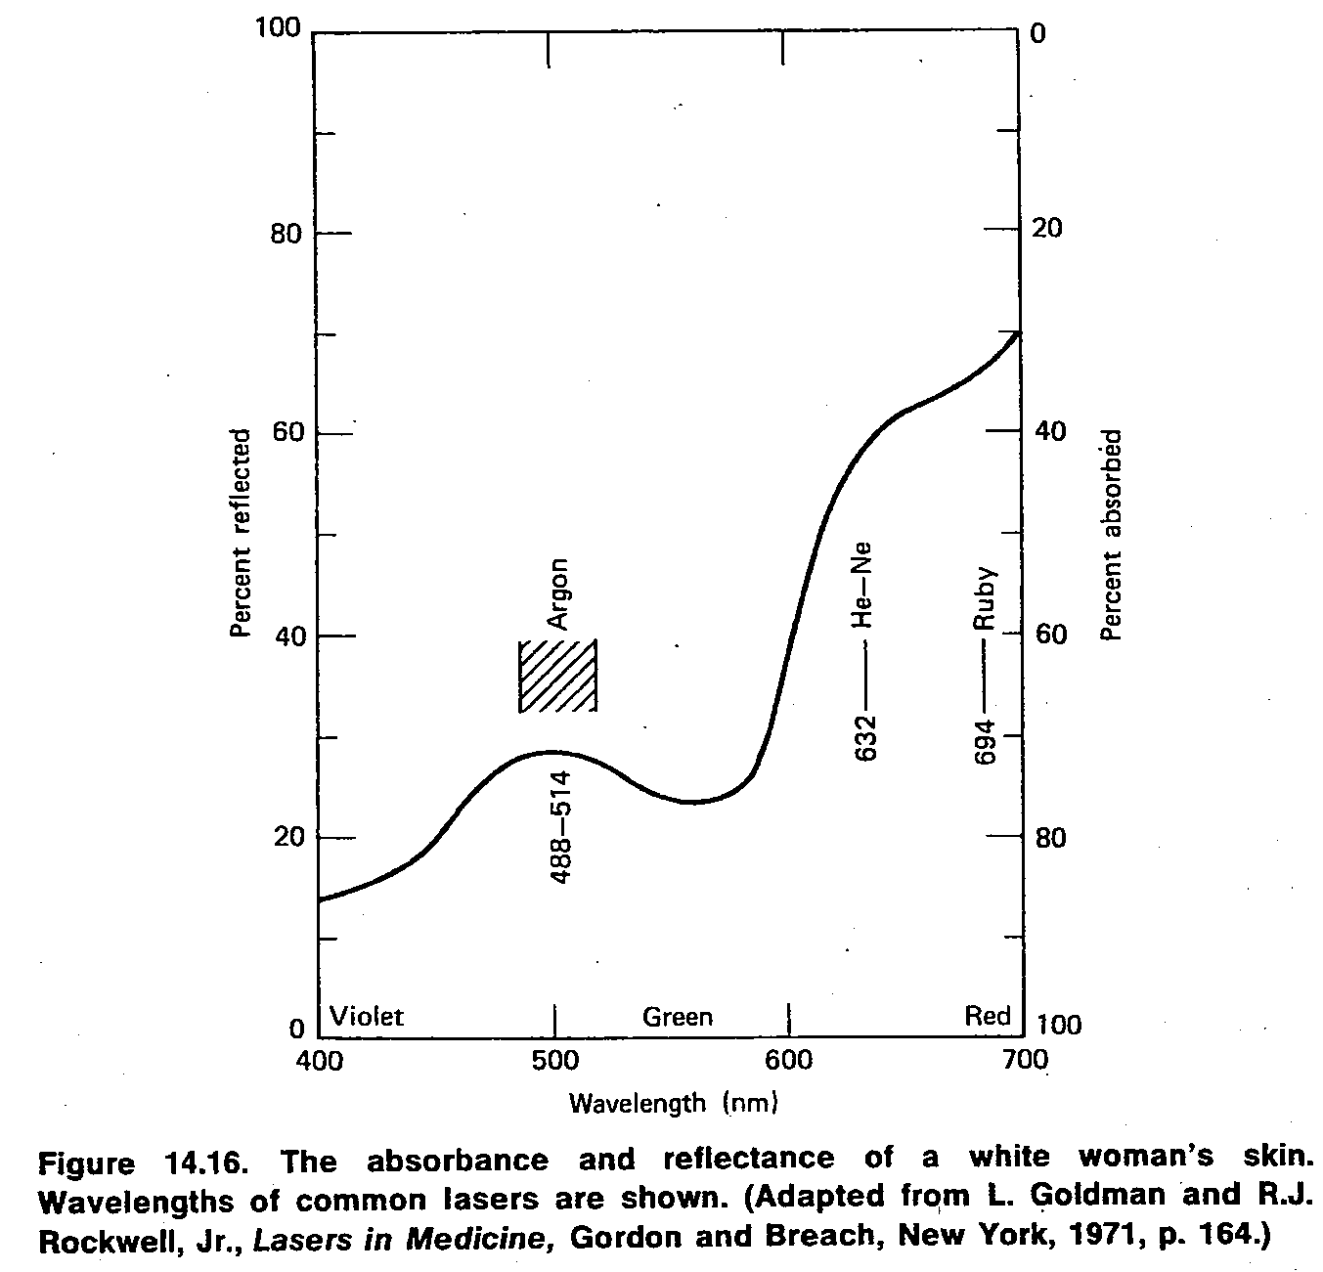

11/12
# Laser energy directed at human tissue causes a rapid rise in temperature and can destroy the tissue (see Figure 14.17). However, not all laser damage is due to heat (e.g.1064nm produces damage to the retina of monkey’s eye), laser of 441.6nm produces primarily photochemical damage to the retina of monkey’s eye.
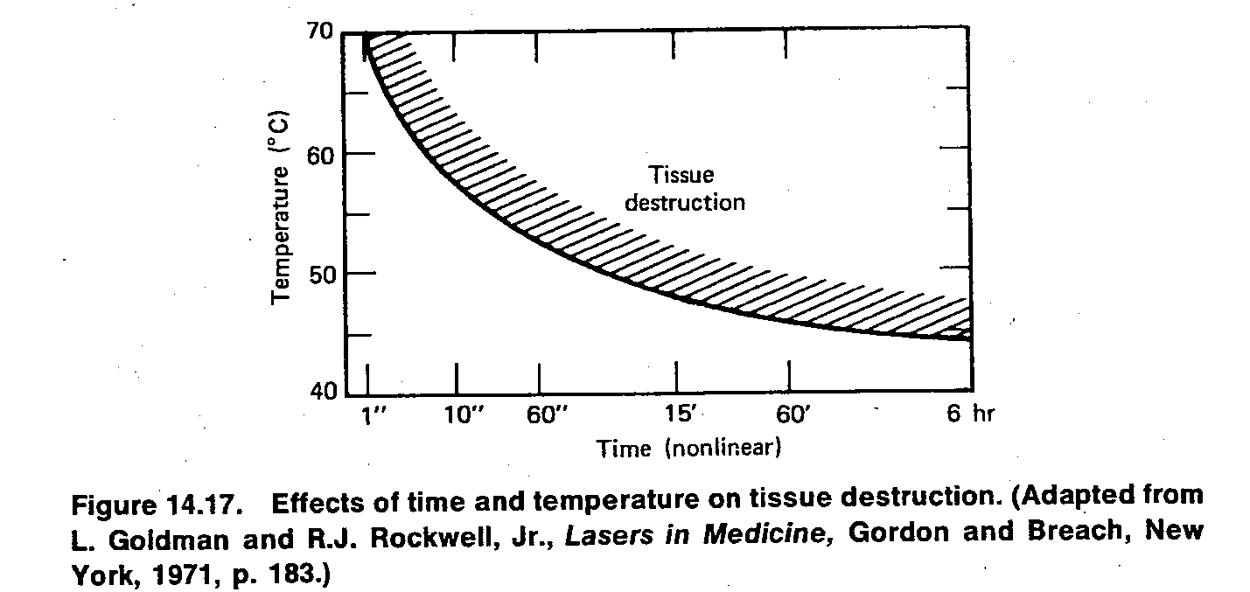

# Its effectiveness in treating certain types of cancer and its usefulness as “bloodless knife” for surgery are under active investigations. Lasers are also being used in medical research for special three-dimensional imaging called holography.
# Ophthalmologists use lasers to photocoagulate small blood vessels in the eye. See Figure 14.18, where the laser spot size is approximately 50 µm. Before lasers were available photocoagulation was done with high intensity xenon arc light source. The minimum amount of laser energy that will do observable damage to the retina is called the minimum reactive dose (MRD). For example, the MRD for a 50µm spot in the eye is about 2.4 mJ delivered in 0.25 sec. Typical exposures needed for photocoagulation are 10 to 50 times the MRD (i.e., 24 to 120 mJ for a 50 µm spot in 0.25 sec). Photocoagulation is useful for repairing retinal tears and holes that develop prior retinal detachment.

12/12

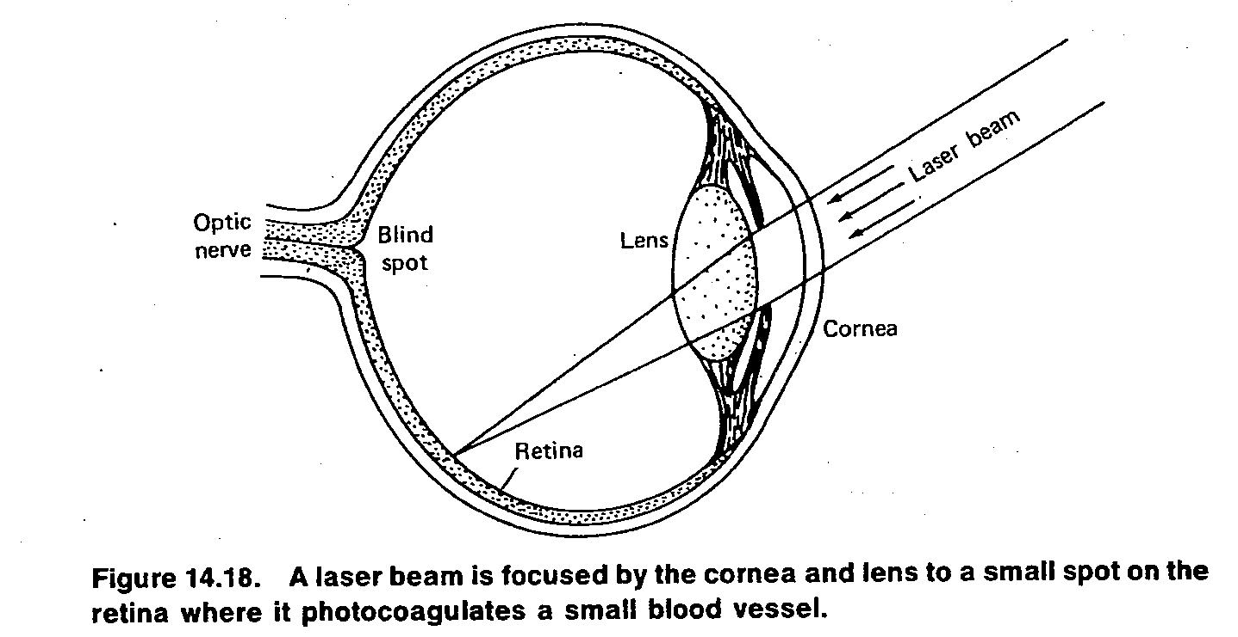

14-5. Applications of microscopes in medicine

