LEC. 9 Pharmacology Dr. Ihab Alkhalifa
Drugs for Heart failure
Overview
Heart failure (HF) is a complex, progressive disorder in which the heart is unable to pump sufficient blood to meet the needs of the body.
Its cardinal symptoms are dyspnea, fatigue, and fluid retention.
HF is due to an impaired ability of the heart to adequately fill with and/or eject blood. It is often accompanied by abnormal increases in blood volume and interstitial fluid.
Underlying causes of HF include :
- arteriosclerotic heart disease
- myocardial infarction,
- hypertensive heart disease
- valvular heart disease,
- dilated cardiomyopathy
- congenital heart disease.

Knowledge of the physiology of cardiac muscle contraction is essential for understanding the compensatory responses evoked by the failing heart, as well as the actions of drugs used to treat HF.

II. PHYSIOLOGY OF MUSCLE CONTRACTION
The myocardium, like smooth and skeletal muscle, responds to stimulation by depolarization of the membrane, which is followed by shortening of the contractile proteins and ends with relaxation and return to the resting state (repolarization).
Cardiac myocytes are interconnected in groups that respond to stimuli as a unit, contracting together whenever a single cell is stimulated.

Action potential
Cardiac myocytes are electrically excitable and have a spontaneous, intrinsic rhythm generated by specialized “pacemaker” cells located in the sinoatrial and atrioventricular (AV) nodes.
Cardiac myocytes also have an unusually long action potential, which can be divided into five phases (0 to 4).
Figure 19.2 illustrates the major ions contributing to depolarization and repolarization of cardiac myocytes.
Cardiac contraction
The force of contraction of the cardiac muscle is directly related to the concentration of free (unbound) cytosolic calcium. Therefore, agents that increase intracellular calcium levels (or that increase the sensitivity of the contractile machinery to calcium) increase the force of contraction (inotropic effect).
Calcium handling by cardiac myocytes is illustrated in Figure 19.3.
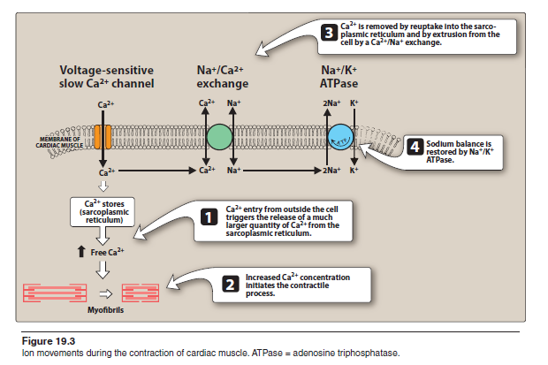
الرسم للاطلاع

Compensatory physiological responses in HF
1. Increased sympathetic activity: Baroreceptors sense a decrease in blood pressure and this through :
A-stimulation of β-adrenergic receptors results in an increased heart rate and a greater force of contraction of the heart muscle.
B- vasoconstriction enhances venous return and increases cardiac preload.
An increase in preload (stretch on the heart) increases stroke volume, which, in turn, increases cardiac output.
These compensatory responses increase the work of the heart, which, in the long term, contributes to further decline in cardiac function.
2. Activation of the renin–angiotensin–aldosterone system:
A fall in cardiac output decreases blood flow to the kidney, prompting the release of renin, and resulting in increased formation of angiotensin II and release of aldosterone.
This results in increased peripheral resistance (afterload) and retention of sodium and water.
Blood volume increases, and more blood is returned to the heart.
If the heart is unable to pump this extra volume, venous pressure increases and peripheral and pulmonary edema occur.
Again, these compensatory responses increase the work of the heart, contributing to further decline in cardiac function.
3. Myocardial hypertrophy: The heart increases in size, and the
chambers dilate and become more globular. Initially, stretching of the heart muscle leads to a stronger contraction of the heart
Typical HF signs and symptoms
include dyspnea on exertion, orthopnea, paroxysmal nocturnal dyspnea,
fatigue, and peripheral edema.

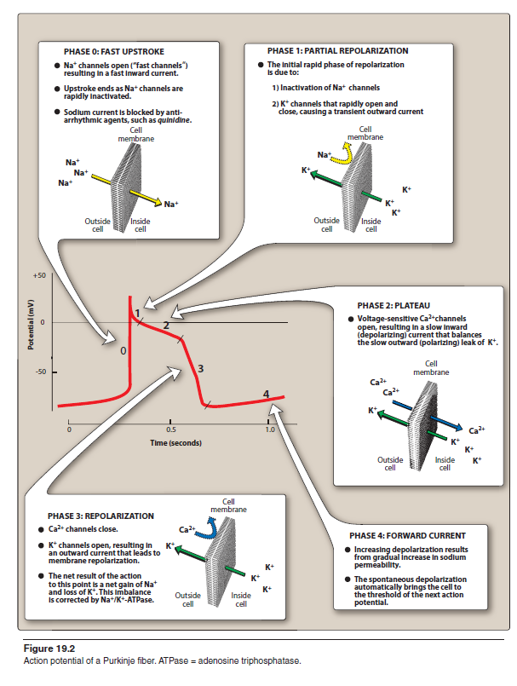
الرسم للاطلاع

Goals of pharmacologic intervention in HF
Goals of treatment are to alleviate symptoms, slow disease progression,
and improve survival achived through 4 general mechanisms :
1-Reduced myocardial work load
2-Decreased extracellular fluid volume
3-Improved cardiac contractility
4-Reduced rate of cardiac remodeling.
NON DRUG THERAPY IN HF
Chronic HF is typically managed by:
- fluid limitations (less than 1.5 to 2 L daily);
- low dietary intake of sodium (less than 2000 mg/d);
Drug classes therapy
Accordingly, seven classes of drugs have been shown to be effective:
1) Angiotensin-converting enzyme Inhibitors
2) Angiotensin-receptor blockers
3) Aldosterone antagonists
4) β-blockers
5) Diuretics
6) direct vaso- and venodilators
7) Inotropic agents
(Figure 19.1). Depending on the severity of HF and individual patient factors, one or more of these classes of drugs are administered.

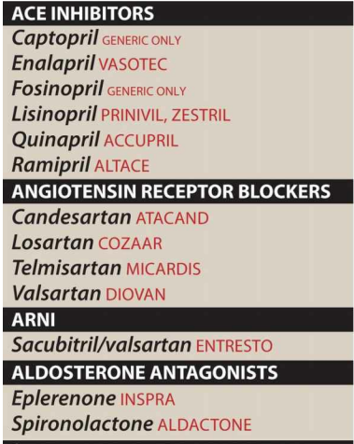
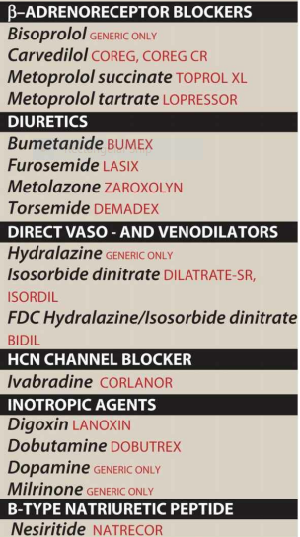
الشكل للاطلاع مع ملاحظة التقسيم للادوية
INOTROPIC DRUGS
Positive inotropic agents enhance cardiac contractility and, thus, increase cardiac output. Although these drugs act by different mechanisms, the inotropic action is the result of an increased cytoplasmic calcium concentration that enhances the contractility of cardiac muscle.
Digitalis glycosides ( Digoxin & Digitoxin )
A-CLASS : The cardiac glycosides are often called digitalis or digitalis glycosides, because most of the drugs come from the digitalis (foxglove) plant. They are a group of chemically similar compounds that can increase the contractility of the heart muscle and, therefore, are used in treating HF.
The most widely used agent is digoxin [di-JOX-in].
Digitoxin [dij-i-TOK-sin] is seldom used due to its considerable LONG duration of action.
B-Mechanism of action:
a. Regulation of cytosolic calcium concentration:
Increase cardiac muscle Ca++ ion conc. Through 2 steps :
1-By inhibiting the Na+/K+-adenosine triphosphatase (ATPase) enzyme, digoxin reduces the ability of the myocyte to actively pump Na+ from the cell (Figure 19.8).
2-This decreases the Na+ concentration gradient and, consequently, reduce the ability of the Na+/ Ca2+-exchanger to move calcium out of the cell, leading to increased intracellular Ca2+, thereby increasing cardiac contractility with increased cardiac output to more closely resemble that of the normal heart (Figure 19.9).
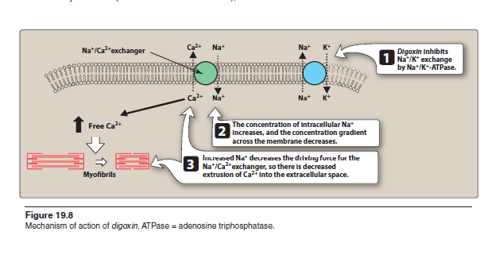
الرسم مطلوب مع التاشير لفعالية الدواء وتوزيع الايونات
C-Pharmacokinetics: Digoxin is available in oral and injectable formulations.
It has a large volume of distribution, because it accumulates in muscle. The dosage is based on lean body weight. In acute situations such as symptomatic atrial fibrillation,
It is mainly eliminated intact by the kidney, requiring dose adjustment in renal dysfunction.
Q/ A loading dose regimen is used ? WHY ?
- Digoxin has a long half-life of 30 to 40 hours. a loading dose regimen is used

D-Therapeutic uses & Adverse effects
- Digoxin therapy is indicated in patients with severe HF after initiation of ACE inhibitor, β-blocker, and diuretic therapy.
- symptomatic atrial fibrillation

DIGOXIN TOXICITY
Toxicity can often be managed by discontinuing digoxin, determining serum potassium levels, and, if indicated, replenishing potassium.
Decreased levels of serum potassium (hypokalemia) predispose a patient to digoxin toxicity, since digoxin normally competes with potassium for the same binding site on the Na+/K+-ATPase pump.
[Note: Patients receiving thiazide or loop diuretics may be prone to hypokalemia.]
Severe toxicity resulting in ventricular tachycardia may require administration of antiarrhythmic drugs .
With the use of a lower serum drug concentration in HFrEF, toxic levels are infrequent

Q/ Specified low dose of digoxin is preferred during heart failure ? why ?
A/ Since The digitalis glycosides have a low therapeutic index, with only a small difference between a therapeutic dose and doses that are toxic or even fatal.
A low serum drug concentration of digoxin (0.5 to 0.8 ng/ mL) is beneficial in HF. At this level, patients may see a reduction in HF admissions, along with improved survival.
At higher serum drug concentrations, mortality likely increases.
NOTE/ Patients with mild to moderate HF often respond to treatment with ACE inhibitors, β-blockers, aldosterone antagonists, direct vaso- and venodilators, and diuretics and may not require digoxin.
Adverse effects of digitalis or digoxin : At low serum drug concentrations, digoxin is fairly
well tolerated. However, it has a very narrow therapeutic index, and
digoxin toxicity is one of the most common adverse drug reactions leading to hospitalization :
- Patients may also experience blurred vision, yellowish vision (xanthopsia)
- various cardiac arrhythmias.
- Anorexia
- nausea, and vomiting may be initial indicators of toxicity.
Drug interactions
- Digoxin interact with clarithromycin, verapamil, and amiodarone, can significantly increase digoxin levels, necessitating a reduced dose of digoxin.
- Digoxin should also be used with caution with other drugs that slow AV conduction, such as β-blockers, verapamil, and diltiazem.
Other inotropic drugs : β-Adrenergic agonists
Dobutamine and Dopamine
A-Class : β-Adrenergic agonists with inotropic effects increase heart contractility
B-Mechanism of action : improve cardiac performance by causing positive inotropic effects and vasodilation , through β-Adrenergic agonists lead to an increase in intracellular cyclic adenosine monophosphate (cAMP), which results in the activation of protein kinase.
Protein kinase then phosphorylates slow calcium channels, thereby increasing entry of calcium ions into the myocardial cells and enhancing contraction (Figure 19.10).
Dobutamine is the most commonly used inotropic agent other than digoxin.
C-Kinetics : Both drugs must be given by intravenous infusion and are primarily used in the short-term treatment of acute HF in the hospital setting.
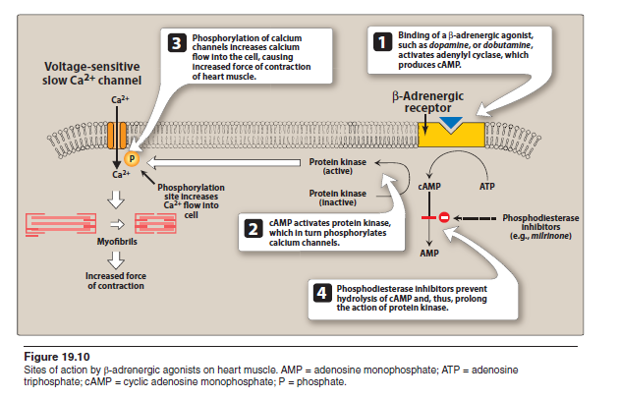
الرسم مطلوب مع التاشير لموقع فعالية الادوية

Phosphodiesterase inhibitors: Milrinone [MIL-rih-nohn]
A-Class : is a phosphodiesterase inhibitor , intropic drugs enhance cardiac contractility
B-Mechanism of action : increases the intracellular concentration of cAMP this results in an increase of intracellular calcium and, therefore, cardiac contractility. (Figure 19.10).,
C-Kinetics : short-term use of intravenous milrinone is not associated with increased mortality in patients without a history of coronary artery disease, and some symptomatic benefit may be obtained in patients with refractory HF.
Long-term, milrinone therapy may be associated with a substantial increased risk of mortality.

Other drugs for CHF therapy
INHIBITORS OF THE RENIN–ANGIOTENSIN– ALDOSTERONE SYSTEM (RAAS)
HF leads to activation of the renin–angiotensin–aldosterone system via two mechanisms:
1) increased renin release by juxtaglomerular cells in renal afferent arterioles due to diminished renal perfusion pressure produced by the failing heart and
2) renin release by juxtaglomerular cells promoted by sympathetic stimulation and activation of β receptors.
The production of angiotensin II, a potent vasoconstrictor, and the subsequent stimulation of aldosterone release that causes salt and water retention lead to increases in both preload and afterload that are characteristic of the failing heart.
In addition, high levels of angiotensin II and of aldosterone have direct detrimental effects on the cardiac muscle, favoring remodeling, fibrosis, and inflammatory changes.

ACE-INHIBITORS
Captopril , Fosinopril , Lisnopril , Enalpril المعلومات التالية نفسها لكل من
A-CLASS : Angiotensin converting enzyme inhibitors ( ACE-I) Affecting renal RAAS system
B-Mechanism of action of Angiotensin-converting enzyme inhibitors : ACE inhibitors decrease vascular resistance (afterload) and venous tone (preload), resulting in increased cardiac output. ACE inhibitors also blunt the usual angiotensin II–mediated increase in epinephrine and aldosterone seen in HF, this achieved through 3 mechanisms :
1-Angiotensin-converting enzyme (ACE) inhibitors are a part of standard pharmacotherapy in HFrEF. These drugs block the enzyme that cleaves angiotensin I to form the potent vasoconstrictor angiotensin II.
2-By reducing angiotensin II levels, ACE inhibitors also decrease the secretion of aldosterone.
3- They also diminish the inactivation of bradykinin leading to more vasodilation effect by bradykinin(potent vasodilator) while reducing ANG II level (vasoconstrictor) (Figure 19.5).
C-Kinetics : نفس الشرح السابق في محاضرة Antihypertensive

D-Therapeutic uses & Adverse effects
1-ACE inhibitors may be considered for patients with
asymptomatic and symptomatic HFrEF.
Depending on the severity of HF, ACE inhibitors may be used in combination with diuretics, β-blockers, digoxin, aldosterone antagonists, and other vasodilators combination.
2-Patients who have had a recent Myocardial infarction or are at high risk for a cardiovascular event also benefit from long-term ACE inhibitor therapy.
3- ACE inhibitors are also used for the treatment of hypertension
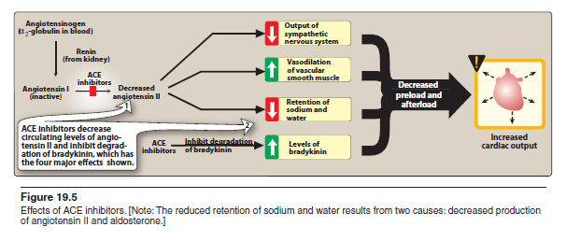
SCHEMATIC DIAGRAM FOR ACE-I action in HF
الرسم مطلوب للحفظ لتوضيح تسلسل الفعالية للادوية

Angiotensin receptor blockers
Candesartan ,losartan & valsartan المعلومات التالية نفسها لكل من
- CLASS : Angiotensin receptor blockers (ARBs) are orally active compounds that are competitive antagonists of the angiotensin II type 1 receptor.
- Mechanism of action : ARBs have the advantage of more complete blockade of angiotensin II action, & do not affect bradykinin levels.
- Therapeutic uses : ARBs are a substitute for ACE inhibitors in those patients who cannot tolerate the ACE-Inhibitors & Some cases of hypertention
Aldosterone antagonists
Spironolactone & Eplerenone
- Class : is a direct competitive antagonist of aldosterone
- Mechanism of action : Patients with advanced heart disease have elevated levels of aldosterone due to angiotensin II stimulation and reduced hepatic clearance of the hormone, thereby preventing Aldosteron action leading to reduced salt retention & myocardial hypertrophy.
Although similar in action to spironolactone , eplerenone has a lower incidence of endocrine-related side effects due to its reduced affinity for glucocorticoid, androgen, and progesterone receptors.
- Therapeutic uses : Aldosterone antagonists are indicated in patients with more severe stages of HF & recent myocardial infarction.

Angiotensin Receptor–Neprilysin Inhibitor (ARNI)
Neprilysin is the enzyme responsible for breaking down vasoactive peptides, such as angiotensin I and II, bradykinin, and ( natriuretic peptides NP ( peptides enhance sodium ion secretion through kidney , reducing blood volume , reducing stroke volume ) .
Inhibition of neprilysin augments or potentiate the activity of the vasoactive peptides ( , To maximize the effect of natriuretic peptides, stimulation of the RAAS must be offset without further increase in bradykinin. Therefore an ARB, instead of an ACE inhibitor, is combined with a neprilysin inhibitor to reduce the incidence of angioedema (Figure 18.6).
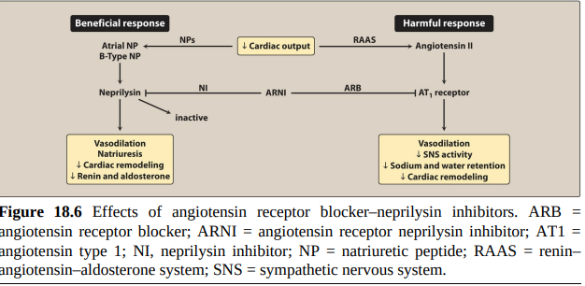
الرسم مطلوب مع التاشير والشرح للميكانيكية

Sacubitril/valsartan
- Class : Sacubitril [sak-UE-bi-tril]/valsartan is the first available angiotensin receptor–neprilysin inhibitor (ARNI).
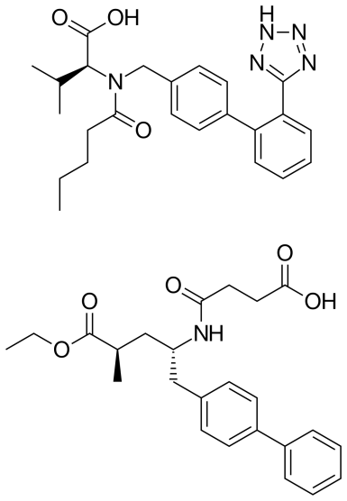
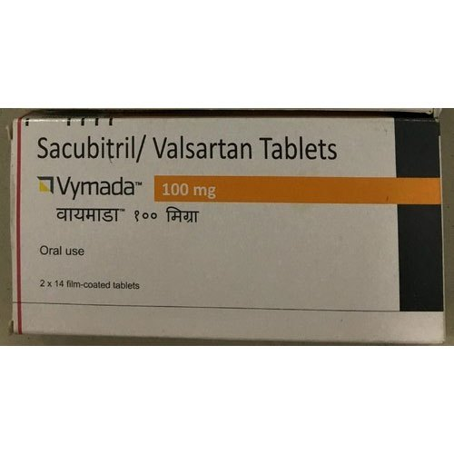
B-Mechanism of Action : Sacubitril/valsartan combines the actions of an ARB with neprilysin inhibition. Inhibition of neprilysin results in increased concentration of vasoactive peptides, leading to natriuresis, diuresis, vasodilation, and inhibition of fibrosis.
Together, the combination decreases afterload, preload, and myocardial fibrosis. An ARNI improves survival and clinical signs and symptoms of HF.
C- Pharmacokinetics : Sacubitril/valsartan is orally active, administered with or without food, and quickly breaks down into the separate components.
Sacubitril is a prodrug that is metabolized by esterases to the active metabolite.
Both drugs have a high volume of distribution and are highly bound to plasma proteins. Sacubitril is mainly excreted in the urine. The half-life of approximately 10 hours for both components allows for twice-daily dosing.
D-Therapeutic uses & Adverse effects
An ARNI should replace an ACE inhibitor or ARB in patients diagnosed as Heart
Adverse effects : The adverse effect profile is similar to that of an ACE inhibitor or ARB. Because of the added reduction of afterload, :
- Hypotension is more common with an ARNI.
- Bradykinin levels may increase and angioedema may occur, due to inhibition of neprilysin with sacubitril,
Hyperpolarization-Activated Cyclic Nucleotide–Gated Channel (HCN) Blocker
The hyperpolarization-activated cyclic nucleotide–gated (HCN) channel is responsible for the SA ( I_{f} ) current and setting the pacemaker activation . Inhibition of the HCN channel results in slowing of depolarization and a lower heart rate required for CHF patient therapy
Ivabradine
A-Class : Ivabradine [eye-VAB-ra-deen] is the only approved drug in the class of HCN channel blockers.
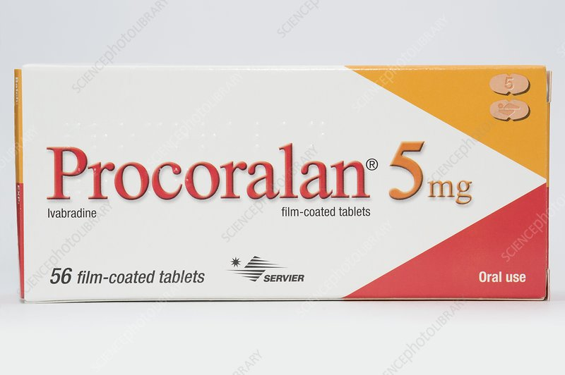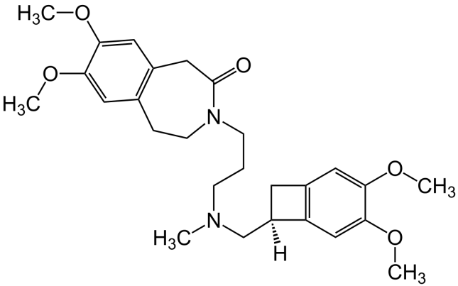
B-Mechanisim of action : By selectively slowing the ( I_{f} ) current in the SA node, reduction of heart rate occurs without a reduction in contractility, AV conduction, ventricular repolarization, or blood pressure.
C- Pharmacokinetics : Ivabradine should be administered with meals to increase absorption. It undergoes extensive first-pass metabolism by cytochrome P450 3A4 to an active metabolite,
The half-life is 6 hours, which allows for twice-daily dosing.
D-Theraputic uses : Ivabradine is utilized in Heart failure therapy to improve symptoms in patients who are in sinus rhythm with a heart rate above 70 beats per minute and are on optimized HF pharmacotherapy. Specifically, patients should be on an optimal dose of β-blocker or have a contraindication to β-blockers.

Adverse effects
- Bradycardia may occur with ivabradine, which may improve with dose reduction.
- Ivabradine inhibits similar channels in the eye, in therapy. This enhanced eye brightness may be ameliorated by dose reduction.
- Ivabradine should not be used in pregnancy or breast-feeding, with more advanced heart block,

𝝱-BLOCKERS
Three β-blockers have shown benefit in HF:
Bisoprolol , carvedilol and long-acting metoprolol succinate
- Class : Carvedilol is a nonselective β-adrenoreceptor antagonist that also blocks α-adrenoreceptors, whereas bisoprolol and metoprolol succinate are β1-selective antagonists.
- Mechanism of action : The benefit of β-blockers is attributed, in part, to their ability to prevent the changes that occur because of chronic activation of the sympathetic nervous system.
These agents decrease heart rate and inhibit release of renin in the kidneys.
In addition, β-blockers prevent the deleterious effects of norepinephrine on the cardiac muscle fibers, decreasing remodeling, hypertrophy, and cell death.
- Therapeutic uses : β-Blockade is recommended for all patients with chronic, stable HF.
Treatment should be started at low doses and gradually titrated to target doses based on patient tolerance and vital signs.

DIURETICS
Furosemide & Torisomide
- CLASS : Loop diuretics affecting kidney tubule function on loop of Henele
- Mechanism of Action : Diuretics relieve pulmonary congestion and peripheral edema. These agents are also useful in reducing the symptoms of volume overload and nocturnal dyspnea, through 3 mechanisms :
1-Diuretics decrease plasma volume and, subsequently, decrease venous return to the heart (preload). -This decreases cardiac workload and oxygen demand.
3-Diuretics may also decrease afterload by reducing plasma volume, thereby decreasing blood pressure.
Note/ As diuretics have not been shown to improve survival in HF, they should only be used to treat signs and symptoms of volume excess.

VASO- AND VENODILATORS
Hydralazine, isosorbide dinitrate or their combination fixed dose
- Hydralazine is Arterial dilator , reduce systemic arteriolar resistance and decrease afterload in patient with CHF .
- Nitrates are commonly used venous dilators to reduce preload for patients with chronic HF. Act by Dilation of venous blood vessels leads to a decrease in cardiac preload by increasing venous capacitance.
- Combination of hydralazine and isosorbide dinitrate may be used.
A fixed-dose combination of these agents has been shown to improve symptoms and survival in patients with HF treatment ,
Headache, hypotension, and tachycardia are common adverse effects with this combination.

