Subject: Medical Physics (Lecture Notes) 1/6
Instructor: Dr. Mohamed Saleh Ahmed
CH. 18

Physics of Radiation Therapy
Within a year of Roentgen’s discovery of x-rays in 1895 it became obvious that x-rays could produce biological damage in the form of reddened skin, ulcers, and so forth. However, today radiation therapy is recognized as an important tool in the treatment of many types of cancer.

* Currently three major methods are used alone or in combination to treat cancer: surgery, radiation therapy, and drugs (chemotherapy).

* The success of radiation therapy depends on the; (1) the type and extent of the cancer; (2) the skill of the radiotherapist, the physician who specializes in the treatment of cancer with radiation; (3) the kind of radiation used in the treatment; (4) and the accuracy with which the radiation is administrated to the tumor (the responsibility of the radiological physicist).

* There is evidence that an error of 5% to 10% in the radiation dose to the tumor can have significant effect on the results of the therapy. Too little radiation does not kill all the tumor; too much can produce serious complications in normal tissue, see figure 18.1, that shows giving a dose just 5% lower than 50 Gy reduces the chance of local cure by a factor of nearly 2 while giving a dose 5% higher dose not greatly increase the cure rate but does greatly increase the number of major complications.

2/6

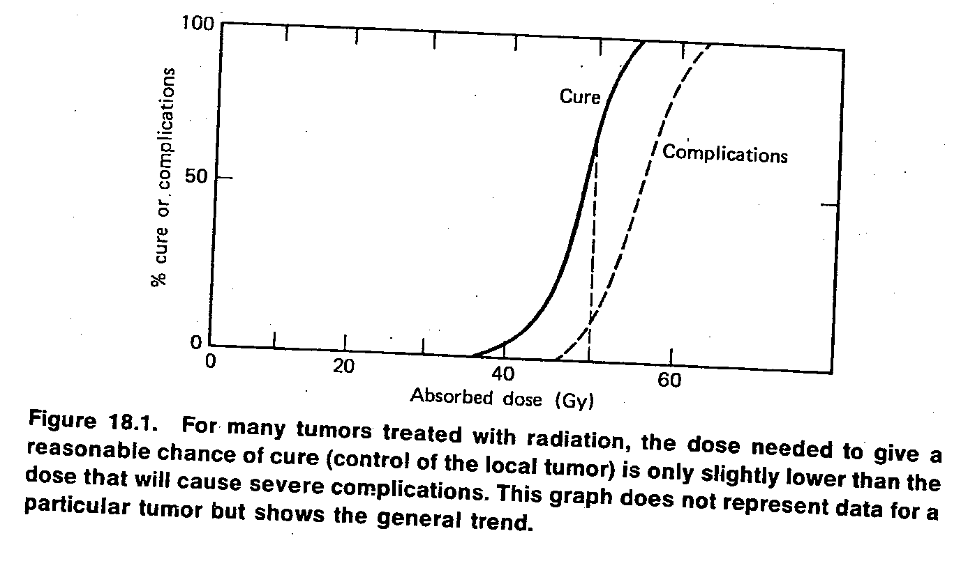

18.1. THE DOSE UNITS USED IN RADITHRAPY- THE RAD AND THE GRAY
In about 1950 the quantity absorbed dose was introduced and the rad was defined to measure it. From 1950 to 1975 the rad was the official unit of absorbed dose.
* The rad is defined as 100 ergs/g. That is, a radiation beam that gives 100 ergs of energy to 1 g of tissue gives the tissue an absorbed dose of 1 rad. (The terms dose and absorbed dose are used interchangeably in radiotherapy).
* The rad can be used for any type of radiation in any material; the roentgen (R) is defined only for x-rays and gamma rays in air.
* The rad can be related to the exposure in roentgens.
* The rad was defined so that for x-rays and gamma rays an exposure of 1 R would result in nearly 1 rad of absorbed dose in soft tissue (water).

3/6
*In bone the ratio of rads to roentgens depends on the energy of the x-ray photons.
* At the energies used in diagnostic radiology the ratio of rads to roentgens in bone is about 4; that is, 1 R exposure results in about 4 rads of absorbed dose.
* At the high energies used in modern radiotherapy the ratio of rads to roentgens is nearly 1 for both bone and soft tissue. (Fig. 18.2).
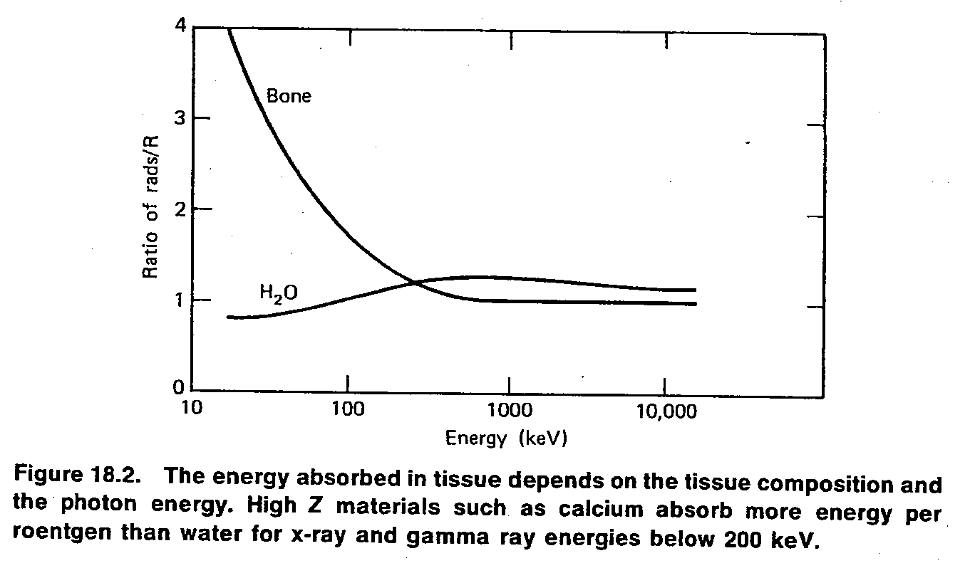
* In 1975 the International Commission on Radiological Units (ICRU) adopted the gray (Gy) as the international (SI) unit of dose. 1 Gy =1 J/kg. Since a joule is 10⁷ergs, a gray equals 100 rads. This unit was named after Harold Gray, the British medical physicist who discovered the oxygen effect.
18.2. PRINCIPLES OF RADIATION THERAPY
*The basic principles of radiation therapy is to maximize damage to the tumor while minimizing damage to normal tissue. This is generally accomplished by directing a beam of radiation at the tumor from several directions so that the maximum dose occurs at the tumor.
4/6
* Some normal tissues are more sensitive to radiation than others, and this is taken into account when therapist and physicist plan to treatment.
* Ionizing radiation, such as x-rays and gamma rays, tears electrons off atoms to produce positive and negative ions. It also breaks up molecules; the new chemicals formed are of no use to the body and can be considered a form of poison. The biochemical process of how x-rays kill cells is still being studied. We can for the present accept the simple theory that toxic chemicals formed in the cell by the breakup of the molecules kill the cell.

* How much radiation does it take to kill a cell? Factors that determine how much radiation is required are (1) the type of radiation , (2) the type of cell, (3) and the environment of the cell, for example, its blood and oxygen supplies. Also, the nucleus of the cell is more sensitive to radiation than the surrounding cytoplasm.
* Some types of radiation are more effective in killing cells, or have a higher relative biological effect (RBE).
*The RBE of a given radiation is defined as the ratio of the number of grays of 250 kV_{p} x-rays needed to produce a given biological effect to the number of grays of the test radiation needed to produce the same effect.

* Radiation that produces dense ionization generally is more lethal and has an RBE greater than 1. The RBE depends on the biological experiment used to measure the effect and is not the same for all tissues.

* Table 18.1 lists some approximate RBE values for several different types of radiation.

5/6
Table 18.1. Some Approximate RBE Values
for Different Types of Radiation
---------------------------------------------------------
Particle RBE
---------------------------------------------------------
Electrons or beta rays 1
X-rays or gamma rays 1
Fast neutrons 5
Alpha particles >10
Note: Experimentally, the quantity of radiation that will kill half of the organisms in a population (cells, mice, people, etc.) is called the lethal dose for 50% or LD₅₀. It is assumed that the radiation is given uniformly over the entire organism in a short period of time. This quantity is sometimes modified to include the time factor. For example, ${LD}_{50}^{30}$ or LD₅₀₍₃₀₎.
* The oxygen effect was discovered by Gray in England in about 1955. It is noticed that cells irradiated in the presence of oxygen were much easier to kill than cells of the same type irradiated without oxygen. The oxygen effect may play a role in the recurrence of cancer. The cells near the center of a large tumor have a poor blood supply and thus a poor oxygen supply. When the tumor is radiated the “healthy” cancer cells with a good blood supply are killed and many of the more poorly oxygenated, radioresistant tumor cells remain alive. These cells may later divide and permit the tumor to regrow. All radiation beams with RBE_{S} greater than 1 (such as fast neutrons) eliminate some or all oxygen effect.
* It was suggested that the radioresistance of the poorly oxygenated cells in the center of large tumors could possibly be overcome by increasing the oxygen supply to the entire body. The hypothesis was that improving the supply of oxygen to the oxygen-starved cells would make them easier to kill.
6/6
* Hyperbaric oxygen tanks were developed for radio therapy, and patients were treated with radiation while in sealed tanks with 3 atm of pure oxygen. The results of the hyperbaric oxygen technique were inconclusive, and most of the studies have been discontinued.
18.3. A SHORT COURSE IN RADIOTHERAPY TREATMENT PLANNING
The physicist working in radiotherapy has three important functions:
1- To determine how much radiation is being produced by a given therapy machine under standard conditions, that is, to calibrate the machine. Calibration includes determining not only the output at the treatment distance but also the grays per minute throughout the volume being irradiated under different operating conditions.
2- To calculate the does to be administrated to the tumor and any normal tissues in the patient. This is not easy, and many radiotherapy departments use computers to aid with this computation. The calculation should take into account irregularities in the shape of the patient and nonuniformities within the patient such as bone and air spaces (e.g., the lungs).
3- To confirm that the correct amount of radiation was really administrated to the patient at the proper locations.

