

**كلية الرشيد الجامعة/ قسم التمريض**

**مادة التشريح للمرحلة الاولى**

**المحاضرة السابعة**

**م.د الان علي**

**2024//2025**

**Endocrine System**

It’s the second major system (first is the CNS) which controls over the body, It’s characterized by rapidly response to various kind of stimuli.

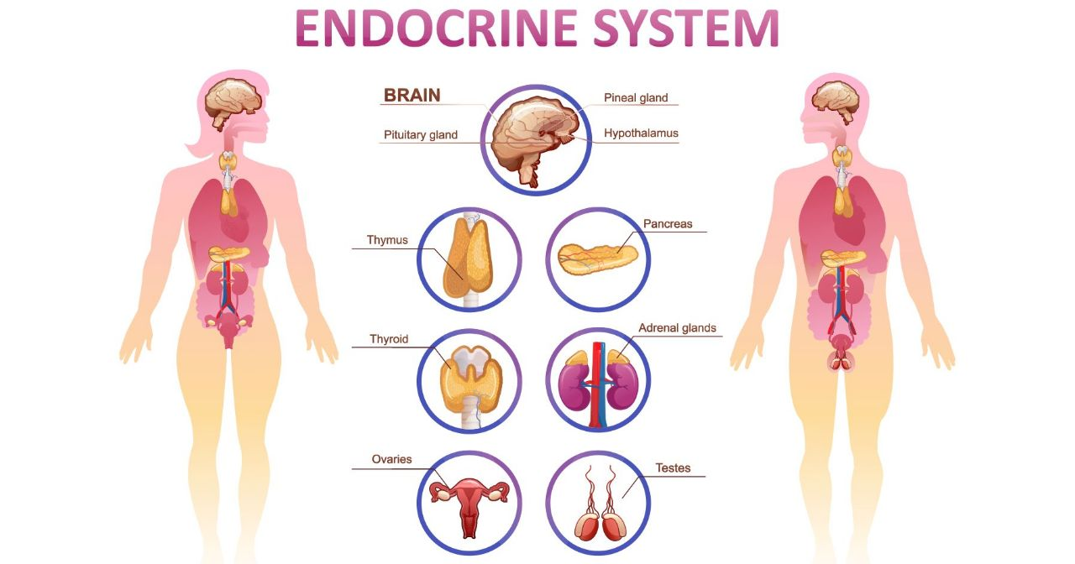

The endocrine system is made up of glands that produce and secrete hormones (which are chemical substances produced in the body that regulate the activity of cells or organs).

These hormones regulate the body's growth, metabolism, sexual development and function. The hormones are released into the bloodstream and may affect one or several organs throughout the body.

**Pituitary Gland**

Characterized by:

1- Size of a grape

2- Hangs by a stalk from the hypothalamus 3.Protected by the sphenoid bone

4- Has two functional lobes

5- Anterior pituitary – glandular tissue

6- Posterior pituitary – nervous tissue

• A signal is sent from the hypothalamus to the pituitary gland in the form of a "releasing hormone," which stimulates the pituitary to secrete a "stimulating hormone" into the circulation.

• The stimulating hormone then signals the target gland to secrete its hormone. As the level of this hormone rises in the circulation, the hypothalamus and the pituitary gland shut down secretion of the releasing hormone and the stimulating hormone, which in turn slows the secretion by the target gland (negative feedback). This system results in stable blood concentrations of the hormones that are regulated by the pituitary gland

**Characteristics of the anterior pituitary hormones:**

1. **Growth Hormone (GH)**

* General metabolic hormone
* Major effects are directed to growth of skeletal muscles and long bones
* Causes amino acids to be built into proteins
* Causes fats to be broken down for a source of energy

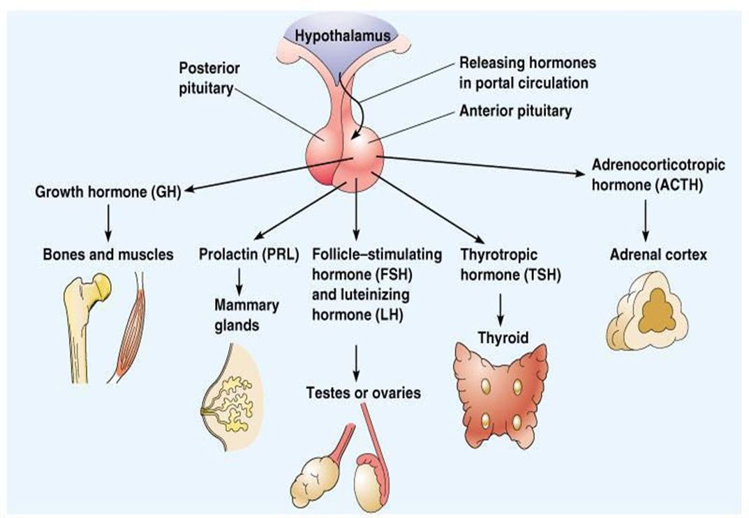

1. **Prolactin (PRL)**

* Stimulates and maintains milk production following childbirth
* Function in males is unknown

1. **Adrenocorticotropic hormone (ACTH)**

* Regulates endocrine activity of the adrenal cortex

1. **Thyroid-stimulating hormone (TSH)**

* Influences growth and activity of the thyroid

1. **Gonadotropic hormones:** Regulate hormonal activity of the gonads

* Follicle-stimulating hormone **(FSH)**

1. Stimulates follicle development in ovaries
2. Stimulates sperm development in testes

* Luteinizing hormone **(LH)**

1. Triggers ovulation
2. Causes ruptured follicle to become the corpus luteum
3. Stimulates testosterone production in males

**Characteristics of the posterior pituitary hormones:**

1. **Oxytocin**

* Stimulates contractions of the uterus during labor
* Causes milk ejection

1. **Antidiuretic hormone (ADH)**

* Can inhibit urine production
* In large amounts, causes vasoconstriction leading to increased blood pressure **(vasopressin)**

|  |  |  |
| --- | --- | --- |
| Hypothalamic Releasing  Hormone | Pituitary Stimulating Hormone | hormones |
| Thyrotrophin-releasing hormone (TRH) | Thyroid-stimulating hormone  (TSH) | Thyroid hormones T4,  T3 |
| Corticotrophin-releasing  factor (CRF) | Adrenocorticotrophin hormone(ACTH) | Cortisol |
| gonadotropin-releasing  hormone (GnRH) | Follicle-stimulating hormone (FSH), luteinizing hormone (LH) | Follicle-stimulating hormone (FSH), luteinizing hormone (LH) |
| Growth hormone-releasing  hormone (GHRH) | Growth hormone | Insulin like growth  factor-I (IGF-I) |

**The Thyroid gland**

It situated in the lower part of the neck the structure of the thyroid gland

1. It consist of two lobes on either side of the trachea, joined together by the isthmus which passes in front of the trachea just below the cricoid cartilage
2. The lobes are conical and have upper and lower poles.
3. Microscopically, it consist of many follicles, their shape depends on the stimulating by Thyrotrophin (thyroid stimulating hormone, TSH).

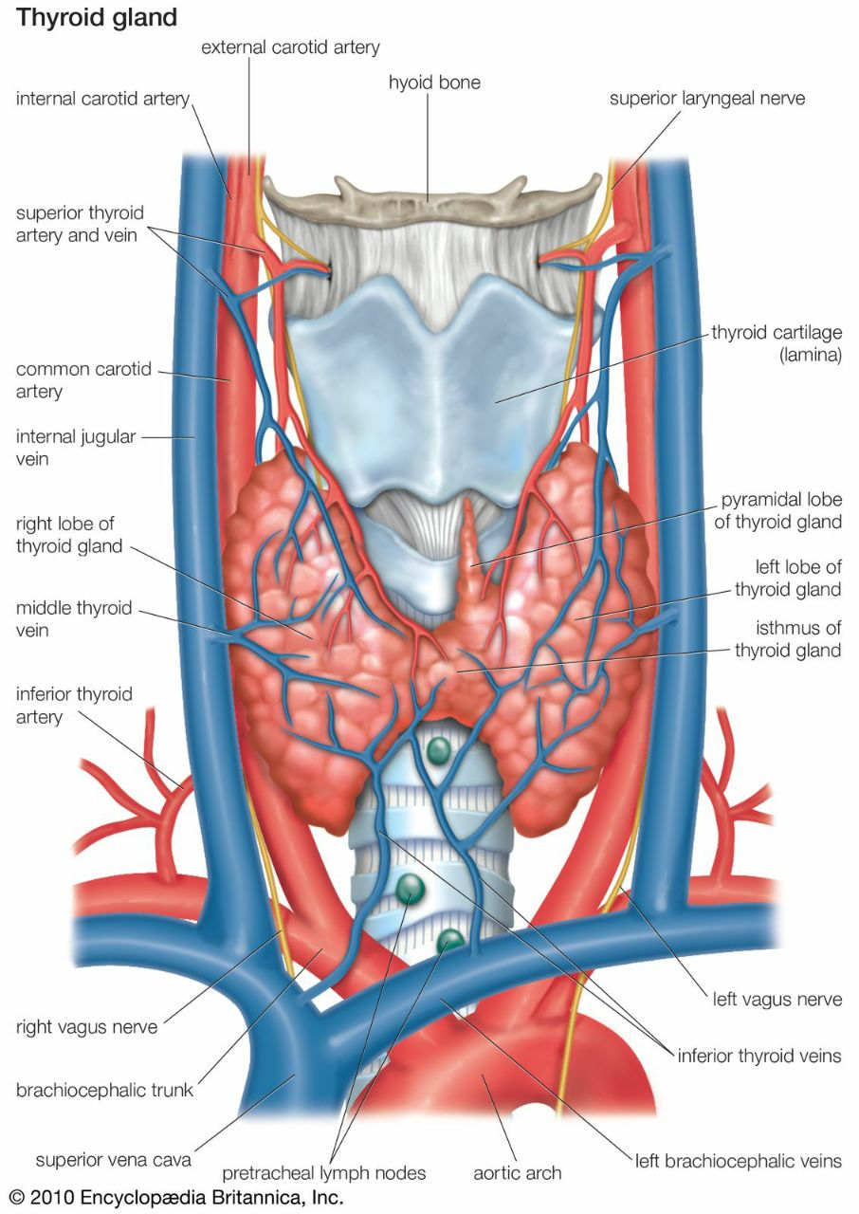

The function of The Thyroid gland

It secrete two types of hormones

1. The follicular cell which produce thyroid hormones Secretes two non-steroid hormones
2. Triiodothyronine (T3)
3. Thyroxin (T4)

• Regulates metabolism

• increases protein synthesis

• promotes glycolysis, gluconeogenesis, glucose uptake

1. Calcitonin: regulate calcium metabolism by decrease blood calcium produce by the Para-follicular cells (C cells) opposing the effect of parathyroid hormone

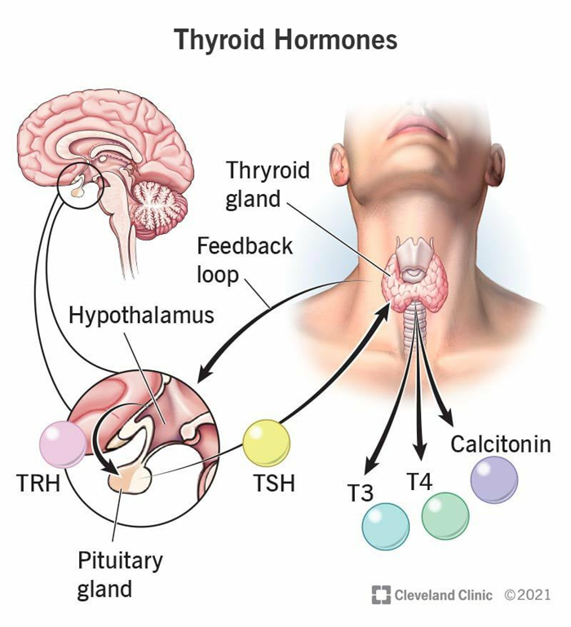

**Parathyroid gland**

• Are small ovoid glands smaller than the pea

• Lie on the posterior surface of the thyroid gland

• They are two pairs superior and inferior

•They released parathyroid hormone which raised serum calcium level

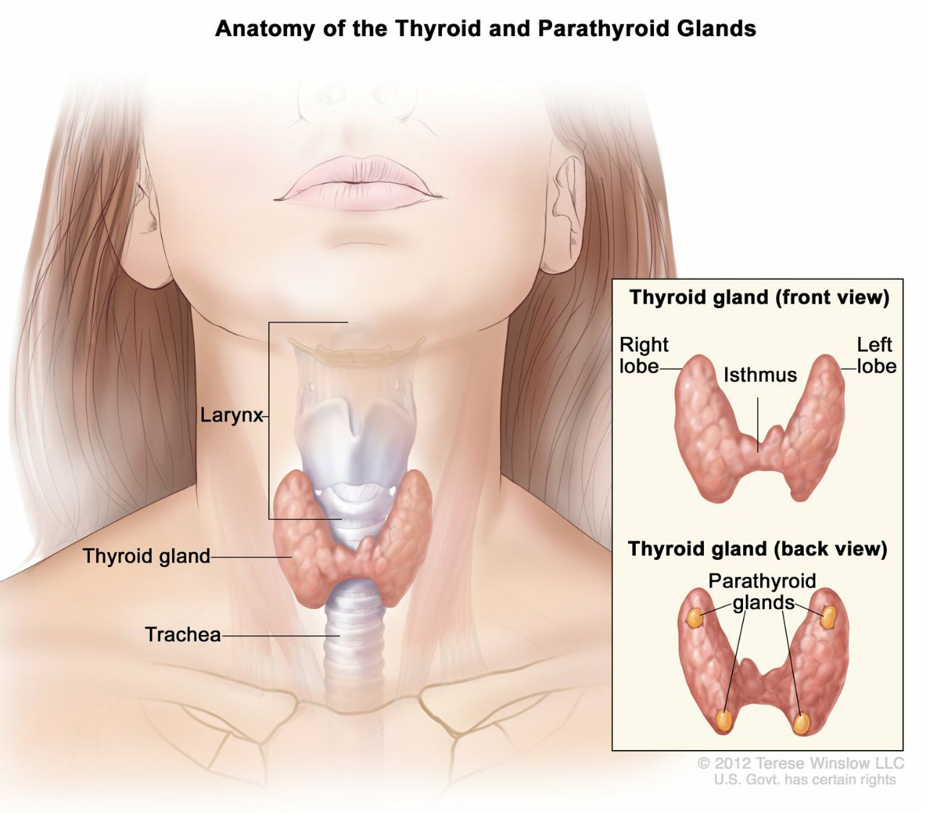

**The Adrenal glands**

• Are two small flattened yellowish bodies situated on the upper of each kidney

• The outer part of the gland is the cortex (yellowish)

• The inner part of the gland is the Medulla (dark)

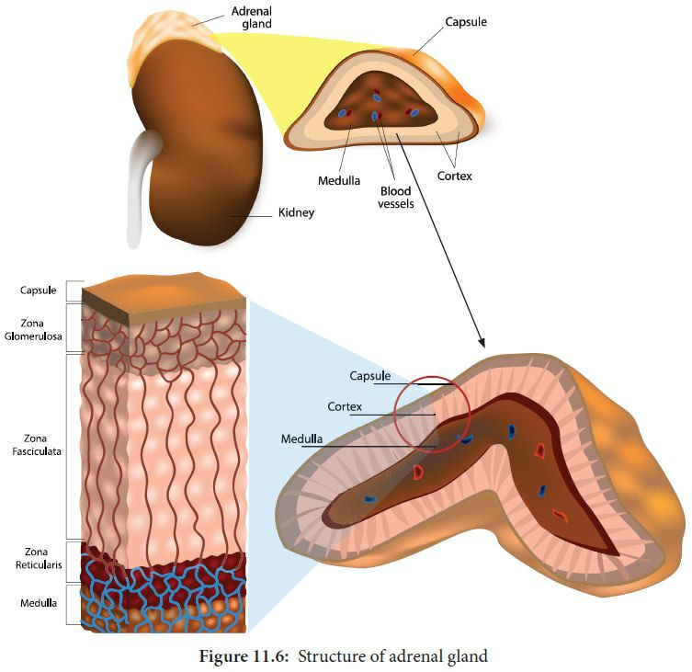

**The adrenal Medulla**

* Situated directly atop each kidney and stimulated by the sympathetic nervous system
* Secretes the catecholamines (epinephrine and norepinephrine)

Epinephrine: elicits a fight or flight response

1. Increase heart rate and blood pressure
2. Increase respiration
3. Increase metabolic rate
4. Increase glycogenolysis
5. Vasodilation

Norepinephrine; also known noradrenaline

**The adrenal Cortex**

• Secretes over 30 different steroid hormones (corticosteroids)

1. **Mineralocorticoids**; Aldosterone which maintains electrolyte balance
2. **Glucocorticoids** such as Cortisol:

• Stimulates gluconeogenesis

• Mobilization of free fatty acids

• Glucose sparing

• Anti-inflammatory agent

1. **Gonadocorticoids;** testosterone, estrogen, progesterone

**Pancreas**

Located slightly behind the stomach

1. **Insulin:** reduces blood glucose

• Facilitates glucose transport into the cells

• Promotes glycogenesis

• Inhibits gluconeogenesis

1. **Glucagon:** increases blood glucose

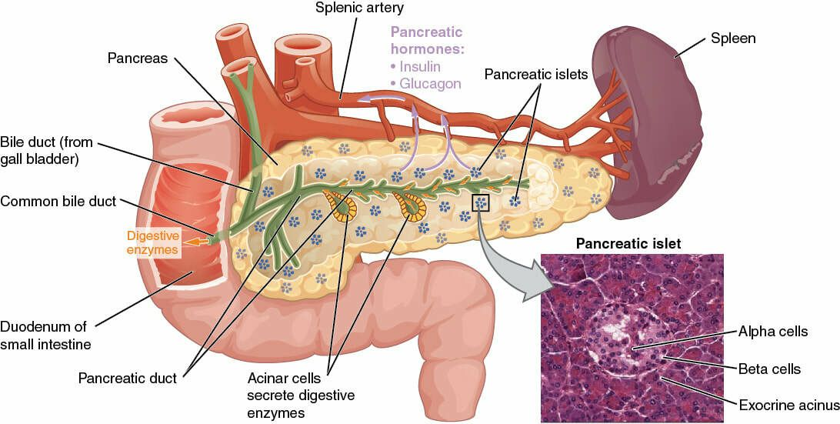

**Pineal Gland**

• Pineal Gland is a small reddish gray structure (about the size of a pea)

• Situated in the midline of the brain immediately behind the third ventricle and under the posterior end of corpus callosum

Pineal Gland produces melatonin Establishes body’s day/ night cycle

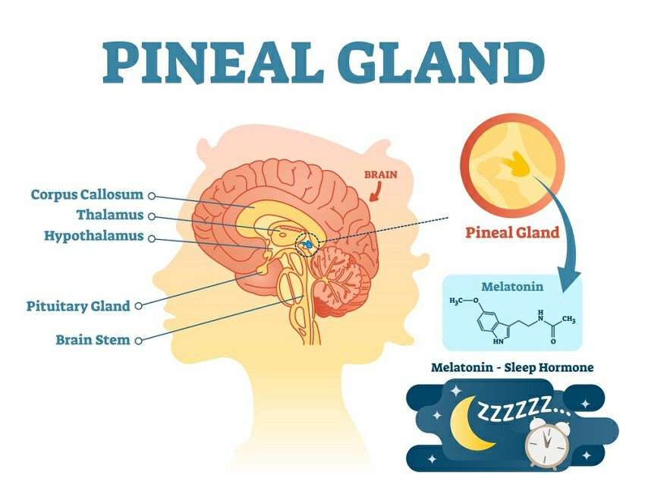

**Gonads**

1. testes (testosterone) = sex characteristics, muscle development and maturity
2. ovaries (estrogen) = sex characteristics, maturity and coordination

**Special senses**

Are the senses that have specialized organs of the five senses related to the organs of sight, hearing, smell, taste.

• vision (the eye)

• Hearing and balance (the ear, which includes the auditory system and vestibular system)

• smell (the nose)

• taste (the tongue)

**Vision;**

Visual perception is the ability to interpret the surrounding environment using light in the visible spectrum reflected by the objects in the environment. The resulting perception is also known as sight, or vision. The various physiological components involved in vision are referred to collectively as the visual system.

The eye itself is made of 10 general components that all work together to keep us seeing well every day.

Cornea; is the outermost layer of the eye and is primarily responsible for focusing the light that comes into our eyes.

Pupil; is the black circle in the center of the eye, and its primary function is to monitor the amount of light that comes into the eye.

Iris; is the colored part of the eye. Although it might seem purely cosmetic, the iris actually functions to adjust the size of the pupil.

Lens; exists behind the pupil and is responsible for allowing your eyes to focus on small details like words in a book.

Vitreous Humour; is a gel-like substance that helps to keep the eyeball in its proper, circular shape.

Retina; is the area at the back of the eye that receives the refined, visual message from the front of the eye, and it transmits that visual message to the brain using electrical signals.

Sclera; is the white part of the eye, and its main function is to provide strength, structure, and protection for the eye.

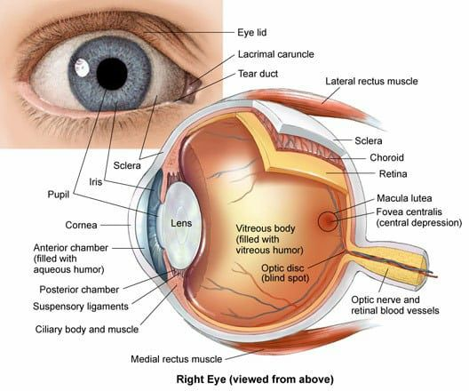

**Hearing;**

• The ear is the organ of hearing and is also involved in balance.

• It is supplied by the 8th cranial nerve (Vestibulocochlear nerve), which is stimulated by vibrations caused by sound waves.

• The ear is divided into three distinct parts

1. outer ear
2. middle ear (tympanic cavity)
3. Inner ear.

The outer ear collects the sound waves and directs them to the middle ear, which in turn transfers them to the inner ear, where they are converted into nerve impulses and transmitted to the hearing area in the cerebral cortex.

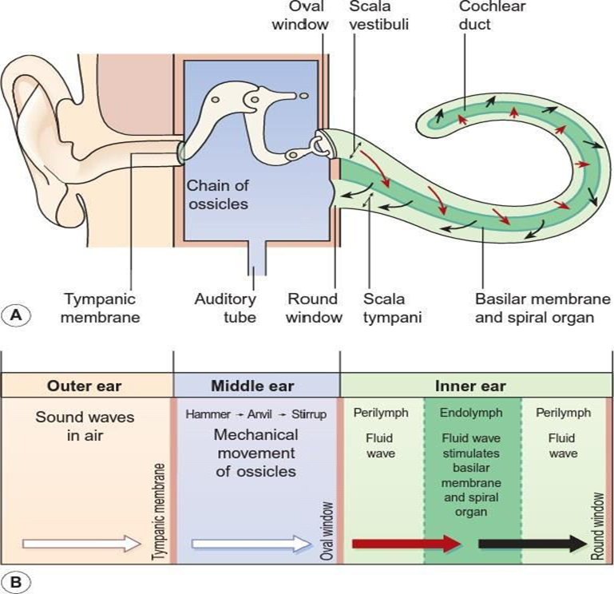

**Smell or olfaction**

Is a chemoreception that forms the sense of smell. Olfaction has many purposes, such as the detection of hazards, pheromones, and food. Olfaction occurs when odorants bind to specific sites on olfactory receptors located in the nasal cavity.

Within the nasal cavity, the turbinates in nasal serve to direct the inspired air toward the olfactory epithelium in the upper posterior region. This contains more than 100 million olfactory receptor cells. These specialized epithelial cells give rise to the olfactory vesicles containing kinocilia, which serve as sites of stimulus transduction.

**Taste**;

Is the sensation produced when a substance in the mouth reacts chemically with taste receptor cells located on taste buds in the oral cavity, mostly on the tongue. The tongue is covered with thousands of small bumps called papillae, which are visible to the naked eye.