

**كلية الرشيد الجامعة/ قسم التمريض**

**مرحلة اولى/ تشريح**

**المحاضرة السابعة**

**م.د الان علي**

**2023/2024**

**Urinary System**

Urinary system is the system of production, storage and elimination of urine.

It also known as excretory system of human body. Urinary system is important for keeping the internal environment of the body clean. Urinary system maintains proper homeostasis of water, salts and nitrogenous wastes.

Formation and elimination of urine is important for human body because urine contains nitrogenous wastes of the body that must be eliminated to maintain homeostasis.

Nitrogenous wastes are formed by metabolic activities in the cells. These nitrogenous wastes along with excess of salts and water are combined in the kidneys to form urine.

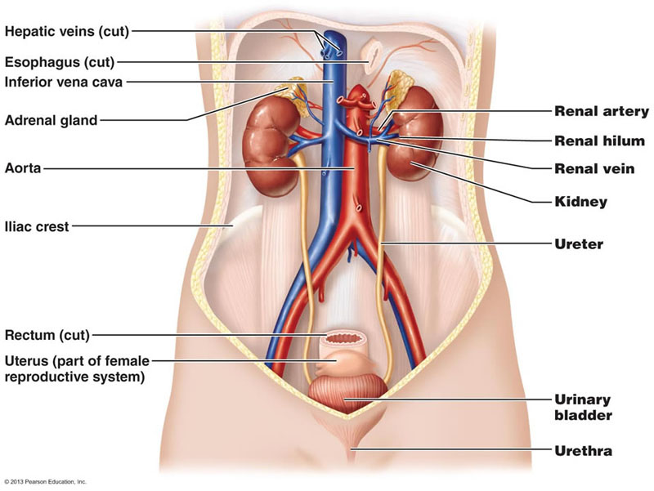

**Components of urinary system**:

Human urinary system consists of two kidneys, two ureters, a urinary bladder, a urethra and sphincter muscles.

Kidneys

1. Kidneys are two bean shaped organs lying close to the lumbar spine on either side, they are multifunction organ, form urine and control its concentration. It filter the blood taking out the waste products of metabolism such as urea.
2. Ureters; Two hollow muscular tubes one arising from each kidney and ending at the urinary bladder, connect kidneys to the bladder and carry urine from the kidney to the urinary bladder.
3. Urinary Bladder; It stores urine before it is excreted from the body, hollow muscular and distensible organ, sits on the pelvic floor.
4. Urethra; is a tube connecting the urinary bladder to the genitals for excretion, carries urine outside of the body.

**Functions of urinary system**: Are Excretion of nitrogenous wastes, Osmoregulation, Acid-Base balance . It performs the following important functions;

1- Formation and elimination of urine: The main function of urinary system is formation and elimination of urine. Urine is formed by the kidneys in 3 steps;

1. Glomerular Filtration
2. Tubular reabsorption,
3. Tubular secretion.

2- Osmoregulation: Kidneys are important osmoregulatory organs of human body. They maintain salt and water balance of the body. If the concentration of salt or water is increased above normal, kidney will excrete the excess amount. If the concentration is decreased, kidneys will reduce the loss of water and salts in urine.

3-Acid base balance: Kidneys are important regulators of pH of body fluids. Kidneys keep the pH balanced within a very small range and provide an optimum environment for all processes of life.

Structure of kidney

There are approximately 1 million nephrons in each kidney.

Nephron -  is the functional unit of the kidney.

They are composed of four main parts:

1- Bowman's capsule - where filtration occurs.

2-Proximal convoluted tubule - where most reabsorption occurs.

3- Loop of Henle - where more reabsorption occurs.

4- Distal convoluted tubule - where reabsorption of water and secretion of drugs and hydrogen ions occurs

