**Special senses**

Are the senses that have specialized organs of the five senses related to the organs of sight, hearing, smell, taste.

• vision (the eye)

• Hearing and balance (the ear, which includes the auditory system and vestibular system)

• smell (the nose)

• taste (the tongue)

**Vision;**

Visual perception is the ability to interpret the surrounding environment using light in the visible spectrum reflected by the objects in the environment. The resulting perception is also known as sight, or vision. The various physiological components involved in vision are referred to collectively as the visual system.

The eye itself is made of 10 general components that all work together to keep us seeing well every day.

Cornea; is the outermost layer of the eye and is primarily responsible for focusing the light that comes into our eyes.

Pupil; is the black circle in the center of the eye, and its primary function is to monitor the amount of light that comes into the eye.

Iris; is the colored part of the eye. Although it might seem purely cosmetic, the iris actually functions to adjust the size of the pupil.

Lens; exists behind the pupil and is responsible for allowing your eyes to focus on small details like words in a book.

Vitreous Humour; is a gel-like substance that helps to keep the eyeball in its proper, circular shape.

Retina; is the area at the back of the eye that receives the refined, visual message from the front of the eye, and it transmits that visual message to the brain using electrical signals.

Sclera; is the white part of the eye, and its main function is to provide strength, structure, and protection for the eye.

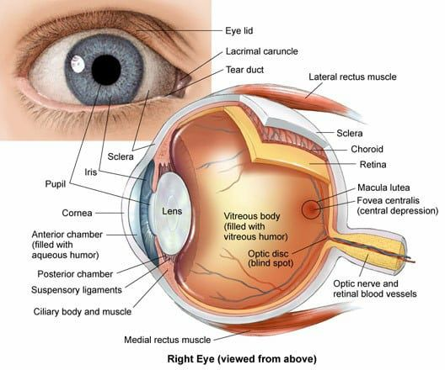

**Hearing;**

• The ear is the organ of hearing and is also involved in balance.

• It is supplied by the 8th cranial nerve (Vestibulocochlear nerve), which is stimulated by vibrations caused by sound waves.

• The ear is divided into three distinct parts

1. outer ear
2. middle ear (tympanic cavity)
3. Inner ear.

The outer ear collects the sound waves and directs them to the middle ear, which in turn transfers them to the inner ear, where they are converted into nerve impulses and transmitted to the hearing area in the cerebral cortex.

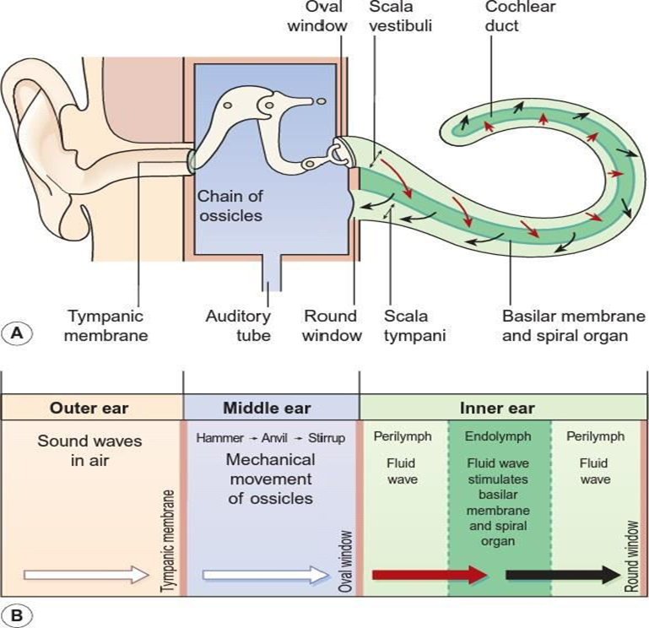

**Smell or olfaction**

Is a chemoreception that forms the sense of smell. Olfaction has many purposes, such as the detection of hazards, pheromones, and food. Olfaction occurs when odorants bind to specific sites on olfactory receptors located in the nasal cavity.

Within the nasal cavity, the turbinates in nasal serve to direct the inspired air toward the olfactory epithelium in the upper posterior region. This contains more than 100 million olfactory receptor cells. These specialized epithelial cells give rise to the olfactory vesicles containing kinocilia, which serve as sites of stimulus transduction.

**Taste**;

Is the sensation produced when a substance in the mouth reacts chemically with taste receptor cells located on taste buds in the oral cavity, mostly on the tongue. The tongue is covered with thousands of small bumps called papillae, which are visible to the naked eye.