

**كلية الرشيد الجامعة / قسم التمريض**

**المرحلة الاولى الكورس الثاني**

**المحاضرة الاولى**

**مادة الفسلجة**

**م.د الان علي**

**/20242023**

**Introduction to physiology**

**Physiology;** is the science which explain the physical and chemical factors that are responsible for the origin, development, and progression of life.

It is a branch of biology that deals with the functions and activities of life or of living matter (such as organs, tissues, or cells) and of the physical and chemical phenomena involved.

Body fluids; are liquids originating from inside the bodies of living humans. They include fluids that are excreted or secreted from the body. Human blood, body fluids

Total amount of fluids in the human body is approximately 60% of body weight and that varies according to (sex, weight, age & amount of body fat)

Body fluid has been divided into two compartments

**Intracellular fluid (ICF);** Inside the cells, 2/3 of total body fluids

**Extracellular fluid (ECF);** Outside the cells, 1/3 of total body fluids, which includes 80% interstitial fluids (fluids between cells) and 20% intravascular fluids (plasma). It also includes; Lymph, synovial fluid, cerebrospinal fluid, pleural, pericardial and peritoneal fluids.

1. **Interstitial fluids**; Also known as intercellular fluid and tissue fluid. It is fluid between the cells of which delivers materials to the cells, intercellular communication, and removal of metabolic waste. it represents the largest portion of the ECF compartment. Interstitial fluid consists of a water solvent containing amino acids, sugars, fatty acids, coenzymes, hormones, neurotransmitters, salts, as well as waste products from the cells. This fluid presents as gel-like extracellular matrix.
2. **Blood plasma:** It is the fluid portion of the blood. which transports oxygen from the lungs to the body cells and carbon dioxide from the body cells to the lungs. Blood also transports nutrients derived from food in the intestine to the body cells., other nutrients between organs.

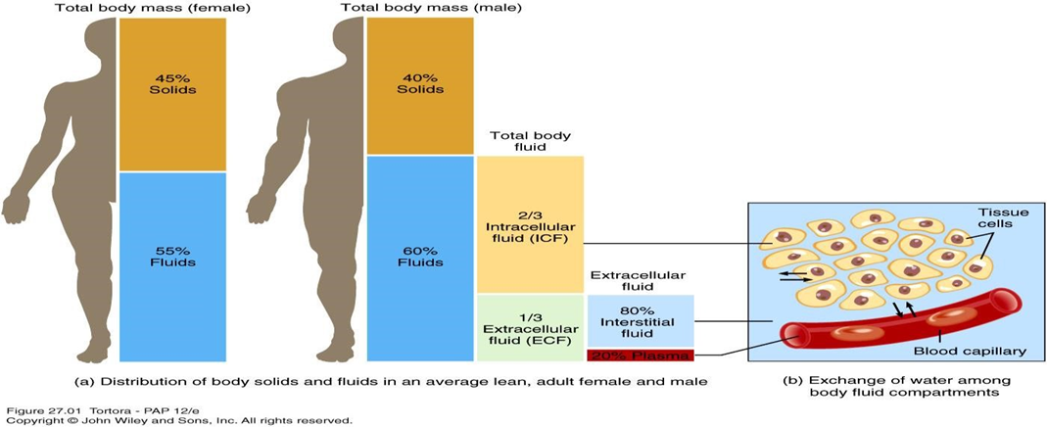

Composition of body fluids;

1. Water; Since water passes freely across cell membrane, the volume of the various fluid compartments is determined by unique solutes that are confined to each space
2. Dissolved solutes;
3. Organic substance; Glucose, Amino acids, Fatty acids, Hormones, Enzymes.
4. Inorganic substance; sodium, potassium, calcium, chloride, magnesium, phosphate, sulphate.

Electrolytes of the body fluids;

Electrolytes are salts and minerals that can conduct electrical impulses in the body. Common human electrolytes are sodium, chloride, potassium, calcium, and bicarbonate.

Electrolytes in body fluids are charged, it can be:

* Cation - positively charged electrolyte, e.g .Na+, k+,Ca+2
* Anion - negatively charged electrolyte, e.g, Cl-, HCO3- , po4-3

The chief extracellular cation is Na+ The chief intracellular cations are k+

Cl- is the predominant anion outside cells whereas phosphates constitute the bulk of intracellular anions.

The important of Electrolytes:

1- Control the fluid balance of the body

2- important in muscle contraction

3-important in energy generation

4-particepat in almost every major biochemical reaction in the body

Movement of body fluids:

Cell membrane can transport body fluids by many processes which includes;

1. **Passive transport;** it is the movement of substances across a membrane from higher to lower concentration, it does not require metabolic energy.
2. Simple diffusion; It is the movement of substances from a region of high concentration to a region of low concentration. Generally, simple diffusion of water, gases, and other small uncharged molecules across plasma membranes can occur in the absence of transport proteins.
3. Facilitated diffusion; It is a transport of substances across a biological membrane from an area of higher concentration to an area of lower concentration by a carrier protein.

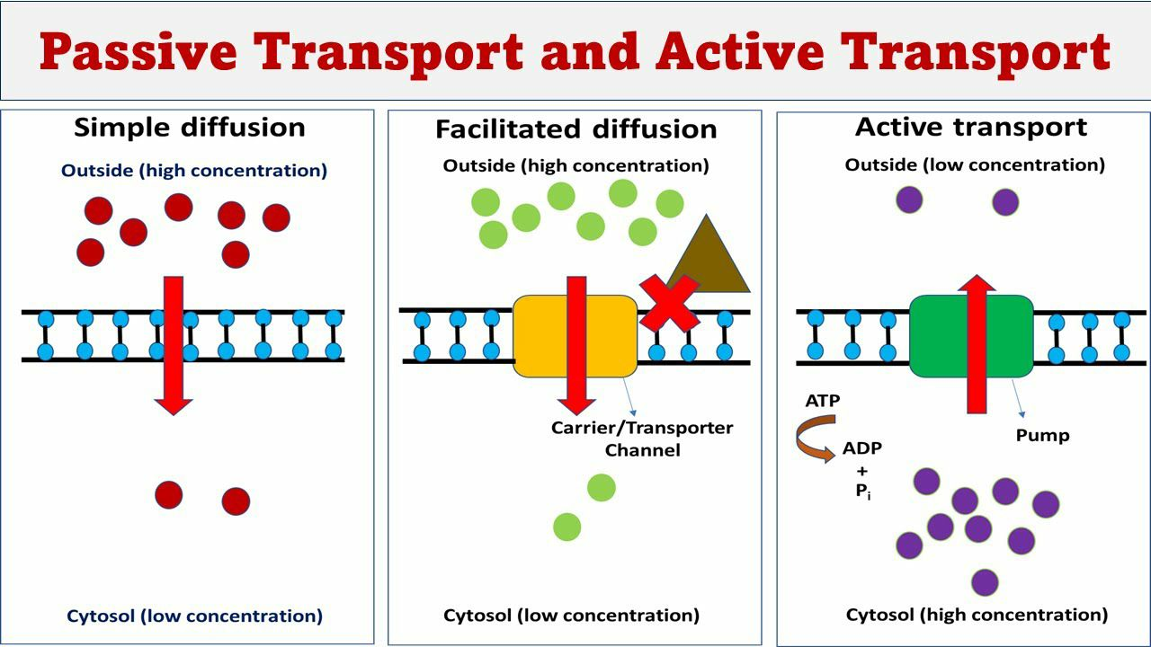

1. **Active transport:** It is the movement of substances across a membrane against gradient (from low concentration to high concentration). Active transport requires energy (ATP) and involves specific carrier proteins.
2. Hydrostatic pressure; It is physiological processes that regulate fluids intake & output as well as movement of water & substances dissolved in it between the body compartments
3. osmotic pressure: The pressure exerted by the flow of water through a semi-permeable membrane separating two solutions with different concentration of solute, which forces the water to move from where there is little dissolved solute to where there is lots dissolved solutes

**Osmosis:** It is diffusion of a solvent (usually water molecules) through a semipermeable membrane from an area of low solute concentration to an area of high solute concentration.

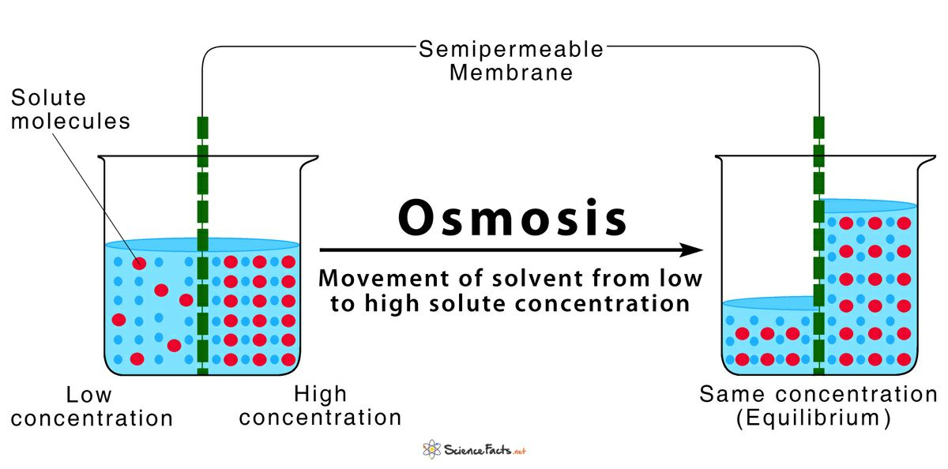

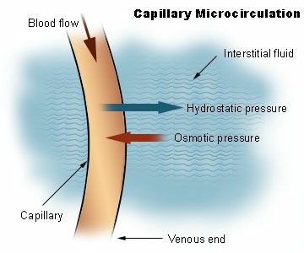

**Regulation of fluid volume in body;**

Water Intake: The volume of water gained each day varies from one individual to the next. About 60% of daily water is gained from drinking, another 30% comes from moist foods, and 10% from the water of metabolism.

Regulation of Water Intake:

* The thirst mechanism is the primary regulator of water intake.

* The thirst mechanism derives from the osmotic pressure of extracellular fluids and a thirst center in the hypothalamus.

* Once water is taken in, the resulting distention of the stomach will inhibit the thirst mechanism

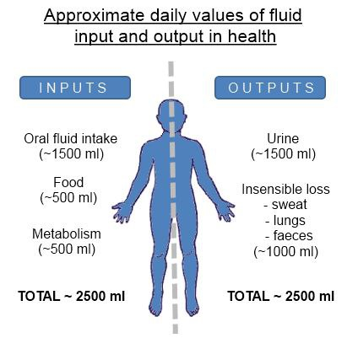

water Output: Water is lost in urine, feces, perspiration, evaporation from skin (insensible perspiration), and from the lungs during breathing. The route of water loss depends on temperature, relative humidity, and physical exercise.

Regulation of Water Output:

* The distal convoluted tubules and collecting ducts of the nephrons regulate water output. Antidiuretic hormone (ADH) from the posterior pituitary causes a reduction in the amount of water lost in the urine. When drinking adequate water, the ADH mechanism is inhibited, and more water is expelled in urine

* Renin/angiotensin/aldosterone system

* Baroreceptors in carotid arteries and aorta

* Stretch receptors in atrium and juxtaglomerular apparatus

* Cortisol