

كلية الرشيد الجامعة/قسم كلية التمريض
مادة الفسلجة للمرحلة الاولى
المحاضرة الثانية
م.د الان علي
2024/2023

Physiology of cardiac system
The heart
Is a muscular pump that drives the blood through the blood vessels. This organ is located between the lung in the center and a bit to the left on the midline of the body. Consist of four chambers, 2 in either side of the heart, one a receiving chamber (antrum) and the other a pumping chamber (ventricle)
Structures of the heart
The heart is a hallow organ, the walls of which are formed of three different layers
- The endocardium; is a very thin smooth layer of cells that lines the interior of the heart
- The myocardium; the muscle of the heart, is the thick layer
- The pericardium; which forms the thin outermost layer of the heart

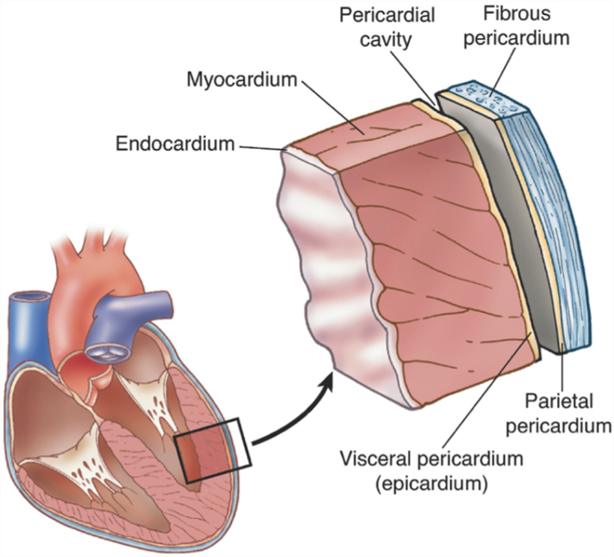

The heart valves:
- The tricuspid valve; regulates blood flow between the right atrium and right ventricle
- The mitral valve; lets oxygen-rich blood from the lungs and pass from the left atrium in to the left ventricle
- The pulmonary valve; controls blood flow from the right ventricles into the pulmonary arteries which carry blood to the lung
- The aortic valve; opens the way for oxygen rich blood to pass from the left ventricle into the aorta, the body's largest artery, where it is delivered to the rest of the body

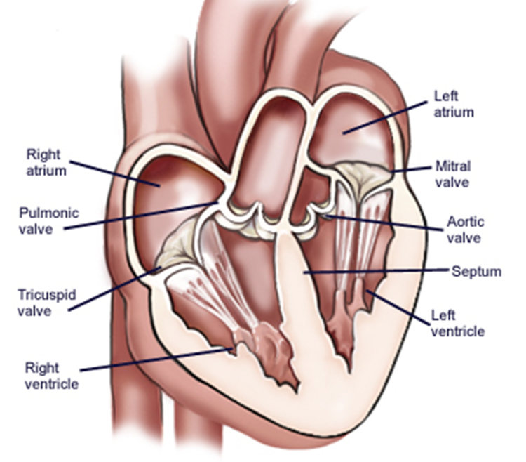

Pulmonary and Systemic Circulations;
Pulmonary circulation:
Path of blood from right ventricle through the lungs and back to the heart.
Systemic circulation:
Oxygenated blood is pumped to all organ systems.
Rate of blood flow through systemic circulation = flow rate through pulmonary circulation.

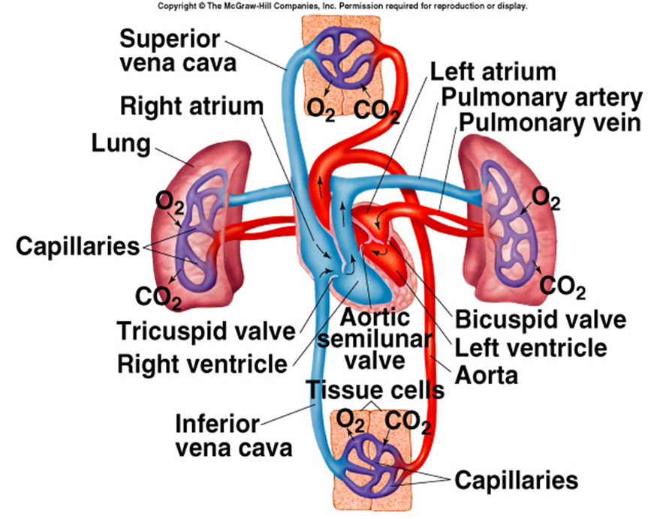

Cardiac Cycle;
Refers to the repeating pattern of contraction and relaxation of the heart.
Systole: Phase of contraction.
Diastole: Phase of relaxation.
The two atria fill with blood and then contract simultaneously. This is followed by simultaneous contraction of both ventricles, which sends blood through the pulmonary and systemic circulations.
Pressure changes in the atria and ventricles as they go through the cardiac cycle are responsible for the flow of blood through the heart chambers and out into the arteries
Step 1: Isovolumetric contraction:
QRS just occurred.
the ventricles begin their contraction
Contraction of the ventricle causes ventricular pressure to rise above atrial pressure: AV valves close.
Ventricular pressure is less than aortic pressure: Semilunar valves are closed.
neither being filled with blood (because the AV valves are closed) nor ejecting blood
Volume of blood in ventricle is end diastolic volume.
Step 2: Ejection:
Contraction of the ventricle causes ventricular pressure to rise above aortic pressure.
Semilunar valves open.
Ventricular pressure is greater than atrial pressure.
AV valves are closed, Semilunar valves open.
Volume of blood ejected is stroke volume
Step 3: isovolumetric relaxation
T wave occurs
Ventricular pressure drops below aortic pressure.
Back pressure causes semilunar valves to close.
AV valves are still closed.
Volume of blood in the ventricle: end systolic volume.
Step 4: Rapid filling of ventricles (passive):
Ventricular pressure decreases below atrial pressure.
AV valves open.
Rapid ventricular filling occurs.
Step 5: Atrial systole (active filling of ventricles):
P wave occurs.
Atrial contraction.
Push 10-30% more blood into the ventricle.

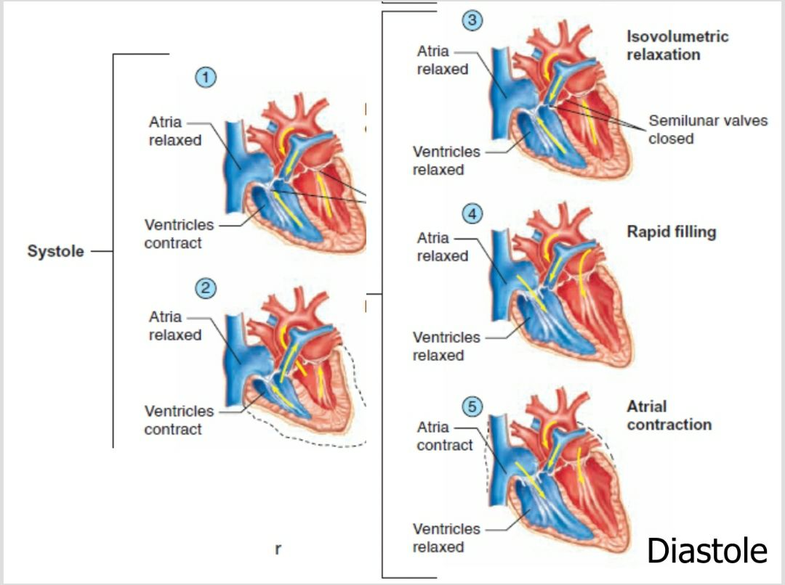
ventricles are about 80% filled with blood even before the atria contract. Contraction of the atria adds the final 20% to the EDV
end-diastolic volume (EDV); which is the total volume of blood in the ventricles at the end of diastole.
End-systolic volume (ESV):
*Amount of blood left in the ventricles at the end of systole.
*ejects about two-thirds of the blood they contain—an amount called the stroke volume —leaving one-third of the initial amount left in the ventricles
Stroke volume (SV): Amount of blood ejected from ventricles during systole.
Cardiac output= heart rate * stroke volume
Conducting Tissues of the Heart;
APs spread through myocardial cells through gap junctions.
Impulses cannot spread to ventricles directly because of fibrous tissue.
Conduction pathway:
- SA node.
- AV node.
- Bundle of His.
- Purkinje fibers.
Stimulation of Purkinje fibers cause both ventricles to contract simultaneously.
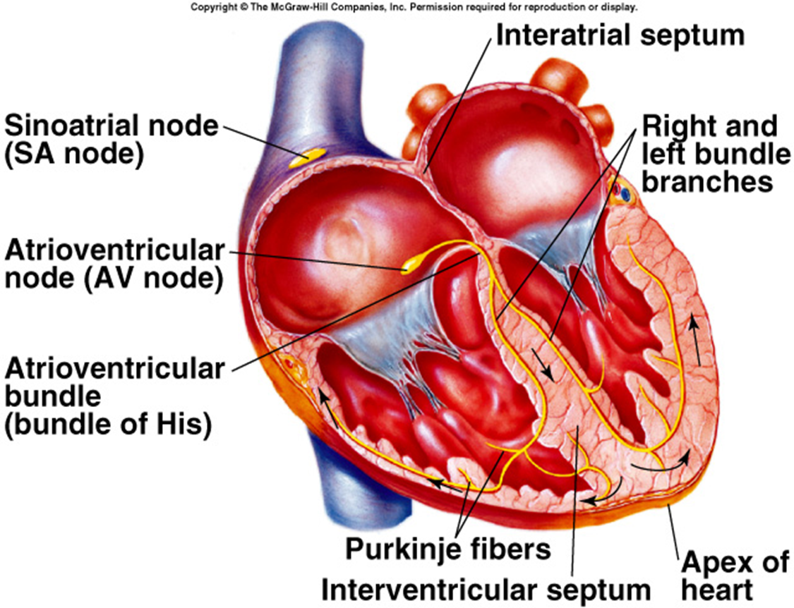

Conduction of Impulse;
Action potential (is a brief change in voltage -membrane potential- across the cell membrane of the heart cells) passes from SA node and spread quickly at rate of 0.8 - 1.0 m/sec.
Time delay occurs as impulses pass through AV node.
Slow conduction of 0.03 – 0.05 m/sec.
Impulse conduction increases as spread to Purkinje fibers at a velocity of 5.0 m/sec.
Ventricular contraction begins 0.1–0.2 sec. after contraction of the atria.
Electrocardiogram (ECG/EKG)
The body is a good conductor of electricity.
Tissue fluids have a high [ions] that move (creating a current) in response to potential differences.
Electrocardiogram: Measure of the electrical activity of the heart per unit time.
Potential differences generated by the heart are conducted to the body surface, where they can be recorded by surface electrodes placed on the skin.
The recording obtained is called an electrocardiogram (ECG or EKG); the recording device is called an electrocardiograph
Ten electrodes are needed to produce 12 electrical views of the heart. An electrode lead, or patch, is placed on each arm and leg and six are placed across the chest wall. The signals received from each electrode are recorded. The printed view of these recordings is the electrocardiogram
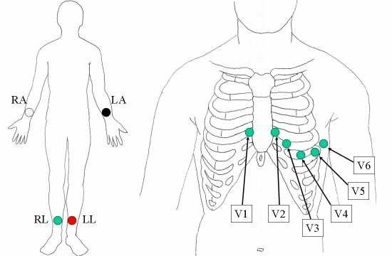
Electrodes and lead Commonly, 10 electrodes attached to the body are used to form 12 ECG leads, which are listed below.
Electrode name Electrode placement
RA On the right arm, avoiding thick muscle.
LA In the same location where RA was placed, but on the left arm.
RL On the right leg, lower end of inner aspect of calf muscle.
LL In the same location where RL was placed, but on the left leg.
V1 In the fourth intercostal space (between ribs 4 and 5) just to the right of the sternum (breastbone).

V2 In the fourth intercostal space (between ribs 4 and 5) just to the left of the sternum.
V3 Between leads V2 and V4.
V4 In the fifth intercostal space (between ribs 5 and 6) in the mid-clavicular line.
V5 Horizontally even with V4, in the left anterior axillary line.
V6 Horizontally even with V4 and V5 in the mid-axillary line.
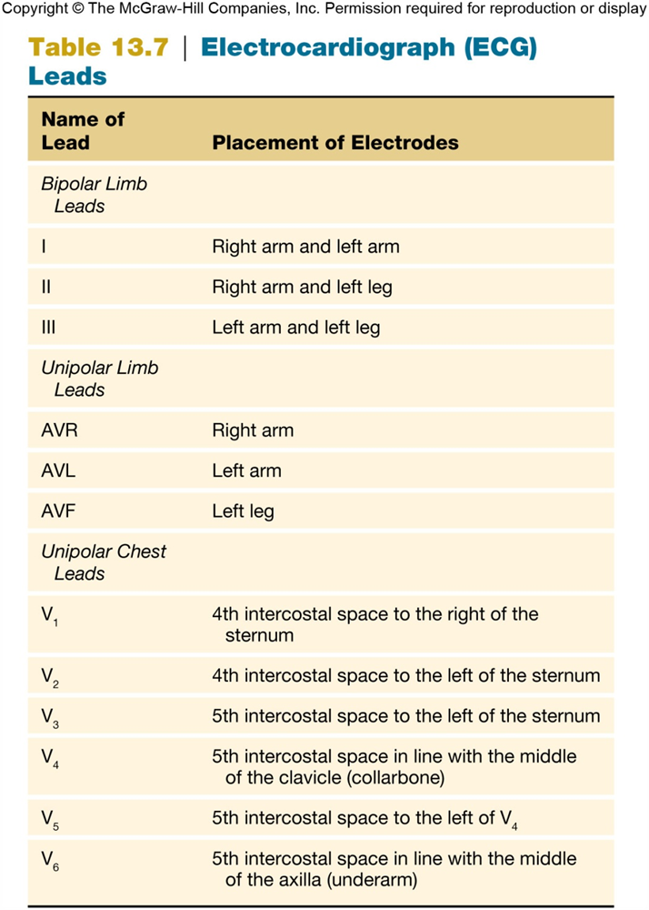

Normal electrocardiogram (ECG): There are three main components to an ECG: The P wave, which represents the depolarization of the atria; the QRS complex, which represents the depolarization of the ventricles; and the T wave, which represents the repolarization of the ventricles. The waves can also be further broken down into the following:
•P is the atrial systole contraction pulse
•Q is a downward deflection immediately preceding the ventricular contraction
•R is the peak of the ventricular contraction
•S is the downward deflection immediately after the ventricular contraction
•T is the recovery of the ventricles
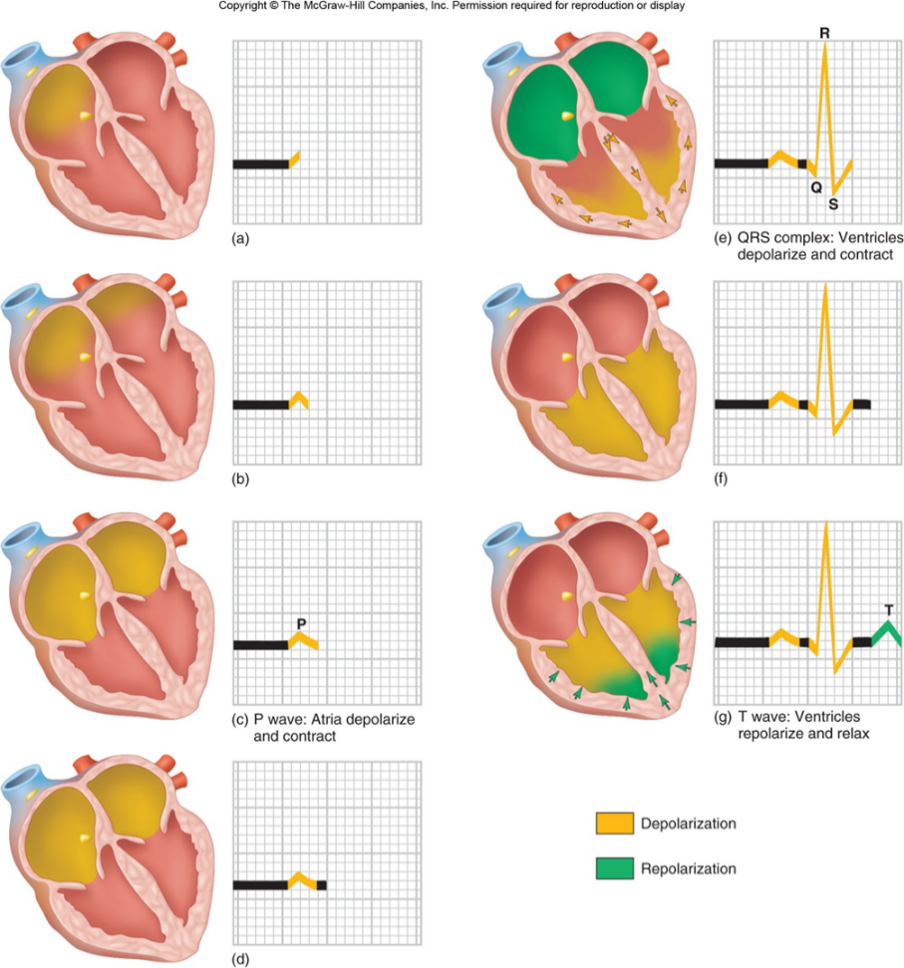
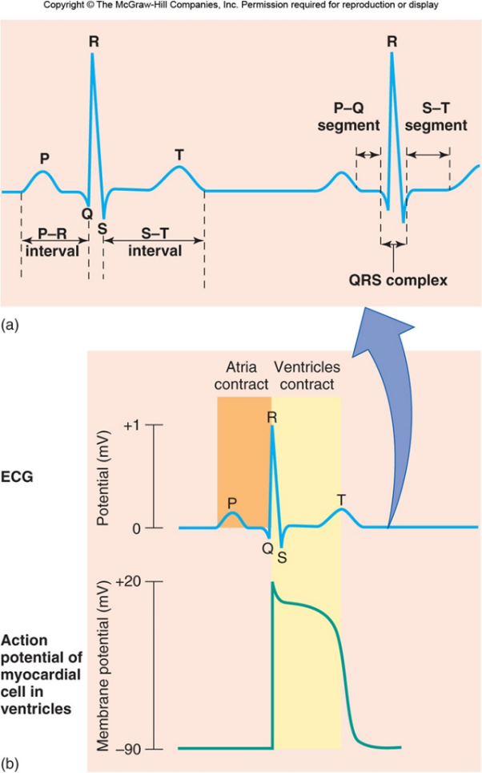
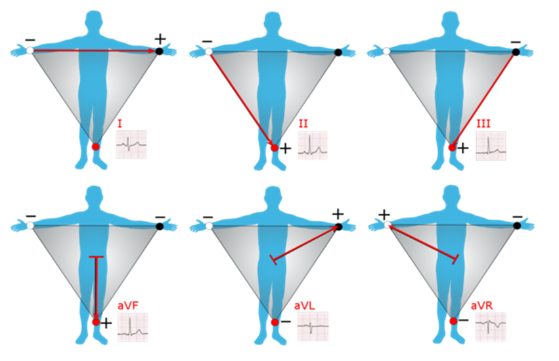

Blood Vessels; Walls composed of 3 “tunics:”
Tunica externa: Outer layer comprised of connective tissue.
Tunica media: Middle layer composed of smooth muscle.
Tunica interna: Innermost simple squamous endothelium.
Basement membrane (a layer of glycoproteins).
Layer of elastin forming an internal elastic lamina.
Arteries have thicker wall (more muscles), more elastic fibers
Veins have wider lumen & valves
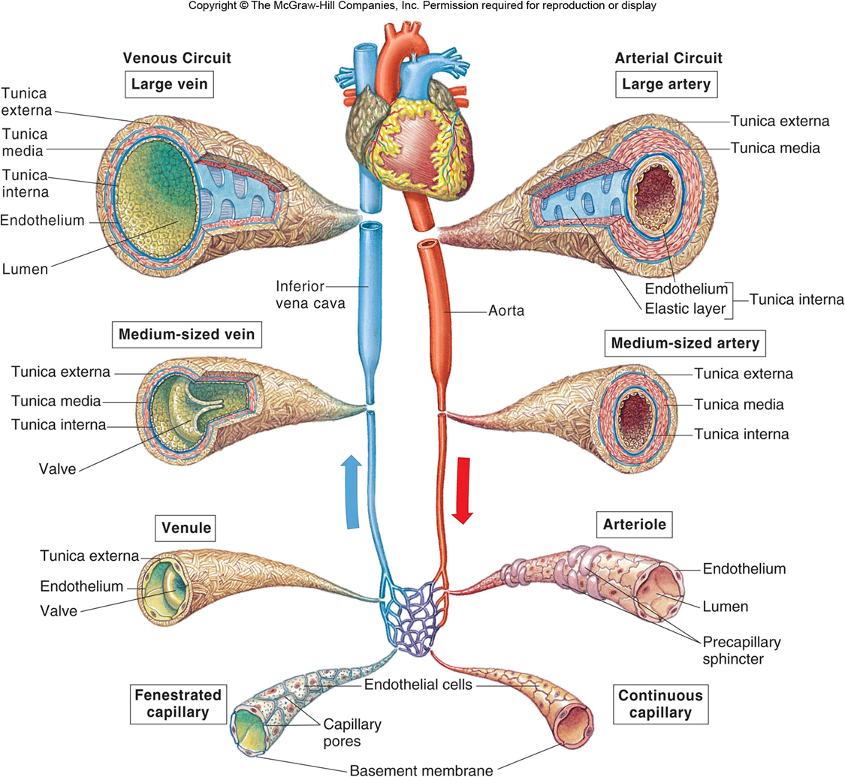
Elastic arteries like aorta:
* Numerous layers of elastin fibers between smooth muscle.
* Expand when the pressure of the blood rises.
* Recoil like a stretched rubber.
Muscular arteries:
Are less elastic and have a thicker layer of smooth muscle. Diameter changes slightly as BP raises and falls.
The small arteries and arterioles are less elastic than the larger arteries and have a thicker layer of smooth muscle for their diameters.
Because arterioles and small muscular arteries have narrow lumina, they provide the greatest resistance to flow.
Vasoconstriction vs. vasodilation
Resistance to blood flow is increased by vasoconstriction of arterioles (by contraction of their smooth muscle layer), which decreases the blood flow downstream in the capillaries.
vasodilation of arterioles (by relaxation of the smooth muscle layer) decreases the resistance and thus increases the flow through the arterioles to the capillaries.
Norepinephrine: vasoconstrictor effect
Acetylcholine: vasodilator effect

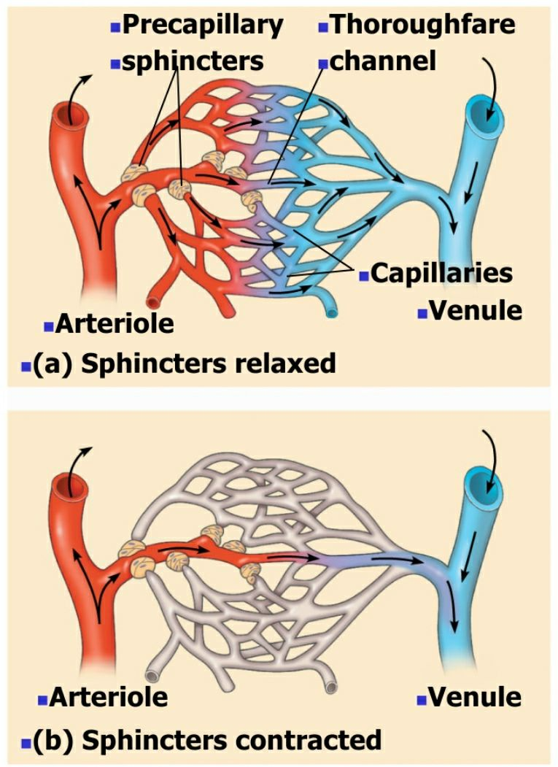
Capillaries;
*Smallest blood vessels.
*1 endothelial cell thick.
*Provide direct access to cells.
*Permits exchange of nutrients and wastes.
Types;
1. Continuous: Adjacent endothelial cells tightly joined together.
Intercellular channels that permit passage of molecules (other than proteins) between capillary blood and tissue fluid.
2. Fenestrated: Provides greater permeability
Wide intercellular pores covered by a layer of mucoprotein, which serves as a basement membrane over the capillary endothelium. This mucoprotein layer restricts the passage of certain molecules.
Kidneys, endocrine glands, and intestines.
3. Discontinuous (sinusoidal): Have large, leaky capillaries. can be found in Liver, spleen, and bone marrow.
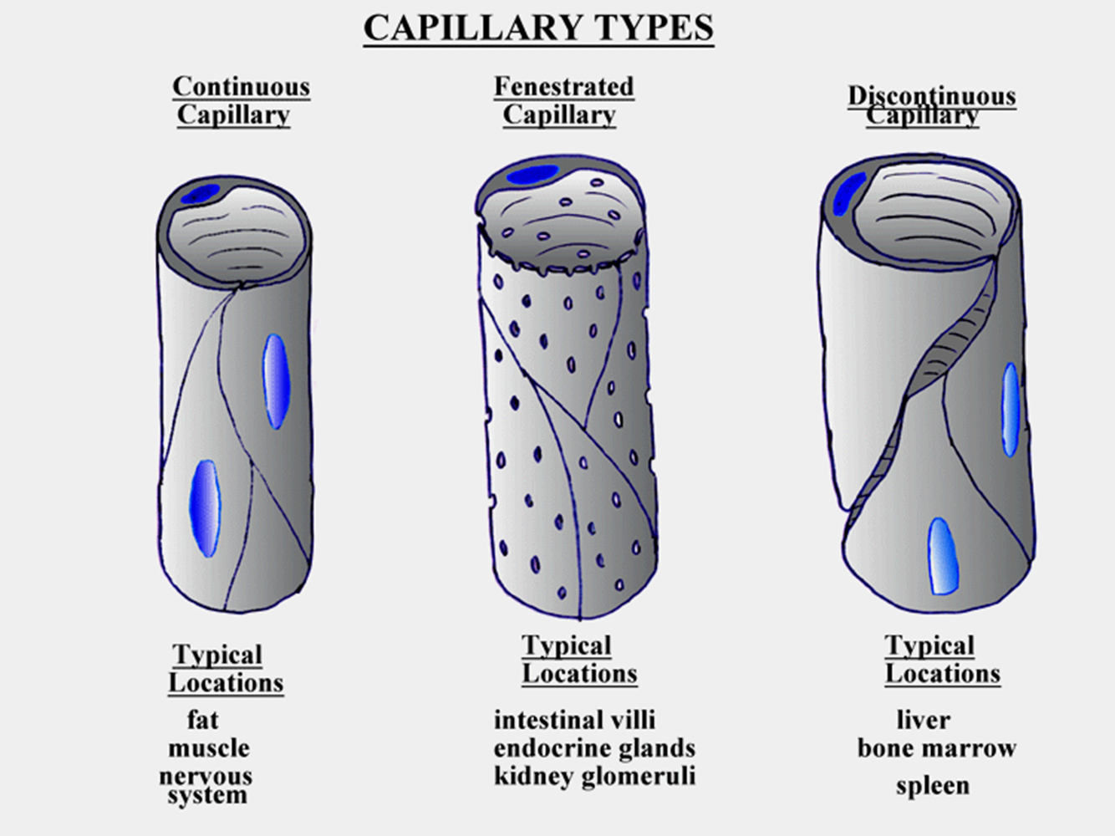

Veins;
Most of the blood volume is contained in the venous system. Able to expand
The average pressure in the veins is only 2 mmHg, arterial pressure of about 100 mmHg.
The low venous pressure is insufficient to return blood to the heart, particularly from the lower limbs.
How blood returns back to heart from veins?
1. Skeletal muscle pump: standing--- bulging of veins
2. Presence of valve
3. contraction of diaphragm:
The pressure difference in the veins created by this inspiratory movement of the diaphragm forces blood into the thoracic veins that return the venous blood to the heart.
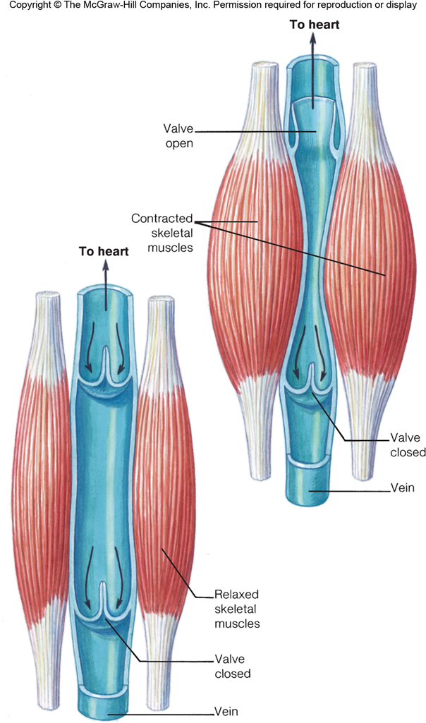
Varicosity veins;
Peripheral arterial disease (PAD);
Peripheral arterial disease is narrowing of one or more blood vessels (arteries). It mainly affects arteries that take blood to legs.
The narrowing of blood vessels (arteries) is caused by atheroma. Atheroma is like fatty patches (plaques) that develop within the inside lining of arteries. A patch of atheroma starts quite small and causes no problems at first. Over the years, become thicker, makes the artery narrower.
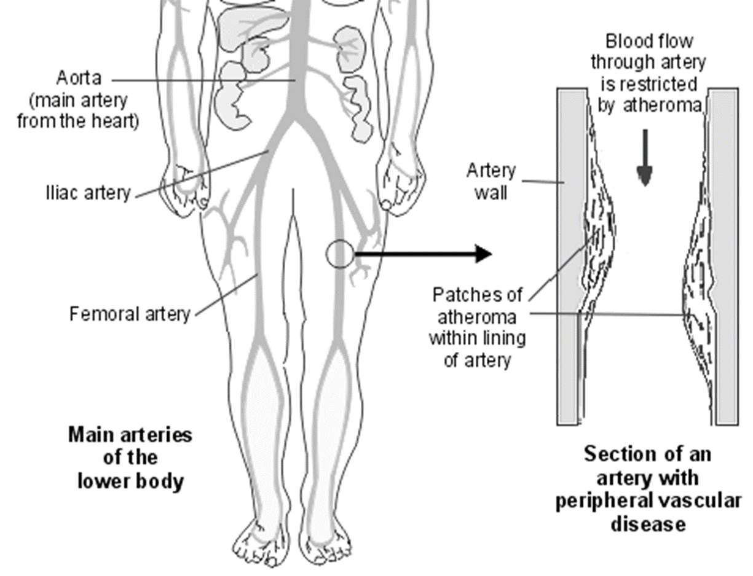
Atheroma can develop in any artery but the common arteries affected are:
- Arteries taking blood to the heart - this is called coronary heart disease and may lead to problems such as angina and heart attacks.
- Arteries taking blood to the brain - which may eventually lead to a stroke.
- Arteries taking blood to the legs - which may lead to PAD.

What causes atheroma?
Certain factors increase the risk of developing atheroma. These factors include: -
Lifestyle risk factors that can be prevented or changed:
* Smoking.
* Lack of physical activity (a sedentary lifestyle).
* Obesity.
* Unhealthy diet.
* Excess alcohol.
Treatable or partly treatable risk factors:
- High blood pressure (hypertension).
- High cholesterol level.
- High fat (triglyceride) blood level.
- Diabetes.
- Kidney diseases causing diminished kidney function
Peripheral arterial disease symptoms
pain develops in one or both calf muscles when walk or exercise, and is relieved when you rest for a few minutes. This pain varies between cases and you may feel aching, cramping or tiredness in your legs. This is called intermittent claudication. It is due to narrowing of one (or more) of the blood vessels (arteries) in your leg.
The most common artery affected is the femoral artery, and so pain occurs from the oxygen-starved muscles. The pain comes on more rapidly when you walk up a hill or stairs than when on the flat.
If the blood supply to the legs becomes worse, the following may be found by a doctor who examines you: -
1 - Poor hair growth below your knee and poor toe nail growth.
2 - Cool feet.
3 - Weak or no pulses in the arteries of your feet
Severe cases: If the blood supply is very much reduced then you may develop pain even at rest, particularly at night when the legs are raised in bed. Typically, rest pain first develops in the toes and feet rather than in the calf muscle.
Heart Sounds
1. S1 (Lub Sound): Made by contraction of ventricles and closure of tricuspid and mitral valves.
2. S2 (Dub Sound): Made by closure of pulmonary and aortic valves. When ventricles relax.

