

كلية الرشيد الجامعة/قسم كلية التمريض

مادة الفسلجة مرحلة اولى

المحاضرة الثالثة

م.د الان علي

2024/2023

**Cardiac Output, Blood Flow, and Blood Pressure**

Cardiac output is the volume of blood pumped by each ventricle per minute (average= 5.5 L/min)

Cardiac rate = Heart rate (pulse) = no. of beats/min Average=70 beats/min, one cycle requires 0.8 sec

Stroke volume = blood volume ejected (pumped) per beat from each ventricle (average=70-80 ml/beat)

Cardiac output = stroke volume X cardiac rate

ml/min = ml/beat X beat/min

Total blood volume is about 5.5L

The entire blood volume passes through each side of the heart in less than 1 minute

**Regulation of Cardiac Rate**

Without neuronal influences, SA node will drive heart at rate of its spontaneous activity

Chronotropic effect: mechanisms that affect heart rate

* Positive chronotropic effect increases heart rate
* negative chronotropic effect decreases heart rate

Autonomic innervation of SA node is main controller of heart rate

Sympathetic & Parasympathetic (vagus) nerve fibers modify rate of spontaneous depolarization (antagonistic effect on heart rate).

Sympathetic system also increases the force of contractions

Cardiac control center of medulla oblongata in brain stem coordinates activity of autonomic nervous system

Baroreceptor Reflex: Reflex is initiated by pressure (sensory) receptors called Baroreceptors (stretch receptors) located in the walls of aorta & carotid artery).

Is most sensitive to decrease & sudden changes in BP

A fall in blood pressure produce a reflex increase in heart rate

Increase in blood pressure causes walls of these regions to stretch, increasing frequency of impulses

Baroreceptors send impulses to vasomotor & cardiac control centers in medulla

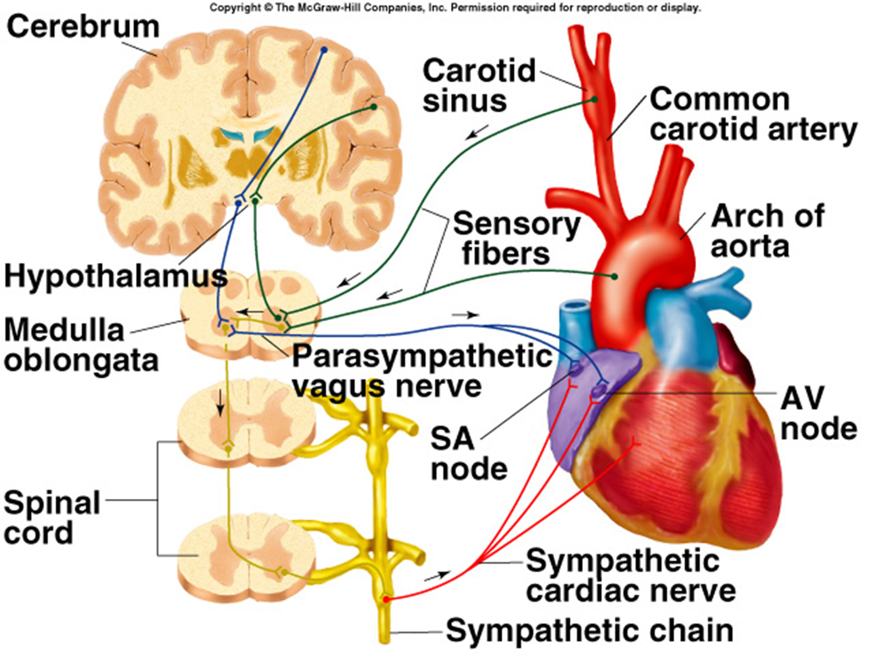

**Regulation of Stroke Volume**

The Stroke Volume is determined by 3 variables:

1. Contractility = strength of ventricular contraction
2. End diastolic volume (EDV) = volume of blood in ventricles at end of diastole
3. Total peripheral resistance = the frictional resistance or impedance to blood flow in arteries

EDV is workload (preload) on heart prior to contraction

Stroke volume is directly proportional to preload & contractility.

When the ventricles contract more forcefully, they pump more blood

**Contractility;**

Contractility is the strength of contraction

depends upon level of sympathoadrenal activity: produce an increase in contraction strength

This positive inotropic effect results from an increase in the amount of Ca 2 + available to the sarcomeres.

Parasympathetic stimulation causes negative chronotropic effect but does not directly affect the contraction strength of the ventricles.

Slower heart rate means increased EDV. This can increase contraction strength but not enough to completely compensate for the slower cardiac rate. Thus, the cardiac output is decreased.

**Regulation of Stroke Volume;**

Total peripheral resistance (TPR) = afterload which impedes ejection from ventricle

A person with high total peripheral resistance has a high arterial blood pressure & thus a high afterload imposed on the ventricular muscle.

SV is inversely proportional to TPR

Ejection fraction is SV/ EDV

(~70-80ml/110-130ml=60%)

Ejection fraction remains relatively constant. So, the strength of ventricular contraction must increase as the end-diastolic volume increases.

**Venous Return**



Is return of blood to heart via veins

Controls EDV & thus SV & CO

Dependent on:

* Blood volume & venous pressure
* Vasoconstriction caused by Sympathetic system
* Skeletal muscle pumps
* Pressure drops during inhalation

Veins hold most of blood in body



(70%) & are thus called capacitance vessels سعة

Veins higher compliance مطاوعة

a given amount of pressure will cause

more distension (expansion) in veins than in arteries, so that the veins can hold more blood.

Have only 0-10 mm Hg pressure

Muscular arteries and arterioles

expand less under pressure (are less compliant), and thus are called resistance vessels مقاومة.

**Blood Volume;**

*Constitutes small fraction of total body fluid

* 2/3 of body H20 is inside cells (intracellular compartment)

* 1/3 total body H20 is in extracellular compartment (80% of this is interstitial fluid; 20% is blood plasma)

**Exchange of Fluid between Capillaries & Tissues;**

Distribution of extracellular fluid between blood & interstitial compartments is in state of dynamic equilibrium

Movement out of capillaries is driven by hydrostatic pressure exerted against capillary wall

Promotes formation of tissue fluid

Net filtration pressure= hydrostatic pressure in capillary (17-37 mm Hg) - hydrostatic pressure of ECF (1 mm Hg)

Movement also affected by colloid osmotic pressure= osmotic pressure exerted by proteins in fluid

Difference between osmotic pressures in & outside of capillaries (oncotic pressure) affects fluid movement

Plasma osmotic pressure = 25 mm Hg; interstitial osmotic pressure = 0 mm Hg

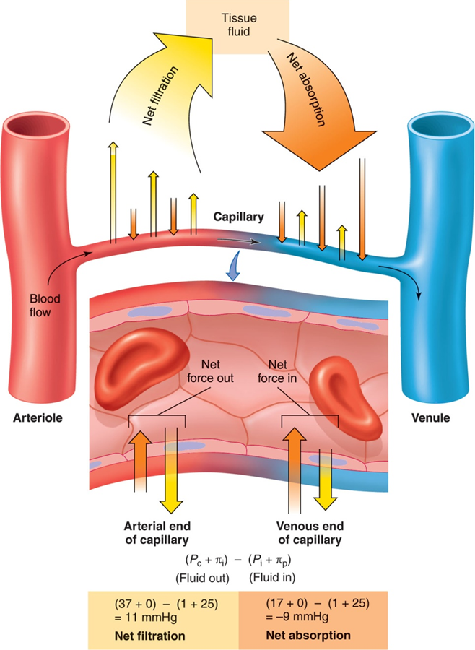

The distribution of fluid across the walls of a capillary. Tissue, or interstitial, fluid is formed by filtration (yellow arrows) as a result of blood pressures at the arteriolar ends of capillaries; it is returned to the venular ends of capillaries by the colloid osmotic pressure of plasma proteins (orange arrows).

Blood pressure (BP)

Is the force of the blood exerting against arterial walls. It is measured in millimeter of Mercury (mmHg), using the sphygmomanometer, and composed of:

1. Systolic blood pressure
2. Diastolic blood pressure

Physiology;

1- During each heartbeat, blood pressure varies between a maximum (systolic) and a minimum (diastolic) pressure. 2-The blood pressure in the circulation is principally due to the pumping action of the heart

3 - The rate of mean blood flow depends on both blood pressure and the resistance to flow presented by the wall of blood vessels. 4 - Mean blood pressure decreases as the circulating blood moves away from the heart through arteries and capillaries due to much losses of energy (The fall occurs along the small arteries and arterioles). 5 - Gravity affects blood pressure via hydrostatic forces (e.g., during standing), and valves in veins, breathing, and pumping from contraction of skeletal muscles also influence blood pressure in veins. 6 - Blood pressure is one of the vital signs, along with respiratory rate, heart rate, oxygen saturation, and body temperature.

Normal blood pressure; In an adult is normal approximately 120 millimeters of mercury systolic, and 80 millimeters of mercury diastolic, abbreviated "120/80 mmHg".

Regulation;

Medulla, by way of the autonomic nervous system, adjusts the mean arterial pressure by altering both the force and speed of the heart's contractions, as well as the systemic vascular resistance.

The following mechanisms of regulating arterial pressure have been well-characterized;

1 - Baroreceptor reflex:

Baroreceptors, are sensory nerve endings in human blood vessels that detect blood pressure levels and report abnormal blood pressure to the central nervous system, which responds by regulating the resistance of the blood vessels and the rate and strength of the heart's contractions. This process is known as the baroreflex. Baroreceptors work by detecting stretching in the blood vessel walls. Then send signals ultimately to the medulla of the brain stem.

Most important arterial baroreceptors are located in the left and right carotid sinuses and in the aortic arch.

Two types of baroreceptors;

1-Arterial high pressure

2-Low pressure.

The high-pressure baroreceptors are found only in the aortic arch. High pressure and low pressure found in the carotid sinuses,

The carotid sinus baroreceptors are quantitatively the most important for regulating arterial pressure. Its receptors respond to pressures ranging from 60-180 mmHg. The aortic arch receptors have a higher threshold pressure and are less sensitive than the carotid sinus receptors.

Arterial baroreceptors

1 - respond very quickly to changes in blood pressure, firing more rapidly as blood pressure increases, resulting in a lowered heart rate and lowered blood vessel resistance. When they stop firing, the central nervous system responds by increasing heart rate and blood vessel resistance. 2 - respond only to short term changes, so if blood pressure remains high over a few days, they will reset themselves to the new "normal" blood pressure in the body, resulting in hypertension.

Low pressure baroreceptors;

1 -They regulate blood volume in the body. They are located in the walls of major veins (venae cava and the pulmonary veins) and in the right atrium of the heart.

2 - Have an effect on the kidneys, by regulating the secretion of antidiuretic hormone (ADH/Vasopressin), renin and aldosterone. causing the retention of salt and water if blood volume is too low; The resultant increase in blood volume led to an increased cardiac output, in turn increasing arterial blood pressure.

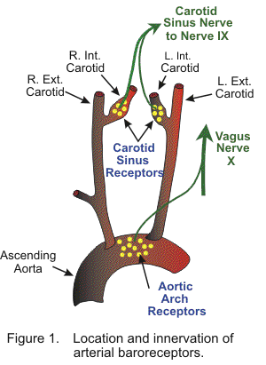

2 - Renin–angiotensin system:

This system is generally known for its long-term adjustment of arterial pressure. It allows the kidney to compensate for loss in blood volume or drops in arterial pressure by activating an endogenous vasoconstrictor known as angiotensin II.

3 - Aldosterone release:

This steroid hormone is released from the adrenal cortex in response to angiotensin II or high serum potassium levels. Aldosterone stimulates sodium retention and potassium excretion by the kidneys. Since sodium is the main ion that determines the amount of fluid in the blood vessels by osmosis. Aldosterone will increase fluid retention, and indirectly, arterial pressure.

Blood pressure is influenced by;

1 - cardiac output,

2 - total peripheral resistance.

3 - arterial stiffness

Blood pressure varies depending on: - situation, emotional state, activity, relative health/disease states, age, sex, obesity. In the short term, blood pressure is regulated by baroreceptors which act via the brain to influence nervous and endocrine systems.

factors determine the blood pressure are:

1 - Blood volume:

the greater the blood volume, the higher the cardiac output. Dietary salt intake causes an increased blood volume, potentially resulting in higher arterial pressure, and is highly dependent on autonomic nervous system response and the renin–angiotensin system.

2 - Cardiac output:

the pumping action of the heart is ultimately responsible for blood pressure. Increases or decreases in cardiac output can result in increases or decreases respectively in blood pressure.

3 - Systemic vascular resistance:

The higher the resistance to blood flow, the higher the arterial pressure.

A - Vessel radius; affect resistance, so the smaller the radius, the much higher the resistance.

B - Vessel length; (the longer the vessel, the higher the resistance). C - Blood viscosity ;(the higher the viscosity, the higher the resistance). D - Stenosis of an artery, increases resistance to flow. E - Vasoconstrictors Substances, can reduce the caliber of blood vessels, thereby increasing blood pressure. F - Vasodilators (as nitroglycerin) increase the caliber of blood vessels, thereby decreasing arterial pressure.

Hypertension

Probably have high blood pressure (hypertension) if your blood pressure readings are consistently 140 / 90, or higher, over a number of weeks, or if just one of the numbers is higher.

This higher pressure puts extra strain on the heart and blood vessels. Over time, this extra strain increases risk of a heart attack or stroke. It’s also can cause heart and chronic kidney failure, and is closely linked to some forms of dementia.

Higher pressures increase heart workload and progression of unhealthy tissue growth (atheroma) that develops within the walls of arteries.

Where atheroma tends to progress and the heart muscle tends to thicken, enlarge and become weaker over time.

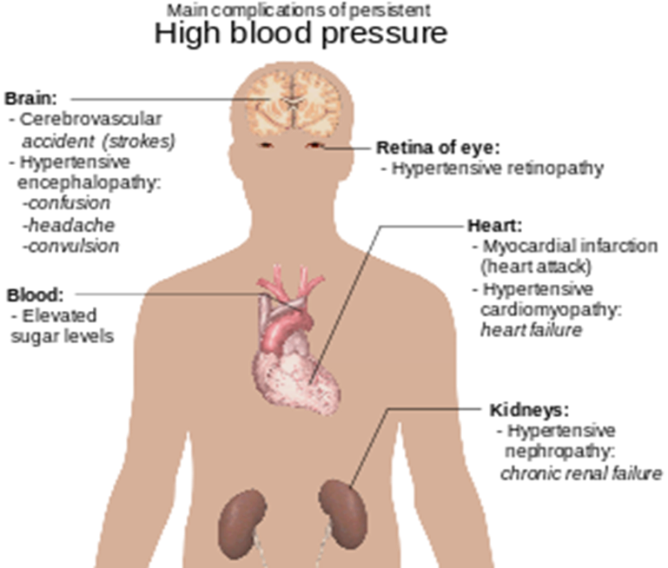

What causes high blood pressure?

most people, may be no single cause for their high blood pressure. Not know exactly what causes high blood pressure.

Risk factors for HT;

1. too much salt
2. Bad diet (high fatty meals, low fruit and vegetables)
3. no activity
4. overweight
5. alcohol.
6. Age: get older, the effects of an unhealthy lifestyle can affect blood pressure to increase.
7. Family history