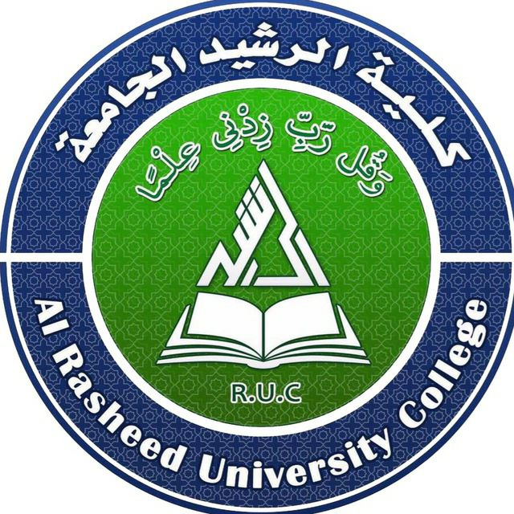

كلية الرشيد الجامعة/ قسم كلية التمريض
مادة الفسلجة مرحلة اولى
المحاضرة الرابعة
م.د الان علي
2024/2023

Digestive System
Digestive system is the gastrointestinal tract (GI tract), starts at the mouth and ends at the anus, it is length about nine meters. The GI tract is a series of hollow organs joined in a long, twisting tube from the mouth to the anus.
The digestive system is made up of the gastrointestinal tract plus the accessory organs of digestion (the tongue, salivary glands, pancreas, liver, and gallbladder).
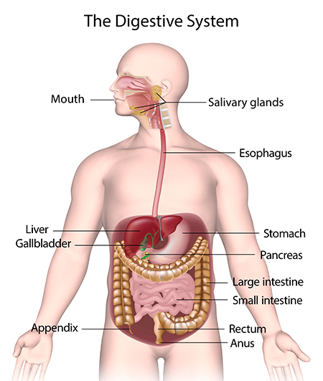
The process of digestion has many stages;
The first stage is the cephalic phase of digestion which begins with gastric secretions in response to the sight and smell of food. The next stage starts in the mouth (mechanical and chemical).
Digestion is the breakdown of large insoluble food molecules into small water-soluble food molecules so that they can be absorbed. Digestion is a form of catabolism that is often divided into two processes based on how food is broken down: mechanical and chemical digestion. The term mechanical digestion refers to the physical breakdown of large pieces of food into smaller pieces. In chemical digestion, enzymes break down food into the small molecules, where the body can use by tissues to produce energy, growth and cell repair.
Proteins break into amino acids Fats break into fatty acids and glycerol Carbohydrates break into simple sugars Bacteria in GI tract, also called gut flora, help with digestion.
Organ | Movement | Digestive Juices Added | Food Particles Broken Down
Mouth | Chewing | Saliva | Starches
Esophagus | Peristalsis | None | None
Stomach | Upper muscle in stomach relaxes to let food enter, and lower muscle mixes food with digestive juice | acid, digestive enzymes | Proteins
Small intestine | Peristalsis | digestive juice | proteins, carbohydrates
Pancreas | None | Pancreatic juice | Carbohydrates, fats, and proteins
Liver | None | Bile | Fats
Large intestine | Peristalsis | None | Bacteria can also break down food

Parts of digestive system;
Mouth:
The digestive process starts in the mouth by rotate the bolus using tongue and masticate by teeth, then, salivary glands make saliva, which is a digestive juice that also moistens food. Saliva also contains a catalytic enzyme called amylase that begins to break down starches in food.
Most of the oral cavity is lined with mucous membrane that produces a lubricating mucus. The main component of mucus is a glycoprotein called mucin. Mucus helps in the mastication of food and collects the food as bolus.
Tongue:
The tongue is a muscular organ, fixed from one side, by attaching to the floor of the mouth, and this gives it great mobility for the manipulation of food, and speech, Is the first sensory organ, which received via the taste buds in the papillae on its surface.
Salivary glands:
There are three main pairs, and between 800 and 1,000 minor salivary glands.
Function: 1- Saliva has a catalytic enzyme called amylase that begins to break down starches in food and convert to maltose 2 - Play an important role in the maintenance of dental health deposition of Ca salts on the teeth. 3-miostening of the food by mucin, and mouth lubrication, without it speech would be impossible. 4 - Contains a glycoprotein called haptocorrin (transcobalamin) which is a binding protein to vitamin B12 in order to carry it safely through the acidic content of the stomach. When it reaches the duodenum, pancreatic enzymes break down the glycoprotein and free the vitamin which then binds with intrinsic factor.
5 – Saliva contains bicarbonate that make the alkaline medium that help the starch digestion 6 - Solvent of some drugs.
Swallowing (Deglutition) Reflex;
The intake of food (ingestion) involves two mechanical processes. First the food is chewed (mastication) and then it is swallowed (deglutition). If the process fails and the material (such as food, drink, or medicine) goes through the trachea and harm the lungs, but this prevent by the automatic temporary closing of the epiglottis is controlled by the swallowing reflex. Swallowing is a complex mechanism using both skeletal muscle (tongue) and smooth muscles of the pharynx and esophagus. The autonomic nervous system coordinates this process.
Coordination and control
Eating and swallowing are complex neuromuscular activities consisting essentially of three phases. Each phase is controlled by a different neurological mechanism. The process of swallowing can be divided into three stages:
- Oral stage is voluntary stage of swallowing. Controlled by the medial temporal lobes and limbic system of the cerebral cortex. Food is chewed, then tongue pushes up the food against the palate and squeezes it into the back of the throat 2. Pharyngeal stage is involuntary stage of swallowing. As the bolus enters the back of the throat, the pharyngeal swallowing, commences. It is an involuntary response triggered by stimulation of the receptors in the epithelium that line the pharynx, and subsequently is coordinated by the swallowing center on the medulla oblongata and pons. The reflex is initiated by touch receptors in the pharynx as a bolus of food is pushed. 3. Esophageal stage is involuntary stage of swallowing. However, propagation of the food bolus is significantly slower than in the pharynx. The bolus enters the esophagus and is propelled downwards first by striated muscle, then by the smooth muscle at a rate of 3–5 cm/s. The upper esophageal sphincter relaxes to let food pass, after which the relaxation of the lower esophageal sphincter sequentially push the bolus into the stomach.
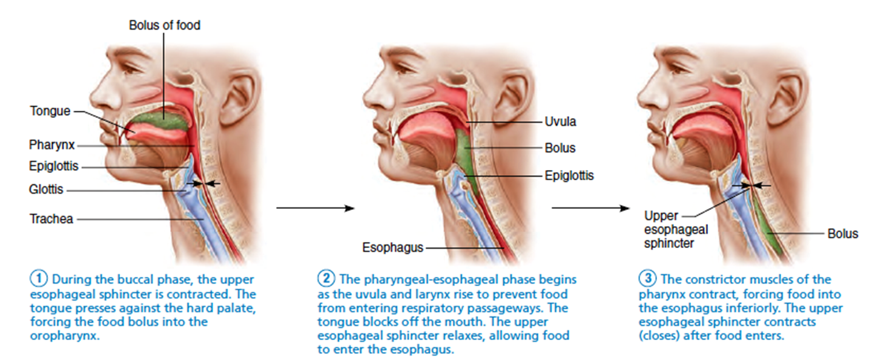
Esophagus:
A muscular tube, its length averages 25 cm. It is divided into cervical, thoracic and abdominal parts. At rest the esophagus is closed at both ends, by the upper and lower esophageal sphincters. After swallow, peristalsis pushes the food down esophagus into stomach. The opening of the upper sphincter is triggered by the swallowing reflex so that food is allowed through. The sphincter also serves to prevent back flow from the esophagus into the pharynx.
Esophagus has a mucous membrane and the epithelium which has a protective function. Once in the esophagus, the bolus travels down to the stomach via rhythmic contraction and relaxation of muscles known as peristalsis.
The lower esophageal sphincter remains constricted at all times other than during swallowing and vomiting to prevent the contents of the stomach from entering the esophagus. As the esophagus does not have the same protection from acid as the stomach, any failure of this sphincter can lead to heartburn.
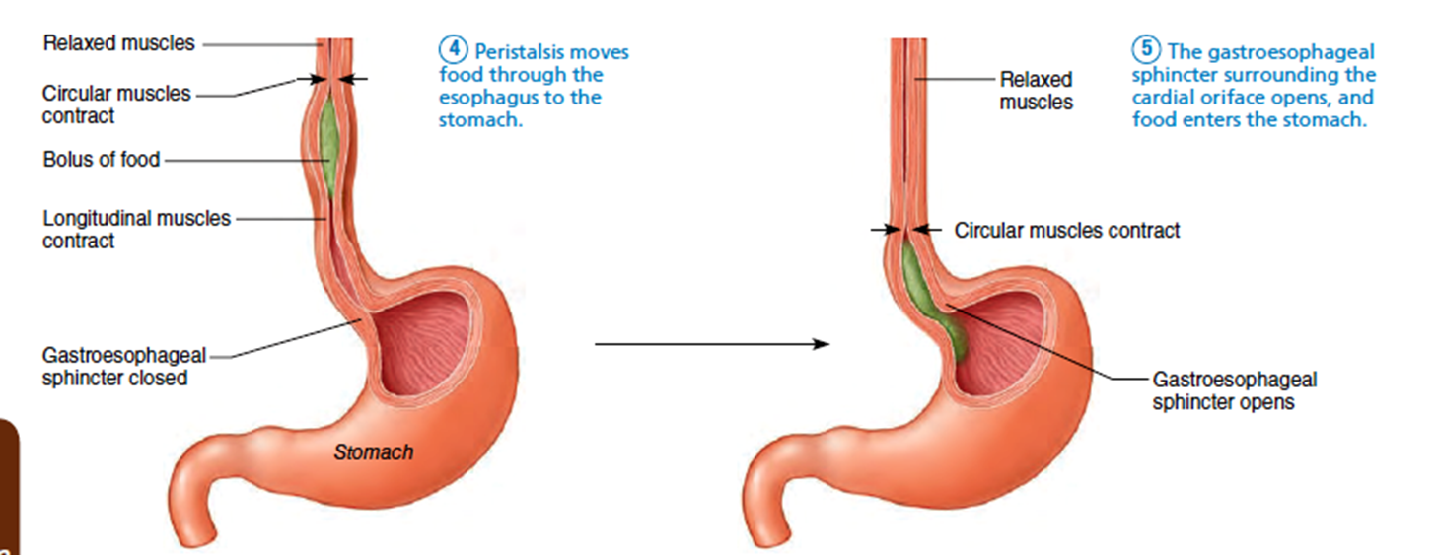
Stomach;
Is a major muscular organ, situated under the diaphragm. It is a J-shaped organ. The stomach is a distensible organ and can normally expand by a series of gastric folds in the inner walls to hold about one liter of food.

Function 1 - Gastric juice, produced in the stomach plays a role in the digestive process, which the main function and component is:-
A-HCL: - It's function
a- Neutralize the alkaline saliva.
b- Acts as antimicrobial agent.
c- Aids the action of pepsin in protein digestion.
B-Pepsinogen: - is a precursor enzyme, produced by gastric chief cells, and gastric acid activates this to the enzyme pepsin Digest protein
Protein -----------pepsin---------peptones.
C-Mucin: - protect the mucous membrane of the stomach from action of pepsin and HCL (prevent gastric ulcer).
D- Sodium chloride. 2 -gastrin, secretes from the lowest section of the stomach that produced by G cells in the gastric glands, stimulates the production of gastric juice which activates the digestive enzymes. 3 - Gastric lipase, is secreted by the chief cells in the fundic glands in the gastric mucosa of the stomach, is an acidic lipase. This break down fats to some degree though is not as efficient as the pancreatic lipase (alkaline). 4 - intrinsic factor, is a glycoprotein produces by the parietal cells in the fundus of the stomach, which is essential for the absorption of vitamin B12.
Vitamin B12 (cobalamin), is carried to, and through the stomach, bound to a glycoprotein secreted by the salivary glands which protects the acid-sensitive vitamin from the acidic stomach contents. The freed vitamin B12 then binds to intrinsic factor which is then absorbed by the enterocytes in the ileum.
At the same time that protein is being digested, a mechanical churning occurs through the action of peristalsis, waves of muscular contractions that move along the stomach wall. This allows the mass of food to further mix with the digestive enzymes. After an hour or two, a thick semi-liquid called chyme is produced
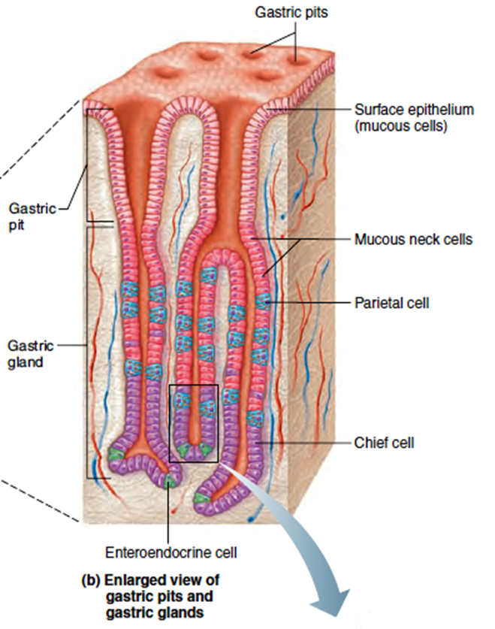
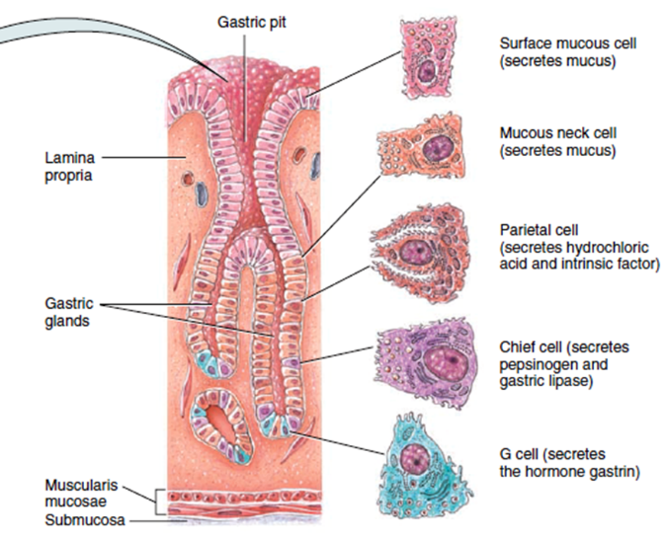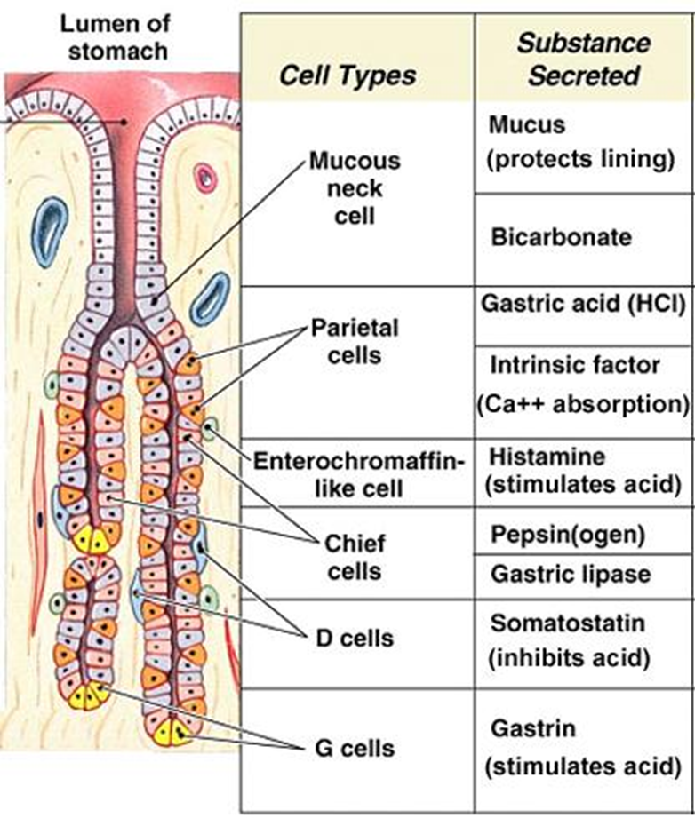
Small intestine
Is a thin tube about 1 inch (2.5 centimeters) in diameter and about 10 feet (3meters) long. Internally is full of many folds, where used to maximize the digestion and absorption of nutrients.
When the pyloric sphincter opens, chyme enters the duodenum where it mixes further with digestive enzymes from the pancreas. Segmentation contractions act to mix and move the chyme more slowly allowing more time for absorption. In small intestine, absorption about 95% of nutrients into the blood. The mucus lubricates the walls of the intestine.
Duodenum:
1 - Is the shortest section of the small intestine, C-shaped tube. 2 - For neutralizes the gastric acid (chyme)and make the fluid alkaline, a bicarbonate secretion from the pancreatic duct and also from secretions of bicarbonate-rich mucus from duodenal glands known as Brunner's glands.
3 - In the duodenum, pancreatic lipase is secreted to digest the fat of the chyme, and breakdown to smaller particles of emulsified fats called chylomicrons. 4 - A digestive cells called enterocytes lining the intestines. They have villi on their surface which in turn have innumerable microvillus on their surface, making a greater surface area, for the absorption of chyme, also for its further digestion by digestive enzymes present on the microvillus. The chylomicrons are small enough to pass through the enterocyte villi and into their lymph capillaries.
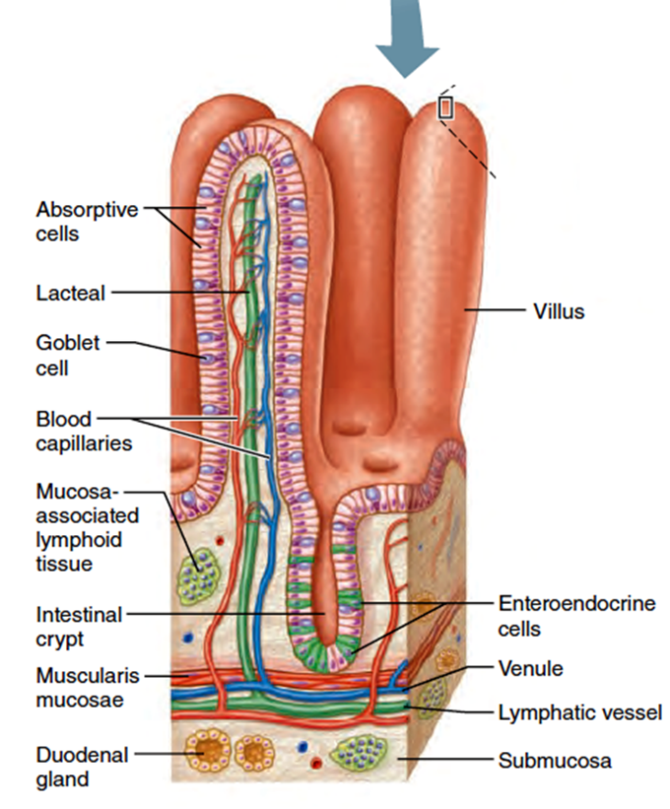
The jejunum
The jejunum contains circular folds of doubled mucosal membrane which encircle the lumen of the intestine. 1 - These folds together with villi serve to increase the surface area of the jejunum enabling an increased absorption of digested sugars, amino acids and fatty acids. 2 - The circular folds also slow the passage of food giving more time for nutrients to be absorbed.
Ileum. Ileum also contains villi. 1 - Bile acids and any residue nutrients are absorbed here. 2 - Bacteria in the gut flora further break down residual proteins and starches.
When the chyme is exhausted of its nutrients the remaining waste material changes into the semi-solids called feces, which pass to the large intestine
Pancreas: Is an accessory digestive gland. The pancreas connects to the duodenum via the pancreatic duct. Both the bile and pancreatic juice can act on the chyme that is released from the stomach. Aqueous pancreatic secretions contain bicarbonate ions which are alkaline and help with the bile to neutralize the acidic chyme. Pancreas is both an endocrine gland and an exocrine gland.

The endocrine part: 1 - Secretes insulin when the blood sugar becomes high; insulin moves glucose from the blood into the muscles and other tissues for use as energy.
2 - Releases glucagon when the blood sugar is low; glucagon allows stored sugar to be broken down into glucose by the liver in order to re-balance the sugar levels. The exocrine part: Produces and releases important digestive enzymes in the pancreatic juice. Some of these are released in response to the production of Cholecytokinin in the duodenum. 1 - Proteases, (trypsinogen, chymotrypsinogen) the pancreatic enzymes which work on proteins. Once released in the intestine, the enzyme enteropeptidase present in the intestinal mucosa activates trypsinogen by cleaving it to form trypsin; further cleavage results in chymotripsingen to form chymotripsin. 2 - Elastase, Breaks down elastin (elastic fiber + collagen). 3 - Secrete smaller amounts of lipase and amylase (fat + carbohydrate digestion).
4 - Also secretes phospholipase A2, lysophospholipase, and cholesterol esterase.
Liver: Is the largest organ, weight 1275 – 1550 g, plays a role in metabolism.
Function: 1-secrete: - bile 2-storage of: A - glucose (in the form of glycogen),
B - Vitamin B12 (3–5 years' supply), vitamin A (1–2 years' supply), vitamin D (1– 4 months' supply), vitamin K, iron, and copper.
3-formation of urea
4-production of:
A- Heat.
B- Heparin.
C- RBC in embryo.
D- Clotting factors (prothrombin + fibrinogen).
E- Plasma protein (albumin + globulin).
F- Synthesizes angiotensinogen, a hormone that is responsible for raising the blood pressure when activated by renin, an enzyme released when the kidney senses low blood pressure.
G- The liver produces the enzyme catalase in order to break down hydrogen peroxide, a very toxic substance due to it being a powerful oxidizing agent.
5-destruction of: A- toxic substance and some drugs.
B- Fat.
C- Old RBC.
D - Is responsible for the breakdown of insulin and other hormones. 6 - The liver is responsible for immunological effects – the mononuclear phagocyte system of the liver contains many immunologically active cells, acting as a 'sieve' for antigens carried to it via the portal system.
Bile Bile is a natural, semi-liquid form, produced by the liver is made up of water (97%), bile salts, mucus, pigments, 1% fats and inorganic salts. Bile is stored in the gallbladder. Bilirubin is its major pigment. Bile acts partly as a surfactant which lowers the surface tension between either two liquids or a solid and a liquid and helps to emulsify the fats in the chyme. Fat breaks down into micelles creates a much larger surface area for the lipase to work on. Lipase digests the triglycerides which are broken down into two fatty acids and a monoglyceride. These are then absorbed by villi. If fats are not absorbed in this way in the small intestine problems can arise later in the large intestine which is not equipped to absorb fats. Bile also helps in the absorption of vitamin K from the diet.

Gallbladder:
The gallbladder is a sac that sits just beneath the liver, where the bile produced by the liver is stored. The bile is released in response to cholecystokinin (CCK) a hormone released from the duodenum, which is stimulated by the presence of fat. Hydrogen ions secreted from the inner lining of the gallbladder keep the bile acidic enough to prevent hardening. Also, salts attach themselves to cholesterol molecules in the bile to keep them from crystallizing. If there is too much cholesterol or bilirubin in the bile, or if the gallbladder doesn't empty properly, this may lead to gallstones form when a small piece of calcium gets coated with either cholesterol or bilirubin and the bile crystallizes and forms a gallstone.
How does the body control the digestive process? Digestive hormones secreted in response to specific stimuli (triggers), and may play additional roles in the body that is indirectly related to digestion, absorption and metabolism of nutrients. Hormones and nerves work together to help control the digestive process.
1 - Hormones *Gastrin Source: G cells in the stomach. Trigger: Protein and amino acids stimulate gastrin secretion. Action: Increases gastric acid secretion. *Somatostatin Source: D cells which are located throughout the gastrointestinal tract(gut).
Trigger: Eating fatty foods. Actions: Reduces gastrin and stomach acid secretion. Inhibits insulin and pancreatic enzyme secretion. Decreases nutrient absorption from the gut.
*Cholecystokinin (CCK): Source: First two parts of the small intestine (duodenum, jejunum) – I cells. Nerve endings in the last part of the small intestine (ileum) and colon.
Triggers: Protein and amino acids, Fatty foods. Trypsin which is a pancreatic enzyme that assists with the digestion of proteins suppresses the secretion of CCK. Actions: 1 - Feeling of satiety which reduces appetite. 2 - Reduces gastric acid secretion and gastric emptying (passing of food from the stomach into the duodenum)
3 - Stimulates pancreatic enzyme secretion. Opens the sphincter of Oddi which allows the pancreatic enzymes and bile to enter the small intestine. 4 - Stimulates gallbladder contraction and bile flow. *Motilin Source: Small intestine, colon Triggers: fasting, starvation, fatty foods. Actions: Controls peristalsis by stimulating smooth muscle contraction and relaxation. to coordinate the movement of food through the gut. Regulates movement of residual undigested material through the gut between meals.

*Gastric Inihibitory Polypeptide (GIP)
Source: Duodenum and jejunum – K cells. Triggers: Glucose, Fatty foods. Actions: Reduces gastric acid secretion. Decreases gastric emptying. Stimulates the release of insulin.

2 - Nerve Regulators:
Two types of nerves help to control the action of the digestive system.
1 - Extrinsic nerves, which come to the digestive organs from the unconscious part of the brain or from the spinal cord. They release a chemical called acetylcholine and another called adrenaline. Acetylcholine causes the muscle of the digestive organs to squeeze with more force and increase the "push" of food through the digestive tract. Also causes the stomach and pancreas to produce more digestive juice. Adrenaline relaxes the muscle of the stomach and intestine, where decreases the flow of blood to these organs. 2 - Intrinsic nerves, a very dense network embedded in the walls of the esophagus, stomach, small intestine, and colon, where triggered to act when the walls of the hollow organs are stretched by food. They release many different substances that speed up or delay the movement of food and the production of juices by the digestive organs. These neurons are collected into two plexuses - the myenteric plexus that lies between the longitudinal and the smooth muscle layers, and the submucosal plexus that lies between the circular smooth muscle layer and the mucosa.
Large intestine: In the large intestine, the passage of the digesting food in the colon is slower, taking from 12 to 50 hours until it is removed by defecation. Water and minerals are reabsorbed back into the blood in the colon, where the environment is slightly acidic. Vitamins, such as biotin and vitamin K produced by bacteria are also absorbed.
1 - Cecum The cecum is a pouch marking the division between the small intestine and the large intestine. At this junction there is a sphincter or valve, the ileocecal valve which slows the passage of chyme from the ileum. It is also the site of the appendix attachment.
2 - Colon The colon mainly serves as a site for the fermentation of digestible matter by the gut flora. The remaining semi-solid waste is termed feces and is removed by the coordinated contractions of the intestinal walls, termed peristalsis,
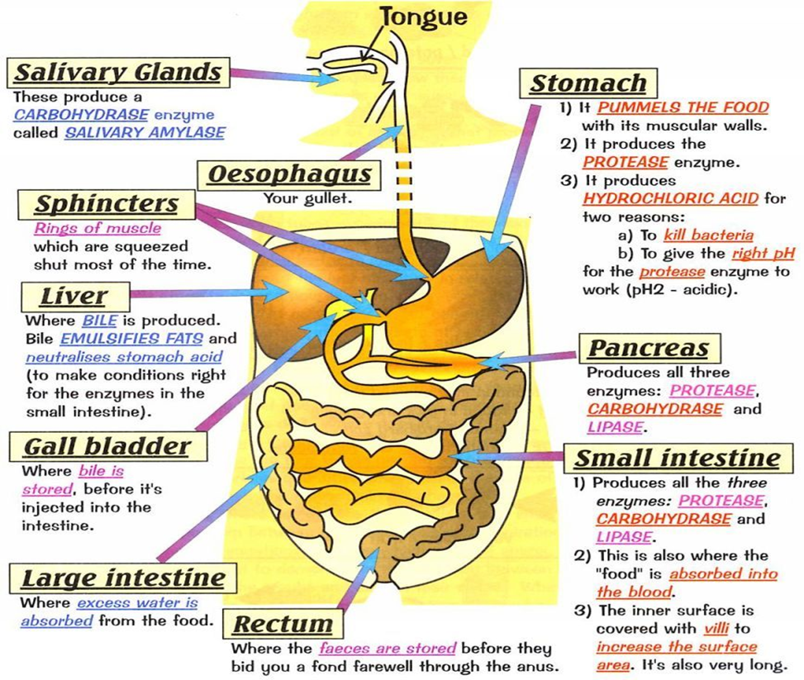
Digestive System Physiology The digestive system is responsible for taking whole foods and turning them into energy and nutrients to allow the body to function, grow, and repair it. The six primary processes of the digestive system include:
1- Ingestion The first function of the digestive system is ingestion, or the intake of food. The mouth is responsible for this function,
2- Secretion In the course of a day, the digestive system secretes around 7 liters of fluids. These fluids include saliva, mucus, hydrochloric acid, enzymes, and bile.
3- Mixing and Movement The digestive system uses 3 main processes to move and mix food: A – Swallowing: Swallowing is the process of using smooth and skeletal muscles.
B– Peristalsis: Peristalsis is a muscular wave that travels the length of the GI tract. C – Segmentation: Segmentation occurs only in the small intestine as short segments of intestine contract like hands squeezing a toothpaste tube.
4- Digestion Is the process of turning large pieces of food into its component chemicals, done by two processes:- A - Mechanical digestion: Is the physical breakdown of large pieces of food into smaller pieces, by chewing of food using the teeth, and is continued through the muscular mixing of food by the stomach and intestines. Bile produced by the liver is also used to mechanically break fats into smaller globules. B- Chemical digestion: Is a larger and more complex molecules are being broken down into smaller molecules that are easier to absorb, begins in the mouth with salivary amylase in saliva splitting complex carbohydrates into simple carbohydrates. The enzymes and acid in the stomach continue chemical digestion, but the bulk of chemical digestion takes place in the small intestine, where the pancreas secretes an incredibly strong pancreatic juice, which is capable of digesting lipids, carbohydrates, proteins and nucleic acids. By the time food has left the duodenum, it has been reduced to its chemical building blocks—fatty acids, amino acids, monosaccharides, and nucleotides.
5- Absorption Once food has been reduced to its building blocks, it is ready for the body to absorb. Absorption begins in the stomach with simple molecules like water and alcohol being absorbed directly into the bloodstream. Most absorption takes place in the walls of the small intestine. The large intestine is also involved in the absorption of water and vitamins B and K before feces leave the body.
6- Excretion The final function of the digestive system is the excretion of waste in a process known as defecation. Defecation removes indigestible substances from the body. The timing of defecation is controlled voluntarily by the conscious part of the brain.

