

كلية الرشيد الجامعة/قسم كلية التمريض
مادة الفسلجة للمرحلة الاولى
المحاضرة الخامسة
م.د الان علي
2024/2023

Physiology of blood
The constituents of blood;
Blood cells become packed at the bottom of the test tube when whole blood is centrifuged, leaving the fluid plasma at the top of the tube. Red blood cells are the most abundant of the blood cells—white blood cells and platelets form only a thin, light-colored “buffy coat” at the interface between the packed red blood cells and the plasma.
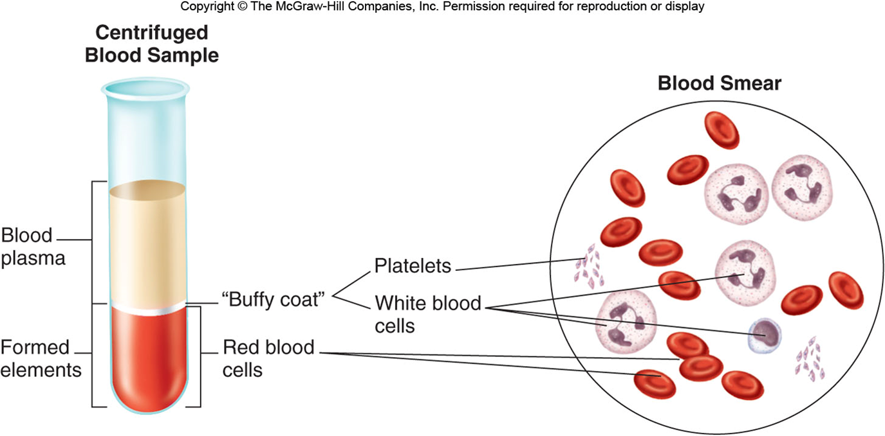
Arterial blood, with the exception of that going to the lungs, is bright red because of a high concentration of oxyhemoglobin (the combination of oxygen and hemoglobin) in the red blood cells.
Venous blood is blood returning to the heart. Except for the venous blood from the lungs, it contains less oxygen and is therefore a darker red than the oxygen-rich arterial blood.
Red blood cells compose most of the formed elements(cells); the percentage of red blood cell volume to total blood volume in a centrifuged blood sample (a measurement called the hematocrit Packed cell volume (PCV), is 36% to 46% in women and 41% to 53% in men.
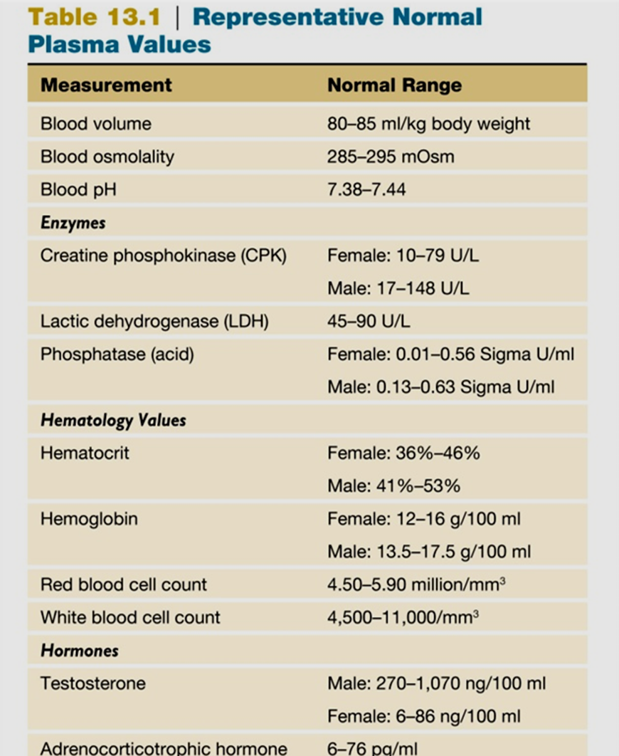

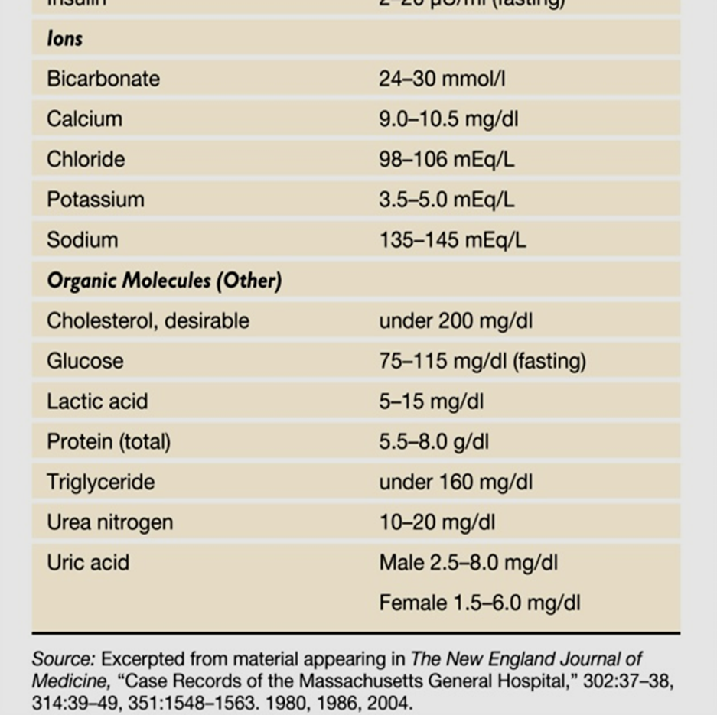
Composition of the Blood;
- Plasma:
Straw-colored liquid, Consists of H20 and dissolved solutes, Ions, metabolites, hormones and antibodies. Na+ is the major solute of the plasma.
Plasma proteins: Constitute 7-9% of plasma.
*Albumin:
Accounts for 60-80% of plasma proteins, produced by the liver. Provides the colloid osmotic pressure needed to draw H20 from interstitial fluid to capillaries and Maintains blood pressure & volume.
*Globulins:
α globulin & β globulin; which Produced by the liver and Transport lipids and fat-soluble vitamins.
γ globulin: Produced by lymphocytes and can Produce antibodies that function in immunity.
Fibrinogen:
Constitutes 4% of plasma proteins, produced by the liver it is an important clotting factor, converted into fibrin during the clotting process.
Serum:
Fluid from clotted blood. Plasma add anticoagulant (EDTA, citrate, heparin) to blood
Serum=plasma-clotting factors
Plasma volume:
Number of regulatory mechanisms in the body maintain homeostasis of plasma volume. Osmoreceptors in hypothalamus, ADH and Renin-angiotensin-aldosterone system.
- Erythrocytes;
- Flattened biconcave discs which provide increased surface area through which gas can diffuse.
- Lack nuclei and mitochondria.
- Half-life ~ 120 days.
- obtain energy through anaerobic metabolism
- Each RBC contains 280 million hemoglobin (red in color) with 4 globin chains each contains a heme group (contain iron) that will bind to oxygen molecule.
- old cells are removed from circulation by phagocytic cells in liver, spleen, and bone marrow.
- heme iron is recycled & travels in the blood to the bone marrow attached to a protein carrier called transferrin
erythrocyte disorders
Iron-deficiency anemia, the most common form of anemia (low red blood cell and/or hemoglobin concentration), results when there is insufficient iron for the production of normal amounts of hemoglobin. This is most often caused by blood loss due to heavy menstruation, peptic ulcers, or other sources of bleeding in the gastrointestinal tract. It can also be caused by the inability to
absorb iron (in celiac disease, for example) or from pregnancy due to the requirements of the fetus.
Pernicious anemia is most commonly due to a lack of intrinsic factor, a molecule produced by the stomach epithelium (intrinsic factor) and needed for the intestinal absorption of vitamin B12. can also be caused by intestinal malabsorption of dietary vitamin B12 due to Crohn’s disease or inadequate dietary intake of vitamin B12.
aplastic anemia, is the most serious anemia which produced by damage to the bone marrow from a variety of causes, including radiation and chemotherapy for cancer.
polycythemia is an abnormally high red blood cell count. This can have many causes, including the low oxygen of life at high altitudes

- Leukocytes:
- Contain nuclei and mitochondria.
- Move in amoeboid fashion.
- Can squeeze through capillary walls (diapedesis= extravasation).
- Almost invisible, so named after their staining properties.
- Granular leukocytes: eosinophils, basophils & neutrophils (the most abundant type of WBC; have little affinity for either stain; have 2-5 lobed nucleus=polymorphonuclear leukocytes (PMNs))
- Agranular leukocytes: Monocytes & Lymphocytes (the second most numerous types of WBC)
- Plasma cells secrete antibodies
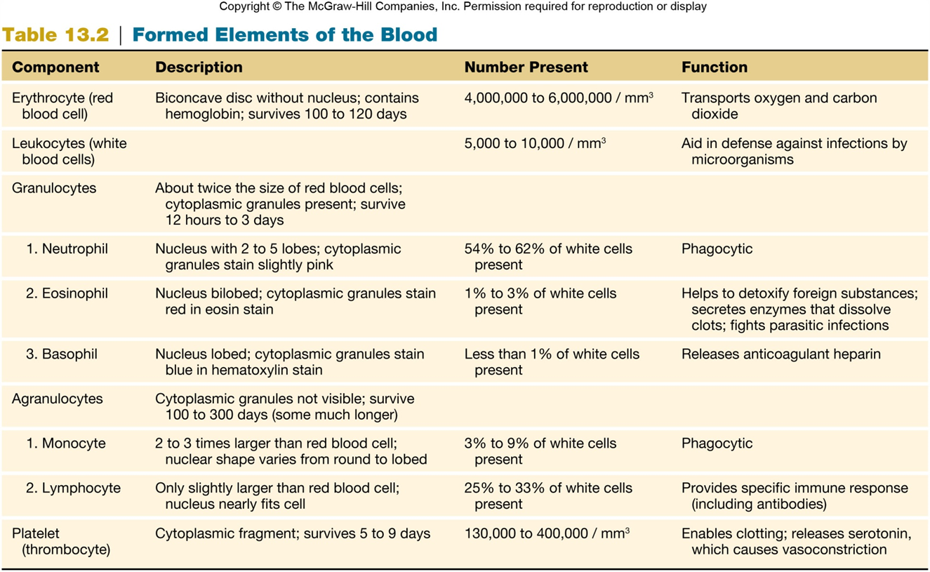

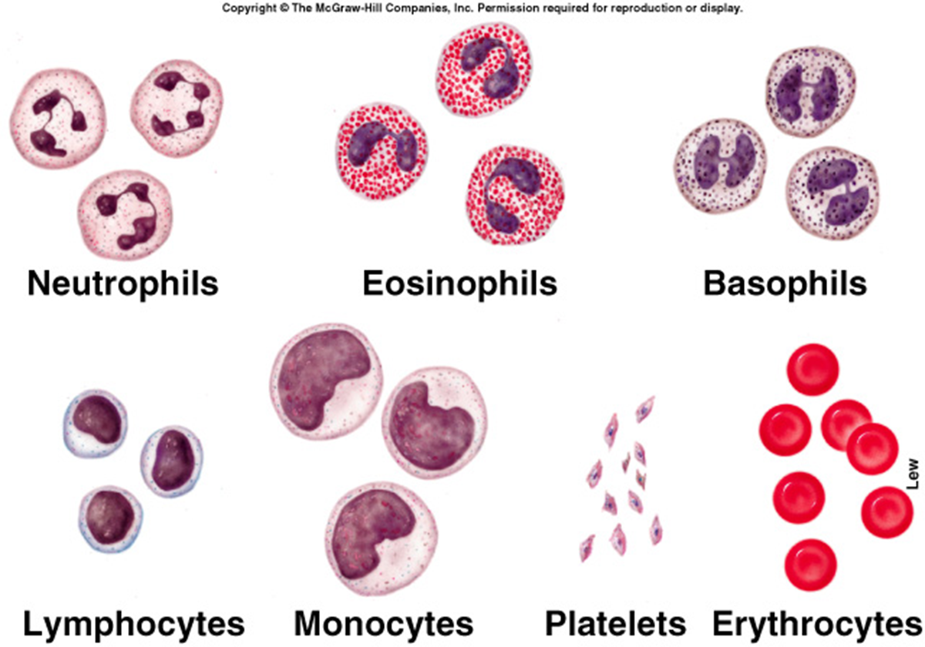
Leukocytes disorders;
Leukopenia is an abnormally low white blood cell count, which may be produced by radiation for cancer, among other causes.
Leukocytosis is an abnormally high white blood cell count, which may be caused by cytokines released from an inflammation during an infection.
Leukemia is cancer of the bone marrow that causes a high number of abnormal and immature white blood cells to appear in the blood.

- Platelets (thrombocytes);
- Smallest of formed elements
- Are fragments of megakaryocytes.
- Lack nuclei.
- Capable of amoeboid movement.
- Important in blood clotting which constitute most of the mass of the clot and release serotonin to vasoconstrict and reduce blood flow to area.
- Secrete growth factors which maintain the integrity of blood vessel wall.
- Survive 5-9 days.
Platelets disorders;
Thrombocytosis is an abnormally elevated platelet count. This occurs when conditions such as acute blood loss, inflammation, cancer, and others stimulate the liver to produce an excess of thrombopoietin.
Thrombocytopathy: A disorder of platelet function is thrombocytopathy. WHICH causes symptoms:
• Excessive menstrual bleeding
• Bleeding gums
• Gastrointestinal bleeding
• Blood in stool
• Bleeding nose
• Easy bruising
• Bleeding into the skin
• Blood in urine
Acquired thrombocytopathy has been known to be associated with such disorders as cirrhosis, leukemia, pernicious anemia, scurvy, and uremia. Temporary platelet dysfunction is sometimes induced by such drugs as antihistamines, aspirin, indomethacin, phenothiazines, phenylbutazone, and tricyclic antidepressants.
Thrombocytopenia;( low count platelets) Symptoms include: easy bruising, and frequent gums bleeding, nose, or GI tract. platelet count drops when something is preventing the body from producing platelets. There are a wide range of causes, including:
• Medications
• An inherited condition
• Certain types of cancer, such as leukemia or lymphoma
• Chemotherapy treatment for cancer
• Kidney infection or dysfunction
• Too much alcohol
Hematopoiesis (hemopoiesis);
The liver is the major hematopoietic organ of the fetus. In adult=bone marrow.
Occurs in myeloid tissue (is the red bone marrow of the long bones, ribs, sternum, pelvis, bodies of the vertebrae, and portions of the skull) and Lymphoid tissue includes the lymph nodes, tonsils, spleen, and thymus
The bone marrow produces all of the different types of blood cells the lymphoid tissue produces lymphocytes derived from cells that originated in the bone marrow.
Types of hematopoiesis:
Erythropoiesis: Formation of RBCs.
Leukopoiesis: Formation of WBCs
Erythropoiesis;
Active process, 2.5 million RBCs are produced every second.
Primary regulator of RBC production is erythropoietin produced by kidney. this hormone is commercially available for treatment of anemia which can stimulates cell division
Erythroblasts transform into normoblasts.
Normoblasts lose their nuclei to become reticulocytes.
Reticulocytes change into mature RBCs.
Old RBCs are destroyed in spleen and liver.
Iron recycled back to myeloid tissue to be reused in hemoglobin production. Also need for iron, vitamin B12 and folic acid for synthesis.
Platelet production: the liver produces thrombopoietin
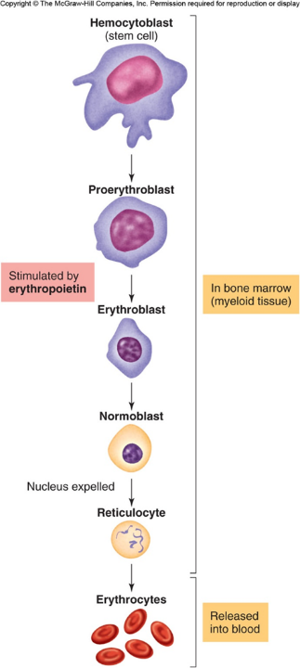
Leukopoiesis;
Cytokines stimulate different types and stages of WBC production.
- Multipotent growth factor-1, interleukin-1, and interleukin-3: Stimulate development of different types of WBC cells.
- Granulocyte-colony stimulating factor (G-CSF): Stimulates development of neutrophils.
- Granulocyte-monocyte colony stimulating factor (GM-CSF): Simulates development of monocytes and eosinophils.

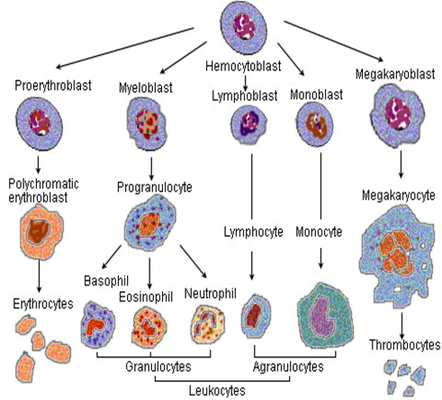

RBC Antigens;
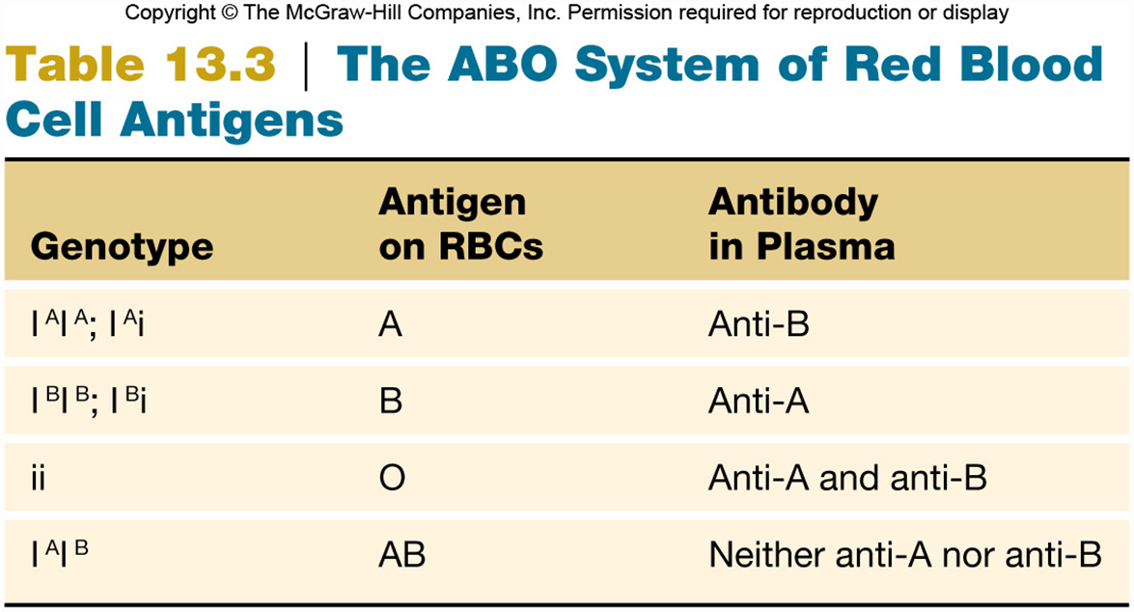
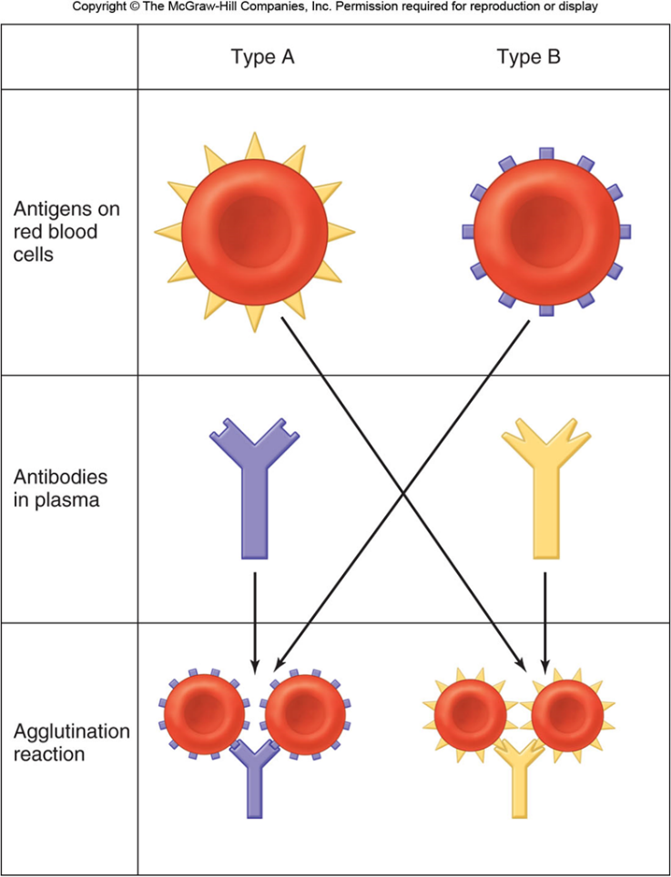
Blood Typing;
If blood types do not match, the recipient’s antibodies attach to donor’s RBCs and agglutinate.
- Type O:
Universal donor:
Lack A and B antigens.
- Type AB:
Universal recipient:
Lack the anti-A and anti-B antibodies.
Cannot agglutinate donor’s RBCs.

Rh Factor;
Another group of antigens found on RBCs named for the rhesus monkey.
Rh positive: Has Rho(D) antigens.
Rh negative: Does not have Rho(D) antigens.
Significant when Rh- mother gives birth to Rh+ baby.
At birth, mother may become exposed to Rh+ blood of fetus.
Mother at subsequent pregnancies may produce antibodies against the Rh factor.
Transfusion Reactions
Each person’s blood type determines which antigens are present on their RBC surface.
Major group of antigens of RBCs is the ABO system. The immune system exhibits tolerance to its own red blood cell antigens. People who are type A do not produce anti-A antibodies.
Before transfusions are performed, a major crossmatch is made by mixing serum from the recipient with blood cells from the donor.
Transfusion errors blockage of blood vessels due to hemolysis which may damage the kidneys and other organs.
Hemolytic disease of the newborn (Erythroblastosis fetalis);
Rh- mother produces antibodies, which cross placenta.
Hemolysis of Rh+ RBCs in the 2nd fetus.
prevented by injecting the Rh-negative mother with an antibody preparation against the Rh factor within 72 hours after the birth of each Rh-positive baby.
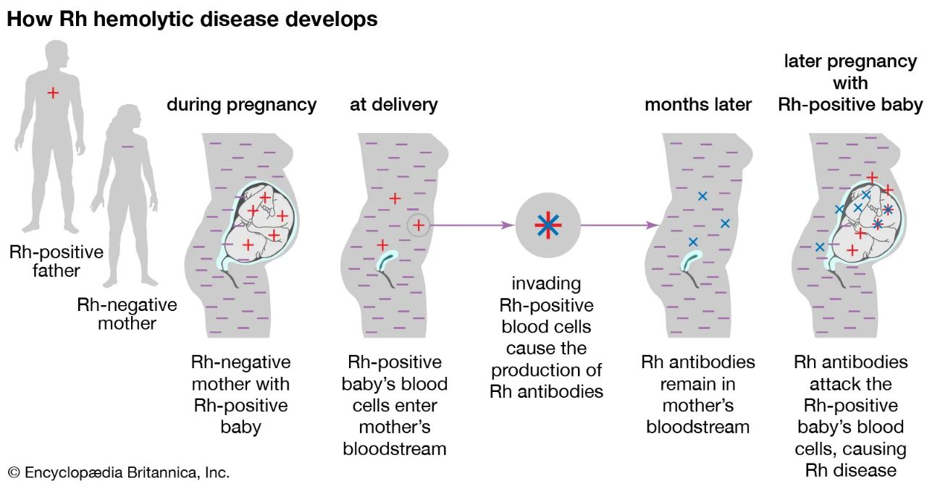

Inhibition of platelet aggregation
Mechanisms that ensure that platelets don’t stick to the vessel wall and to each other
1. An intact endothelium physically separates the blood from collagen and other platelet activators in the vessel wall.
2. Endothelial cells secrete prostacyclin (PGI 2) and nitric oxide (NO), which;
a- act as vasodilators
b- act on the platelets to inhibit platelet aggregation.
3. Endothelial cells contains an CD39 enzyme that breaks down ADP in the blood to AMP
Platelet aggregation;
The main function of platelets is to contribute to hemostasis: the process of stopping bleeding at the site of interrupted endothelium. They gather at the site and unless the interruption is physically become too large, they plug the hole. First, platelets attach to substances outside the interrupted endothelium: adhesion.
Second, they change shape, turn on receptors and secrete chemical messengers: activation. Third, they connect to each other through receptor bridges: aggregation.
Formation of this platelet plug (primary hemostasis) is associated with activation of the coagulation cascade with resultant fibrin deposition and linking (secondary hemostasis).

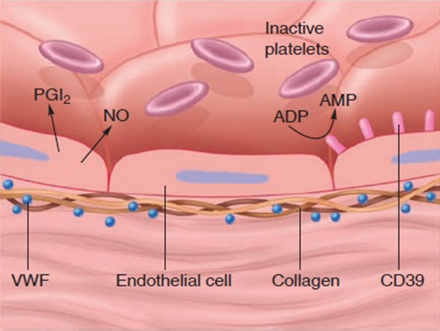
Figure 13.7 Platelet aggregation.
(a) Platelet aggregation is prevented in an intact endothelium because it separates the blood from collagen, a potential platelet activator. Also, the endothelium secretes nitric oxide (NO) and prostaglandin I2 (PGI2), which inhibit platelet aggregation. An enzyme called CD39 breaks down ADP in the blood, which would otherwise promote platelet aggregation. (b) When the endothelium is broken, platelets adhere to collagen and to von Willebrand’s factor (V WF), which helps anchor the platelets that are activated by this process and by the secretion of ADP and thromboxane A2 ( Tx A2), a prostaglandin. (c) A platelet plug is formed and reinforced with fibrin proteins
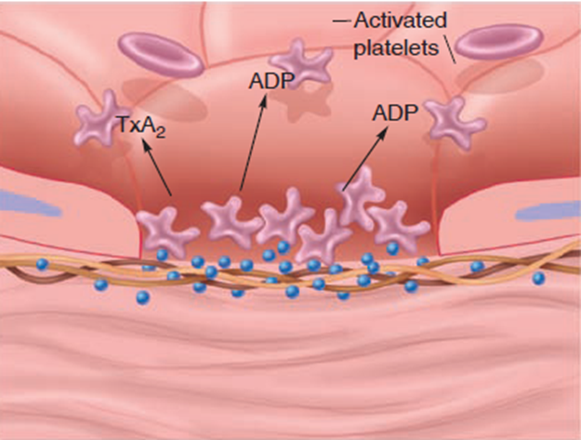
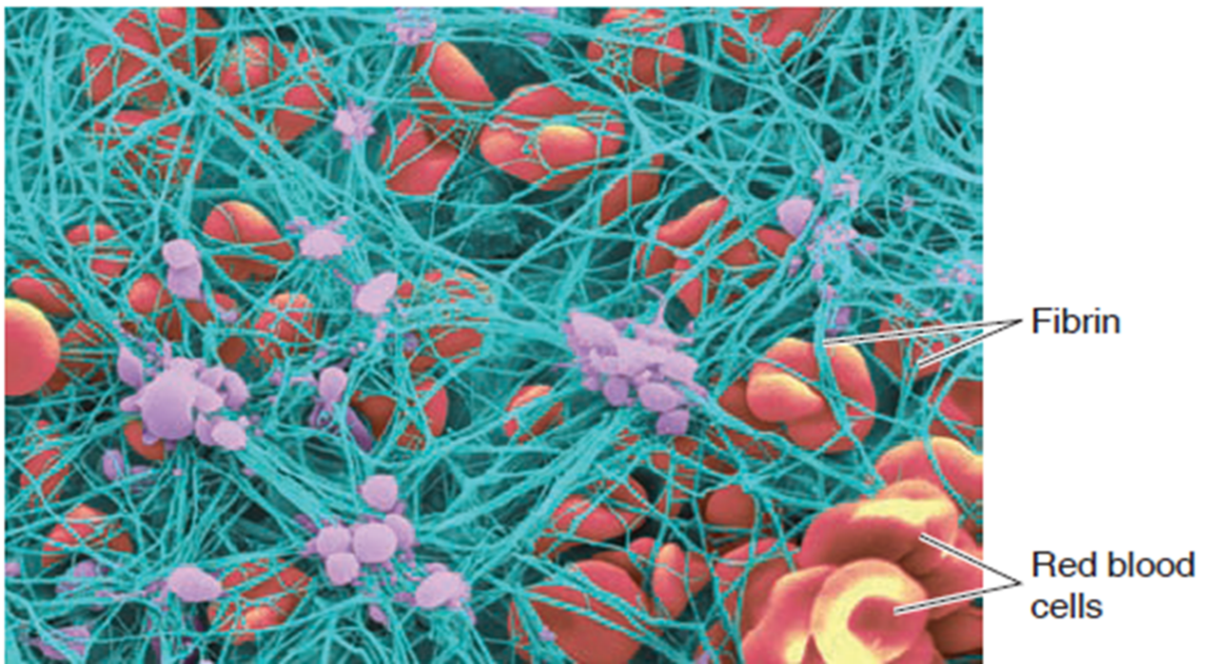
Figure 13.8 Colorized scanning electron micrograph of a blood clot. The threads of fibrin have been colored green, the erythrocytes are shown red, and the platelets have been colored purple
Normal platelets can respond to an abnormality on the vessel wall rather than to hemorrhage, resulting in inappropriate platelet adhesion/activation and thrombosis: the formation of a clot within an intact vessel.
Platelet Activation, Agglutination and Aggregation;
Platelets play an important role in the initiation of a blood clot, as following:
1 - The first step in healing a wound is the activation of platelets. When platelets around a wound, or encounter specific chemicals in the blood, then they become "sticky". 2 - They bind to the injured cells in a wound as well as to each other, then platelets become more rounded in shape and develop spikes. 3 - Activated platelets form a mesh, or a platelet plug, that covers and fills a wound. The plug temporarily stops bleeding. It's quite weak, however, and may be removed by flowing blood unless it's strengthened by a blood clot. The activated platelets in a plug release chemical that are needed by the blood clotting process.
Summary of the Blood Clotting Process
The blood clotting process is complex and involves many reactions. However, the process can be summarized in following steps:
• A complex known as a prothrombin activator is produced by a long sequence of chemical reactions.
• The prothrombin activator that release after injury the blood vessel, converts an inactive protein found in the blood called prothrombin into active protein called thrombin.
• Thrombin is an enzyme that converts a soluble inactive blood protein called fibrinogen into an insoluble protein called fibrin.
• Fibrin exists as solid fibers which form a tight mesh over the wound. The mesh traps platelets and other blood cells and forms the blood clot.
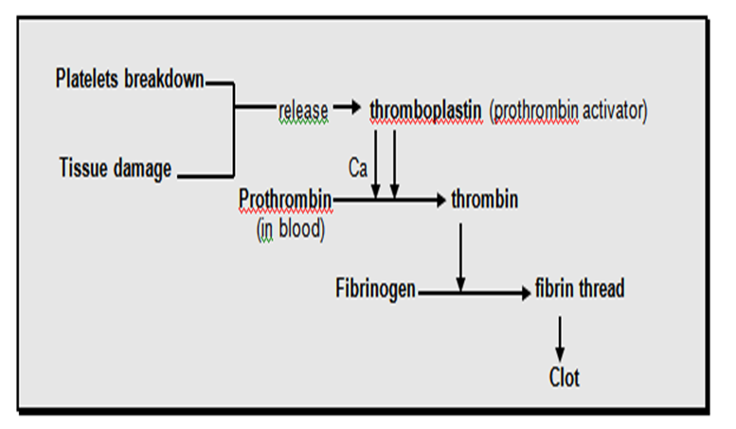
The coagulation cascade is often classified into three pathways—the extrinsic pathway, the intrinsic pathway, and the common pathway;
1 - The extrinsic pathway is triggered by a chemical called tissue factor that is released by damaged cells. This pathway is "extrinsic" because it's initiated by a factor outside the blood vessels. It's also known as the tissue factor pathway. 2 - The intrinsic pathway is triggered by blood coming into contact with collagen fibers in the broken wall of a blood vessel. It's "intrinsic" because it's initiated by a factor inside the blood vessel. It's sometimes called the contact activation pathway. Both pathways eventually produce a prothrombin activator by a series of activation as in diagram below: -

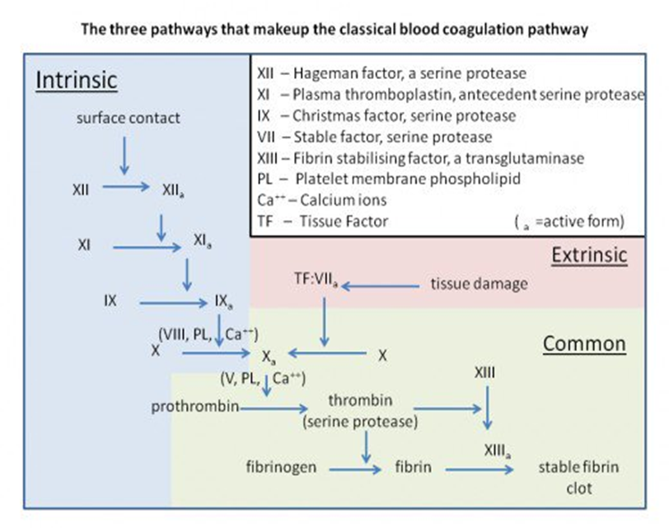
3 - The common pathway was triggers by prothrombin activator, in which prothrombin becomes thrombin followed by the conversion of fibrinogen to fibrin.
Clotting Factors
The chemicals involved in the coagulation cascade are called clotting or coagulation factors. There are twelve clotting factors, which are numbered with Roman numerals and given a common name as well. The factors are numbered according to the order in which they were discovered and not according to the order in which they react.
Other chemicals are needed for blood clotting in addition to those numbered in the coagulation cascade. For example, vitamin K is an essential chemical in the blood clotting process.

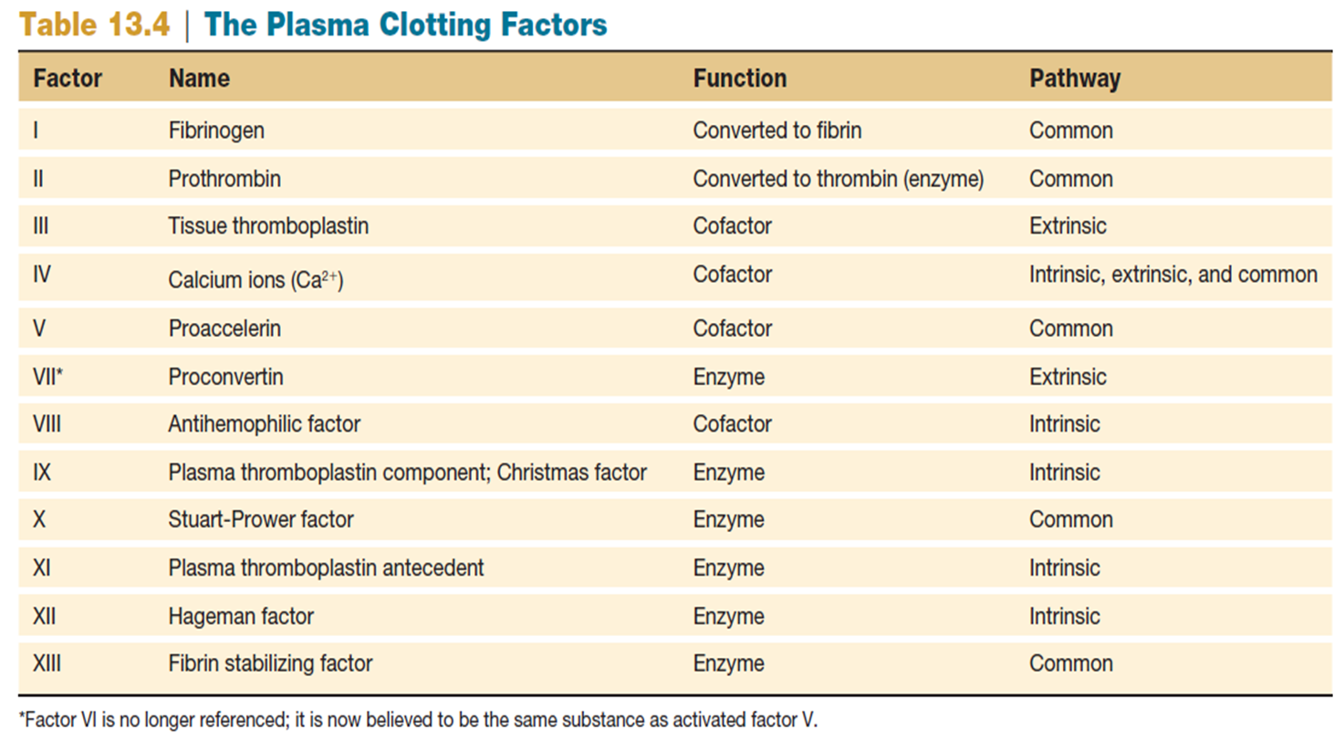
Dissolution of Clots
Activated factor XII converts an inactive molecule into the active form (kallikrein).
Kallikrein converts plasminogen to plasmin.
Plasmin is an enzyme that digests the fibrin.
Clot dissolution occurs.
Anticoagulants:
Heparin: Activates antithrombin III.
Coumarin: Inhibits cellular activation of vitamin K.
