
كلية الرشيد الجامعة/ قسم كلية التمريض
مادة الفسلجة للمرحلة الاولى
المحاضرة السادسة
Dr. Alan Ali
2024/2023

Physiology of nervous system
There are 2 types of cells in the nervous system:
- Neurons.
- Supporting cells.
Nervous system is divided into:
- Central nervous system (CNS):
- Brain.
- Spinal cord.
- Peripheral nervous system (PNS):
- Cranial nerves.
- Spinal nerves.
- Ganglia
Neurons;
Basic structural and functional units of the nervous system (Cannot divide by mitosis). Respond to physical and chemical stimuli, produce and conduct electrochemical impulses and release chemical regulators.
Nerve: Bundle of axons located outside CNS, most composed of both motor and sensory fibers.
It composed of;
1- Cell body (perikaryon): contains the nucleus, Nissl bodies, neurofibrils, and other organelles.
2-Cell bodies within CNS clustered into nuclei, and in PNS in ganglia.
3-Dendrites: Provide receptive area and transmit electrical impulses to cell body.
4-Axon: Conducts impulses away from cell body
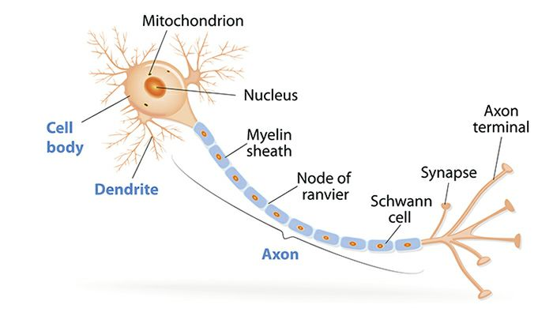
Functional Classification of Neurons;
Based upon direction impulses conducted;
- Sensory or afferent: Conduct impulses from sensory receptors into CNS.
- Motor or efferent: Conduct impulses out of CNS to effector organs.
- Association or interneurons: Located entirely within the CNS. Serve an integrative function.
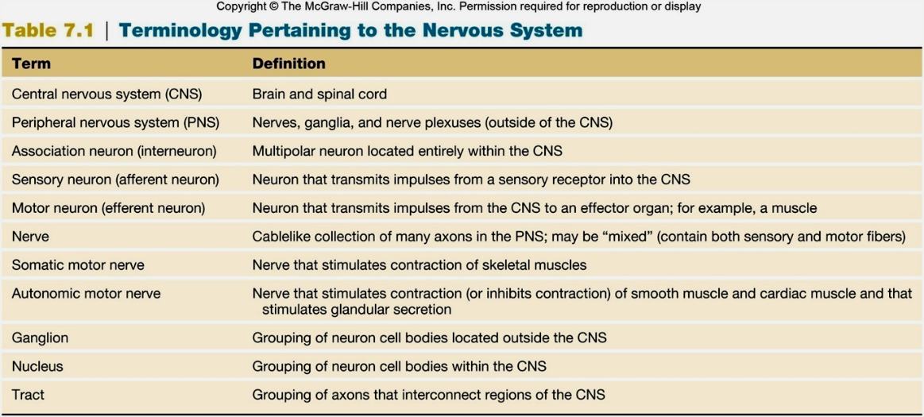
Structural Classification of Neurons;
Based on the shape of processes that extend from cell body.
- Pseudounipolar: Short single process that branches like a T. Sensory neuron.
- Bipolar neurons: Have 2 processes, found in retina of the eye.
- Multipolar: Have several dendrites and 1 axon, Motor neuron.
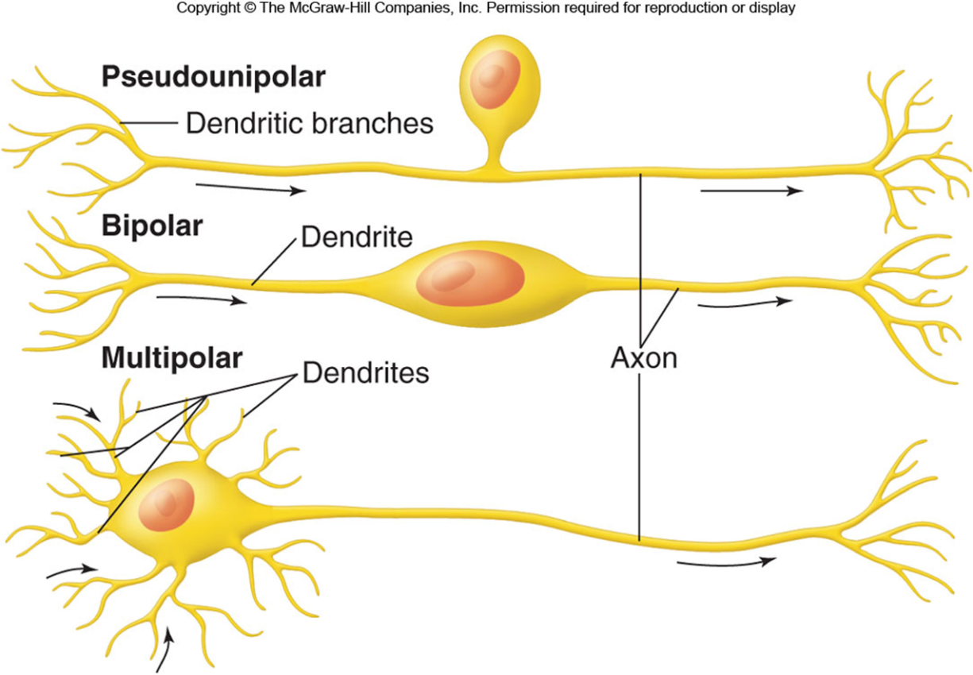
PNS Supporting Cells;
- Schwann cells:
- Successive wrapping of the cell membrane.
- Outer surface encased in glycoprotein basement membrane.
- Provide insulation.
- Nodes of Ranvier: Unmyelinated areas between adjacent Schwann cells that produce nerve impulses.
- Satellite cells: Support neuron cell bodies within ganglia.
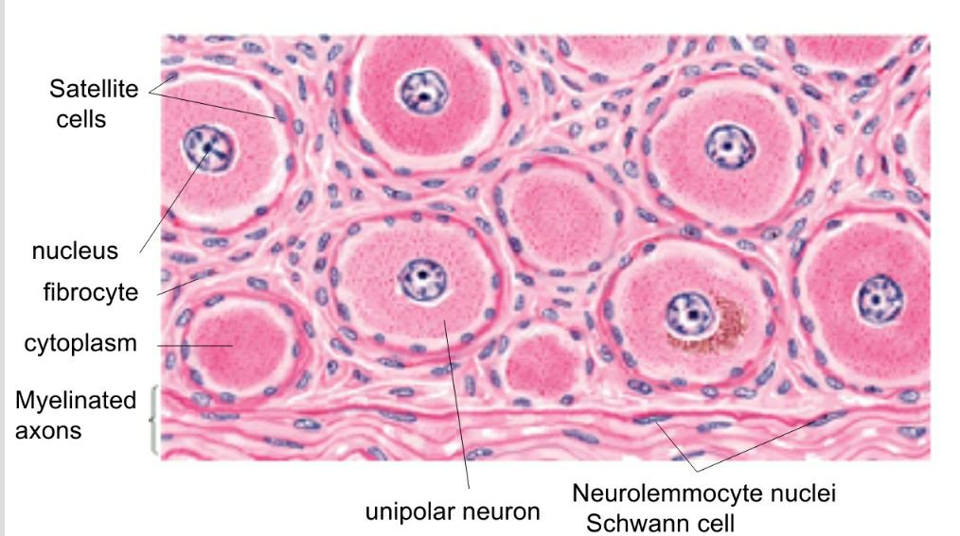
CNS Supporting Cells;
- Oligodendrocytes:
- Process occurs mostly postnatally.
- Each has extensions that form myelin sheaths around several axons.
- Insulation.
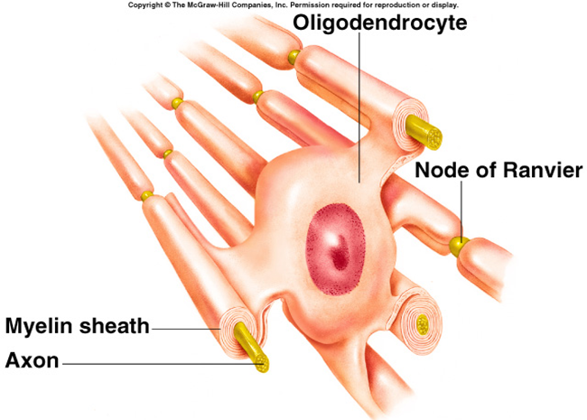
- Microglia: Phagocytes, migratory.
- Ependymal cells: Line ventricles.
- Astrocytes:
- Most abundant glial cell.
- Vascular processes terminate in end-feet that surround the capillaries.
- Stimulate tight junctions, contributing to blood-brain barrier.
- Regulate external environment of K+ and pH.
- Take up K+ from ECF, NTs released from axons, and lactic acid (convert for ATP production).
- Other extensions adjacent to synapses.
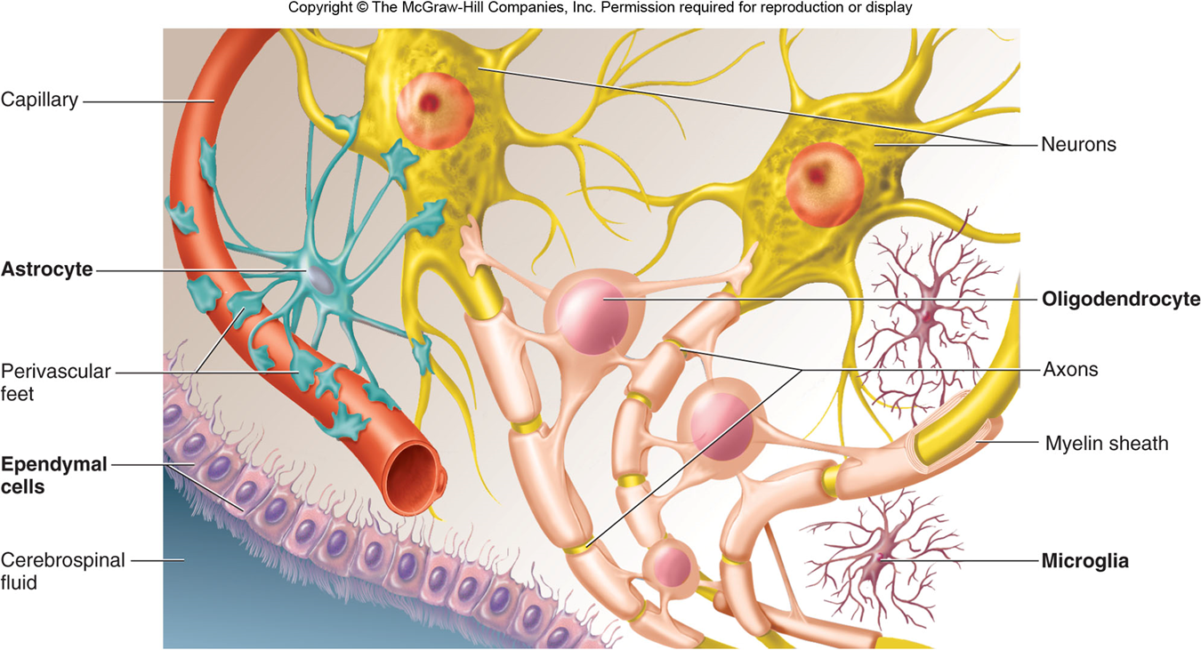
The different types of neuroglial cells. Myelin sheaths around axons are formed in the CNS by oligodendrocytes. Astrocytes have extensions that surround both blood capillaries and neurons. Microglia are phagocytic, and ependymal cells line the brain ventricles and central canal of the spinal cord
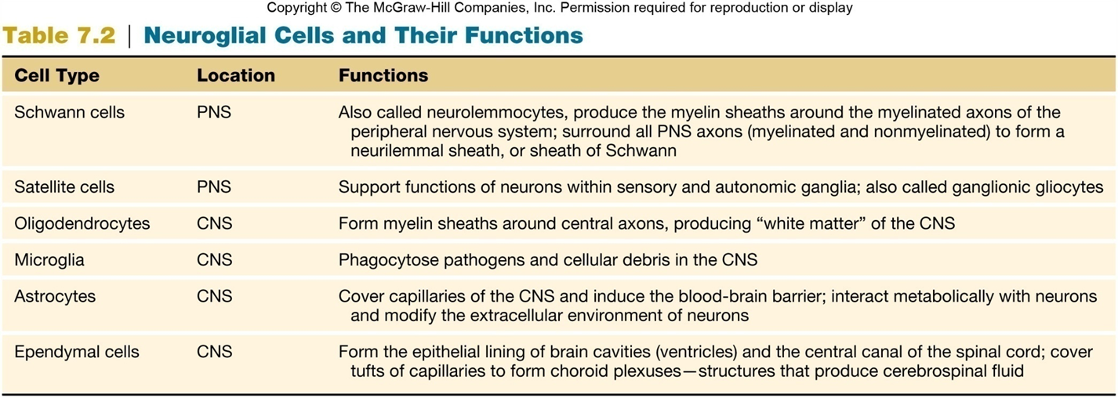
The Cerebrospinal Fluid (CSF);
CSF is formed by diffusion and active transport, rather than by the non-specific simple filtration of blood plasma, has a constant composition. Slightly hypertonic, and differs from plasma in its concentration of various ions. Humans secrete nearly 500 mL of CSF daily. Only about 140 milliliters are in the nervous system at any time. It is turned over 3–5 times per day. The CSF is formed by the Choroid plexus (These are structures project into the cavities of the ventricles).
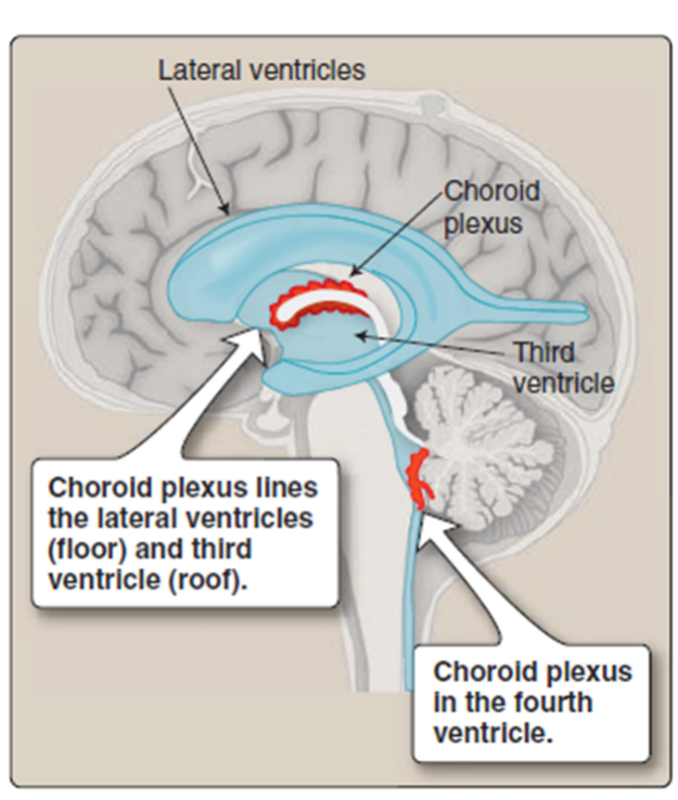
Blood-Brain Barrier;
Capillaries in brain do not have pores between adjacent endothelial cells so they joined by tight junctions.
Molecules within brain capillaries moved selectively through endothelial cells by:
- Diffusion.
- Active transport.
- Endocytosis.
- Exocytosis.
Electrical Activity of Axons;
All cells maintain a resting membrane potential (RMP):
- Potential voltage difference across membrane.
- Largely the result of negatively charged organic molecules within the cell.
- Limited diffusion of positively charged inorganic ions.
- Permeability of cell membrane:
- Electrochemical gradients of Na+ and K+.
- Na+/K+ ATPase pump.
- Excitability/irritability:
- Ability to produce and conduct electrical impulses
- Increase in membrane permeability for specific ion can be measured by placing 2 electrodes (1 inside and 1 outside the cell).
- Depolarization:
- Potential difference reduced (become more positive).
- Repolarization:
- Return to resting membrane potential (become more negative).
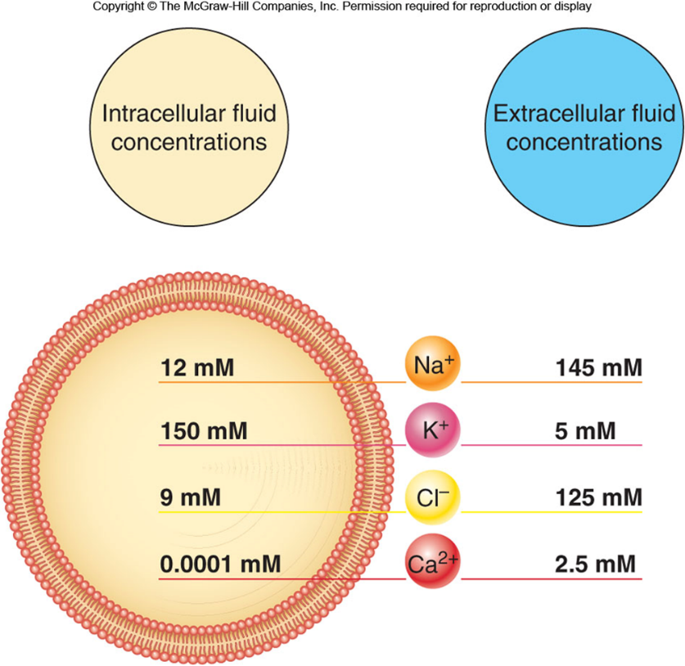
Ion Gating in Axons;
- Changes in membrane potential caused by ion flow through ion channels.
- Voltage gated (VG) channels open in response to change in membrane potential.
- Gated channels are part of proteins that comprise the channel, can be open or closed in response to change.
- 2 types of channels for K+:
- 1 always open.
- 1 closed in resting cell.
- Channel for Na+:
- Always closed in resting cells.
- Some Na+ does leak into the cells.
Na + and K + channels;
The voltage-regulated Na+ and K + channels open in response to the stimulus of depolarization.
When the membrane is depolarized to a threshold level, the Na+ channels open first, followed quickly by opening of the K+ channels.
The explosive increase in Na + diffusion causes rapid depolarization and then overshoot of the membrane potential so that the inside of the membrane actually becomes positively charged (almost + 30 mV)
voltage-regulated channels;
The opening of voltage-regulated channels produces an action potential.
The opening of Na+ channels in response to depolarization allows Na+ to diffuse into the axon, thus further depolarizing the membrane in a positive feedback fashion.
The inward diffusion of Na+ causes a reversal of the membrane potential from − 70 mV to + 30 mV.
The opening of K + channels and outward diffusion of K+ causes the reestablishment of the resting membrane potential. This is called repolarization.
Action Potentials (APs);
Stimulus causes depolarization to threshold.
- Voltage gate Na+ channels open.
- Electrochemical gradient inward (+ve feedback loop).
- Rapid reversal in membrane potential from –70 to + 30 mV.
- Voltage gate Na+ channels become inactivated.
- Voltage gate K+ channels open.
- Electrochemical gradient outward (-ve feedback loop).
- Restore original RMP.

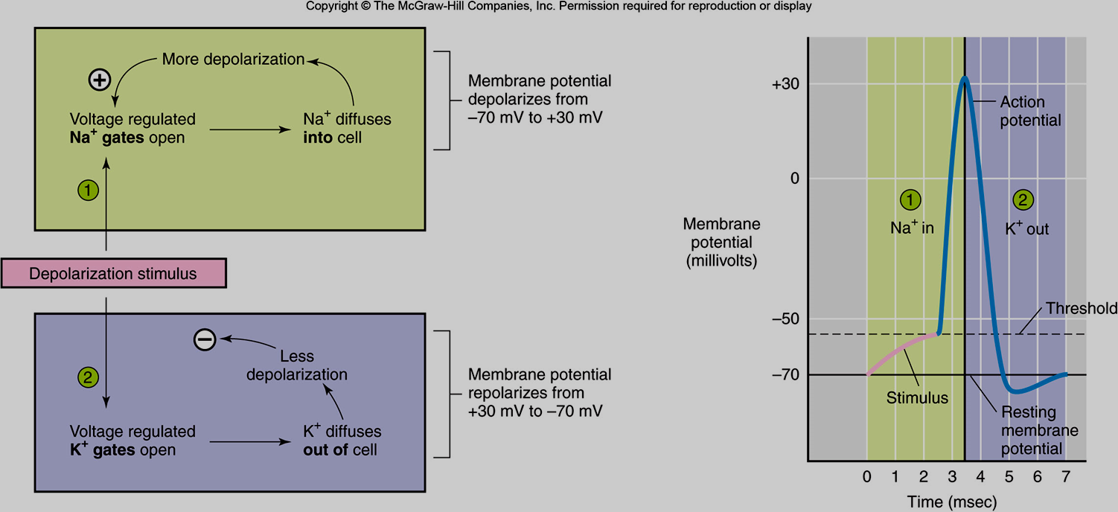
Depolarization of an axon affects Na+ and K+ diffusion in sequence. (1) Na+ gates open and Na+ diffuses into the cell. (2) After a brief period, K+ gates open and K+ diffuses out of the cell. An inward diffusion of Na+ causes further depolarization, which in turn causes further opening of Na+ gates in a positive feedback (+) fashion. The opening of K+ gates and outward diffusion of K+ makes the inside of the cell more negative, and thus has a negative feedback effect (–) on the initial depolarization
AP is produced by an increase in Na+ permeability.
After short delay, increase in K+ permeability
Depolarization and repolarization occur via diffusion, do not require active transport. Once AP completed, Na+/K+ ATPase pump extrudes Na+, and recovers K+.
All or none: When threshold reached, maximum potential change occurs. Amplitude does not normally become more positive than + 30 mV because VG Na+ channels close quickly and VG K+ channels open.
Duration is the same, only open for a fixed period of time.
Coding for Stimulus Intensity:
Increased frequency of AP indicates greater stimulus strength.
Recruitment:
Stronger stimuli can activate more axons with a higher threshold.
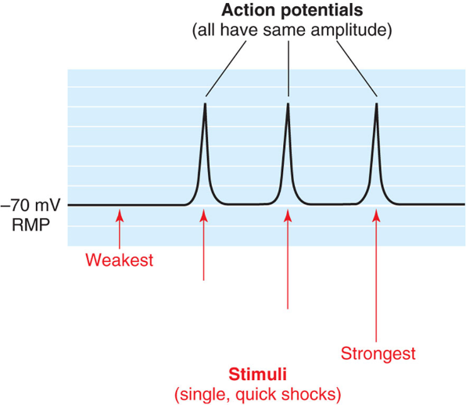
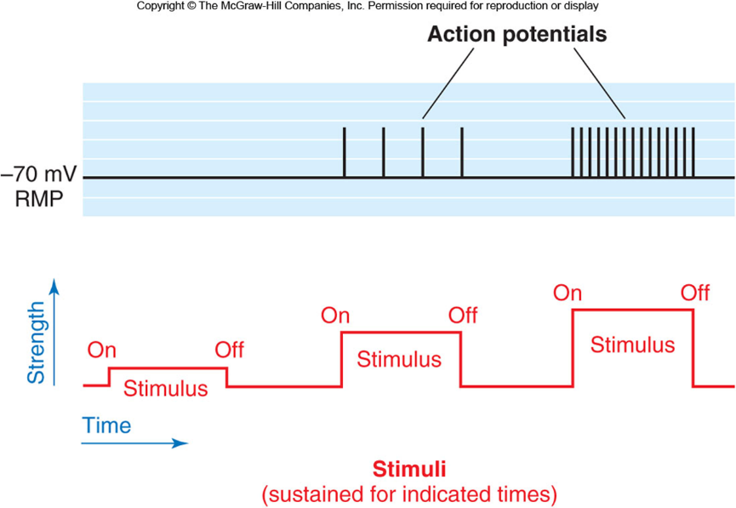
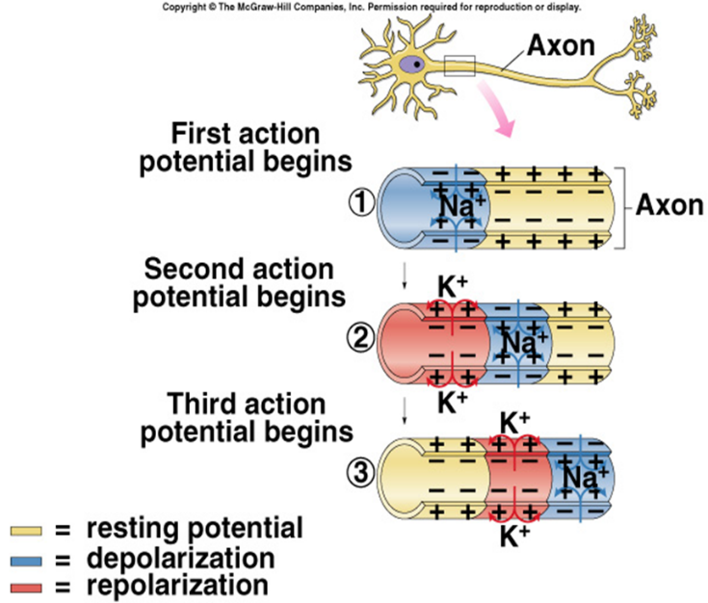
The Synapse; it is a Functional connection between a neuron and another neuron or effector cell, transmission in one direction only.
Axon of first (presynaptic) to second (postsynaptic) neuron.
Synaptic transmission is through a chemical gated channel.
Presynaptic terminal (bouton) releases a neurotransmitter (NT)
Gap junctions are electrical synapses found in cardiac muscle, smooth muscle, and some regions of the brain.
In chemical synapses, neurotransmitters are packaged in synaptic vesicles and released by exocytosis into the synaptic cleft.
1. The neurotransmitter can be called the ligand of the receptor.
2. Binding of the neurotransmitter to the receptor causes the opening of chemically regulated gates of ion channels.
Electrical Synapse;
Impulses can be regenerated without interruption in adjacent cells.
Gap junctions: Adjacent cells electrically coupled through a channel.
Each gap junction is composed of 12 connexin proteins.
Examples: Smooth and cardiac muscles, brain, and glial cells
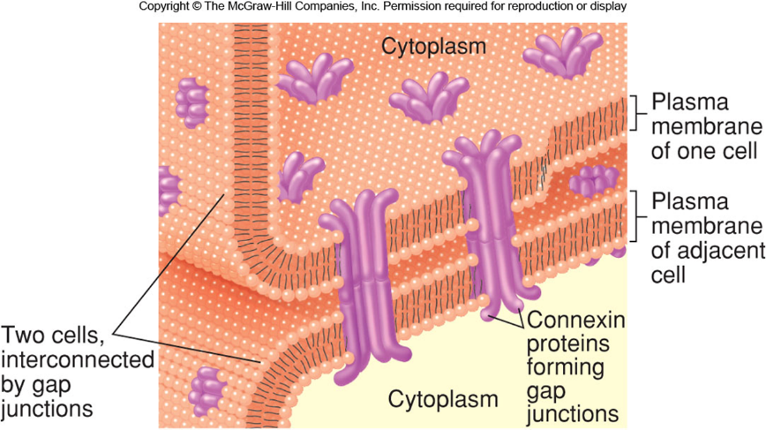
The structure of gap junctions
Gap junctions are water-filled channels through which ions can pass from one cell to another. This permits impulses to be conducted directly from one cell to another. Each gap junction is composed of connexin proteins. Six connexin proteins in one plasma membrane line up with six connexin proteins in the other plasma membrane to form each gap junction.
The release of neurotransmitter. Steps 1–4 summarize how action potentials stimulate the exocytosis of synaptic vesicles. Action potentials open channels for Ca2+, which enters the cytoplasm and binds to a sensor protein, believed to be synaptotagmin. Meanwhile, docked vesicles are held to the plasma membrane of the axon terminals by a complex of SNARE proteins.
The Ca2+-sensor protein complex alters the SNARE complex to allow the complete fusion of the synaptic vesicles with the plasma membrane, so that neurotransmitters are released by exocytosis from the axon terminal. Terminal bouton is separated from postsynaptic cell by synaptic cleft.
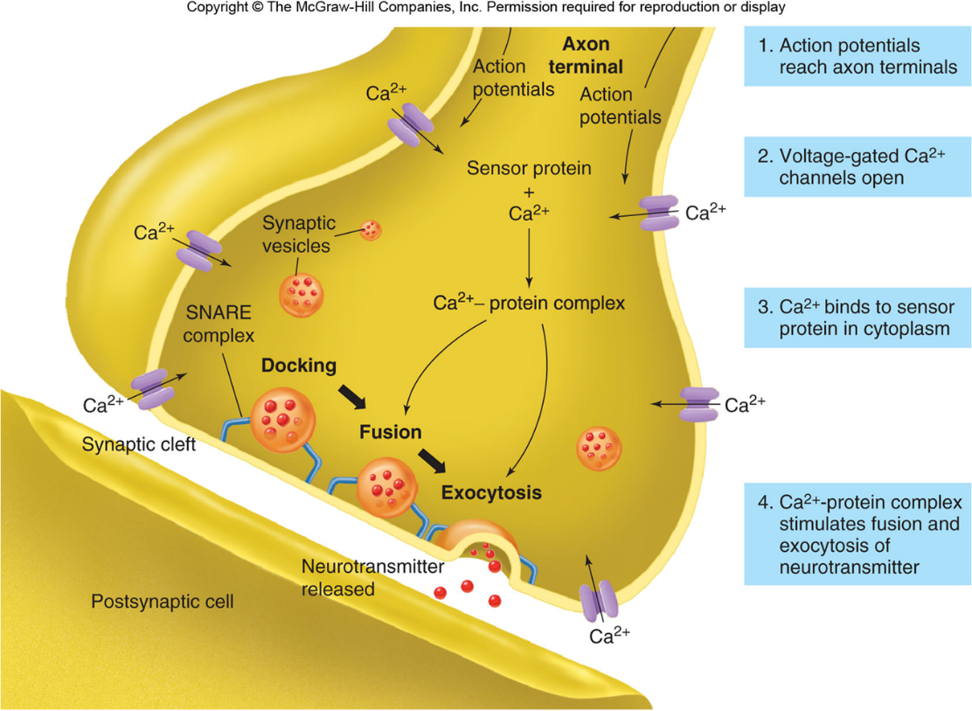
Synaptic Transmission
NTs are released and diffuse across synaptic cleft.
NT (ligand) binds to specific receptor proteins in postsynaptic cell membrane.
Chemically-regulated gated ion channels open.
Neurotransmitter inactivated to end transmission.
Axon bouton synapses with dendrites or cell body of another neuron.
Neuron-neuron synapses
involve a connection between the axon of one neuron and the dendrites, cell body, or axon of a second neuron. These are called, respectively, axodendritic, axosomatic, and axoaxonic synapses. In almost all synapses, transmission is in one direction only—from the axon of the first (or presynaptic) neuron to the second (or postsynaptic) neuron. Most commonly, the synapse occurs between the axon of the presynaptic neuron and the dendrites or cell body of the postsynaptic neuron
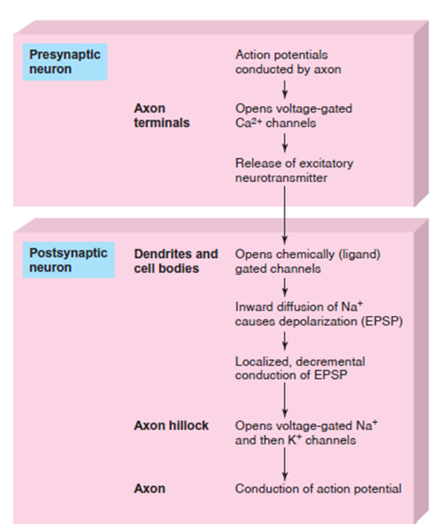
different regions of the postsynaptic neuron are specialized, with ligand-(chemically) gated channels located in the dendrites and cell body, and voltage-gated channels located in the axon.
Acetylcholine (Ach) as a Neurotransmitter (NT)
Cholinergic neurons: Use ACh as NT.
A. There are two subtypes of ACh receptors: nicotinic and muscarinic.
1. Nicotinic receptors enclose membrane channels and open when ACh binds to the receptor. This causes a depolarization called an excitatory postsynaptic potential (EPSP).
2. The binding of ACh to muscarinic receptors opens ion channels indirectly, through the action of G-proteins. This can cause either an EPSP or an inhibitory postsynaptic potential (IPSP).
ACh is both an excitatory and inhibitory NT, depending on organ involved. Causes the opening of chemical gated ion channels.
- Nicotinic ACh receptors: Found in autonomic ganglia and skeletal muscle fibers.
- Muscarinic ACh receptors: Found in the plasma membrane of smooth and cardiac muscle cells, and in cells of particular glands.
ACh is used in the PNS as the neurotransmitter of somatic motor neurons, which stimulate skeletal muscles to contract, and by some autonomic neurons.
ACh in the CNS produces EPSPs at synapses in the dendrites or cell body. These EPSPs travel to the axon hillock, stimulate opening of voltage-regulated channels, and generate action potentials in the axon.
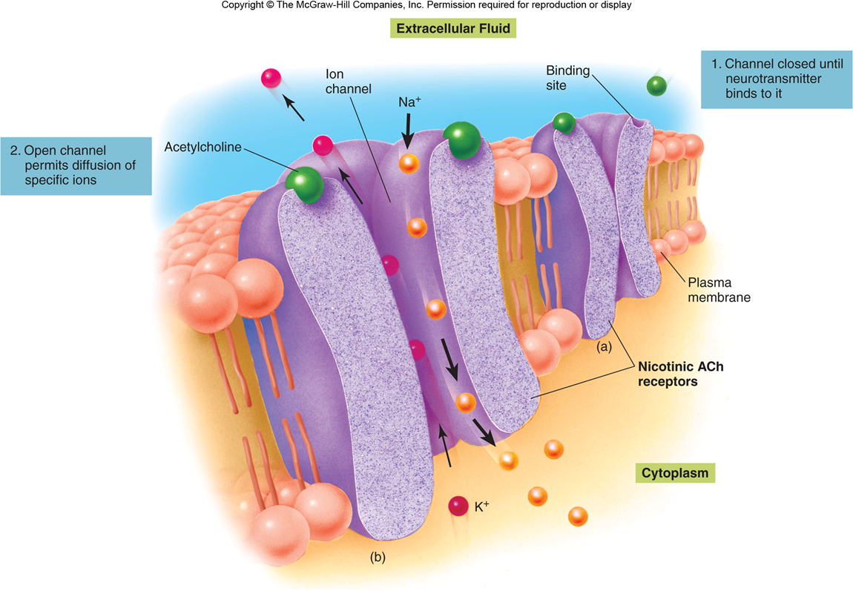
Nicotinic acetylcholine (ACh) receptors also function as ion channels. The nicotinic acetylcholine receptor binds to ACh. Na+ and K+ diffuse simultaneously, and in opposite directions, through the open ion channel. The electrochemical gradient for Na+ is greater than for K+, so that the effect of the inward diffusion of Na+ predominates, resulting in a depolarization known as an excitatory postsynaptic potential (EPSP).
Ligand-Operated ACh Channels
Most direct mechanism. Ion channel runs through receptor.
Receptor has 5 polypeptide subunits that enclose ion channel. Has 2 subunits contain ACh binding sites. Channel opens when both sites bind to ACh. Permits diffusion of Na+ into and K+ out of postsynaptic cell.
Inward flow of Na+ dominates. Produces EPSPs.
G Protein-Operated ACh Channel
- Only 1 subunit.
- Ion channels are separate proteins located away from the receptors.
- Binding of ACh activates alpha G-protein subunit.
- Alpha subunit dissociates.
- Alpha subunit or the beta-gamma complex diffuses through membrane until it binds to ion channel, opening it.
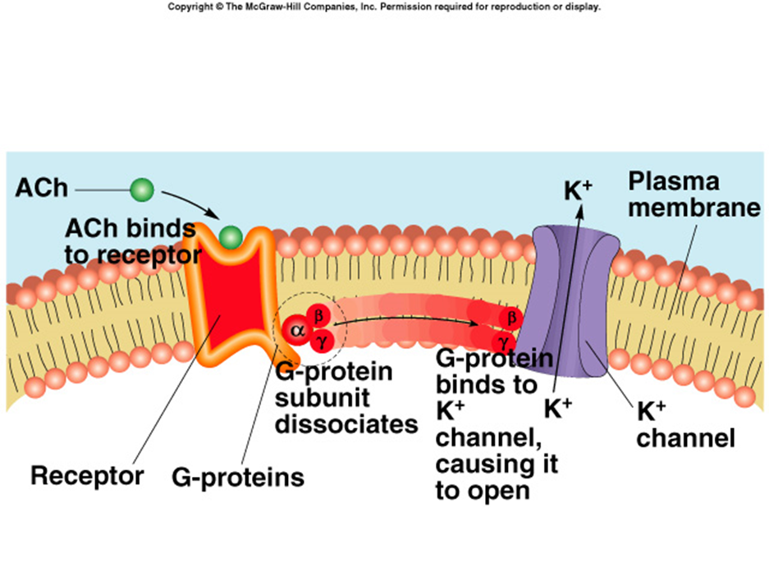
Muscarinic ACh receptors require the action of G-proteins. The figure depicts the effects of ACh on the pacemaker cells of the heart. Binding of ACh to its muscarinic receptor causes the beta-gamma subunits to dissociate from the alpha
subunit. The beta-gamma complex of G-proteins then binds to a K+ channel, causing it to open. Outward diffusion of K+ results, slowing the heart rate.

acetylcholinesterase (AChE);

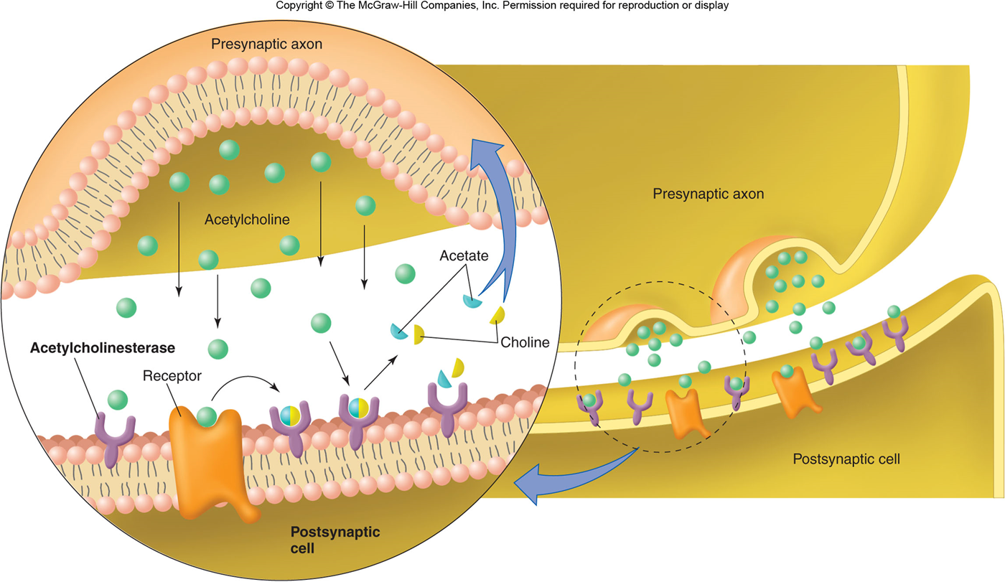
The action of acetylcholinesterase (AChE). The AChE in the postsynaptic cell membrane inactivates the Ach released into the synaptic cleft. This prevents continued stimulation of the postsynaptic cell unless more ACh is released by the axon. The acetate and choline are taken back into the presynaptic axon and used to resynthesize acetylcholine.
Spinal Nerves
Produces Two roots to each nerve.
- Dorsal root composed of sensory fibers.
- Ventral root composed of motor fibers
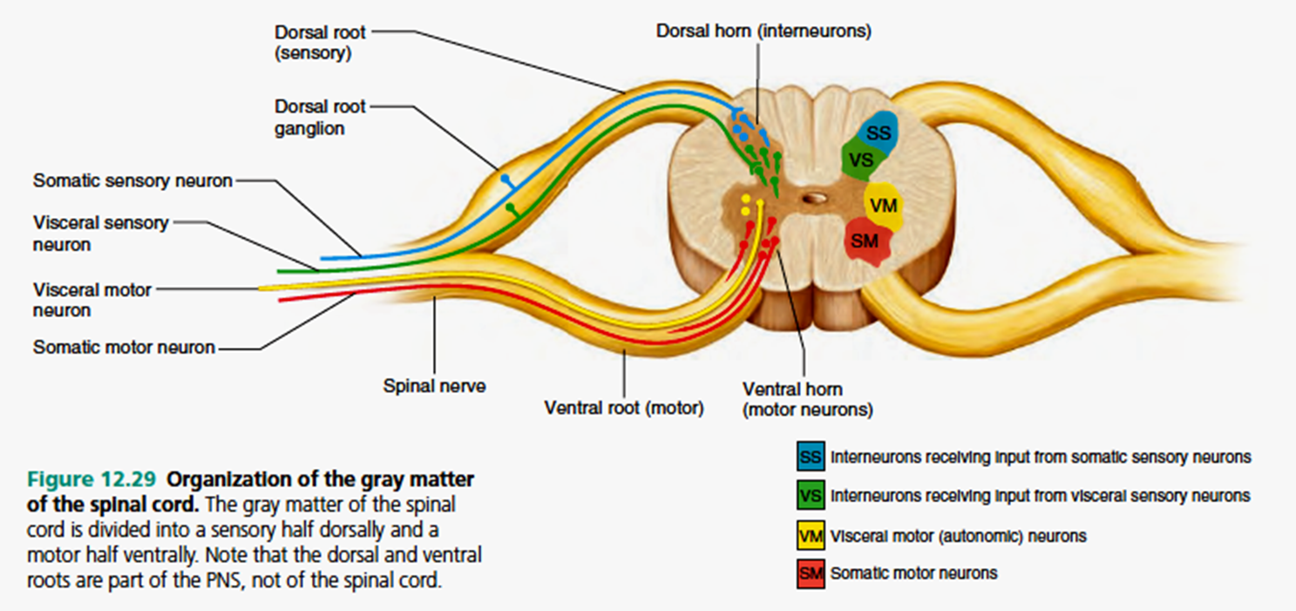
Reflex Arc;
Unconscious motor response to a sensory stimulus.
Stimulation of sensory receptors evokes APs that are conducted into spinal cord.
Synapses with association neuron, which synapses with somatic motor neuron.
Conducts impulses to muscle and stimulates a reflex contraction.
Brain is not directly involved.
