

**كلية الرشيد الجامعة/ كلية التمريض**

**مادة الفسلجة للمرحلة الاولى**

**المحاضرة السابعة**

**م.د الان علي**

**2024/2023**

**The lymphatic and immune system**

The lymphatic system;

Is part of the vascular system and an important part of the immune system, comprising a large network of lymphatic vessels that carry a clear fluid called *lymph* directly towards the heart.

**Lymph** is a clear and colorless fluid that circulates all the way through the lymphatic system is formed when interstitial fluid enters the initial lymphatic vessels of the lymphatic system. The lymph is then moved along the lymphatic vessel network by either intrinsic contractions of the lymphatic passages or by extrinsic compression of the lymphatic vessels via external tissue forces (e.g., the contractions of skeletal muscles)

**Composition of the Lymph**

Lymph consists of the following components:

• Proteins – Albumin, globulin, and fibrinogen.

• Non-protein nitrogenous substance.

• Carbohydrates.

• Lymphocytes.

• Water – 94%.

• Very low amount of fat.

• Creatinine.

• Urea.

• Chlorides.

• Enzymes

**Lymphatic Vessels;**

The function of the lymphatic vessels is to form an elaborate drainage system that picks up excess tissue fluid, now called *lymph*. The lymphatics are responsible for maintaining the balance of the body fluids. Its network of capillaries and collecting lymphatic vessels work to efficiently drain and transport extravasated fluid, along with proteins and antigens, back to the circulatory system. Numerous intraluminal valves in the vessels ensure a unidirectional flow of lymph without reflux.

The lymphatic vessels, also called lymphatic’s, form a one-way system, and lymph flows only toward the heart. Which are: - 1- Lymph capillaries; The microscopic, blind-ended lymph capillaries weave between the tissue cells and blood capillaries in the loose connective tissues of the body and absorb the leaked fluid. The valves at the ends of capillaries use specialized junctions together with anchoring filaments to allow a unidirectional flow to the primary vessels

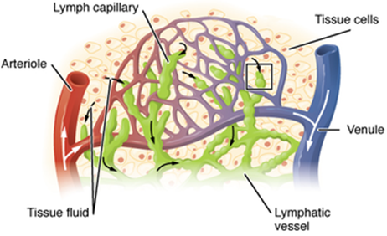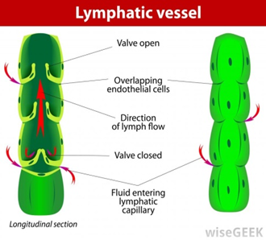

2- Lymphatic collecting vessels; Lymph is transported from the lymph capillaries through successively larger lymphatic vessels referred to as lymphatic collecting vessels, until it is finally returned to the venous system through one of the two large ducts in the thoracic region. 3- Right lymphatic duct; The right lymphatic duct drains the lymph from the right arm and the right side of the head and thorax. 4- Thoracic duct; The large thoracic duct receives lymph from the rest of the body. Both ducts empty the lymph into the subclavian vein on their own side of the body.

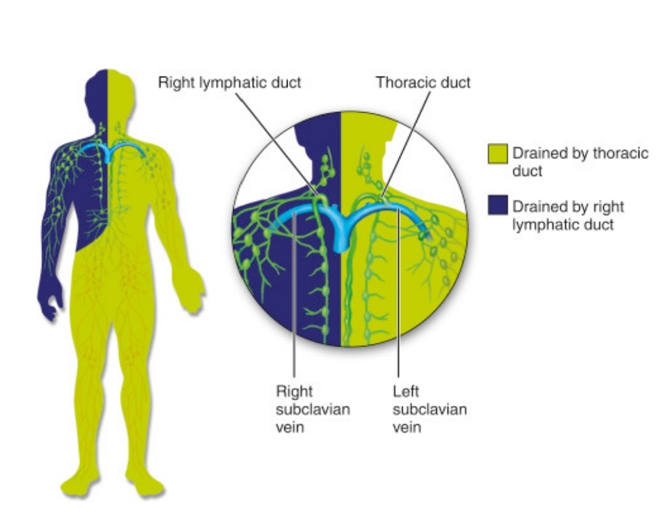

**Functions of the Lymphatic System**

The functions of the lymphatic system are:

1. Fluid balance; The lymphatic vessels transport back to the blood the fluids that have escaped from the blood vascular system. About 30 liters of fluid pass from the blood capillaries into the interstitial spaces each day, whereas only 27 L pass from the interstitial spaces back into the blood capillaries. If the extra 3 L of interstitial fluid remained in the interstitial spaces, edema would result, causing tissue damage and eventually death.
2. Fat absorption; The lymphatic system absorbs fats and other substances from the digestive tract.
3. Body’s defenses; The lymphoid tissues, as organs house of phagocytic cells and lymphocytes. It also filters out foreign bodies such as bacteria, toxins, and cancer cells by trapping them in the lymph nodes.
4. Supply nutrients to the body
5. Remove the metabolic wastes from the tissue cells.
6. Maintaining the composition of tissue fluid.

**Lymphoid tissue ;(Lymph Nodes)**  *Lymph nodes* (filters the body fluid from pathogens) is an organized collection of lymphoid tissue exist throughout the body, but are most commonly found at places where the body bends, like the armpits, elbows, hip crease, the knees, and the neck (cervical area), and around the intestine. When we are sick or are fighting an infection, the lymph nodes are often swollen and sore because they are busy breaking down the viruses, bacteria, etc.). Lymph nodes are located at intervals along the lymphatic system. Several afferent lymph vessels bring in lymph, which percolates through the substance of the lymph node, and is then drained out by an efferent lymph vessel. There are between five and six hundred lymph nodes in the human body, many of which are grouped in clusters in different regions as in the under arm and abdominal areas. Lymph nodes vary in size and shape, but most are kidney-shaped, less than 1 inch (approximately 2.5 cm) long, and “buried” in the connective tissue that surrounds them. Its structure: - 1 – *Cortex;* The outer part of the node, contains collections of lymphocytes called follicles

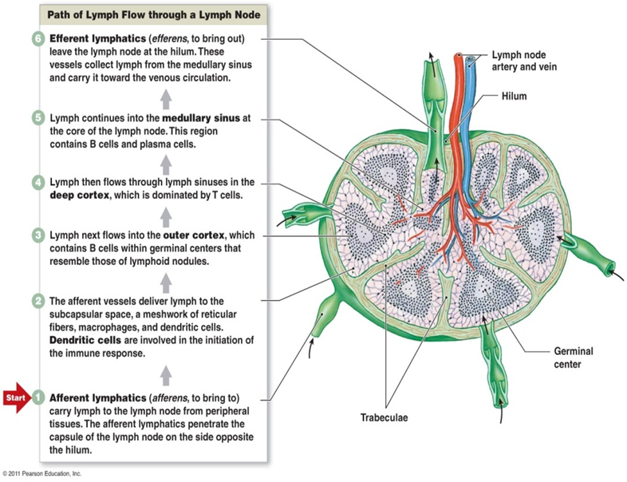

2 *– Trabeculae*; Each node is surrounded by a fibrous capsule from which strands called trabeculae extend inward to divide the node into a number of compartments. 3 *– Medulla*; Contain Phagocytic macrophages in the central medulla. 4 *- Afferent lymphatic vessels*; Lymph enters the convex side of a lymph node through the afferent lymphatic vessels. 5 *- Efferent lymphatic vessels*; The lymph exits from the node at the hilum, via the efferent lymphatic vessels.

**Lymph Nodes contain defendable cells**

• Macrophages. which engulf and destroy bacteria, viruses, and other foreign substances in the lymph before it is returned to the blood.

• Lymphocytes. Collections of lymphocytes are located in the lymph nodes and respond to foreign substances in the lymphatic stream.

• Plasma cells. The B cells are generating daughter cells called plasma cells, which release antibodies.

• T cells. The rest of the cortical cells are lymphocytes, the so-called T cells that circulate continuously between the blood, lymph nodes and lymphatic stream, performing their surveillance role.

**Other Lymphoid Organs** Beside the lymph nodes as lymphoid organs in the body, also the spleen, thymus, tonsils, and Peyer’s patches of the intestine, considered as lymphoid tissue.

**Thymus;** Is the site of maturation for T cells . In addition, thymic stromal cells allow for the selection of a functional and self-tolerant T cell repertoire. Therefore, one of the most important roles of the thymus is the induction of central tolerance. The thymus is largest and most active during the neonatal and pre-adolescent periods. By the early teens, the thymus begins to atrophy and thymic stroma is mostly replaced by adipose tissue. *Location;* The thymus gland is a lymphoid mass found low in the throat overlying the heart. *Functions*; It is a gland produces thymosin, that function in the programming of certain lymphocytes so they can carry out their protective roles in the body.

**Spleen** The main functions of the spleen are: 1- To produce immune cells to fight antigens 2- To remove particulate matter and aged blood cells, mainly red blood cells.

3- To produce blood cells during fetal life

The spleen synthesizes antibodies in its white pulp and removes antibody-coated bacteria and antibody-coated blood cells by way of blood and lymph node circulation. The spleen contains, in its reserve, half of the body's monocytes within the red pulp. These monocytes, upon moving to injured tissue (such as the heart), turn into dendritic cells and macrophages while promoting tissue healing. The spleen stores red blood cells and lymphocytes. It can store enough blood cells to help in an emergency. Up to 25% of lymphocytes can be stored at any one time.

**Tonsils** Are small masses of lymphoid tissue that ring the pharynx (the throat), where they are found in the mucosa. *Function*; Their job is to trap and remove any bacteria or other foreign pathogens entering the throat, so efficiently that sometimes they become congested with bacteria and become red, swollen, and sore, a condition called tonsillitis.

**Peyer’s Patches**

Peyer’s patches resemble the look of the tonsils. *Location*; Peyer’s patches are found in the wall of the small intestine. *Function*; The macrophages of Peyer’s patches are in an ideal position to capture and destroy bacteria (always present in tremendous numbers in the intestine), thereby preventing them from penetrating the intestinal wall.

**Mucosa-associated lymphatic tissue**. Peyer’s patches and the tonsils are part of the collection of small lymphoid tissues referred to as mucosa-associated lymphatic tissue (MALT); acts as a sentinel to protect the upper respiratory and digestive tracts from the never-ending attacks of foreign matter entering those cavities.

**Immune system**

We have first to know about WBC;

They are Cells of the immune system protecting the body against

1. infectious disease
2. foreign invaders

Produced and derived from multipotent cells (hematopoietic stem cells) in the bone marrow. Found throughout the body including the blood and lymphatic system. Capable of motility, Nucleated.

Number of leukocytes - indicator of disease

Normal white cell count - 4,000 -11,000 /microlite of blood

Fluctuations in No.: occur during the day;

- lower values are during rest

- higher values during exercise

Count may increase in response to:

* intense physical exertion
* acute emotional reactions
* pain
* pregnancy
* labor
* disease such as infections and intoxications

Count may decrease in response to certain types of

* infections
* Drugs
* chronic anemia
* malnutrition
* anaphylaxis

Increase in number over the upper limits is called (leukocytosis):

normal when it is part of healthy immune responses, which happen frequently

It is abnormal, when it is neoplastic autoimmune in origin

A decrease below the lower limit is called (leukopenia): This indicates a weakened immune system

WBC can be classified in standard ways:

1 - by structure (granulocytes or agranulocytes)

2 - by cell lineage (myeloid cells or lymphoid cells)

These broadest categories can be further divided into the five main types: neutrophils, eosinophils (acidophiles), basophils, lymphocytes, and monocytes

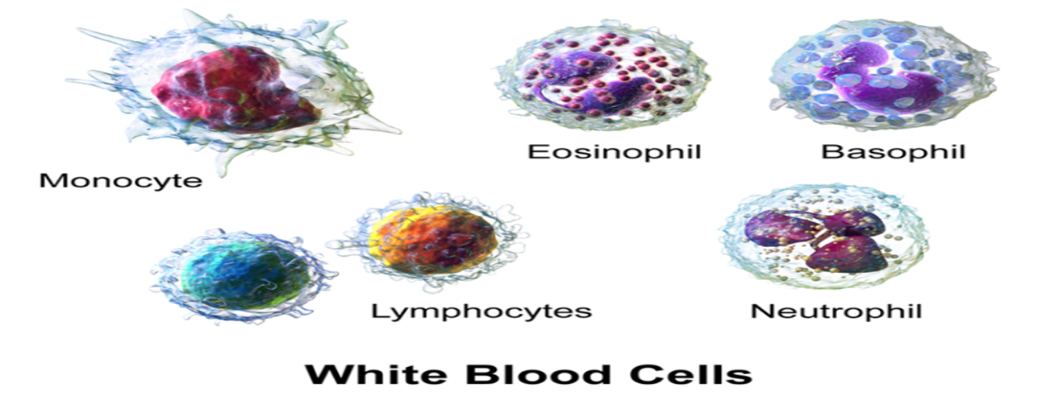

**Neutrophils**

-most common type

-between 2000 to 7500 cells per mm3 in the bloodstream

-medium-sized, irregular nuclei and many granules

-Function: Including two functionally unequal subpopulations:

1 - *neutrophil-cagers*: It is function by attaching to the walls of the blood vessels, blocking the passageway of germs

2 - *neutrophil-killers*: search on and ingesting microorganisms or particles

**Main neutrophil’s function is;**

1 - Chemotaxis: Leave blood vessels and migrate toward sites of infection or inflammation, following chemical signals such as Interleukin-8(IL-8), and interferon gamma (IFN-γ).

2 - Anti-microbial function: are the first cells to reach an infected area, congregate, and release cytokines, which in turn amplify inflammatory reactions

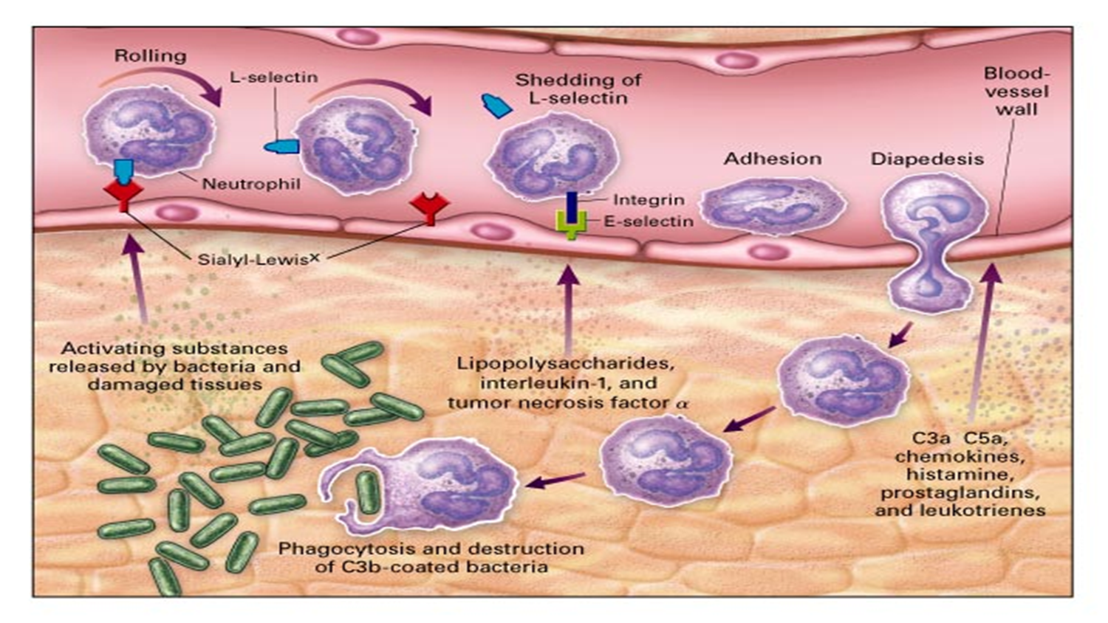

3 - Phagocytosis: Are phagocytes, capable of ingesting microorganisms or particles. For targets to be recognized, they must be coated in opsonin (opsonization; the coating of pathogens with antibodies in order to increase their susceptibility to ingestion by phagocytes). They can neutralize and kill many microbes.

They also release a burst of super oxides that have the ability to kill many bacteria at the same time.

They are not able to renew their lysosomes (used in digest)

4 - Degranulation: also release an assortment of proteins, which have antimicrobial properties, and help combat infection

**Eosinophil**

about 2-4% of the WBC total, are rare in the blood only about 40-400 cells /mm3 but numerous in the mucous membranes of the respiratory, digestive and lower urinary tracts.

This count fluctuates throughout the: day, seasonally, and during menstruation

It rises in response to: allergies, parasitic infections, collagen diseases, disease of the spleen and central nervous system

They secrete chemicals that destroy large parasites, such as hook worms and tape worms

Causes of eosinophilia include:

allergies such as:

* asthma
* hay fever
* hives
* and also, parasitic infections.

**Basophil**

are chiefly responsible for allergic and antigen response by releasing the chemical histamine.

They excrete two chemicals that aid in the body's defenses: histamine and heparin

Basophils, also release chemical signals that attract eosinophils and neutrophils to an infection site.

Histamine causing the dilation of blood vessels and increasing the blood flow to injured tissue. It also makes blood vessels more permeable so neutrophils and clotting proteins can get into injured connective tissue more easily

Heparin is an anticoagulant that inhibits blood clotting

**Mast cell**

is a type of white blood cell, it is a type of granulocyte derived from the myeloid stem cell.

are scattered throughout the connective tissues, especially beneath the surface of the skin, near blood vessels and lymphatic vessels, within nerves, throughout the respiratory system, and digestive and urinary tracts.

It is a part of the immune and neuroimmune systems contains granules rich in histamine, interleukins and heparin

Mast cells play an important protective role as well, being involved in wound healing, angiogenesis, immune tolerance, defense against pathogens, and blood–brain barrier function.

best known for their role in allergy and anaphylaxis

Upon stimulation by an allergen, the mast cells release the contents of their granules into the surrounding tissues.

The chemical mediators produce local responses characteristic of an allergic reaction, such as increased permeability of blood vessels (i.e., inflammation and swelling), contraction of smooth muscles (e.g., bronchial muscles), and increased mucus production.

**Lymphocyte**

are much more common in the lymphatic system than in blood. nucleus eccentric in location, and a relatively small amount of cytoplasm.

Lymphocyte levels can change according to:

a person's race, gender, location, and lifestyle habits.

Lymphocytes include:

(1) B cells: make antibodies that can bind to pathogens, block pathogen invasion, activate the complement system, and enhance pathogen destruction.

(2) Natural killer cells: are a type of cytotoxic lymphocyte provide rapid responses to viral-infected cells, acting at around 3 days after infection, and respond to tumor formation

(3) T cells: Classified into

A- helper T cells:

* Have T-cell receptors and CD4 molecules that, in combination, bind antigenic peptides on antigen-presenting cells (is a cell that displays antigen complexed with major histocompatibility complexes (MHCs) on their surfaces)

((CD4: cluster of differentiation 4: is a glycoprotein found on the surface of immune cells such as: T helper cells, monocytes, macrophages, and dendritic cells)).

* make cytokines and help coordinate the immune response.
* In HIV infection, these T cells are the main index to identify the individual's immune system integrity.

B- cytotoxic T cells:

These cells bind antigens of virus-infected or tumor cells and kill them.

C- γδ T cells:

Possess an alternative T cell receptor. Found in tissue more commonly than in blood

D- Natural killer T- cells:

Are able to kill cells of the body that do not display MHC class I molecules (major histocompatibility complex) ((The main function of MHC molecules is to bind to antigens derived from pathogens and display them on the cell surface for recognition by the appropriate T-cells)).

Natural killer T-cell activation is important for antibody responses against allergens, parasites, bacteria, viruses. NKT-derived soluble factors such as cytokines may contribute to B-cell help

**Monocyte**

They have the kidney shaped nucleus and are typically a granulated. They also possess abundant cytoplasm.

the largest type of WBCs, share the "vacuum cleaner" (phagocytosis) function of neutrophils, but are much longer lived.

They present pieces of pathogens to T cells so that the pathogens may be recognized again and killed. This causes an antibody response to be mounted

Monocytes eventually leave the bloodstream and become tissue macrophages, which remove dead cell debris as well as attack microorganisms. Neither dead cell debris nor attacking microorganisms can be dealt with effectively by the neutrophils.

Unlike neutrophils, monocytes are able to replace their lysosomal contents and are thought to have a much longer active life.

**The physiology of immune system**

Every second of the day, an army of hostile bacteria, viruses, and fungi swarms on our skin and invades our inner passageways yet we stay amazingly healthy most of the time, thanks to our body defense, the immune system. The body’s defenders against these tiny but mighty enemies are two systems, the innate and the adaptive defense systems; together, make up the immune system.

**Innate Defense System** The innate defense system (non-specific defense system), responds immediately to protect the body from all foreign substances, whatever they are. The term innate body defense refers to the mechanical barriers that cover body surfaces and to the cells and chemicals that act on the initial battlefronts to protect the body from invading pathogens. Surface Membrane Barriers The body’s first line of defense against the invasion of disease-causing microorganisms is the skin and mucous membranes.

• Skin. As long as the skin is unbroken, its keratinized epidermis is a strong physical barrier to most microorganisms that swarm on the skin.

• Mucous membranes. Intact mucous membranes provide similar mechanical barriers within the body; the mucous membranes line all body cavities open to the exterior: the digestive, respiratory, urinary, and reproductive tracts.

• Besides serving as physical barriers, these membranes produce a variety of protective secretion: (1) The acidic pH of skin secretions (pH of 3-5) inhibits bacterial growth; sebum contains chemicals that are toxic to bacteria; vaginal secretions of adult females are also very acidic; (2) The stomach mucosa secretes hydrochloric acid and protein-digesting enzymes, both kill pathogens. (3) Saliva and lacrimal fluid contain lysozyme, an enzyme that destroys bacteria. Sticky mucus traps many microorganisms that enter digestive and respiratory passageways.

• Structural modifications. Mucus-coated hairs inside the nasal cavity trap inhaled particles, and the respiratory tract mucosa is ciliated; the cilia sweep dust- and bacteria-laden mucus toward the mouth, preventing it from entering the lungs. Internal Defenses: Cells and Chemicals For its second line of defense, the body uses an enormous number of cells and chemicals to protect itself. 1 -Phagocytes. Macrophage or neutrophil, engulfs a foreign particle much like the way an amoeba ingests a food particle 2 - Natural killer cells. are a unique group of lymphocytes that can lyse and kill cancer cells and virus-infected body cells well before the adaptive arm of the immune system is enlisted to fight; they attack the target cell’s membrane and release a lytic chemical called perforins. 3 - Inflammatory response. The inflammatory response is a nonspecific response that is triggered whenever body tissues are injured; the four most common indicators of an acute inflammation are redness, heat, swelling, and pain. 4 - Antimicrobial proteins. A variety of antimicrobial proteins enhances the innate defenses:

(A) Complement is a group of plasma proteins that lyses microorganisms, enhances phagocytosis by opsonization, and intensifies inflammatory response. (B) Interferons are proteins released by virus-infected cells that protect uninfected tissue cells from viral takeover and mobilize immune system.

(C) Urine has a normally acidic pH that inhibits bacterial growth. 5 - Fever. Fever, or abnormally high body temperature, is a systemic response to invading microorganisms; normally the body’s “thermostat” is set at approximately 37 degrees Celsius, but it can be reset upward in response to pyrogens, chemicals secreted by white blood cells and macrophages exposed to foreign cells or substances in the body.

**• Adaptive Body Defenses**  Sometimes referred to as the body’s third line of defense, the specific defense system is a functional system that recognizes foreign molecules (antigens) and acts to inactivate or destroy them. The adaptive immune system, also known as the acquired immune system or, more rarely, as the specific immune system, is a subsystem of the overall immune system that is composed of highly specialized, systemic cells and processes that eliminate pathogens or prevent their growth. Acquired immunity creates immunological memory after an initial response to a specific pathogen, and leads to an enhanced response to subsequent encounters with that pathogen. This process of acquired immunity is the basis of vaccination. **The Inflammatory Process** The inflammatory sequence of events is described below. 1 - *Chemical alarm*. When cells are injured, they release inflammatory chemicals, including histamine and kinins. 2 - *Body’s reaction*. The release of histamine, kinins, and other chemicals cause blood vessels in the involved area to dilate and capillaries to become leaky, activate pain receptors, and attract phagocytes and WBCs to the area (chemotaxis). 3 - *Redness and heat*. Dilatation of the blood vessels increases the blood flow to the area, accounting for the redness and heat observed. 4 - *Edema and pain*. Increased permeability of the capillaries allows plasma to leak from the blood into the tissue spaces, causing local edema (swelling) that also activates pain receptors in the area. 5 - *Limitation of joint movement*. If the swollen, painful area is a joint, its function may be impaired temporarily, which forces the injured part to rest, which aids healing.

Antigens An antigen (Ag) is any substance capable of mobilizing our immune system and provoking an immune response. 1 - Foreign intruders. Any substances can act as antigens, including virtually all foreign proteins, nucleic acids, many large carbohydrates, and some lipids; proteins are the strongest antigens. 2 - Self-antigens. Our own cells are richly studded with a variety of protein molecules or self-antigens; although these self-antigens do not trigger an immune response in us, they are strongly antigenic to other people.

3 - Hapten. As a rule, small molecules are not antigenic, but when they link up with our own proteins, the immune system may recognize the combination as foreign and mount an attack that is harmful rather than protective; in such cases, the troublesome small molecule is called a hapten or incomplete antigen. Antibodies referred to as immunoglobulins. Antibodies are soluble proteins secreted by activated B cells or by their plasma-cell offspring in response to an antigen and they are capable of binding specifically with that antigen. Basic antibody structure: Regardless of its class, every antibody has a basic structure consisting of four amino acid (polypeptide) chains linked together by disulfide (sulfur-to-sulfur) bonds. 1- Heavy chains. Two chains are identical, contain 400 amino acids each. 2 - Light chains. The two other chains, also identical to each other but are only about half as long as the heavy chains.

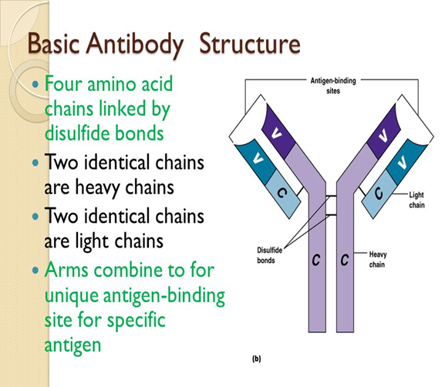

Antibody classes. There are five major immunoglobulin classes: -

**• IgD**. is always attached to B cell; and it is also important in activation of B cell.

**• IgM**. is attached to B cell and free in plasma, it serves as an antigen receptor. **\* IgG**. is the most abundant antibody in plasma, it crosses the placenta and provides passive immunity to fetus.

**• IgA**. Some are found in plasma; dime in secretions such as saliva, tears, intestinal juice, and milk; it bathes and protects mucosal surfaces from attachment of pathogens.

**• IgE.** It is secreted by plasma cells in skin, mucosae of gastrointestinal, respiratory tracts, and tonsils; it binds to mast cells and basophiles and triggers release of histamine and other chemicals that mediate inflammation and certain allergic responses.

Antibody function Antibodies inactivate antigens in a number of ways- by complement fixation, neutralization, agglutination, and precipitation.

1 - Complement fixation. Complement is the chief antibody ammunition used against cellular antigens, and it is fixed (activated) during innate defenses.

2 - Neutralization. Neutralization occurs when antibodies bind to specific sites on bacterial exotoxins or on viruses that can cause cellular injury; in this way they block the harmful effects of the exotoxin or virus 3 - Agglutination. When the cross-linking involves cell-bound antigens, the process causes clumping of the foreign cells, a process called agglutination; this type of antigen-antibody reaction occurs when mismatched blood is transfused. 4 - Precipitation. When the cross-linking involves soluble antigenic molecules, the resulting antigen-antibody complexes are so large that they become insoluble and settle out of solution.

**Enlarged lymph node** (**Lymphadenopathy)**

Is refers to one or more enlarged lymph nodes. Small groups or individually enlarged lymph nodes are generally reactive in response to infection or inflammation. **Lymphedema**  Is the swelling caused by the accumulation of lymph, which may occur if the lymphatic system is damaged or has malformations. It usually affects limbs, though the face, neck and abdomen may also be affected. In an extreme state, called elephantiasis, the edema progresses to the extent that the skin becomes thick with an appearance similar to the skin on elephant limbs. Causes may be there is a previous history of severe infection, usually caused by a parasitic disease. Lymphedema can also occur after surgical removal of lymph nodes in the armpit (causing the arm to swell due to poor lymphatic drainage) or groin (causing swelling of the leg). Lymphangiomatosis Is a disease involving multiple cysts or lesions formed in lymphatic vessels.