

**كلية الرشيد الجامعة/قسم كلية التمريض**

**مادة الفسلجة للمرحلة الاولى**

**المحاضرة الثامنة**

**Dr. Alan Ali**

**2021/2022**

**Urinary System**

Function of the Urinary System;

In addition to its main function (**making and getting rid of urine**) the urinary system has other important roles in the body:

• Regulate and keeping blood volume and composition (e.g., sodium, potassium and calcium) within normal range.

• Regulate and keeping blood pressure within normal range.

• Regulate pH homeostasis of the blood.

• Contributes to the production of red blood cells by the kidney.

• Helps synthesize calcitriol the (active form of Vitamin D).

• Stores waste product (mainly urea and uric acid) and other products before it is removed from the body.

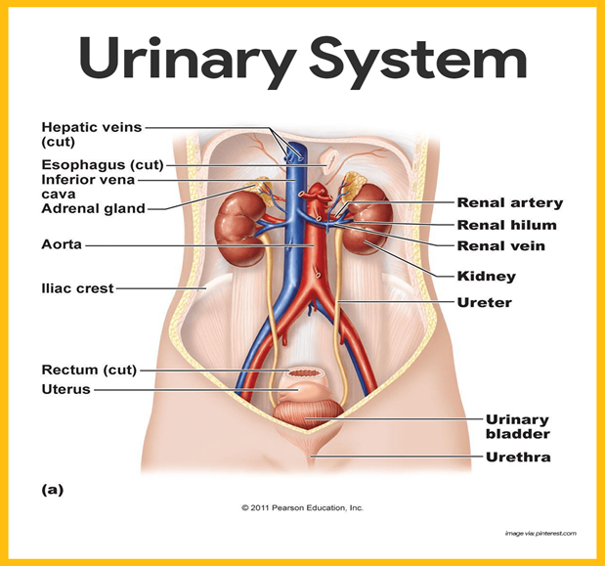

**1 - The Kidneys**  Location; Small, dark red organs with a bean shape lie against the dorsal body wall.; They extend from the T12 to the L3 vertebra; thus, they receive protection from the lower part of the rib cage. Positioning; Because it is crowded by the liver, the right kidney is positioned slightly lower than the left. Size; An adult kidney is about 12 cm (5 inches) long, 6 cm (2.5 inches) wide, and 3 cm (1 inch) thick.

• There is adrenal gland found atop each kidney, which is part of the endocrine system is a distinctly separate organ functionally.

• Also, Perirenal fat capsule, A fatty mass surrounds each kidney and acts to cushion it against blows.

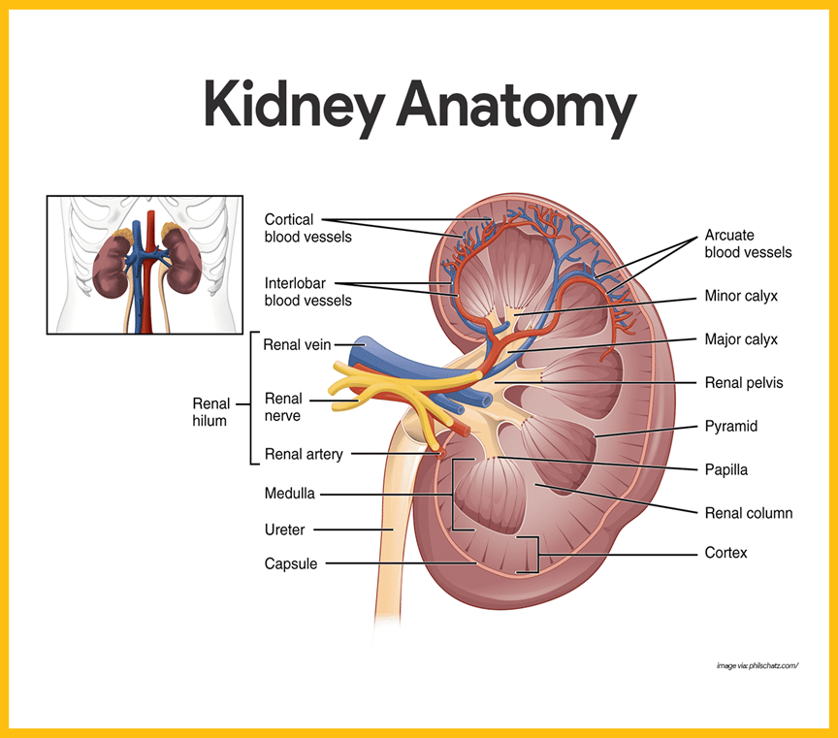

***Nephrons***; Are the structural and functional units of the kidneys. Each kidney contains over a million nephrons, and they are responsible for forming urine, its chief function is to regulate the concentration of water and soluble like sodium by filtering the blood, reabsorbing what is needed and excreting the rest as urine. It is composed of: **1 -** **Bowman’s capsule**; the closed end of the renal tubule is enlarged and cup-shaped and completely surrounds the glomerulus. **2 – Glomerulus**; is a knot of capillaries. A - *Afferent arteriole*. This arises from a cortical radiate artery, is the “feeder vessel”. B - *Efferent arteriole*. The efferent arteriole receives blood that has passed through the glomerulus. **3 - Renal tubule**;

A - *Proximal convoluted tubule*. This is the part of the tubule that is near to the glomerular capsule. B *- Loop of Henle*. A loop following the proximal convoluted tubule. C *- Distal convoluted tubule*. After the loop of Henle, the tubule continues to coil and twist before connects the collecting duct. **4 - Collecting duct**; which receives urine from many nephrons.

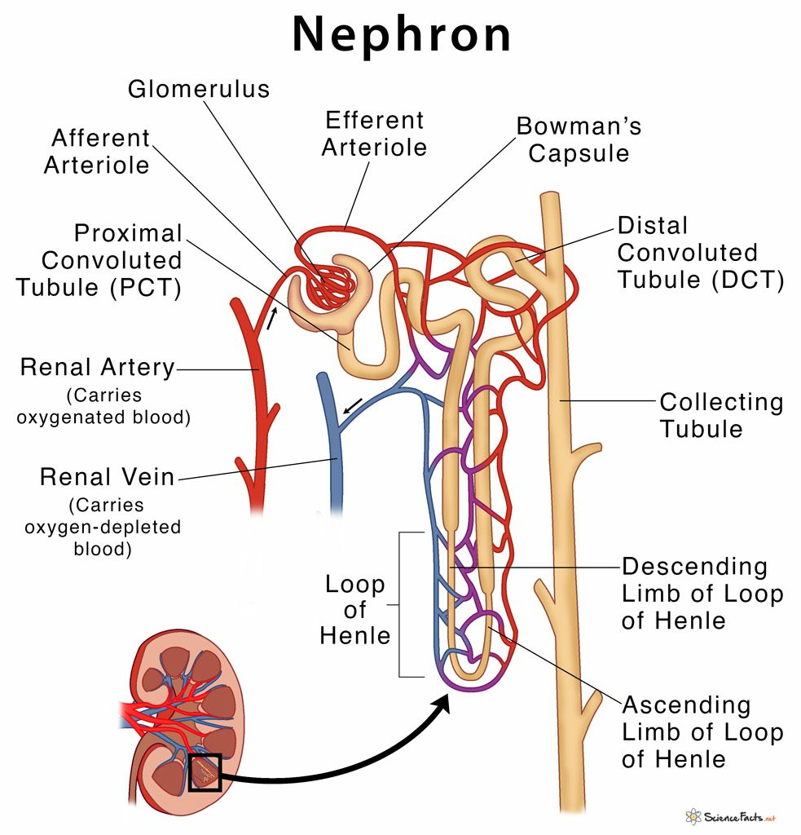

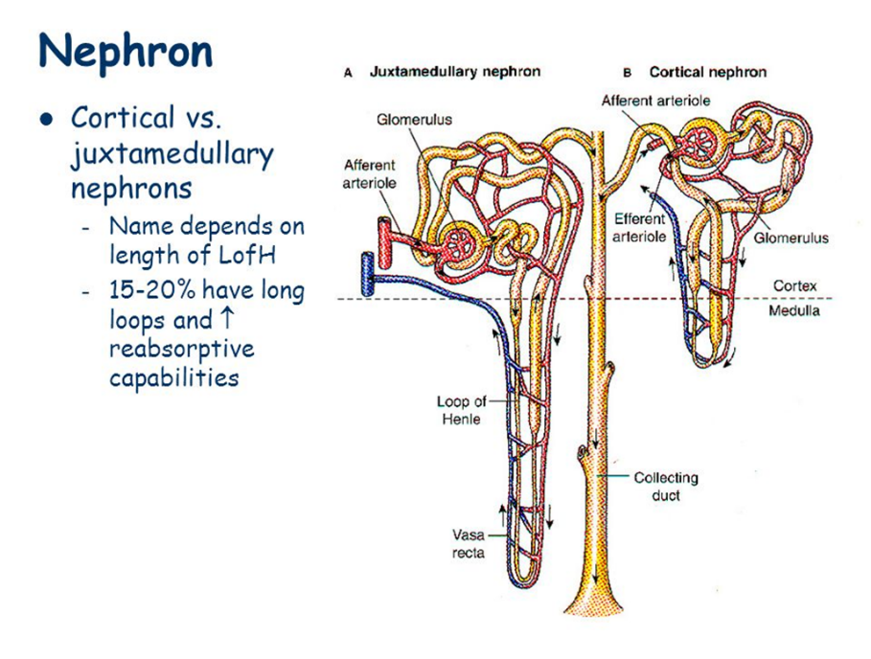

**Type of nephron;**

1 - Cortical nephrons. Most nephrons are called cortical nephrons because they are located almost entirely within the cortex.

2 - Juxtamedullary nephrons. In a few cases, the nephrons are called juxtamedullary nephrons because they are situated next to the cortex-medullary junction, and their loops of Henle dip deep into the medulla. **2 - Ureter**  plays an active role in urine transport. Size: Are two slender tubes each 25 to 30 cm long and 6 mm in diameter.

Location: Each ureter runs behind the peritoneum from the renal hilum to the posterior aspect of the bladder, which it enters at a slight angle.

**3 - Urinary Bladder** The urinary bladder is a collapsible, muscular sac that stores urine temporarily.

Location: in the pelvis just posterior to the symphysis pubis. **4 - Urethra** The urethra is a thin-walled tube that carries urine by peristalsis from the bladder to the outside of the body. *Internal urethral sphincter*: At the bladder-urethral junction, a thickening of the smooth muscle, an involuntary sphincter that keeps the urethra closed when the urine is not being passed. *External urethral sphincter*: A second sphincter, the external urethral sphincter, is fashioned by skeletal muscle and is voluntarily controlled.

• **Female urethra**; The female urethra is about 3 to 4 cm long, and its external orifice, or opening, lies anteriorly to the vaginal opening.

• **Male urethra**; is approximately 20 cm long and has three named regions: the prostatic, membranous, and spongy (penile)

**Physiology of the Urinary System;**

Every day, the kidneys filter gallons of fluid from the bloodstream. The normal physiology that takes place in the urinary system is as follows: Urine Formation: is a result of three processes: 1 - Glomerular filtration: Water and solutes smaller than proteins are forced through the capillary walls and pores of the glomerular capsule into the renal tubule. Hydrostatic and osmotic pressure gradients facilitate filtration across a semi permeable membrane. However larger molecules such as proteins and blood cells are prevented from passing through the filtration membrane. The amount of filtrate produced every minute is called the glomerular filtration rate or GFR and amounts to 180 liters per day. About 99% of this filtrate is reabsorbed as it passes through the nephron and the remaining 1% becomes urine. 2 - Tubular re-absorption.: Water, glucose, amino acids, and needed ions are transported out of the filtrate into the tubule cells and then enter the capillary blood. 3 - Tubular secretion: Hydrogen, potassium, creatinine, and drugs are removed from the peritubular blood and secreted by the tubule cells into the filtrate.

Average urine production in adult is about 1–2 liters L/ day, depending on state of hydration, activity level, environmental factors, weight, and the individual's health. Producing too much or too little urine requires medical attention. Polyuria is a condition of excessive urine production (> 2.5 L/day). Oliguria when < 400 mL (milliliters) are produced. anuria one of < 100 mL per day.

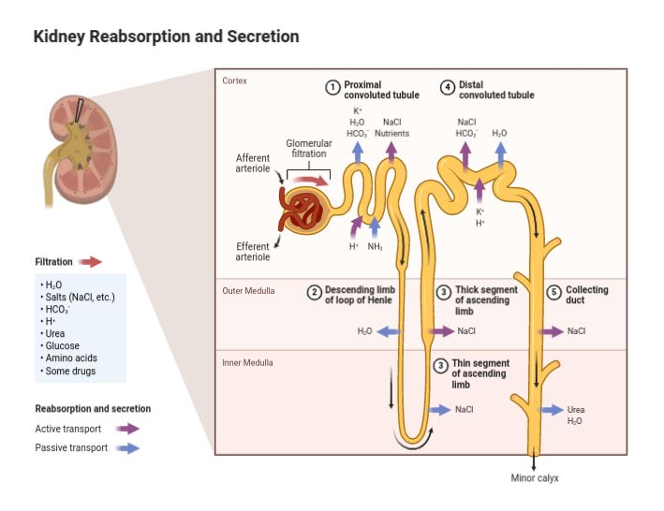

**Micturition (Urination**)

Is the ejection of urine from the urinary bladder through the urethra to the outside of the body. In healthy humans (and many other animals), the process of urination is under voluntary control. In infants, some elderly individuals, and those with neurological injury, urination may occur as an involuntary reflex. Physiologically, micturition involves coordination between the central, autonomic, and somatic nervous systems. Brain centers that regulate urination include the pontine micturition center, and the cerebral cortex.

Sequence of events: 1 -Accumulation. Ordinarily, the bladder continues to collect urine until about 200 ml have accumulated. 2 - Activation. Stretching of the bladder wall activates stretch receptors.

3 - Transmission. Impulses transmitted to the sacral region of the spinal cord and then back to the bladder via the pelvic splanchnic nerves cause the bladder to go into reflex contractions. 4 - Passage. As the contractions become stronger, stored urine is forced past the internal urethral sphincter into the upper part of the urethra. 5 - External sphincter. Because the lower external sphincter is skeletal muscle and voluntarily controlled (consciously), we can choose to keep it closed or it can be relaxed so that urine is flushed from the body.

**Regulation of concentration and volume** the urinary system is under influence of the circulatory system, nervous system, and endocrine system (by hormones such as antidiuretic hormone, aldosterone, and parathyroid hormone).

**Antidiuretic hormone (ADH)**

also known as vasopressin, is a small peptide hormone which regulates the body’s retention of water. It is secreted by the posterior pituitary gland in the brain.

Synthesis and Storage The synthesis of ADH occurs in the hypothalamus. It is then transported to the posterior pituitary gland; its synthesis is completed and it is stored here until it is ready to be released.

Release and Action Osmoreceptors in the hypothalamus regulate the amount of ADH released. Osmoreceptors are cells which are sensitive to the changes in the osmotic pressure of plasma. The osmotic pressure is dependent on the plasma osmolality. The plasma osmolality in turn is determined by the total body plasma volume. So, if there is a fall in total body volume then the osmolality of the plasma will rise as there will be an increase in the Na+ concentration in the plasma.

ADH acts in the kidney to regulate the volume and osmolarity of the urine. Specifically, it acts in the distal convoluted tubule (DCT) and collecting ducts (CT)cells.

ADH can also act on the blood vessels to increase peripheral vascular resistance in order to increase blood pressure. This mechanism is useful in restoring blood pressure during hypovolemic shock.

**The Renin-Angiotensin-Aldosterone System (RAAS**)

is a hormone system within the body that is essential for regulation of blood pressure and fluid balance. It is comprised of the three hormones renin, angiotensin II and aldosterone and regulated primarily by renal blood flow. The stimuli for the activation of the system are: 1 - Decrease in arterial mean pressure. 2 - Decrease in the concentration of NaCl. 3 - Decrease in blood volume. 4 - Activation of sympathetic nervous system. All these stimuli produce a decrease in the renal perfusion volume, this is sensed by receptors in the kidney and the kidney starts transforming pro-renin into renin. The renin will diffuse to the circulation where it will act upon angiotensinogen, transforming it into Angiotensin I, in tissues like lungs, endothelial smooth muscle, myocardium we will find the converting enzyme that act upon Angiotensin I transforming it into Angiotensin II. **Angiotensin II is an active hormone**. Renin Release The first stage of the RAAS is release of the enzyme renin. This is released from granular cells of the renal juxtaglomerular apparatus (JGA) in response to one of three factors: 1 - Reduced NaCl delivery to the distal tubule detected by macula densa cells.

2 - Reduced perfusion pressure in the kidney detected by baroreceptors in the afferent arteriole 3 - Sympathetic stimulation of the JGA Production of Angiotensin II Angiotensinogen is a precursor protein produced in the liver and cleaved by renin to form angiotensin I, then converted to angiotensin II by angiotensin converting enzyme (ACE). ACE is found within the renal endothelium, the lungs and capillary endothelium.

**Effects of Angiotensin II** angiotensin II exerts its action at various sites throughout the body. Cardiovascular Effects It acts on the endothelium of arterioles to achieve vasoconstriction. This results in an increase in total peripheral resistance and therefore, blood pressure. Neural Effects 1 - Angiotensin II acts on the hypothalamus to stimulate the sensation of thirst, resulting in an increase in fluid consumption. This helps to raise the circulating volume and in turn, blood pressure. 2 - It also increases the secretion of ADH from the posterior pituitary gland – resulting in the production of more concentrated urine to reduce the loss of fluid from urination. This allows the circulating volume to be better maintained until more fluids can be consumed. 3 - It also acts on the sympathetic nervous system to increase the release of Noradrenaline. This hormone is typically associated with the “fight or flight” response in stressful situations and has a variety of actions that are relevant to the RAAS:

1 - Increase in cardiac output 2 -Vasoconstriction of arterioles 3 - Release of rennin Renal Effects Angiotensin II acts on the kidneys to produce a variety of effects, including:

1 - afferent and efferent arteriole constriction and increased Na+ reabsorption.

2 - It also acts as a sensitizer to tubuloglomerular feedback, which helps to prevent an excessive rise in glomerular filtration rate. Adrenal Effects Finally, angiotensin II acts on the adrenal cortex to stimulate the release of aldosterone. This then acts on the principal cells of the collecting ducts in the nephron to stimulate Na+ and water re-absorption.

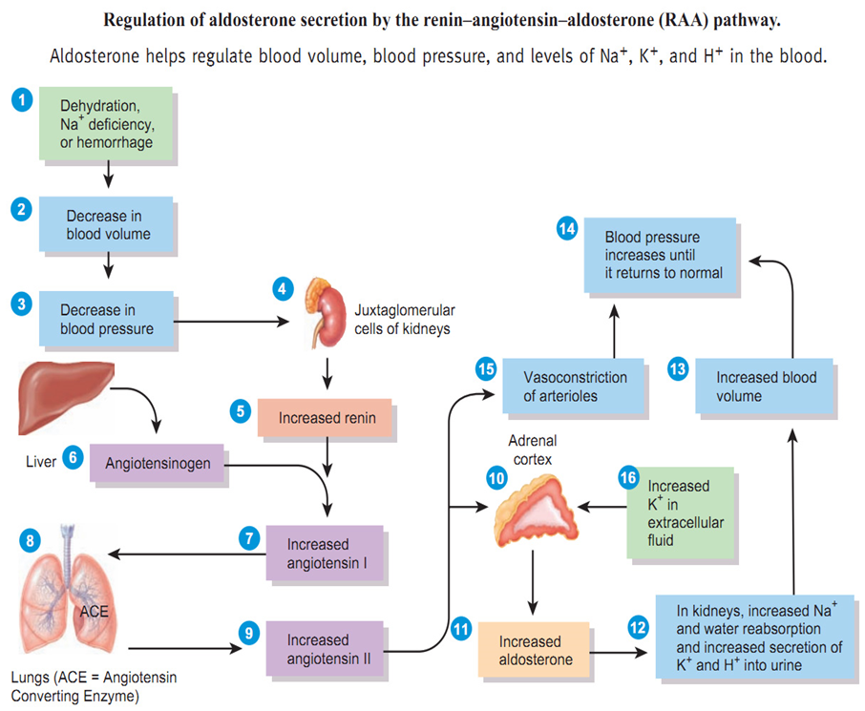

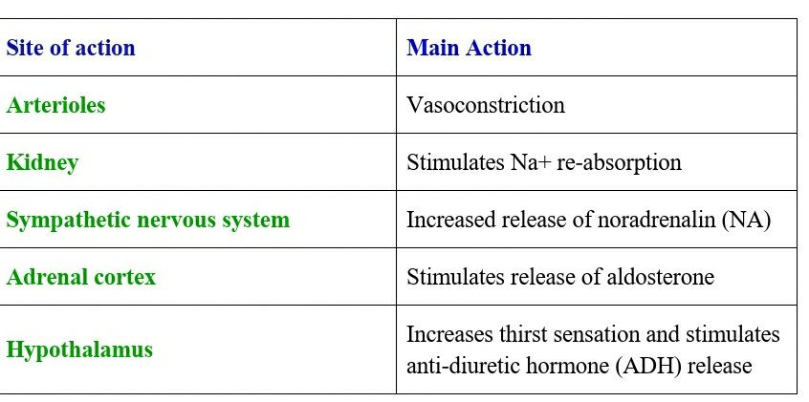

Effects of Angiotensin II and its action at various sites throughout the body.

**Physiology of female reproductive system**

The function of the female reproductive system;

1. Formation of ova
2. Produce sex hormones like estrogens, progesterone
3. Reception of spermatozoa
4. Provide suitable environment for fertilization and fetal development
5. Parturition (childbirth)
6. Lactation; the production of breast milk which provides complete nourishment for the baby in its early life

Female reproductive system composed of;

**Ovary;**

primary sex organ that produces egg cells in a process called oogenesis

oogenesis; means maturation of primary oocyte to the secondary oocyte and also produce female sex hormones such as estrogens and progesterone

**uterine tube (fallopian tube)** consists of;

* Fimbriae; finger like appendage that collect the ovum from the ovary during ovulation
* Infundibulum channels the ovum from the fimbriae in to the uterine tube
* Ampulla is the curvature of the tube where most of ferritization occurs
* Isthmus where it sits next to the opening of the fallopian tube into the uterus

Inner wall of the fallopian tube is made of ciliated cells where the cilia propel the ovum toward the uterus

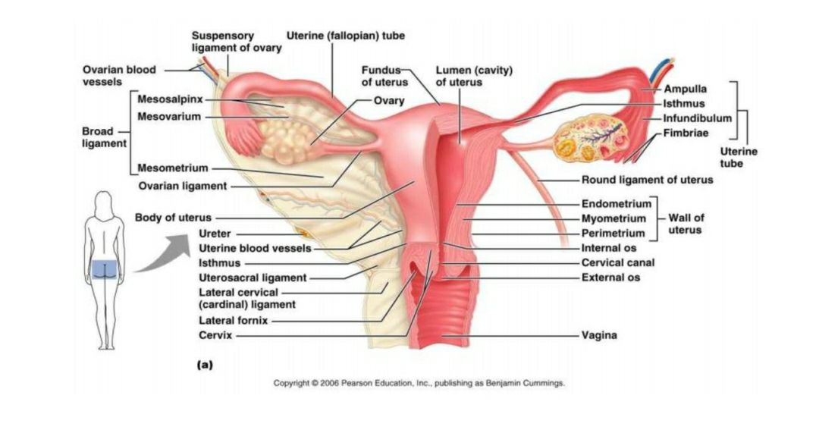

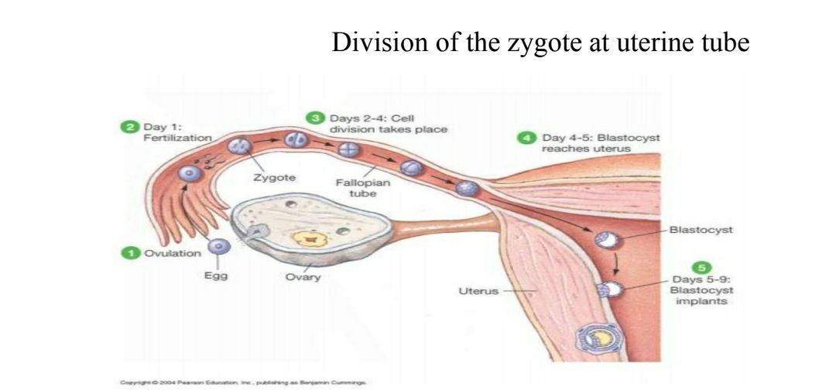

**Uterus**

A pear shape cavity formed by the union of the two uterine tubes which is composed of 3 layers;

1. Endometrium

* After ferritization embryo adheres to the endometrium layer for further development in an event called implantation
* To prepare for implantation and development endometrium is stimulated by estrogen to thicken and become vascularized in a process called the menstrual cycle

1. Myometrium under the stimulation of oxytocin contracts during labor to expel the fetus into the vagina
2. Perimetrium is the outer serous layer of the uterus

The base of uterus is closed by a narrow passageway called cervix to prevent the entry of foreign substance

The uterus serves many function

1. Site of implantation
2. 2- the uterus gives supporting, protection and nutrition to the fetus
3. Important in the delivery

**Vagina**; serve as

1. Birth canal during parturition
2. serve as the copulatory receptacle where it receives the penis during the sexual intercourse
3. in addition to the acids secretion from the cervix is also conveys uterine secretions (i.e., menstrual flow)

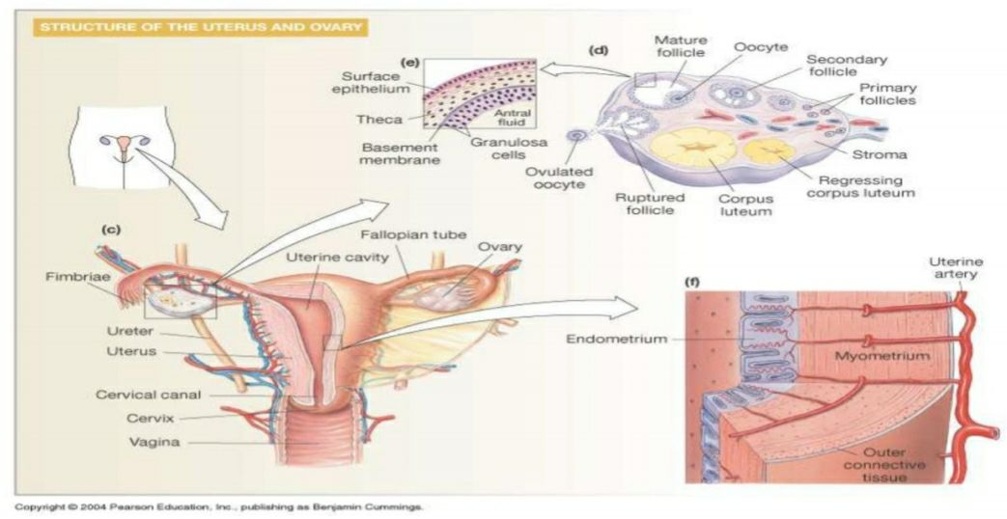

**Oogenesis;**

In the ovarian cortex a process called oogenesis (formation of egg) occurs to develop a mature ovum

Before birth several million cells called primordial oocytes exist in the ovary most of them spontaneously degenerate. At birth, only 1 million oocytes are left and by puberty (age 10-11) only 400,000 remain in the ovaries

From puberty to menopause some of these primordial oocytes (contain 46 chromosomes) undergo DNA replication and become primary oocytes (with 46 chromosomes)

Primary oocytes will then undergo crossing over to shuffle their genes and meiosis I will occur to divide the cells into secondary oocytes (containing 46 unique chromosomes) but will be degenerated oogenesis now to arrest where the ovary discharge a mature secondary oocyte into the uterine tube (in a process called ovulation)

Meiosis II is reactivated when this secondary oocyte is fertilized by a sperm (if no fertilization occurs secondary oocyte is discarded along with the menstrual flow) instantly dividing the 46 chromosomes into 23 (inside the second polar body) and another 23 will be united with the 23 chromosomes that released from the sperm to form fertilized ovum.

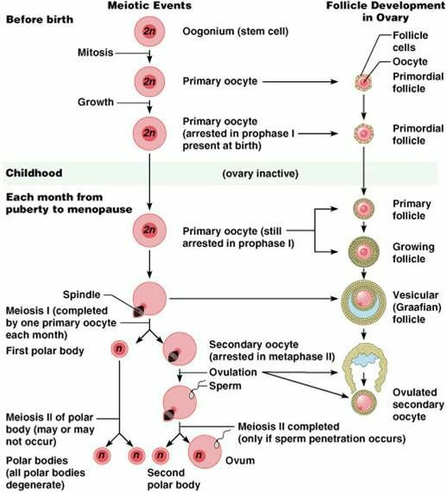

**Hormonal control of female secondary sex characteristic;**

the hypothalamus releases GnRH (gonadotropin releasing hormone) which stimulates the anterior pituitary gland.

The anterior pituitary gland secretes FSH (follicle stimulating hormone) and LH (luteinizing hormone)

FSH stimulates the maturation of a follicle

Granulose cells of the follicle produce and secrete estrogen. Estrogen is responsible for the development and maintenance of most female secondary sex characteristics

LH trigger the release of an egg from the ovary (ovulation) and helps to control the menstrual cycle and stimulate certain cell to produce progesterone and androgen

Concentration of androgen affect other secondary sex characteristics including skeletal growth and growth of hair

Progesterone secreted by the ovaries affect cyclical changes in the uterus and mammary gland

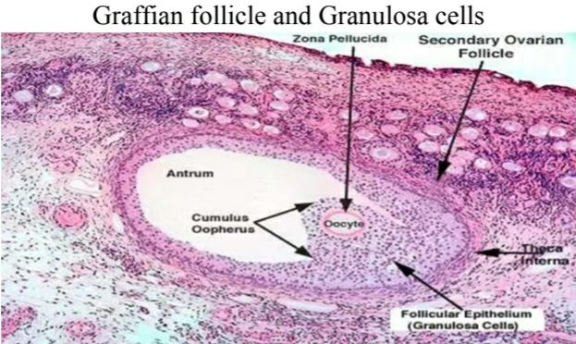

**Types of cells and hormones in the ovarian follicle**;

1. follicle cell
2. zona pellucida
3. thecal cells produce androgen that transfer onto estrogen in females
4. granulosa cells produce inhibin, estrogen and enzyme called aromatase
5. cells of corpus luteum produce progesterone and estrogen

**ovarian cycle;**

three phases of ovarian cycle;

1. follicular phase
2. ovulation
3. luteal phase

the period of each cycle is approximately 28 days

1. **follicular phase**

it is characterized by;

* follicular maturation by the effect of FSH
* increase level of estrogens (produced by granulosa cells)
* at the late period of this phase the level of FSH decreases while the level of LH increases

1. **ovulation;**

* means release of the secondary oocyte from graafian follicle
* only one ovulate each month
* ovulation is induced by peak level of LH
* It occurs on day 14 of a 28 days ovarian cycle

1. **Luteal phase;**

* Occur during days 15-28 of ovarian cycle and formation of corpus luteum
* Corpus luteum secretes mainly progesterone hormone
* Progesterone is important for implantation of fertilized ovum and to maintain pregnancy
* The life spine of corpus luteum is about 10-13 days if fertilization does not occur

**Uterine cycle (menstrual cycle)**

The uterine cycle under effect of estrogen (E2) and progesterone (P4)

Phases of uterine cycle

1. Menstrual phase
2. Proliferative phase
3. Secretary phase

**Menstrual phase**

It occurs during 1-5 days of the cycle

It is characterized by sloughing of functional layer of endometrium and bleeding occur

**Proliferative phase**

It occurs during 6-14 days of the cycle

It is characterized by development of functional layer of endometrium mainly by the action of estrogen

**Secretory phase**

It occurs from day 15-28 of the cycle and the uterus under the effect of progesterone

The functional layer of endometrium undergoes;

1. Increase vascularization
2. Development of uterine glands

If the oocyte is not fertilized the corpus luteum degenerated and the level of progesterone drops so the functional layer undergoes sloughing

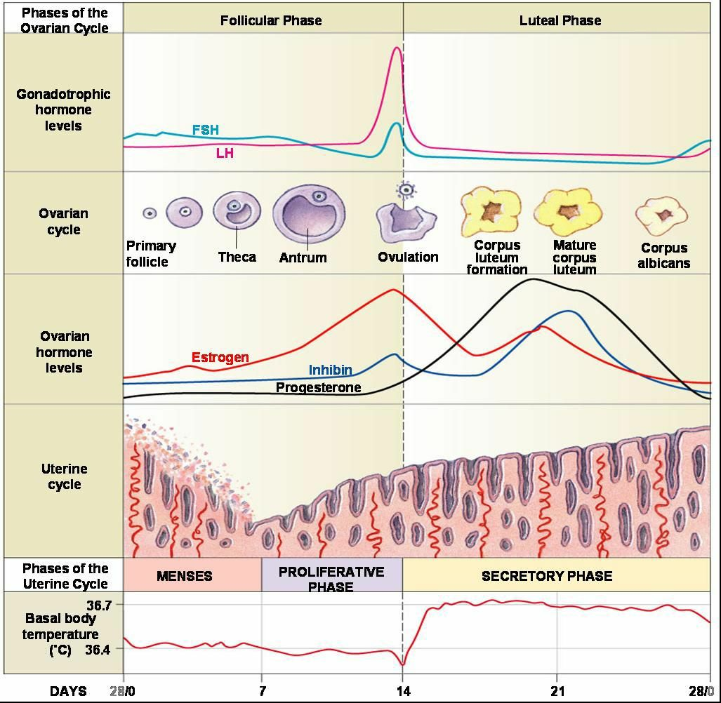

Fertilization;

Within an hour after sexual intercourse sperm would have traveled from the vagina through the cervix into the uterus and uterine tube. During the journey the acrosome on the head of spermatozoa would be worn off releasing acrosin enzyme by the time sperm are attached to the outer coating of the ovum

About 50 spermatozoa are attached to the outermost coatings called corona radiate. Using hydrolysis reaction aided by acrosin some of these sperm reach the inner coating called zone pellucida

One of the sperm will eventually penetrate through the zone pellucida and allow its cell membrane to fuse with the cell membrane of ovum. This causes a rapid electrical despoliation at the cell membrane of the ovum preventing other sperms entering the ovum

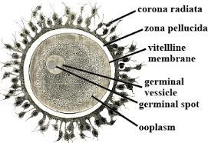

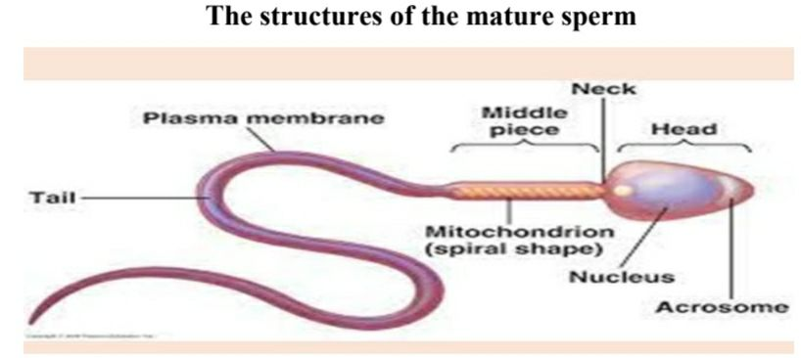

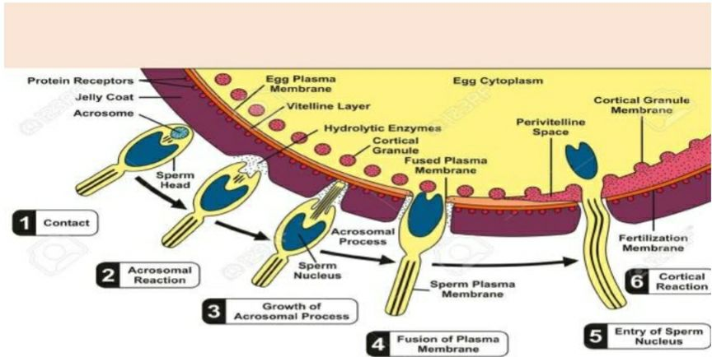

Now **meiosis II** is reactivated in the cytoplasm of ovum dividing the 46 chromosomes in the nucleus onto 23 for fertilization and 23 chromosomes to be eliminated along with the second polar body

The head of the penetrated sperm is now detached from its mid piece and tail. It will then rapture release 23 chromosomes in the form of long strands of DNA molecules

The chromosomes from the sperm and ovum now unite to form a complete set of genetic makeup for the of offspring (2 haploid cells) sperm and ovum are now joined to become a single diploid called **zygote**

Fertilization is now complete

**Hormonal control of mammary glands**

At puberty;

Ovarian hormones secreted during menstrual cycles stimulate alveolar glands and ducts of mammary glands to develop

During pregnancy

Estrogen causes the ductile system to grow and branch

Progesterone stimulates development of alveolar glands

Placental lactogen promotes development of the breasts

Prolactin (from ant. Pituitary) is secreted throughout pregnancy but placental progesterone inhibits milk production (until after birth)

**Mechanical stimulation of breast milk release**

Oxytocin from ant. Pituitary gland stimulates **ejection** of milk from ducts. **As long as milk is removed more prolactin is released;** if milk is not removed milk ceases